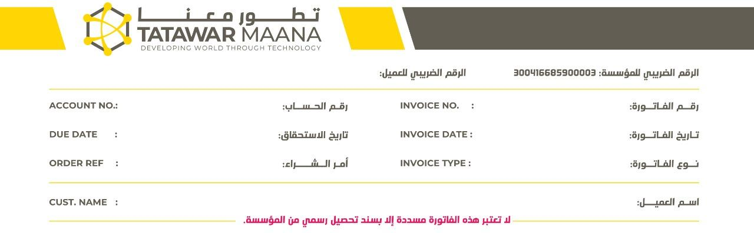

${f_1} ${f_2}

${f_3} ${f_4}

${f_5} ${f_6}

${f_7}

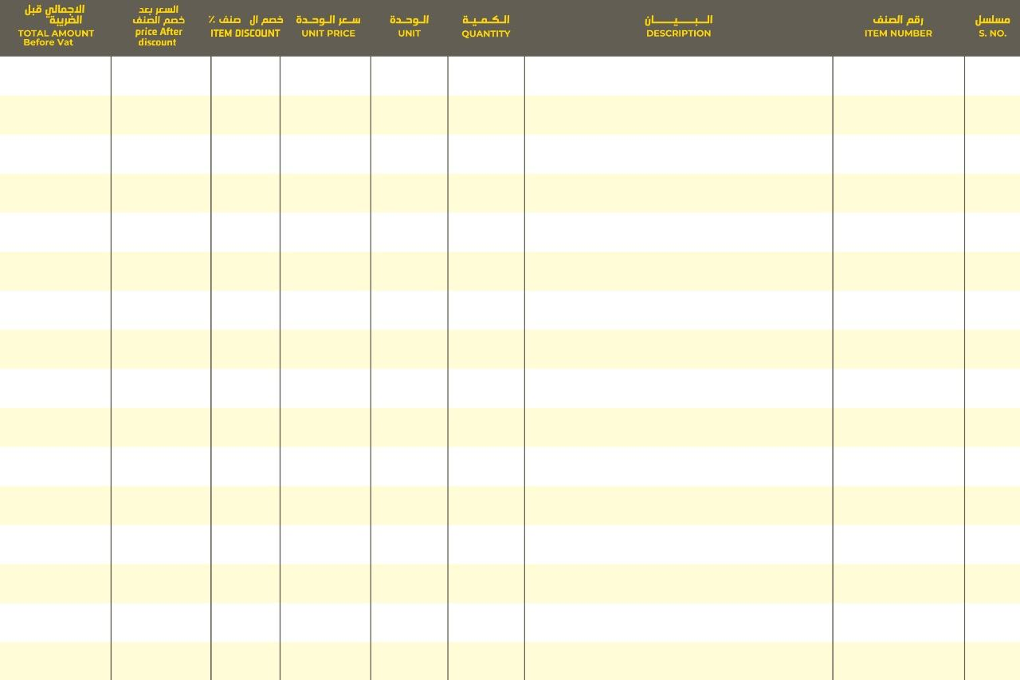

${a_1} ${a_2} ${a_3} ${a_4} ${a_5} ${a_6} ${a_7} ${a_8} ${a_9}