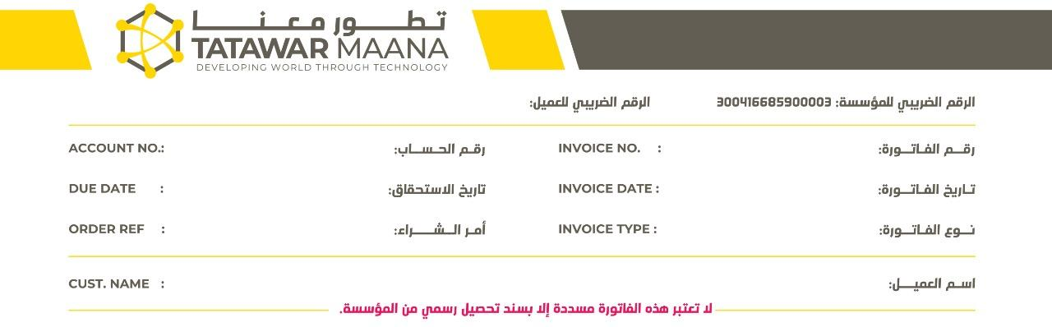

${f_1} ${f_2}

${f_3} ${f_4}

${f_5} ${f_6}

${f_7}

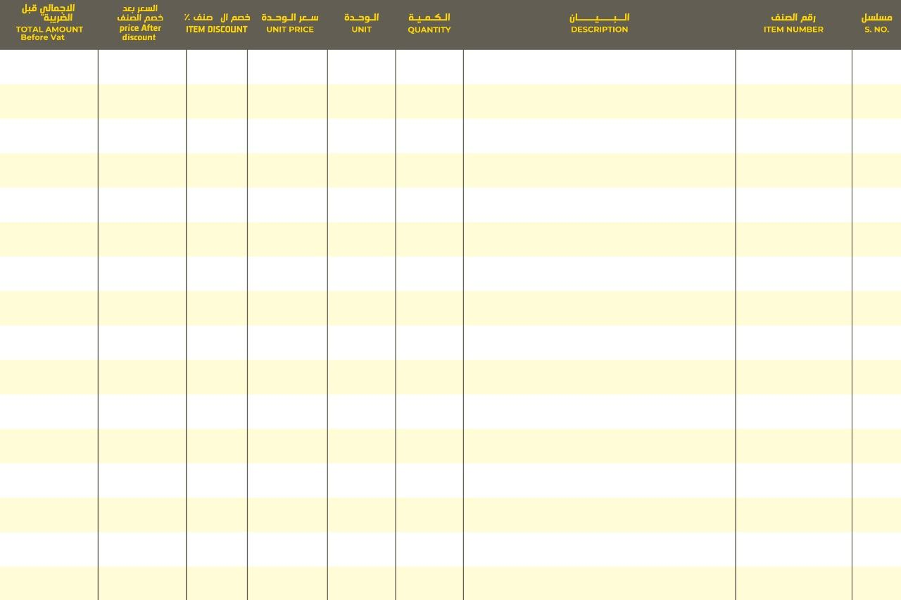

1,380.00 23.00 0.00 % 23.00 حبة E 60 This is Going to be the long text to abcvvv 1