

**Department of Electrical & Computer Engineering First Semester**

**2022/2023 ENCS3130 Linux Laboratory**

**Python Project two (report) – My Advisor**

**Name:** Ayman Qashoo  **Id:** 1200312

**Name:** Majeed Issa **Id:** 1201193

**Instructor:** Dr-Mohammad Jubran

**Section:** 2

Contents

**Table of figures 🡪** 3

**Brief introduction and background 🡪** 4

**Output from the code 🡪** 5

**Conclusion 🡪** 7

# **Table of figures 🡪**

Figure 1:the all courses 6

Figure 2:this courses after he past the some courses 6

Figure 3 : this is sugestet for student 7

# **Brief introduction and background 🡪**

The aim of this project is to delve deeper into dealing with the Python programming language. The idea of ​​the project is to provide the best semester program for the student, which depends on several things, including the materials he has completed and the number of chapters he wants to propose to him.

# **Output from the code 🡪**

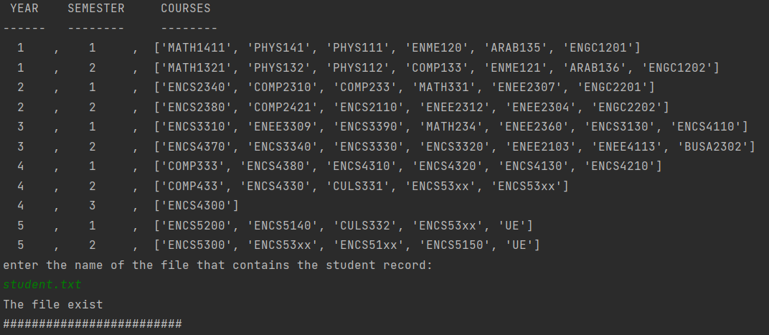

Figure 1:the all courses

After all we read a data from file and show it like in photo sort it to can show first all the courses and after it ask the user enter the file name it is data is saved in student file and check if the file is existed or not.

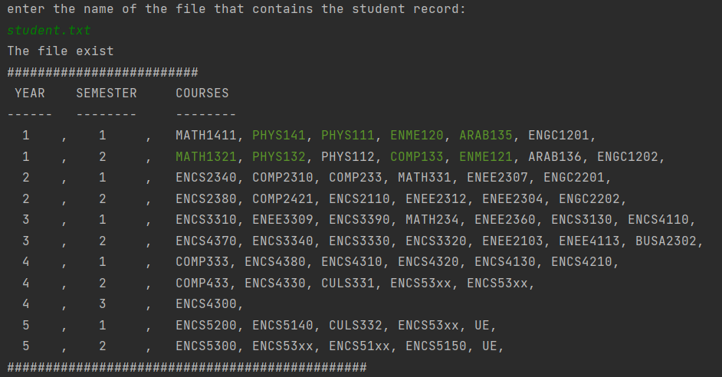

Figure 2:this courses after he past the-some courses

After the check if the file is exist we split this file and take the course name he passed it before and add it in the list after that we print in screen the courses he past it with a green color.

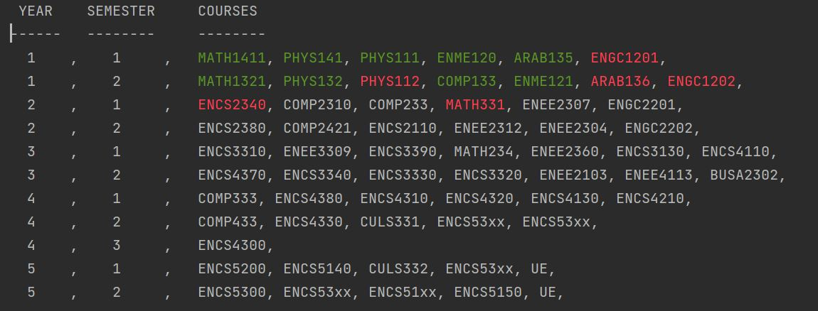

Figure 3 : this is suggested for student

here the student entered that he wants 15 hours of credit at max, so we made the courses painted in red based on the priority of courses and which do not correspond with each other’s times and days.

# **Conclusion 🡪**

In the end, we learned a lot while working on the project, including new things, and we faced many problems in which we faced many difficulties, but in the end, we found a solution to them and learned how to deal with them.