2/12/2025
Milestone # 3
Robotics (Edpt1009) W’21 course project
Robotics (EDPT1009)
Project Milestone: MS#4
Team Number: #02
Chess Playing Robotic Arm
Marwan Ashraf Saad, Adam Mohamed Ismail, Ahmed Amr Abdelhay, Ayman Tarek, Bassel Mostafa Mahran, Youssef Nader Greis

1. Mathematical Formulation
To ensure smooth motion for the robotic manipulator during the pick-and-place operation, a Cubic Polynomial Trajectory was developed in the Task Space (Cartesian $x,y,z$ coordinates). This method ensures continuous position and velocity, ensuring the velocity is zero at the start and end of every motion segment to prevent vibrations or jerky movements.
For a single trajectory segment moving from an initial position $P_{0}$ to a final position $P_{f}$ over a duration $T_{f}$, the position profile $P\left(t\right)$ is defined as a third-degree polynomial:
$$P\left(t\right)=a_{0}+a_{1}t+a_{2}t^{2}+a_{3}t^{3}$$
The velocity profile $\dot{P}\left(t\right)$ is the time derivative of the position:
$$\dot{P}\left(t\right)=a_{1}+2a_{2}t+3a_{3}t^{2}$$
Boundary Conditions: To solve for the coefficients ($a_{0},a_{1},a_{2},a_{3}$), the following boundary conditions were applied based on the code logic: 1. At $t=0$: $P\left(0\right)=P_{0}$ and $\dot{P}\left(0\right)=0$ (Start from rest). 2. At $t=T_{f}$: $P\left(T_{f}\right)=P_{f}$ and $\dot{P}\left(T_{f}\right)=0$ (Stop at target).
Coefficient Solution: Substituting the boundary conditions into the equations yields the coefficients used in the task_space_traj.m function:
- $a_{0}=P_{0}$
- $a_{1}=0$
- $a_{2}=\frac{3\left(P_{f}-P_{0}\right)}{T_{f}^{2}}$
- $a_{3}=\frac{-2\left(P_{f}-P_{0}\right)}{T_{f}^{3}}$
This calculation is performed for the $x$, $y$, and $z$ coordinates independently at every segment of the operation.

2. Design of the Motion Trajectories
The pick-and-place operation is designed as a sequence of 6 distinct segments to move an object from a Left location to a Right location while avoiding collisions with the workspace floor.
The Waypoints (defined in Mainscript.m):
Start Pose: Center/Front ($0.07,0.00,0.20$)
Left (Pick) Location: ($0.12,0.10$) at Heights $0.20$ (Above) and $0.10$ (Pick).
Right (Place) Location: ($0.12,-0.10$) at Heights $0.20$ (Above) and $0.10$ (Place).
Visualized Path: The robot traces a square-bridge path. It hovers high, descends vertically to interact with the object, retracts vertically, moves horizontally to the destination, and descends again.
Motion Sequence segments:
1. Approach: Start $→$ Left Above ($z_{high}$)
2. Descent: Left Above $→$ Left Down ($z_{low}$) $→$ Gripper Close
3. Retraction: Left Down $→$ Left Above ($z_{high}$)
4. Transport: Left Above $→$ Right Above ($z_{high}$)
5. Descent: Right Above $→$ Right Down ($z_{low}$) $→$ Gripper Open
6. Retraction: Right Down $→$ Right Above ($z_{high}$)

Validation Comments (Simscape, Gazebo, Hardware)
The developed Inverse Kinematics (IK) and trajectory generation algorithms were validated across three distinct environments to ensure robustness before physical deployment.

3. Simscape Multibody Validation
- Role: The Simscape model (TrajectoryPlanning.slx) served as the Ground Truth for physics-aware kinematics.
- Implementation: The model utilizes a MATLAB Function block to solve the Newton-Raphson IK algorithm in real-time simulation steps.
- Observation: The Simscape simulation validated that the computed joint angles ($q$) result in the correct End-Effector position when applied to the rigid body tree. It confirmed that the link lengths ($l_{1},l_{2},l_{3},l_{4}$) defined in the script matches the CAD physical parameters imported into the XML/SLX file.

4. Gazebo (ROS) Validation
- Role: Gazebo provided a system integration test to verify the logic in a distributed node environment (ik_from_xyz.py and task_space_pick_place.py).
- Implementation: The ROS nodes implement the exact same cubic trajectory generation and numerical IK solver (Damped Least Squares) as the MATLAB scripts.
- Observation: The visualization in Gazebo verified the coordinate frame assignments. Specifically, the Python script handles the mapping of the computed 4-DOF solution to the specific joint names (Joint_1, Joint_2, Joint_3, Joint_5) required by the URDF/Gazebo model.

5. Hardware Validation (Arduino/Physical Robot)
- Role: Final validation dealing with real-world constraints such as servo limits and offsets.
- Implementation: The Mainscript.m connects to the Arduino (COM3) and maps the simulation angles (radians) to servo commands (0-180 degrees).
- Key Adjustments:
  - Offsets: The hardware validation revealed the need for specific joint offsets. While the theoretical model assumes 0 as the home position, the physical servos required a $+{90}^{∘}$ offset for servos 2, 3, and 4 to align with the kinematic model.
  - Saturation: Code was added to saturate commands between $0^{∘}$ and ${180}^{∘}$ to prevent mechanical stalling or damage to the servos.
Accuracy Check: The script calculates p_hw (actual FK from sent angles) vs Pd (desired trajectory) in real-time. Discrepancies here highlight physical calibration errors (e.g., link deflection or servo deadband) rather than algorithmic errors.

6. Plots

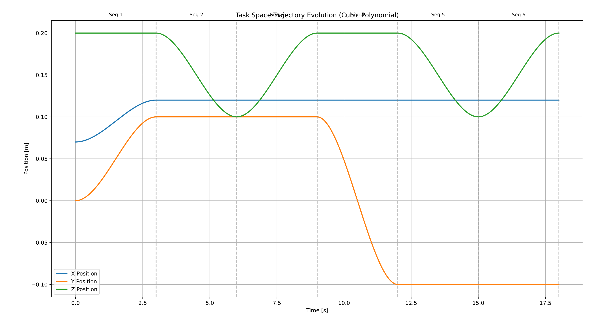
Fig 1. Task Space Trajectory Evolution

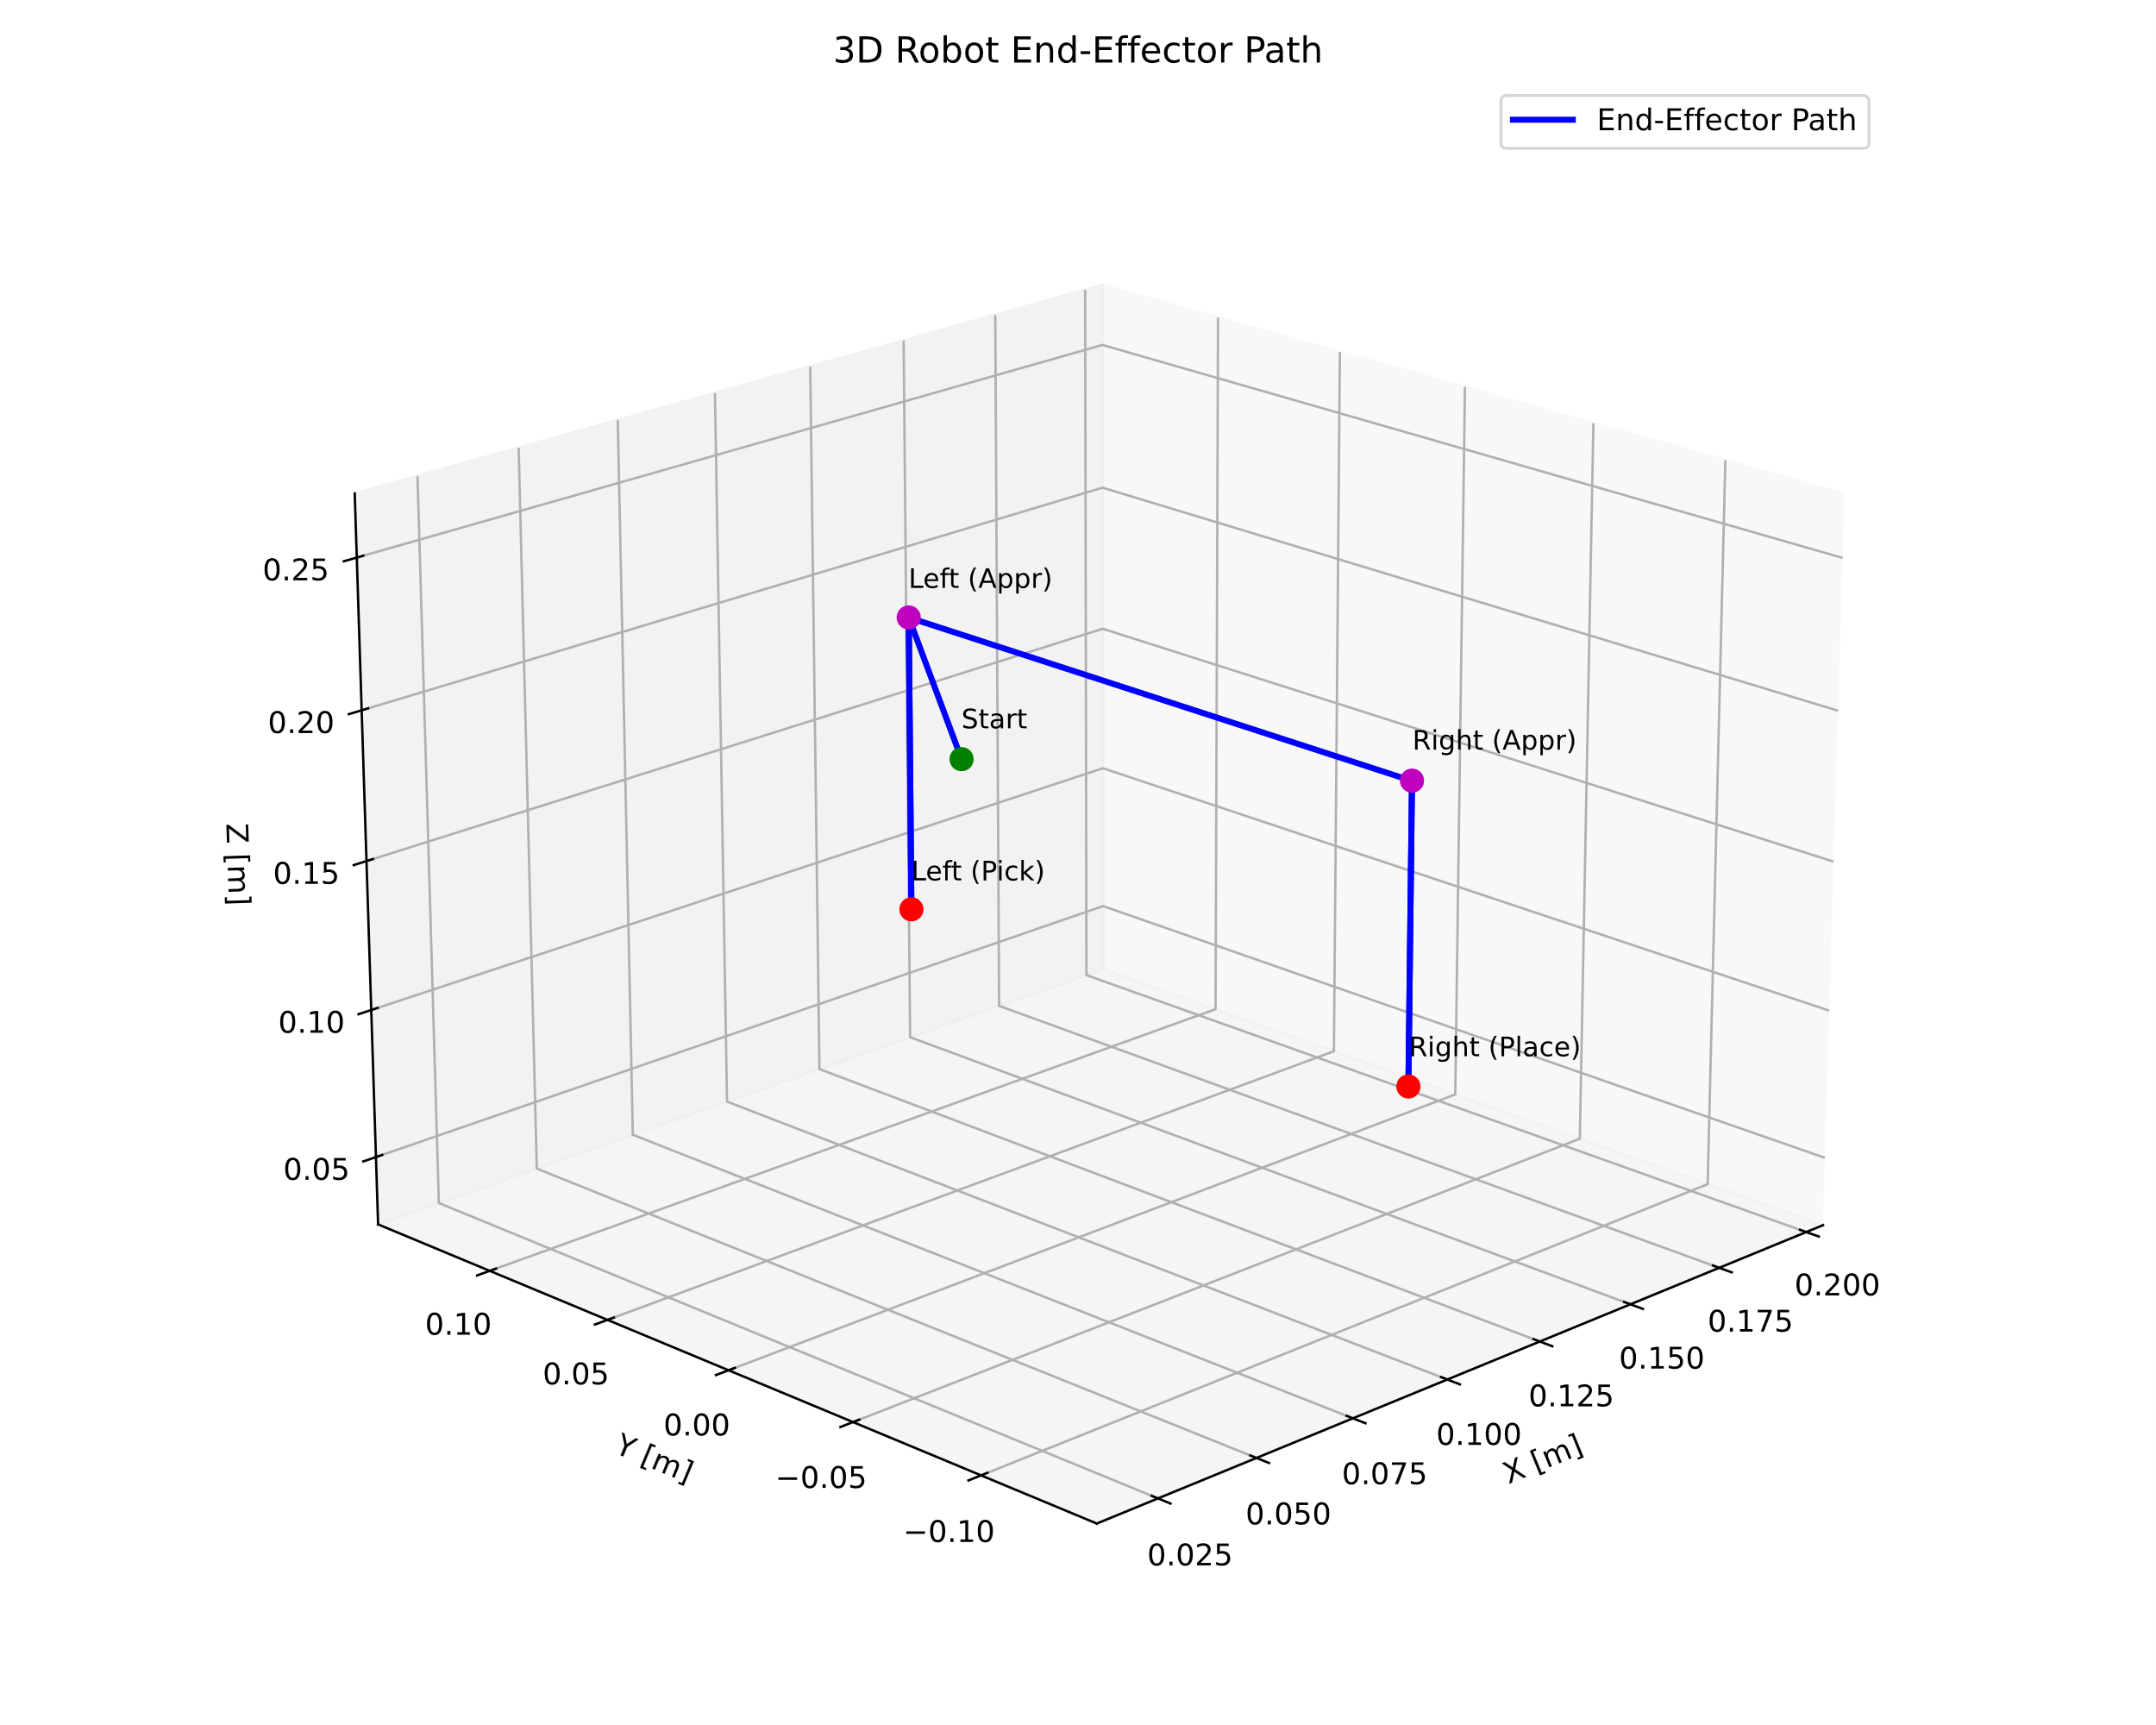
Fig 2. 3D Robot End Effector Path

