11/15/2025
Milestone # 3
Robotics (Edpt1009) W’21 course project
Robotics (EDPT1009)
Project Milestone: MS#3
Team Number: #02
Chess Playing Robotic Arm
Marwan Ashraf Saad, Adam Mohamed Ismail, Ahmed Amr Abdelhay, Ayman Tarek, Bassel Mostafa Mahran, Youssef Nader Greis

Inverse Position Kinematics

The MATLAB script implements an iterative numerical inverse kinematics (IK) algorithm to find the robot's joint angles that achieve a desired end-effector position.
The specific method is a form of the Newton-Raphson algorithm (also known as the Jacobian-based method). Here's how it works:
- Forward Kinematics (FK): The algorithm starts with an initial guess for the joint angles. It calculates the robot's current end-effector position by multiplying the transformation matrices T1 through T4.
- Position Error: It computes the error, which is the difference between the desired position and the current position.
- The Jacobian: The core of this method is the Jacobian matrix. This matrix describes how small changes in the joint angles will cause small changes in the end-effector's position. Your script calculates this numerically by slightly moving each joint one by one and seeing how the end-effector position changes.
- Inverting the Relationship: The algorithm's goal is to find the change in joint angles needed to correct the position error. It uses the Jacobian to solve for this required change.
- Pseudo-Inverse: Since the robot has 4 joints and is only trying to control 3 position coordinates (x, y, z), the Jacobian matrix isn't square. A standard inverse can't be used. The script uses a "pseudo-inverse" (the pinv function in MATLAB). This is a mathematical tool that finds the most efficient change in joint angles to correct the error.
- Iteration and Update: The joint angles are then updated by adding the calculated change (scaled by the alpha value). This entire process (Steps 1-6) repeats in a loop.
This loop continues until the position error is smaller than the specified tolerance, meaning the robot's end-effector has successfully reached the target position.

Iter 1 | Error = 0.452840 m
Iter 2 | Error = 0.422518 m
Iter 3 | Error = 0.392861 m
Iter 4 | Error = 0.364811 m
Iter 5 | Error = 0.339347 m
Iter 6 | Error = 0.317417 m
Iter 7 | Error = 0.299830 m
Iter 8 | Error = 0.287114 m
Iter 9 | Error = 0.279383 m
Iter 10 | Error = 0.275685 m
Iter 11 | Error = 0.270621 m
Iter 12 | Error = 0.265295 m
Iter 13 | Error = 0.258711 m
Iter 14 | Error = 0.251456 m
Iter 15 | Error = 0.244101 m
Iter 16 | Error = 0.237181 m
Iter 17 | Error = 0.227795 m
Iter 18 | Error = 0.215003 m
Iter 19 | Error = 0.200409 m
Iter 20 | Error = 0.184416 m
Iter 21 | Error = 0.167971 m
Iter 22 | Error = 0.150418 m
Iter 23 | Error = 0.131678 m
Iter 24 | Error = 0.111802 m
Iter 25 | Error = 0.090889 m
Iter 26 | Error = 0.069083 m
Iter 27 | Error = 0.046632 m
Iter 28 | Error = 0.024307 m
Iter 29 | Error = 0.009886 m
Iter 30 | Error = 0.003962 m
Iter 31 | Error = 0.001587 m
Iter 32 | Error = 0.000635 m
Iter 33 | Error = 0.000254 m
Iter 34 | Error = 0.000102 m
Iter 35 | Error = 0.000041 m
Converged after 35 iterations.

Final Joint Angles (deg):
q1 = 78.6881°
q2 = -44.1315°
q3 = 85.4983°
q4 = 99.7213°

Final End-Effector Position:
x = 0.0500, y = 0.2500, z = 0.2000
Final Error Norm = 0.000041 m
Final Jacobian Jv =
-0.2500 -0.0219 0.0022 -0.0188
0.0500 -0.1093 0.0108 -0.0939
0 0.2549 -0.1574 0.0551

Forward and Inverse Velocity Kinematics

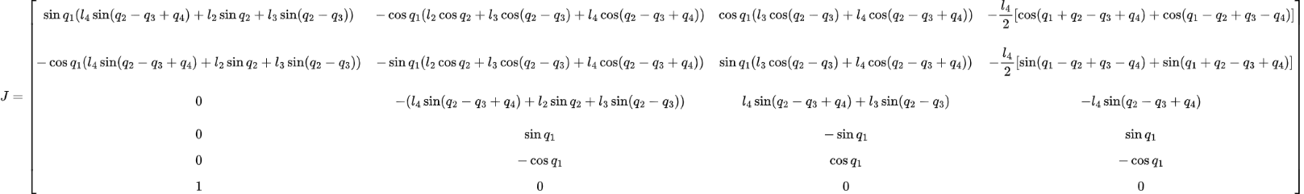

Symbolic Jacobian J (per-degree)
[ (pi*sin((pi*q1)/180)*(l4*sin((pi*(q2 - q3 + q4))/180) + l2*sin((pi*q2)/180) + l3*sin((pi*(q2 - q3))/180)))/180, -(pi*cos((pi*q1)/180)*(l2*cos((pi*q2)/180) + l3*cos((pi*(q2 - q3))/180) + l4*cos((pi*(q2 - q3 + q4))/180)))/180, (pi*cos((pi*q1)/180)*(l3*cos((pi*(q2 - q3))/180) + l4*cos((pi*(q2 - q3 + q4))/180)))/180, -(l4*pi*(cos((pi*(q1 + q2 - q3 + q4))/180) + cos((pi*(q1 - q2 + q3 - q4))/180)))/360]
[-(pi*cos((pi*q1)/180)*(l4*sin((pi*(q2 - q3 + q4))/180) + l2*sin((pi*q2)/180) + l3*sin((pi*(q2 - q3))/180)))/180, -(pi*sin((pi*q1)/180)*(l2*cos((pi*q2)/180) + l3*cos((pi*(q2 - q3))/180) + l4*cos((pi*(q2 - q3 + q4))/180)))/180, (pi*sin((pi*q1)/180)*(l3*cos((pi*(q2 - q3))/180) + l4*cos((pi*(q2 - q3 + q4))/180)))/180, -(l4*pi*(sin((pi*(q1 - q2 + q3 - q4))/180) + sin((pi*(q1 + q2 - q3 + q4))/180)))/360]
[0, -(pi*(l4*sin((pi*(q2 - q3 + q4))/180) + l2*sin((pi*q2)/180) + l3*sin((pi*(q2 - q3))/180)))/180, (pi*(l4*sin((pi*(q2 - q3 + q4))/180) + l3*sin((pi*(q2 - q3))/180)))/180, -(l4*pi*sin((pi*(q2 - q3 + q4))/180))/180]
[0, (pi*sin((pi*q1)/180))/180, -(pi*sin((pi*q1)/180))/180, (pi*sin((pi*q1)/180))/180]
[0, -(pi*cos((pi*q1)/180))/180, (pi*cos((pi*q1)/180))/180, -(pi*cos((pi*q1)/180))/180]
[pi/180, 0, 0, 0]

Symbolic Jacobian J (per-radian)
Row 1:
[ sin(q1)*(l4*sin(q2 - q3 + q4) + l2*sin(q2) + l3*sin(q2 - q3)),
-cos(q1)*(l2*cos(q2) + l3*cos(q2 - q3) + l4*cos(q2 - q3 + q4)),
cos(q1)*(l3*cos(q2 - q3) + l4*cos(q2 - q3 + q4)),
- (l4/2)*( cos(q1 + q2 - q3 + q4) + cos(q1 - q2 + q3 - q4) ) ]
Row 2:
[ -cos(q1)*(l4*sin(q2 - q3 + q4) + l2*sin(q2) + l3*sin(q2 - q3)),
-sin(q1)*(l2*cos(q2) + l3*cos(q2 - q3) + l4*cos(q2 - q3 + q4)),
sin(q1)*(l3*cos(q2 - q3) + l4*cos(q2 - q3 + q4)),
- (l4/2)*( sin(q1 - q2 + q3 - q4) + sin(q1 + q2 - q3 + q4) ) ]
Row 3:
[ 0,
- ( l4*sin(q2 - q3 + q4) + l2*sin(q2) + l3*sin(q2 - q3) ),
( l4*sin(q2 - q3 + q4) + l3*sin(q2 - q3) ),
- l4*sin(q2 - q3 + q4) ]
Row 4:
[ 0, sin(q1), -sin(q1), sin(q1) ]
Row 5:
[ 0, -cos(q1), cos(q1), -cos(q1) ]
Row 6:
[ 1, 0, 0, 0 ]

Forward Kinematics (numeric)
x = -0.1570 m
y = -0.0605 m
z = 0.3727 m
Euler ZYX (deg):
roll = -90.0000°
pitch = -26.7800°
yaw = -158.9300°

Jacobian from differentiation (numeric)
0.0011 -0.0046 0.0029 -0.0008
-0.0027 -0.0018 0.0011 -0.0003
0 -0.0029 0.0013 -0.0017
0 0.0063 -0.0063 0.0063
0 -0.0163 0.0163 -0.0163
0.0175 0 0 0

Inverse Velocity Kinematics
Desired v = [0.019036 -0.006411 -0.013865] m/s
qdot (deg/s) = [-4.477675 2.306787 2.771328 4.811676]
Reconstructed v = [0.019036 -0.006411 -0.013865] m/s
-220.3858 44.0510 0.0000
-1.3446 -6.7270 -165.1104
-85.5201 -427.8540 -119.4602
-86.9873 -435.1946 -265.2387

Appendices

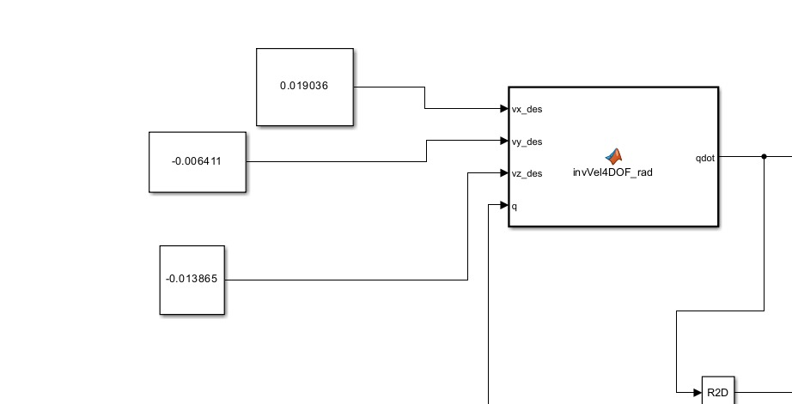
Fig1. Desired velocities on simscape
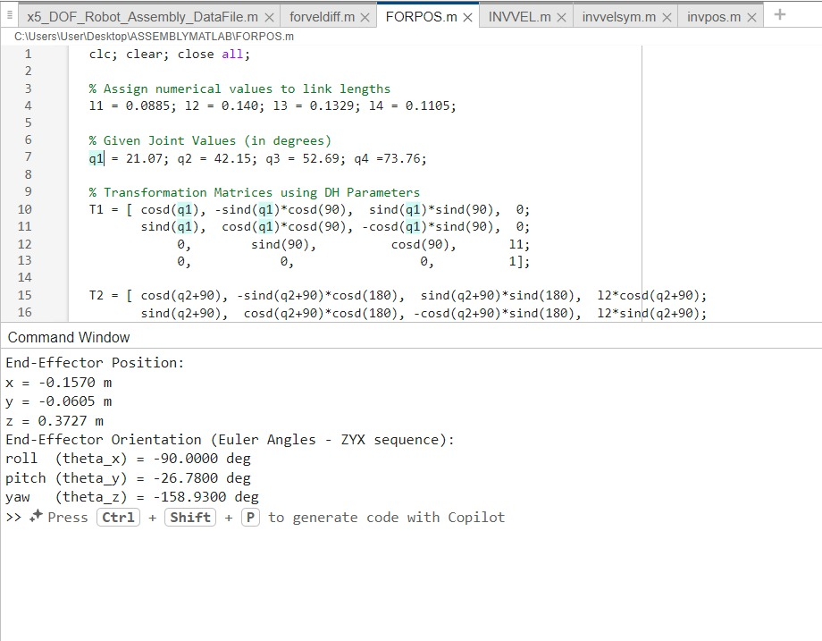
Fig2. Forward Position
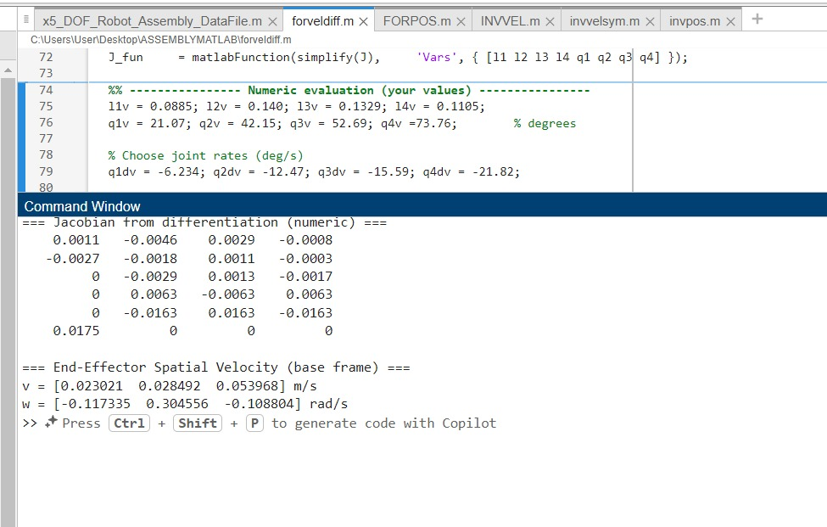
Fig3. Forward Velocity Differentiation

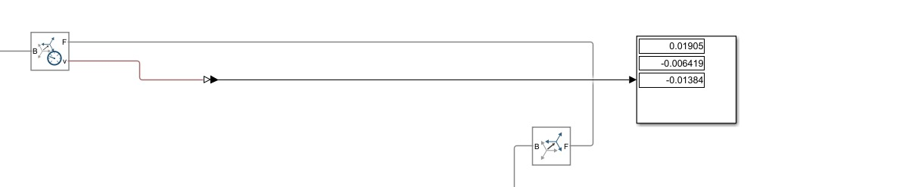
Fig4. output velocity on transform sensor

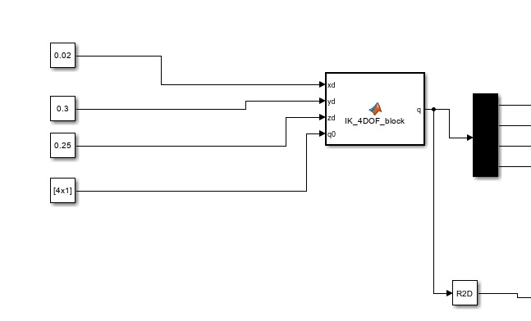
Fig5. Desired Positions on simscape

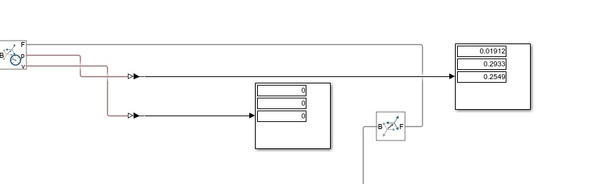
Fig6. Output Position on transform sensor

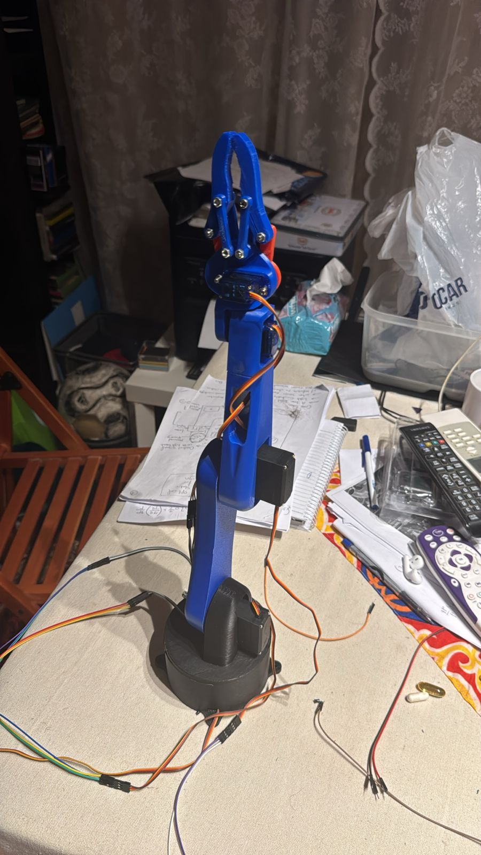
Fig7. Robotic arm

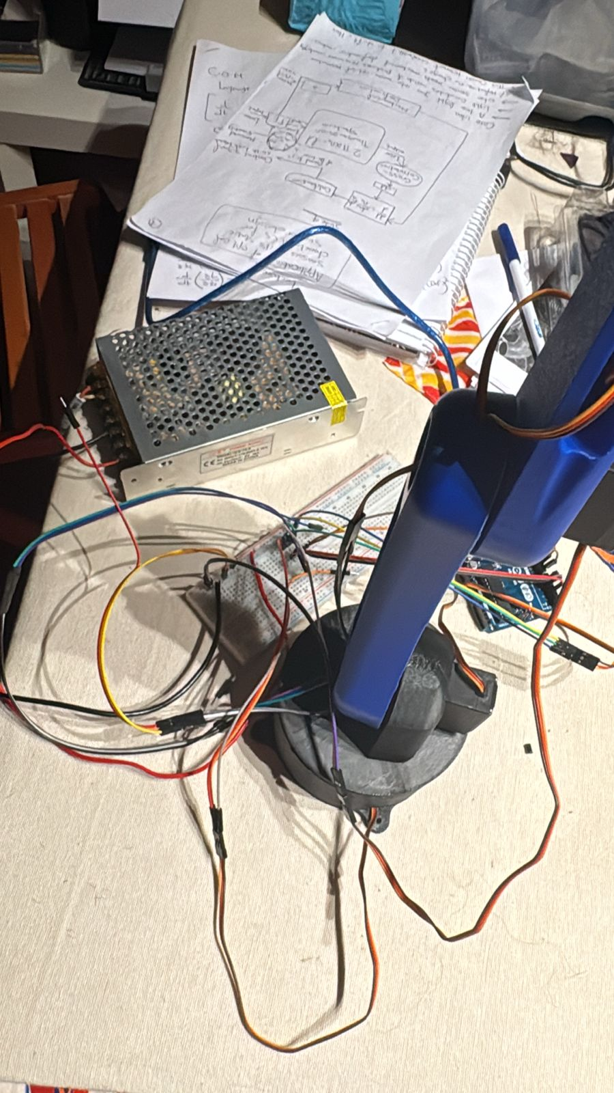
Fig8. Circuitry

