YACHAOUI Ayman _ JSON Stores LAB (MongoDB)

Setting MongoDB for Ubuntu Xenial

In this section, I will install, configure, and test MongoDB connectivity.
Step 1 : I import the GPG keys of MongoDB© required by the Ubuntu package manager apt.
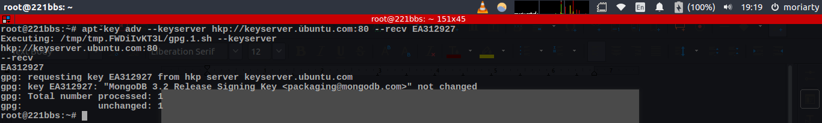
Step 2 : I add MongoDB entry to the apt repository list
Step 3 : I proceed to installing MongoDB with apt
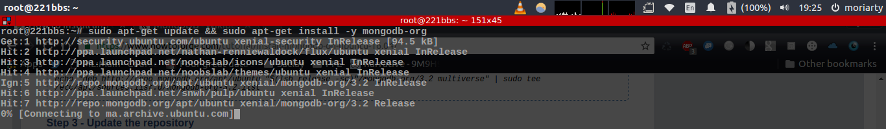
Step 4 : In order to launch the server, Mongod deamon must be invoked and since Ubuntu Xenial uses systemd, I create a new MongoDB systemd service file as /lib/systemd/system/mongod.service
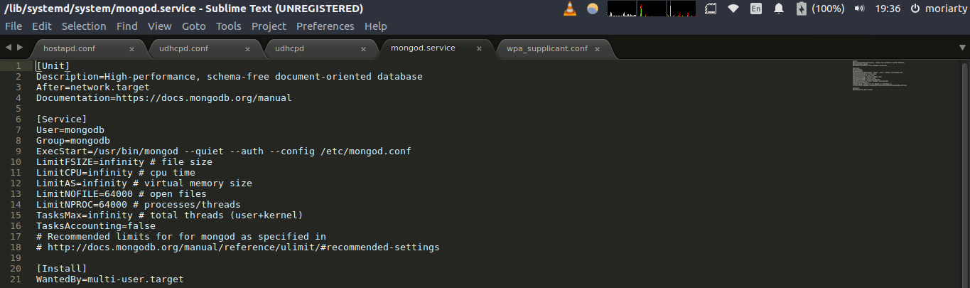
Step 5 : I update afterwards the newly defined systemd service
Step 6 : I launch mongod – MongoDB daemon – the server is running on port 27017 of local host
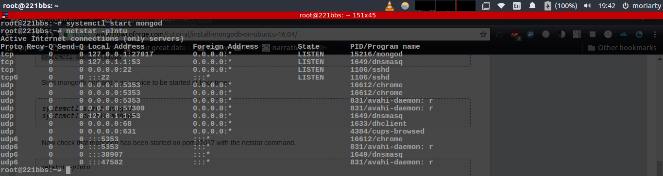
Step 7 : I create a new database “LabDK” and then use mongoimport in the Linux shell to import the moviepeople-10 json file as the mp10 collection within the LabDK database :
mongoimport --db LabDK --collection mp10 --type json --file /home/moriarty/Desktop/DK/BigDataArchitecture/LAB-MONGO/moviepeople-10.json
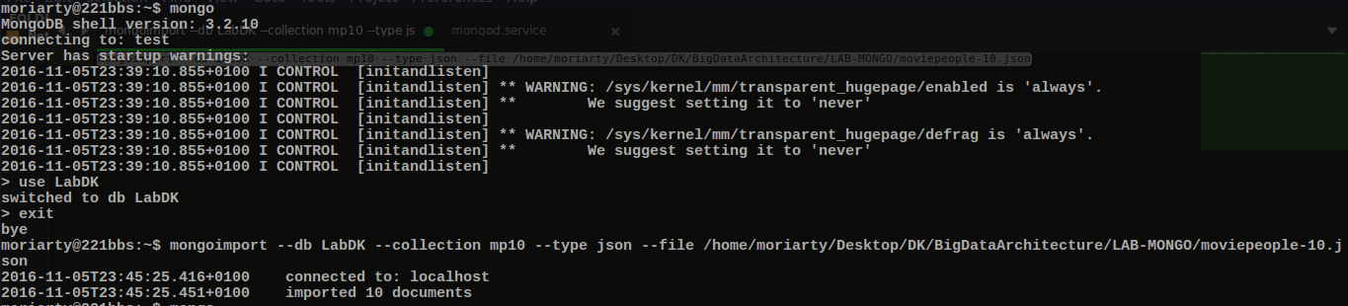
Step 8 : We retrieve all the documents by querying the mongo client :
db.mp10.find()
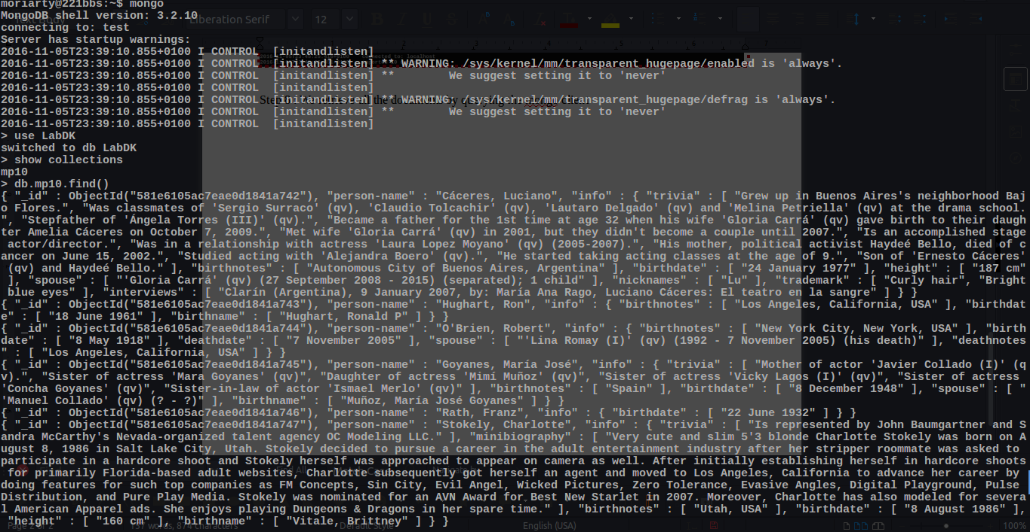

MongoDB : import, query
1 - I import cities.json and moviepeople-3000.json using mongoimport in the Linux shell into the LabDK database to the collections mp3000 and cts respectively
mongoimport --db LabDK --collection mp3000 --type json --file /home/moriarty/Desktop/DK/BigDataArchitecture/LAB-MONGO/moviepeople-3000.json
mongoimport --db LabDK --collection cts --type json --file /home/moriarty/Desktop/DK/BigDataArchitecture/LAB-MONGO/cities.json
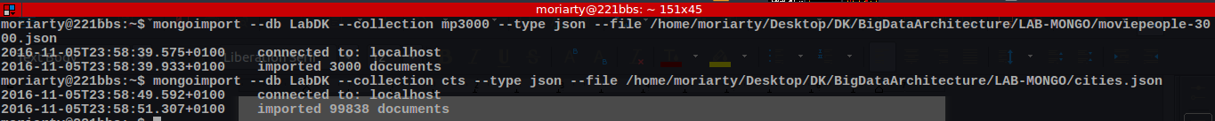
2 - The query to find Anabela Teixeira :
db.mp3000.find( { "person-name": "Teixeira, Anabela" } )
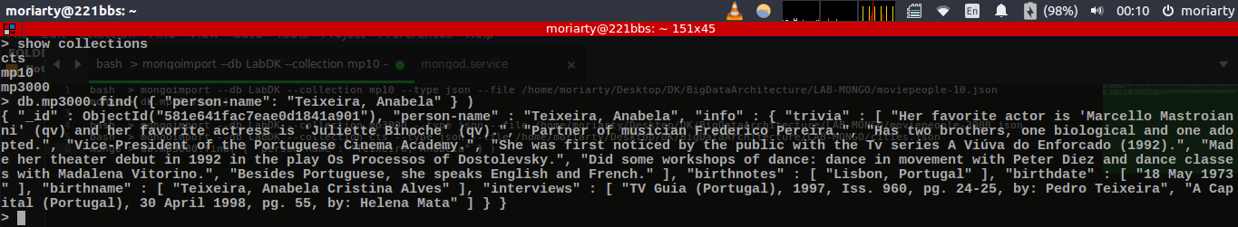
3 - Steven Spielberg was born in Cincinnati :
db.mp3000.find( {"person-name" : "Spielberg, Steven"}, {"info.birthnotes" : 1})
4 - The number of people born in “Lisbon, Portugal” is 171:
db.runCommand( { count:'mp3000', query: { "info.birthnotes": "Lisbon, Portugal" } } )
5-
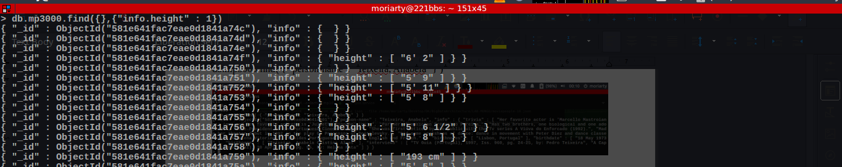
The query db.mp3000.find({},{"info.height" : 1}) shows that info.height is given in imperial and SI
To find that 1312 = 346 + 966 people are taller than 170 cms, we proceed in two steps :
- db.runCommand( { count:'mp3000',
query: {
"info.height": { $gt: "170" },
"info.height" : /cm/}
} ) in order to count fields with regex /cm/, returns 346
- db.runCommand( { count:'mp3000',
query: {
"info.height": { $gt: "5' 7\" " },
"info.height" : /'/}
} ) in order to count fields with regex /cm/, returns 966
6 - The query to find the word “Opera” in all subfields of the info subdocument is :
db.mp3000.find({$where: function() { for (var field in this.info) { for (var iter = 0;iter<this.info[field].length;iter+ +) { if(this.info[field][iter].includes("Opera") || this.info[field].includes("Opera")) return true; }} return false; }}, {"person-name":1})
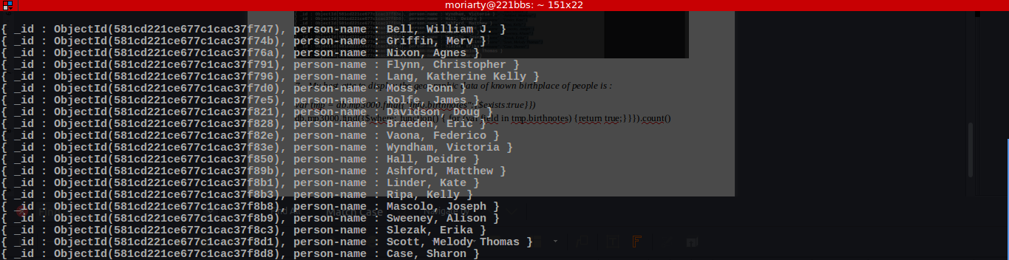
7 – I couldn’t answer this question

MongoDB replication
8 – In a first shell I create in /tmp directory, 3 subfolders mongo0, mongo1, mongo2, followed by :
mongod --dbpath ~/mongo1 --port 20000 --replSet “rs”
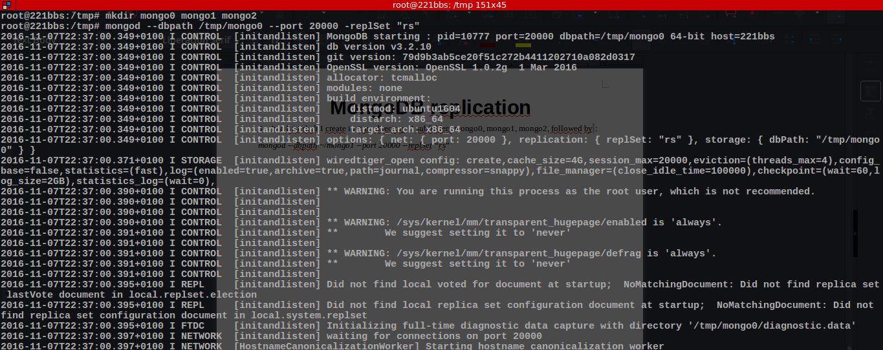
In three separate shells, port 21000 for mongo1 and 22000 for mongo 2 the result is :
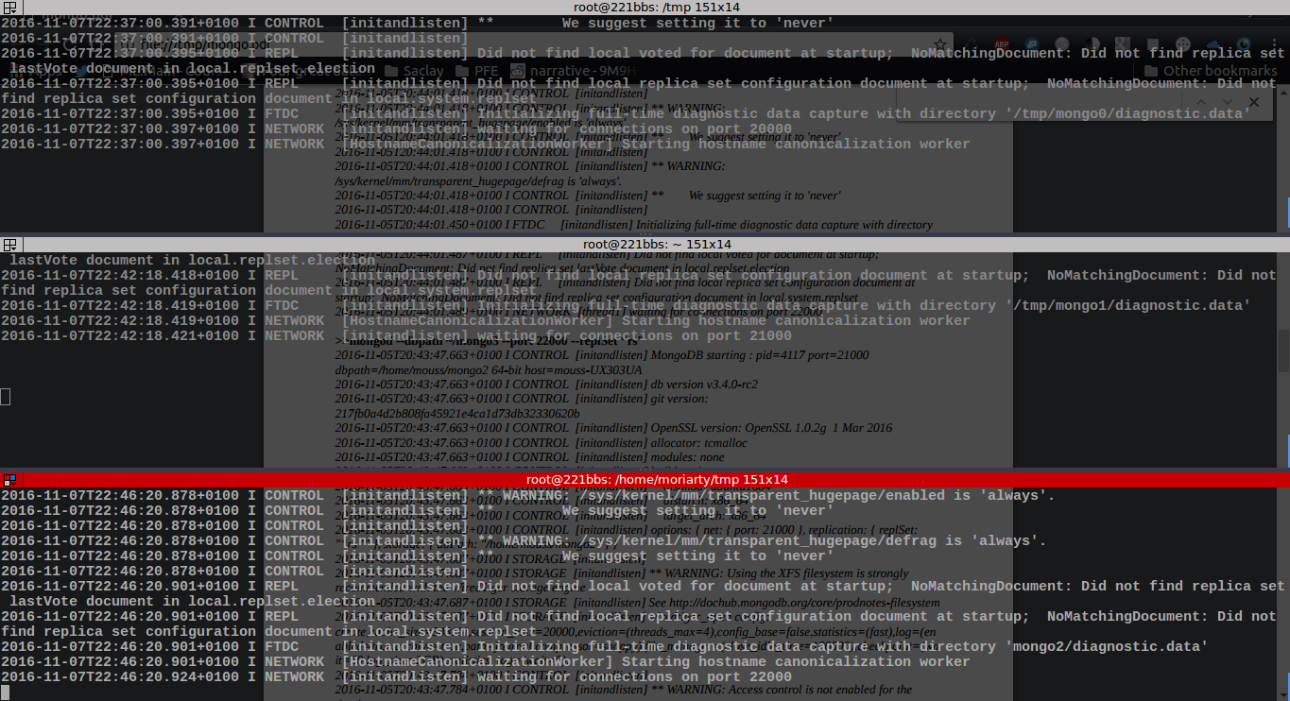
I will connect to mongo0 which open port is 20000 via the command :
mongo localhost:20000
For screening convenience, the remaining commands and std outputs are mentionned below

>rs.initiate()
{
"info2" : "no configuration specified. Using a default configuration for the set",
"me" : "221bbs:20000",
"ok" : 1
}
>rs.add(“221bbs:21000”)
{ "ok" : 1 }
>rs.addArb(“221bbs:22000”)
{ "ok" : 1 }
>rs.status()
{
"set" : "“rs”",
"date" : ISODate("2016-11-07T22:08:22.657Z"),
"myState" : 1,
"term" : NumberLong(1),
"heartbeatIntervalMillis" : NumberLong(2000),
"optimes" : {
"lastCommittedOpTime" : {
"ts" : Timestamp(1478376501, 1),
"t" : NumberLong(1)
},
"appliedOpTime" : {
"ts" : Timestamp(1478376501, 1),
"t" : NumberLong(1)
},
"durableOpTime" : {
"ts" : Timestamp(1478376501, 1),
"t" : NumberLong(1)
}
},
"members" : [
{
"_id" : 0,
"name" : "221bbs:20000",
"health" : 1,
"state" : 1,
"stateStr" : "PRIMARY",
"uptime" : 1495,
"optime" : {
"ts" : Timestamp(1478376501, 1),
"t" : NumberLong(1)
},
"optimeDate" : ISODate("2016-11-07T22:08:21Z"),
"electionTime" : Timestamp(1478556070, 1),
"electionDate" : ISODate("2016-11-05T19:44:30Z"),
"configVersion" : 5,
"self" : true
},
{
"_id" : 1,
"name" : "221bbs:21000",
"health" : 1,
"state" : 2,
"stateStr" : "SECONDARY",
"uptime" : 1396,
"optime" : {
"ts" : Timestamp(1478376491, 1),
"t" : NumberLong(1)
},
"optimeDurable" : {
"ts" : Timestamp(1478376491, 1),
"t" : NumberLong(1)
},
"optimeDate" : ISODate("2016-11-07T22:08:11Z"),
"optimeDurableDate" : ISODate("2016-11-07T22:08:11Z"),
"lastHeartbeat" : ISODate("2016-11-07T22:08:20.731Z"),
"lastHeartbeatRecv" : ISODate("2016-11-07T22:08:21.692Z"),
"pingMs" : NumberLong(0),
"syncingTo" : "221bbs:20000",
"configVersion" : 5
},
{
"_id" : 2,
"name" : "221bbs:22000",
"health" : 1,
"state" : 7,
"stateStr" : "ARBITER",
"uptime" : 1118,
"lastHeartbeat" : ISODate("2016-11-07T22:08:20.727Z"),
"lastHeartbeatRecv" : ISODate("2016-11-07T22:08:22.343Z"),
"pingMs" : NumberLong(0),
"syncingTo" : "221bbs:20000",
"configVersion" : 5
}
],
"ok" : 1
}
Secondary server (mongo2) :
2016-11-07T22:45:06.323+0100 I NETWORK [thread1] connection accepted from 127.0.0.1:58030 #1 (1 connection
now open)
2016-11-07T22:45:06.323+0100 I - [conn1] end connection 127.0.0.1:58030 (1 connection now open)
2016-11-07T22:45:06.323+0100 I NETWORK [thread1] connection accepted from 127.0.0.1:58032 #2 (1 connection
now open)
2016-11-07T22:45:06.323+0100 I NETWORK [conn2] received client metadata from 127.0.0.1:58032 conn2:
{ driver: { name: "NetworkInterfaceASIO-Replication", version: "3.4.0-rc2" }, os: { type: "Linux", name: "Ubuntu",
architecture: "x86_64", version: "16.04" } }
2016-11-07T22:45:06.323+0100 I ASIO [NetworkInterfaceASIO-Replication-0] Connecting to moussUX303UA:20000
2016-11-07T22:45:06.324+0100 I ASIO [NetworkInterfaceASIO-Replication-0] Successfully connected to moussUX303UA:20000
2016-11-07T22:45:06.325+0100 I NETWORK [thread1] connection accepted from 127.0.0.1:58038 #3 (2 connections
now open)
2016-11-07T22:45:06.325+0100 I - [conn3] end connection 127.0.0.1:58038 (2 connections now open)
2016-11-07T22:45:06.348+0100 I REPL [replExecDBWorker-2] Starting replication storage threads
2016-11-07T22:45:06.350+0100 I REPL [ReplicationExecutor] New replica set config in use: { _id: "“rs”", version:
2, protocolVersion: 1, members: [ { _id: 0, host: "221bbs:20000", arbiterOnly: false, buildIndexes: true,
hidden: false, priority: 1.0, tags: {}, slaveDelay: 0, votes: 1 }, { _id: 1, host: "221bbs:21000", arbiterOnly:
false, buildIndexes: true, hidden: false, priority: 1.0, tags: {}, slaveDelay: 0, votes: 1 } ], settings: { chainingAllowed:
true, heartbeatIntervalMillis: 2000, heartbeatTimeoutSecs: 10, electionTimeoutMillis: 10000, catchUpTimeoutMillis:
2000, getLastErrorModes: {}, getLastErrorDefaults: { w: 1, wtimeout: 0 }, replicaSetId:
ObjectId('581e369d7baaadc2af290555') } }
2016-11-07T22:45:06.350+0100 I REPL [ReplicationExecutor] This node is 221bbs:21000 in the config
2016-11-07T22:45:06.350+0100 I REPL [ReplicationExecutor] transition to STARTUP2
2016-11-07T22:45:06.351+0100 I REPL [ReplicationExecutor] Member 221bbs:20000 is now in state
PRIMARY
2016-11-07T22:45:06.421+0100 I REPL [initial sync-0] DataReplicator::_anyActiveHandles_inlock returned false
as nothing is active.
2016-11-07T22:45:06.448+0100 I REPL [initial sync-0] sync source candidate: 221bbs:20000
2016-11-07T22:45:06.449+0100 I STORAGE [replication-0] dropAllDatabasesExceptLocal 1
2016-11-07T22:45:06.449+0100 I REPL [replication-0] ******
2016-11-07T22:45:06.449+0100 I REPL [replication-0] creating replication oplog of size: 1110MB...
2016-11-07T22:45:06.467+0100 I STORAGE [replication-0] Starting WiredTigerRecordStoreThread local.oplog.rs
2016-11-07T22:45:06.468+0100 I STORAGE [replication-0] The size storer reports that the oplog contains 0 records
totaling to 0 bytes
2016-11-07T22:45:06.468+0100 I STORAGE [replication-0] Scanning the oplog to determine where to place markers
for truncation
2016-11-07T22:45:06.519+0100 I REPL [replication-0] ******
2016-11-07T22:45:06.520+0100 I ASIO [NetworkInterfaceASIO-RS-0] Connecting to 221bbs:20000
2016-11-07T22:45:06.522+0100 I ASIO [NetworkInterfaceASIO-RS-0] Successfully connected to moussUX303UA:20000
2016-11-07T22:45:06.524+0100 I ASIO [NetworkInterfaceASIO-RS-0] Connecting to 221bbs:20000
2016-11-07T22:45:06.525+0100 I ASIO [NetworkInterfaceASIO-RS-0] Successfully connected to moussUX303UA:20000
2016-11-07T22:45:06.527+0100 I REPL [replication-1] CollectionCloner::start called, on ns:admin.system.version
2016-11-07T22:45:06.565+0100 I INDEX [InitialSyncInserters-admin.system.version0] build index on:
admin.system.version properties: { v: 2, key: { version: 1 }, name: "incompatible_with_version_32", ns:
"admin.system.version" }
2016-11-07T22:45:06.565+0100 I INDEX [InitialSyncInserters-admin.system.version0] building index using
bulk method
2016-11-07T22:45:06.584+0100 I INDEX [InitialSyncInserters-admin.system.version0] build index on:
admin.system.version properties: { v: 1, key: { _id: 1 }, name: "_id_", ns: "admin.system.version" }
2016-11-07T22:45:06.584+0100 I INDEX [InitialSyncInserters-admin.system.version0] building index using
bulk method
2016-11-07T22:45:06.586+0100 I COMMAND [InitialSyncInserters-admin.system.version0] setting
featureCompatibilityVersion to 3.4
2016-11-07T22:45:06.598+0100 I REPL [repl writer worker 15] data clone finished, status: OK
2016-11-07T22:45:06.599+0100 I REPL [replication-1] No need to apply operations. (currently at { : Timestamp
1478556106000|1 })
2016-11-07T22:45:06.600+0100 I REPL [initial sync-0] Initial sync attempt finishing up.
2016-11-07T22:45:06.601+0100 I REPL [initial sync-0] Initial Sync Statistics: { failedInitialSyncAttempts: 0,
maxFailedInitialSyncAttempts: 10, initialSyncStart: new Date(1478556106350), initialSyncEnd: new
Date(1478556106601), initialSyncElapsedMillis: 251, initialSyncAttempts: [ { durationMillis: 78, status: "OK",
syncSource: "221bbs:20000" } ], fetchedMissingDocs: 0, appliedOps: 0, initialSyncOplogStart: Timestamp
1478556106000|1, initialSyncOplogEnd: Timestamp 1478556106000|1, databases: { databasesCloned: 1, admin:
{ collections: 1, clonedCollections: 1, start: new Date(1478556106526), end: new Date(1478556106598),
elapsedMillis: 72, admin.system.version: { documentsToCopy: 1, documentsCopied: 1, indexes: 2, fetchedBatches: 1,
start: new Date(1478556106527), end: new Date(1478556106598), elapsedMillis: 71 } } } }
2016-11-07T22:45:06.601+0100 I REPL [initial sync-0] DataReplicator::_anyActiveHandles_inlock returned false
as nothing is active.
2016-11-07T22:45:06.601+0100 I REPL [initial sync-0] DataReplicator::_anyActiveHandles_inlock returned false
as nothing is active.
2016-11-07T22:45:06.604+0100 I REPL [initial sync-0] initial sync done; took 0s.
2016-11-07T22:45:06.604+0100 I REPL [initial sync-0] Starting replication fetcher thread
2016-11-07T22:45:06.604+0100 I REPL [initial sync-0] Starting replication applier thread
2016-11-07T22:45:06.605+0100 I REPL [initial sync-0] Starting replication reporter thread
2016-11-07T22:45:06.605+0100 I REPL [rsBackgroundSync] could not find member to sync from
2016-11-07T22:45:06.605+0100 I REPL [rsSync] transition to RECOVERING
2016-11-07T22:45:06.606+0100 I REPL [rsSync] transition to SECONDARY

