Register

Login

Register error handling

Login error handling

Sales dashboard

Sales add row

Sales edit row

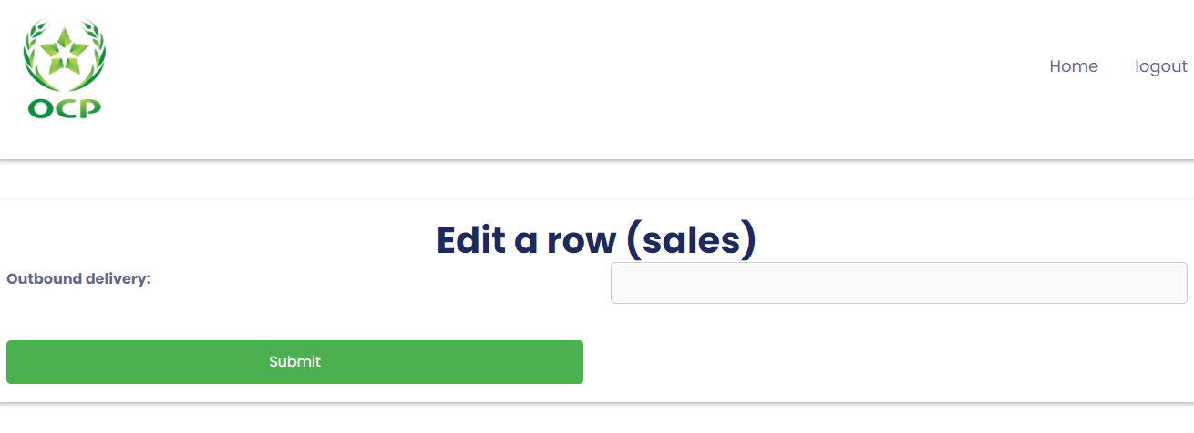

Sales edit row (contd.)

Sales view table

Full database view

Export to csv

Charts

