Ayman El Balaa - 40200099

**COEN 346**

**LAB 1 : SYSTEM CALLS**

**Activity 1 :**

1. **What does the function syscall do?**

The syscall function is used to invoke system calls in the operating system. It allows programs to request services from the operating system kernel-mode directly.

1. **How are parameters passed to the system call?**

They are passed as arguments to the syscall function : *AT_FDCWD* represents the current working directory , *“samplefile.txt”* indicates the name of the file and *O_RDONLY* opens the file in Read Only mode.

1. **What does the system call execve do?**

After running the *strace* commands, we inspect the different system calls made by the program. *Execve* is a system call used to announce the start of a new program, which is why it is the first system call to be executed.

1. **Can you locate our system call in the trace?**

The open system call is highlighted below ,after it the file descriptor is outputted and then terminates the program

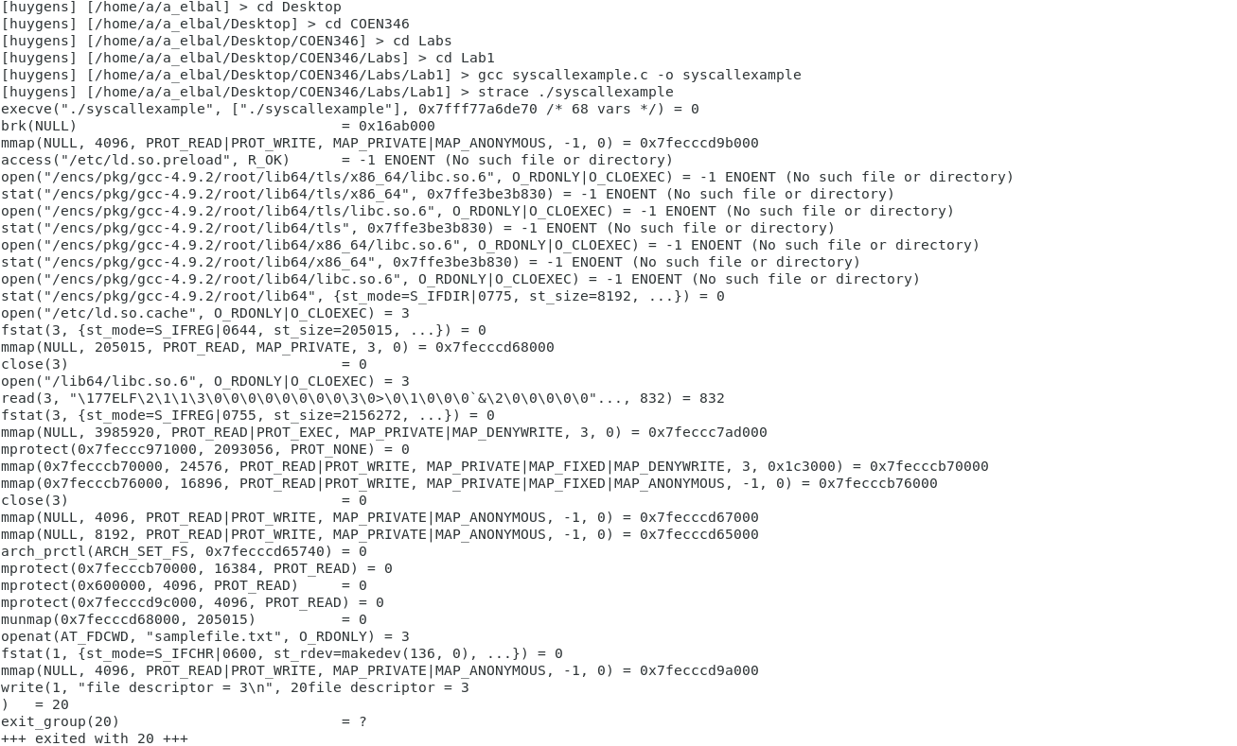



1. **Why do we need a system call to open a file?**

When we need to open a file we need to make use of the operating system , the system calls are used to facilitate that interaction between the programs and the kernel.

1. **Try to modify the program to close the file we just opened.**

The following code allows to close the file after it was opened.

#include <syscall.h> #include <errno.h> #include <fcntl.h> #include <stdio.h>  
  
int main(){  
    int rc;  
    rc = syscall(SYS_openat, AT_FDCWD, "samplefile.txt", O_RDONLY);  
    if (rc == -1){  
        fprintf(stderr, "open failed, errno = %d\n", errno);  
    }  
    else{  
        fprintf(stdout, "file descriptor = %d\n", rc);  
    }  
   if (syscall(SYS_close,rc) == -1){  
        fprintf(stderr, "close failed");  
    }  
    else{  
        fprintf(stdout, "file closed");  
    }  
}

This code was tested and ran the trace command as well to check the system calls invoked

The close system call is highlighted belo



**Activity 2 :**

1. **What are the system calls to open, read and close a file?** 
   1. open() is used as a system call to open a file. It takes as a parameter the path of the file used as well as flags ( flags can be O_WRONLY or O_RDONLY like in activity 1 ).
   2. read() is used to read data form the file. It’s parameters usually are the file descriptor , the buffer where the data will be stored and the number of characters to be read.
   3. close() is the system call that closes the file after the user no longer needs access to it. It only needs the file descriptor as a parameter.
2. **Why are the system calls so different if the two programs have the same functionality? What are some system calls made by the JAVA program that are not made by the C program and why might they be called?**

The Java program takes more time , wastes resources and invoked more system calls. The difference comes from how the languages are designed and how they interact with the operating system. Some system calls that are only used by Java are : futex,readlink and clone and they are all specifically used by Java to interact with the kernel. 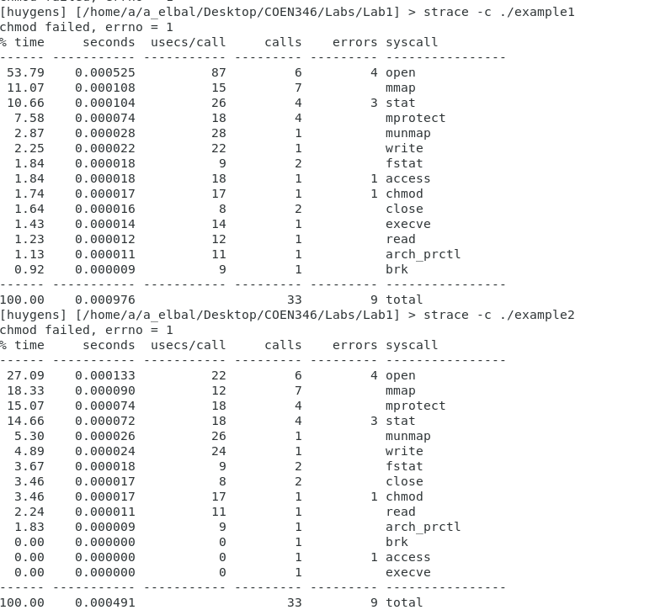

1. **Run the two programs and find the system call -. Is it the same? What is it doing?**