CAMPAIGN
1. THE KEY VISUAL & CAMPAIGN PAYOFF
CAMPAIGN SLOGAN & PAYOFF: "EVERY LABEL HAS A STORY"
Key Visual Concept: High-contrast composition combining vibrant fashion artwork with bold Bebas Neue typography. A central pile of upcycled clothes wrapped in bright red action verbs (RE-DUCE, RE-USE, RE-CYCLE, RE-WEAR, RE-PEAT) visually represents the transformation of discarded garments into ethical festival fashion.
[ KEY VISUAL IN CONTEXT / MOCK-UP PLACEHOLDER ]
(A3 Outdoor Poster Mock-Up on Bus Stop Shelter / School Bulletin Board)
[ INSERT KEY VISUAL MOCK-UP IMAGE HERE ]

2. CAMPAIGN ASSETS ACROSS PHASES
To ensure complete coverage throughout Sarah's journey, the campaign is divided into three strategic phases (Teaser, Launch, and During), reaching her through multiple physical and digital channels.

PHASE 1: TEASER (3 WEEKS BEFORE FESTIVAL)
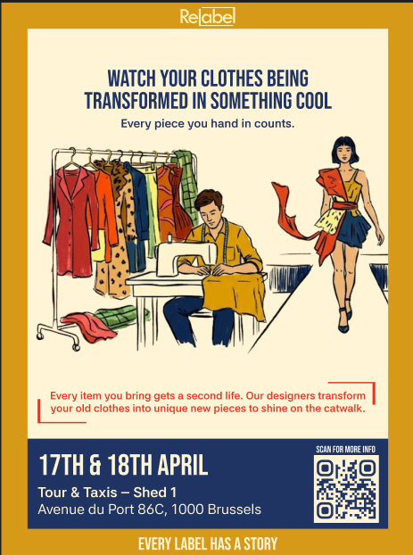 | CHANNEL 1: PRINT & OUT-OF-HOME (A3 POSTER WITH QR CODE)
Displayed at bus stops, school walls, and local shops in Brussels.
Objective: Capture Sarah's attention during her daily commute, introducing the clothing donation concept and driving traffic to Instagram via QR code.
Specs & Budget: A3 Poster | Printed via Print.brussels | Budget: €75

PHASE 2: LAUNCH (DONATION WEEKEND - 27TH & 28TH MARCH)
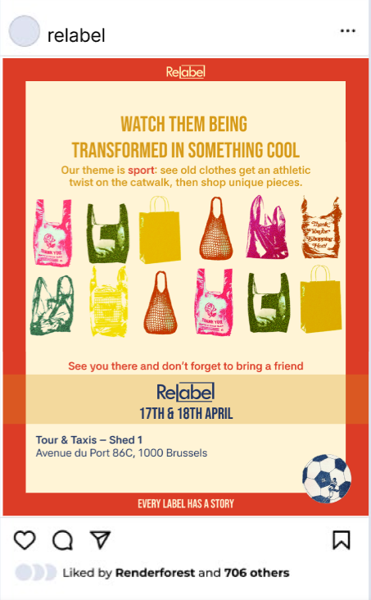  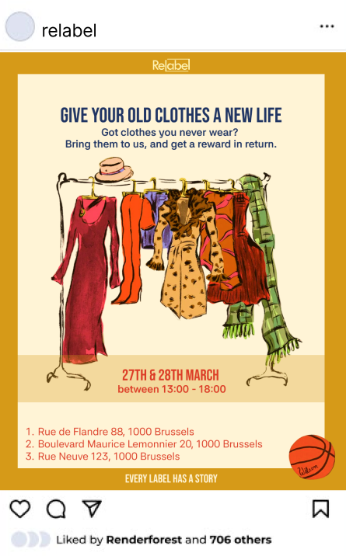 | CHANNEL 2: INSTAGRAM CAROUSEL
Targeted social media feed post for persona Sarah.
Objective: People can drop their clothes off at 3 locations written on the post. The voucher gives motivation AND can be used on festival (so they have to come if they want to use their voucher)
Specs & Budget: 1080 × 1350 px Instagram Carousel, 4:5 Aspect Ratio, JPEG format
PHASE 3: DURING (FESTIVAL WEEKEND - 17TH & 18TH APRIL)
[PHASE 3]  Spatial Photo Mock-Up of Interactive Mirror inside Tour & Taxis Shed 1  [ INSERT MOCK-UP / PHOTO HERE ] | CHANNEL 3: NON-CONVENTIONAL SPATIAL TOUCHPOINT (SLOGAN SELFIE MIRROR)
Located inside Shed 1 at Tour & Taxis, positioned near the Rework Station.
Objective: Engages visitors directly on-site. Sarah takes a selfie wearing her reworked outfit in front of the branded mirror with quote vinyls, creating organic user-generated content.
Specs & Budget: Full-length mirror (IKEA LINDBYN) + Cut vinyl lettering, Budget: €124.99

3. FOUR-CHANNEL COVERAGE MATRIX
The campaign spans four distinct channels to guide Sarah seamlessly from initial awareness to festival participation:
Channel | Medium | Campaign Phase | Persona Action
1. Core Touchpoint (Digital) | Instagram Carousel Campaign | Teaser & Launch (3 Weeks Before) | Sarah discovers donation incentive, saves/shares post, and collects drop-off info.
2. Print & OOH (Physical) | A3 Poster with QR Code | Teaser (3 Weeks Before) | Sarah sees poster at bus stop/school, scans QR code.
3. Spatial / Event (Physical) | Physical Drop-Off Stands | Launch Weekend (27–28 March) | Sarah drops off unused clothing at Oxfam/CITY2 and receives her festival voucher.
4. Non-Conventional (Spatial) | Selfie Mirror at Rework Station | During Festival (17–18 April) | Sarah poses in front of slogan mirror, snaps photo, and shares tagged post.

