TOUCHPOINT
1. THE KEY MOMENT SENTENCE
KEY MOMENT: At home 3 weeks before the festival, Sarah discovers she can exchange her unused clothes for a discount voucher to use at the festival, feeling energetic and excited to contribute to a sustainable cause.

2. THE MEDIUM & STRATEGY
Instagram is the primary medium to reach our persona Sarah. Her goal is to be more sustainable with a limited budget. Sarah actively relies on social media to discover local events, seek style inspiration, and find practical updates.
An Instagram carousel encourages users to swipe through the slides, increasing engagement and keeping them on the post longer. This can help the post reach a wider audience through Instagram’s algorithm and appear in more users’ suggested content.

3. STEP-BY-STEP (CAROUSEL EVOLUTION)
How the carousel changed step by step placeholder frames (formatted to 1080 × 1350 px aspect ratio, aspect 4:5).
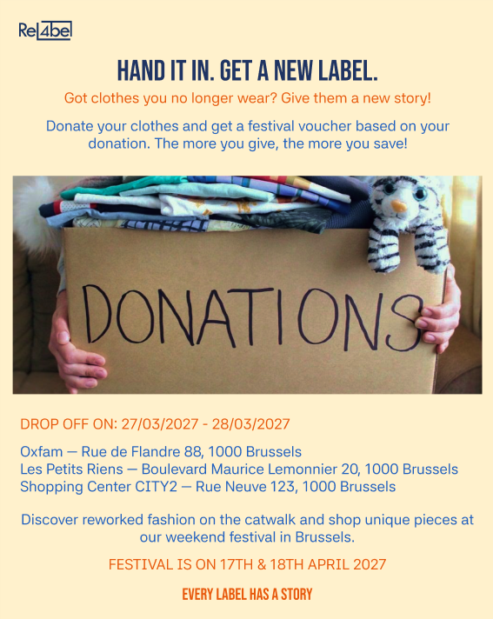 | FiRST TRY  A single static post featuring a stock photograph of a cardboard box labeled "DONATIONS" filled with clothes, paired with plain text lists for dates and drop-off locations.  Feedback: Too much information on page. Uneasy to read, and you must be really focused.
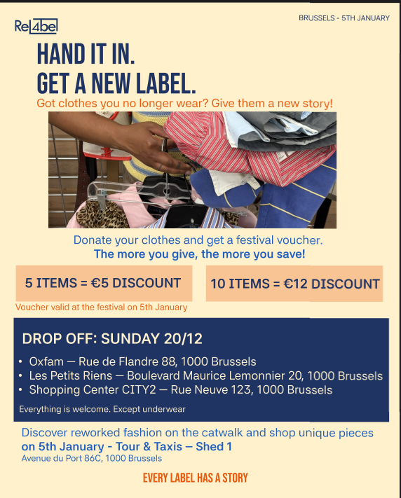 | Second try  The picture is much clearer. The visual accents around the vouchers and drop-off info make the text easier to read and scan quickly.  Feedback: The information is still too compact. Placing everything on a single post makes the layout look overcrowded.

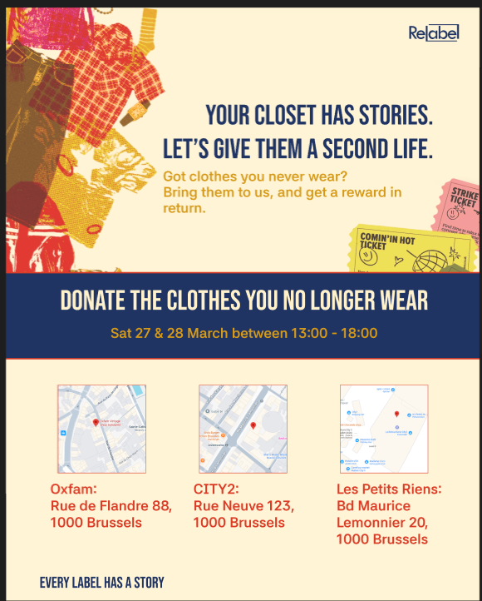 | Carousel 1: slide 1  At first glance, it is immediately clear that this post is about locations and dropping off something. Adding maps makes it much easier to find the physical collection points.  Feedback: The layout now uses a clear image of clothes. This makes viewers instantly understand that the post is about fashion and clothing donation

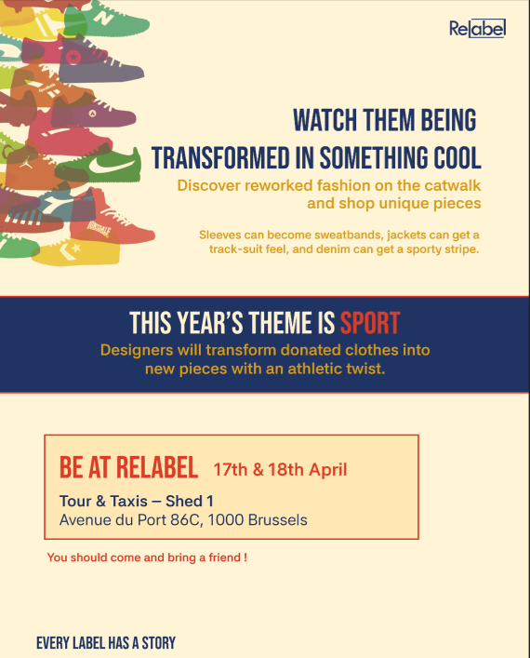 | Carousel 1: slide 2  The illustrations replace boring text blocks, matching feedback from test round 1. It builds excitement by explaining how old garments get an athletic twist  Feedback: The layout still feels a bit empty. The middle and bottom sections need more visual elements to fill the space better.

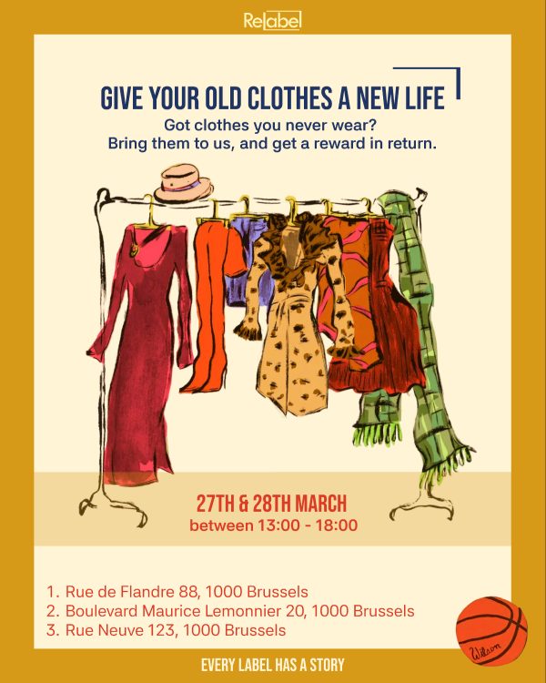 | Prototype Version 2  Carousel 2: slide 1  Illustration of clothes is in the center. It makes it clear what the post is talking about. Only necessary information is shown.  Feedback: The colors are warm and eye-catching, and the message is clear and straight to the point.

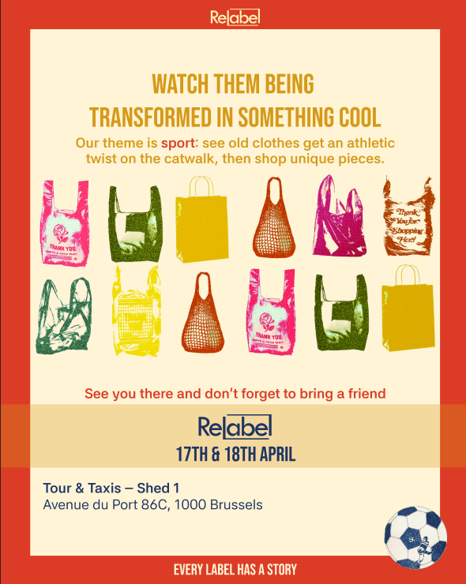 | Carousel 2: slide 2  The colors really pop, and the repeated shopping bag illustrations reinforce the theme while making the design playful and engaging.  Feedback: The same bold heading style and typography are maintained across both slides. The consistency in both slides is making the carousel feel more connected to the brand identity.

4. WHAT CHANGED AFTER THE FINAL PITCH AND WHY
Based on feedback received during the pitch and user testing rounds, key improvements were implemented across visual composition, typography, and content structure:
Design Element | What Changed (v1 → v2 / Final) | Feedback
Format & Layout | Transitioned from a single congested Instagram post (v1) into a multi-slide carousel (v2). | Version 1 contained too much text on a single image. Splitting content across slides improved visual breathing room and legibility.
Color | Colors did change to a warmer palette. | Tester feedback indicated v1 was visually dull. The new palette brings youth, energy, and strong brand contrast.
Illustrations & Style | Replaced plain text blocks with hand-drawn fashion illustrations (clothing racks, sewing atelier). | Testers found the initial design boring. Custom illustrations create an eye-catching aesthetic suited for visual learners.
Visual Hierarchy | It was clear that the 2 posts were made in the same style with the text in the middle and then underneath body text. And in the middle of the page a big illustration | Testers did not immediately grasp what action to take. Clearer headline hierarchy instantly communicates the goal.

