Test report
- How?
I showed the testers my first Instagram prototype and asked them to look at it without giving too much explanation. I observed their reactions to see if the design was clear and attractive.
Afterwards, I asked them a few questions:
- What do you understand from this post?
- Is the message clear?
- Does the design catch your attention?
- Is there anything that distracts you from the main message?
This helped me understand how people reacted to the design and if they could understand the campaign without extra explanation.

- Hallway test
During the hallway test, the testers understood the concept of the campaign. However, they were not very impressed by the design. They felt there was too much information on one page. There were also not enough big headings or empty spaces. This made the post look crowded and harder to read.

- The process
The following pages show the design process from the first prototype (Version 1) to the final result. Each version includes the changes made based on the feedback from the testers and explains why these adjustments were necessary.
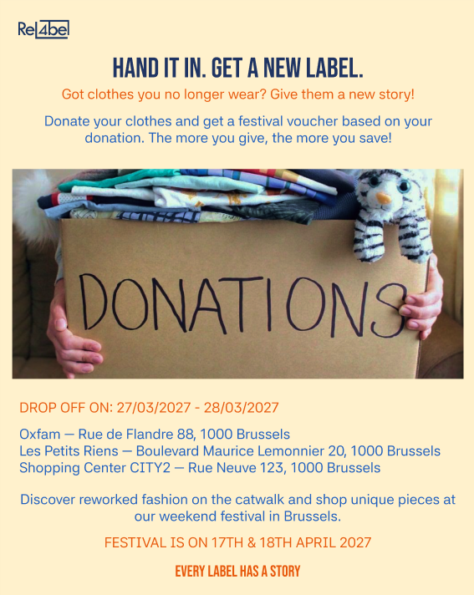 | FiRST TRY  The illustration is not very attractive and does not immediately catch the reader's attention. At first glance, it is not clear what the post is about or what people are being asked to do. There is also too much information on one page, which makes it look crowded and difficult to read. You have to focus too much to understand the message.
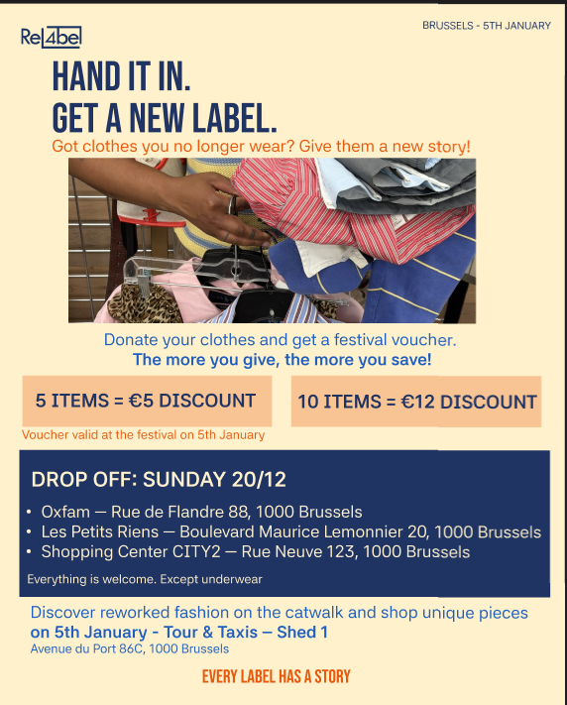 | Second try  What i did:  I decided to create boxes so that the voucher concept stands out more and using more colors so it enhances more important text.  Feedback: The picture is much clearer and more attractive. The visual accents around the vouchers and drop-off information make the text easier to read. However, there is still too much information on one post. The layout looks crowded and could be easier to scan.

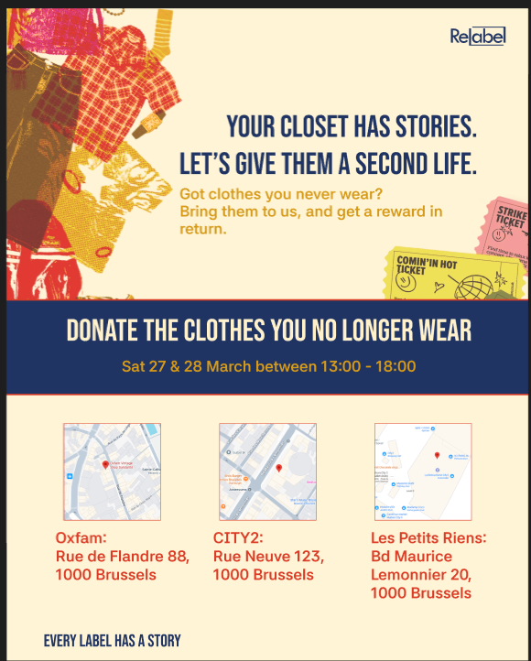 | Carousel 1: slide 1  What i did:  I added more illustrations; vouchers, clothes on the side, location points. And a banner in the middle to enhance the important details  Feedback: At first glance, the title catches your attention and the clothing image makes the topic clear. The maps also help people find the drop-off locations. However, the message could be clearer with more illustrations or visual elements. The locations are clear, but the purpose of the campaign could stand out more. More visuals could help keep the viewer's attention.

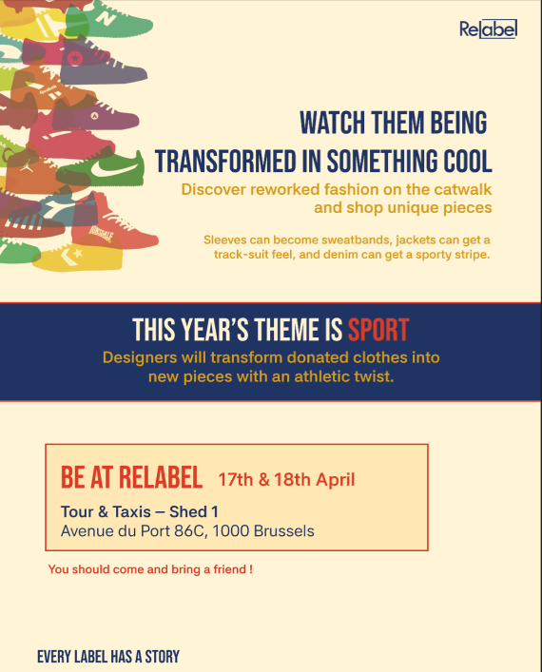 | Carousel 1: slide 2  What I did:  I kept the same box in the middle so that the first and second carousel are in the same theme. I added shoes on the side to give it a sporty look.  Feedback: The illustrations make the post more interesting and replace boring text blocks. They also show how old clothes can get a new sporty look. But, it is still not clear enough that the campaign is about clothing donations. The layout feels a bit empty and the visual identity is not fully visible yet. The middle and bottom sections could use more visual elements.

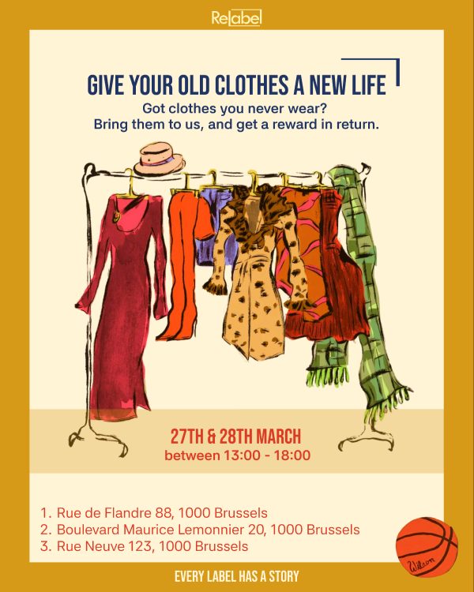 | Prototype Version 2  Carousel 2: slide 1  What I did:  I completely changed the layout because I felt like the other ones were too plain and boring. I put a heading at the top of the page. The first thing that catches the eye is the clothing. That was my goal. And I deleted all the extra text that made the post busy  Feedback: The clothing illustration in the center makes it clear that the post is about clothing donations. The colors are fun, warm and eye-catching. The small sports details add something extra and make the design more interesting. The visual identity is now much stronger and more consistent. Only the most important information is shown, so the message is clear and easy to understand.

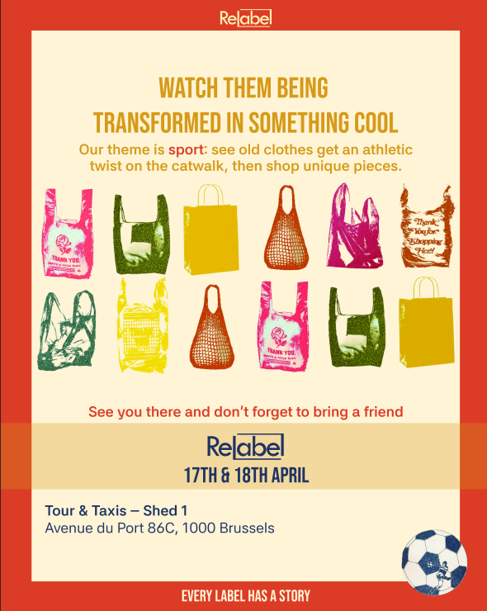 | Carousel 2: slide 2  What I did:  I used the same visual hierarchy as on the other slide to keep the consistency. Also the illustration catches the eye by being colorful.  Feedback: The colors really pop and immediately catch the viewer's attention. The repeated shopping bag illustrations make the design playful and help reinforce the clothing donation theme. They also make the slides feel more connected and visually interesting. The same bold heading style and typography are used on both slides. This creates a clear and consistent look that fits well with the brand identity. The information is easy to follow and the overall design feels more complete.

- WHAT CHANGED?
Based on feedback received during the pitch and user testing rounds, key improvements were implemented across visual composition, typography, and content structure:
Design Element | What Changed (v1 → v2 / Final) | Feedback
Format & Layout | Went from 1 post to a carousel of 2 posts | Version 1 contained too much text on a single image. Splitting content across slides improved visual breathing room and legibility.
Color | There is a better harmony between the colors in the final version | Tester feedback indicated v1 was visually dull. The new palette brings youth, energy, and strong brand contrast.
Illustrations & Style | Replaced plain text blocks with hand-drawn fashion illustrations (clothing racks, sewing atelier). | Testers found the initial design boring. Custom illustrations create an eye-catching aesthetic suited for visual learners.
Visual Hierarchy | It was clear that the 2 posts were made in the same style with the text in the middle and then underneath body text. And in the middle of the page a big illustration | Testers did not immediately grasp what action to take. Clearer headline hierarchy instantly communicates the goal.

- What did not change?
Throughout the design process, I tried to keep the original colors, such as yellow and red. However, I found it difficult to combine them in a way that looked visually appealing. I also kept the same typography throughout all the versions. I felt that this font style fitted the concept best and worked well with the overall visual identity.

