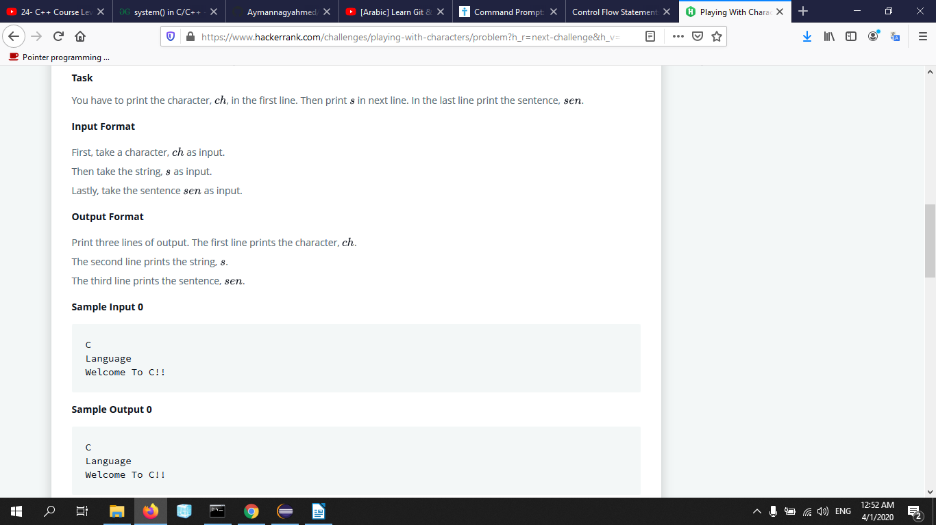
#include <stdio.h>
#include <string.h>
#include <math.h>
#include <stdlib.h>
int main(){
char ch;
char s[100];
char sen[500];
gets(&ch);
fflush(stdout);
gets(s);
fflush(stdout);
fflush(stdout);
gets(sen);
fflush(stdout);
printf("%c\n",ch);
fflush(stdout);
printf("%s\n",s);
printf("%s\n",sen);
/* Enter your code here. Read input from STDIN. Print output to STDOUT */
return 0;
}

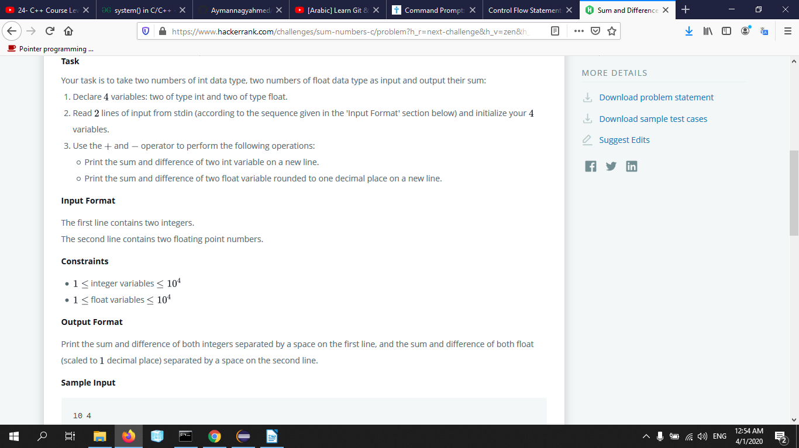
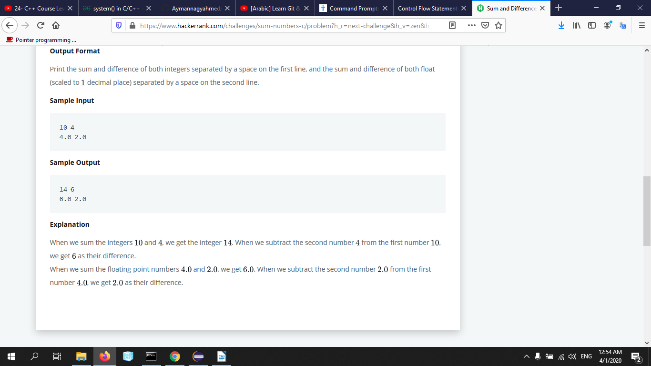

#include <stdio.h>
#include <string.h>
#include <math.h>
#include <stdlib.h>
int main(){
int fNum=14,secNum=6;
float ffNum=6.0,ssecNum=2.0;
scanf("%d",&fNum);
fflush(stdout);
scanf("%d",&secNum);
fflush(stdout);
scanf("%f",&ffNum);
fflush(stdout);
scanf("%f",&ssecNum);
fflush(stdout);
printf("%d ",(fNum+secNum));
fflush(stdout);
printf("%d\n",(fNum-secNum));
fflush(stdout);
printf("%.1f ",(ffNum+ssecNum));
fflush(stdout);
printf("%.1f ",(ffNum-ssecNum));
return 0;
}

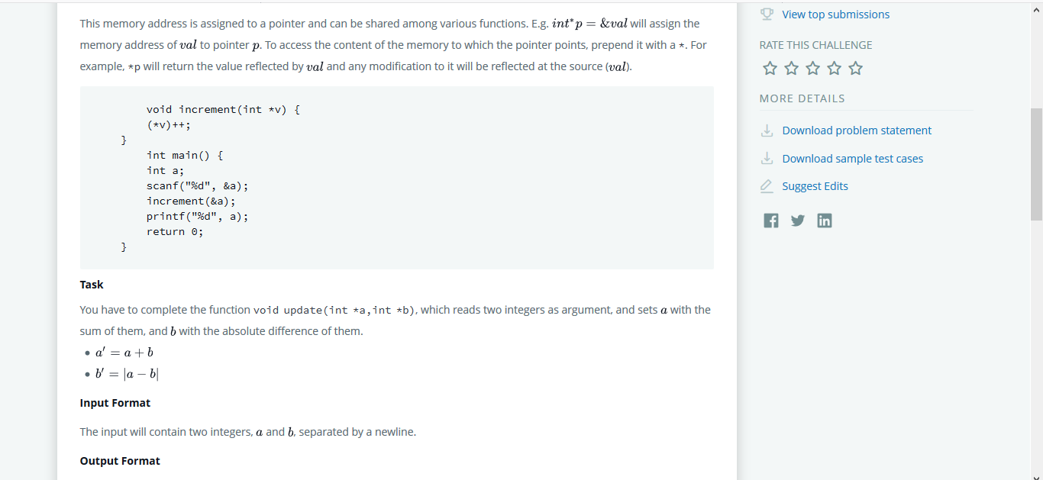

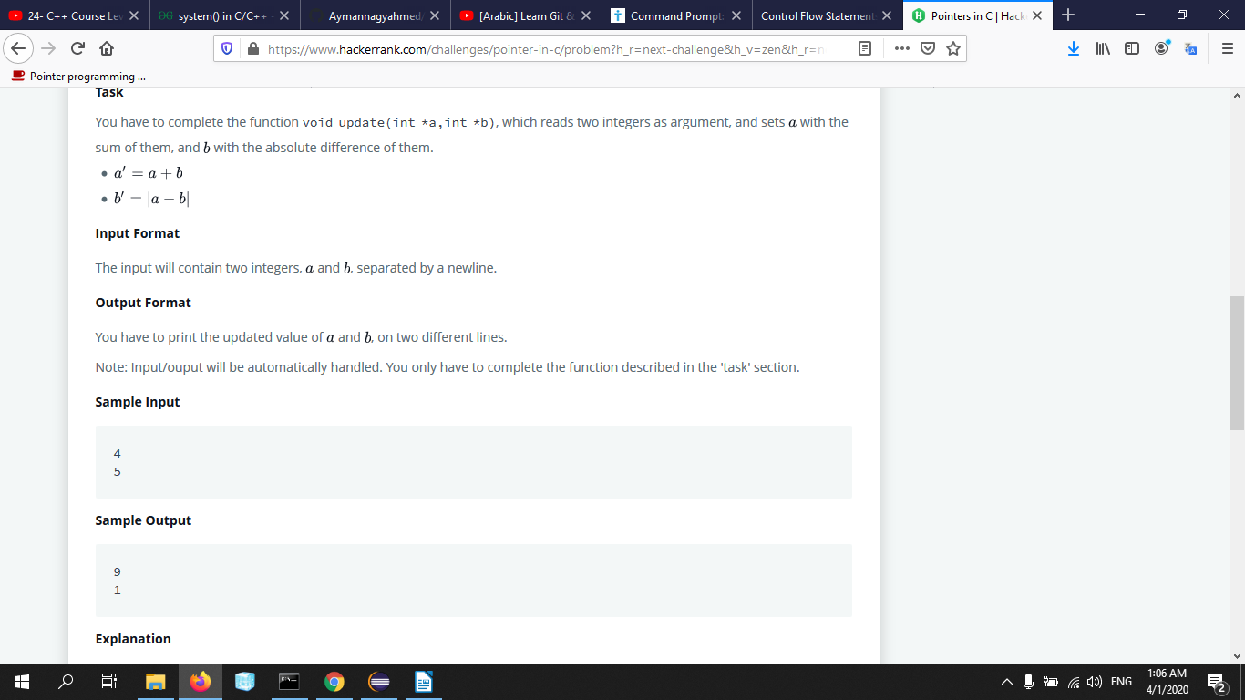
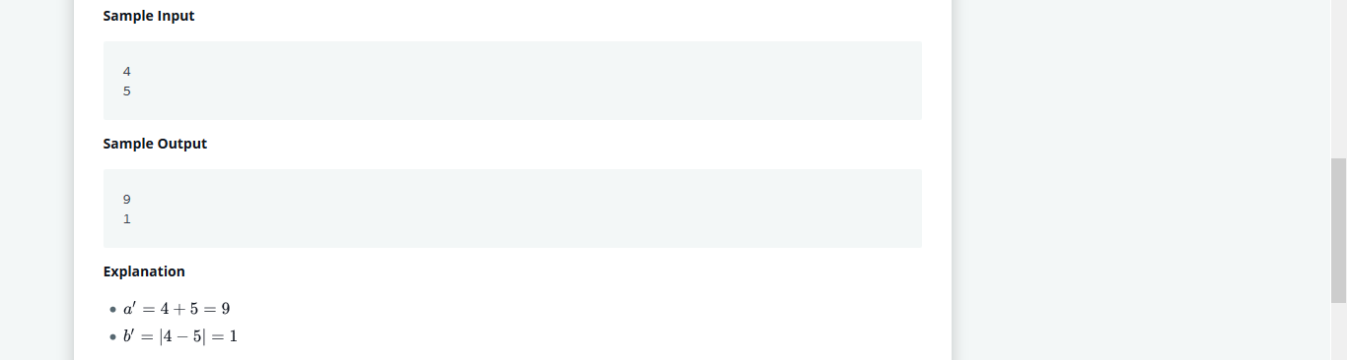
#include <stdio.h>
void update(int *a,int *b) {
// Complete this function
int* temb;
if(*a >= *b){
*temb= (*a) + (*b);
*b=(*a) - (*b);
*a=*temb;
}
else{
*temb= (*a) + (*b);
*b=(*b) - (*a);
*a=*temb;
}
}

int main() {
int a, b;
int *pa = &a, *pb = &b;
scanf("%d %d", &a, &b);
update(pa, pb);
printf("%d\n%d", a, b);
return 0;}

For Loop
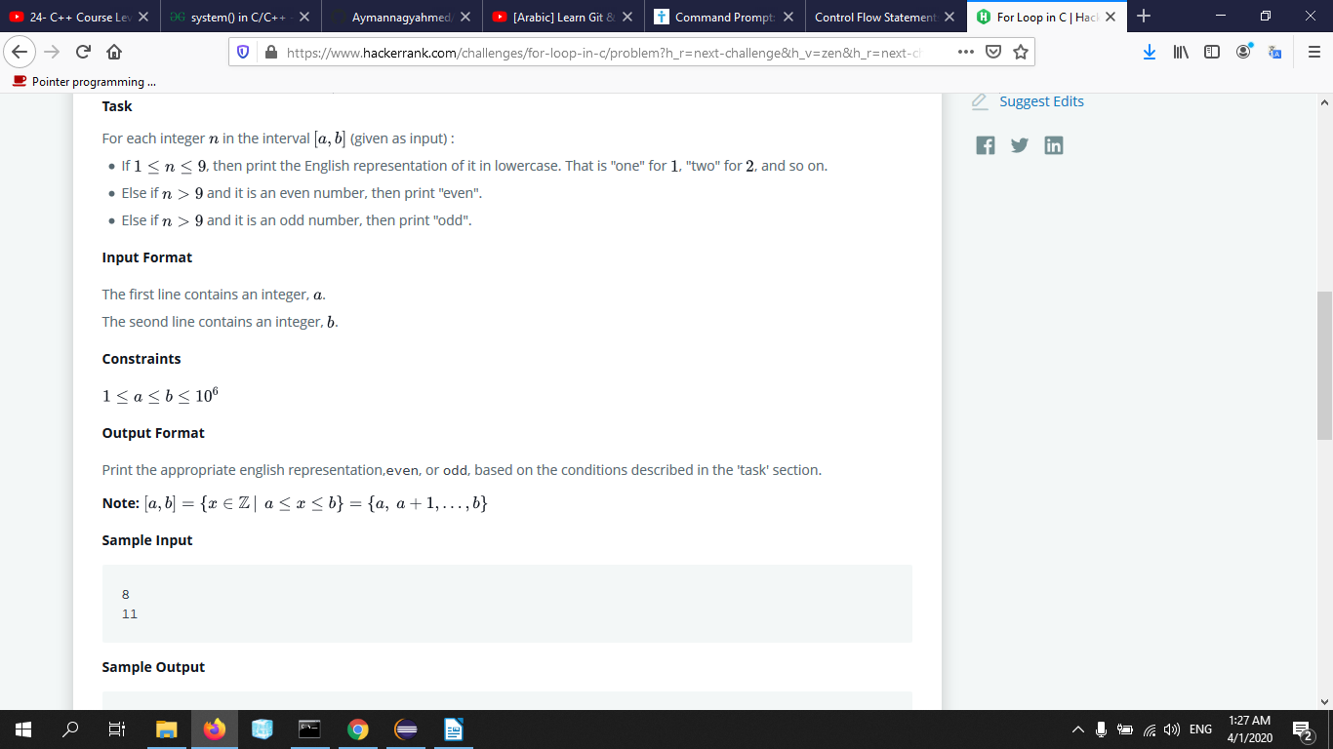
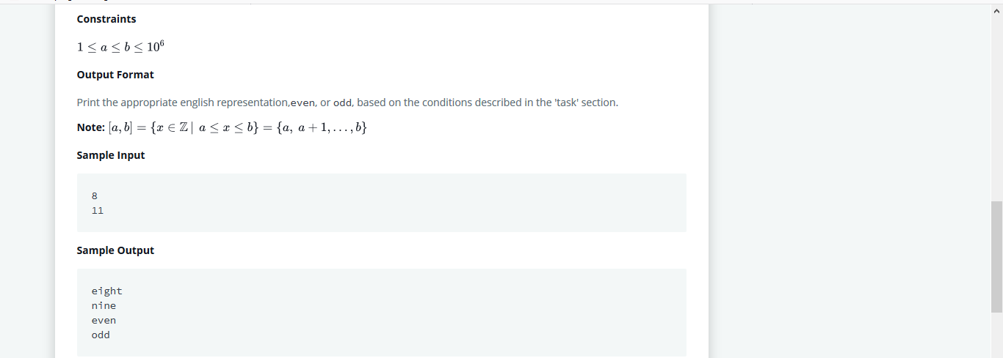

#include <stdio.h>
#include <string.h>
#include <math.h>
#include <stdlib.h>
int main()
{
int a, b,i,first,end;
char num[[10]={"one","two","three","four","five","six","seven","eight","nine"};
scanf("%d\n%d", &a, &b);
end=b;
for(first=a;first<=end;first++){
if((first<=9)&& (first>=1)){
printf("%s\n",num[first-1]);
}
else{
if((first%2)==0){
printf("even\n");
}
else{
printf("odd\n");
}
}
}
return 0;
}

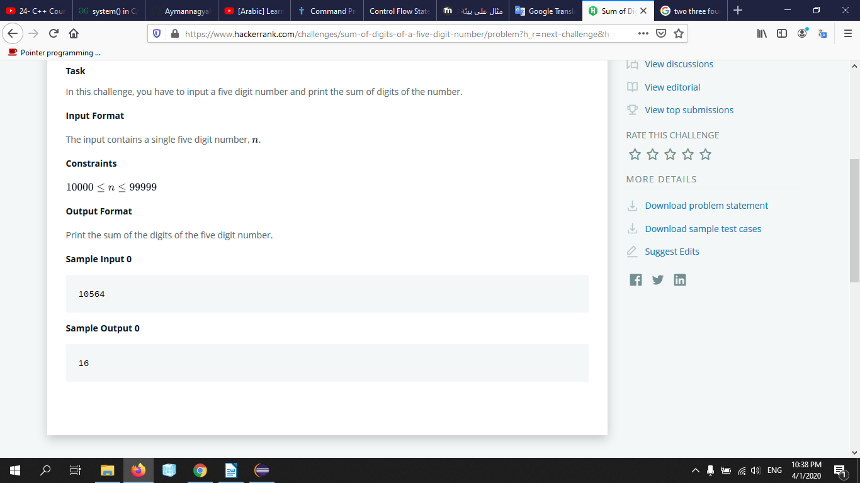
#include <stdio.h>
#include <string.h>
#include <math.h>
#include <stdlib.h>
int main() {
int n, sum = 0;
scanf("%d", &n);
while(n != 0){
sum += (n%10);
n/= 10;
}
printf("%d",sum);
return 0;
}

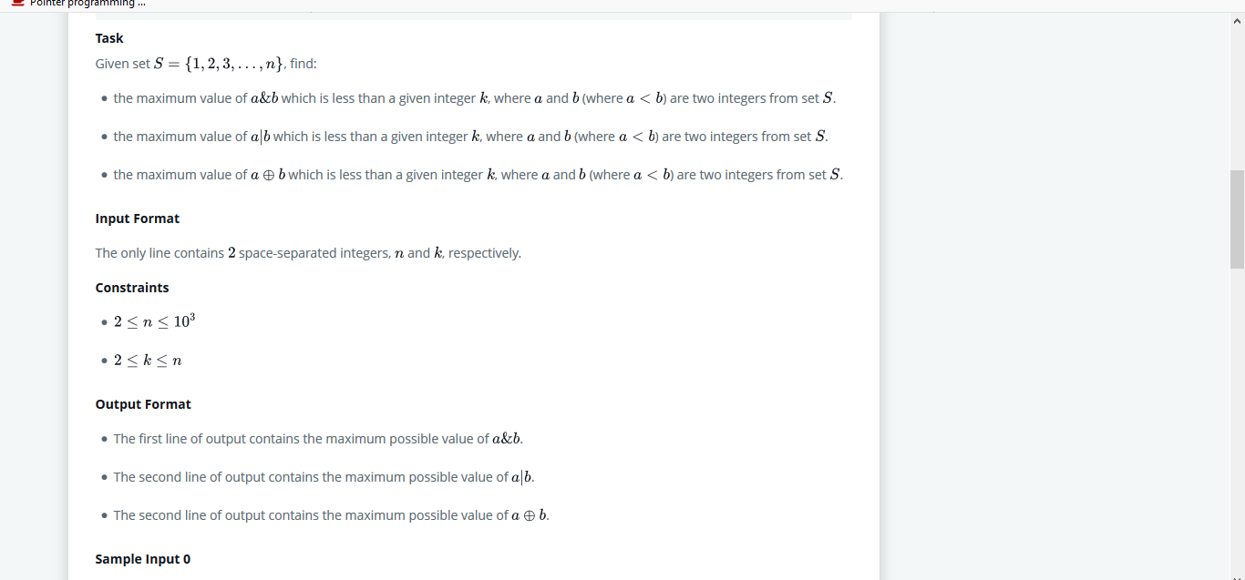
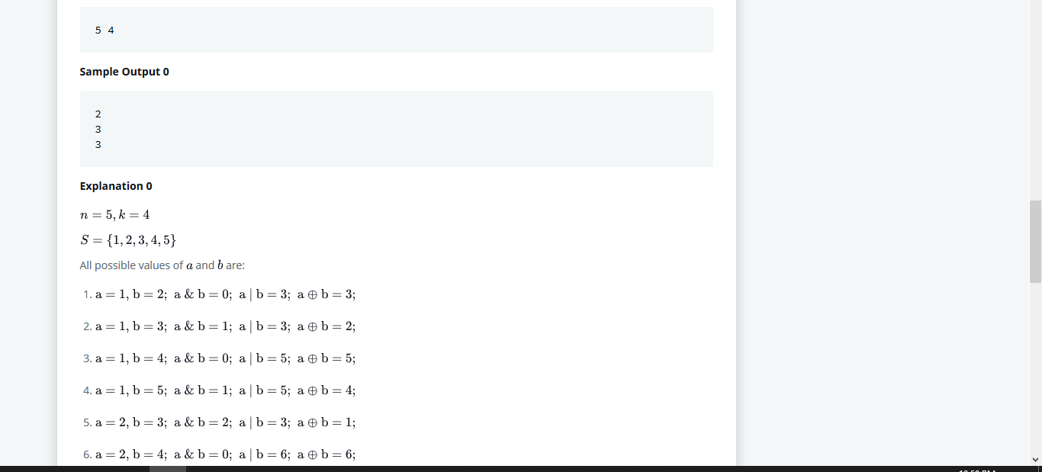

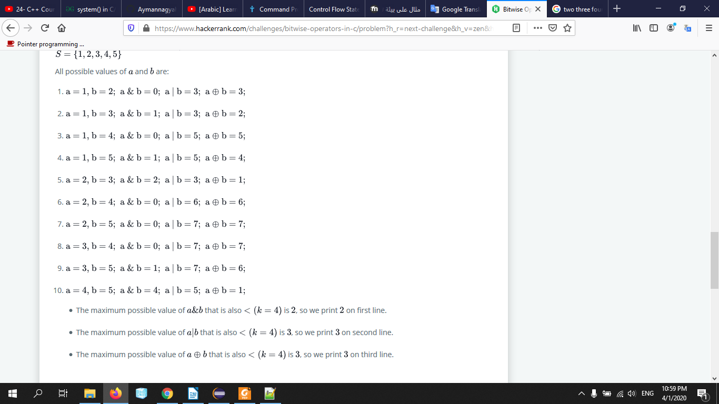

#include <stdio.h>
#include <string.h>
#include <math.h>
#include <stdlib.h>
//Complete the following function.
void calculate_the_maximum(int n, int k) {
int i,j,a=0,o=0,x=0;
for(i=1;i<n;i++){
for(j=i+1;j<=n;j++){
if( ( (i&j) <k ) && (i&j)>a ){
a=(i&j);}
if( ( (i|j) <k) && (i|j)>o ){
o=(i|j);}
if( ( (i^j) <k) && (i^j)>x ){
x=(i^j);}
}
}
printf("%d\n%d\n%d",a,o,x);
}
int main() {
int n, k;
scanf("%d %d", &n, &k);
calculate_the_maximum(n, k);
return 0;}

Functions
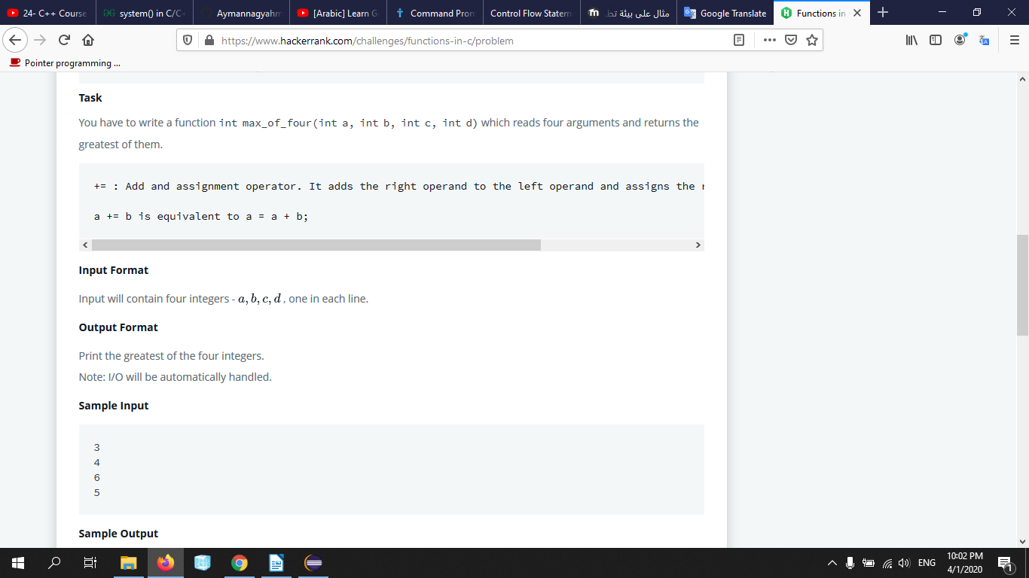
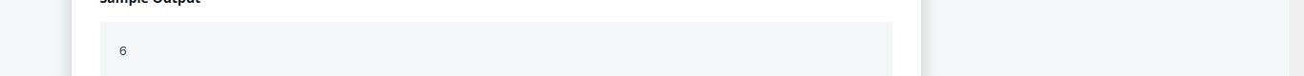
int max_of_four(int a, int b, int c, int d){
int temb=a;
if(temb<b){
temb=b;
}
if(temb<c){
temb=c;
}
if(temb<d){
temb=d;
}
return temb;
}

