SALESFORCE CRM MIGRATION
Business Analysis Document
Quote Handling Process · AS-IS & TO-BE · Pre-Migration Impact Assessment

Organisation | ARROW ECS

Team | Quote Factory (QF) Team

Document type | Pre-Migration Impact Assessment — Salesforce CRM Migration

Prepared by | Aymen El Ibrahimi — Business Analyst & Salesforce Administrator

Date | April 24, 2025

Version | 2.0 — Final

Classification | Confidential — Internal Use Only

GitHub | github.com/[your-username]/sf-migration-ba-portfolio

About this document
This document was produced by Aymen El Ibrahimi as a pre-migration feasibility and impact assessment for the transition from the current Excel/VBA-based QFTools workflow to Salesforce CRM at ARROW ECS. It follows the five-step Salesforce implementation lifecycle: Requirement Gathering, Solution Design, Development, Testing, and Deployment.
The document incorporates findings from a technical interview with the senior application engineer responsible for the current QFTools system, correcting earlier assumptions about direct API connectivity and documenting the real file-based ODS extract pipeline. Two migration scenarios are assessed: Scenario A (full Salesforce replacement with direct SWB/Unity API) and Scenario B (hybrid transition preserving the existing pipeline).

1 | Requirement Gathering

Requirement gathering is the foundation of the entire project. Its purpose is to document not only what stakeholders say they want, but what the business actually needs — grounded in the confirmed technical architecture and real operational pain points.

1.1 Business context & objectives

Item | Description
Project name | Salesforce CRM Migration — QF Quote Handling Process
Business driver | The current Excel/VBA/QFTools workflow relies on a batch file pipeline with up to 7-day data lag, causing recurring manual corrections and offering zero operational visibility
Strategic goal | Eliminate data freshness lag, reduce the manual correction rate, automate the SWB sync trigger, and provide real-time management visibility into QF team performance
Root cause identified | Part Master DB is populated from weekly ODS extract files — parts added to SWB after the last extract are not found by QFTools, leaving empty lines that QF members must fill manually
Expected outcome | Fewer manual corrections, faster SWB sync, formal access control, live dashboards, and — if Scenario A is confirmed — real-time data via a direct SWB/Unity API
Project sponsor | [Name of Manager or IT Lead at ARROW ECS]
BA & SF Admin | Aymen El Ibrahimi
Key technical contact | Senior Application Engineer (QFTools system owner) + Holger (potential SWB/Unity API contact)
Target go-live | To be confirmed following Phase 1 feasibility study completion

1.2 Confirmed AS-IS technical architecture
Documented following a technical interview with the senior application engineer. Replaces earlier assumptions about direct API connectivity.

Part Master data pipeline

How part data reaches QFTools today
1. ODS generates a weekly extract: part number, qty per pack, FOH, pricing — all details available via F6 part/mfr search
2. Extract files are dropped to a shared file server — file-based batch delivery, no API at any stage
3. Part Master DB server picks up the files, cleans them, reads them into the DB, and creates output files
4. QFTools reads those output files ('Reading Part Master...') to populate quote line data
5. There is NO direct API connection to ODS or SWB at any point in this pipeline
6. Result: Part Master data in QFTools is always up to 7 days out of date

History data pipeline (LOAD-sheet blue columns)

How history data reaches QFTools today
1. ODS generates daily extract files for history data — more frequent than the Part Master extract
2. Files are split into unique 'OperatingUnit_acct#' files — one per region and account combination
3. Files are processed similarly to Part Master and made available to QFTools
4. History data is more current than part data (daily vs weekly) but remains batch-based, not real-time

1.3 Confirmed root cause of manual line filling

Root cause confirmed — data freshness lag from the weekly ODS extract cycle
The manual line filling requirement is NOT primarily caused by VBA fragility.
It is caused by the data pipeline architecture: parts added to SWB/Unity after the last weekly extract are invisible to QFTools until the following week's extract is processed.
When a QF member runs QFTools on a quote containing recently added parts, those parts return no match — leaving empty lines that must be filled manually.
Senior engineer's view: 'things like the occasional new partnum not matching is an issue, but I don't think it's the root issue... it doesn't impact stability.'
BA assessment: While operational stability is not impacted, this represents a measurable quality and efficiency gap. Quantifying the correction rate is a key Phase 1 deliverable.

1.4 Stakeholder map

Stakeholder | Role | Interest & impact | Involvement level
QF Team members | End users | High — full daily workflow change | High — UAT, training, feedback
QF Team lead | Process owner | High — signs off on process design | High — requirements, validation
Sales team | Quote requestors / SWB users | Medium — faster quote turnaround | Medium — notification & testing
IT / SF Admin | Technical implementation | High — builds Flows, Profiles, API config | High — build & deployment
Sr. Application Engineer | QFTools system owner & technical advisor | High — owns current architecture | High — feasibility, VBA audit
Holger (TBC) | Potential SWB/Unity platform owner | Critical — API availability = Scenario A gate | High — feasibility study only
Management | Decision maker / budget owner | High — ROI, risk, reporting visibility | Medium — approval & review
SWB/Unity platform owner | SWB/Unity system owner | Critical — determines Scenario A viability | Medium — feasibility input

1.5 Business needs — stated vs actual

Stakeholder | What they say they want | What they actually need
QF Team members | Fewer empty lines to fill manually | Fresh part data at quoting time — eliminating the 7-day ODS lag that causes missing matches
QF Team lead | To know how the team is performing | Live dashboard: volume per agent, time spent on corrections, SLA adherence
Sales team | Quotes returned faster | Reliable, faster SWB sync and reduced turnaround time from fewer manual steps
Management | Fewer errors and more control | Audit trail, formal access rights, and reporting to quantify time lost to data lag corrections
IT / SF Admin | Clear requirements before any build begins | Confirmed data flow, API availability, object model, and a tested rollback plan
Sr. App Engineer | BA to understand the current system first | Accurate documentation of QFTools architecture so TO-BE doesn't assume non-existent capabilities

1.6 Functional requirements

ID | Functional requirement
FR-01 | The system shall allow QF members to view and accept assigned quotes from a centralised Salesforce Queue, replacing the shared Excel Work List
FR-02 | Scenario A: the system shall call the direct SWB/Unity API in real-time to fetch fresh part data, eliminating the weekly ODS lag. Scenario B: the system shall connect to the Part Master DB server output files via the existing pipeline, replicating current VBA behaviour with improved error handling
FR-03 | The system shall provide a guided SF record page for manual line filling, with required field validation and clear error messages preventing submission of incomplete records
FR-04 | The system shall trigger an automatic SF Flow to call the SWB HTTP endpoint when a quote status is set to 'Done', replacing the Excel X-mark VBA batch trigger
FR-05 | The SF Flow SWB sync trigger shall fire measurably faster than the current VBA batch detection mechanism
FR-06 | The system shall enforce formal, role-based access: Sales sees quote header and status only; QF sees the full record with edit rights
FR-07 | The system shall provide a management dashboard including volume per agent, average handling time, manual correction rate KPI, and SLA adherence
FR-08 | The system shall allow QF members to correct wrong SWB uploads and re-trigger the sync from within Salesforce, with a full audit trail of each correction event

1.7 Non-functional requirements

ID | Non-functional requirement
NFR-01 | Scenario A: data freshness shall be real-time, fully eliminating the current 7-day Part Master lag
NFR-02 | The SF Flow SWB sync trigger shall fire within seconds of a status change — a measurable improvement over the current VBA batch polling delay
NFR-03 | A full audit trail of all quote records, field edits, status changes, and SWB sync events shall be maintained within Salesforce
NFR-04 | The system shall support simultaneous access by all QF team members without file-locking conflicts
NFR-05 | Validation rules shall prevent incomplete or malformed records from being submitted to SWB
NFR-06 | All QF team members shall be trained and capable of operating Salesforce independently before go-live
NFR-07 | A rollback plan shall be documented and tested before go-live, enabling reversion to the Excel/VBA pipeline within 24 hours if needed

2 | Solution Design

Solution design translates requirements into a concrete technical blueprint before any build work begins. Every design decision here is grounded in the confirmed data architecture from the Phase 1 technical interview. Mistakes made at this stage are the most expensive to fix later.

2.1 AS-IS process — structured summary
Updated to accurately reflect the QFTools data pipeline confirmed by the senior application engineer.

Step | Actor | Description
1 | Sales | Creates quote headers in SWB and sends the quote request to the QF team
2 | QF Member | Picks a line from the shared Excel Work List — one quote per member, with no collision-prevention mechanism
3 | QF Member | Opens Excel and runs VBA macros (QFTools). The tool reads Part Master output files from the DB server ('Reading Part Master...')
4 | QFTools / VBA | Part Master DB output files used to match: part number, qty per pack, FOH, and pricing. Data is from the latest weekly ODS extract — up to 7 days old
5 | QFTools / VBA | History data (blue LOAD-sheet columns) fetched from the daily ODS extract files, split by OperatingUnit_acct# region
6 | QF Member | If parts are not matched (recently added parts not yet in the weekly extract): manually runs automations again or fills empty lines by hand
7 | QF Member | Finalises the quote in Excel once all lines are complete
8 | QF Member | Marks an X in the Work List cell — VBA detects the trigger and sends data to SWB (takes several minutes — batch detection, not instant)
9 | QF Member | If a wrong upload is detected: deletes lines in SWB, corrects in Excel, and re-marks X to re-trigger the send
10 | Sales / System | SWB processes the data and Sales receives a Quote Completed notification

2.2 AS-IS process diagram
Swim-lane diagram — Sales and QF Team lanes — showing the VBA/file pipeline and the X-mark SWB trigger.

AS-IS — Quote Handling Process
Current state · Excel + VBA/QFTools · Weekly ODS extract pipeline · Manual X-mark trigger to SWB
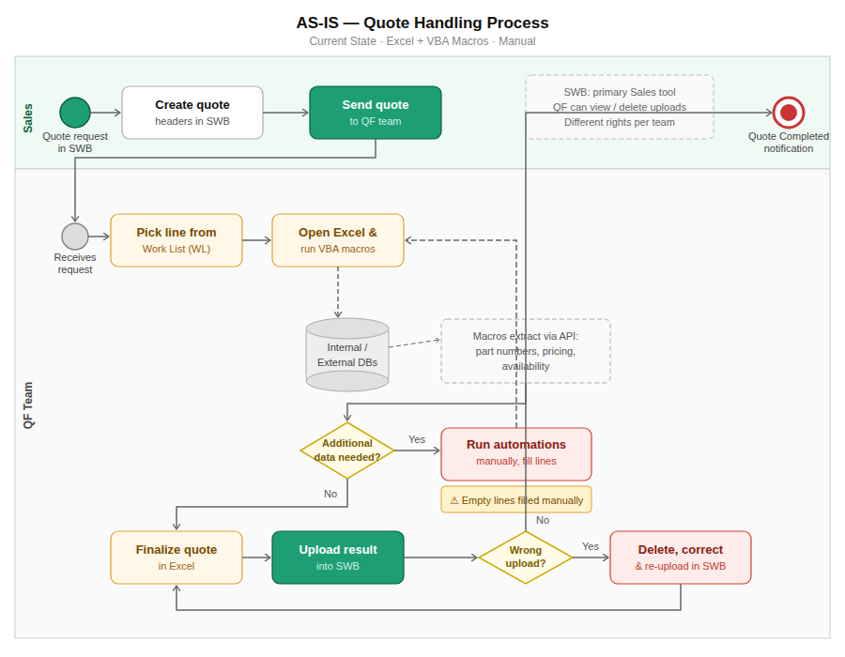

2.3 Gap analysis
Data freshness is the primary gap. All remaining gaps contribute to efficiency, auditability, and scalability.

Area | AS-IS pain point | TO-BE improvement | Priority
Data freshness | Weekly ODS extract — Part Master up to 7 days old — new parts not matched — empty lines required | Direct SWB/Unity API (Scenario A) — real-time data — eliminates missing part matches at source | Critical
Work queue | Shared Excel Work List — no collision prevention — two members can pick the same quote | SF Queues — records assigned per member on acceptance — no overlap — full visibility | High
Data extraction | VBA reads Part Master DB output files — Excel must be open — no error logging or monitoring | SF Flows + REST callouts — auto-triggered on record creation — errors logged and monitored | High
Manual filling | Free-form Excel cells — no field validation — correction frequency untracked | SF Record Page + Validation Rules — guided fields — correction rate tracked as a KPI | High
SWB sync trigger | Mark X in Excel — VBA batch detects change — takes several minutes to fire | SF Flow fires immediately on status = Done — calls SWB endpoint — auditable and reliable | High
Error correction | Delete in SWB + fix Excel + re-mark X — no record of what happened, when, or why | Delete and re-trigger from within SF — full audit trail: actor, timestamp, reason | Medium
Access control | Informal Sales/QF rights split in SWB — undocumented and impossible to enforce | SF Profiles + Permission Sets — formal, auditable, role-based access definitions | Medium
Visibility | Zero management visibility — no workload data, correction rate, or SLA tracking available | SF Dashboards — live KPIs: volume, correction rate, average handling time, bottlenecks | Medium
Scalability | Excel file-locking prevents true concurrent use across multiple QF team members | Salesforce cloud — full concurrent multi-user access with no file-locking issues | Low

2.4 Two-scenario TO-BE approach
Scenario B is the default build path and can start immediately. Scenario A requires API confirmation first.

Factor | Scenario A — Full SF + direct SWB/Unity API | Scenario B — SF hybrid + existing Part Master pipeline
Data source | Direct SWB/Unity API — real-time, zero lag | Existing Part Master DB pipeline — weekly ODS extract cycle, same lag as AS-IS
Excel & VBA | Fully decommissioned at go-live | Kept during transition — phased out in the next project iteration
SWB trigger | SF Flow replaces VBA X-mark trigger — fires instantly on status change | VBA X-mark trigger kept — same delay as current AS-IS
Key dependency | SWB/Unity exposes a callable REST API (contact: Holger) | No API required — SF layers over the existing file-based pipeline
Data freshness | Fully resolved — real-time data eliminates the empty line problem | Unchanged for Part Master (weekly); daily for history data
Migration risk | Higher — full workflow and data source changed simultaneously | Lower — incremental change with a familiar Excel/VBA fallback
Recommendation | Target end state — pursue once API feasibility is confirmed | Default path — implement immediately regardless of API outcome

2.5 Salesforce data model

Primary object: Quote_Line_Item__c (custom object)

Field name | Field type | Purpose
Quote_ID__c | Text (External ID) | Unique quote identifier — maps from the Excel Work List reference
Part_Number__c | Text | Fetched via direct API or Part Master DB — maps from the VBA QFTools extraction
Pricing__c | Currency | FOH/pricing from the ODS extract or the direct SWB/Unity API
Availability__c | Picklist | Qty per pack and availability from the ODS extract or direct API
Data_Source__c | Picklist | NEW — 'Direct API' or 'Part Master DB' — tracks which source populated each record
Status__c | Picklist | Draft / In Progress / Done — replaces the X-mark trigger in the Excel Work List
Assigned_To__c | Lookup (User) | The QF member who accepted the quote — replaces the manual Work List pick
SWB_Sync_Status__c | Picklist | Pending / Sent / Failed — tracks the outcome of each SWB Flow trigger
SWB_Triggered_At__c | DateTime | Timestamp of the last SWB Flow trigger — new audit capability not available in AS-IS
Manual_Correction__c | Checkbox | NEW — flags records that required manual line filling — enables the correction rate KPI
Correction_Reason__c | Text | NEW — reason for manual correction, e.g. 'Part not in current weekly extract'
History_File__c | Text | NEW — the OperatingUnit_acct# file used — traceability for regional history data
Sales_Contact__c | Lookup (User/Account) | The Sales requestor — links back to the SWB header creator

2.6 Automation design

Automation | Trigger | Logic & what it replaces
Flow: Data Fetch — Scenario A | Record created or Status = 'In Progress' AND API confirmed | Calls SWB/Unity API in real-time. Sets Data_Source__c = 'Direct API'. Eliminates weekly lag. Replaces VBA Part Master read entirely.
Flow: Data Fetch — Scenario B | Record created or Status = 'In Progress' AND no confirmed API | Reads Part Master DB output files via existing pipeline. Sets Data_Source__c = 'Part Master DB'. Same data behaviour as VBA; improved error handling and logging.
Flow: SWB Sync Trigger | Status__c changed to 'Done' | Immediately calls SWB HTTP endpoint. Replaces the Excel X-mark VBA batch polling mechanism. Faster, auditable, and resilient.
Flow: Error Re-trigger | SWB_Sync_Status__c set to 'Correct & Resend' | Re-calls the SWB endpoint after a wrong upload is corrected. Logs the correction event with actor, timestamp, and reason.
Flow: Manual Correction Flag | Record saved with an empty required field after the first fetch attempt | Sets Manual_Correction__c = true and prompts the QF member to complete Correction_Reason__c. Enables the correction rate KPI in dashboards.
Validation Rule: Required Fields | On every record save | Blocks save if Part_Number, Pricing, or Availability is empty. Enforces data quality, replacing free-form Excel cells with no validation.
Assignment Rule: QF Queue | New quote record created | Routes the record to the QF Queue. Members accept individually, eliminating the collision risk of the shared Excel Work List.

2.7 Integration requirements & feasibility

Critical open question — must be resolved in Phase 1 before Scenario A can begin
Does SWB/Unity expose a direct REST API that Salesforce Flows could call to fetch real-time part data, bypassing the ODS extract pipeline entirely?
Suggested contact: Holger — identified by the senior application engineer as the most likely person with SWB/Unity platform knowledge.
Scenario B proceeds independently. Scenario A cannot begin until this is resolved.

System | Direction | AS-IS method | TO-BE approach
Part Master DB server | QFTools reads | Output files from shared file server (weekly ODS extract) | Scenario B: SF Flow reads the same output files via Named Credentials. Scenario A: replaced by direct SWB/Unity API.
History data files | QFTools reads | OperatingUnit_acct# daily extract files from the file server | Scenario B: SF reads the correct regional file per quote. Scenario A: replaced by direct SWB/Unity API.
SWB/Unity (direct) | SF writes/reads | No direct API exists today — file-based pipeline only | CRITICAL: Confirm API availability with Holger. Enables Scenario A and eliminates all data freshness lag.
SWB (sync trigger) | VBA writes | VBA detects X-mark in Excel WL → batch sends to SWB (minutes) | SF Flow fires on status = Done → calls the same SWB HTTP endpoint → faster and fully auditable.
SWB (QF view/delete) | QF reads | Manual browser access to verify or delete wrong uploads | Unchanged — QF continues to use the SWB UI for manual verification and deletion as needed.

TO-BE Process Diagrams

The two TO-BE scenarios below represent the future state of the Quote Handling Process after migration to Salesforce. Scenario A is the ideal target state — real-time data via direct SWB/Unity API and full retirement of Excel and VBA. Scenario B is the practical transition path, implementable immediately regardless of API feasibility outcome.

Scenario A — Salesforce fully replaces Excel, VBA, and the file pipeline
Ideal target state. Contingent on SWB/Unity direct API confirmation (contact: Holger).

TO-BE Scenario A — SF Fully Replaces Excel + VBA
Ideal state · Direct SWB/Unity API · Real-time data · No ODS lag · Instant SWB sync via SF Flow
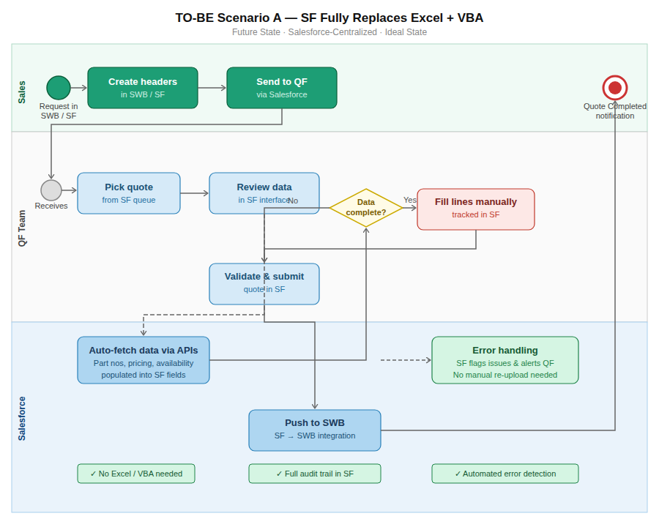

Scenario B — Salesforce hybrid alongside the existing pipeline
Transition state. Implementable immediately. SF manages workflow and tracking; Part Master DB pipeline unchanged.

TO-BE Scenario B — SF Hybrid Alongside Excel
Transition state · Part Master DB pipeline unchanged · SF adds tracking & faster SWB trigger · Excel kept temporarily
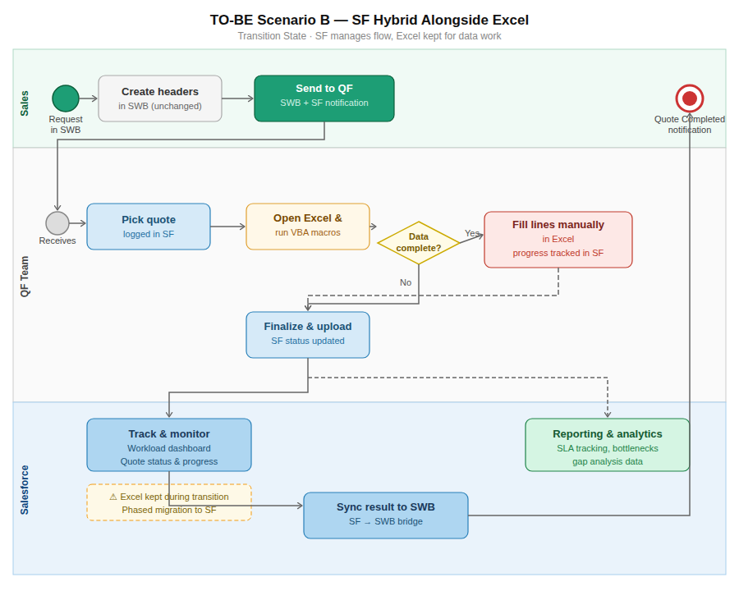

3 | Development

Development translates the approved solution design into a working Salesforce configuration. The BA's role at this stage is not to write code, but to validate that each built component matches requirements, track progress, and escalate deviations immediately. Scenario B is the baseline build; Scenario A items are marked as pending API confirmation.

3.1 Build inventory & ownership

Build item | Salesforce tool | Scope | Status
QF Queue and assignment rules | Queues + Assignment Rules | Both scenarios | [ ] Not started
Quote_Line_Item__c object and all fields | Object Manager | Both scenarios | [ ] Not started
Flow: Data Fetch — Scenario B (Part Master DB) | Flow Builder — Auto-launched | Scenario B | [ ] Not started
Flow: Data Fetch — Scenario A (SWB/Unity API) | Flow Builder + Named Credentials | Scenario A only | [ ] Pending API confirmation
Flow: SWB Sync Trigger (fires on status = Done) | Flow Builder — Record-Triggered | Both scenarios | [ ] Not started
Flow: Error Re-trigger | Flow Builder — Record-Triggered | Both scenarios | [ ] Not started
Flow: Manual Correction Flag | Flow Builder — Record-Triggered | Both scenarios | [ ] Not started
Validation rules (required fields) | Object Manager | Both scenarios | [ ] Not started
Lightning Record Page (guided form layout) | Lightning App Builder | Both scenarios | [ ] Not started
Profiles: Sales (read-only) vs QF (read/write) | Setup — Profiles | Both scenarios | [ ] Not started
Named Credentials (SWB endpoint + Part Master access) | Setup — Named Credentials | Both scenarios | [ ] Not started
Remote Site Settings (SWB HTTP callout) | Setup — Remote Site Settings | Both scenarios | [ ] Not started
Reports + Dashboards (incl. correction rate KPI) | Reports & Dashboards | Both scenarios | [ ] Not started

3.2 BA responsibilities during development

- Review each built component against requirements in Step 1 — particularly FR-02 (conditional data source logic between Scenario A and B)
- Coordinate with the senior application engineer to confirm the exact Part Master DB output file path, format, and schema for the Scenario B Flow configuration
- Drive the SWB/Unity API feasibility investigation with Holger — this gates the Scenario A build start and cannot be deferred or assumed
- Maintain the Requirements Traceability Matrix — every FR and NFR must map to a specific built Flow, rule, or configuration item
- Log all scope changes and new findings in the Change Request register — especially any constraints uncovered during the API investigation
- Prepare UAT test scripts before testing begins, covering both pipeline scenarios independently and including the Scenario A vs B comparison test case

4 | Testing

Testing is not simply verifying that features work in isolation. It must cover bulk data scenarios, edge cases, integration failures, and — specific to this project — a direct comparison test between the Part Master DB pipeline (Scenario B) and the direct API pipeline (Scenario A) to quantify the data freshness improvement.

4.1 Test plan

Test ID | Scenario | Expected result | Category
T-01 | QF member accepts a quote from the SF Queue | Record assigned to the accepting member; removed from the queue for all others | Functional
T-02 | New quote — Data Fetch Flow runs via Part Master DB (Scenario B) | Part number, pricing, and availability populated from the latest weekly extract within 30 seconds | Functional
T-03 | New quote — Data Fetch Flow runs via direct SWB/Unity API (Scenario A, if confirmed) | Real-time data returned; Data_Source__c = 'Direct API'; no empty lines for recently added parts | Functional
T-04 | Part added to SWB after the last weekly ODS extract — queried under Scenario B | Manual_Correction__c flagged; Correction_Reason__c entry prompted to the QF member | Edge case
T-05 | Same recently-added part tested under Scenario B vs Scenario A | Scenario A returns the part with current data; Scenario B returns empty — gap is documented | Comparison
T-06 | QF member attempts to save a record with empty required fields | Validation rule blocks the save; a clear, actionable error message is displayed | Functional
T-07 | Quote status set to Done — SWB Sync Trigger Flow fires | SWB receives the callout; sync time measured and confirmed faster than the VBA batch baseline | Integration
T-08 | SWB HTTP endpoint unreachable when the Flow fires | SWB_Sync_Status__c = 'Failed'; automatic alert sent to the QF member; no silent failure | Failure
T-09 | QF member corrects a wrong upload and triggers a re-send | Corrected data delivered to SWB; audit trail shows actor, timestamp, and correction reason | Functional
T-10 | Sales user attempts to edit a QF quote field | Edit blocked by the Sales profile; read-only access confirmed for all QF-owned fields | Security
T-11 | Ten quotes processed simultaneously by ten different QF members | No data collision; all records saved independently; Queue operates correctly throughout | Bulk & load
T-12 | Dashboard viewed after 20 quotes are processed | Correction rate KPI matches manual count; all metrics display correctly | Reporting
T-13 | Full end-to-end: Sales request → QF completes → SWB sync → Sales notified | Complete lifecycle without manual intervention; total time faster than the VBA baseline | End-to-end

4.2 UAT acceptance criteria
All criteria must be met before go-live approval is granted.

- All Priority 1 test cases (T-01 through T-09 and T-13) pass with zero critical defects open
- SWB sync timing benchmarked and confirmed measurably faster than the current VBA batch detection delay
- Scenario A (if confirmed): at least one live quote processed via direct API returns part data absent from the current Part Master DB
- Manual correction rate KPI validated against the frequency observed in the current AS-IS process
- At least two QF team members have independently completed a full quote lifecycle in Salesforce without assistance
- Rollback procedure tested and confirmed: reversion to the Excel/VBA pipeline achievable within 24 hours
- Signed UAT sign-off form received from the QF Team lead and the IT lead

5 | Deployment

Deployment moves the validated configuration from sandbox to production using Salesforce Change Sets or a DevOps toolchain, with controlled validation at each stage. The deployment plan minimises disruption by scheduling during low-activity windows and maintaining a tested rollback path. Scenario B can be deployed independently of the API feasibility outcome.

5.1 Go-live checklist

Phase | Action item | Owner
Pre-deployment | Final UAT sign-off received from QF Team lead and IT lead | Aymen El Ibrahimi — BA / QF Lead
Pre-deployment | Scenario A or B confirmed — decision documented with full rationale and stakeholder sign-off | BA + IT + Management
Pre-deployment | Change Set built and validated in sandbox — zero errors or warnings | SF Admin
Pre-deployment | Part Master DB file path, format, and access confirmed in Named Credentials (Scenario B) | SF Admin + Sr. App Engineer
Pre-deployment | SWB/Unity API credentials confirmed in Named Credentials (Scenario A only) | SF Admin + Holger / SWB owner
Pre-deployment | Rollback plan documented and distributed — revert to Excel/VBA achievable within 24 hours | Aymen El Ibrahimi — BA
Pre-deployment | All QF team members trained and signed off as independently capable in Salesforce | BA / QF Lead
Pre-deployment | Sales team notified of go-live date and expected changes to their notification workflow | BA / Manager
Go-live | Change Set deployed to production during a confirmed low-traffic window | SF Admin
Go-live | First live quote processed end-to-end; SWB sync timing measured against the VBA batch baseline | Aymen El Ibrahimi + QF Member
Go-live | Data_Source__c confirmed on the first five live records | Aymen El Ibrahimi — BA
Post go-live | Excel Work List access restricted (Scenario A) or set to read-only (Scenario B) | IT / SF Admin
Post go-live | Manual correction rate KPI monitored over first two weeks and compared to the AS-IS baseline | BA + QF Lead
Post go-live | Hypercare support active — BA and SF Admin on standby for two weeks post go-live | BA + SF Admin
Post go-live | Post go-live review: data freshness improvement quantified, next iteration scoped and planned | BA + Manager

Risk Register

The risk register captures all identified project risks, their assessed likelihood and impact, and the agreed mitigation strategy. It is a living document and must be reviewed at the start of each project phase.

Risk | Likelihood | Impact | Mitigation strategy
SWB/Unity direct API does not exist — Scenario A is not achievable | Medium | High | Confirm in Phase 1 via Holger / SWB platform owner. If unavailable, commit to Scenario B immediately and document the decision with full rationale.
Part Master DB file path or format changes without the BA or SF Admin being notified | Medium | High | Document the exact file path, format, and schema with the Sr. App Engineer. Establish a formal change notification process for the duration of the project.
QFTools contains undocumented business logic beyond Part Master file reads | Medium | High | Full QFTools code walkthrough with the Sr. App Engineer in Phase 1. Document every data operation, branch condition, and exception handling pattern.
Weekly Part Master lag persists in Scenario B — manual corrections continue post go-live | High | Medium | Communicate clearly to all stakeholders that Scenario B does not resolve data freshness. Quantify the current correction rate as the baseline KPI before go-live.
QF team resistance to leaving the Excel/QFTools workflow | High | Medium | Involve QF members in UAT design and execution from Phase 3. Run Scenario B in parallel with Excel for the first two weeks. Surface correction rate dashboard results early.
SF Named Credentials or file server access to Part Master DB fails in production | Low | High | Test Named Credentials and file server access in the sandbox environment with the Sr. App Engineer before any deployment. Do not rely on sandbox-only validation.
OperatingUnit_acct# history files not correctly matched to the QF member's region | Low | High | Map the full file naming convention and region-to-user assignment logic in Phase 1. Include explicit regional file test cases in the UAT plan.
SWB sync not measurably faster in practice despite the SF Flow trigger | Low | Medium | Benchmark the current VBA polling delay before the build begins. Measure the SF Flow trigger-to-SWB response time during testing. Document results for stakeholder reporting.
Incorrect SF Profiles allow Sales users to edit QF quote fields | Low | High | Profile access control tested as a dedicated test case (T-10). Reviewed and signed off by the IT lead before any production deployment.
Go-live scheduled during a high-volume quote period, causing service disruption | Medium | Medium | Schedule go-live during a confirmed low-activity window. For Scenario B, run in parallel with Excel for the first full week minimum.

Appendix

A.1 Confirmed AS-IS data architecture

Full data pipeline — confirmed by the senior application engineer
ODS (Operational Data Store)
└─ Weekly extract → Part Master files → Shared File Server
└─ Part Master DB Server (cleans files, reads to DB, creates output files)
└─ QFTools reads those output files ('Reading Part Master...')
└─ VBA macros use data to match and fill quote lines in the Excel Work List

ODS (Operational Data Store)
└─ Daily extract → History files split by OperatingUnit_acct# → Shared File Server
└─ QFTools reads the correct regional history file → populates LOAD-sheet blue columns

CONFIRMED: There is NO direct API connection to ODS or SWB at any point in the current pipeline.
CONFIRMED: Part Master data is always up to 7 days old. History data is always at least 1 day old.

A.2 Glossary

Term | Definition
Work List (WL) | The shared Excel spreadsheet used as the QF team's quote queue — one row per Sales request, with no collision-prevention mechanism
SWB / Unity | The external platform used by Sales to create quote headers and receive completed quotes. QF team has limited view and delete access. May expose a direct REST API (feasibility TBC via Holger).
ODS | Operational Data Store — the central source of record. Generates the weekly Part Master extract files and the daily history extract files delivered to the shared file server.
Part Master DB | Internal DB server that receives the weekly ODS extract, cleans it, and creates output files that QFTools reads. Data is always up to 7 days old due to the extract cycle.
QFTools / VBA Macros | Current tooling embedded in Excel. Reads Part Master DB output files and history files to populate quote lines. The core system being replaced in this migration.
OperatingUnit_acct# | The file naming convention for regional history data files, split by operating unit and account number. QFTools selects the correct regional file for each quote.
SF Flow | Salesforce Flow Builder automation. Replaces VBA logic by triggering on record events and calling APIs or reading pipeline files to populate Salesforce fields automatically.
SF Queue | A Salesforce feature that holds records for a team. Members accept records individually, eliminating the Work List collision risk of the current shared Excel file.
Named Credentials | Salesforce configuration that securely stores external endpoint URLs and authentication credentials for use in automated Flow callouts.
Change Set | A Salesforce deployment package containing metadata (Flows, Profiles, objects, etc.) moved from a sandbox environment to production in a controlled release.
Hypercare | A defined post-go-live support period (typically two weeks) during which the BA and SF Admin provide immediate assistance to resolve any production issues quickly.
UAT | User Acceptance Testing — the phase in which QF team members validate the built system against real business scenarios before go-live approval is formally granted.

A.3 Open questions — Phase 1 action items
All items below must be resolved in Phase 1 before build activities can begin on the relevant scenario.

Question | Impact if unresolved | Owner & priority
Does SWB/Unity expose a direct REST API callable from SF Flows? | Scenario A cannot begin — build defaults to Scenario B | Holger / SWB owner — P1, Phase 1
What is the exact file path and format of the Part Master DB output files? | Scenario B Data Fetch Flow cannot be configured | Sr. App Engineer — P1, Phase 1
What authentication is required to access the Part Master DB output files from SF? | Named Credentials for Scenario B cannot be set up | Sr. App Engineer + IT — Phase 1
What is the exact HTTP endpoint and method used by VBA to send data to SWB? | SWB Sync Trigger Flow cannot be built or tested | Sr. App Engineer — P1, Phase 1
What is the OperatingUnit_acct# naming convention and file server location? | History data Flow for Scenario B cannot be configured | Sr. App Engineer — Phase 1
What is the current average weekly rate of manual corrections in QFTools? | No KPI baseline — correction rate improvement cannot be measured | QF Team Lead — Phase 1
Which Salesforce edition and org does ARROW ECS have or plan to acquire? | Flow, REST callout, and Named Credentials feature availability unknown | IT Manager — Project start
Should historical Excel Work List data be archived or migrated to Salesforce? | Data migration scope undefined — may affect the go-live timeline | Manager — Phase 1

A.4 Document revision history

Version | Date | Author | Summary of changes
1.0 | March 2025 | Aymen El Ibrahimi | Initial draft — all five steps created with architecture assumptions based on available information at the time
1.1 | April 2025 | Aymen El Ibrahimi | Major update following technical interview with the Sr. App Engineer: real ODS extract pipeline documented, API assumption removed, root cause corrected, FR-02 made conditional, new risks and open questions added
2.0 | April 24, 2025 | Aymen El Ibrahimi | Final version: all placeholder content resolved, instructional drafting notes removed, formatting updated for professional presentation and GitHub portfolio publication

End of document · Aymen El Ibrahimi · Salesforce Migration BA Document v2.0 · April 24, 2025

