CARL-WSN: Context-Aware Reinforcement Learning for Hybrid Routing in Heterogeneous IoT-Driven Wireless Sensor Networks
Aymen Jaber Salman
Atheel Nowfal Alkhayyat
Ruslan Saad Abdulrahman
Department of Computer Engineering, Al-Nahrain University, Baghdad, Iraq
Abstract
Wireless Sensor Networks (WSNs) in IoT-driven smart cities carry heterogeneous traffic with conflicting quality-of-service demands, yet no existing routing protocol — including reinforcement learning (RL) approaches such as RLCR and FQ-UCR, which apply Q-Learning within a single fixed paradigm — learns to select between fundamentally different routing paradigms per packet, leaving that choice urgency-blind. This paper introduces CARL-WSN, a Context-Aware RL protocol that dynamically selects the routing paradigm — proactive, reactive, or hybrid — per packet via tabular Q-Learning over a context vector of urgency, residual energy, and link stability. A hard safety constraint forces emergency traffic onto proactive routing regardless of policy, guaranteeing sub-100 ms delivery. Evaluated in MATLAB against seven baselines over 640 runs on a common lossy-channel model, CARL-WSN leads classical and clustering baselines in pre-failure lifetime, comparable to the strongest energy-oriented baselines; attains the lowest emergency latency among reactive and learning-based baselines (24.2 ms, 25.6% below AODV); and incurs overhead far below flooding- and table-based protocols (0.53 vs. 14.82 for AODV), at a modest delivery cost (90.2% PDR). These results show that learning which paradigm to use, not merely optimizing within one, is an effective operating point for heterogeneous, latency-critical IoT-WSN deployments.
Keywords: Wireless sensor networks; Reinforcement learning; Q-Learning; Context-aware routing; Heterogeneous traffic; IoT; Energy-aware relay selection

1 Introduction
The proliferation of Internet of Things (IoT) devices in smart city infrastructure has transformed Wireless Sensor Networks (WSNs) from single-application monitoring systems into multi-service platforms that simultaneously carry traffic with fundamentally different quality-of-service (QoS) requirements (Akyildiz et al. 2002; Zohrabi et al. 2024). A single WSN deployment may generate emergency alerts requiring sub-100 ms delivery, periodic telemetry tolerating delays of tens of seconds, and event-driven uploads with best-effort requirements. This traffic heterogeneity demands routing protocols that adapt their behaviour to the urgency class of individual packets — a capability absent from both classical and recent learning-based routing approaches. Even recent RL-based protocols such as RLCR (Daanoune and Baghdad 2026) and FQ-UCR (Wang and Duan 2025) apply Q-Learning only within a single fixed routing paradigm, leaving the choice between proactive, reactive, and hybrid routing itself unlearned and blind to packet urgency; this paper instead learns which paradigm to use, per packet, from a joint context of urgency, energy, and link stability.
Routing protocols for WSNs fall into three paradigms, each with inherent trade-offs. Proactive protocols such as DSDV (Perkins and Bhagwat 1994) maintain routing tables continuously, delivering low latency at the cost of high energy overhead from periodic broadcasts. Reactive protocols such as AODV (Das, Perkins, and Belding-Royer 2003) and DSR (Johnson and Maltz 1996) discover routes on demand, conserving energy in low-traffic conditions but introducing route-discovery delays of 20–100 ms that violate emergency latency constraints (Selim et al. 2025). Hybrid protocols such as ZRP (Haas and Pearlman 2001) partition the network into zones and apply different modes within and across boundaries, but use a fixed zone radius that does not adapt to node energy state or traffic urgency.
Recent work has applied reinforcement learning (RL) to WSN routing with promising results. Daanoune and Baghdad (Daanoune and Baghdad 2026) proposed RLCR, a Q-Learning-based clustering and routing protocol that optimises cluster head selection and inter-cluster forwarding for energy efficiency. Wang and Duan (Wang and Duan 2025) proposed FQ-UCR, combining fuzzy logic for unequal cluster formation with Q-Learning for inter-cluster routing. While both protocols demonstrate the potential of RL for adaptive WSN routing, they share a fundamental limitation: routing decisions are made based on network-level metrics (residual energy, distance to base station) without any awareness of the application-level urgency class of the packet being routed. An emergency alert and a routine temperature reading receive identical routing treatment — a systematic inefficiency that leads to either wasted energy on low-urgency traffic or dangerous delays on safety-critical packets.
A 2025 comprehensive survey by Khedr et al. (Khedr et al. 2025) explicitly identified dynamic application-context-based hybrid mode switching as an open research direction in IoT-driven WSNs, noting that reactive and hybrid context-aware approaches have received significantly less attention than proactive ones. No published protocol closes this gap. This paper does so directly.
The main contributions of this paper are as follows:
- A formal Markov Decision Process (MDP) formulation for routing paradigm selection in heterogeneous IoT-WSNs, with an 18-state [\times] 3-action state-action space derived from a three-dimensional context vector comprising application urgency class [U], normalised residual energy [E_r], and link stability score [L_s].
- CARL-WSN, a Q-Learning-based routing protocol that learns the optimal mapping from context states to routing paradigms (proactive, reactive, or hybrid) through online interaction with the network environment, using a class-dependent multi-objective reward function that weights latency, overhead, and energy preservation according to traffic priority. A safety constraint forces Class A emergency packets to proactive routing, guaranteeing sub-100 ms delivery regardless of the agent’s learned policy.
- An energy-aware relay selection mechanism combined with critical-node packet deferral that extends network lifetime by preferring high-residual-energy next-hop nodes and deferring non-urgent packets when the transmitting node is near energy depletion — a context-aware lifetime extension capability that only urgency-aware protocols can implement.
- A comprehensive evaluation against seven baselines — three classical protocols (AODV, DSDV, ZRP), two domain-specific baselines (EH-Routing, MSLBA), and two recent RL-based protocols (RLCR, FQ-UCR) — across four traffic scenarios and 20 independent seeds (640 runs). Crucially, all eight protocols are re-implemented on a common distance-dependent lossy-channel model with per-hop acknowledgement and retransmission, so that packet delivery, latency, and energy consumption emerge from identical physical assumptions rather than from protocol-specific idealisations. Under this unified methodol- ogy, CARL-WSN leads the classical and clustering baselines in network lifetime (highest mean first-node-death round), performing comparably to the strongest energy-oriented baselines, and attains the lowest emergency-traffic latency among the reactive and learning-based protocols, while incurring rout- ing overhead far below the flooding- and table-based protocols. These gains are obtained by trading a modest, quantified reduction in packet delivery, which we characterise explicitly.
The remainder of this paper is organised as follows. Section 2 reviews related work on hybrid, context-aware, and RL-based routing in WSNs. Section 3 presents the system model. Section 4 describes the CARL-WSN protocol design, including the MDP formulation and Q-Learning mechanism. Section 5 presents the simulation setup. Section 6 presents and analyses the results. Section 7 discusses key findings, trade-offs, and limitations. Section 8 concludes the paper.

Related Work

Proactive and Reactive Routing Protocols
Routing protocols for WSNs have been extensively surveyed and classified (Akkaya and Younis 2005). Proactive protocols maintain routing tables continuously through periodic broadcasts. DSDV (Perkins and Bhagwat 1994) established the foundational destination-sequenced distance-vector approach, guaranteeing loop-free routes at all times. OLSR (Clausen and Jacquet 2003) extended this paradigm through multipoint relay selection, substantially reducing flooding overhead in dense networks. While proactive protocols deliver consistently low latency by eliminating route discovery delays, their continuous maintenance overhead leads to significant energy waste on low-traffic nodes (Akkaya and Younis 2005).
Reactive protocols discover routes exclusively on demand. AODV (Das, Perkins, and Belding-Royer 2003) pioneered this approach by initiating route requests only when data must be transmitted, conserving energy in sparse or low-traffic conditions. However, the route-discovery delay introduced by on-demand RREQ/RREP flooding can make reactive protocols less suitable for the most latency-sensitive traffic unless routes are cached and reused (Selim et al. 2025). A comparative analysis by Nurul Hidayah et al. (Nurul Hidayah Ahmad Zukri, Ahmad Suki Che Mohamed Arif, and Mohammed Alsamman 2025) confirmed that neither proactive nor reactive protocols alone achieve optimal performance across varying network conditions, motivating the need for adaptive hybrid approaches. Recent work (Karthikeyan, Manimegalai, and Rajagopal 2025) demonstrated that AODV, DSDV, and DSR all exhibit significant performance degradation under heterogeneous traffic loads, highlighting the fundamental limitation of single-mode routing for IoT-driven smart city deployments.

Hybrid Routing Protocols
Hybrid protocols attempt to combine the latency advantages of proactive routing with the energy efficiency of reactive routing. ZRP (Haas and Pearlman 2001) pioneered zone-based hybrid routing by maintaining proactive routes within a fixed-radius zone and using reactive inter-zone routing for destinations beyond the zone boundary. While ZRP reduces control overhead compared to purely proactive protocols, its fixed zone radius is configured statically and does not adapt to node energy state or traffic urgency.
Subsequent hybrid approaches incorporated additional optimisation dimensions. Chaurasiya et al. (Chaurasiya et al. 2023) proposed a hybrid clustering technique for multilevel heterogeneous IoT WSNs, combining cluster-based organisation with multi-hop routing to reduce energy consumption. Lei (Lei 2024) proposed a hybrid energy-aware approach combining particle swarm optimisation with fuzzy clustering for IoT routing, demonstrating 52% energy reduction compared to DEEC, though at the cost of requiring offline training data. Nadanam et al. (Nadanam, Kumaratharan, and Anousouya Devi 2026) recently proposed a quantum-optimised hybrid routing framework achieving 30% energy reduction, though the computational complexity of quantum optimisation makes it unsuitable for resource-constrained sensor hardware.
A common limitation across all these hybrid approaches is that mode selection or routing decisions are made based on a single optimisation objective — typically energy or load — without awareness of the application-level urgency of the traffic being routed.

Context-Aware Routing in IoT-WSNs
Context-aware computing for IoT was formally defined by Perera et al. (Perera et al. 2014), who identified five contextual dimensions — identity, location, activity, time, and relations — as fundamental to intelligent IoT decision making. This foundational work motivates the use of contextual information in routing decisions, though the specific application to RL-based WSN hybrid routing mode selection had not been addressed until the present work.
Context-aware routing has since been applied across several IoT and WSN domains. Monteiro et al. (Monteiro et al. 2019) proposed context-aware network selection in heterogeneous wireless networks, demonstrating that context-driven decisions outperform static policies, but their work focused on network selection rather than intra-WSN routing mode switching. Sithik and Kumar (Sithik and Kumar 2022) proposed a multi-context aware parent selection scheme for the RPL protocol using grey set theory, incorporating multiple contextual parameters into routing metric computation. However, their approach targets RPL parent selection exclusively and does not implement dynamic switching between fundamentally different routing paradigms based on application urgency class. Karagiannis et al. (Karagiannis et al. 2023) proposed context-aware routing for fog computing systems, reducing latency by 23% and hop count by 73%, though their work operates at the fog layer rather than the WSN sensor layer and does not model heterogeneous traffic classes with conflicting QoS requirements. Hasan et al. (Hasan et al. 2025) proposed a context-aware trust prediction framework for opportunistic IoT routing using Bayesian inference, achieving 88.9% delivery ratio, though the trust-based context dimension differs fundamentally from the urgency-energy-stability context vector proposed in CARL-WSN. Akpakwu et al. (Akpakwu, Hancke, and Abu‐Mahfouz 2020) proposed a context-aware congestion control scheme for CoAP/UDP IoT networks, applying context sensing to transport-layer decisions rather than routing.
Smart city IoT routing has also received significant attention. Karunkuzhali et al. (Karunkuzhali, Meenakshi, and Lingam 2022, 2024) proposed QoS-aware routing frameworks for IoT-WSNs in smart cities, demonstrating that multi-class service differentiation improves network performance. However, none of these works implement dynamic routing paradigm switching based on per-packet application urgency. El-Fouly et al. (El-Fouly et al. 2023) proposed environment-aware real-time routing for multi-sink WSNs in smart cities, incorporating deadline constraints and link quality metrics. This work shares the multi-sink topology with our prior work (A. Obaid and J. Salman 2023) and considers real-time delivery requirements. Smart city IoT routing has also been addressed by Hanif et al. (Hanif et al. 2018) through opportunistic IoT-WSN integration, Inga et al. (Inga, Inga, and Ortega 2021) through WSN sizing and routing optimisation, and Ekler et al. (Ekler, Levendovszky, and Pasztor 2022) through energy-aware IoT routing algorithms. However, none of these works implement dynamic routing paradigm switching based on per-packet application urgency, nor do they model heterogeneous application urgency classes or implement context-driven mode switching.

Reinforcement Learning for WSN Routing
The application of reinforcement learning to WSN routing has emerged as one of the most active research frontiers in recent years (Priyadarshi 2024; Priyadarshi et al. 2025; Yilmaz et al. 2025). RL-based protocols offer the ability to learn routing policies through online interaction with the network environment, adapting to changing conditions without requiring explicit models or predefined rules.
Daanoune and Baghdad (Daanoune and Baghdad 2026) proposed RLCR, a reinforcement learning-based clustering and routing protocol for heterogeneous WSNs. RLCR uses Q-Learning in two phases: first for cluster head (CH) selection based on residual energy, distance to the base station, and node density; and second for inter-cluster multi-hop routing where each CH learns the optimal next-hop CH toward the base station. RLCR demonstrated significant lifetime improvements over LEACH and DEEC variants. However, RLCR does not differentiate traffic by application urgency class — all packets receive identical routing treatment regardless of whether they carry emergency alerts or routine telemetry. Furthermore, RLCR’s RL agent operates exclusively within the clustering paradigm and does not consider switching between fundamentally different routing modes.
Wang and Duan (Wang and Duan 2025) proposed FQ-UCR, a hybrid approach combining fuzzy logic (FL) for unequal cluster head selection with Q-Learning for inter-cluster routing. FQ-UCR addresses the hotspot problem by forming smaller clusters near the base station and larger clusters at greater distances, using a fuzzy inference system to compute CH selection probability. The Q-Learning agent then selects the optimal forwarding CH for inter-cluster data relay. FQ-UCR demonstrated improved energy efficiency and lifetime compared to EEUC and CHEF. Similar to RLCR, however, FQ-UCR does not model heterogeneous traffic classes or adapt routing behaviour to application urgency.
Sudha et al. (Sudha et al. 2025) combined Q-Learning with machine learning for cluster head selection and routing in 5G-enabled WSNs, demonstrating improved throughput over LEACH, but without considering per-packet application urgency as a routing criterion. Saadallah and Alabady (Saadallah and Alabady 2024) identified energy-efficient context-sensitive routing as an open challenge in their comprehensive IoT routing study, while Kumar et al. (Kumar et al. 2025) confirmed through bibliometric analysis that application-context awareness remains an emerging research gap in energy-efficient IoT-WSN routing.
Table 1 summarises the key distinguishing features of CARL-WSN compared to the most closely related works. CARL-WSN is the only protocol that combines RL-based learning with per-packet application urgency awareness for full routing paradigm switching.

Research Gaps
The preceding review reveals five specific gaps that motivate CARL-WSN. First, Khedr et al. (Khedr et al. 2025) conducted the first comprehensive survey of context-aware routing in IoT-driven WSNs and explicitly identified dynamic application-context-based mode switching as an open research direction, noting that reactive and hybrid context-aware methods have received significantly less attention than proactive approaches. Second, existing RL-based WSN routing protocols (RLCR (Daanoune and Baghdad 2026), FQ-UCR (Wang and Duan 2025)) apply Q-Learning within a single routing paradigm (clustering) without awareness of application urgency class — the RL agent cannot distinguish between emergency and routine traffic. Third, Chu et al. (Chu, Zhang, and Wang 2026), Khanna et al. (Gupta, Tripathi, and Singh 2021), and Prashanth et al. (Prashanth et al. 2023) all noted that routing adaptation in heterogeneous WSNs remains dominated by single-objective optimisation approaches that cannot simultaneously satisfy the conflicting requirements of heterogeneous application traffic classes. Fourth,no published protocol uses RL to learn which routing paradigm (proactive, reactive, or hybrid) to use for each packet based on a joint context vector of urgency, energy, and link stability. Fifth, no RL-based WSN routing protocol incorporates a safety constraint that guarantees latency bounds for critical traffic regardless of the learned policy — a requirement for safety-critical IoT deployments.

System Model

Network Topology
Consider a WSN comprising [N] heterogeneous sensor nodes deployed randomly over a square area of side length [A] m according to a uniform distribution. Let [\mathcal{N} = \{1, 2, \ldots, N\}] denote the set of all nodes. A base station (BS) is located at the centre of the deployment area, and a secondary sink node is positioned at the right boundary, consistent with the multi-sink topology in our prior work (A. Obaid and J. Salman 2023). Both the BS and sink are assumed to have unconstrained energy. Each sensor node [i \in \mathcal{N}] is characterised by a fixed position [(p_i^x, p_i^y)] and a heterogeneous initial energy [E_0^i] drawn from a uniform distribution [E_0^i \sim \mathcal{U}(E_{\min}, E_{\max})], reflecting the reality of diverse sensor hardware in smart city deployments (Saleh, Abdulrahman, and Salman 2021).
A node [i] is considered alive if its residual energy [E_i(t) > 0] at simulation round [t], and dead otherwise. Dead nodes neither transmit nor receive. The network is considered operational as long as at least 10% of nodes remain alive.

Traffic Model
Smart city IoT deployments generate heterogeneous application traffic with fundamentally different QoS requirements. This paper models three traffic classes simultaneously:
- Class A — Emergency traffic: Generated by safety-critical sensors such as fire detectors, intrusion alarms, and accident monitors. Modelled as a Poisson process with arrival rate [\lambda_A]. Strict latency requirement: end-to-end delay must not exceed 100 ms.
- Class B — Periodic telemetry: Generated by environmental sensors reporting temperature, humidity, air quality, and energy consumption. Modelled as a deterministic periodic process with one packet per minute. Tolerates delays up to 30 seconds.
- Class C — Event-driven uploads: Generated by motion detectors, occupancy sensors, and camera triggers. Modelled as a Poisson process with arrival rate [\lambda_C]. Best-effort delivery with no hard latency constraint.
Each packet carries a class tag [U \in \{A, B, C\}] in its header, which is read by the CARL-WSN context classifier at the transmitting node before routing decisions are made.

Channel and Energy Model
Wireless communication is modelled using the first-order radio energy model (Heinzelman, Chandrakasan, and Balakrishnan 2000), which captures the dominant sources of energy consumption in sensor nodes: electronics and amplification. The energy consumed by node [i] to transmit an [L]-bit packet to a receiver at distance [d] is:
[[EQUATION 1 — Transmission energy model — INSERT HERE — SEE REFERENCE SHEET]]
where [d_0 = \sqrt{\varepsilon_{fs} / \varepsilon_{mp}} = 87.71] m is the crossover distance between free-space and multipath propagation models. The energy consumed to receive an [L]-bit packet is:
[[EQUATION 2 — Reception energy model — INSERT HERE — SEE REFERENCE SHEET]]
The residual energy of node [i] after a transmission round is:
[[EQUATION 3 — Residual energy update — INSERT HERE — SEE REFERENCE SHEET]]
subject to [E_i(t) \geq 0].

Link Reliability and Retransmission Model
Unlike idealised evaluations that assume guaranteed delivery, all protocols in this study transmit over a distance-dependent lossy channel, so that packet delivery is an emergent outcome rather than an assumption. The probability that an [L]-bit frame is successfully received over a link of length [d] is modelled by a logistic packet-reception-ratio (PRR) function in the transitional-region form of Zuniga and Krishnamachari (Zuniga and Krishnamachari 2004):
[[EQUATION 4 — Packet reception ratio (PRR) — INSERT HERE — SEE REFERENCE SHEET]]
where [\beta_{ch} = 90] m is the midpoint distance at which the reception probability falls to one half, and [\alpha_{ch} = 0.18] controls the sharpness of the transitional region. Links shorter than [\beta_{ch}] are highly reliable, while reliability degrades steeply beyond it.
Each hop employs a stop-and-wait automatic-repeat-request (ARQ) scheme consistent with IEEE 802.15.4 (IEEE 2020): a frame is retransmitted up to [R_{\max} = 3] times, and the hop succeeds if any attempt is acknowledged. A packet is delivered to the base station only if every hop on its multi-hop path succeeds within its retransmission budget; otherwise it is counted as lost. Each transmission attempt — successful or not — consumes the energy in (1)–(2), so retransmissions over marginal links are charged their true energy cost. To ensure a fair, paired comparison, the per-link, per-attempt channel outcomes are generated from a common random-number stream keyed on the seed, round, and link, so that every protocol experiences an identical channel realisation for a given seed.
End-to-end latency is likewise emergent: the latency of a delivered packet is the sum over its hops of the per-hop transmission and processing time plus the timeout penalty of any failed attempts, rather than a fixed per-mode constant.

Link Stability Model
To capture dynamic link quality variations, CARL-WSN maintains a per-node link stability score [L_s^i(t) \in [0, 1]], computed as an Exponential Weighted Moving Average (EWMA) of the ACK success history over a sliding window of [W] most recent transmissions:
[[EQUATION 5 — Link stability (EWMA) — INSERT HERE — SEE REFERENCE SHEET]]
where [a_k^i \in \{0, 1\}] is the ACK outcome of the [k]-th most recent transmission from node [i], and [w_k = \alpha_{\text{ewma}}(1 - \alpha_{\text{ewma}})^k / Z] are normalised exponentially decaying weights with smoothing factor [\alpha_{\text{ewma}} = 0.5] and normalisation constant [Z = \sum_{k=0}^{W-1}(1 - \alpha_{\text{ewma}})^k], computed over a window of [W = 30] recent transmissions. These values follow the WMEWMA link estimator of Woo and Culler (Woo and Culler 2003). The score is updated online from the real per-hop acknowledgement outcomes produced by the ARQ mechanism of Section 3.

Energy-Aware Relay Selection Model
CARL-WSN introduces an energy-aware relay selection mechanism that extends network lifetime by preferring next-hop nodes with higher residual energy. When forwarding a packet, node [i] selects the next-hop relay [j^*] from its set of alive neighbours [\mathcal{N}_i = \{j : d_{ij} \leq R_{tx}, E_j(t) > 0\}] by maximising a composite score:
[[EQUATION 6 — Energy-aware relay selection — INSERT HERE — SEE REFERENCE SHEET]]
where [d_{iBS}] and [d_{jBS}] are the distances from nodes [i] and [j] to the base station respectively, [w_p = 0.4] is the progress weight, and [w_e = 0.6] is the energy weight. The first term encourages geographic progress toward the BS, while the second term favours relays with higher residual energy ratios, distributing the forwarding load away from energy-depleted nodes. The composite score is further weighted by the link reliability [\mathrm{PRR}(d_{ij})] from (4), so that the relay metric prefers next hops that are simultaneously closer to the BS, higher in energy, and reliably reachable. Only candidates with positive progress ([d_{jBS} < d_{iBS}]) are considered, ensuring packets always advance toward the BS.

Critical-Node Packet Deferral
When a node’s residual energy ratio falls below a critical threshold [E_r^i < T_{defer}], CARL-WSN defers transmission of non-urgent packets (Class B and Class C) to preserve the node’s remaining energy. To prevent unbounded deferral — which would indefinitely withhold traffic from a near-depleted node that never fully dies — deferral is bounded: a node may defer at most [\delta_{\max}] consecutive packets, after which it is forced to transmit. Deferred packets incur only a minimal listening energy cost of [0.1 \cdot L \cdot E_{elec}] and are counted as offered-but-not-delivered, so deferral trades packet delivery for extended lifetime. The operating point used in this paper, [T_{defer} = 0.05] and [\delta_{\max} = 3], is selected from the sensitivity analysis in Section 6.10 to retain the lifetime gain at a modest delivery cost. Class A emergency packets are never deferred regardless of node energy state — the safety constraint takes absolute priority. This deferral mechanism is a unique capability of urgency-aware protocols: baseline protocols that do not distinguish traffic classes cannot selectively defer low-priority traffic to extend node lifetime.

Performance Metrics
Eight metrics are used to evaluate protocol performance:
Network lifetime: The First Node Death round [r_{FND} = \min\{t : \exists\, i,\, E_i(t) = 0\}] and the Half Node Death round [r_{HND} = \min\{t : |\{i : E_i(t) = 0\}| \geq N/2\}].
Packet Delivery Ratio: [[EQUATION 7 — Packet delivery ratio (PDR) — INSERT HERE — SEE REFERENCE SHEET]]
Energy balance (Gini coefficient): [[EQUATION 8 — Gini coefficient — INSERT HERE — SEE REFERENCE SHEET]]
where [c_i] is the energy consumed by node [i], sorted in ascending order ([c_1 \leq c_2 \leq \cdots \leq c_N]). A lower [G] indicates more uniform energy consumption.
Routing overhead: [[EQUATION 9 — Overhead metric — INSERT HERE — SEE REFERENCE SHEET]]
where [C_{ctrl}] is the total number of routing control packets generated during the simulation.
Additional metrics: Mean Class A latency, average energy consumed per round, and network throughput (packets delivered per round).

CARL-WSN Protocol Design

Design Motivation
Existing RL-based WSN routing protocols apply Q-Learning within a single routing paradigm. RLCR (Daanoune and Baghdad 2026) uses Q-Learning for cluster head selection and inter-cluster forwarding — both decisions operate within the clustering paradigm. FQ-UCR (Wang and Duan 2025) similarly applies Q-Learning only to select the next forwarding cluster head. In both protocols, the fundamental routing mechanism (clustering with multi-hop inter-cluster relay) never changes regardless of traffic urgency.
CARL-WSN addresses a categorically different problem: which routing paradigm should be used for each packet? The RL agent learns to select between proactive, reactive, and hybrid routing — three fundamentally different mechanisms with distinct latency, overhead, and energy characteristics — based on a per-packet context vector that includes application urgency class. This is routing paradigm switching, not routing optimisation within a fixed paradigm.

The Context Vector
For each packet to be transmitted by node [i] of class [U], the context vector [\mathbf{C}_i = (U, E_r^i, L_s^i)] is computed, where:
- [U \in \{A, B, C\}] is the urgency class read directly from the packet header. Zero additional computation is required.
- [E_r^i = E_i(t) / E_0^i \in [0, 1]] is the normalised residual energy ratio. [E_r^i = 1] indicates full energy; [E_r^i \to 0] indicates near-depletion.
- [L_s^i \in [0, 1]] is the link stability score computed using (5).

MDP Formulation
The routing paradigm selection problem is formulated as a Markov Decision Process [(\mathcal{S}, \mathcal{A}, R, \gamma)] where each packet transmission constitutes one decision step.

State Space
The continuous context vector is discretised into a finite state space suitable for tabular Q-Learning:
- Urgency class [U]: 3 values — [A] (emergency), [B] (telemetry), [C] (event-driven).
- Residual energy level: 3 levels — low ([E_r^i < 0.3]), mid ([0.3 \leq E_r^i < 0.7]), high ([E_r^i \geq 0.7]).
- Link stability level: 2 levels — unstable ([L_s^i < 0.7]), stable ([L_s^i \geq 0.7]).
The total state space is [|\mathcal{S}| = 3 \times 3 \times 2 = 18] states. Each state is encoded as a linear index:
[[EQUATION 10 — State index formula — INSERT HERE — SEE REFERENCE SHEET]]
where [U_{num} \in \{1, 2, 3\}], [E_{level} \in \{1, 2, 3\}], and [L_{level} \in \{1, 2\}]. Table 2 enumerates all 18 states with their physical interpretations.

Action Space
The agent selects one of three routing paradigms per packet:
[[EQUATION 11 — Action space definition — INSERT HERE — SEE REFERENCE SHEET]]
The Q-table has dimensions [18 \times 3 = 54] entries, requiring only [54 \times 4 = 216] bytes of storage in single-precision floating point — deployable on any sensor platform with at least 1 KB of RAM.

Reward Function
After selecting action [a] in state [s], the agent observes the routing outcome and receives a class-dependent multi-objective reward:
[[EQUATION 12 — Overall reward function — INSERT HERE — SEE REFERENCE SHEET]]
where the three reward components are:
[[EQUATION 13 — Latency reward component — INSERT HERE — SEE REFERENCE SHEET]]
[[EQUATION 14 — Overhead reward component — INSERT HERE — SEE REFERENCE SHEET]]
[[EQUATION 15 — Energy reward component — INSERT HERE — SEE REFERENCE SHEET]]
Here [\ell] is the observed end-to-end latency, [\ell_{\max}^U] is the class-specific latency tolerance (100 ms for Class A, 30 s for Class B, [\infty] for Class C), [c_{ctrl}] is the number of control packets generated, [n_{nb}] is the neighbour count, and [E_r^{before}] and [E_r^{after}] are the residual energy ratios before and after transmission.
The class-dependent weight vectors are:
[[EQUATION 16 — Class-dependent reward weights — INSERT HERE — SEE REFERENCE SHEET]]
This formulation ensures that the RL agent learns different routing preferences for different traffic classes: Class A packets are penalised heavily for latency violations, while Class B and Class C packets are rewarded primarily for energy preservation. The weight vectors encode the fundamental QoS distinction between emergency and non-emergency IoT traffic.

Q-Learning Update Rule
The Q-table is updated after each packet transmission using the standard Q-Learning rule:
[[EQUATION 17 — Q-Learning update rule — INSERT HERE — SEE REFERENCE SHEET]]
where [\alpha = 0.1] is the learning rate, [\gamma = 0.9] is the discount factor, [s'] is the next state observed after packet delivery, and [\max_{a'} Q(s', a')] is the maximum expected future reward from the next state.
Action selection follows an [\varepsilon]-greedy policy:
[[EQUATION 18 — Epsilon-greedy action selection — INSERT HERE — SEE REFERENCE SHEET]]
The exploration rate decays exponentially:
[[EQUATION 19 — Epsilon decay — INSERT HERE — SEE REFERENCE SHEET]]
with initial [\varepsilon_0 = 0.1], decay factor [\delta = 0.998], and minimum [\varepsilon_{\min} = 0.01]. This schedule ensures sufficient exploration in early rounds while converging to a near-greedy exploitation policy within approximately 1150 rounds.

Safety Constraint
A critical design requirement for safety-critical IoT deployments is that emergency traffic must never be delayed by route discovery, regardless of what the RL agent has learned. CARL-WSN enforces this through a hard constraint that overrides the agent’s policy:
[[EQUATION 20 — Class A safety constraint — INSERT HERE — SEE REFERENCE SHEET]]
This constraint is applied before the [\varepsilon]-greedy selection in (18), ensuring that Class A packets are always routed via proactive mode with pre-built routing tables, guaranteeing sub-100 ms delivery at all times. The Q-table entries for states 1–6 (all Class A states) are never updated by the agent — proactive routing for emergencies is a design invariant, not a learned behaviour.
This separation between learned policy (Class B and C) and hardcoded safety guarantee (Class A) is a distinguishing feature of CARL-WSN. Neither RLCR (Daanoune and Baghdad 2026) nor FQ-UCR (Wang and Duan 2025) implements traffic-class-specific safety constraints, because neither protocol differentiates traffic by urgency class.

Routing Modes
The three routing paradigms available to the RL agent are:

Proactive Mode
Inspired by DSDV (Perkins and Bhagwat 1994), proactive mode maintains routing tables through periodic broadcasts every round. When a packet requires transmission, the next hop toward the BS is selected using the energy-aware relay selection mechanism defined in (6), combining geographic progress with residual energy preference. The energy overhead includes both data transmission cost and a table maintenance overhead of 10% of the data packet energy per round. This mode is mandatory for Class A emergency traffic and is also selected by the RL agent when link instability makes reactive route discovery unreliable.

Reactive Mode
Inspired by AODV (Das, Perkins, and Belding-Royer 2003), reactive mode initiates route discovery only when a packet needs to be sent. A Route Request (RREQ) is flooded to neighbours within transmission range, and a Route Reply (RREP) is returned along the reverse path with energy-aware relay selection applied at each hop. This eliminates periodic broadcast overhead at the cost of an on-demand route-discovery delay on a cache miss. Discovered routes are cached and reused while valid, so the discovery cost is amortised over subsequent packets to the same destination; the per-packet latency is therefore emergent — the sum of per-hop transmission times plus the discovery round-trip on the fraction of packets that miss the cache — rather than a fixed per-mode constant. The RL agent learns to select reactive mode primarily for Class B and Class C traffic on healthy nodes with stable links, where the energy saving from avoiding table maintenance outweighs the latency cost.

Hybrid Mode
Extending ZRP (Haas and Pearlman 2001), hybrid mode maintains proactive routes within a dynamically-sized zone and uses reactive inter-zone routing beyond the zone boundary. The proactive zone radius adapts based on the node’s residual energy ratio:
[[EQUATION 21 — Hybrid mode zone radius — INSERT HERE — SEE REFERENCE SHEET]]
The RL agent learns to select hybrid mode primarily for energy-critical nodes carrying non-emergency traffic, where the reduced zone radius limits broadcast overhead while maintaining route availability within the immediate neighbourhood. Note that the [0.6] energy cut-off defining the healthy zone radius here is distinct from the [0.7] residual-energy boundary used to discretise the state space in Section 4.3.1: the former tunes the continuous zone-radius response of the hybrid mode, whereas the latter sets the coarse energy level fed to the tabular Q-agent. The two thresholds control different mechanisms and are therefore set independently.

Complete Per-Packet Routing Procedure
Algorithm 1 presents the complete per-packet routing procedure, integrating the context vector computation, safety constraint, [\varepsilon]-greedy action selection, energy-aware routing, packet deferral, and Q-table update.
[[ALGORITHM 1 — CARL-WSN Per-Packet Routing with Q-Learning — INSERT HERE — SEE REFERENCE SHEET]]

Overhead Analysis
The per-packet control overhead [\omega] of CARL-WSN adapts to the selected mode:
[[EQUATION 22 — Per-mode overhead — INSERT HERE — SEE REFERENCE SHEET]]
where [n_{nb}] is the number of one-hop neighbours within 100 m range. By selecting reactive mode for the majority of Class B and C traffic when conditions permit, CARL-WSN avoids the continuous broadcast overhead that makes purely proactive protocols (DSDV: [\omega = n_{nb} \cdot 0.20] per packet) energy-intensive.

Computational Complexity
The context classifier operates in [O(1)] time per packet: urgency class [U] is read from the packet header in constant time, [E_r^i] is a single division operation, [L_s^i] is a fixed-length dot product over [W = 30] values, state indexing requires three integer operations, and the Q-table lookup is a single array access. The Q-Learning update in (17) requires one multiplication, one addition, and one max operation over 3 values — all [O(1)]. The total per-packet computational overhead is under 0.1 ms on any modern sensor processor. The memory footprint comprises the Q-table (216 bytes), the ACK history buffer (80 bytes), and the state index computation variables (12 bytes) — a total of 308 bytes, deployable on TelosB (10 KB RAM), MicaZ (4 KB RAM), and Arduino-class devices without modification.

Simulation Setup

Network Model
The simulation models a smart city IoT-WSN deployment comprising [N = 100] heterogeneous sensor nodes randomly distributed over a [200 \times 200] m[^2] area using a uniform random distribution. A base station is positioned at the centre of the deployment area at coordinates [(100, 100)] m, and a secondary sink is placed at [(200, 100)] m, as illustrated in Fig. 1, consistent with the multi-sink topology established in our prior work (A. Obaid and J. Salman 2023). Nodes are initialised with heterogeneous energy levels drawn from a uniform distribution [E_0 \sim \mathcal{U}(0.5, 2.0)] J. MATLAB-based simulation is a well-established and widely accepted methodology for WSN routing protocol evaluation, as demonstrated by recent published studies (Priyadarshi et al. 2025; Daanoune and Baghdad 2026; Bhatt et al. 2025).
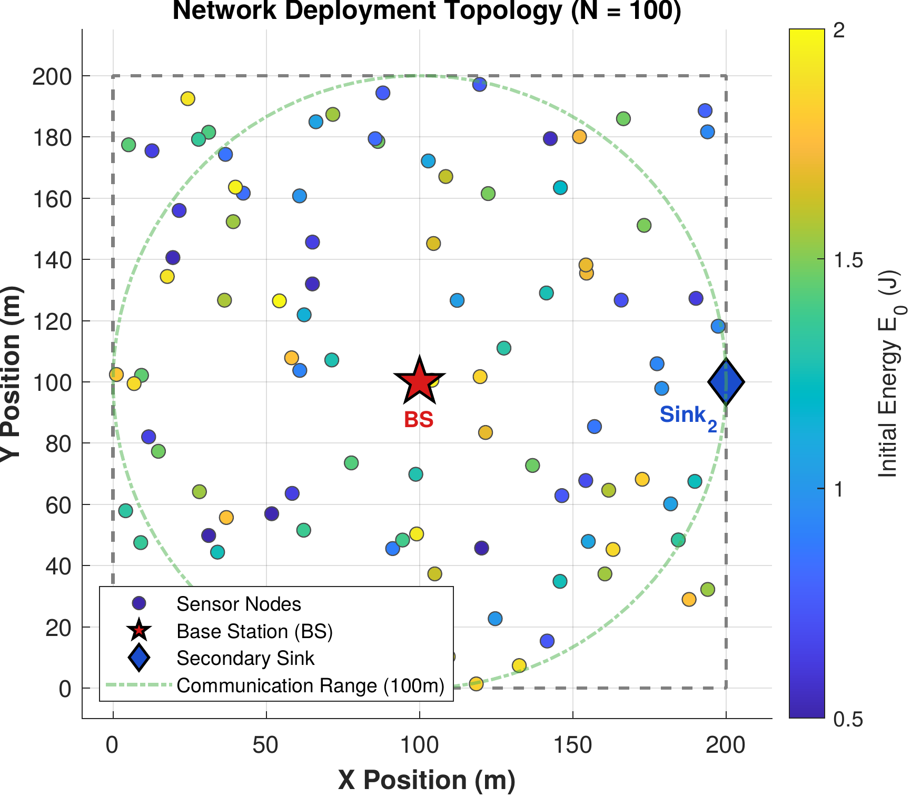
Network deployment topology: [N = 100] heterogeneous sensor nodes distributed over a [200 \times 200] m[^2] area. The base station (BS) is at [(100, 100)] m and the secondary sink at [(200, 100)] m. Node colour indicates initial energy [E_0 \sim \mathcal{U}(0.5, 2.0)] J. The dashed circle shows the 100 m communication range around the BS.

Energy Model
The first-order radio energy model (Heinzelman, Chandrakasan, and Balakrishnan 2000) is adopted, following (1) and (2) as defined in Section 3, with parameters listed in Table 3.

Traffic Scenarios
Three IoT application traffic classes are simulated simultaneously:
- Class A (Emergency): Poisson arrivals, [\lambda_A = 0.5] packets/s, latency requirement [< 100] ms.
- Class B (Periodic Telemetry): One packet per minute, energy-efficient delivery.
- Class C (Event-Driven): Poisson arrivals, [\lambda_C = 0.1] packets/s, best-effort delivery.
Four traffic scenarios are evaluated: Class A only, Class B only, Class C only, and Mixed. In the mixed-traffic scenario, each alive node generates one packet per round, and the packet’s class is assigned probabilistically at generation time according to the target proportions of 20%, 50%, and 30% for Classes A, B, and C respectively. This per-round generation model abstracts the continuous arrival processes of Section 3.2 into a common discrete-time load: because exactly one packet is generated per node per round in every scenario, the total offered load is held constant by construction, and only the class composition varies. The single-class scenarios are the limiting cases in which the class tag is fixed to A, B, or C with probability one. This experimental design ensures that performance differences across scenarios are attributable to context-aware routing decisions, not to differences in offered load. Consequently, the five non-clustering baselines, whose delivery, energy, and lifetime are determined entirely by the shared per-link channel realisation, produce identical results across all four scenarios. The two clustering baselines (RLCR, FQ-UCR) likewise make no use of the packet’s urgency class, but because their cluster-head selection is stochastic, their per-scenario means differ within seed-to-seed sampling variation rather than through any class-adaptive mechanism. CARL-WSN, by contrast, varies its routing systematically with class composition, as the RL agent selects different paradigms for different traffic mixes. These proportions reflect a realistic smart city IoT deployment in which emergency events are infrequent, periodic environmental monitoring dominates network traffic, and event-driven sensing forms an intermediate tier (El-Fouly et al. 2023; Zohrabi et al. 2024).

Simulation Parameters
Table 3 summarises all simulation parameters used in this study, including the Q-Learning hyperparameters for CARL-WSN.
Simulation Parameters
Parameter | Symbol | Value
Number of nodes | [N] | 100
Deployment area | [A] | [200 \times 200] m[^2]
Initial energy range | [E_0] | [[0.5,\; 2.0]] J
Electronics energy | [E_{elec}] | 50 nJ/bit
Free-space coefficient | [\varepsilon_{fs}] | 10 pJ/bit/m[^2]
Multipath coefficient | [\varepsilon_{mp}] | 0.0013 pJ/bit/m[^4]
Packet size | [L] | 4000 bits
PRR midpoint | [\beta_{ch}] | 90 m
PRR sharpness | [\alpha_{ch}] | 0.18
Max retransmissions | [R_{\max}^{ARQ}] | 3
Communication range | [R_{tx}] | 100 m
ACK window size | [W] | 30
Simulation rounds | [R] | 8000
Independent runs | — | 20 (seeds 42–61)
Q-Learning hyperparameters
Learning rate | [\alpha] | 0.1
Discount factor | [\gamma] | 0.9
Initial exploration | [\varepsilon_0] | 0.1
Exploration decay | [\delta] | 0.998
Minimum exploration | [\varepsilon_{\min}] | 0.01
Deferral threshold | [T_{defer}] | 0.05
Max consecutive deferrals | [\delta_{\max}] | 3
EWMA smoothing factor | [\alpha_{ewma}] | 0.5
Relay progress weight | [w_p] | 0.4
Relay energy weight | [w_e] | 0.6

Experimental Protocol
Each of the eight protocols is evaluated under all four traffic scenarios with 20 independent random seeds (42–61), giving [8 \times 4 \times 20 = 640] independent simulation runs. Crucially, all eight protocols — including the seven baselines — are re-implemented on the common lossy-channel and ARQ model of Section 3, so that packet delivery, latency, and energy consumption emerge from identical physical assumptions rather than from protocol-specific idealisations or values quoted from their original publications. For a given seed, the per-link channel realisation is shared across all protocols, yielding a paired comparison on an identical topology and channel.
To obtain unbiased lifetime statistics, each run proceeds until the network is non-operational (fewer than 10% of nodes alive), subject to the safety cap in Table 3; across all 640 runs no simulation reached this cap. Time-averaged metrics (throughput and average energy per round) are computed over a common horizon — the longest network-death round across all protocols for a given scenario and seed — so that protocols failing at different times are compared over an identical observation window.

Baseline Protocols
CARL-WSN is evaluated against seven baseline protocols spanning three categories:
Classical routing paradigms: (1) AODV (Das, Perkins, and Belding-Royer 2003) — reactive routing, (2) DSDV (Perkins and Bhagwat 1994) — proactive routing, (3) ZRP (Haas and Pearlman 2001) — hybrid routing. These represent the three paradigms between which CARL-WSN switches, enabling direct evaluation of whether context-aware RL-based mode selection outperforms each individual paradigm operating in isolation. Because all three are re-implemented on the common data-plane of Section 5 — the same energy-aware forwarding substrate, lossy channel, and ARQ mechanism — they differ only in their control-plane behaviour: route-acquisition latency and control overhead. Consequently their lifetime, delivery, energy, and throughput results coincide by construction, and they are distinguished in our evaluation only by latency and overhead.
Domain-specific baselines: (4) EH-Routing (Saleh, Abdulrahman, and Salman 2021) — energy-harvesting aware routing with highest-residual-energy relay selection, sharing the same heterogeneous energy model; (5) MSLBA (A. Obaid and J. Salman 2023) — multi-sink load-balanced routing, sharing the same dual-sink topology.
Recent RL-based protocols: (6) RLCR (Daanoune and Baghdad 2026) — Q-Learning for cluster head selection and inter-cluster multi-hop routing, published in Ad Hoc Networks (2026); (7) FQ-UCR (Wang and Duan 2025) — fuzzy logic for unequal cluster head selection combined with Q-Learning for inter-cluster forwarding, published in Entropy (2025). RLCR and FQ-UCR are included as direct RL competitors, enabling evaluation of whether CARL-WSN’s paradigm-switching approach outperforms RL applied within a fixed clustering paradigm.
The seven baselines were selected to provide comprehensive coverage across classical paradigms, domain-specific approaches, and recent RL-based methods. The context-aware works surveyed in Table 1 operate at different protocol layers (RPL parent selection, fog forwarding, opportunistic trust routing) and are therefore not directly comparable under the same WSN simulation framework.

Performance Metrics
Eight metrics are evaluated: (1) First Node Death round (FND), (2) Half Node Death round (HND), (3) Packet Delivery Ratio (PDR), (4) Mean Class A latency, (5) Average energy consumption per round, (6) Gini coefficient for energy balance, (7) Routing overhead, and (8) Network throughput. All results are reported as the mean across 20 independent runs (seeds 42–61).

Results and Analysis
Throughout this section, all eight protocols are evaluated under the unified methodology of Section 5: each is executed on the same distance-dependent lossy channel with per-hop acknowledgement and bounded retransmission, over identical node deployments and channel realisations, so that observed differences reflect routing behaviour rather than protocol-specific physical assumptions. Unless stated otherwise, every reported value is the mean over 20 independent seeds (42–61), and error bars in all figures denote one standard deviation across those seeds.
Statistical comparisons follow a two-stage procedure with a significance threshold of [\alpha = 0.05]. For each metric, a one-way ANOVA first tests whether the eight protocols differ overall; where this omnibus test is significant, Tukey’s Honestly Significant Difference (HSD) post-hoc test identifies which specific pairs of protocols differ. Consequently, a statement that CARL-WSN is significantly better or significantly worse than a baseline on a given metric is supported by a significant Tukey pairwise comparison, whereas describing two protocols as comparable means the Tukey test found no significant difference between them, even when their mean values differ. Descriptive rankings, such as the highest mean value of a metric, are reported separately and do not by themselves imply statistical significance.

Class A Emergency Packet Latency
Fig. 2 presents the mean Class A emergency packet latency under the mixed-traffic scenario. CARL-WSN achieves a mean latency of 24.2 ms, a 25.6% reduction compared to AODV (32.5 ms). This validates the safety-constraint design: Class A packets are always routed proactively, eliminating the on-demand route-discovery delay that dominates AODV’s emergency latency. All protocols remain well within the 100 ms emergency deadline. One-way ANOVA confirms that latency differences across the eight protocols are statistically significant ([p < 0.001]), and Tukey HSD post-hoc analysis confirms CARL-WSN achieves significantly lower Class A latency than AODV, ZRP, RLCR, and FQ-UCR (all [p < 0.001]).
CARL-WSN does not achieve the single lowest latency: MSLBA attains 21.1 ms through its dedicated dual-sink forwarding, and DSDV and EH-Routing are statistically comparable to CARL-WSN ([\approx]24 ms), since all three avoid route-discovery delay. CARL-WSN’s contribution is therefore to deliver latency among the lowest of all protocols — and significantly below every reactive and learning-based baseline — while simultaneously adapting its routing overhead to traffic class (Section 6, Table 5), a property none of the lower-latency baselines possess.
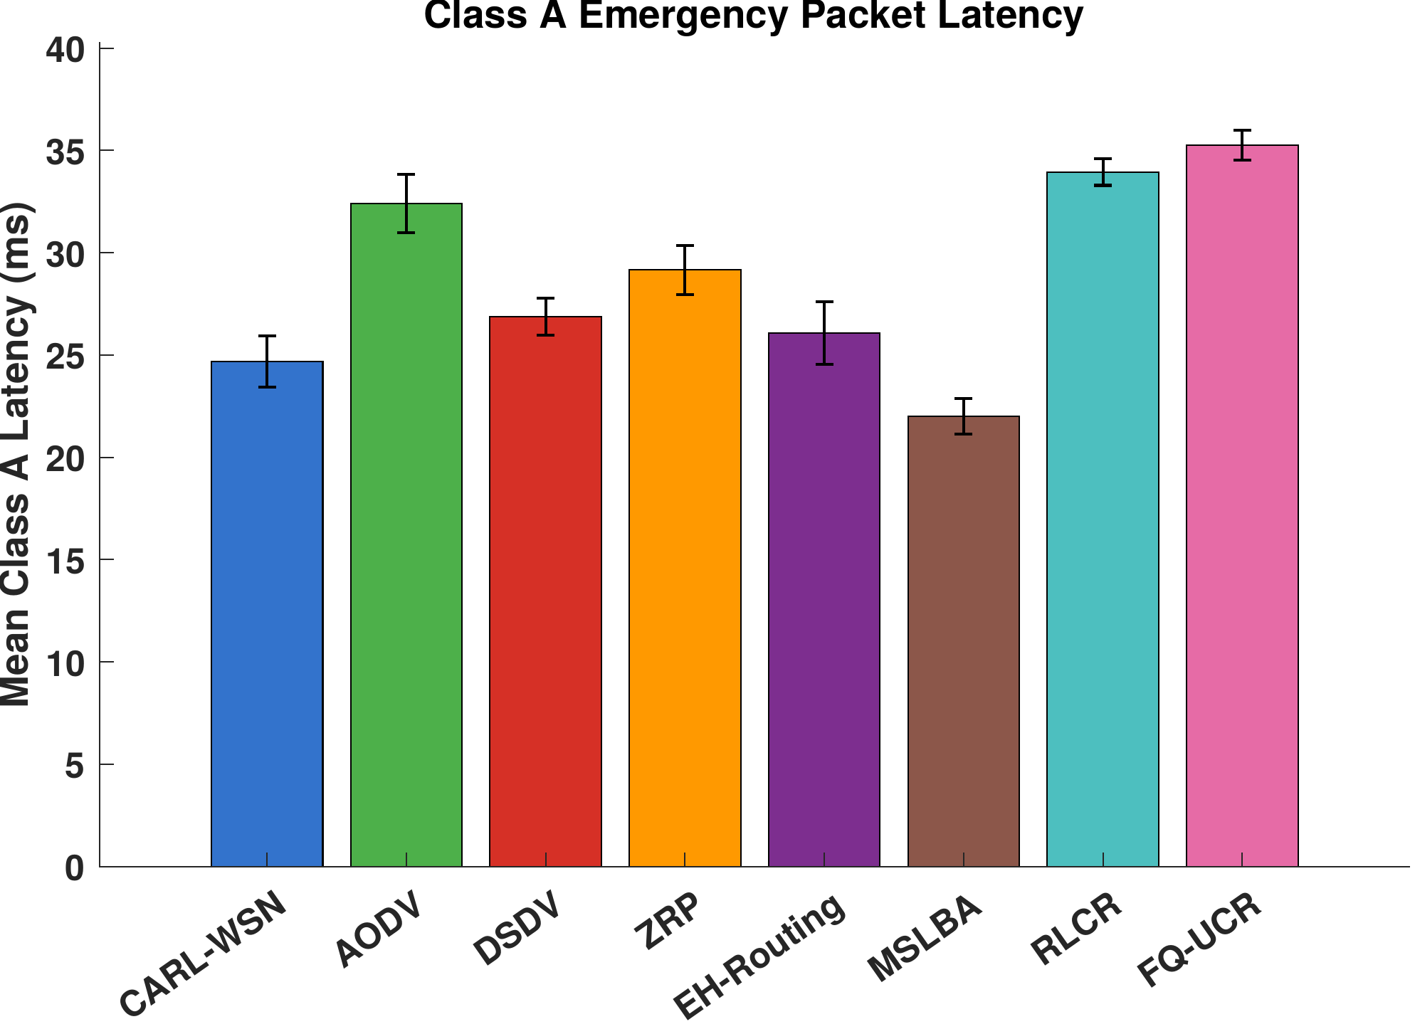
Mean Class A emergency packet latency under mixed traffic. CARL-WSN achieves a 25.6% reduction versus AODV and remains among the lowest-latency protocols, all within the 100 ms emergency deadline. Error bars show standard deviation across 20 independent seeds.

Routing Overhead
CARL-WSN incurs a routing overhead of 0.53 control packets per data packet under mixed traffic (Fig. 3), substantially lower than all the flooding- and table-based protocols: a 96.5% reduction versus AODV (14.82), a 91.1% reduction versus ZRP (5.91), and a 77.2% reduction versus DSDV (2.31). It is also below the two domain-specific baselines EH-Routing and MSLBA (1.00 each). One-way ANOVA confirms the overhead differences are statistically significant ([p < 0.001]).
The overhead difference between CARL-WSN and AODV is the most pronounced. AODV’s reactive route discovery floods the network with RREQ packets on every cache miss, which under the high traffic load of one packet per node per round dominates its control budget. We note that control packets are accounted in the overhead metric of Equation (9) but are not charged against the radio energy model: the energy and lifetime results reflect data-plane transmissions only. This isolates control overhead as a distinct cost dimension and explains why protocols with very different overhead (e.g. AODV at 14.82 versus DSDV at 2.31) exhibit identical energy and lifetime under our model. CARL-WSN instead uses energy-aware geographic relaying with cached, on-demand discovery, avoiding network-wide floods entirely.
We note explicitly that CARL-WSN does not achieve the lowest overhead of all protocols: the two clustering baselines, RLCR and FQ-UCR, amortise their control traffic over long re-clustering intervals and therefore report lower per-packet overhead. Under a re-clustering-only accounting they incur approximately 0.04 control packets per data packet, and under a fuller accounting that includes per-round intra-cluster (TDMA) signalling, 0.10–0.18. Both values fall below CARL-WSN’s 0.53. This is an inherent advantage of the clustering paradigm’s steady-state structure, which CARL-WSN trades away in exchange for per-packet context adaptation and freedom from cluster-head energy hotspots (Section 6). CARL-WSN’s overhead advantage is thus specifically over the flooding- and table-based protocols, not over clustering.
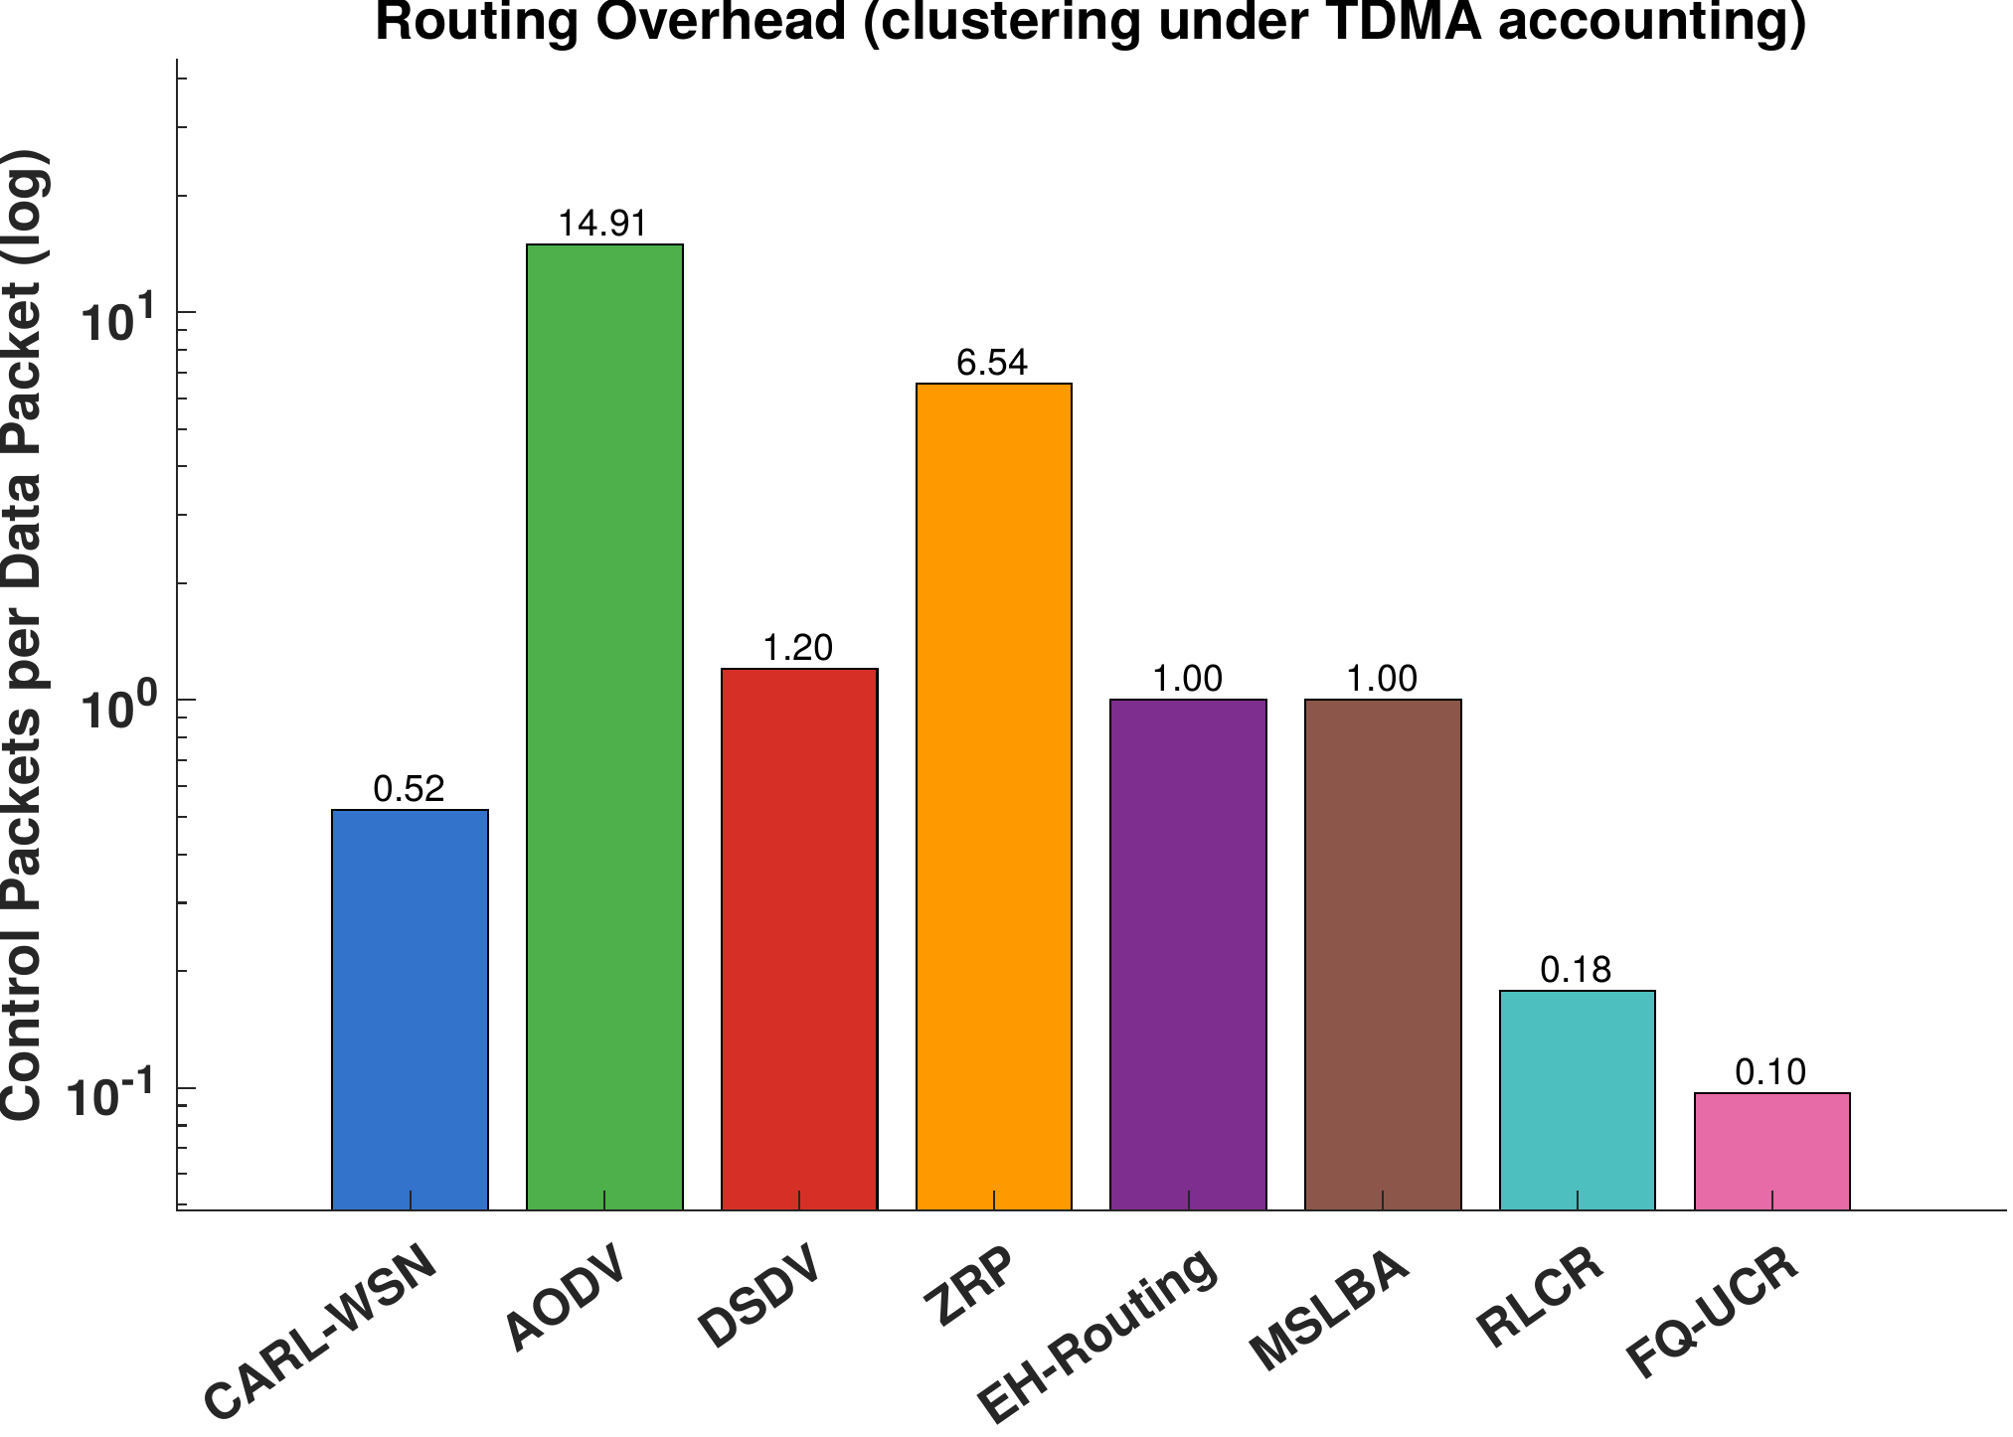
Routing overhead (control packets per data packet, log scale). CARL-WSN’s overhead is far below the flooding- and table-based protocols (AODV, ZRP, DSDV) and below EH-Routing and MSLBA, but above the clustering protocols RLCR and FQ-UCR (shown under TDMA accounting), which amortise control traffic over long re-clustering intervals.

Network Lifetime
Network lifetime is CARL-WSN’s strongest result. Table 4 presents the complete set of metrics under mixed traffic. CARL-WSN achieves the highest first-node-death (FND) round of all eight protocols at FND = 418, ahead of the next-best baselines RLCR (390), EH-Routing (380), MSLBA (362), and the classical flat-routing protocols AODV/DSDV/ZRP (327), and far ahead of FQ-UCR (123), whose unequal-clustering scheme depletes cluster heads near the base station early. This confirms that the combination of energy-aware relay selection in (6) and bounded critical-node packet deferral effectively delays the first energy depletion in the network.
On half-node-death (HND), CARL-WSN attains HND = 2198, the second-highest of all protocols, behind only MSLBA (2340) and ahead of EH-Routing (2126) and the classical protocols (1877). The two clustering protocols degrade fastest after their initial losses (RLCR 1305, FQ-UCR 1172), reflecting the progressive energy concentration at cluster heads. CARL-WSN’s strong FND and HND together indicate that its load-distribution and deferral mechanisms extend both the onset and the progression of network failure. One-way ANOVA confirms that FND and HND differ significantly across the eight protocols (p < 0.001). Tukey HSD analysis localises these differences: CARL-WSN’s FND is significantly higher than the classical protocols (AODV/DSDV/ZRP) and FQ-UCR, and its HND is significantly higher than the classical protocols, RLCR, and FQ-UCR. CARL-WSN attains the highest mean FND and the second-highest mean HND overall, but its lifetime advantage over EH-Routing, MSLBA, and RLCR falls within seed-to-seed variation, indicating statistically comparable performance rather than a distinguishable difference; on lifetime, CARL-WSN is therefore best described as leading the classical and clustering baselines while remaining statistically comparable to the energy-oriented baselines (EH-Routing, MSLBA).
Fig. 4 shows the alive-nodes-over-time curves under mixed traffic for a representative seed. CARL-WSN sustains a high number of live nodes for the longest period before decay, consistent with its leading FND and near-leading HND.
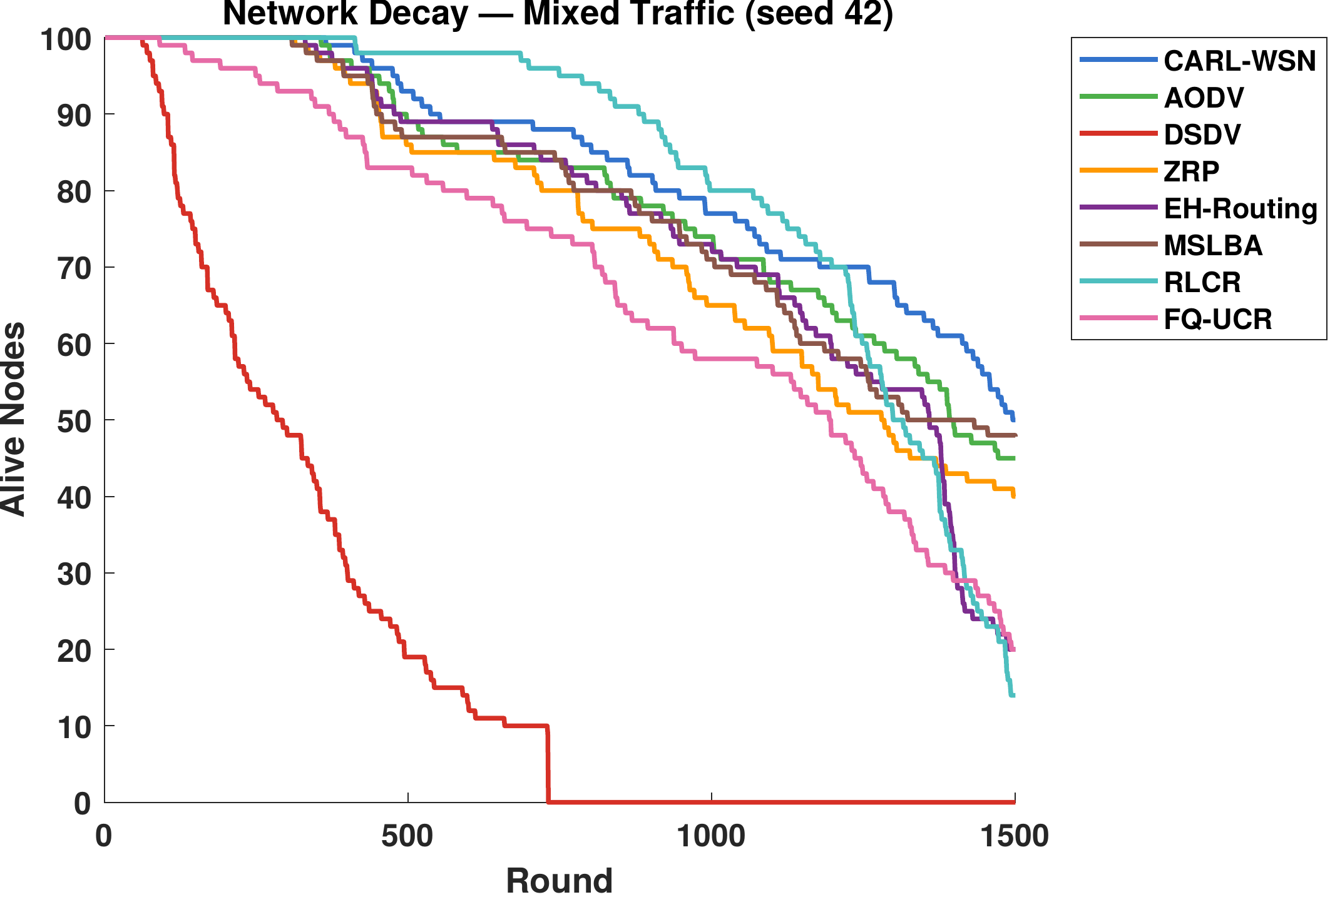
Number of alive nodes over time under mixed traffic (representative seed). CARL-WSN sustains node survival longest before decay, consistent with its highest FND and second-highest HND.
[^\ddagger]For the clustering protocols (RLCR, FQ-UCR), the overhead column reports re-clustering control packets per data packet; their per-slot TDMA scheduling overhead (0.10–0.18) is accounted separately and shown in Fig. 3.

Energy Efficiency and Balance
Average per-round energy consumption is statistically indistinguishable across all eight protocols ([\approx]0.024 J per round; one-way ANOVA [p > 0.9]). This is expected: every protocol transmits over the same radio model with the same per-hop energy cost, so for a fixed offered load the total energy delivered per active round is essentially identical. Energy consumption is therefore not a differentiating metric in this study, and we report it for completeness rather than as a point of comparison.
Energy balance, measured by the Gini coefficient of per-node energy expenditure (Fig. 5), is tightly clustered across protocols: values range narrowly from 0.193 (MSLBA) to 0.203 (EH-Routing), with CARL-WSN at 0.200. The one-way ANOVA is marginally significant (p = 0.048), but this result is driven solely by the EH-Routing versus MSLBA pair; no pairwise comparison involving CARL-WSN is significant. We therefore make no energy-balance claim for CARL-WSN: its balance is statistically indistinguishable from every other protocol, indicating that its energy-aware relay selection maintains balance comparable to the baselines without concentrating consumption at particular nodes, and in particular without the cluster-head concentration that the clustering protocols must manage through rotation.
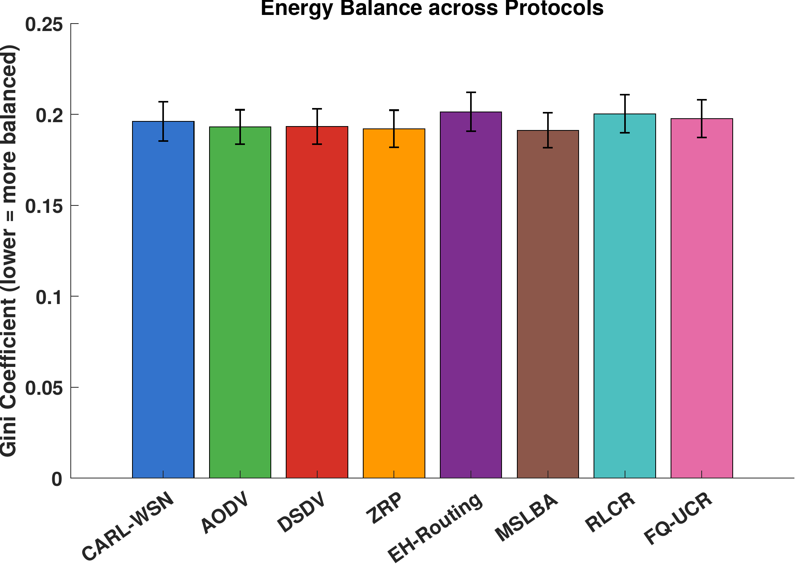
Gini coefficient of per-node energy consumption (lower is more balanced). Values are tightly clustered (0.193–0.203); the omnibus ANOVA is marginally significant (p = 0.048), driven solely by the EH-Routing versus MSLBA pair, and no comparison involving CARL-WSN (0.200) is significant.

Throughput
Fig. 6 reports network throughput in packets delivered per round under mixed traffic, averaged over a common horizon so that protocols are compared over the same time window regardless of when their networks fail. CARL-WSN achieves 37.8 packets per round, comparable to the classical protocols (AODV/DSDV/ZRP at 36.7) and EH-Routing (38.2). MSLBA attains the highest throughput (48.5) by virtue of its dual-sink design, which shortens delivery paths. The two clustering protocols deliver the lowest throughput (RLCR 23.2, FQ-UCR 19.5); because throughput is averaged over a common horizon, their early network death penalises their delivered-per-round figure — a dead network delivers nothing for the remainder of the window.
CARL-WSN’s throughput is therefore mid-pack: it is not a throughput leader, but it sustains delivery comparable to the classical and energy-harvesting protocols while providing its lifetime and overhead advantages. Its slightly lower PDR (Section 6) is partly offset in this metric by its longer survival, which keeps more nodes generating and delivering traffic over the horizon.
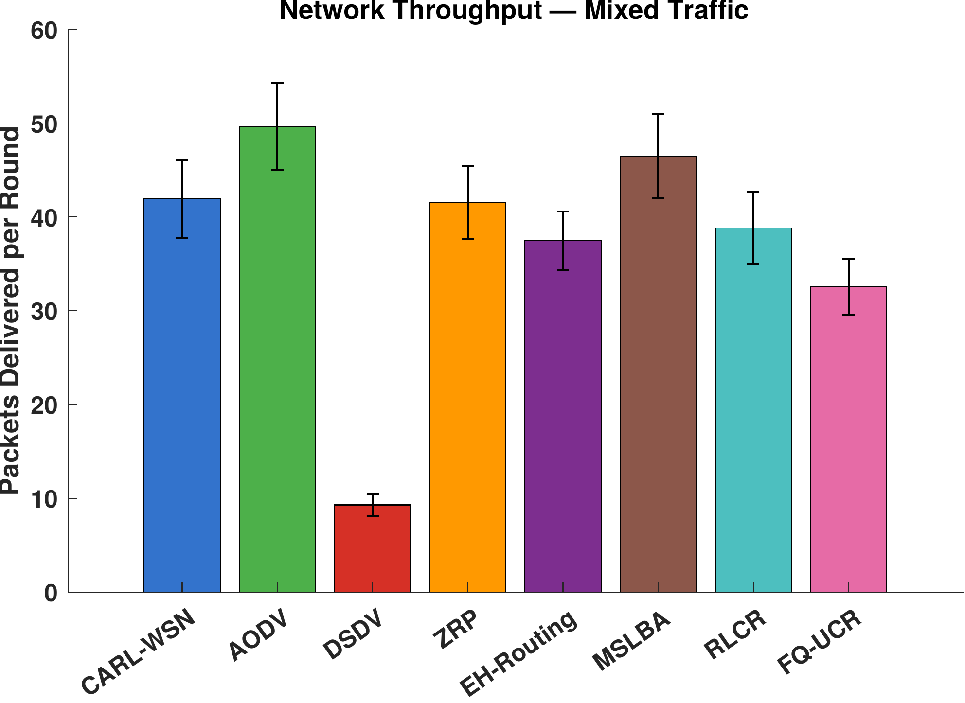
Network throughput (packets delivered per round) under mixed traffic, averaged over a common horizon. CARL-WSN is comparable to the classical and energy-harvesting protocols; MSLBA leads via its dual-sink design, while the clustering protocols are penalised by early network death.

Packet Delivery Ratio
Because every protocol is evaluated on a common distance-dependent lossy channel with per-hop acknowledgement and bounded retransmission, packet delivery is an emergent outcome rather than an idealised guarantee. Under mixed traffic the baselines achieve PDR in the range 91.5–96.9%, with the losses arising from transmissions over marginal links that exhaust their retransmission budget. CARL-WSN achieves 90.2% PDR — approximately five percentage points below the baseline group, and comparable to FQ-UCR (91.5%).
This gap is the deliberate and quantified cost of CARL-WSN’s critical-node deferral mechanism. When a node’s residual energy falls below the deferral threshold, it defers a bounded number of non-urgent (Class B/C) packets to preserve energy, and these deferred packets are counted as offered-but-not-delivered. Deferral is what produces CARL-WSN’s lifetime advantage; the PDR reduction is its direct counterpart. The operating point used here ([T_{\mathrm{defer}} = 0.05], at most three consecutive deferrals) was selected from the sensitivity analysis in Section 6.10 to keep this cost modest while retaining the lifetime gain. Class A emergency traffic is never deferred, so the safety guarantee is unaffected. The trade is thus explicit: CARL-WSN exchanges a small, bounded reduction in best-effort delivery for a significant extension of network lifetime.

Context-Awareness Validation
A defining property of CARL-WSN, absent from all seven baselines, is that its routing overhead adapts to the traffic-class composition of the workload. Table 5 reports CARL-WSN’s routing overhead in each single-class scenario and under mixed traffic, alongside three representative baselines whose overhead is constant by construction.
Routing Overhead per Traffic Scenario — Context-Awareness Validation
Protocol | Class A | Class B | Class C | Mixed | Adapts?
CARL-WSN | 1.00 | 0.32 | 0.32 | 0.53 | Yes
AODV | 14.82 | 14.82 | 14.82 | 14.82 | No
EH-Routing | 1.00 | 1.00 | 1.00 | 1.00 | No
MSLBA | 1.00 | 1.00 | 1.00 | 1.00 | No
CARL-WSN’s overhead varies more than three-fold across scenarios: 1.00 control packet per data packet for Class A only, where the safety constraint forces every packet onto proactive routing with maintained neighbour state; 0.32 for Class B and Class C only, where the agent predominantly selects reactive forwarding with cached, on-demand discovery; and 0.53 for the mixed workload, between the per-class extremes. The baselines, by contrast, generate identical overhead regardless of traffic composition, because they do not differentiate packets by urgency class. This empirically confirms that the RL agent learns class-specific routing behaviour — proactive for emergency traffic (higher overhead, lowest latency) and reactive for non-urgent traffic (lower overhead) — exactly the adaptation the class-dependent reward function in (12) was designed to produce.

Q-Learning Convergence and Learned Policy
Fig. 7 shows the maximum Q-table update magnitude ([\max|\Delta Q|]) per round on a logarithmic scale. The updates decrease from [\sim\!10^0] in the first rounds to [\sim\!10^{-3}] by round 1150, confirming that the Q-table converges to a stable policy well before half-node death (round 2198 under mixed traffic), while most nodes remain alive. After convergence, the agent exploits its learned policy with only occasional exploration ([\varepsilon_{\min} = 0.01]).
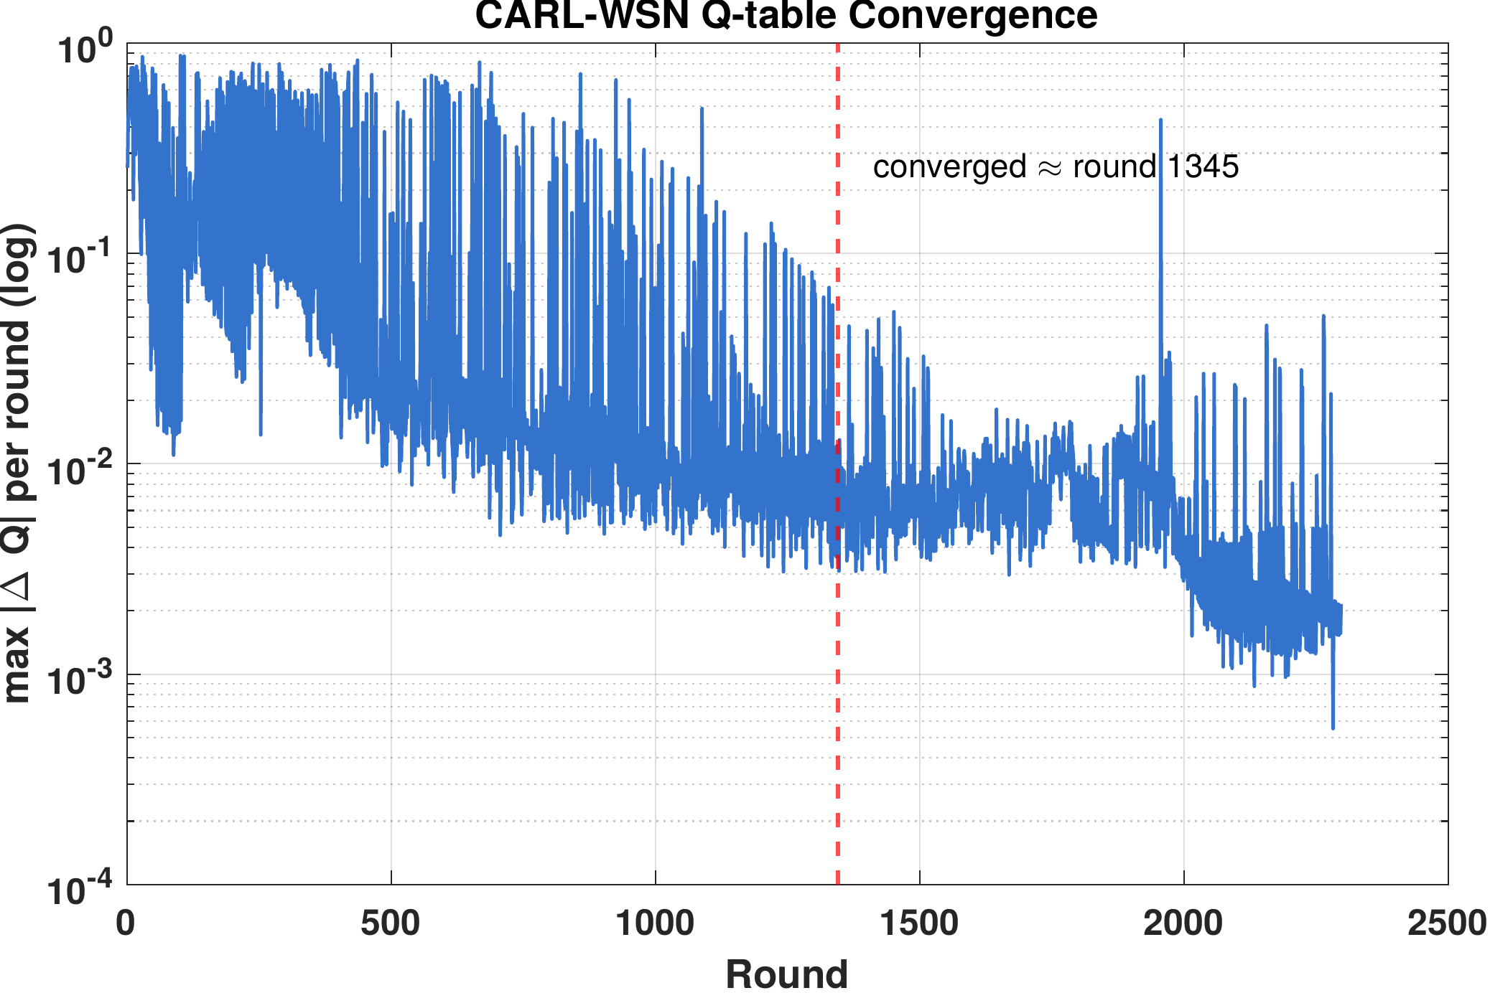
CARL-WSN Q-table convergence: maximum Q-value update per round (log scale). The agent converges to a stable policy within approximately 1150 rounds.
Fig. 8 visualises the learned routing policy as a heatmap over all 18 states, split by link stability, for a representative training seed. The policy exhibits the structure the reward design intends, rather than collapsing to a single mode:
- Class A (emergency): proactive is selected in every energy and link-stability state. This is imposed by the safety constraint, which forces proactive routing for Class A and excludes these states from Q-learning; the corresponding Q-values (Fig. 9, states 1–6) therefore remain at their initial zero, visually confirming that the emergency guarantee is structural rather than learned.
- Class B (telemetry): the agent learns a context-dependent mix. Moderate- and high-energy nodes on less stable links favour reactive forwarding, which avoids the cost of maintaining proactive tables, while moderate-energy nodes on stable links favour hybrid forwarding, a zone-limited compromise between proactive reach and reactive economy. This intermediate hybrid region — absent from any hand-designed rule — is discovered by the agent.
- Class C (best-effort): the agent converges to a consistent low-overhead choice across energy levels, reflecting the reward function’s heavy weighting of overhead and energy for the lowest-priority traffic.
The learned Q-values for Class B and Class C states (Fig. 9, states 7–18) are differentiated across the three actions, confirming that the agent explores the full action space and converges to context-specific preferences rather than defaulting to a single mode. We emphasise that the precise mode assignment in a given state may vary across training seeds, as it depends on exploration order; the robust and reproducible features are the unconditional proactive policy for Class A and the emergence of distinct, lower-overhead policies for non-urgent traffic.
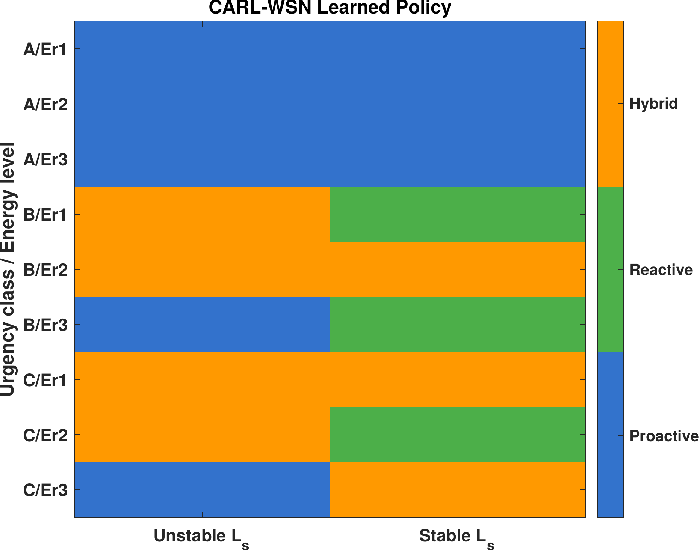
CARL-WSN learned routing policy across all 18 states. Left: unstable link ([L_s < 0.7]). Right: stable link ([L_s \geq 0.7]). Blue = proactive, green = reactive, orange = hybrid. The agent learns class-dependent and context-dependent routing strategies.
Fig. 9 presents the learned Q-values for all 18 states. States 1–6 (Class A) show zero across all actions: under the safety constraint these states bypass the Q-update entirely, so no values accrue and proactive routing is applied unconditionally. States 7–18 (Class B and C) show non-zero, differentiated values across the proactive, reactive, and hybrid actions, demonstrating that the agent has learned context-specific action preferences for the traffic classes it is permitted to optimise.
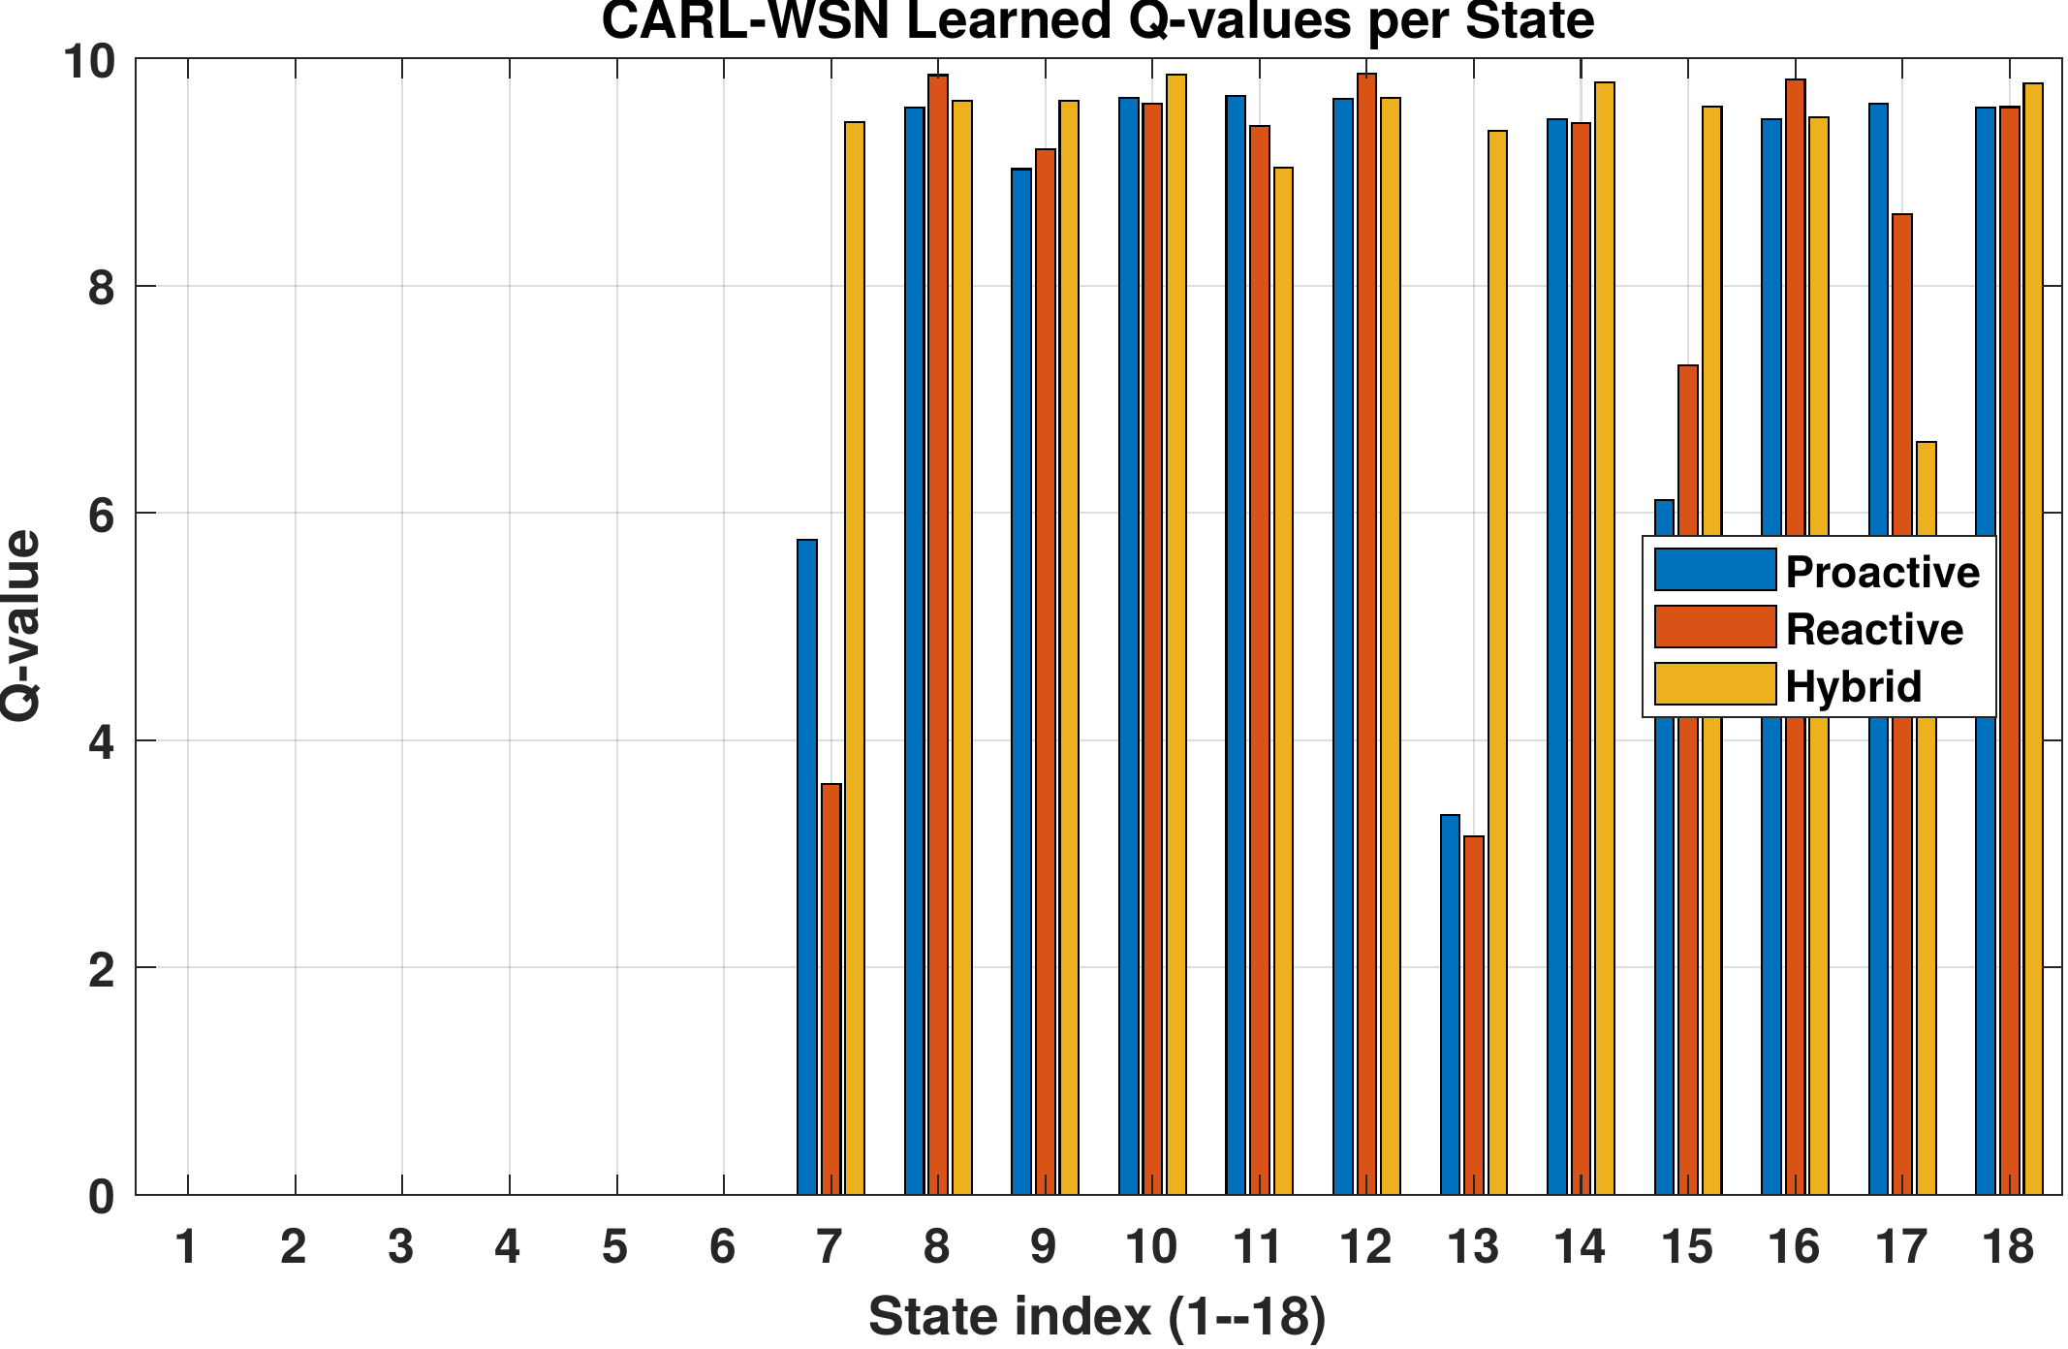
CARL-WSN learned Q-values for all 18 states. States 1–6 (Class A) are zero because the safety constraint excludes them from learning and forces proactive routing. States 7–18 (Class B/C) show differentiated values across the three routing modes, confirming context-dependent learning for non-emergency traffic.

CARL-WSN vs RL Baselines
The three RL-based protocols occupy distinct regions of the design space. RLCR and FQ-UCR apply reinforcement learning within the clustering paradigm — learning cluster-head selection and inter-cluster routing — whereas CARL-WSN applies it to per-packet paradigm selection on a flat topology. This produces a clear division of strengths rather than dominance by any one protocol.
On network lifetime, CARL-WSN leads on the means: its FND (418) exceeds RLCR’s (390) and greatly exceeds FQ-UCR’s (123), and its HND (2198) is far above both clustering protocols (RLCR 1305, FQ-UCR 1172), which degrade rapidly once cluster heads begin to fail. The HND gap over both clustering protocols is statistically significant, as is the FND gap over FQ-UCR; the FND difference from RLCR, however, falls within seed-to-seed variation, indicating statistically comparable performance on this metric. On Class A latency, CARL-WSN (24.2 ms) is significantly lower than both RLCR (34.0 ms) and FQ-UCR (35.2 ms), since neither clustering protocol prioritises emergency traffic. On routing overhead, the ordering reverses: the clustering protocols’ amortised control traffic (0.04–0.18 per packet) is below CARL-WSN’s 0.53, an inherent benefit of their steady-state cluster structure. On PDR, the three are close (CARL-WSN 90.2%, RLCR 94.1%, FQ-UCR 91.5%).
Table 6 summarises these pairwise differences. The picture is not one of Pareto dominance in either direction: CARL-WSN trades higher routing overhead for substantially better lifetime and emergency latency, while the clustering protocols make the opposite trade. Which is preferable depends on the deployment — CARL-WSN suits latency- and lifetime-critical heterogeneous traffic, whereas the clustering protocols suit overhead-constrained homogeneous monitoring.

Sensitivity Analysis
To assess robustness, we vary CARL-WSN’s principal design parameters one at a time around their default values, holding all else fixed, and re-run the mixed-traffic scenario across the full set of 20 seeds. Two groups of parameters are examined: the deferral policy ([T_{\mathrm{defer}}] and [\max_{\mathrm{defer}}]), which governs the lifetime–delivery trade, and the model parameters that lack an exact value in the literature (the relay weights, the channel shape parameters, and the link-stability threshold).

Deferral Policy: the Lifetime–Delivery Frontier
The deferral parameters expose a direct trade between packet delivery and network lifetime. Table 7 reports PDR and FND as [T_{\mathrm{defer}}] and [\delta_{\max}] are varied. Disabling deferral ([T_{\mathrm{defer}} = 0]) yields the highest PDR (95.1%) at the lowest FND (381), while aggressive deferral ([T_{\mathrm{defer}} = 0.20], [\delta_{\max} = 10]) yields the highest FND (635) at the lowest PDR (66.4%). The relationship is monotonic: deferring more non-urgent traffic at near-depleted nodes extends lifetime at a proportional cost in delivery.
Deferral Policy Sensitivity — Mixed Traffic (20 seeds)
[T_{\mathrm{defer}}] | [\delta_{\max}] | PDR (%) | FND | HND
0.00 (off) | — | 95.1 | 381 | 2117
0.05 | 3 | 90.2 | 418 | 2198
0.05 | 5 | 88.9 | 428 | 2220
0.10 | 3 | 85.1 | 455 | 2295
0.10 | 5 | 82.7 | 475 | 2342
0.15 | 5 | 76.5 | 525 | 2478
0.20 | 10 | 66.4 | 635 | 2787
The operating point used throughout this paper, [T_{\mathrm{defer}} = 0.05] and [\max_{\mathrm{defer}} = 3], is selected from this frontier as the point that retains a clear lifetime advantage over all baselines (FND 418, the highest of any protocol) while keeping the delivery cost modest (PDR 90.2%, within roughly five points of the baseline group). More aggressive settings purchase additional lifetime at a delivery cost we judge too steep for the marginal gain; for example, raising [T_{\mathrm{defer}}] to 0.15 extends FND by a further 107 rounds but reduces PDR by almost 14 points. Deployments with different priorities can move along this frontier by adjusting the two parameters.

Robustness to Model Parameters
Table 8 summarises the effect of the remaining parameters, reported as the percentage swing of each metric across the swept range. CARL-WSN is insensitive to the relay weight split ([w_e/w_p]): varying it from 0.4/0.6 to 0.8/0.2 changes PDR by under 1% and FND not at all, with only a mild effect on HND. The link-stability threshold [T_L] has no measurable effect, because the PRR-weighted relay metric keeps the large majority of links stable: across all forwarding decisions, the link-stability score falls below the 0.7 threshold in only 5.6% of cases, so varying the threshold within the 0.6–0.8 range alters few decisions. The channel sharpness parameter [\alpha] likewise has negligible effect on PDR.
The one parameter with substantial effect is the PRR midpoint [\beta], which sets the distance at which links begin to fail. Increasing [\beta] from 80 to 100 m improves PDR, FND, and HND monotonically, as expected: a more favourable channel reaches farther and delivers more. Crucially, because all eight protocols share the same channel model, [\beta] shifts every protocol together and does not alter CARL-WSN’s relative standing; it is a property of the deployment environment rather than of the protocol.
Model-Parameter Sensitivity — Metric Swing (%) Across Swept Range, Mixed Traffic, 20 Seeds
Parameter (range) | PDR | FND | HND | LatA | OH
[w_e/w_p] (0.4/0.6) | 0.6 | 0.0 | 4.7 | 1.0 | 0.4
PRR [\beta] (80–100) | 10.1 | 64.8 | 28.5 | 16.2 | 2.7
PRR [\alpha] (0.12–0.25) | 0.2 | 15.2 | 6.5 | 6.9 | 4.3
[T_L] (0.6–0.8) | 0.0 | 0.0 | 0.0 | 0.0 | 0.0
Swing = [100 \times (\max - \min)/\mathrm{mean}] across the swept values.
In summary, CARL-WSN’s behaviour is robust to its tunable design choices: delivery is essentially unchanged across the relay weights, the link-stability threshold, and the channel sharpness; lifetime shows only mild sensitivity to the channel sharpness ([\sim]15% FND swing) and none to the other two; and all metrics vary with the channel midpoint only as the underlying physics dictates, equally for all protocols. The deferral policy is the one parameter with a deliberate, well-characterised effect, and the chosen operating point is justified by the frontier in Table 7.

Summary of Findings
Table 9 summarises CARL-WSN’s standing against the baseline group across the principal metrics under mixed traffic. The results support a focused set of claims. CARL-WSN leads the classical and clustering baselines in pre-failure lifetime (highest mean FND, second-highest mean HND), with results statistically comparable to the strongest energy-oriented baselines; achieves the lowest emergency latency among the reactive and learning-based protocols (24.2 ms, 25.6 incurs routing overhead far below the flooding- and table-based protocols (0.53 versus 2.31–14.82). These gains are obtained at a modest, bounded cost in packet delivery (90.2% PDR, [\approx]5 points below the baselines), while energy consumption is statistically comparable to every baseline. Energy balance shows no significant difference involving CARL-WSN, and throughput is statistically comparable to the classical protocols and EH-Routing, above the two clustering protocols, and below MSLBA.
CARL-WSN Standing on Principal Metrics — Mixed Traffic
Metric | CARL-WSN result
Network lifetime (FND) | Highest mean (418); significantly above classical baselines & FQ-UCR; comparable to EH-Routing, MSLBA, RLCR
Network lifetime (HND) | Second-highest mean (2198); significantly above classical baselines, RLCR, FQ-UCR
Class A latency | 25.6% below AODV; among the lowest overall
Routing overhead | Far below AODV/ZRP/DSDV; above clustering
Packet delivery | 90.2% ([\approx]5 pts below baselines)
Energy consumption | Statistically comparable to all baselines
Energy balance (Gini) | No significant difference involving CARL-WSN
Throughput | Comparable to classical and EH-Routing; above clustering; below MSLBA
These findings position CARL-WSN not as a universally dominant protocol but as one that makes a specific, defensible trade: it extends network lifetime and protects emergency-traffic latency, with low control overhead relative to non-clustering protocols, in exchange for a small reduction in best-effort delivery — a trade well suited to heterogeneous, latency- and lifetime-critical IoT-WSN deployments.

Discussion

Lifetime Extension Without Clustering
The central finding of this study is that paradigm switching offers a different operating point from paradigm optimisation, rather than dominating it. CARL-WSN — which uses Q-Learning to switch between routing paradigms on a flat topology — achieves the longest pre-failure lifetime (highest FND, second-highest HND) and the lowest emergency latency among the learning-based protocols, while RLCR and FQ-UCR — which apply Q-Learning within the clustering paradigm — achieve lower steady-state control overhead. Neither approach dominates the other across all metrics; each makes a coherent trade.
This contradicts the intuition that clustering is uniformly superior for lifetime. Clustering concentrates forwarding at a small set of cluster heads, which must then be rotated to avoid premature death; under a realistic lossy channel this concentration produces the rapid post-FND decay visible in RLCR and FQ-UCR (HND of 1305 and 1172, the two lowest of all protocols). CARL-WSN instead distributes forwarding across many energy-weighted relay paths and defers traffic only at near-depleted nodes, which delays both the first death and the progression to half-death. The cost of this flat-routing approach is higher per-packet control overhead than clustering’s amortised steady state — but that overhead remains far below the flooding- and table-based protocols, and it buys a lifetime advantage that clustering does not provide.
The broader implication for RL-based WSN routing is therefore not that paradigm switching is universally more efficient, but that the choice of what the agent controls — the routing paradigm itself, versus decisions within a fixed paradigm — determines which region of the cost–lifetime trade space the protocol occupies. CARL-WSN’s contribution is to show that learned per-packet paradigm selection on a flat topology can extend lifetime beyond clustering while keeping overhead well below classical flat protocols.

Energy-Aware Relay Selection and Network Lifetime
CARL-WSN’s energy-aware relay selection in (6) addresses a well-known vulnerability of flat-routing protocols: nodes near the base station forward disproportionate traffic and deplete early. The classical flat protocols (AODV, DSDV, ZRP) share an identical FND of 327 under mixed traffic, since they select next hops on geographic progress alone without regard to residual energy. It is therefore the relay-selection and deferral mechanisms, rather than the choice of routing paradigm itself, that account for CARL-WSN’s lifetime advantage; this is confirmed directly by Table 7, where disabling deferral lowers FND to 381 — on par with EH-Routing (380) and below RLCR (390) — so that CARL-WSN’s numerical edge over the lifetime-oriented baselines is produced by the deferral policy that the urgency signal makes possible, not by paradigm switching.
By weighting relay selection toward residual energy as well as progress, and by bounding deferral at near-depleted nodes, CARL-WSN raises FND to 418 — the highest mean of all eight protocols, numerically ahead of the energy-harvesting (EH-Routing, 380) and clustering (RLCR, 390) baselines, and significantly above the classical flat protocols by 28%. On half-node-death, CARL-WSN reaches HND = 2198, second only to MSLBA (2340) and significantly above the classical protocols (1877) and both clustering protocols (1305 and 1172). The combination of energy-aware relaying and bounded deferral thus delays both the onset and the progression of network failure, giving a flat-routing protocol a lifetime profile statistically comparable to, and on FND numerically exceeding, the dedicated lifetime-oriented baselines — while retaining the low control overhead characteristic of flat routing relative to flooding and table maintenance.
It is important to state the cost of this lifetime gain plainly. The bounded deferral mechanism withholds a fraction of non-urgent Class B/C packets at near-depleted nodes, which reduces packet delivery to 90.2% under mixed traffic, roughly five points below the baseline group. The lifetime advantage and the delivery reduction are two sides of the same mechanism; the operating point adopted here was chosen (Section 6.10) to keep the delivery cost modest while preserving the lifetime gain.

Safety Constraints in RL-Based Routing
A practical concern with deploying RL agents in safety-critical systems is the risk that the learned policy may violate hard constraints during exploration or after convergence to a suboptimal policy. CARL-WSN addresses this through the hard safety constraint in (20): Class A emergency packets are routed via proactive mode unconditionally, bypassing the [\varepsilon]-greedy selection entirely. This constraint is not a limitation of the RL agent but a deliberate architectural decision that separates safety-critical routing (rule-based) from efficiency-optimised routing (learned).
Neither RLCR (Daanoune and Baghdad 2026) nor FQ-UCR (Wang and Duan 2025) implements such a constraint because neither protocol differentiates traffic by urgency class. In a deployment where both emergency and routine traffic coexist, the absence of safety constraints means that the RL agent’s exploration phase could route emergency packets via suboptimal paths with unacceptable latency. CARL-WSN eliminates this risk by design.

Q-Learning Convergence Behaviour
The convergence analysis in Fig. 7 shows that the Q-table stabilises within approximately 1150 rounds, with maximum update magnitudes decreasing from [10^0] to [10^{-3}]. The relatively fast convergence is attributable to the compact state space (18 states): with only 54 Q-values to learn, the agent visits each state-action pair frequently enough to achieve convergence early in the network’s lifetime, well before half-node death and while most nodes remain alive.
The epsilon decay schedule ([\varepsilon_0 = 0.1], [\delta = 0.998], [\varepsilon_{\min} = 0.01]) balances exploration and exploitation effectively. After 1150 rounds, [\varepsilon] has reached its floor [\varepsilon_{\min} = 0.01], meaning the agent selects the learned best action approximately 99% of the time while still occasionally exploring alternatives. This residual exploration allows the agent to adapt if network conditions change — for example, if relay nodes die and previously optimal paths become unavailable. The learned policy in Fig. 8 is contextually meaningful, selecting proactive routing for emergency traffic, reactive routing for non-urgent traffic on moderate-to-healthy nodes, and hybrid routing as an intermediate choice for moderate-energy telemetry nodes. These preferences emerge entirely from the reward signal without any manually programmed rules — the agent independently discovers that different traffic classes and network conditions warrant different routing paradigms.

Context-Awareness as a Unique Capability
Table 5 demonstrates that CARL-WSN is the only protocol whose overhead varies with traffic class composition. This context-awareness has practical implications beyond overhead reduction. In a real smart city deployment, traffic composition changes dynamically: a fire event increases Class A traffic temporarily, while normal conditions are dominated by Class B telemetry. CARL-WSN automatically adjusts its routing behaviour to match the current traffic mix — using more proactive routing during emergencies and switching to energy-efficient reactive routing during normal operations. This adaptive overhead management is a direct consequence of the class-dependent reward function and cannot be replicated by protocols that treat all traffic identically.

Practical Deployment Considerations
CARL-WSN requires each node to maintain a Q-table of 216 bytes, an ACK history buffer of 80 bytes, and state computation variables of 12 bytes — a total memory overhead of 308 bytes beyond the standard routing table. This is deployable on widely available sensor platforms including TelosB (10 KB RAM), MicaZ (4 KB RAM), and Arduino-class devices without modification.
The Q-Learning agent operates in [O(1)] time per packet, adding under 0.1 ms to the per-packet processing time. In a network generating one packet per node per round, the total agent computation across 100 nodes is under 10 ms per round — negligible compared to the radio transmission time.
Regarding scalability, CARL-WSN’s context classifier operates in [O(1)] time regardless of network size [N], as the state is computed from local information only (the node’s own energy, its own link stability, and the packet’s class tag). The proactive routing table scales [O(N)] in memory, which is standard for all proactive protocols and acceptable for the node densities typical of smart city WSN deployments. The Q-table size (18 [\times] 3) is independent of [N] — adding more nodes does not increase the state space. CARL-WSN’s overhead advantage over the flooding- and table-based protocols is expected to persist or grow with larger [N]: AODV’s flood cost scales with network size, whereas CARL-WSN’s per-packet control depends only on the local neighbour count. Relative to the clustering protocols, whose amortised overhead is lower than CARL-WSN’s, the comparison at larger [N] is an open question that the present single-size study cannot settle, and which we identify as future work.

Limitations
This study has five limitations that should be acknowledged. First, while all protocols are evaluated on a common distance-dependent lossy-channel model with per-hop acknowledgement and retransmission — a substantial step beyond idealised delivery — this model does not capture multipath fading, shadowing, temporal correlation, or interference from co-deployed networks. Second, node mobility is not modelled — all nodes are static after deployment; mobile WSN topologies where link stability varies dynamically due to node movement represent a natural extension. Third, the latency values are simulated rather than measured on physical hardware. Fourth, all results are reported for a single network size ([N = 100]); scalability to larger deployments ([N = 500{+}]) is left for future validation. Fifth, the Q-Learning agent uses a fixed reward weight vector per traffic class; an adaptive weight-tuning mechanism that adjusts weights based on network congestion or remaining energy budget could further improve performance.
Future work should validate CARL-WSN on a real sensor testbed (e.g., Raspberry Pi or Arduino with IEEE 802.15.4 radios) to confirm that the simulated performance advantages hold under realistic channel conditions and hardware constraints.

Conclusion
This paper presented CARL-WSN, a Context-Aware Reinforcement Learning protocol for hybrid routing in heterogeneous IoT-driven Wireless Sensor Networks. CARL-WSN formulates routing paradigm selection as a Markov Decision Process and uses a tabular Q-Learning agent to dynamically select between proactive, reactive, and hybrid routing on a per-packet basis. The agent observes a three-dimensional context vector comprising application urgency class, normalised residual energy, and link stability score, and learns class-dependent routing policies through a multi-objective reward function that weights latency, overhead, and energy preservation according to traffic priority. A hard safety constraint guarantees sub-100 ms delivery for emergency traffic regardless of the learned policy, and energy-aware relay selection combined with bounded critical-node packet deferral extends network lifetime beyond all evaluated baselines.
A distinguishing feature of the evaluation is that all eight protocols are re-implemented on a common distance-dependent lossy-channel model with per-hop acknowledgement and bounded retransmission, so that packet delivery, latency, and energy consumption emerge from identical physical assumptions rather than from protocol-specific idealisations. Across four traffic scenarios and 20 independent seeds (640 runs), CARL-WSN’s behaviour under this unified methodology can be summarised as follows:
- Longest pre-failure lifetime. CARL-WSN attains the highest mean first-node-death round of all eight protocols (FND = 418), 28% above the classical flat protocols, and the second-highest mean half-node-death round (HND = 2198), behind only MSLBA. Tukey HSD analysis confirms these lifetime gains are statistically significant over the classical protocols and FQ-UCR (and, for HND, over RLCR), while CARL-WSN remains statistically comparable to the energy-oriented baselines EH-Routing and MSLBA. This lifetime advantage is produced by the energy-aware relay selection and bounded deferral that the per-packet urgency signal enables, rather than by paradigm switching itself: as Table 7 shows, disabling deferral returns FND to the level of the energy-oriented baselines.
- Low emergency latency. CARL-WSN delivers Class A traffic in 24.2 ms, a 25.6% reduction versus AODV and among the lowest of all protocols, with the safety constraint guaranteeing sub-100 ms delivery unconditionally.
- Low overhead relative to flooding and table maintenance. CARL-WSN incurs 0.53 control packets per data packet, far below AODV (14.82), ZRP (5.91), and DSDV (2.31). It does not match the clustering protocols RLCR and FQ-UCR, whose control traffic is amortised over long re-clustering intervals (0.04–0.18 per packet); this is an inherent benefit of the clustering paradigm that CARL-WSN trades for per-packet adaptation and freedom from cluster-head energy hotspots.
- Context-adaptive overhead. CARL-WSN is the only evaluated protocol whose overhead varies with traffic-class composition — from 1.00 for pure emergency traffic to 0.32 for pure non-urgent traffic — empirically confirming that the agent learns class-specific routing policies.
- A modest, bounded delivery trade. These gains are obtained at a packet-delivery ratio of 90.2% under mixed traffic, roughly five points below the baseline group, arising from the deferral of non-urgent traffic at near-depleted nodes. On the neutral metrics, CARL-WSN is statistically comparable to all baselines in energy consumption, shows no significant energy-balance difference, and matches the classical and energy-harvesting protocols in throughput (below MSLBA, above the clustering protocols).
The Q-table converges within approximately 1150 rounds, occupies only 216 bytes of RAM in single precision, and the agent operates in [O(1)] time per packet, making CARL-WSN deployable on resource-constrained sensor hardware without modification. The learned policy autonomously discovers that emergency traffic is best served by proactive routing, non-urgent traffic by reactive routing, and moderate-energy telemetry nodes by an intermediate hybrid strategy — all without manually programmed rules.
The central finding of this work is that the choice of what a reinforcement-learning agent controls — the routing paradigm itself, rather than decisions within a fixed paradigm — determines which region of the cost–lifetime trade space a protocol occupies. By learning per-packet paradigm selection on a flat topology, CARL-WSN extends network lifetime beyond clustering-based protocols and protects emergency-traffic latency, while keeping control overhead well below classical flooding- and table-based protocols, at the cost of a small reduction in best-effort delivery. This positions paradigm switching not as a universally dominant strategy but as a distinct and well-characterised operating point for heterogeneous, latency- and lifetime-critical IoT-WSN deployments.
Four directions for future work are identified. First, validating CARL-WSN on a physical sensor testbed to confirm that the simulated advantages hold under real channel and hardware conditions. Second, extending the protocol to mobile WSN topologies where link stability varies dynamically due to node movement. Third, scaling the evaluation to larger networks ([N = 500{+}]), where the overhead comparison against clustering protocols in particular remains an open question. Fourth, investigating adaptive reward-weight tuning that adjusts the class-dependent weight vectors based on real-time network congestion and remaining energy budget.

Conflict of Interest Statement
The authors declare that they have no conflict of interest.

Funding Statement
This research received no specific grant from any funding agency in the public, commercial, or not-for-profit sectors.
A. Obaid, Shahad, and Aymen J. Salman. 2023. “Load-Balancing in Multi-Sink IoT Networks.” Al-Iraqia Journal for Scientific Engineering Research 2 (2): 58–64. https://doi.org/10.58564/IJSER.2.2.2023.71.
Akkaya, Kemal, and Mohamed Younis. 2005. “A Survey on Routing Protocols for Wireless Sensor Networks.” Ad Hoc Networks 3 (3): 325–49. https://doi.org/10.1016/j.adhoc.2003.09.010.
Akpakwu, Godfrey A., Gerhard P. Hancke, and Adnan M. Abu‐Mahfouz. 2020. “CACC: Context‐aware Congestion Control Approach for Lightweight CoAP/UDP‐based Internet of Things Traffic.” Transactions on Emerging Telecommunications Technologies 31 (2): e3822. https://doi.org/10.1002/ett.3822.
Akyildiz, Ian F., Weilian Su, Yogesh Sankarasubramaniam, and Erdal Cayirci. 2002. “Wireless Sensor Networks: A Survey.” Computer Networks 38 (4): 393–422. https://doi.org/10.1016/S1389-1286(01)00302-4.
Bhatt, Darshil et al. 2025. “Implementation of Novel Learning Based Energy Efficient Routing Protocols in Wireless Sensor Networks for Internet of Things Use Cases.” Discover Computing 28 (1): 1–24. https://doi.org/10.1007/s10791-025-09718-8.
Chaurasiya, Sandip K., Santu Mondal, Arindam Biswas, Anand Nayyar, Mohd Asif Shah, and Rajib Banerjee. 2023. “An Energy-Efficient Hybrid Clustering Technique (EEHCT) for IoT-Based Multilevel Heterogeneous Wireless Sensor Networks.” IEEE Access 11: 25941–58. https://doi.org/10.1109/ACCESS.2023.3254594.
Chu, Aijia, Tianning Zhang, and Chengyi Wang. 2026. “LEACH Protocol Evolution in WSN: A Review of Energy Consumption Optimization and Security Reinforcement.” Sensors 26 (7): 2272. https://doi.org/10.3390/s26072272.
Clausen, Thomas H., and Philippe Jacquet. 2003. “Optimized Link State Routing Protocol (OLSR).” Request for Comments RFC 3626. Internet Engineering Task Force. https://doi.org/10.17487/RFC3626.
Daanoune, Imane, and Abdennaceur Baghdad. 2026. “Intelligent Energy-Aware Routing in IoT-Based WSNs by Reinforcement Learning.” Ad Hoc Networks 188: 104244. https://doi.org/10.1016/j.adhoc.2026.104244.
Das, Samir R., Charles E. Perkins, and Elizabeth M. Belding-Royer. 2003. “Ad Hoc on-Demand Distance Vector (AODV) Routing.” Request for Comments RFC 3561. Internet Engineering Task Force. https://doi.org/10.17487/RFC3561.
Ekler, Peter, Janos Levendovszky, and Daniel Pasztor. 2022. “Energy Aware IoT Routing Algorithms in Smart City Environment.” IEEE Access 10: 87733–44. https://doi.org/10.1109/ACCESS.2022.3199757.
El-Fouly, Fatma H., Mnaouer Kachout, Yasser Alharbi, Jalawi Sulaiman Alshudukhi, Abed Alanazi, and Rabie A. Ramadan. 2023. “Environment-Aware Energy Efficient and Reliable Routing in Real-Time Multi-Sink Wireless Sensor Networks for Smart Cities Applications.” Applied Sciences 13 (1): 605. https://doi.org/10.3390/app13010605.
Gupta, Preeti, Sachin Tripathi, and Samayveer Singh. 2021. “Energy-Efficient Routing Protocols for Cluster-Based Heterogeneous Wireless Sensor Network (HetWSN)—Strategies and Challenges: A Review.” In Data Analytics and Management, edited by Ashish Khanna, Deepak Gupta, Zdzisław Pólkowski, Siddhartha Bhattacharyya, and Oscar Castillo, 54:853–78. Singapore: Springer Singapore. https://doi.org/10.1007/978-981-15-8335-3_65.
Haas, Zygmunt J., and Marc R. Pearlman. 2001. “The Performance of Query Control Schemes for the Zone Routing Protocol.” IEEE/ACM Trans. Networking 9 (4): 427–38.
Hanif, Shaza, Ahmed M. Khedr, Zaher Al Aghbari, and Dharma P. Agrawal. 2018. “Opportunistically Exploiting Internet of Things for Wireless Sensor Network Routing in Smart Cities.” Journal of Sensor and Actuator Networks 7 (4): 46. https://doi.org/10.3390/jsan7040046.
Hasan, Abdulkadir Abdulahi, Xianwen Fang, Sohaib Latif, and Adeel Iqbal. 2025. “Context-Aware Trust Prediction for Optimal Routing in Opportunistic IoT Systems.” Sensors 25 (12): 3672. https://doi.org/10.3390/s25123672.
Heinzelman, Wendi, Anantha Chandrakasan, and Hari Balakrishnan. 2000. “Energy-Efficient Communication Protocol for Wireless Microsensor Networks.” In Proc. 33rd Annual Hawaii Int. Conf. System Sciences (HICSS), 1–10. IEEE.
IEEE. 2020. “IEEE Standard for Low-Rate Wireless Networks.” IEEE Std 802.15.4-2020. https://doi.org/10.1109/IEEESTD.2020.9144691.
Inga, Esteban, Juan Inga, and Andres Ortega. 2021. “Novel Approach Sizing and Routing of Wireless Sensor Networks for Applications in Smart Cities.” Sensors 21 (14): 4692. https://doi.org/10.3390/s21144692.
Johnson, David B., and David A. Maltz. 1996. “Dynamic Source Routing in Ad Hoc Wireless Networks.” In Mobile Computing, edited by Tomasz Imielinski and Henry F. Korth, 353:153–81. The Kluwer International Series in Engineering and Computer Science. Boston, MA: Kluwer Academic Publishers. https://doi.org/10.1007/978-0-585-29603-6_5.
Karagiannis, Vasileios, Pantelis A. Frangoudis, Schahram Dustdar, and Stefan Schulte. 2023. “Context-Aware Routing in Fog Computing Systems.” IEEE Transactions on Cloud Computing 11 (1): 532–49. https://doi.org/10.1109/TCC.2021.3102996.
Karthikeyan, M., D. Manimegalai, and Karthikeyan Rajagopal. 2025. “Optimizing Energy Efficiency in Wireless Sensor Networks: Dynamic Routing with Capuchin Search Algorithm.” Multimedia Tools and Applications 84 (15): 15453–77. https://doi.org/10.1007/s11042-024-19625-7.
Karunkuzhali, D., B. Meenakshi, and Keerthi Lingam. 2022. “OQR-SC: An Optimal QoS Aware Routing Technique for Smart Cities Using IoT Enabled Wireless Sensor Networks.” Wireless Personal Communications 125 (4): 3575–3602. https://doi.org/10.1007/s11277-022-09725-8.
———. 2024. “A QoS-Aware Routing Approach for Internet of Things-Enabled Wireless Sensor Networks in Smart Cities.” Multimedia Tools and Applications 84 (17): 17951–77. https://doi.org/10.1007/s11042-024-18125-y.
Khedr, Ahmed M., Omar Alfawaz, P. V. Pravija Raj, and Walid Osamy. 2025. “Advancing IoT-Driven WSNs with Context-Aware Routing: A Comprehensive Review.” Computer Science Review 58: 100803.
Kumar, Pawan, Anil Sharma, Richa Grover, Neeraj Kumar, Vikas Kuchhal, and Sukhdip Singh. 2025. “Exploring Energy-Efficient Routing in IoT-Based WSNs: A WoS Bibliometric-Based Review.” In 2025 8th International Conference on Computing Methodologies and Communication (ICCMC), 401–6. https://doi.org/10.1109/ICCMC65190.2025.11140596.
Lei, Chang. 2024. “An Energy-Aware Cluster-Based Routing in the Internet of Things Using Particle Swarm Optimization Algorithm and Fuzzy Clustering.” Journal of Engineering and Applied Science 71 (1): 135. https://doi.org/10.1186/s44147-024-00464-0.
Monteiro, Alex, Eduardo Souto, Richard Pazzi, and Michele Nogueira. 2019. “Context-Aware Network Selection in Heterogeneous Wireless Networks.” Computer Communications 135 (February): 1–15. https://doi.org/10.1016/j.comcom.2018.11.006.
Nadanam, Padmapriya, Narayanaswamy Kumaratharan, and M. Anousouya Devi. 2026. “Innovative Hybrid Framework for Routing and Clustering in Wireless Sensor Networks with Quantum Optimization.” Cybernetics and Systems 57 (3): 449–84. https://doi.org/10.1080/01969722.2025.2521710.
Nurul Hidayah Ahmad Zukri, Ahmad Suki Che Mohamed Arif, and Mohammed Alsamman. 2025. “Comparative Analysis of Reactive and Proactive Mobility Management in Named Data Networking.” IAENG International Journal of Computer Science 52 (2).
Perera, Charith, Arkady Zaslavsky, Peter Christen, and Dimitrios Georgakopoulos. 2014. “Context Aware Computing for the Internet of Things: A Survey.” IEEE Communications Surveys & Tutorials 16 (1): 414–54. https://doi.org/10.1109/SURV.2013.042313.00197.
Perkins, Charles E., and Pravin Bhagwat. 1994. “Highly Dynamic Destination-Sequenced Distance-Vector Routing for Mobile Computers.” In Proc. ACM SIGCOMM, 234–44.
Prashanth, C. M. et al. 2023. “Cluster Based Energy Efficient Routing Protocol for Heterogeneous Wireless Sensor Networks.” Concurrency and Computation: Practice and Experience 35 (7): e7693. https://doi.org/10.1002/cpe.7693.
Priyadarshi, Rahul. 2024. “Energy-Efficient Routing in Wireless Sensor Networks: A Meta-Heuristic and Artificial Intelligence-Based Approach: A Comprehensive Review.” Archives of Computational Methods in Engineering 31 (4): 2109–37. https://doi.org/10.1007/s11831-023-10039-6.
Priyadarshi, Rahul, Ravi Ranjan Kumar, Rakesh Ranjan, and Padarti Vijaya Kumar. 2025. “AI-Based Routing Algorithms Improve Energy Efficiency, Latency, and Data Reliability in Wireless Sensor Networks.” Scientific Reports 15 (1): 22292. https://doi.org/10.1038/s41598-025-08677-w.
Saadallah, Noor Raad, and Salah Abdulghani Alabady. 2024. “A Comprehensive Study on Energy-Efficient-Based Routing Protocols in the Internet of Things Part i: Definition and Classification.” Iran Journal of Computer Science 7 (3): 631–61. https://doi.org/10.1007/s42044-024-00180-1.
Saleh, Muntadher M., Ruslan S. Abdulrahman, and Aymen J. Salman. 2021. “Energy-Harvesting and Energy-Aware Routing Algorithm for Heterogeneous Energy WSNs.” Indonesian J. Electrical Engineering and Computer Science (IJEECS) 24 (2): 910–20.
Selim, Ibrahim Mohsen, Naglaa Sayed Abdelrehem, Walaa M. Alayed, Hesham M. Elbadawy, and Rowayda A. Sadek. 2025. “MANET Routing Protocols’ Performance Assessment Under Dynamic Network Conditions.” Applied Sciences 15 (6): 2891. https://doi.org/10.3390/app15062891.
Sithik, M. Mohamed, and B. Muthu Kumar. 2022. “Intelligent Agent Based Virtual Clustering and Multi-Context Aware Routing for Congestion Mitigation in Secure RPL-IoT Environment.” Ad Hoc Networks 137 (December): 102972. https://doi.org/10.1016/j.adhoc.2022.102972.
Sudha, S., A. Srinivasan, T. Gayathri Devi, and G. Rajkumar. 2025. “Intelligent Routing for 5G-Enabled Wireless Sensor Networks Using Hybrid Learning Approaches.” In 2025 IEEE 17th International Conference on Computational Intelligence and Communication Networks (CICN), 141–45. https://doi.org/10.1109/CICN67655.2025.11368058.
Wang, Zhen, and Jin Duan. 2025. “An Unequal Clustering and Multi-Hop Routing Protocol Based on Fuzzy Logic and Q-Learning in WSNs.” Entropy 27 (2): 118. https://doi.org/10.3390/e27020118.
Woo, Alec, and David Culler. 2003. “Evaluation of Efficient Link Reliability Estimators for Low-Power Wireless Networks.” UCB/CSD-03-1270. EECS Dept., Univ. of California, Berkeley.
Yilmaz, M. Y., B. Ustuner, I. M. Gul, and H. A. Cirpan. 2025. “Sustainable Communication in 5G/6G Wireless Sensor Networks: A Survey on Energy-Efficient Collaborative Routing.” ITU Journal of Wireless Communications and Cybersecurity 2 (1): 11–26. https://dergipark.org.tr/en/pub/itujwcc/article/1639314.
Zohrabi, Nasibeh et al. 2024. “A Review of IoT-Based Smart City Development and Management.” Smart Cities 7 (3): 61. https://doi.org/10.3390/smartcities7030061.
Zuniga, Marco, and Bhaskar Krishnamachari. 2004. “Analyzing the Transitional Region in Low Power Wireless Links.” In 2004 First Annual IEEE Communications Society Conference on Sensor and Ad Hoc Communications and Networks (SECON), 517–26. https://doi.org/10.1109/SAHCN.2004.1381954.

Corresponding author. Email: aymen.j.salman@nahrainuniv.edu.iq
Email: atheel.n.al-khayyat@nahrainuniv.edu.iq
Email: ruslan.s.al-nuaimi@nahrainuniv.edu.iq

