Taking 32000 images for training and 8000 images for testing from MNIST dataset and a single hidden layer containing 5000 hidden nodes.

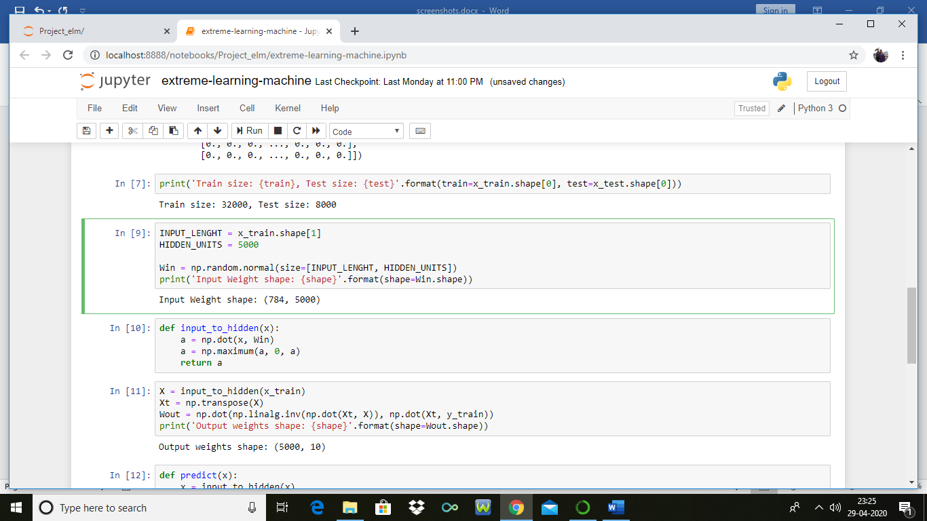

Accuracy obtained: 96.8 %

Sample Output:

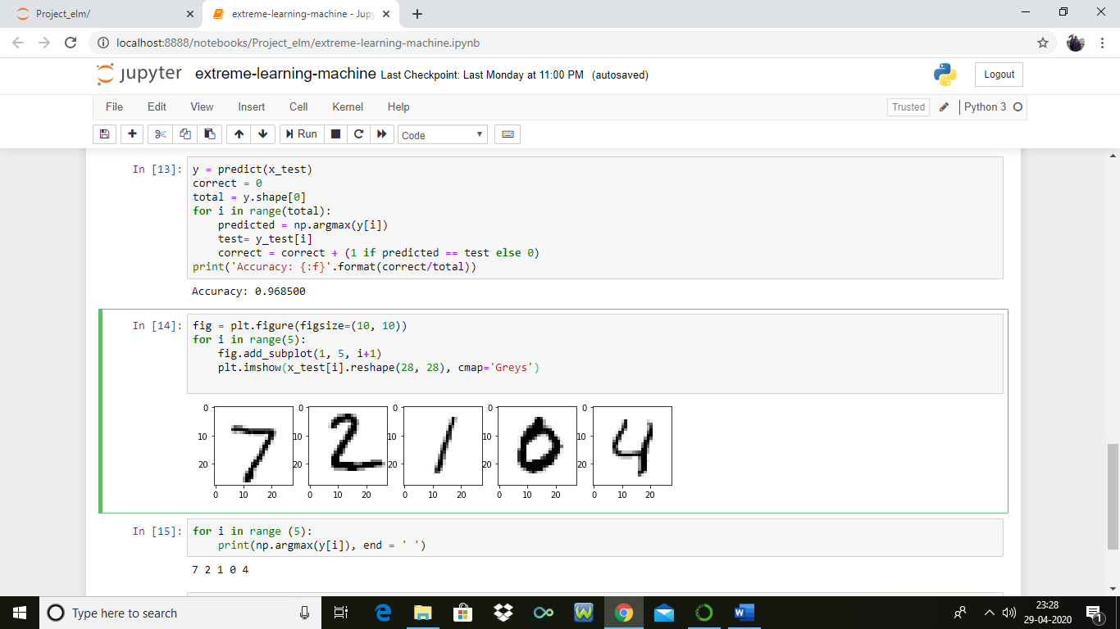

QPSO Implementation to generate 50 \* 784 values

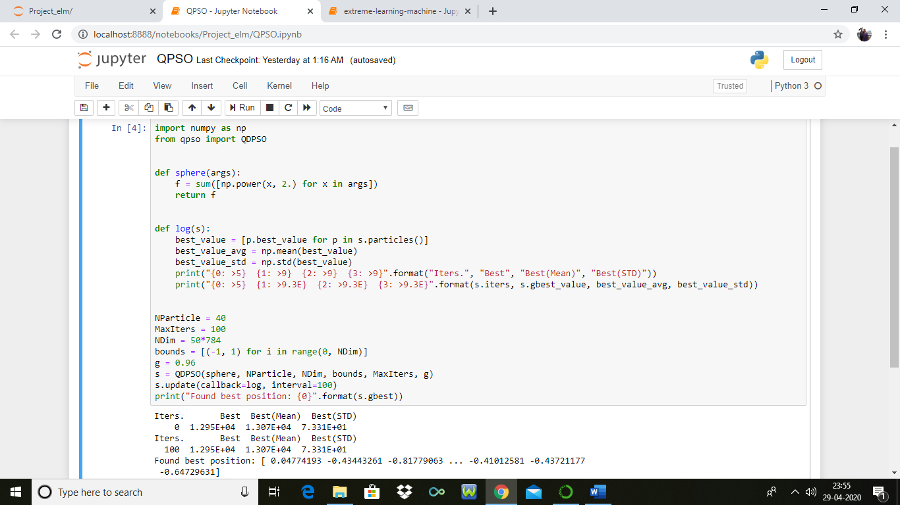

Saving the values obtained in csv file

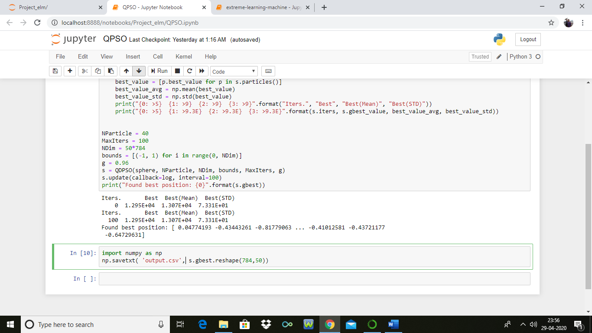

Taking the values form CSV file and inserting in 2D weight matrix:

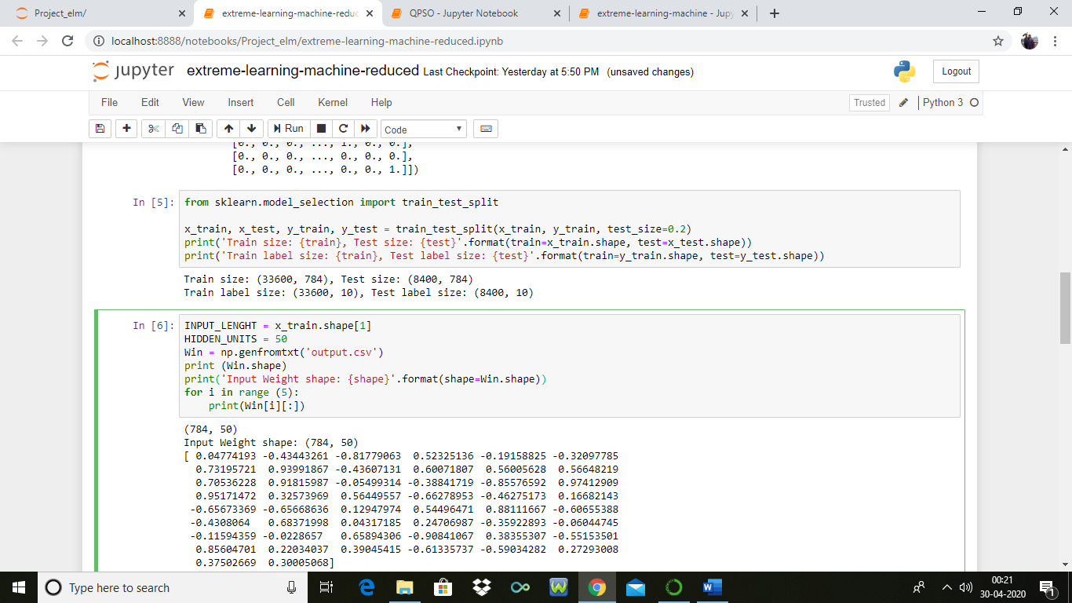

Taking 50 nodes in single hidden layer and using QPSO accuracy obtained: 73.32 %

