JAMC Devs

Members:

Sevilla, Marc Roger

Uson, Ayn

Dungog, Clarisse

Gonzaga, Johncel

Project Link via GitHub:<https://github.com/MrSevilla1022/ecommerce-ite5.git>

Presentation Video Link: [https://drive.google.com/file/d/1PfoOIy_rFSqK6sOK8hip62Aw5P2gnct/view?usp=sharing](https://drive.google.com/file/d/1PfoOIy_rFSqK6sOK8hip62A-w5P2gnct/view?usp=sharing)

User Interface Screenshots:

ADMIN SIDE

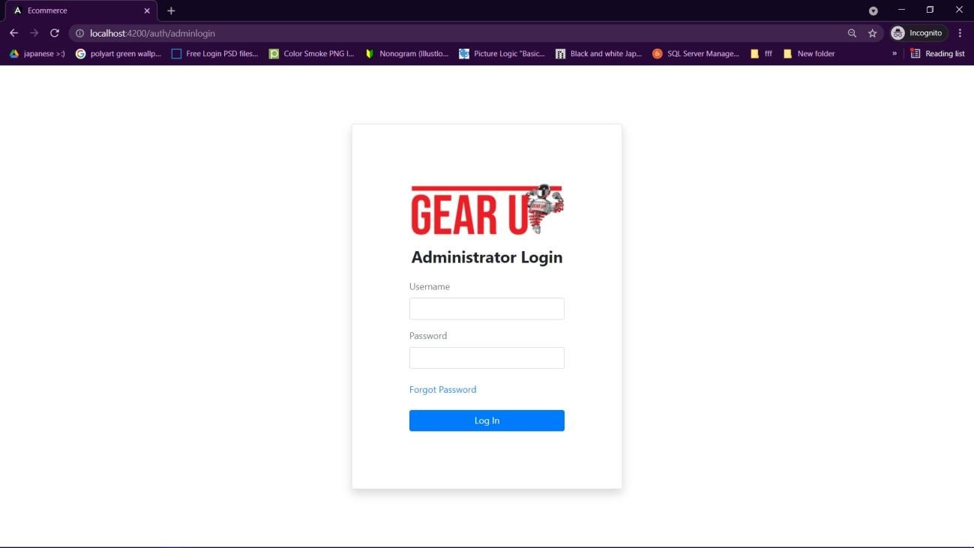

Admin Login Screen

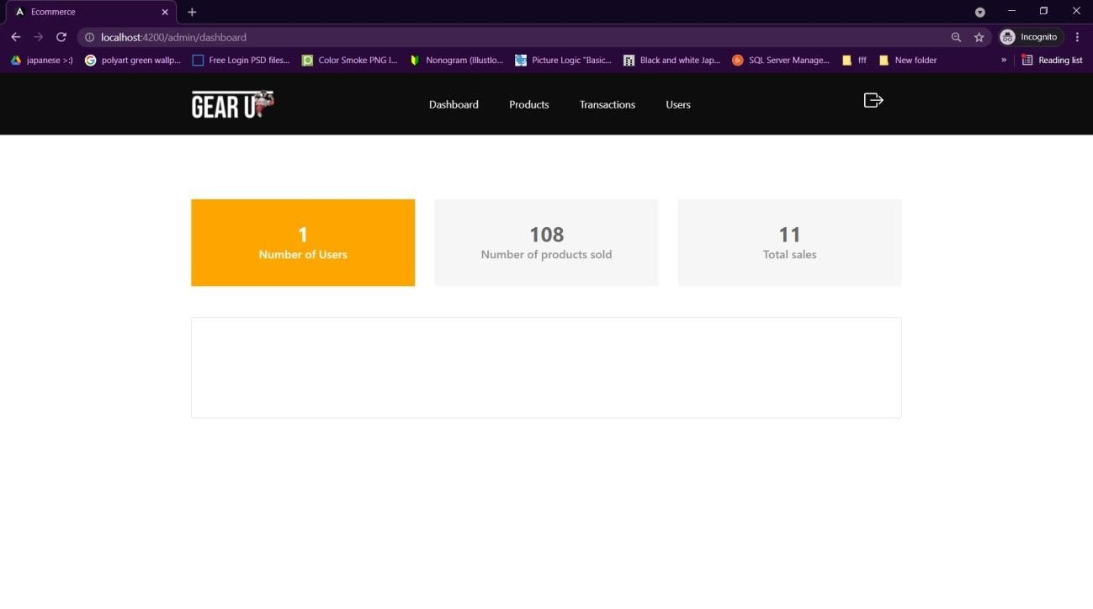

Dashboard

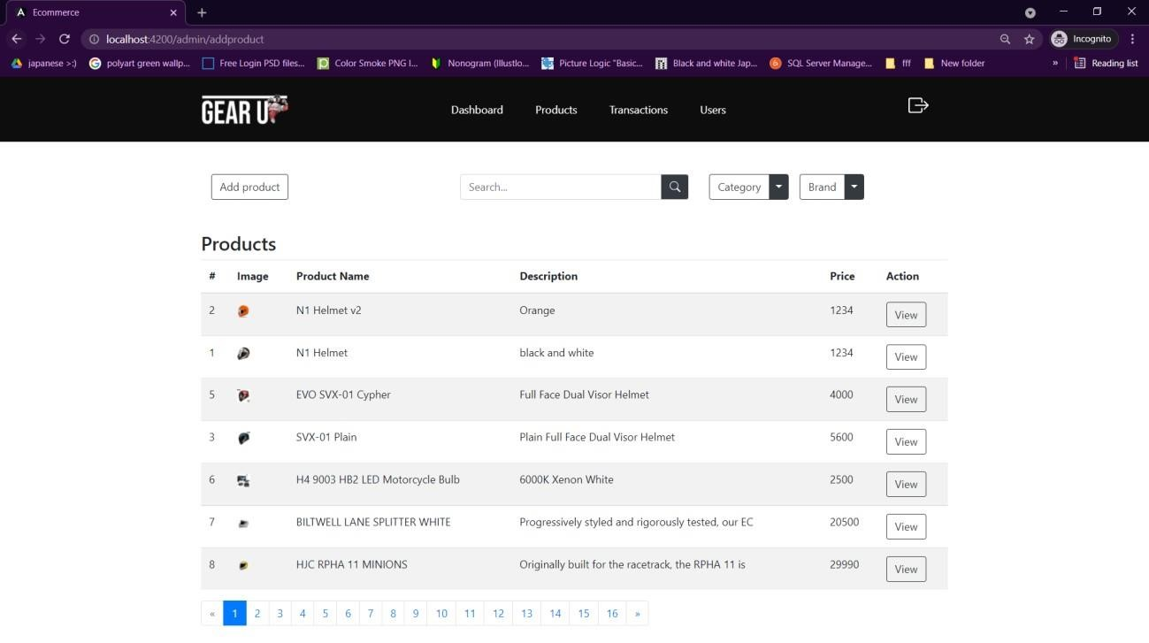

Products Table

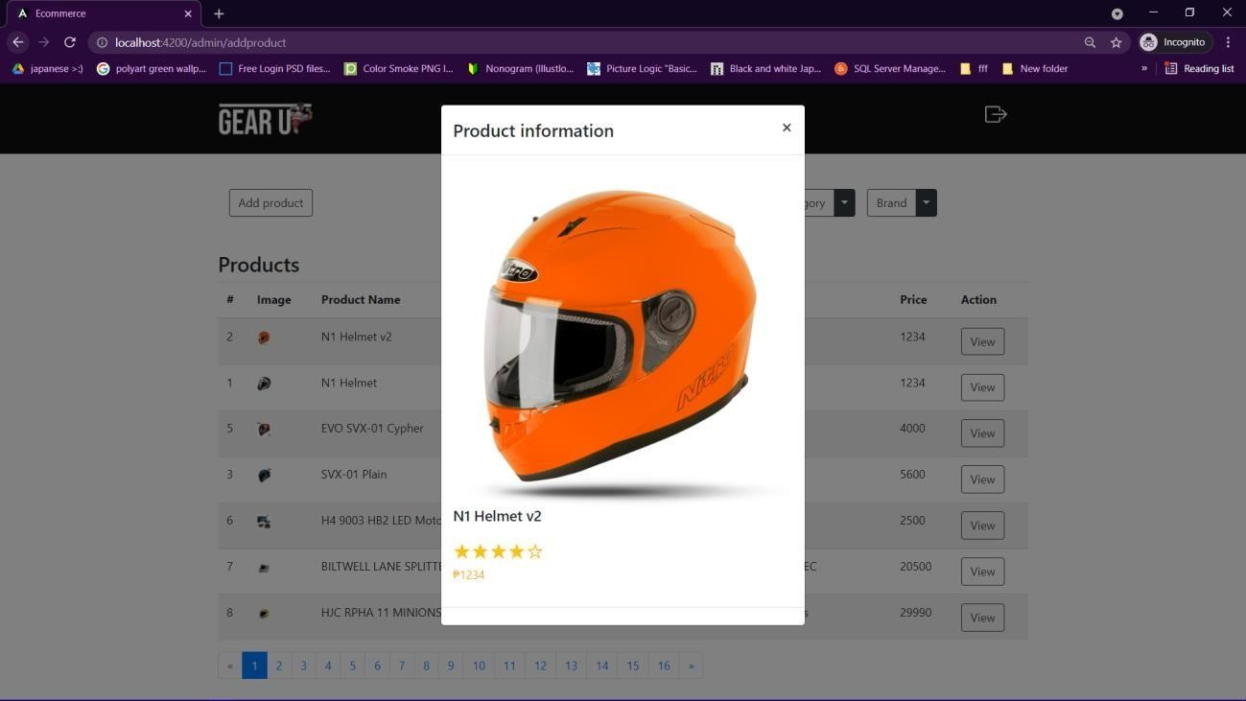

View Product Modal

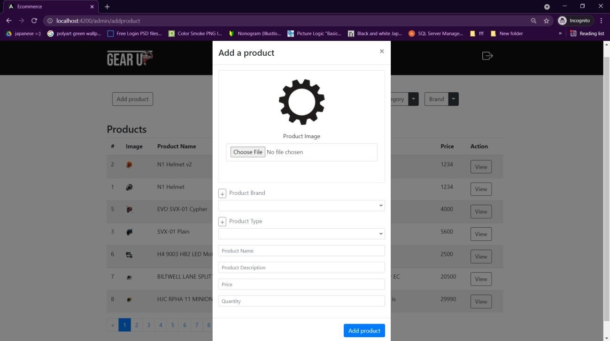

Add Product Modal

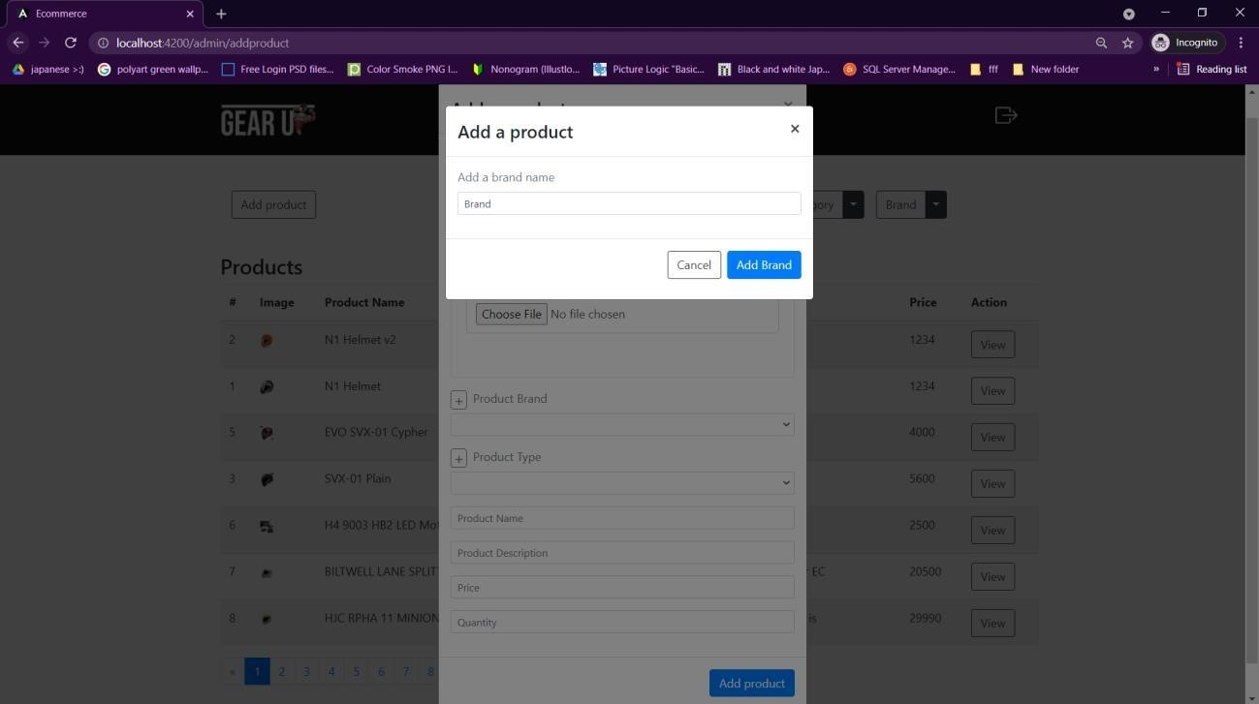

Add Product Brand Modal

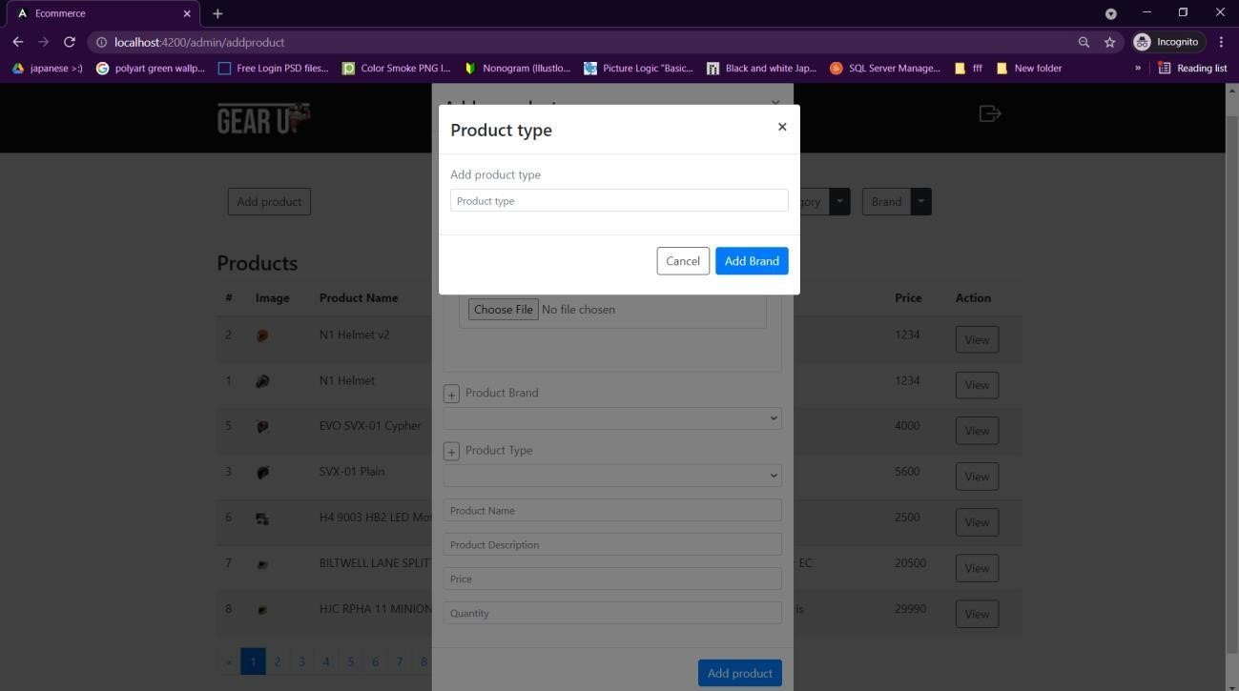

Add Product Category Modal

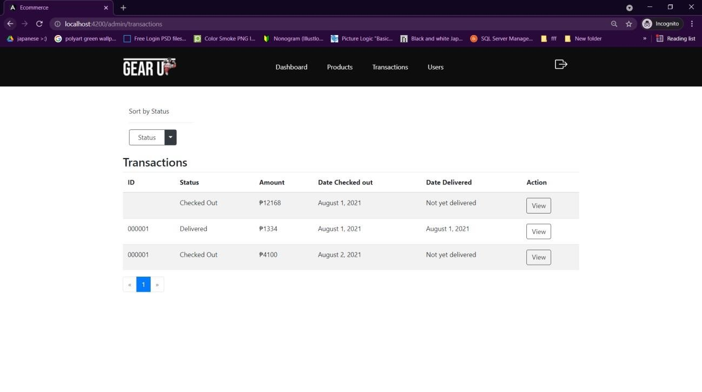

Transactions Table

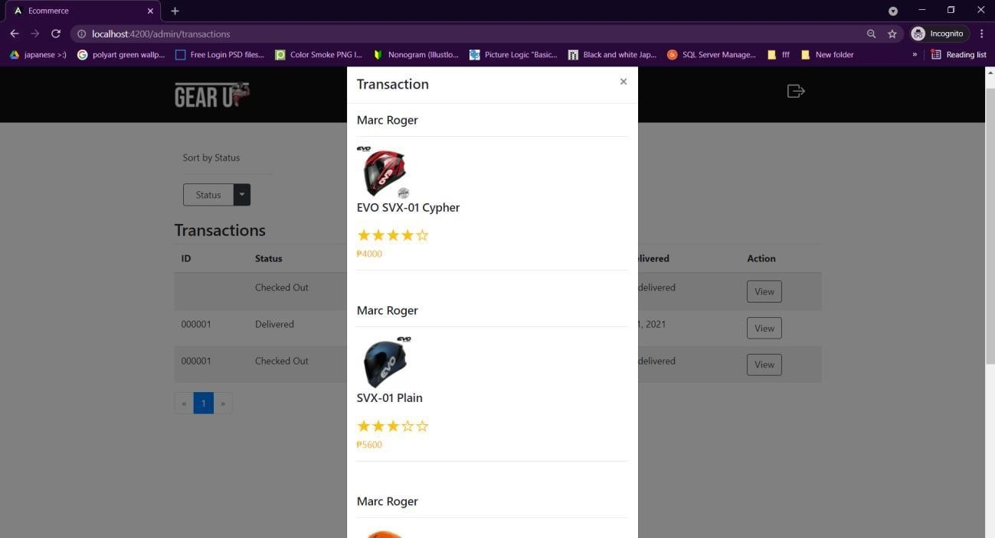

View Transaction Modal

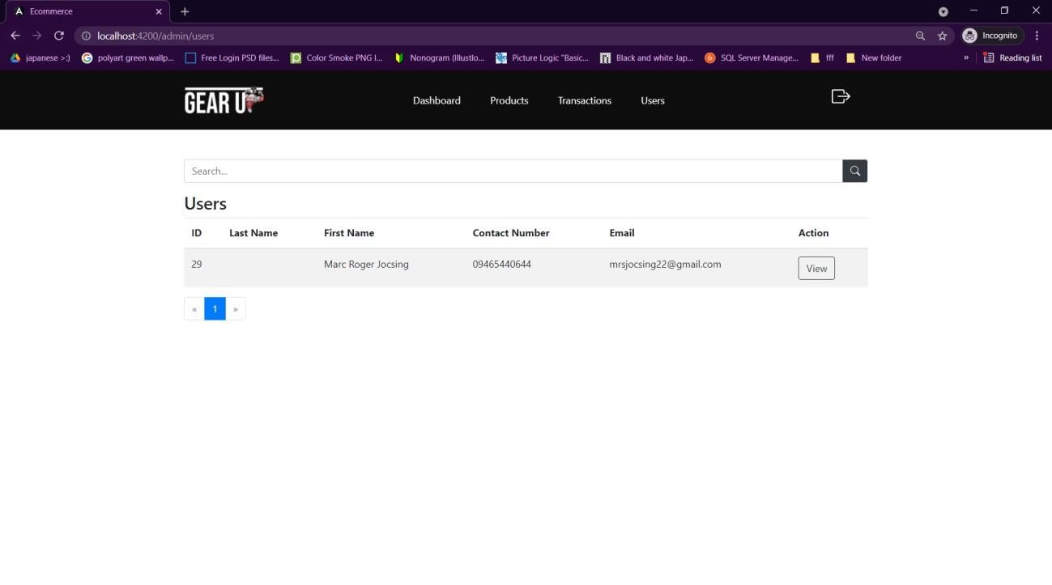

Users Table

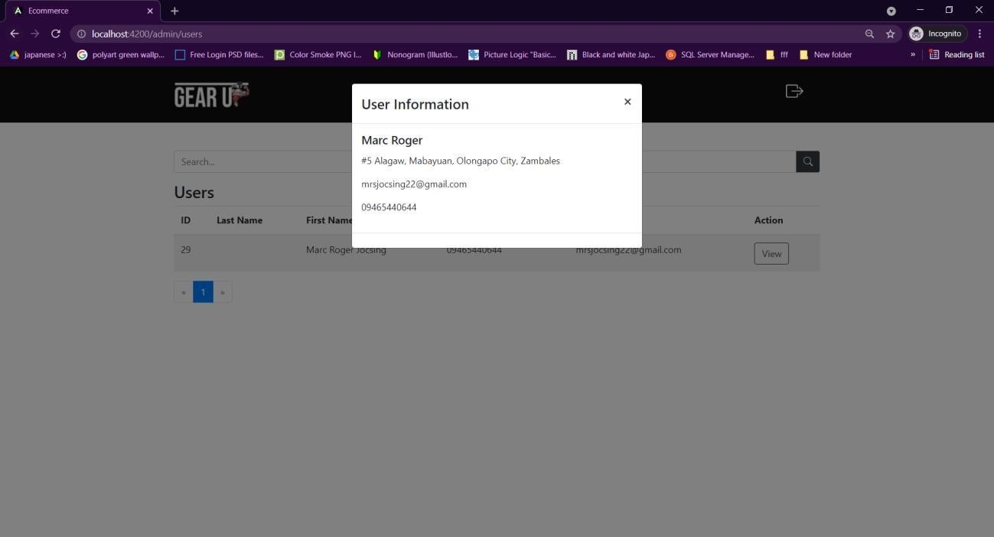

View User Modal

USER SIDE

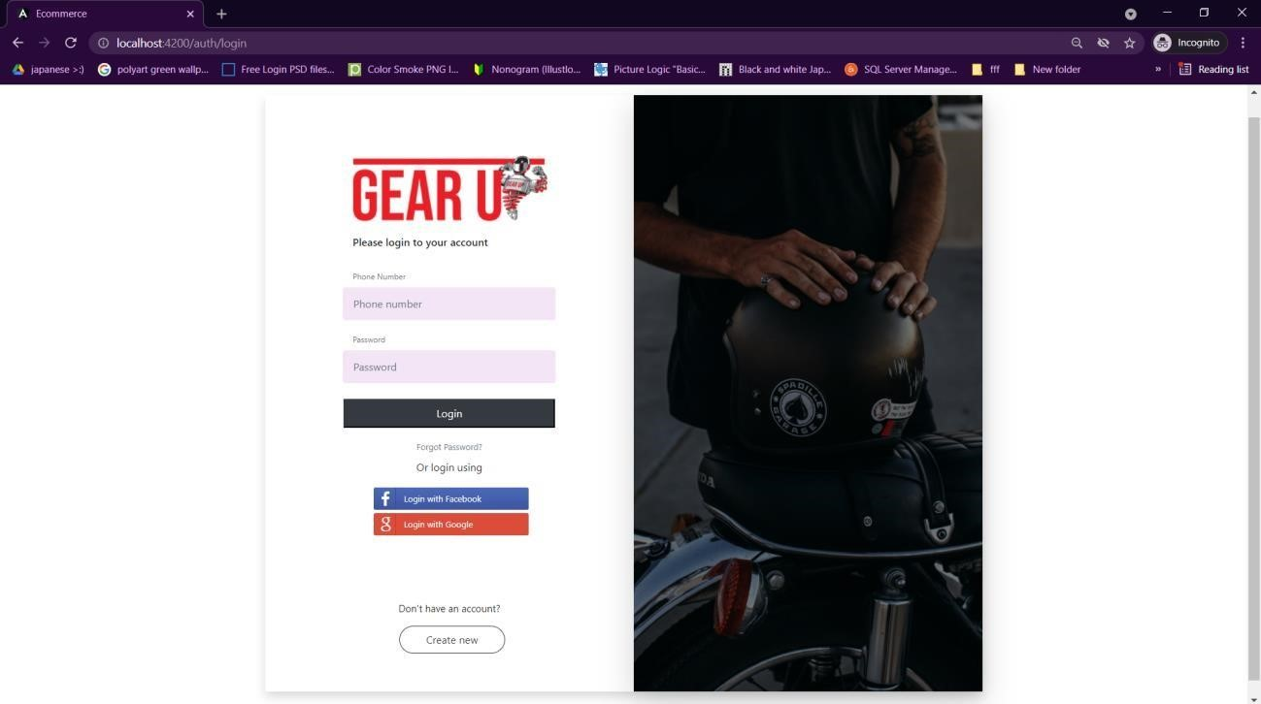

User Login Screen

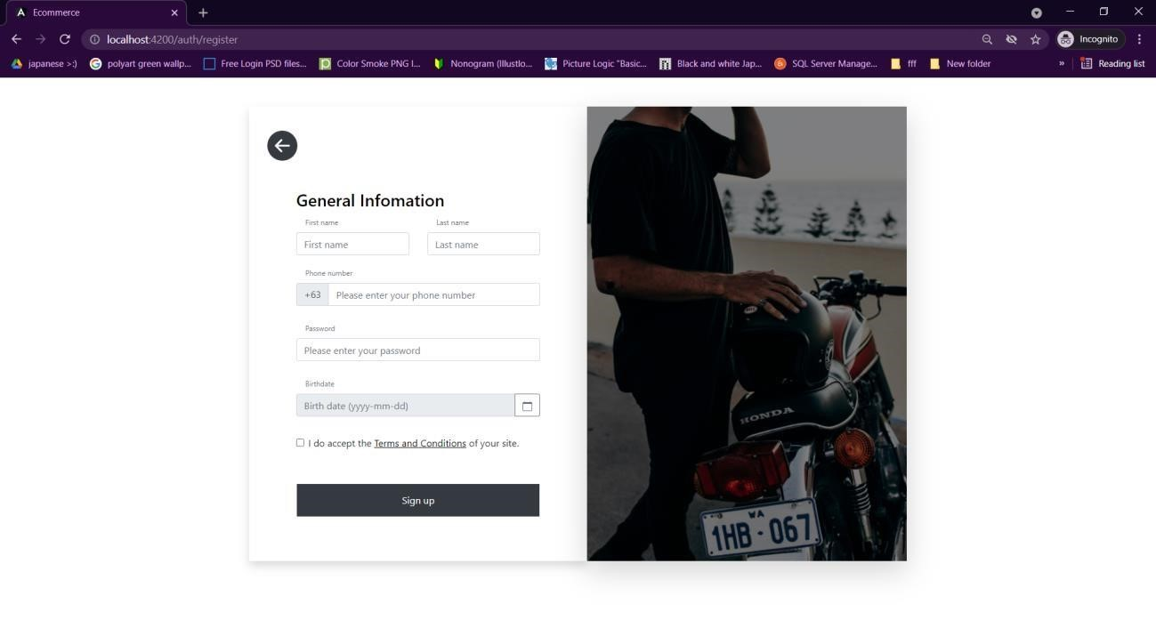

Create Account/Register Screen

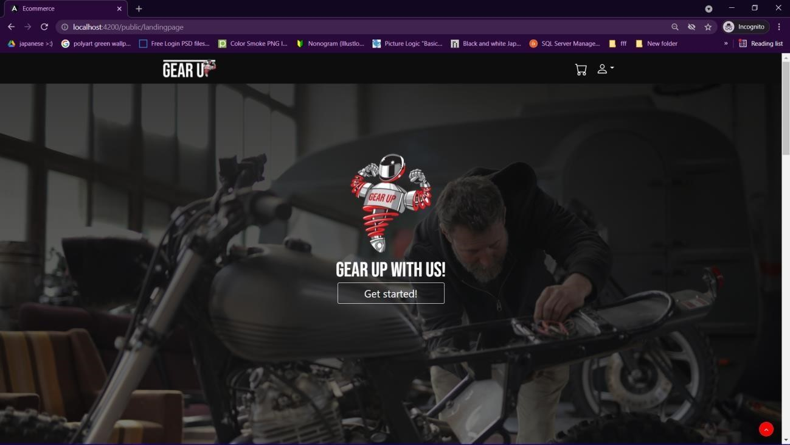

Landing Page – Banner & Navigation Bar

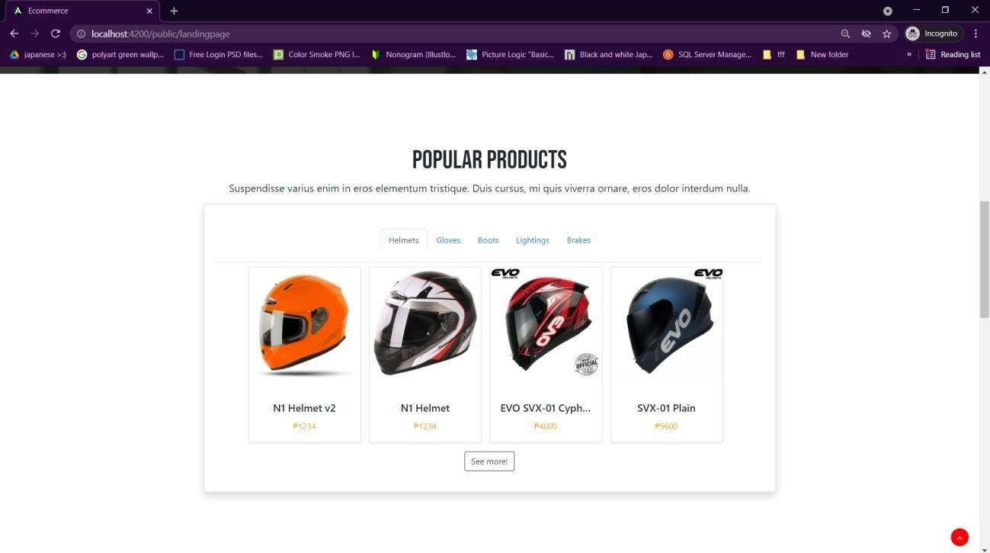

Landing Page – Popular Products Section

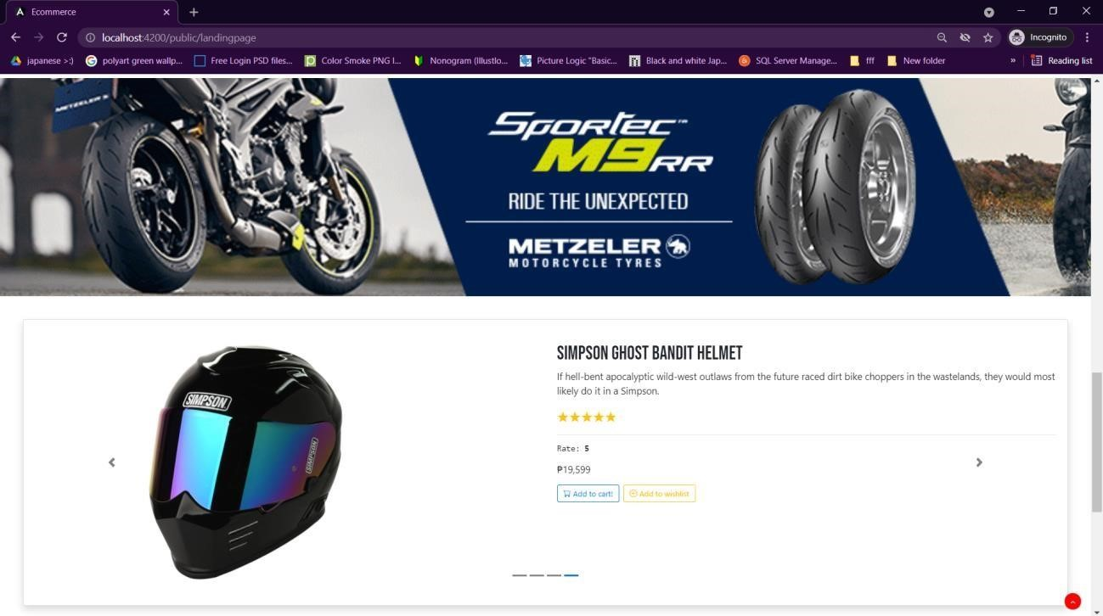

Landing Page – Ads and Carousel Section

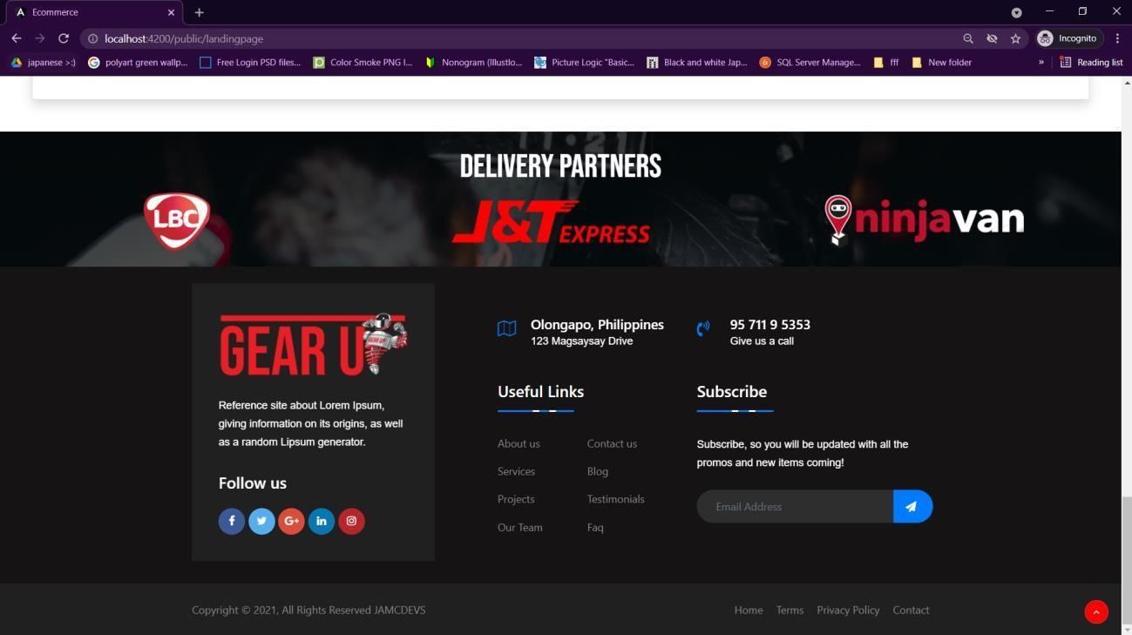

Landing Page – Delivery Partners Section and Footer

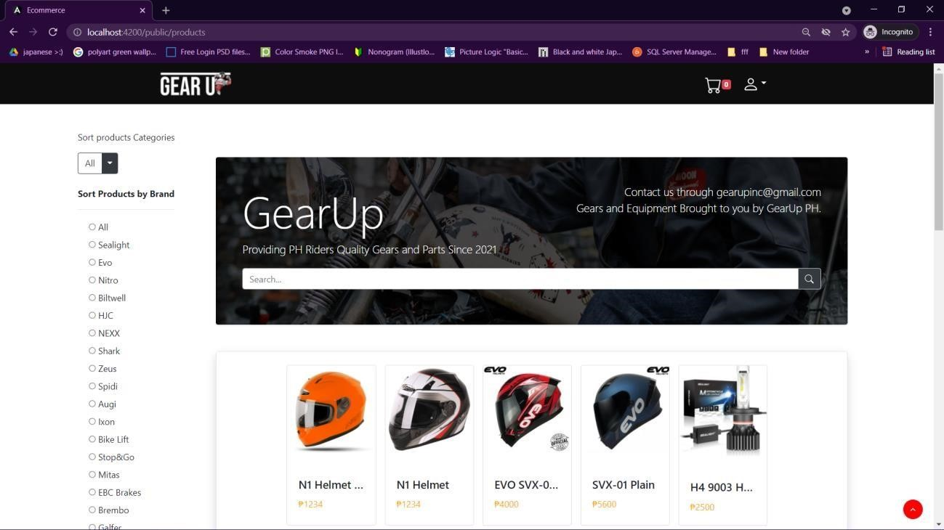

Products Page

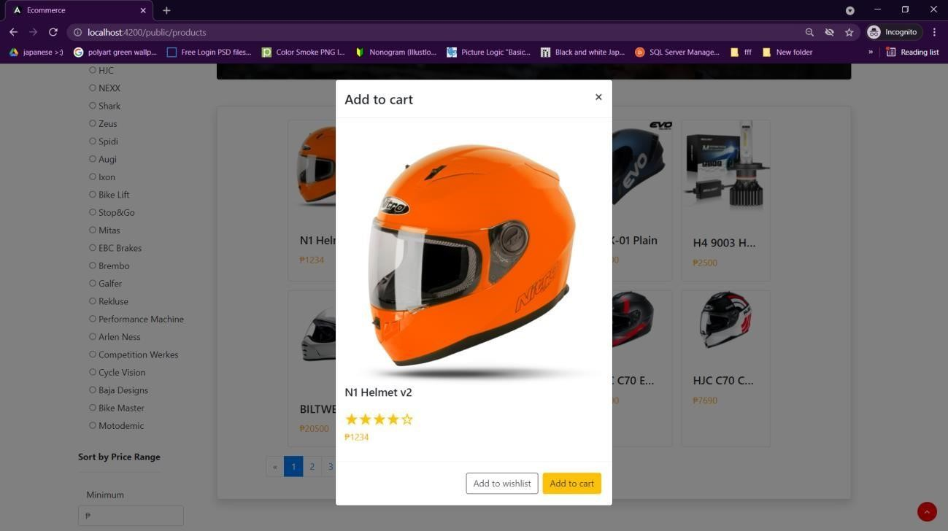

View Product Modal

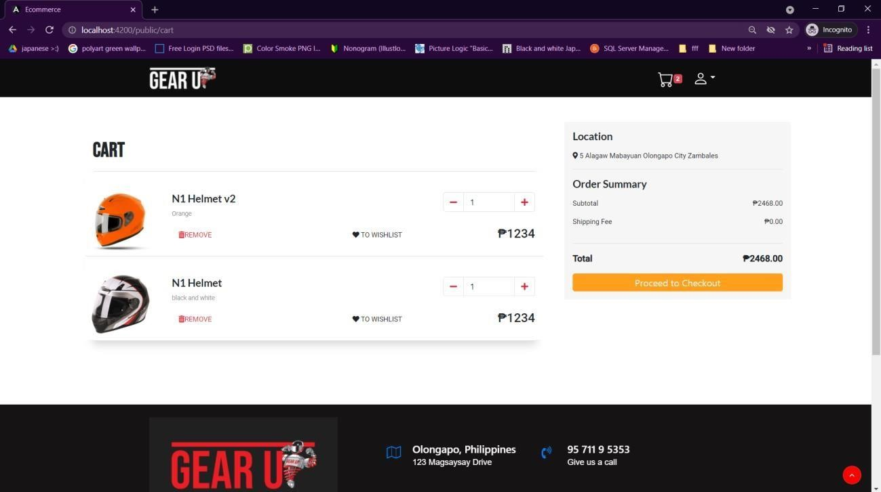

Cart Page

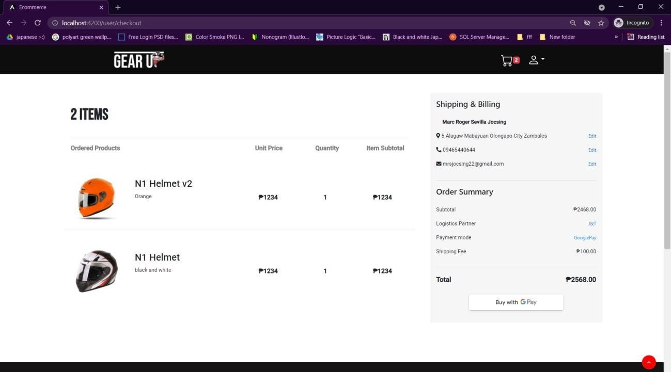

Checkout Page

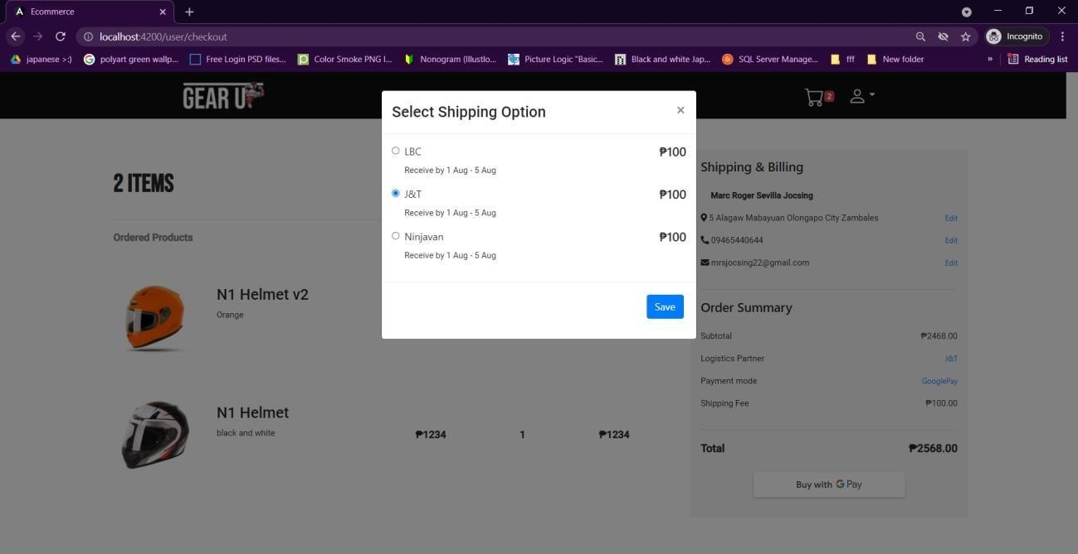

Select Shipping Option Modal

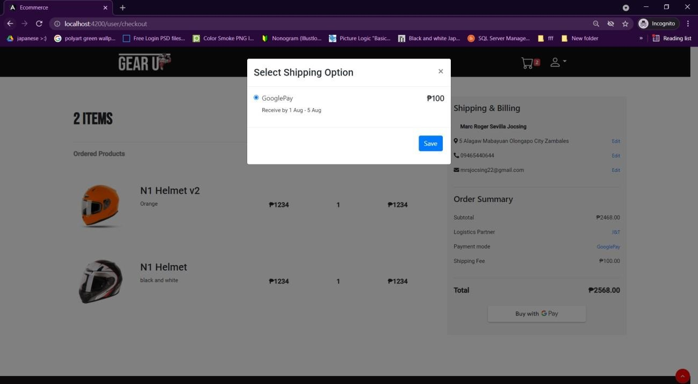

Select Payment Mode Modal

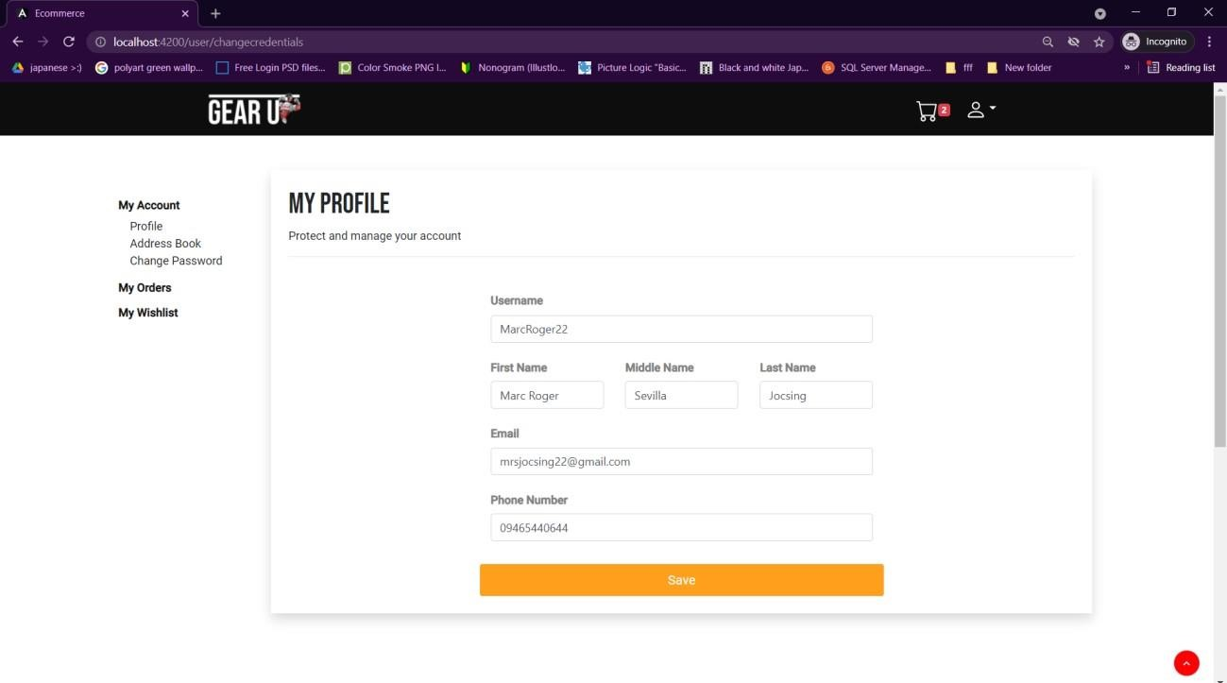

User Profile

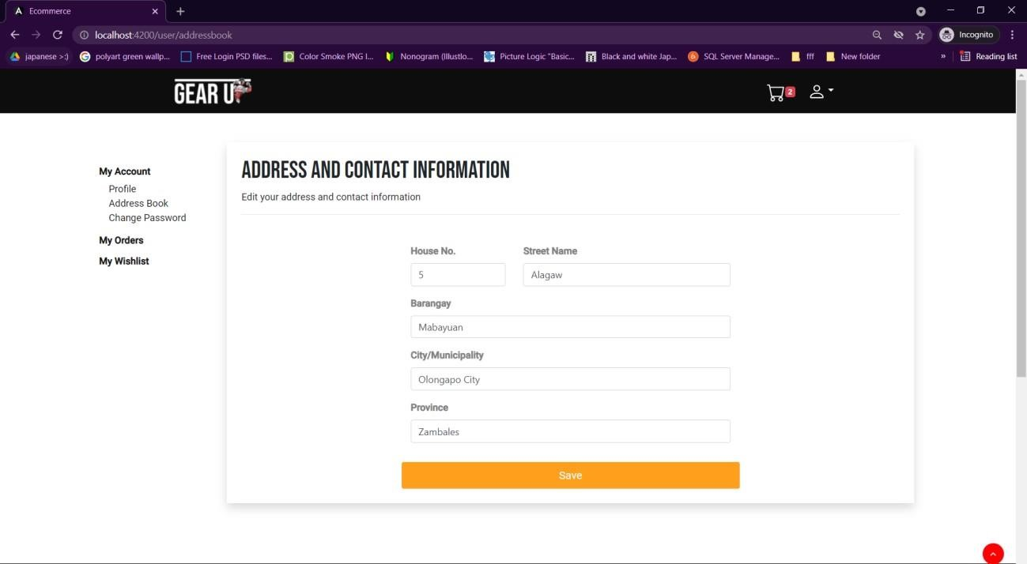

User Address Book

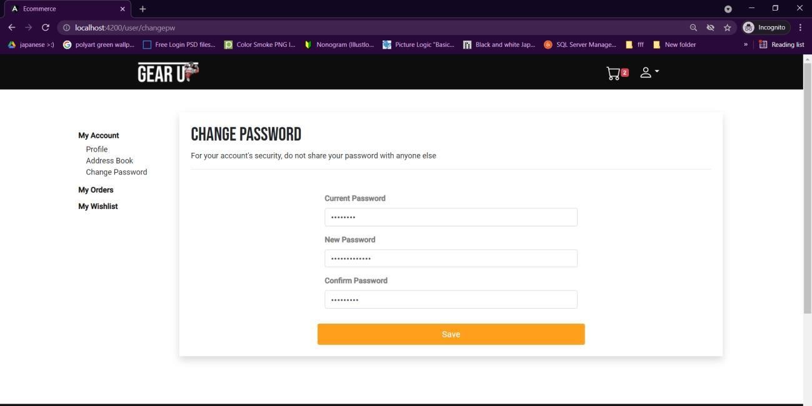

Change Password Settings

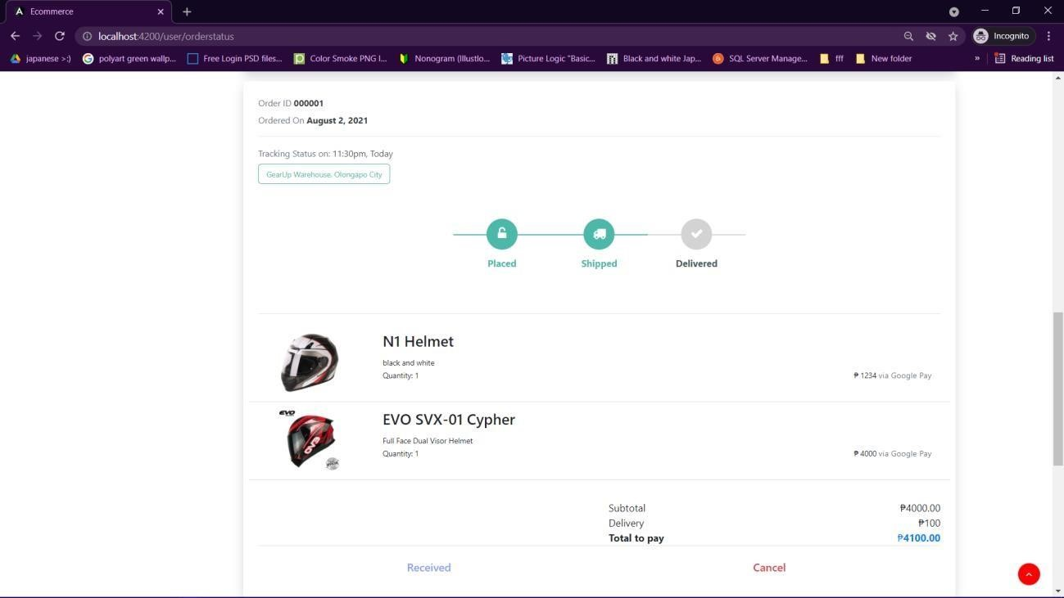

My Orders Page

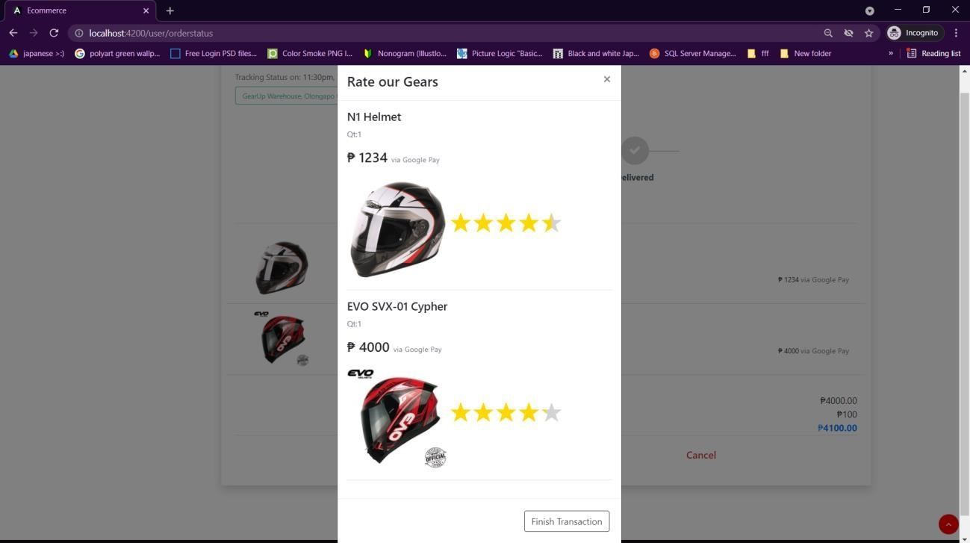

Rate Items/Finish Transaction Modal

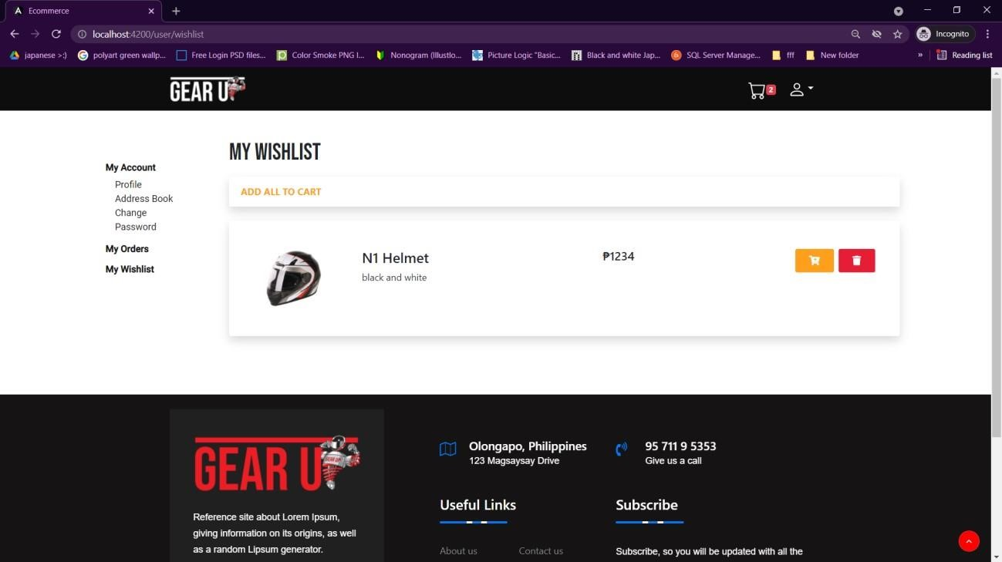

My Wishlist Page