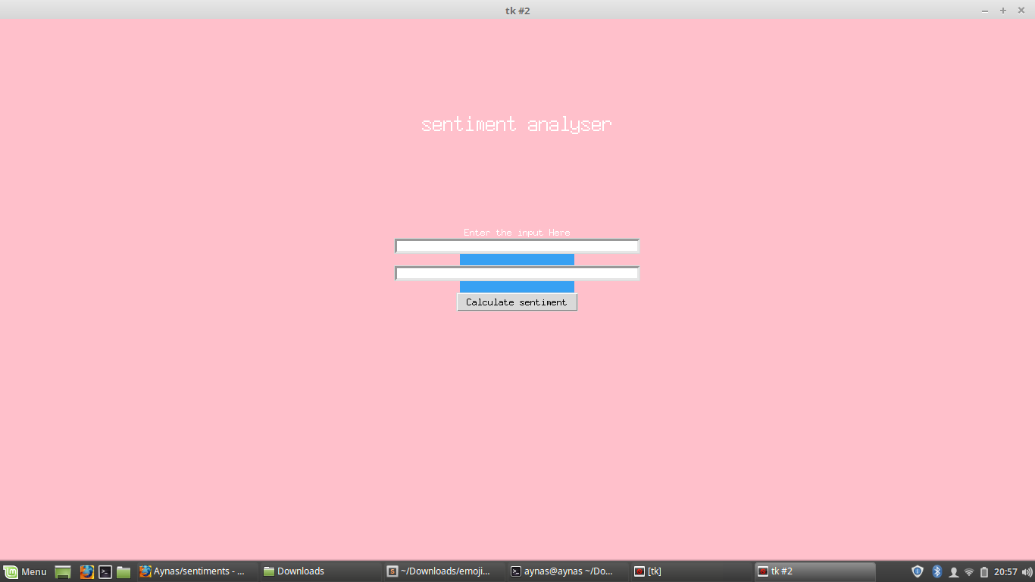

**1**.Hashtag and Tweets to be searched

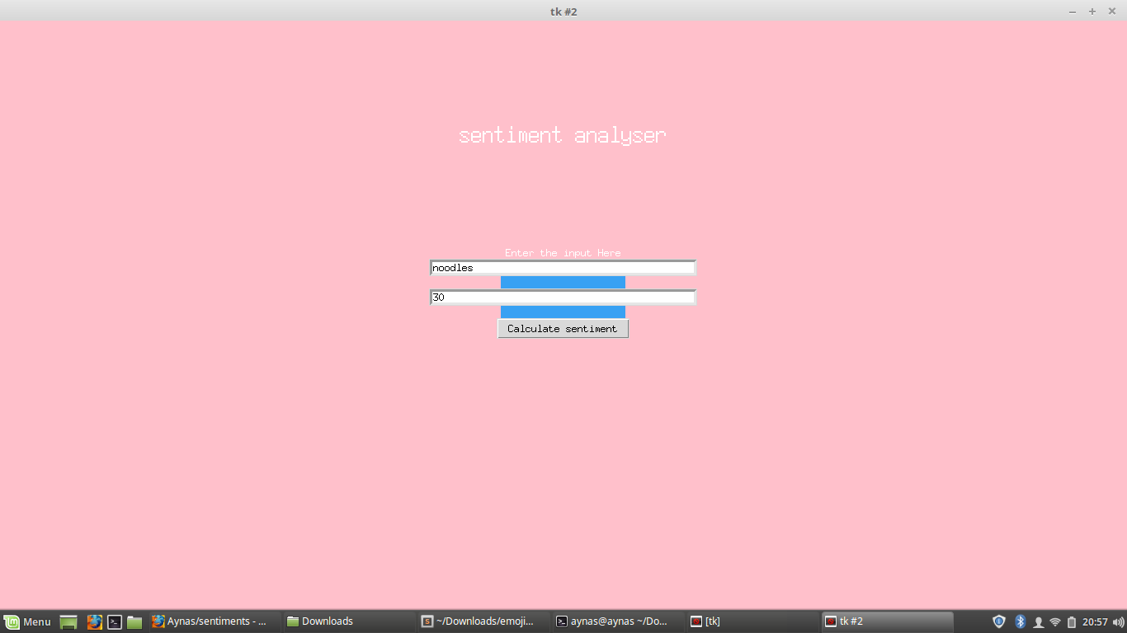

**2.**Enter Hashtag and Tweets which you need to find

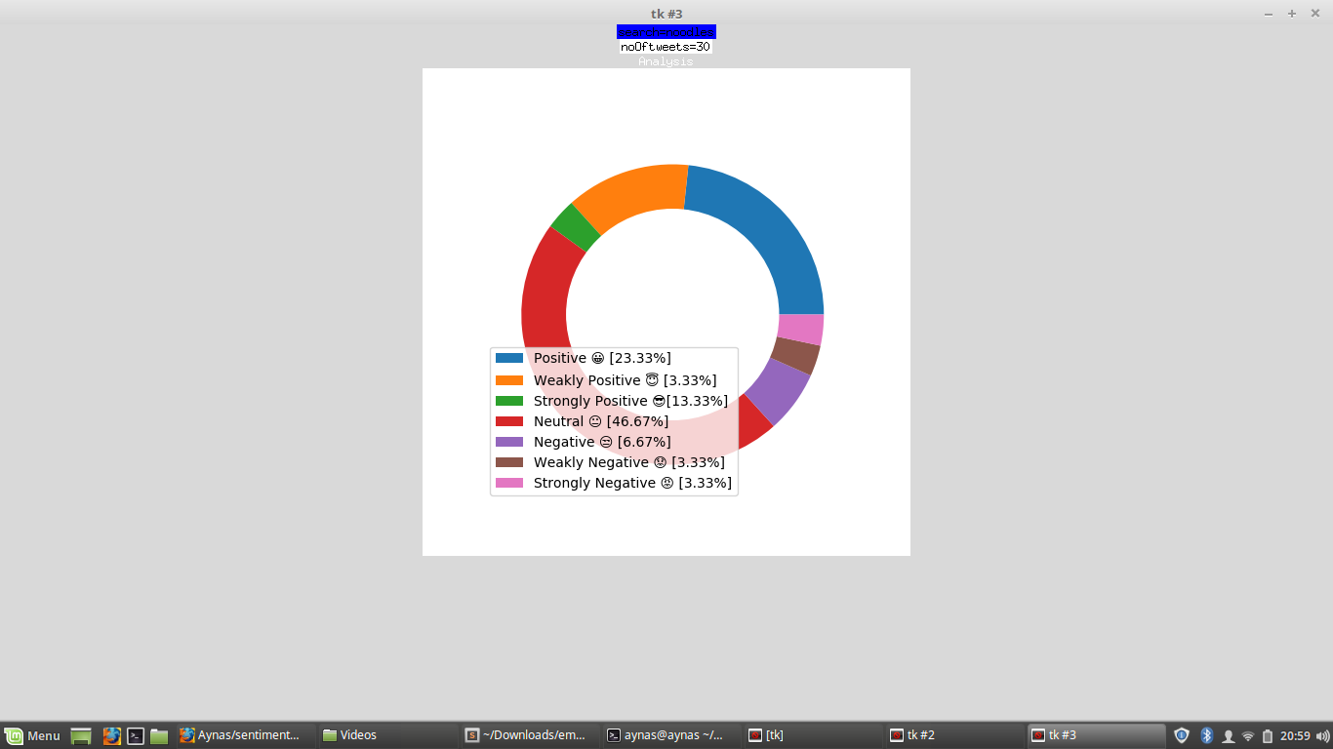

**3.**Analysis of Tweets with emojis