

ORDERLY DEMEANOR INSPECTION SYSTEM [ODIS]

A PROJECT REPORT
Submitted by

AYNGARAN K
[REGISTER NO:211417104028]
BASAVARAJU BHAVAN KUMAR
[REGISTER NO:211417104033]
BALAJI V
[REGISTER NO:211417104030]

in partial fulfillment for the award of the degree of

BACHELOR OF ENGINEERING

IN

COMPUTER SCIENCE AND ENGINEERING

PANIMALAR ENGINEERING COLLEGE, CHENNAI-600123.

ANNA UNIVERSITY: CHENNAI 600 025

APRIL 2021

BONAFIDE CERTIFICATE

Certified that this project report “ORDERLY DEMEANOR INSPECTION SYSTEM [ODIS]” is the bonafide work of “AYNAGRAN K (2017PECCS369), BASAVARAJU BHAVAN KUMAR (2017PECCS372), BALAJI V (2016PECCS370)” who carried out the project work under my supervision.

SIGNATURE SIGNATURE

Dr.S.MURUGAVALLI,M.E.,Ph.D., Mr.C. THYAGARAJAN
HEAD OF THE DEPARTMENT ASSISTANT PROFESSOR, DEPARTMENT OF CSE, DEPARTMENT OF CSE,
PANIMALAR ENGINEERING COLLEGE, PANIMALAR ENGINEERING COLLEGE, NAZARATHPETTAI, NAZARATHPETTAI,
POONAMALLEE, POONAMALLEE,
CHENNAI-600 123. CHENNAI-600 123.

Certified that the above candidate(s) was/ were examined in the Anna University Project Viva-Voce Examination held on _________

INTERNAL EXAMINER EXTERNAL EXAMINER

ACKNOWLEDGEMENT

We express our deep gratitude to our respected Secretary and Correspondent Dr.P.CHINNADURAI, M.A., Ph.D. for his kind words and enthusiastic motivation, which inspired us a lot in completing this project.

We would like to extend our heartfelt and sincere thanks to our Directors

Tmt.C.VIJAYARAJESWARI, Thiru.C.SAKTHIKUMAR,M.E., and
Tmt. SARANYASREE SAKTHIKUMAR B.E.,M.B.A., for providing us with the necessary facilities for completion of this project.

We also express our gratitude to our Principal Dr.K.Mani, M.E., Ph.D. for his timely concern and encouragement provided to us throughout the course.

We thank the HOD of CSE Department, Dr. S. Murugavalli , M.E.,Ph.D.,
for the support extended throughout the project.

We would like to thank my Project Guide Mr.C.Thyagarajan, and all the faculty members of the Department of CSE for their advice and suggestions for the successful completion of the project.
AYNGARAN KRISHNAMOORTHY, BASAVARAJU BHAVAN KUMAR,
BALAJI. V.

ABSTRACT

In the current world, time is considered as an immense treasure. People never want to waste the time and schedule their day with prioritized works. The things people fail to understand is trying to balance the time they forget to balance their mental states. For a healthy run of the body we not only require healthy exterior but also fruitful interior. When our mind runs smoothly then the body reflects the same. Failing to understand this concept the people ignore their mental balance, resulting in affects such as stress, sensation to commit extreme measures, etc. This type of behavior is always dangerous to them and also to the society around them. To contain this type of sociopathic behaviors, psychologists and other professionals were trying to develop a system which detects such type of behaviors. But in this paper we propose a system which intends to cut the problem in it roots than identifying it later. The system proposed is a semi-robotic interface which interacts with the user in toil and solves their cause of distress and maintain a mental equilibrium of that particular user. Introduction of this system brings a drastic change in the society which always struggle to maintain peace and equilibrium with itself.

LIST OF FIGURES

CHAPTER NO. | TITLE | PAGE NO.
4. | SYSTEM DESIGN
 | 4.1.ER-Diagram | 26
 | 4.2.DataFlowDiagram | 29
 | 4.3.UseCaseDiagram | 33
 | 4.4ClassDiagram | 34
 | 4.5SequenceDiagram | 35
 | 4.6ActivityDiagram | 36
5. | SYSTEMARCHITECTURE
 | 5.1.SystemArchitecture | 38

LIST OF TABLES

CHAPTER NO. | TITLE | PAGE NO.
3. | SYSTEM ANALYSIS
 | 3.1. Minimum Hardware Requirements | 15
 | 3.2. Minimum Software Requirements | 16
4. | SYSTEM DESIGN
 | 4.1. Data Dictionary of User | 26
 | 4.2. Data Dictionary of Patient | 26
 | 4.3. Data Dictionary of Doctor | 27
6. | SYSTEM TESTING
 | 6.1. Test Case for User Module | 46
 | 6.2. Test Case for Knowledge System | 47
 | 6.3. Test Case for Doctor Module | 47

TABLE OF CONTENTS

CHAPTER NO. | TITLE | PAGE NO.
 | ABSTRACT | IV
1. | INTRODUCTION | 1
 | 1.1 Overview | 2
2. | LITERATURE SURVEY | 5
3. | SYSTEM ANALYSIS | 12
 | 3.1 Existing System | 13
 | 3.2 Proposed system | 13
 | 3.3 Requirement Analysis and Specification | 13
 | 3.3.1 Input Requirements | 14
 | 3.3.2 Output Requirements | 14
 | 3.3.3 Functional Requirements | 14
 | 3.4 Feasibility Study | 14
 | 3.4.1 Technical Feasibility | 15
 | 3.4.2 Economic Feasibility | 15
 | 3.5 Hardware Environment | 15
 | 3.6 Software Environment | 16
 | 3.7 Software Specification | 16

CHAPTER NO. | TITLE | PAGE NO.
4. | SYSTEM DESIGN | 25
 | 4.1. ER diagram | 26
 | 4.2 Data dictionary | 26
 | 4.3 Data Flow Diagram | 27
 | 4.4 UML Diagrams | 29
5. | SYSTEM ARCHITECTURE | 38
 | 5.1 Architecture Overview | 39
 | 5.2 Module Design Specification | 40
 | 5.2.1 Module Explanation | 40
 | 5.3 Program Design Language | 41
6. | TESTING | 45
 | 6.1 System Testing | 46
 | 6.2 Unit Testing | 47
 | 6.3 Test Cases & Reports / Performance Analysis | 48
7. | CONCLUSION | 49
 | 7.1 Conclusion and Future Enhancements | 50
 | APPENDICES
 | A.1 Sample Screens | 51
 | A.1 Sample Code | 55
 | REFERENCES | 74

CHAPTER 1 INTRODUCTION

1.1 OVERVIEW

The worlds we live in require a society which withholds mental equilibriums rather than a group of sociopaths. The reason we tend to move towards contradiction of a proper society is lack of human interactions and spending time with people. Due to this the humans tend to diverge towards a path where he will be taking extreme decisions and develop hatred towards the surroundings rather than being part of it. We introduce a method where a person can feel free to interact with the proposed system in order to reduce the tensions and stress building around in absence of people around. These types of serious conditions can be viewed in scenarios like children who have working parents or lost them tragically, people trying to maintain work-life balance, etc. These people can just express their feelings with the system till he feel relieved and back to happy life.

We try to design the system in a way that it infiltrates the user feelings by capturing his facial expressions and analyzing his condition. This helps the person itself as he might hesitate to initiate during some intimate scenarios, where our system steps forward to initiate the conversation. The major addition we try to provide is a two way conversation. We may not express in assurance that the answer from the system in a two way conversation can be utilized as idea in real life but can be said surely that it will lift the morale of the person in depression. Another major additional feature we are trying to embed is self-learning capability of system as per the user’s previous experiences and his way of interest in length of conversations. In a short form the previous feature stated can be expressed as “customization”, which means adapting as per the users requirement and change in behavior through reaction to conversation. For designing such products we require support of technologies like machine learning, image processing and etc., which can act as human in the absence of real people. The reason we choose these technologies is because we want to enforce a type of environment where a person with senses needs aid and any wrong move can cause damage to his life, so we tend to be careful and conscious in designing with a good efficiency rate in order to prove the safety in using such products. To support those proposals we also like to add the topic of confidence on the output provided by the system and the consequences created. We need to first channelize our mind that how efficient a device may be but it has its restrictions in understanding few feelings which a person understands in a facile manner. These are the ones which differentiate and draw a line between humans and other organisms (also the electronic devices). Here we try to render a device which try to eliminate evil thoughts arose in the minds of the user during certain emotional phase through making the user to flush out the feelings hidden and making him suffer.
We ensure the affect of the device we design remains loyal to the user and maintain confidentiality of particular’s data and also avoid being as replacement for human. The range of features it possesses can impact the life of the user in many ways. We try to input as many conversational inputs as we can to make the user feel better before acting anything in the state of urgency. This particular product is suitable to all sorts of age groups and also no gender restrictions. The arguments from the people around being the similarity of this to a voice assistant and face capturing can be countered by stating its real time usage and the amount benefits it provides and situations it fixates can be enough to side track those comments.

CHAPTER 2 LITERATURE SURVEY

EEG-Based Emotion Recognition Using Regularized Graph Neural Networks, PeixiangZhong, Di Wang, Chunyan Miao

PeixiangZhong, Di Wang, Chunyan Miao examined that the Electroencephalography (EEG) measures the neuronal activities in different brain regions via electrodes. Many existing studies on EEG-based emotion recognition do not fully exploit the topology of EEG channels. In this paper, we propose a regularized graph neural network (RGNN) for EEG-based emotion recognition. RGNN considers the biological topology among different brain regions to capture both local and global relations among different EEG channels. Specifically, we model the inter-channel relations in EEG signals via an adjacency matrix in a graph neural network where the connection and sparseness of the adjacency matrix are inspired by neuroscience theories of human brain organization. In addition, we propose two regularizers, namely node-wise domain adversarial training (NodeDAT) and emotion-aware distribution learning (EmotionDL), to better handle cross-subject EEG variations and noisy labels, respectively. Extensive experiments on two public datasets, SEED and SEED-IV, demonstrate the superior performance of our model than state-of-the-art models in most experimental settings. Moreover, ablation studies show that the proposed adjacency matrix and two regularizers contribute consistent and significant gain to the performance of our RGNN model. Finally, investigations on the neuronal activities reveal important brain regions and inter-channel relations for EEG-based emotion recognition.

Factors Affecting the Impact of Emotional Intelligence on Workplace Behaviour: A Study of Bank Employees SimarjeetMakkar, SriparnaBasu

SimarjeetMakkar, SriparnaBasu examined that the impact of emotional intelligence (EI) on the workplace behaviour of the employees in the Indian banking sector. Banking industry was chosen for this research owing to the dynamic nature of this sector propelling a heightened need for compatibility and resilience of employees. The purpose of the study was twofold: (a) to examine if there is a significant impact of EI on workplace behaviour of the employees in both private and public sector banks; and (b) to determine if the impact is more in one sector than the other. Goleman’s EI framework (1995) and Emotional Competence Inventory (ECI) was used for data collection. Six banks were selected for this study: three from the public sector and three from the private sector as sample covering Mumbai. The findings of the study revealed that there is a strong relationship between EI and workplace behaviour of employees in the banking sector and there is also a difference of the impact of EI on workplace behaviour of the employees in private and public sector banks. The analysis derives meaningful implications for managerial policy in banks as well as for future research.
this review, I discuss how we measure inaccuracy, the source of errors in self- monitoring of blood glucose (SMBG), clinical testing of the systems, and how some of these errors can be minimized or eliminated.

A study on emotion recognition method and its application using face image Hyeon-Jung Lee; Kwang-Seok Hong

Hyeon-Jung Lee; Kwang-Seok Hong examined that the introduce seven emotions and positive and negative emotion recognition methods using facial images and the development of apps based on the method. In previous researches, they used the deep-learning technology to generate models with emotion-based facial expressions to recognized emotions. There are existing apps that express six emotions, but not seven emotions and positive and negatives in graphs and percentages. Thus, we recognized seven emotions such as Angry, Disgust, Fear, Happy, Sad, Surprise, and Neutral and also classified the calculated emotion-recognition scores into positive, negative and neutral emotions. Then we implemented an app that provides the user with seven emotions scored and positive and negative emotions.

Speech Based Voice Recognition System for Natural Language Processing, Kavitharaju

Kavitha Raju examined that a system that recognizes and authenticates the voice of a user by extracting the distinct features of their voice samples is usually termed as Voice recognition system. Voice identification is carried out by converting the human voice into digital data. The digitized audio samples then undergo feature excerption process to extract Mel Frequency Cepstral Coefficients features. These coefficients are subjected to feature matching through Dynamic Time Warping to match with the patterns existing in the database for limited Tamil words. This paper focuses on a secure system that deploys the voice recognition for a natural language (Tamil) by combining the digital and mathematical knowledge using MFCC and DTW to extract and match the features to improve the accuracy for better performance.

Deep Audio-Visual Speech Recognition,TriantafyllosAfouras, Joon Son Chung, Andrew Senior, Oriol Vinyals, Andrew Zisserman

TriantafyllosAfouras, Joon Son Chung, Andrew Senior, Oriol Vinyals, Andrew Zisserman examined that the goal of this work is to recognise phrases and sentences being spoken by a talking face, with or without the audio. Unlike previous works that have focussed on recognising a limited number of words or phrases, we tackle lip reading as an open-world problem – unconstrained natural language sentences, and in the wild videos. Our key contributions are: (1) we compare two models for lip reading, one using a CTC loss, and the other using a sequence-to-sequence loss. Both models are built on top of the transformer self-attention architecture; (2) we investigate to what extent lip reading is complementary to audio speech recognition, especially when the audio signal is noisy; (3) we introduce and publicly release a new dataset for audio-visual speech recognition, LRS2-BBC, consisting of thousands of natural sentences from British television. The models that we train surpass the performance of all previous work on a lip reading benchmark dataset by a significant margin

Audio-visual speech recognition incorporating facial depth information captured by the kinect, Georgios Galatas,Gerasimosotamianos , FilliaMakedon

Georgios Galatas ,Gerasimosotamianos , FilliaMakedon examined that the investigate the use of facial depth data of a speaking subject, captured by the Kinect device, as an additional speech informative modality to incorporate to a traditional audiovisual automatic speech recognizer. We present our feature extraction algorithm for both visual and accompanying depth modalities, based on a discrete cosine transform of the mouth region-of-interest data, further transformed by a two-stage linear discriminant analysis projection to incorporate speech dynamics and improve classification. For automatic speech recognition utilizing the three available data streams (audio, visual, and depth), we consider the feature and decision fusion paradigms, the latter via a state-synchronous tri-stream hidden Markov model. We report multi-speaker recognition results on a small-vocabulary task employing our recently collected bilingual audio-visual corpus with depth information, demonstrating improved recognition performance by the addition of the proposed depth stream, across a wide range of audio conditions.

A Survey of Sentiment Analysis Based on Transfer Learning, Ruijun liu, yuqian shi , changjiang ji , and ming jia

Ruijun liu, yuqian shi , changjiang ji , and ming jia examined that the rapid development of the Internet industry, sentiment analysis has grown into one of the popular areas of natural language processing (NLP). Through it, the implicit emotion in the text can be effectively mined, which can help enterprises or organizations to make an effective decision, and the explosive growth of data undoubtedly brings more opportunities and challenges to the sentiment analysis. At the same time, transfer learning has emerged as a new machine learning technique that uses the existing knowledge to solve different domain problems and produces state-of-the-art prediction results. Many scholars apply transfer learning to the field of the sentiment analysis. This survey summarizes the relevant research results of the sentiment analysis in recent years and focuses on the algorithms and applications of transfer learning in the sentiment analysis, and we look forward to the development trend of the sentiment analysis.

A Study on Emotional Intelligence at Work Place, DestiKannaiah, R. Shanthi
Destikannaiah,R.Shanthi examined that the Emotional Intelligence (EI) must somehow combine two of the three states of mind cognition and affect, or intelligence and emotion. Emotional intelligence refers to the ability to perceive, control, and evaluate emotions. Some researchers suggest that emotional intelligence can be learned and strengthened, while other claim it is an inborn characteristic. A number of testing instruments have been developed to measure emotional intelligence, although the content and approach of each test varies. If a worker has high emotional intelligence, he or she is more likely to be able to express his or her emotions in a healthy way, and understand the emotions of those he or she works with, thus enhancing work relationships and performance. Emotional Intelligence is not about being soft! It is a different way of being smart - having the skill to use his or her emotions to help them make choices in the moment and have more effective control over themselves and their impact on others.
Emotional Intelligence allows us to think more creatively and to use our emotions to solve problems. Emotional Intelligence probably overlaps to some extent with general intelligence. The emotionally intelligent person is skilled in four areas: Identifying emotions, using emotions, understanding emotions, and regulating emotions.
“Emotional Intelligence is the ability to sense, understand, value and effectively apply the power of emotions as a source of human energy, information, trust, creativity and influence”
-DANIEL GOLEMAN

CHAPTER 3 SYSTEM ANALYSIS

3.1 EXISTING SYSTEM
We can say that in the present day world proposals similar to the stated one can be present but never a prototypic model of it is displayed. So we considered the existing voice assistants as a model of existing systems. These systems interact with the user and act accordingly.

3.2 PROPOSED SYSTEM
Proposed system majorly concentrates on the topic of emotional balancing of a human. It tries to eliminate the loneliness of the user through interactions at critical and depressed times. Simply stating it acts as a part-time companion for the person in need.
This system interacts with the user in the time of need through image capturing and emotional analysis. Later it tries to consolidate the user and bring to a neutral or pleasant mood.
3.2.1 Advantages

      - Helps to stabilize mental health of an individual.

      - Provides emotional support.

      - Customizable

3.3 REQUIREMENT ANALYSIS AND SPECIFICAITON

The requirement specification and analysis try to identify, analyze and model the functionality or distinguish one’s features. The requirement engineering holds phases namely feasibility study, elicitation, specification and validation. These stated phases are needed to be managed by requirements management. As the process is followed in a spiral of activities elicitation and analysis of requirements can be performed in iterative manner. The iterative cycle involves identification of requirements, classification and organization, negotiation and documentation of requirements.

3.3.1 INPUT REQUIREMENT

The inputs required at the initial phase of development and design is the photos of face of the user which are continuously captured using a camera. These are provided for processing and analyzing of emotion through image. In the later stages another input is needed speech which can be taken through microphone used to build a conversation.

3.3.2 OUTPUT REQUIREMENT

The output things necessary for these are a database for storing and accessing the user data stored at the end of each successful conversation. We also require a screen or monitor to showcase the resultant output to user for further clarifications.

3.4 FEASIBILITY STUDY
A Feasibility Study in Software Engineering is a study to evaluate feasibility of proposed project or system. Feasibility study is one of stage among important four stages of Software Project Management Process. As name suggests feasibility study is the feasibility analysis or it is a measure of the software product in terms of how much beneficial product development will be for the organization in a practical point of view. Feasibility study is carried out based on many purposes to analyze whether software product will be right in terms of development, implantation, and contribution of project to the organization.

3.4.1 TECHNICAL FEASIBILITY

In Technical Feasibility current resources both hardware software along with required technology are analyzed/assessed to develop project. This technical feasibility study gives report whether there exists correct required resources and technologies which will be used for project development. Along with this, feasibility study also analyzes technical skills and capabilities of technical team, existing technology can be used or not, maintenance and up-gradation is easy or not for chosen technology

3.4.2 ECONOMIC FEASIBILITY

In Economic Feasibility study cost and benefit of the project is analyzed. Means under this feasibility study a detail analysis is carried out what will be cost of the project for development which includes all required cost for final development like hardware and software resource required, design and development cost and operational cost and so on. After that it is analyzed whether project will be beneficial in terms of finance for organization or not.

3.5 MINIMUM HARDWARE REQUIREMENTS

Processor | Core i3, 2.4 GHz
Hard disk | 500 GB
RAM | 2 GB
GPU | AMD R5M230, Nvidia Geforce 720
CAMERA | 12 megapixels
3.6 SOFTWARE REQUIEMENTS

Development Environment | Conda Prompt  Visual Studio Code
Front End Language | Python
Back-End Language | Python
Database | Mongo DB

3.7 SOFTWARE SPECIFICATION

3.7.1 Conda Prompt

Anaconda Individual Edition contains conda and Anaconda Navigator, as well as Python and hundreds of scientific packages. When you installed Anaconda, you installed all these too.
Conda works on your command line interface such as Anaconda Prompt on Windows and terminal on macOS and Linux.
Navigator is a desktop graphical user interface that allows you to launch applications and easily manage conda packages, environments, and channels without using command-line commands.
You can try both conda and Navigator to see which is right for you to manage your packages and environments. You can even switch between them, and the work you do with one can be viewed in the other.
Anaconda command prompt is just like command prompt, but it makes sure that you are able to use anaconda and conda commands from the prompt, without having to change directories or your path.
When you start Anaconda command prompt, you'll notice that it adds/ ("prepends") a bunch of locations to your PATH. These locations contain commands and scripts that you can run. So as long as you're in the Anaconda command prompt, you know you can use these commands.
During the installation of Anaconda there is a choice to add these to the PATH by default, and if checked you can also use these commands on the regular command prompt. But the anaconda prompt will always work.
If you prefer using a command line interface (CLI), you can use conda to verify the installation using Anaconda Prompt on Windows or terminal on Linux and macOS.
To open Anaconda Prompt:
1. Windows: Click Start, search, or select Anaconda Prompt from the menu.
2. macOS: Cmd+Space to open Spotlight Search and type “Navigator” to open the program.
3. Linux–CentOS: Open Applications - System Tools - terminal.
4. Linux–Ubuntu: Open the Dash by clicking the upper left Ubuntu icon, then type “terminal”.
After opening Anaconda Prompt or the terminal, choose any of the following methods to verify:
Enter conda list. If Anaconda is installed and working, this will display a list of installed packages and their versions.
Enter the command python. This command runs the Python shell. If Anaconda is installed and working, the version information it displays when it starts up will include “Anaconda”. To exit the Python shell, enter the command quit().
Open Anaconda Navigator with the command anaconda-navigator. If Anaconda is installed properly, Anaconda Navigator will open.

3.7.2 VISUAL STUDIO CODE

Visual Studio Code is a lightweight but powerful source code editor which runs on your desktop and is available for Windows, macOS and Linux. It comes with built-in support for JavaScript, TypeScript and Node.js and has a rich ecosystem of extensions for other languages (such as C++, C#, Java, Python, PHP, Go) and runtimes (such as .NET and Unity).
Visual Studio Code highlights keywords in your code in different colors to help you easily identify coding patterns and learn faster. You can also take advantage of features like IntelliSense and Peek Definition, which help you understand how functions can be used, and how they relate to one another.
As you code, Visual Studio Code gives you suggestions to complete lines of code and quick fixes for common mistakes. You can also use the debugger in VS Code to step through each line of code and understand what is happening.
You can also change the look and feel of VS Code by picking your favorite fonts and icons and choosing from hundreds of color themes. It is feasible to use the built-in source control to save your work over time so you don't lose progress. See a graphical side-by-side view to compare versions of your code from different points in time. If you want to try a project in data science or data visualization, you can use Jupyter notebooks inside VS Code. Run your code step-by-step, and visualize and interact with your data, variables, graphs, and plots.
Visual Studio Code is built with extensibility in mind. From the UI to the editing experience, almost every part of VS Code can be customized and enhanced through the Extension API. In fact, many core features of VS Code are built as extensions and use the same Extension API.
Visual Studio Code provides smart editing features for different programming languages through Language Extensions. VS Code doesn't provide built-in language support but offers a set of APIs that enable rich language features. For example, it has a bundled HTML extension that allows VS Code to show syntax highlighting for HTML files. Similarly, when you type “console.” and “log” shows up in IntelliSense, it is the Typescript Language Features extension at work.
Language features can be roughly put into two categories:
1. Declarative Language Features
2. Programming Language Features

3.7.3 PYTHON

3.7.3.1 INTRODUCTION
In general, developing a mobile application is a complex and challenging task. There are many frameworks available to develop a mobile application. Android provides a native framework based on Java language and iOS provides a native framework based on Objective-C / Swift language.
However, to develop an application supporting both the OSs, we need to code in two different languages using two different frameworks. To help overcome this complexity, there exists mobile frameworks supporting both OS. These frameworks range from simple HTML based hybrid mobile application framework (which uses HTML for User Interface and JavaScript for application logic) to complex language specific framework (which do the heavy lifting of converting code to native code). Irrespective of their simplicity or complexity, these frameworks always have many disadvantages, one of the main drawbacks being their slow performance.
In this scenario, Flutter – a simple and high performance framework based on Dart language, provides high performance by rendering the UI directly in the operating system’s canvas rather than through native framework.
Flutter also offers many ready to use widgets (UI) to create a modern application. These widgets are optimized for mobile environment and designing the application using widgets is as simple as designing HTML.
To be specific, Flutter application is itself a widget. Flutter widgets also supports animations and gestures. The application logic is based on reactive programming. Widget may optionally have a state. By changing the state of the widget, Flutter will automatically (reactive programming) compare the widget’s state (old and new) and render the widget with only the necessary changes instead of re-rendering the whole widget.

3.7.3.2 FEATURES OF PYTHON

Flutter framework offers the following features to developers −
- Modern and reactive framework.
- Uses Dart programming language and it is very easy to learn.
- Fast development.
- Beautiful and fluid user interfaces.
- Huge widget catalog.
- Runs same UI for multiple platforms.
- High performance application.

3.7.3.3 ADVANTAGES OF PYTHON
Flutter comes with beautiful and customizable widgets for high performance and outstanding mobile application. It fulfils all the custom needs and requirements. Besides these, Flutter offers many more advantages as mentioned below −
- Dart has a large repository of software packages which lets you to extend the capabilities of your application.
- Developers need to write just a single code base for both applications (both Android and iOS platforms). Flutter may to be extended to other platform as well in the future.
- Flutter needs lesser testing. Because of its single code base, it is sufficient if we write automated tests once for both the platforms.
- Flutter’s simplicity makes it a good candidate for fast development. Its customization capability and extendibility makes it even more powerful.
- With Flutter, a developer has full control over the widgets and its layout.
- Flutter offers great developer tools, with amazing hot reload.

3.7.4 PYTHON IN BACK-END

The fact that machine learning is revolutionizing the mobile app industry is undeniable. Because of its emphasis on code readability and its vast libraries and frameworks, Python is an ideal backend language when it comes to this area of technology. Since the language is simple and consistent, developers can write reliable systems, focusing on the issues of machine learning without having to worry about any potential headaches commonly associated with complex programming languages. Moreover, Python has a vast set of libraries specific to machine learning, such as Keras, TensorFlow and Scikit-learn. Python’s extensive set of libraries and frameworks can be extremely useful and time-saving, which translates into quicker turnover times and a more motivated and productive team. You can look at some other of Python’s machine learning libraries here.

Python’s countless resources come in many forms, including a wide variety of web application frameworks. Here are just some you can choose from depending on the needs of your web app:

⦁ Django. Django is a popular open-source Python web framework built by experienced developers. It aims at using automation wherever possible to speed up web development and let software developers focus on the important work. It is fast, secure and versatile.
⦁ Flask. Flask is a Python web framework that provides various tools for developing web apps. Flask is considered a micro-framework, which means it pretty much has no dependencies to external libraries. This framework is light, flexible and easy to learn.
⦁ Bottle. As another micro web framework, Bottle is light, easy to integrate and customize, and depends solely on the Python Standard Library. Bottle is great for prototyping ideas and building simple web apps.
⦁ Tornado. Tornado is not only a web app framework but also an asynchronous library. It is ideal for developing long polling and Web Sockets and has been dubbed a middle ground between Django and Flask.
⦁ CherryPy. CherryPy is a minimalistic, object-oriented web framework that works wonders for web apps. It is fast, stable and versatile.
⦁ Hug. Hug brands itself as a clean, obvious and simple framework for web development. It was built with performance in mind and includes built-in version management as well as automatic documentation.

3.7.5 MONGO DB
MongoDB, the most popular NoSQL database, is an open-source document-oriented database. The term ‘NoSQL’ means ‘non-relational’. It means that MongoDB isn’t based on the table-like relational database structure but provides an altogether different mechanism for storage and retrieval of data. This format of storage is called BSON (similar to JSON format).
MongoDB’s document model is simple for developers to learn and use, while still providing all the capabilities needed to meet the most complex requirements at any scale.
MongoDB is a cross-platform, document-oriented database that works on the concept of collections and documents. MongoDB offers high speed, high availability, and high scalability.
SQL databases store data in tabular format. This data is stored in a predefined data model which is not very much flexible for today’s real-world highly growing applications. Modern applications are more networked, social and interactive than ever. Applications are storing more and more data and are accessing it at higher rates.
Relational Database Management System (RDBMS) is not the correct choice when it comes to handling big data by the virtue of their design since they are not horizontally scalable. If the database runs on a single server, then it will reach a scaling limit. NoSQL databases are more scalable and provide superior performance. MongoDB is such a NoSQL database that scales by adding more and more servers and increases productivity with its flexible document model.
MongoDB currently provides official driver support for all popular programming languages like C, C++, C#, Java, Node.js, Perl, PHP, Python, Ruby, Scala, Go and Erlang.
MongoDB has been adopted as backend software by a number of major websites and services including EA, Cisco, Shutterfly, Adobe, Ericsson, Craigslist, eBay, and Foursquare.

CHAPTER 4 SYSTEM DESIGN

ER DIAGRAM

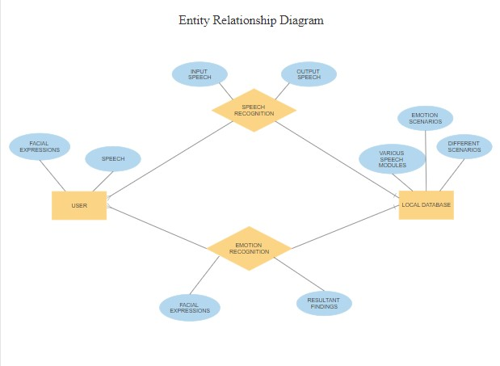

Fig 4.1 ER diagram

DATA DICTIONARY
A data dictionary, or metadata repository, as defined in the IBM Dictionary of Computing, is a "centralized repository of information about data such as meaning, relationships to other data, origin, usage, and format". Oracle defines it as a collection of tables with metadata. The term can have one of several closely related meanings pertaining to databases and database management systems (DBMS):
- A document describing a database or collection of databases
- An integral component of a DBMS that is required to determine its structure
- A piece of middleware that extends or supplants the native data dictionary of a DBMS

DATA FLOW DIAGRAM

A picture is worth a thousand words. A Data Flow Diagram (DFD) is traditional visual representation of the information flows within a system. A neat and clear DFD can depict a good amount of the system requirements graphically. It can be manual, automated, or combination of both. It shows how information enters and leaves the system, what changes the information and where information is stored. The purpose of a DFD is to show the scope and boundaries of a system as a whole. It may be used as a communications tool between a systems analyst and any person who plays a part in the system that acts as the starting point for redesigning a system.
It is usually beginning with a context diagram as the level 0 of DFD diagram, a simple representation of the whole system. To elaborate further from that, we drill down to a level 1 diagram with lower level functions decomposed from the major functions of the system. This could continue to evolve to become a level 2 diagram when further analysis is required. Progression to level 3, 4 and so on is possible but anything beyond level 3 is not very common. Please bear in mind that the level of details for decomposing functions really depending on the complexity that functions.
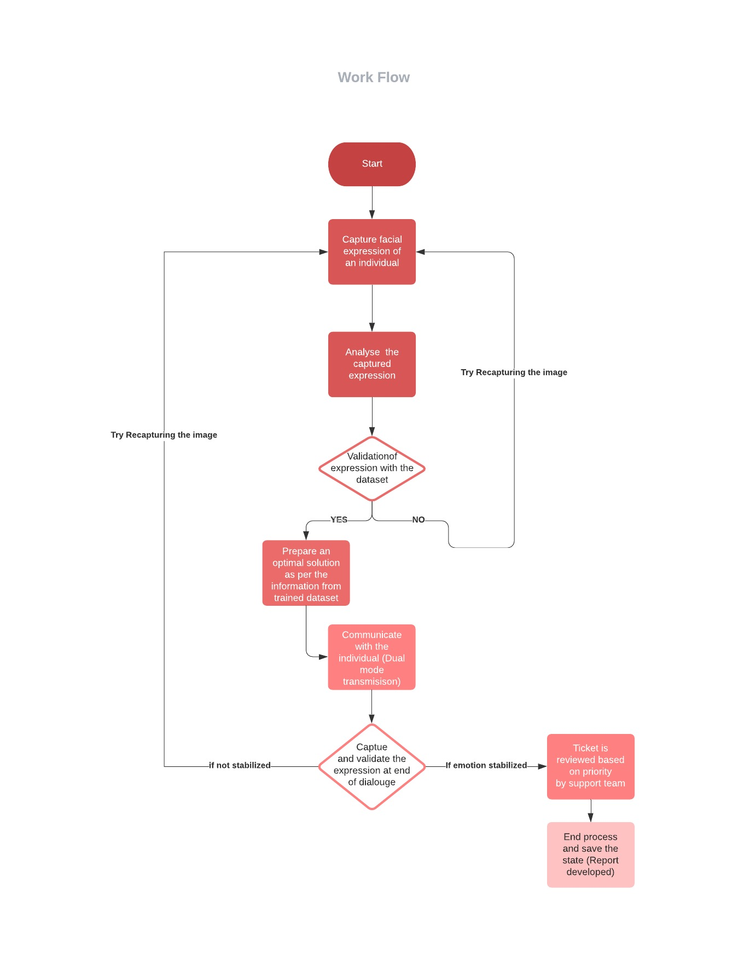

Fig 4.2 Data flow diagram

UML DIAGRAMS
UML stands for Unified Modeling Language. It’s a rich language to model software solutions, application structures, system behavior and business processes. There are 14 UML diagram types to help you model these behaviors. Unified Modeling Language™ (UML®) is a standard visual modeling language intended to be used for
- modeling business and similar processes,
- analysis, design, and implementation of software-based systems

UML is a common language for business analysts, software architects and developers used to describe, specify, design, and document existing or new business processes, structure and behavior of artifacts of software systems.
Specification explained that process:
- provides guidance as to the order of a team’s activities,
- specifies what artifacts should be developed,
- directs the tasks of individual developers and the team as a whole, and
- offers criteria for monitoring and measuring a project’s products and activities.

UML is intentionally process independent and could be applied in the context of different processes. Still, it is most suitable for use case driven, iterative and incremental development processes. An example of such process is Rational Unified Process (RUP).UML is not complete, and it is not completely visual. Given some UML diagram, we can't be sure to understand depicted part or behavior of the system from the diagram alone. Some information could be intentionally omitted from the diagram, some information represented on the diagram could have different interpretations, and some concepts of UML have no graphical notation at all, so there is no way to depict those on diagrams. For example, semantics of multiplicity of actors and multiplicity of use cases on use case diagrams is not defined precisely in the UML specification and could mean either concurrent or successive usage of use cases.
Name of an abstract classifier is shown in italics while final classifier has no specific graphical notation, so there is no way to determine whether classifier is final or not from the diagram.

List of UML Diagram Types
So, what are the different UML diagram types? There are two main categories; structure diagrams and behavioral diagrams. Click on the links to learn more about a specific diagram type.

Structure Diagrams

Structure diagrams show the things in the modeled system. In a more technical term, they show different objects in a system. Behavioral diagrams show what should happen in a system. They describe how the objects interact with each other to create a functioning system.

Class Diagram
Class diagrams are the main building block of any object-oriented solution. It shows the classes in a system, attributes, and operations of each class and the relationship between each class. In most modeling tools, a class has three parts. Name at the top, attributes in the middle and operations or methods at the bottom.
In a large system with many related classes, classes are grouped together to create class diagrams. Different relationships between classes are shown by different types of arrows.

Component Diagram
A component diagram displays the structural relationship of components of a software system. These are mostly used when working with complex systems with many components. Components communicate with each other using interfaces. The interfaces are linked using connectors. The image below shows a component diagram.

Deployment Diagram
A deployment diagram shows the hardware of your system and the software in that hardware. Deployment diagrams are useful when your software solution is deployed across multiple machines with each having a unique configuration. Below is an example deployment diagram.

Package Diagram
As the name suggests, a package diagram shows the dependencies between different packages in a system. Check out this wiki article to learn more about the dependencies and elements found in package diagrams.

Composite Structure Diagram
Composite structure diagrams are used to show the internal structure of a class. For a detailed explanation of composite structure diagrams, click here.

Use Case Diagram
As the most known diagram type of the behavioral UML diagrams, use case diagrams give a graphic overview of the actors involved in a system, different functions needed by those actors and how these different functions interact.
It’s a great starting point for any project discussion because you can easily identify the main actors involved and the main processes of the system. You can create use case diagrams using our tool and/or get started instantly using our use case templates.

Activity Diagram
Activity diagrams represent workflows in a graphical way. They can be used to describe the business workflow or the operational workflow of any component in a system. Sometimes activity diagrams are used as an alternative to State machine diagrams. Check out this wiki article to learn about symbols and usage of activity diagrams.

Sequence Diagram
Sequence diagrams in UML show how objects interact with each other and the order those interactions occur. It’s important to note that they show the interactions for a scenario. The processes are represented vertically, and interactions are shown as arrows. This article explains the purpose and the basics of Sequence diagrams. Also, check out this complete Sequence Diagram Tutorial to learn more about sequence diagrams. You can also instantly start drawing using our sequence diagram templates.

USE CASE DIAGRAM
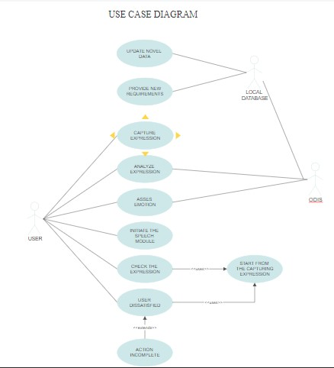

Fig 4.3 Use case diagram

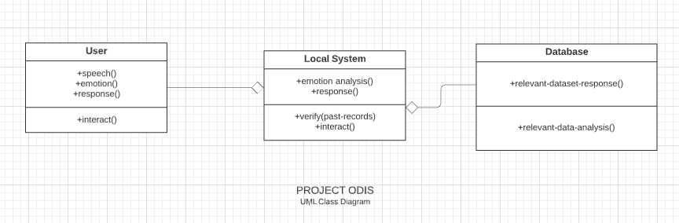

Fig 4.4 Class diagram
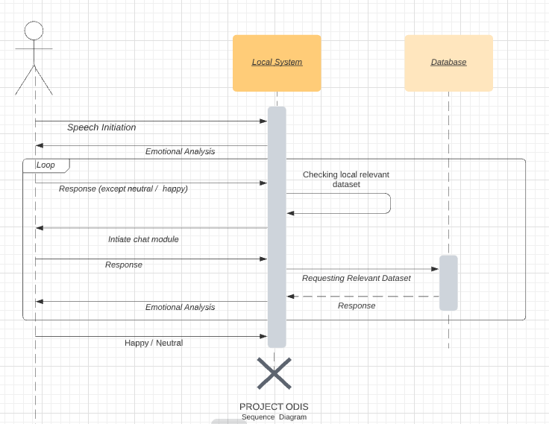

Fig 4.5 Sequence diagram

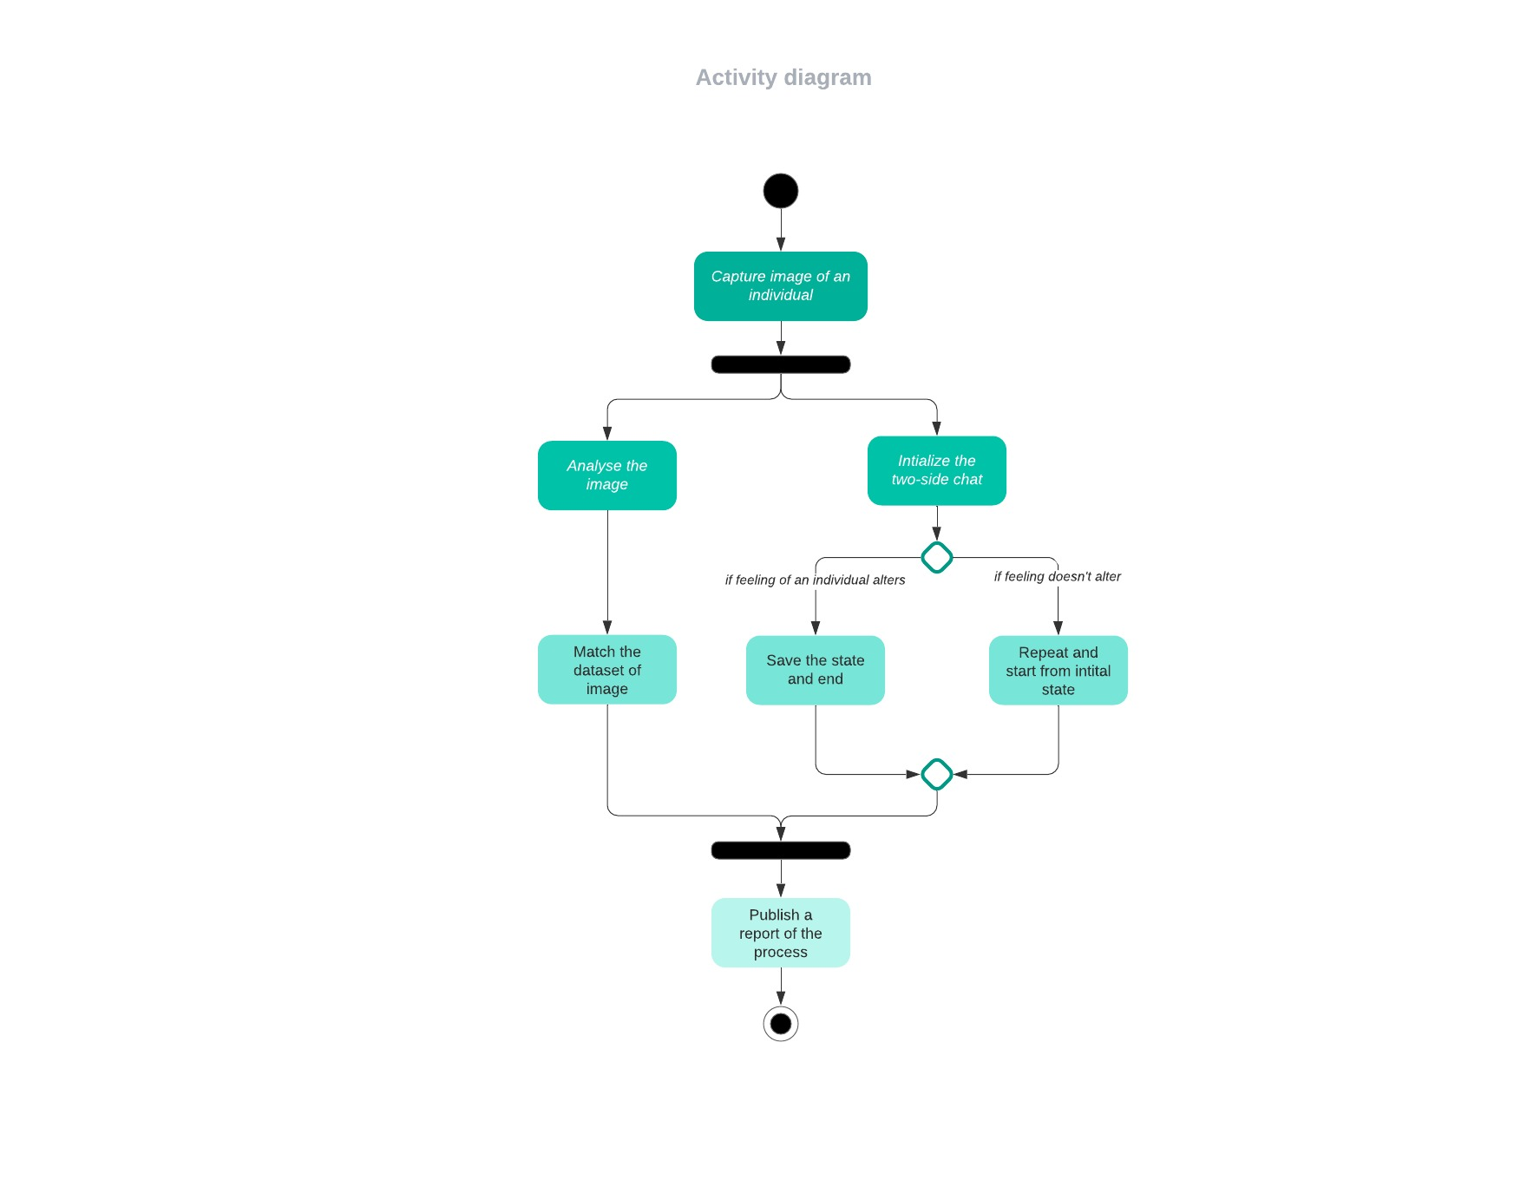
Fig 4.6 Activity diagram

CHAPTER 5 ARCHITECTURE

SYSTEM ARCHITECTURE
The system architecture is the structural design of systems. Systems are a class of software that provides foundational services and automation. The system architecture of software provides a detailed view of the functions and workings of a system. The below diagram represents the system architecture of ODIS.
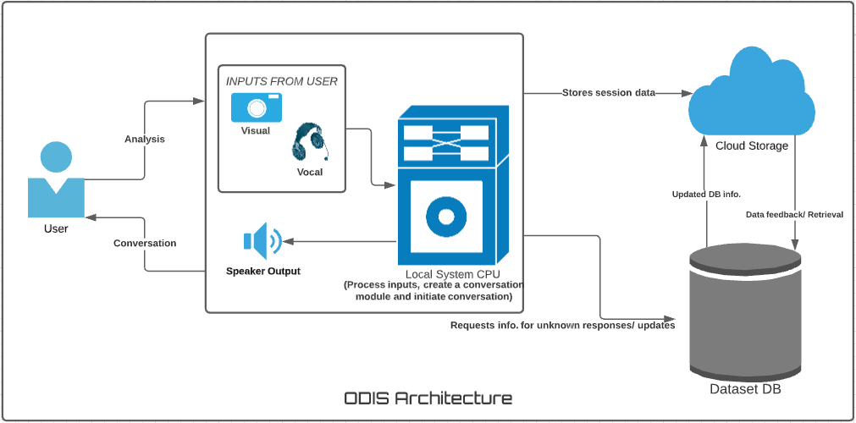

Fig 5.1 System Architecture

SYSTEM MODULE

The ODIS has three modules where two modules are accountable for I/O and the third module is responsible for processing and executing the complete process. The three modules of ODIS are:
- Facial Analysis Module
- Speech Synthesis Module
- Process Function

MODULES EXPLAINATION:

Facial Analysis Module:

The work of facial analysis module is to capture real-time images of the individual facing the webcam and convert the image obtained into a form of an array using the keras module (Tensor-Flow),the array is analyzed with the trained dataset for emotion prediction. Once the prediction is done the system loads in respective dataset into the speech module to create the conversation, after each response is generated another real-time image is captured to check if there is any change in the emotion of the user.
The process goes-on until the emotion is neutral or happy and once the prediction turns out to be either of them, then the entire session is formed as a record for future conversational efficiency and requirements.

Speech Synthesis Module:

The speech synthesis module is initiated when a dataset is loaded in, containing information about the emotional state of the individual. Once the dataset is loaded in, the speech synthesis recreates a conversation from the dataset to converse with the user to soothe their emotion to provide them emotional support when they require it, every such conversation and response generated is being recorded locally to train the model to work as a custom unit and this helps the system to work more efficiently, which will aid in providing a better understanding over the user's emotional stability and needs.

Processing Module:

The work of the processing module is to retain and collect data from both the user as well as the main database. The Emotion analyzed from the Facial Analysis module is processed and relevant data is looked-up for in the local system if no dataset supports the current emotional state of the user then the processing module checks the major dataset DB for all relevant datasets, such datasets are imported and utilized to initiate a conversation.
Once the conversation is initiated when an unidentified response is generated by the user the processing units break down the sentence into a set of keywords and searches the main storage DB Cloud for support towards the response obtained if no support is available then the response is pinned to the cloud to generate the response request so that any such similar response request in future can be satisfied for user comfort.
When the conversation has led to the desired result the entire request-response and conversation data are stored for a future record which will help the processing unit to get a broader idea over the required conversation response-request chat.

PROGRAM LANGUAGE DESIGN:

Emotion Checking Algorithm:
Emotion Recognition:
- for pixels in frame
- convert pixels into arrays;
- While pixel_array > 0:
- Compare pixels from data;
- If pixels do not match data present:
- Send frame to main server for analyzing;
- Get response and update current dataset;
- Set emotion data as current
Conversation:
- Switch case for current
- While current != happy || neutral
- Load respective conv dataset;
- Current == curr
- While conv_itr != 5:
- Get response of user for question;
- Analyze response ;
- Run Emotion Recognition;
- If current != curr:
- Break;
- If current == happy || neutral:
- Run general dataset;
- Update records;
- Exit;

Analyze Facial Expression

The facial recognition is initially run to understand the user’s emotional state. The emotional state is analyzed by converting the captured real-time image into an array of matrices and then each array is analyzed with the trained dataset to predict the emotional state.

Preprocess emotional data
Initially, before creating a conversation the emotional data obtained is used to choose the relevant datasets that can be utilized to create a meaningful and worth-while conversation for the user. The datasets chosen are consolidated and a conversational module is created.

Initializing conversation
As the conversation with the user is initiated, the system checks for any previous records of the user that is relevant to the current emotional state. If no such record exists the consolidated conversation is carried out, else if there is a previous record, the recorded response-request is refactored and run for better results.

Conversation
As the conversation with the user is initialized and running if there is a response from the user that cannot be processed or if the system does not have an idea over the response then the response is split into keywords and is searched over the major cloud data storage if there are no results for the response in the cloud then the response is pinned to be updated to the data storage

End of conversation
The conversation ends when the result of the emotional recognition turns out to be either happy or neutral, until then the conversation will be carried on. Once the desired emotion is attained then the conversation stops and the entire session is recorded.

Post-Session Data Handling
After the end of the conversation, the recorded data is saved as documentation for future purposes when the user has the same emotional state. This helps in utilizing the data to analyze the emotional mindset and initiate a more user-centered conversation.

CHAPTER 6 TESTING

SYSTEM TESTING

The testing approach document is designed for Information and Technology Services’ upgrades to ODIS. This document has an overview about the testing activities to be performed when the system is upgraded or if any future functions/ modules are added to ensure the proper functioning of the system. Testing a system is as important as developing a system, it is important to notice that reducing the amount of testing done to the system post changes may result in a potential malfunction of the system post-production. It is crucial t ensure the proper functionality of the system as it might affect user experiences.

System testing is simply testing the functionalities of the system as per the documented needs determined at the pre-development phase of the system, during system testing every requirement discussed is analyzed and reports are generated whether or not the system has satisfied the particular requirement.

The various domains to be tested post changes in the system are:

Test Plan

Test Case

Test Data

The system testing takes part post system integration as this involves testing the system process as a whole and looking up for system functionality as intended. If the integration stage was carried out with higher accuracy those most of the test cases would have been successfully satisfied and only a few liable test cases need to be run on the system to ensure that there is no bugs affecting the intended work flow of the system for a seamless performance and user experience.

Unit Testing

In computer programming, unit testing is a software testing method by which individual units of source code, sets of one or more computer program modules together with associated control data, usage procedures, and operating procedures are tested to determine if they are fit for use. In object-oriented programming, a unit is often an entire interface, such as a class, but could be an individual method. Unit tests are short code fragments created by programmers or occasionally by white box testers during the development process. Ideally, each test case is independent from the others. Substitutes such as method stubs, mock objects, fakes, and test harnesses can be used to assist testing a module in isolation. Unit tests are typically written and run by software developers to ensure that code meets its design and behaves as intended. As vital as system testing is for a system, unit testing plays a major role in testing the internal functionalities of the system, the way a system communicates within and how each modules function as a self-sophisticated system themselves with sample inputs for system functionality. This testing provides a more in-depth view of how the system performs and what are the changes and corrections to be made in case of any process failure or during a debugging process. The unit testing tests the roles of the individual modules and system testing tests for the system productivity and system function as a whole.

TEST CASES

Test Case Id | Test Case | Priority | Input Test Data | Test Case Description | Expected Results | Actual Results | Pass/Fai l
TU0 1 | Frame Capture and analysis | A | Webcam feed. | Capturing a frame from the live video feed and analyze it. | Analyzed Pixels | Pixels analyzed successfully. | Pass
TU0 2 | Predict emotion | A | Pixel matrix. | Analyzed frame data used to predict emotion. | Should predict emotion from data. | Emotion Predicted successfully | Pass
TU0 3 | Conversation Initiation | A | Emotion | Select the assigned model for emotion captured and initiate conversation. | Conversation from the emotion model. | Model identified and conversation initiated successfully. | Pass
TU0 4 | Speech Analysis | A | Response from user | Clean up the response and identify the sentence. | Appropriate system response for user response. | Appropriate response generated | Pass

Table 6.1 Test Cases for User Module

CHAPTER 7
CONCLUSION AND FUTURE ENHANCEMENT

7.1 CONCLUSION

We conclude by stating that no machine in this world is capable to match and replace a living being especially a human, but we try to consolidate this matter by giving the system a single human task which is to understand a person feeling and respond accordingly in a way to make him feel better and secure. We here using this system attempt to fixate a lack of emotional connection of a person and loneliness with help of key technologies like Machine Learning, Image processing. In a whole we perform a scientific study on the technologies and its benefits with the fact that the way we are going to utilize them in building of our system.

7.2 FUTURE ENHANCEMENT

Discussing about the future scope, in reality every object in this world deserves and requires betterment or up gradation. Similar law applies to this system too, the betterment in the efficiency rates or refined conversation building, etc are feasible to embed in the proposed system. However add on you try to infiltrate into the device the core remains the constant which is user system interaction and aid his emotional balance. This is the core of the proposal and remains unaltered.
APPENDICES

A 1. SAMPLE SCREENS:
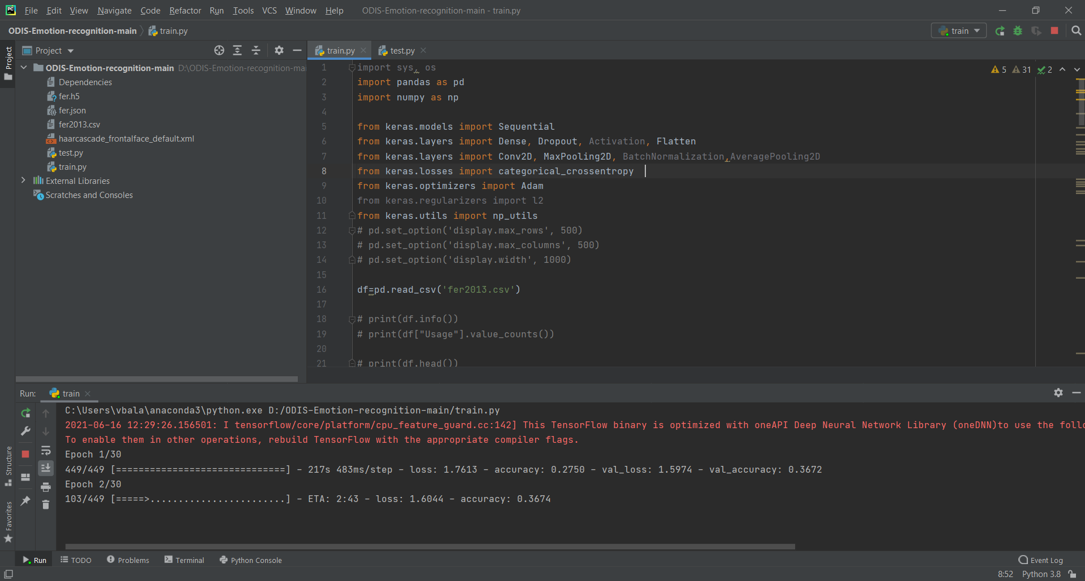

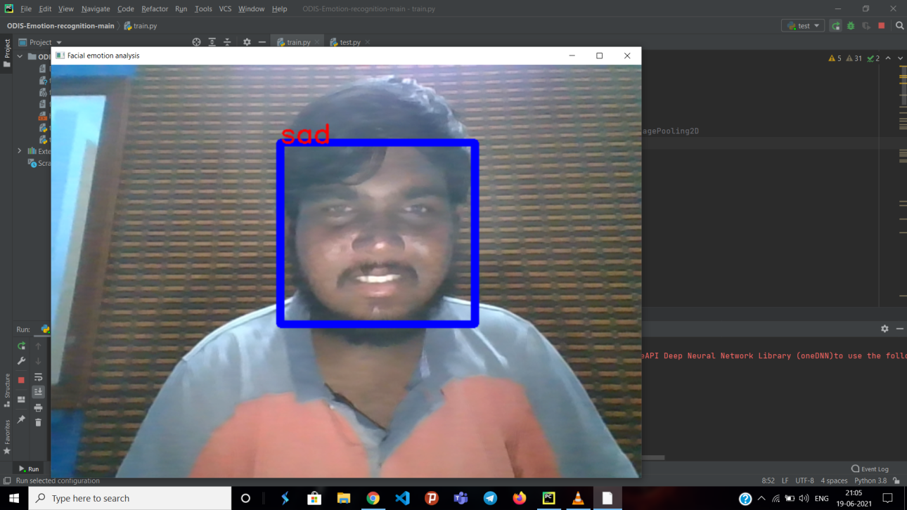

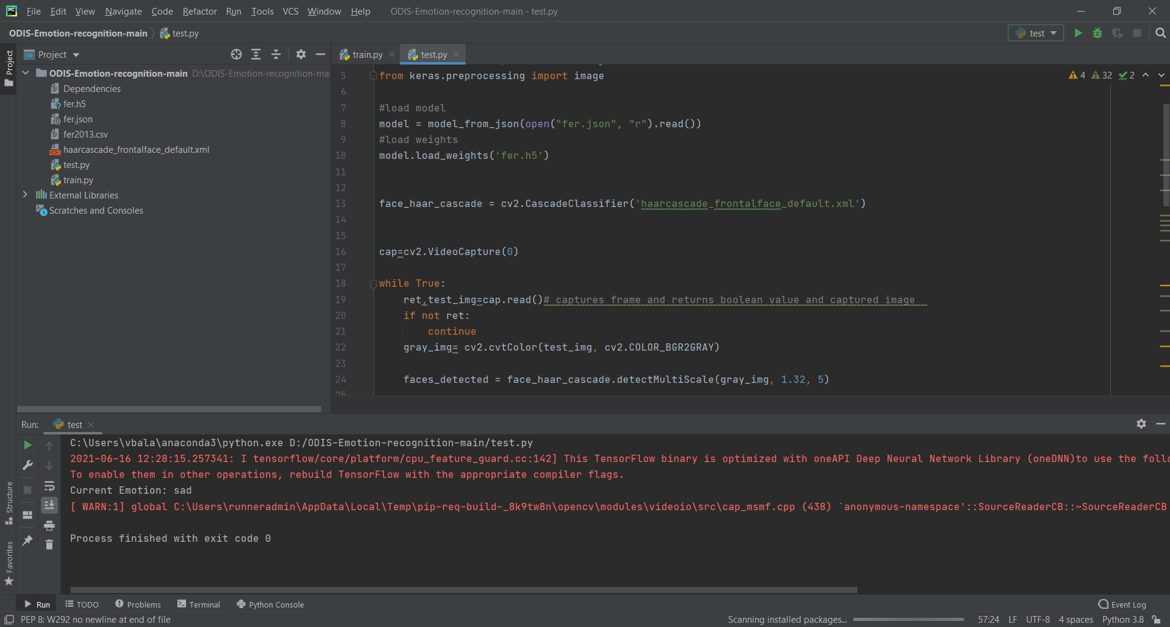

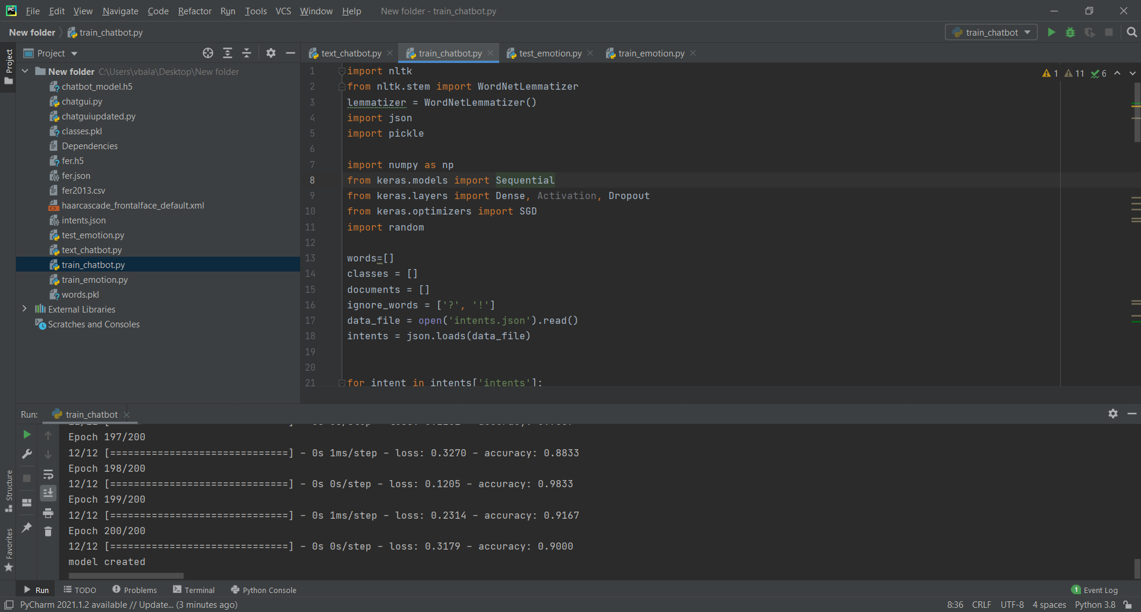
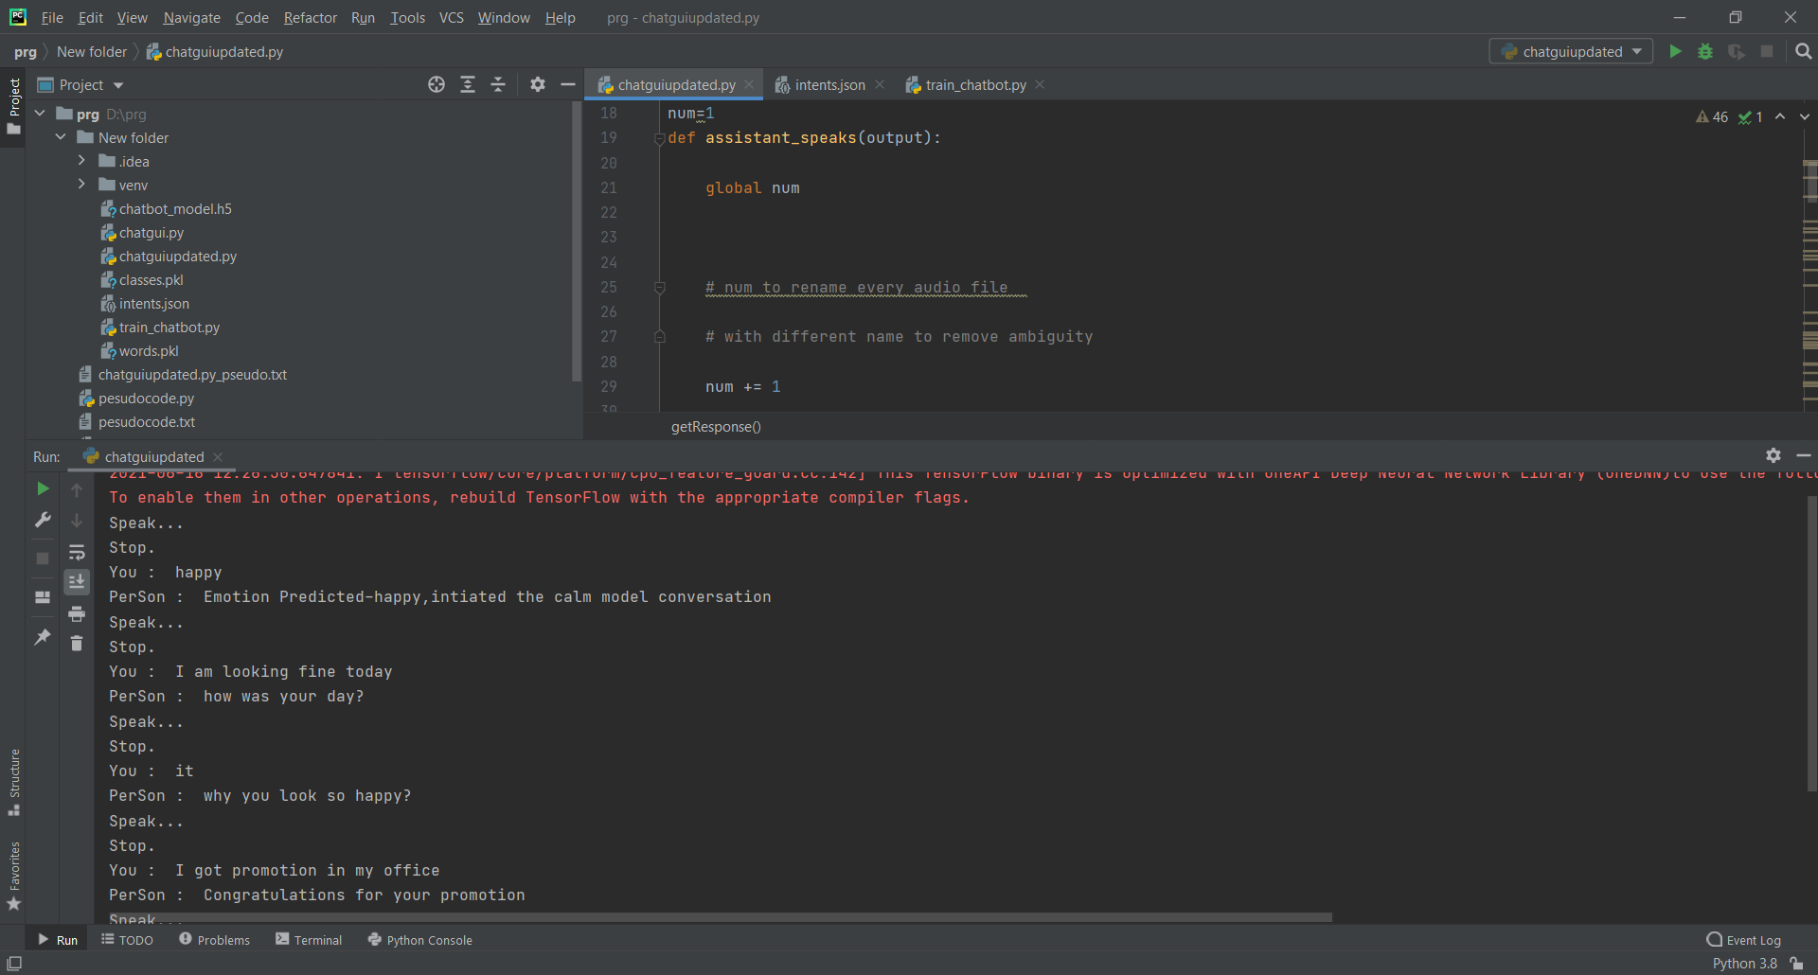

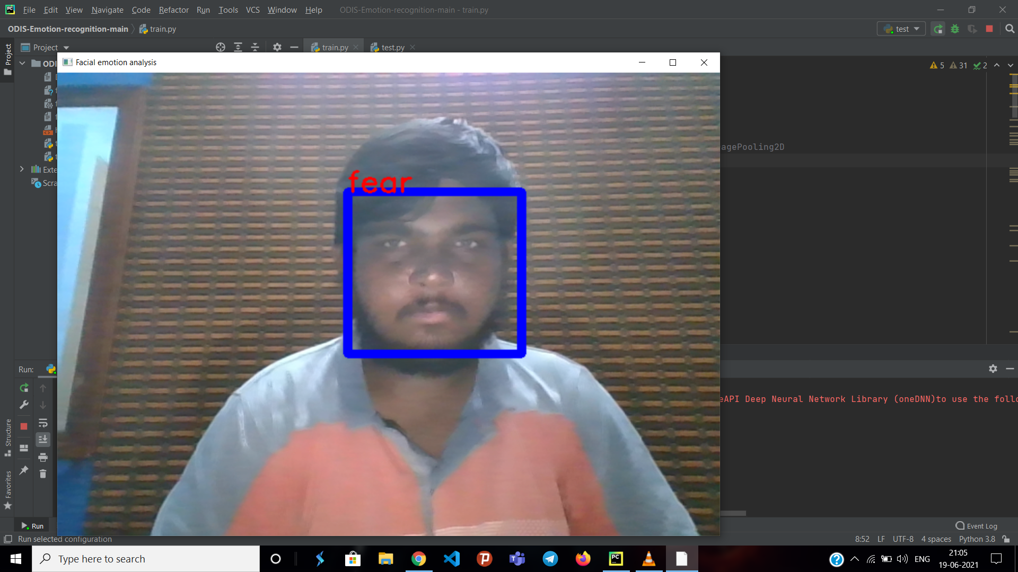

A2. SAMPLE CODE
Expression Recognition:
import os
import cv2
import numpy as np
from keras.models import model_from_json
from keras.preprocessing import image
#load model
model = model_from_json(open("fer.json", "r").read())
#load weights
model.load_weights('fer.h5')
face_haar_cascade = cv2.CascadeClassifier('haarcascade_frontalface_default.xml')
cap=cv2.VideoCapture(0)

while True:
ret,test_img=cap.read()# captures frame and returns boolean value and captured image
if not ret:
continue
gray_img= cv2.cvtColor(test_img, cv2.COLOR_BGR2GRAY)
faces_detected = face_haar_cascade.detectMultiScale(gray_img, 1.32, 5)
for (x,y,w,h) in faces_detected:
cv2.rectangle(test_img,(x,y),(x+w,y+h),(255,0,0),thickness=7)
roi_gray=gray_img[y:y+w,x:x+h]#cropping region of interest i.e. face area from image
roi_gray=cv2.resize(roi_gray,(48,48))
img_pixels = image.img_to_array(roi_gray)
img_pixels = np.expand_dims(img_pixels, axis = 0)
img_pixels /= 255
predictions = model.predict(img_pixels)

#find max indexed array
max_index = np.argmax(predictions[0])

emotions = ('angry', 'disgust', 'fear', 'happy', 'sad', 'surprise', 'neutral')
predicted_emotion = emotions[max_index]

cv2.putText(test_img, predicted_emotion, (int(x), int(y)), cv2.FONT_HERSHEY_SIMPLEX, 1, (0,0,255), 2)

resized_img = cv2.resize(test_img, (1000, 700))
cv2.imshow('Facial emotion analysis ',resized_img)
if cv2.waitKey(10) == ord('q'):#wait until 'q' key is pressed
break

cap.release()
cv2.destroyAllWindows
Training File:

import sys, os
import pandas as pd
import numpy as np

from keras.models import Sequential
from keras.layers import Dense, Dropout, Activation, Flatten
from keras.layers import Conv2D, MaxPooling2D, BatchNormalization,AveragePooling2D
from keras.losses import categorical_crossentropy
from keras.optimizers import Adam
from keras.regularizers import l2
from keras.utils import np_utils
# pd.set_option('display.max_rows', 500)
# pd.set_option('display.max_columns', 500)
# pd.set_option('display.width', 1000)

df=pd.read_csv('fer2013.csv')

# print(df.info())
# print(df["Usage"].value_counts())

# print(df.head())
X_train,train_y,X_test,test_y=[],[],[],[]

for index, row in df.iterrows():
val=row['pixels'].split(" ")
try:
if 'Training' in row['Usage']:
X_train.append(np.array(val,'float32'))
train_y.append(row['emotion'])
elif 'PublicTest' in row['Usage']:
X_test.append(np.array(val,'float32'))
test_y.append(row['emotion'])
except:
print(f"error occured at index :{index} and row:{row}")

num_features = 64
num_labels = 7
batch_size = 64
epochs = 30
width, height = 48, 48

X_train = np.array(X_train,'float32')
train_y = np.array(train_y,'float32')
X_test = np.array(X_test,'float32')
test_y = np.array(test_y,'float32')

train_y=np_utils.to_categorical(train_y, num_classes=num_labels)
test_y=np_utils.to_categorical(test_y, num_classes=num_labels)

#cannot produce
#normalizing data between oand 1
X_train -= np.mean(X_train, axis=0)
X_train /= np.std(X_train, axis=0)

X_test -= np.mean(X_test, axis=0)
X_test /= np.std(X_test, axis=0)

X_train = X_train.reshape(X_train.shape[0], 48, 48, 1)

X_test = X_test.reshape(X_test.shape[0], 48, 48, 1)

# print(f"shape:{X_train.shape}")
##designing the cnn
#1st convolution layer
model = Sequential()

model.add(Conv2D(64, kernel_size=(3, 3), activation='relu', input_shape=(X_train.shape[1:])))
model.add(Conv2D(64,kernel_size= (3, 3), activation='relu'))
# model.add(BatchNormalization())
model.add(MaxPooling2D(pool_size=(2,2), strides=(2, 2)))
model.add(Dropout(0.5))

#2nd convolution layer
model.add(Conv2D(64, (3, 3), activation='relu'))
model.add(Conv2D(64, (3, 3), activation='relu'))
# model.add(BatchNormalization())
model.add(MaxPooling2D(pool_size=(2,2), strides=(2, 2)))
model.add(Dropout(0.5))

#3rd convolution layer
model.add(Conv2D(128, (3, 3), activation='relu'))
model.add(Conv2D(128, (3, 3), activation='relu'))
# model.add(BatchNormalization())
model.add(MaxPooling2D(pool_size=(2,2), strides=(2, 2)))

model.add(Flatten())

#fully connected neural networks
model.add(Dense(1024, activation='relu'))
model.add(Dropout(0.2))
model.add(Dense(1024, activation='relu'))
model.add(Dropout(0.2))

model.add(Dense(num_labels, activation='softmax'))

# model.summary()

#Compliling the model
model.compile(loss=categorical_crossentropy,
optimizer=Adam(),
metrics=['accuracy'])

#Training the model
model.fit(X_train, train_y,
batch_size=batch_size,
epochs=epochs,
verbose=1,
validation_data=(X_test, test_y),
shuffle=True)

#Saving the model to use it later on
fer_json = model.to_json()
with open("fer.json", "w") as json_file:
json_file.write(fer_json)
model.save_weights("fer.h5")
Response Generation:

train_chatbot.py

import nltk
from nltk.stem import WordNetLemmatizer
lemmatizer = WordNetLemmatizer()
import json
import pickle

import numpy as np
from keras.models import Sequential
from keras.layers import Dense, Activation, Dropout
from keras.optimizers import SGD
import random

words=[]
classes = []
documents = []
ignore_words = ['?', '!']
data_file = open('intents.json').read()
intents = json.loads(data_file)

for intent in intents['intents']:
for pattern in intent['patterns']:

#tokenize each word
w = nltk.word_tokenize(pattern)
words.extend(w)
#add documents in the corpus
documents.append((w, intent['tag']))

# add to our classes list
if intent['tag'] not in classes:
classes.append(intent['tag'])

# lemmaztize and lower each word and remove duplicates
words = [lemmatizer.lemmatize(w.lower()) for w in words if w not in ignore_words]
words = sorted(list(set(words)))
# sort classes
classes = sorted(list(set(classes)))
# documents = combination between patterns and intents
print (len(documents), "documents")
# classes = intents
print (len(classes), "classes", classes)
# words = all words, vocabulary
print (len(words), "unique lemmatized words", words)

pickle.dump(words,open('words.pkl','wb'))
pickle.dump(classes,open('classes.pkl','wb'))

# create our training data
training = []
# create an empty array for our output
output_empty = [0] * len(classes)
# training set, bag of words for each sentence
for doc in documents:
# initialize our bag of words
bag = []
# list of tokenized words for the pattern
pattern_words = doc[0]
# lemmatize each word - create base word, in attempt to represent related words
pattern_words = [lemmatizer.lemmatize(word.lower()) for word in pattern_words]
# create our bag of words array with 1, if word match found in current pattern
for w in words:
bag.append(1) if w in pattern_words else bag.append(0)

# output is a '0' for each tag and '1' for current tag (for each pattern)
output_row = list(output_empty)
output_row[classes.index(doc[1])] = 1

training.append([bag, output_row])
# shuffle our features and turn into np.array
random.shuffle(training)
training = np.array(training)
# create train and test lists. X - patterns, Y - intents
train_x = list(training[:,0])
train_y = list(training[:,1])
print("Training data created")

# Create model - 3 layers. First layer 128 neurons, second layer 64 neurons and 3rd output layer contains number of neurons
# equal to number of intents to predict output intent with softmax
model = Sequential()
model.add(Dense(128, input_shape=(len(train_x[0]),), activation='relu'))
model.add(Dropout(0.5))
model.add(Dense(64, activation='relu'))
model.add(Dropout(0.5))
model.add(Dense(len(train_y[0]), activation='softmax'))

# Compile model. Stochastic gradient descent with Nesterov accelerated gradient gives good results for this model
sgd = SGD(lr=0.01, decay=1e-6, momentum=0.9, nesterov=True)
model.compile(loss='categorical_crossentropy', optimizer=sgd, metrics=['accuracy'])

#fitting and saving the model
hist = model.fit(np.array(train_x), np.array(train_y), epochs=200, batch_size=5, verbose=1)
model.save('chatbot_model.h5', hist)

print("model created")

text_chatbot.py

import nltk
import speech_recognition as sr
import playsound
import os
from gtts import gTTS
from nltk.stem import WordNetLemmatizer
lemmatizer = WordNetLemmatizer()
import pickle
import numpy as np

from keras.models import load_model
model = load_model('chatbot_model.h5')
import json
import random
intents = json.loads(open('intents.json').read())
words = pickle.load(open('words.pkl','rb'))
classes = pickle.load(open('classes.pkl','rb'))
num=1
def assistant_speaks(output):

global num

# num to rename every audio file

# with different name to remove ambiguity

num += 1

print("PerSon : ", output)

toSpeak = gTTS(text = output, lang ='en', slow = False)

# saving the audio file given by google text to speech

file = str(num)+".mp3"

toSpeak.save(file)
playsound.playsound(file, True)

os.remove(file)

def get_audio():

rObject = sr.Recognizer()

audio = ''

with sr.Microphone() as source:

print("Speak...")

# recording the audio using speech recognition

audio = rObject.listen(source, phrase_time_limit = 2)

print("Stop.") # limit 5 secs

try:

text = rObject.recognize_google(audio, language ='en-US')

print("You : ", text)

return text

except:

assistant_speaks("Could not understand your audio, PLease try again !")

return 0
def clean_up_sentence(sentence):
# tokenize the pattern - split words into array
sentence_words = nltk.word_tokenize(sentence)
# stem each word - create short form for word
sentence_words = [lemmatizer.lemmatize(word.lower()) for word in sentence_words]
return sentence_words

# return bag of words array: 0 or 1 for each word in the bag that exists in the sentence

def bow(sentence, words, show_details=True):
# tokenize the pattern
sentence_words = clean_up_sentence(sentence)
# bag of words - matrix of N words, vocabulary matrix
bag = [0]*len(words)
for s in sentence_words:
for i,w in enumerate(words):
if w == s:
# assign 1 if current word is in the vocabulary position
bag[i] = 1
if show_details:
print ("found in bag: %s" % w)
return(np.array(bag))

def predict_class(sentence, model):
# filter out predictions below a threshold
p = bow(sentence, words,show_details=False)
res = model.predict(np.array([p]))[0]
ERROR_THRESHOLD = 0.25
results = [[i,r] for i,r in enumerate(res) if r>ERROR_THRESHOLD]
# sort by strength of probability
results.sort(key=lambda x: x[1], reverse=True)
return_list = []
for r in results:
return_list.append({"intent": classes[r[0]], "probability": str(r[1])})
return return_list

def getResponse(ints, intents_json):
global result
tag = ints[0]['intent']
list_of_intents = intents_json['intents']
for i in list_of_intents:
if(i['tag']== tag):
result = random.choice(i['responses'])
break
return result

while True:
msg=get_audio()
while(msg==0):
msg = get_audio()
ints = predict_class(msg, model)
res = getResponse(ints, intents)
assistant_speaks(res)

REFERENCES

- A Review paper on emotional intelligence:Models and Relationships with otherconstructs,Dr.SandhyaMehata,NamrataSingh,2013,https://www.researchgate.net/publication/331082949_A_Review_paper_on_emotional_intelligence_Models_and_relationship_with_other_constructs,
- A Study on Emotional Intelligence At Work Place,Dr.DestiKannaiah,Dr.R.Shanthi,2015,https://researchonline.jcu.edu.au/40340/1/40340%20Kannaiah%20and%20Shanthi%202015.pdf
- A study on emotion recognition method and its application using face image, Hyeon-Jung Lee , Kwang-Seok Hong ,2017, https://ieeexplore.ieee.org/document/8191005A
- Real-Time Analytics and Machine Learning by IBM. (https://www.ibm.com/it-infrastructure/z/capabilities/real-time-analytics)
- An Introduction to Neural Networks by James A. Anderson.(ISBN:978-02-623-1588-3)
- Fundamentals of Neural Networks by Lauren Fausett.(ISBN:978-81-317-0053-2, 813-17-0053-4)
- Data Communications and Computer Networks by Michael Duck & Richard Read (ISBN: 978-81-317-2698-2)
- The Hindu Website https://www.thehindu. com/ todays-paper/tp-opinion/loneliness-could-literally-kill you/article 19437568.ece)
- The webpsychology webpage (https://www.web psychology.com/news/2015/12/14/severe-loneliness-lead s -depression-248116)
- Image Processing using Partial Differential Equations (https://www.lri.fr/~gcharpia/VisionSeminar/slides/2014-04-02-kornprobst-vist.pdf)
- Python and Machine Learning for Dummies by John Paul Mullar & Luca Massaron (ISBN: 978-81-265-6305-0)

