

**DIPARTIMENTO DI INGEGNERIA INFORMATICA, MODELLISTICA, ELETTRONICA E SISTEMISTICA**

"2D Cutting Machine" Project Report Industrial Automation Systems A.A 2021/2022

Professor: Student:

Pietro M. Muraca Rustemova A.

INTRODUCTION ....................................................................................................................

1. Description. Laser cut .......................................................................................................

2. Technical specifications of the design to be made............................................................

3. Generation of the trajectory..............................................................................................

4. Control structure of a DC motor. .......................................................................................

5. Mathematical model of the DC engine ..............................................................................

6. Specifications of the motors used ......................................................................................

7. Control scheme for the DC engine......................................................................................

8. Classical method…………………………………………………………………………………………………………….

9. Feedforward action.............................................................................................................

10. Final result of the cut. ......................................................................................................

CONCLUSION...........................................................................................................................

**Introduction**

Laser cutting machine is a tool used in a wide range of industries for [precision cutting](https://shapecut.com.au/plates-stocked/) and designing projects.

The laser cutting machine emits a high-powered laser beam to either cleanly cut or etch a specific design on materials such as steel, plastic or wood. It is generally used more for industrial manufacturing applications and the beam will either burn, vaporise or melt away the excess product, leaving a superior finished design or edge.

A [laser cutting machine](https://shapecut.com.au/services/laser-cutting/) has settings known as the computer numerical control (CNC), as well as laser optics, which control and direct the laser beam’s intensity for the desired design effect, or the specific cuts required in a manufacturing or design project. The laser beam is generated by a process whereby electrical discharges or a lamp trigger a lasing material within a confined container causing a chemical reaction, resulting in a high-powered beam being released. The beam is then reflected using a mirror in a stream of monochromatic light. From the mirror, the light is then directed by fibre optics or mirrors to the work area, with the narrowest point of the beam cutting or making the design etch on the material.

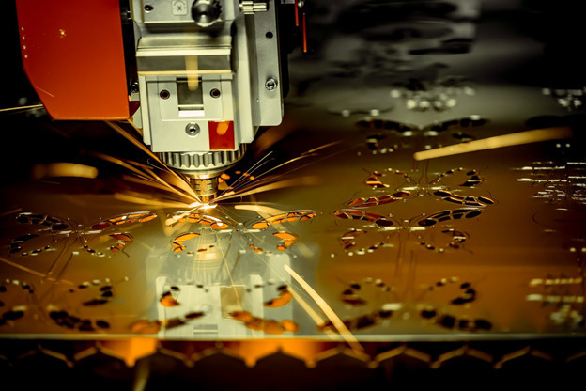

**Fig 1: Example of laser cutting machine.**

A [laser cutting machine](https://shapecut.com.au/services/laser-cutting/) is often used in engineering for the precision cutting of components of machines. For industrial applications, a laser cutting machine is often used to cut structural and piping materials and flat sheet material such as metal. The CNC setting can also be changed to etch or engrave all types of designs on metal, wood and plastic. Speciality CAD (computer aided design) software is used to program the CNC and direct it to perform either the cutting, engraving or etching specifications required for the laser cutting project. The size and capacity of the laser cutting machine determines whether it can be used for smaller or larger-scale manufacturing projects.

**1. Description.**

**Laser cut**

The Design Mechanism consists of two structures, one on the X axis and the other on the Y axis, supported on linear guides. The carriage on the X axis will move through this supporting the weight of the laser module, the carriage on the Y axis will travel together with the structure of the X axis so it will support the greatest load.

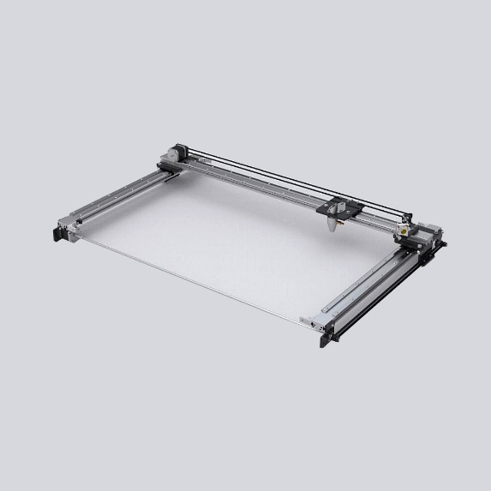

**Fig 2: Movement mechanism**

**2. Technical specifications of the design to be made**

The type of machinery that was considered in this work is a two-axis plane laser cutting machine, which has two equal DC motors that allow it to operate in a two-dimensional workspace, which has been described as a cartesian space. The main task of this mechanical system is to cut and extract the assigned geometric shapes, moving along the two coordinated axes. The design to be made is as follows:

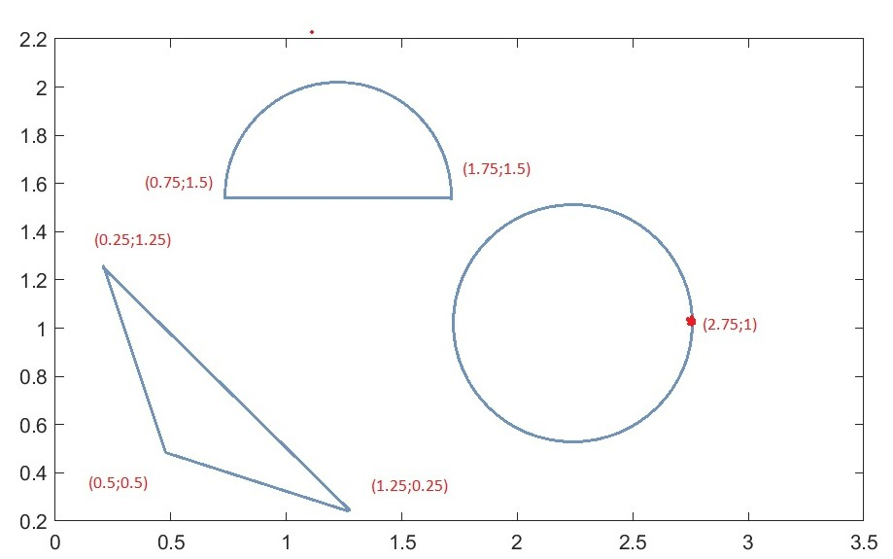

**Fig 3: Cut to be made.**

Description of the cut

1. Initially the machine is located in the position (3; 2).

2. The first cut to be made is a triangle. For this purpose, the cutting path to be followed by the machine was set (see coordinate points, figure 3), with (0.5; 0.5) being the starting point and the cutting end point for this figure.

3. Then, the machine moves towards the point (1.75; 1.5) where the cutting of a semicircle of radius 0.5m will begin.

4.Finally, the machine moves towards the point (2.75; 1) where the cutting of a circle of radius 0.5m will begin.

**3. Generation of the trajectory**

Being able to fix the position of each geometric shape on the laminated plate reduces the waste of material, for this reason the laser path is chosen in order to reduce the number of movements that the machine has to do to perform its task. To this end, a cutting path is provided to define, point by point, the operations that the machine must perform to cut the designed shapes, moving its axes in assigned mechanical parameters, such as the position of the laser tool, or the speed and acceleration that both axes must reach during their movements. The trajectory has been described by means of the polynomial interpolation between two adjacent points, using a polynomial of five degree for the generation of the reference.

The polynomial is chosen as follows: 𝑥(𝑡) = 𝑎0𝑡 𝑚 + 𝑎1𝑡 𝑚−1 + ⋯ + 𝑎𝑚𝑡 𝑚

We proceed to normalize the trajectory:

𝜆

Xf 2π 1

Xi 0

Ti **Tf Ti**  Tf 0 1 δ

𝜆 = (𝑋 – 𝑋𝑖)/( 𝑋𝑓 – 𝑋) 𝜆 = (𝜃 − 𝜃𝑖)/( 𝜃𝑓 − 𝜃i) 𝜎 = (𝑡 − 𝑇𝑖)/( 𝑇𝑓 − 𝑇i)

𝑋 = 𝑋𝑖 + 𝜆(𝑋𝑓 − 𝑋𝑖) 𝜃 = 𝜃𝑖 + 𝜆(𝜃𝑓 − 𝜃𝑖) 𝑡 = 𝑇𝑖 + 𝜎(𝑇𝑓 − 𝑇𝑖)

(𝑡, 𝑥) ↔ (𝜎, 𝜆) The property in space (𝑡, 𝑥) is completely analogous to that of space (𝜎, 𝜆) 𝑥(𝑡) ↔ 𝜆(𝜎) The property of the function 𝑥(𝑡) is equivalent to the property 𝜆 (𝜎).

You can write the polynomial as: 𝜆(𝜎) = a0𝜎 𝑚 + 𝑎1𝜎 𝑚−1 + ⋯ + 𝑎𝑚𝜎 𝑚

The expression of fifth degree generic polynomial is shown below:

𝜆(𝜎) = 𝑎0𝜎 5+𝑎1𝜎 4+𝑎2𝜎 3+𝑎3𝜎 2+𝑎4𝜎+𝑎5

As the trajectory from 0 to has been regulated now the extremes are 𝑇𝑖 = 0 y 𝑇𝑓 = 1 and it must be satisfied that the speed 𝑉(𝑇𝑖 ) = 0 and 𝑉(𝑇𝑓) = 0. Then to calculate 𝑎𝑛, the position, velocity and acceleration polynomials are evaluated for:

λ(0) = 0 𝜆̇(0) = 0 𝜆̈(0) = 0 𝜆(1) = 1 𝜆̇(1) = 0 𝜆̈(1) = 0

We have the following system of linear equations:

λ(0)=b5=0

λ̇(0)=b4=0

λ̈(0)=b3=0

λ(1)=b0+ b1+ b2=1

λ̇(1)=5b0+ 4b1+ 3b2=0

λ̈(1)=20b0+ 12b1+ 6b2=0

The solution to the system of linear equations is:

𝑎0 = 6, a1 = −15 , a2 = 10, a3 = 0, a4 = 0

When substituting the coefficients of the polynomial it remains:

𝜆(𝜎) = 6𝜎 5 − 15𝜎 4 + 10𝜎 3

Equation for calculating a straight path:

𝑋 = 𝑋𝑖 + 𝜆(𝜎)(𝑋𝑓 – 𝑋*i*)

𝑌 = 𝑌𝑖 + 𝜆(𝜎)(𝑌𝑓 − 𝑌𝑖 )

Equation for calculating the trajectory of a circle:

𝑋(𝛳) = 𝑋𝑐 + 𝑅𝑐𝑜𝑠(𝛳)

𝑌(𝛳) = 𝑌𝑐 + 𝑅𝑠i𝑛(𝛳)

The following graphs plotted using MatLab represent the behavior of fifth degree polynomial, in terms of position, velocity and acceleration profiles.

**Position**

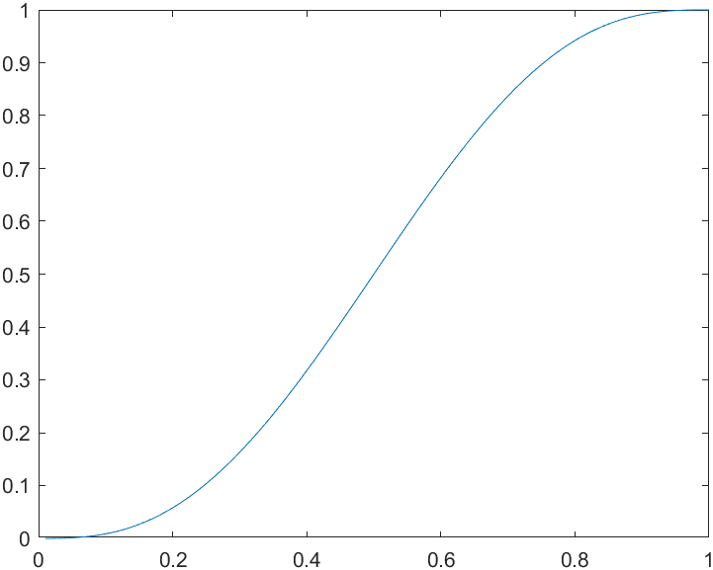

**Velocity**

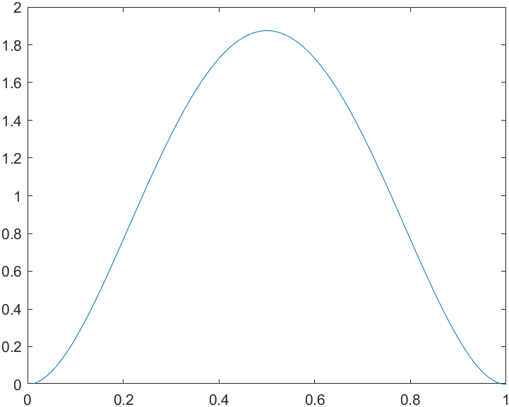

**Acceleration**

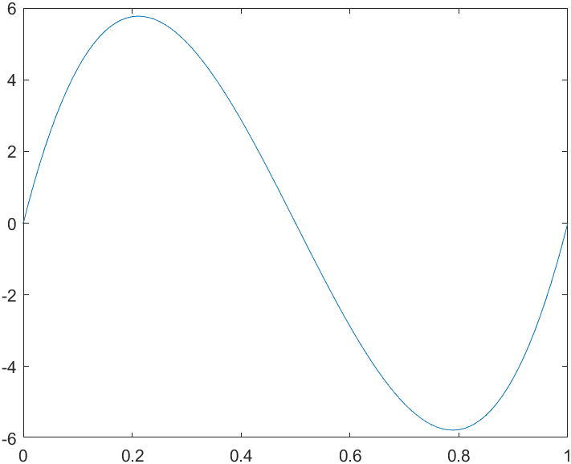

**Fig 4: Graphs of position, velocity and acceleration in fifth order polynomial.**

**4. Control structure of DC motor.**

To move the machine to the desired cutting position, a direct current motor is mounted on each axis. Direct current electric motors, also known as direct current, DC motor were invented before alternating current, however they are used less frequently today. This type of motor converts electrical energy into mechanical energy by means of a rotary movement, said movement is generated as a consequence of the magnetic field. The main characteristic of the DC motor is the possibility of regulating the speed from empty to full load. A direct current machine is mainly composed of two parts, a stator that gives mechanical support to the device and has a hole in the center, generally cylindrical in shape. In the stator there are also the poles, which can be permanent magnets or windings with copper wire on an iron core. The rotor is generally cylindrical in shape, also wound and with a core, to which the current reaches through two brushes. This DC machine is one of the most versatile in the industry. Its easy control of position, torque and speed have made it one of the best options in process control and automation applications.

**1.5. Mathematical model of the DC engine**

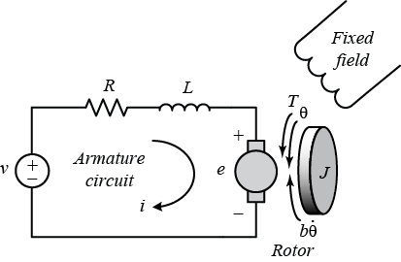 **Fig 5: Direct current motor system.**

Electric model:

𝐿𝑎 *𝑑𝑖𝑎 /𝑑𝑡 = 𝑉𝑎 − 𝑅𝑎𝑖𝑎 – 𝐾tω

Mechanical model:

𝐽*𝑑ω/𝑑𝑡 = 𝐾t𝑖𝑎 − 𝑏ω − 𝜏r

𝑑𝛳/𝑑𝑡 = ω

Where:

|  |  |
| --- | --- |
| 𝐿a | Armature inductance |
| 𝐾t | Torque coefficient and electromotive force |
| 𝑅a | Armature Resistance |
| 𝐽 | Inertia |
| **B** | Friction coefficient |
| 𝑖𝑎 | Armature current |
| Ω | Rotor speed |
| 𝛳 | Rotor position |
| 𝑉𝑎 | Income voltage |
| 𝜏r | Disturbance |

The motor transfer function is expressed as an input-output form, that is:

𝐺(𝑠) = 𝛳(𝑠)/ 𝑉𝑎 = 𝐾t /((𝑆𝐿𝑎 + 𝑅𝑎 )(𝐽𝑆 + B) + 𝐾 t2)

The direct current motor scheme is the following:

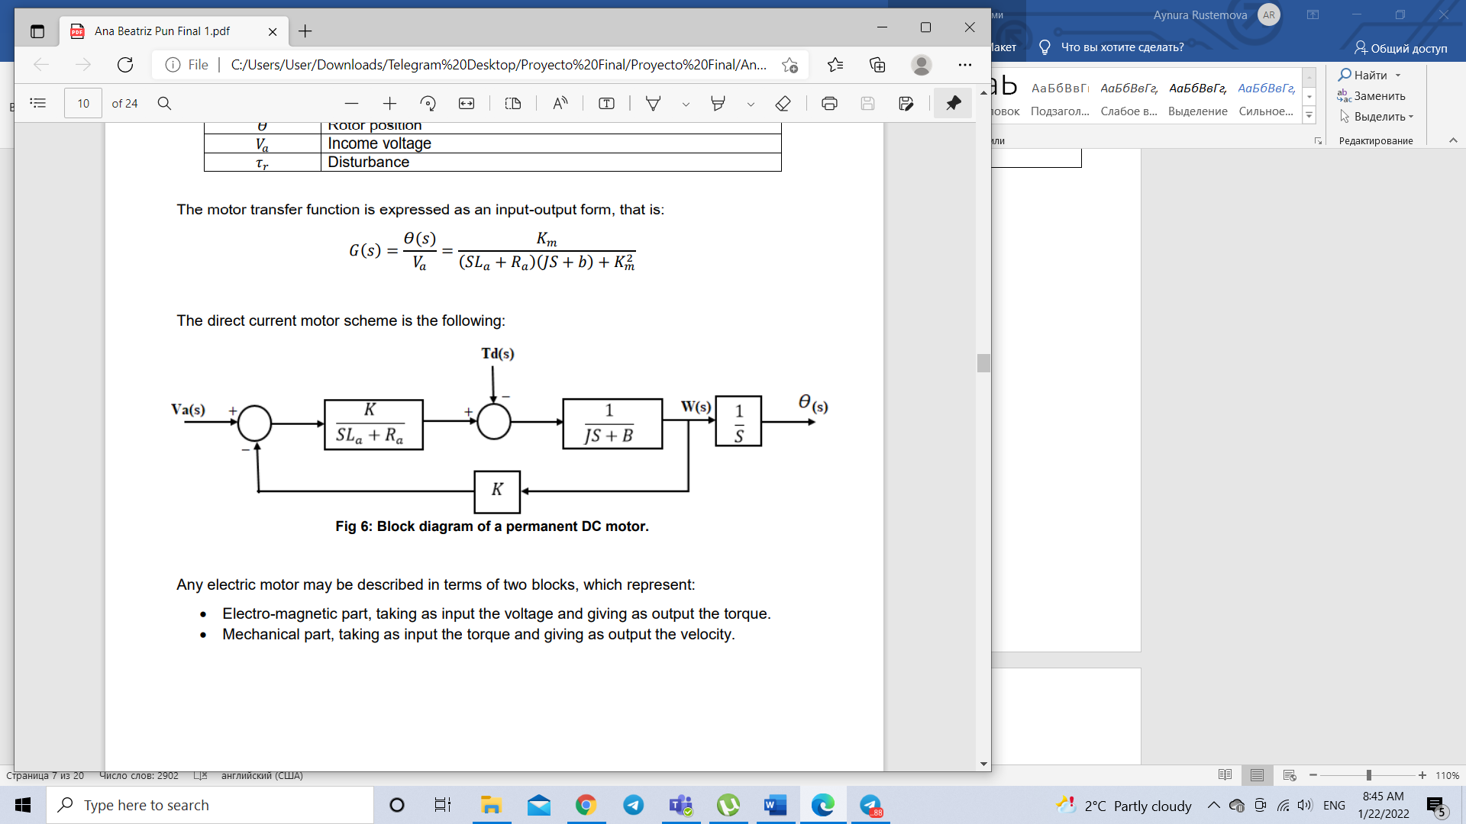

**Fig 6: Block diagram of a permanent DC motor.**

Any electric motor may be described in terms of two blocks, which represent:

• Electro-magnetic part, taking as input the voltage and giving as output the torque.

• Mechanical part, taking as input the torque and giving as output the velocity. So, the electrical subsystem of the motor is therefore characterized by first order dynamics, having a real pole equal to 𝑃𝑒 = − 𝑅𝑎/𝐿𝑎 named electric pole and the mechanical subsystem that is of the first order too, characterized by the pole 𝑃𝑚 = − 𝑏/𝐽, that is called mechanical pole.

**6. Specifications of the motors used**

To cut the slabs, two equal direct current motors were used on each axis, with the following characteristics:

Ra=1 Ω;

La=1mH;

ke=0.6;

kt=0.6;

J=0.1 Kgm2;

B=0.029 𝑁𝑚𝑠/𝑟𝑎d;

|V| ≤ 200 Volts

|I| ≤ 20 Amperes

The mechanism that transforms the rotation into translation has a transformation coefficient equal to: 1m= 2000revolution.

Block diagram implemented in Simulink of a continuous current engine:

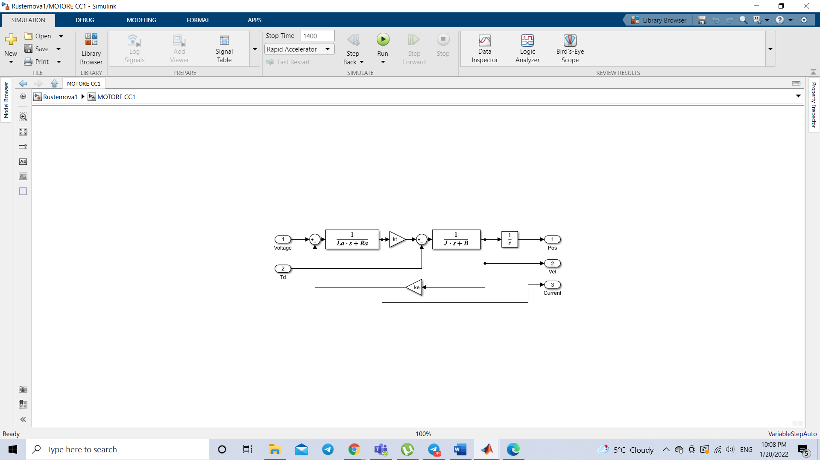

**Fig 7: Direct current motor design in Simulink**

**7. Classical method.**

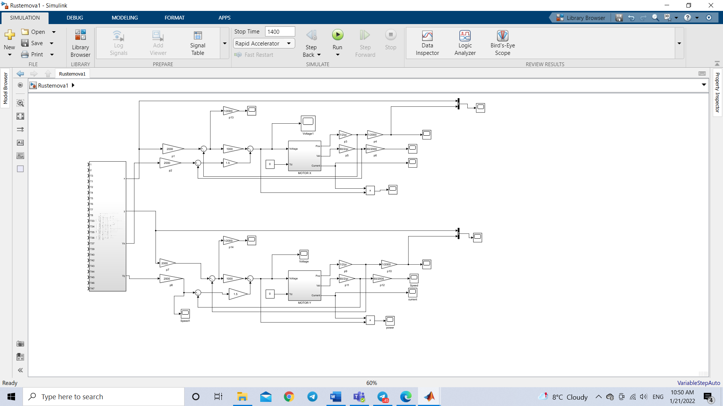

**Fig8: General diagram of the cutting machine with classical method**

In this method, reference signals for position and velocity are obtained with Matlab function block. Separate blocks with respective formulas are created for each figure (triangle, semicircle, circle) and line connecting figures. Since, I have used sampling time 0.01, I got the values of the functions for all values of sampling interval. In order to proceed the data, I have used lookup tables. Following this, Matlab function is applied to obtain the necessary information about signal in required interval. For example, in the interval T1:t:T4 the information regarding the triangle is needed. Furthermore, another Matlab function is used to show in which interval the machine should cut and not. Proportional controllers and position, velocity feedbacks are used to control the given system. The obtained errors meet the requirements of the given task, being less than 2mm in both axes. Another thing, which should be taken into account is the parameters of motor. During the cutting, motors work not exceeding the given physical parameters, such as, current, voltage and power.

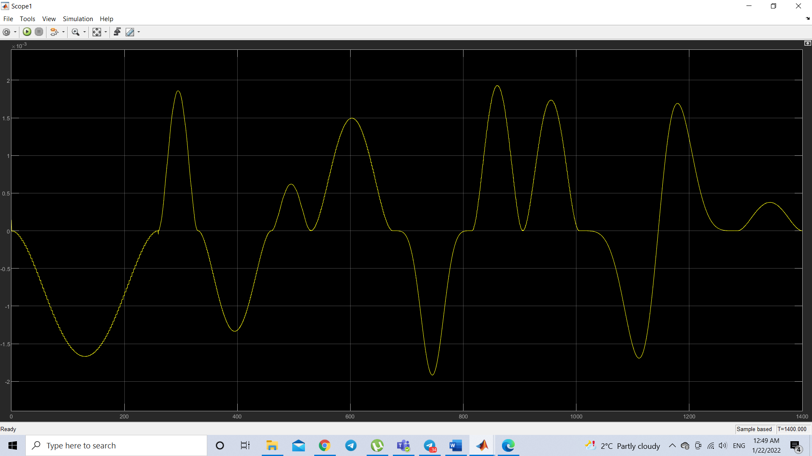

**Fig9: Error comparison between target and real position along x-axis**

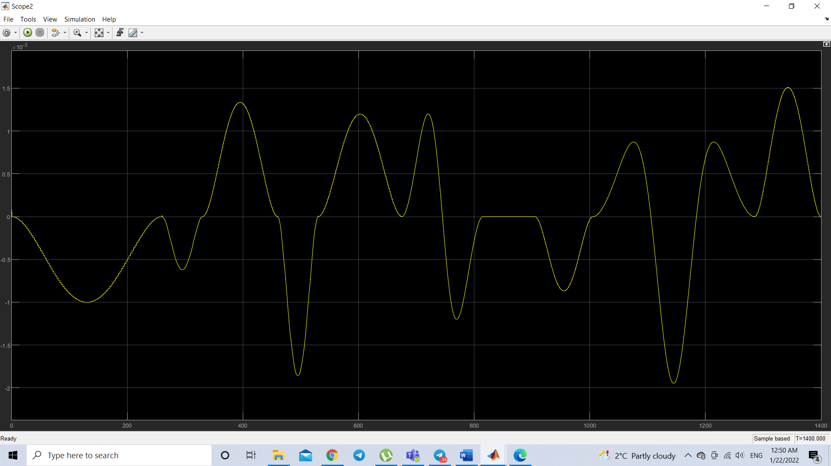

**Fig10: Error comparison between target and real position along y-axis**

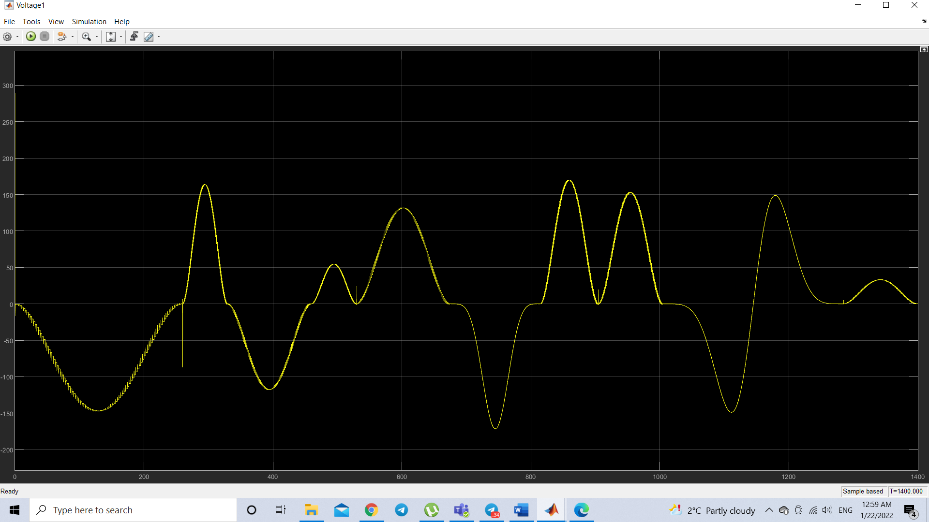

**Fig11: Graph of voltage on x axis**

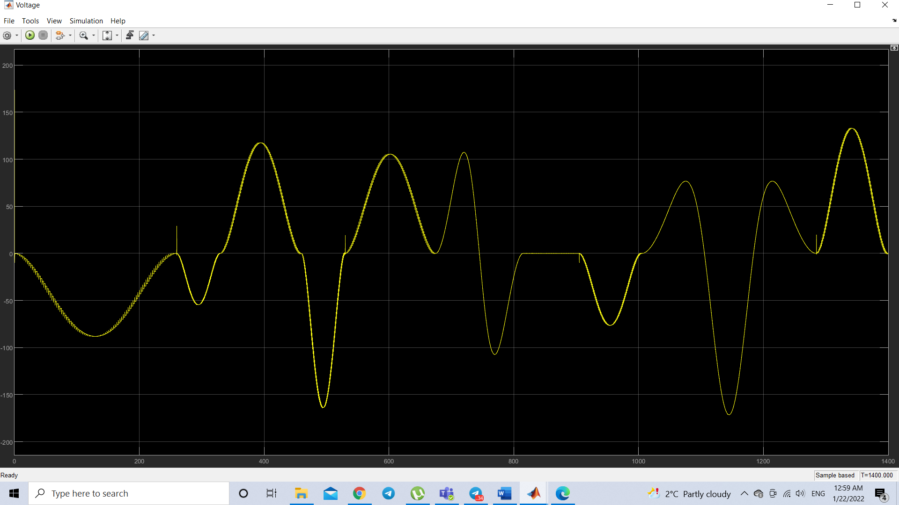

**Fig12: Graph of voltage on y axis**

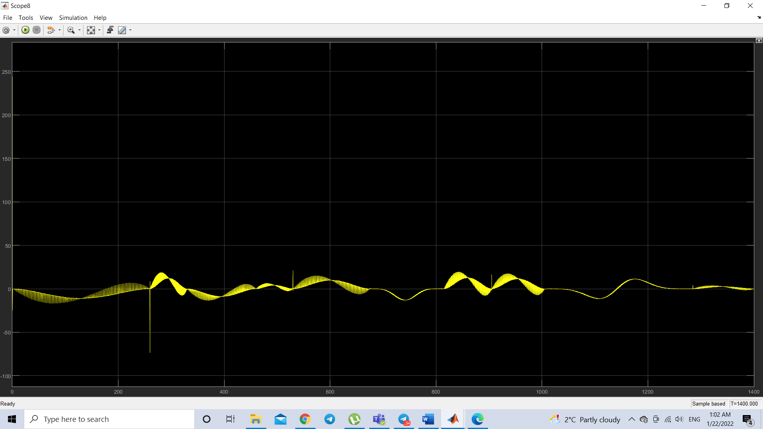

**Fig13: Graph of current on x axis**

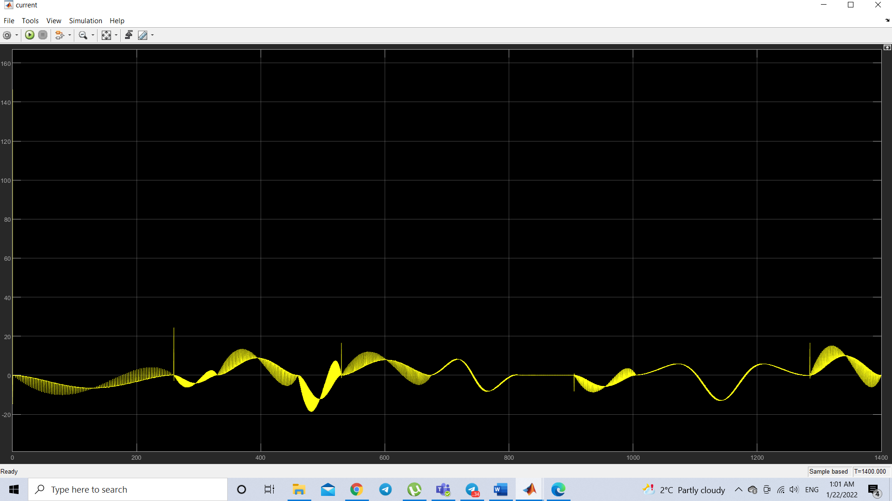

**Fig14: Graph of current on y axis**

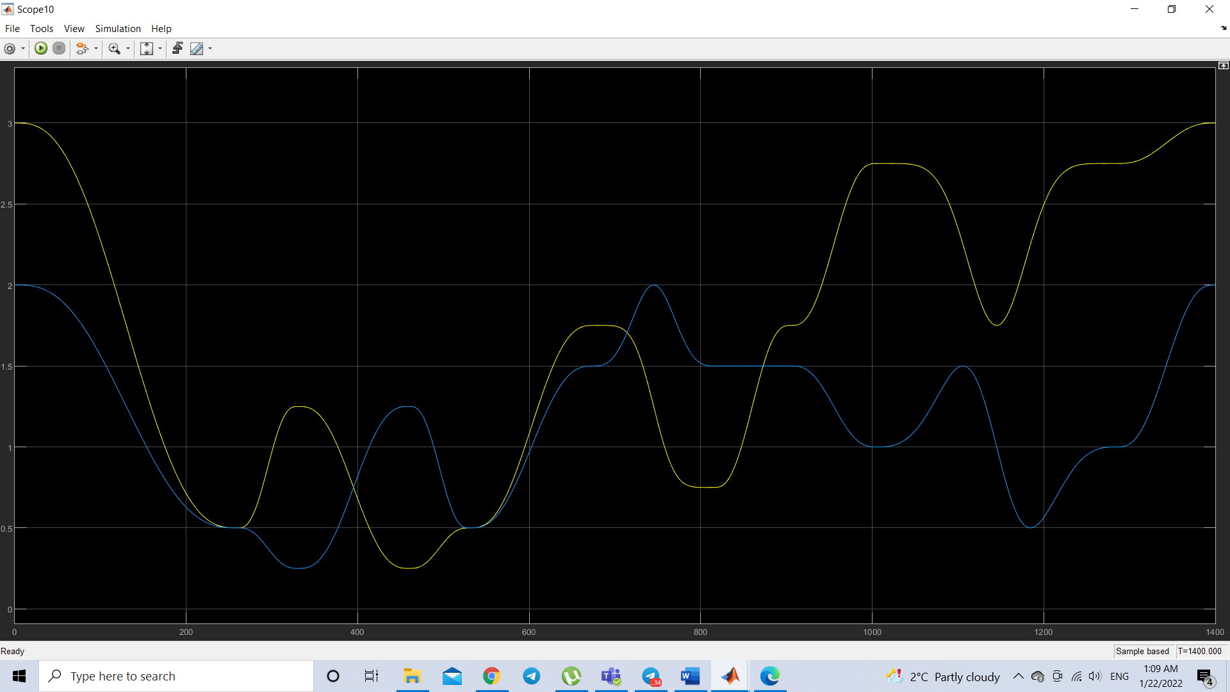

**Fig15: Description of the position of each motor during cutting**

**8. Control scheme for the DC engine.**

DC motor control techniques are tools used to control the speed, torque, and power supply of DC motors.

PID control is a control mechanism that through a feedback loop allows regulating the variables of a process in general. The PID controller calculates the difference between our real variable versus the desired variable.  
**P- Controller**  
Proportional or P- controller gives an output that is proportional to current error e (t). It compares the desired or set point with the actual value or feedback process value. The resulting error is multiplied with a proportional constant to get the output. If the error value is zero, then this controller output is zero.  
**I-Controller**  
Due to the limitation of p-controller where there always exists an offset between the process variable and setpoint, I-controller is needed, which provides necessary action to eliminate the steady-state error.  It integrates the error over a period of time until the error value reaches zero. It holds the value to the final control device at which error becomes zero.  
**PI controller**  
Integral control decreases its output when a negative error takes place. It limits the speed of response and affects the stability of the system. The speed of the response is increased by decreasing integral gain, Ki. **D-Controller**  
I-controller doesn’t have the capability to predict the future behavior of error. So it reacts normally once the setpoint is changed. D-controller overcomes this problem by anticipating the future behavior of the error. Its output depends on the rate of change of error with respect to time, multiplied by derivative constant. It gives the kick start for the output thereby increasing system response.  
So, finally we observed that by combining these three controllers, we can get the desired response for the system.

In this way it’s possible to divide the assigned control problem into three subproblems that are simpler than the first.

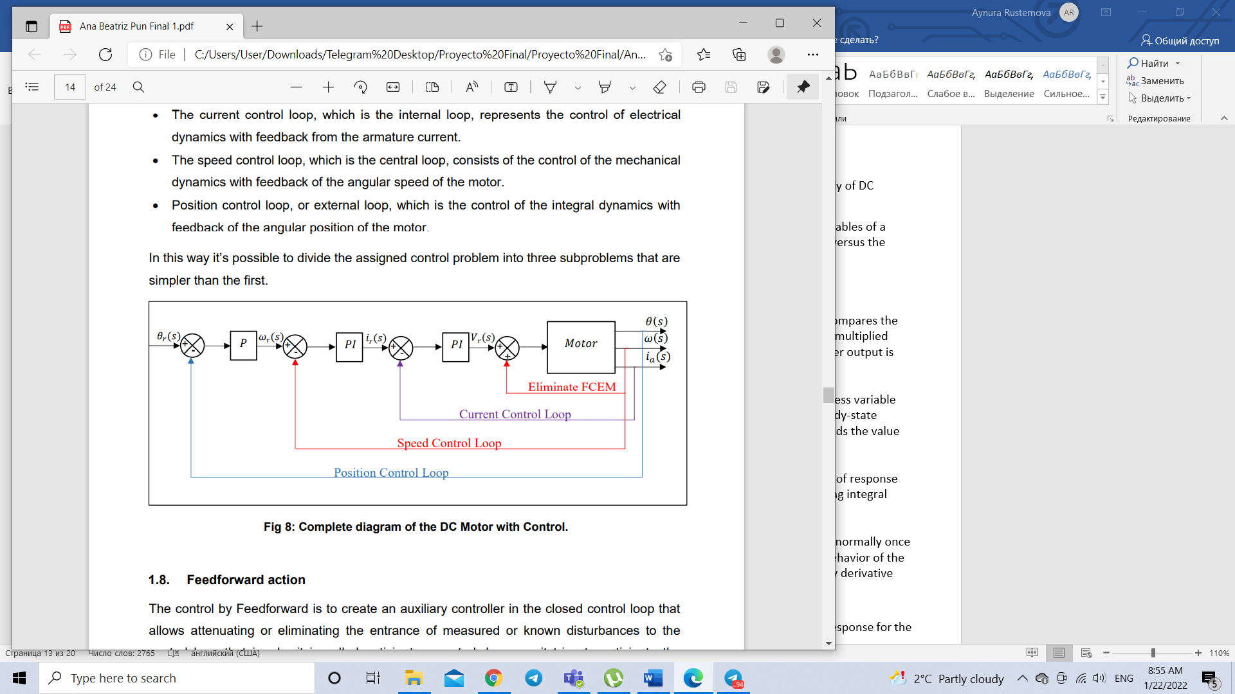

**9. Feedforward action**

The control by Feedforward is to create an auxiliary controller in the closed control loop that allows attenuating or eliminating the entrance of measured or known disturbances to the control loop that is why it is called anticipatory control, because it tries to anticipate the disturbances that go to affect the system. The general control scheme using the feedforward action is shown below:

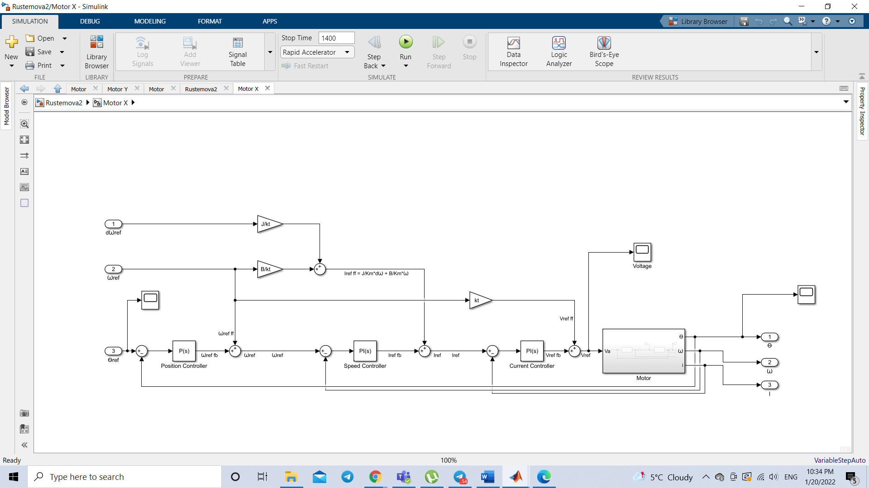

**Fig16: Control scheme of feedforward action.**

**Controller parameter calculation**

The constants of the PID selected for the control of the cutting machine after were the following:

Calculation of the controller parameters in the current cycle:

• To calculate the proportional action, choose: 𝐾𝑝 = 𝐾*𝐿𝑎 𝐾𝑝 = 1000 ∗ 𝐿𝑎

• To calculate the integral action, choose: 𝐾𝑖 = 𝐾*𝑅𝑎 𝐾𝑖 = 1000 ∗ 𝑅𝑎

K is chosen so that K≈ |𝑃𝑒 | = 1000, what is important is that there is feedback on the current, without modifying the tempo constant. In general, what you are looking for is not to modify the electrical part so much, to find that there is a quiet transient. In general, the integral effect tends to compensate for the errors made in the measurement of Ra y La.

Calculation of controller parameters in the speed cycle:

• To calculate the proportional action, choose: 𝐾𝑝 = 𝐾*𝐽 𝐾𝑝 = 344 ∗ 𝐽

• To calculate the integral action, choose: 𝐾𝑖 = 𝐾*𝐵 𝐾𝑖 = 344*𝐵

K is chosen in such a way as to allow the mechanical part to be given a little speed, of at least a decade, In this case 𝐾 = 344. With this type of feedback, ignorance or eventual errors with respect to nominal values of J and B are compensated; it also reduces or eliminates the disturbance effects that are present.

Calculation of controller parameters in the position cycle:

• Only a proportional action is chosen, setting the value of 𝐾𝑝 at least 1 decade to the right of the velocity pole, In This case 𝐾𝑝 = 10. These values are the same, both for the direct current motor controller along abscissa axis and for the one along ordinate axis.

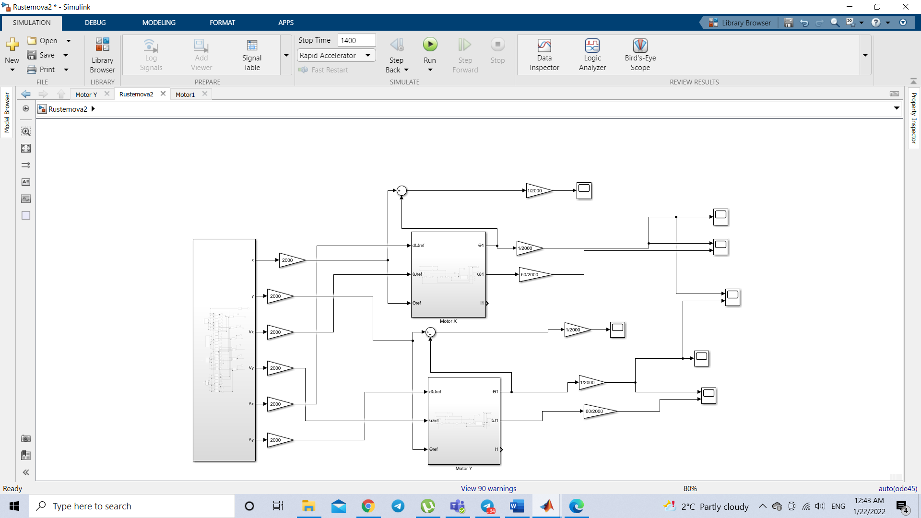

**Fig17: General diagram of the cutting machine**

Simulink model of the Motor control scheme:

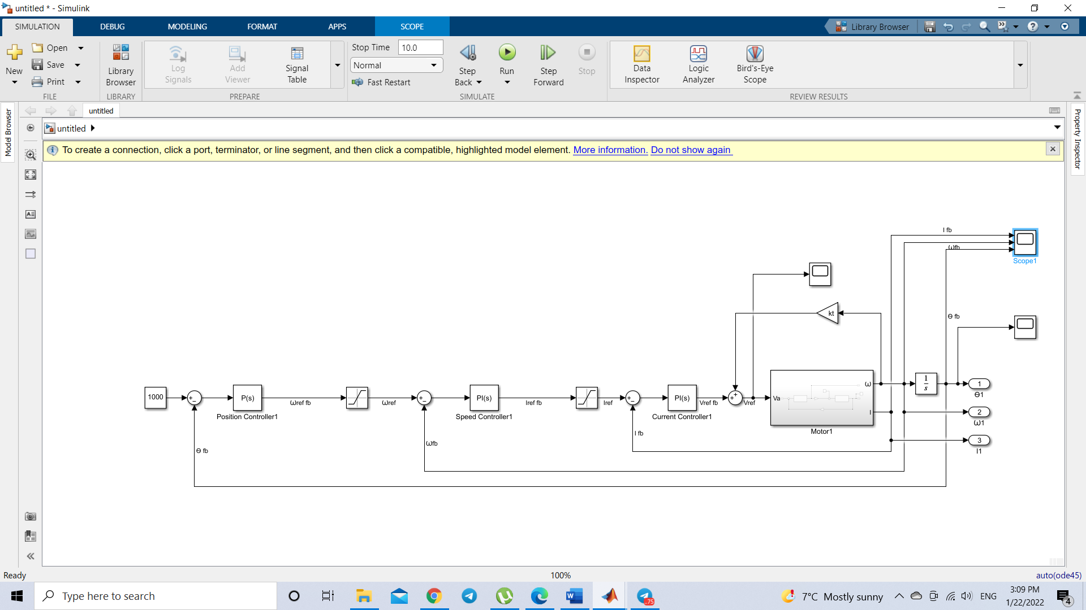

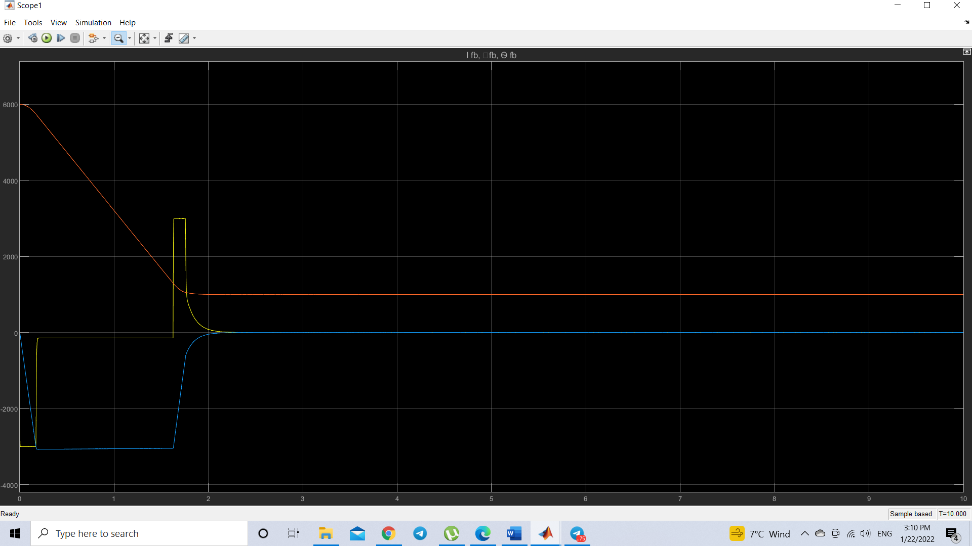

**Fig 18: System stability analysis.**

As can be seen, the System is stable before a chosen random reference of 50 rad, so it can be concluded that the selected parameters of the controller are correct.

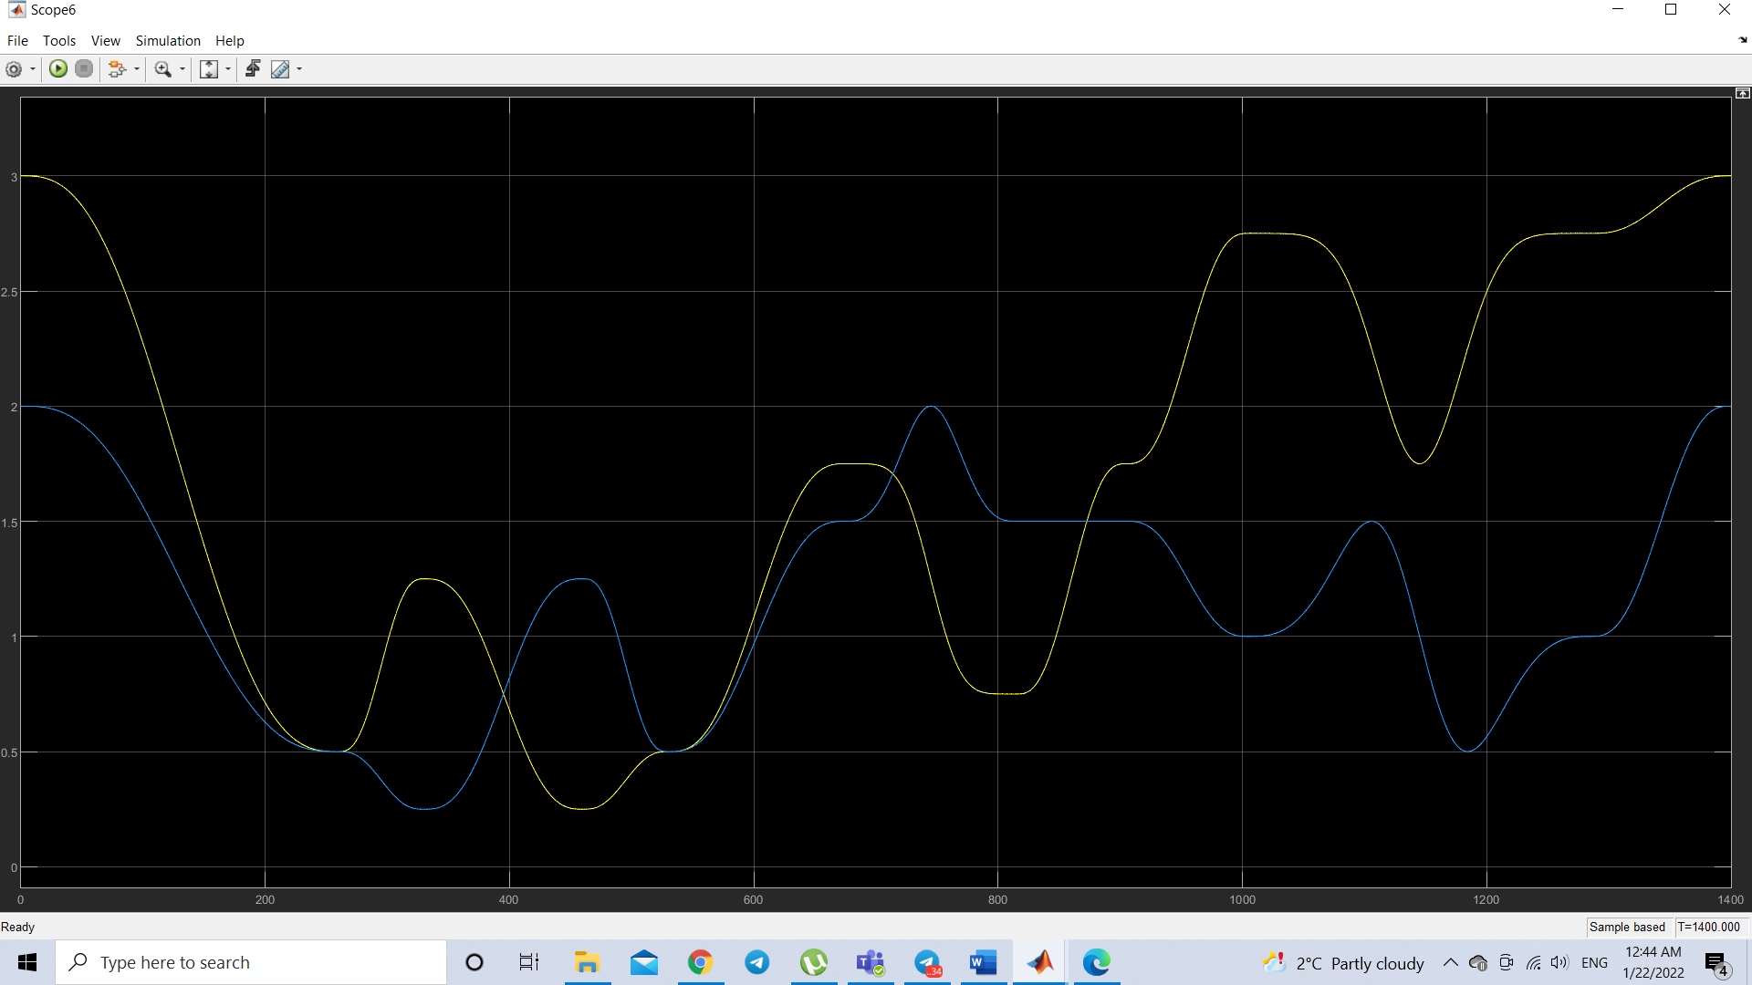

**Fig19: Description of the position of each motor during cutting**

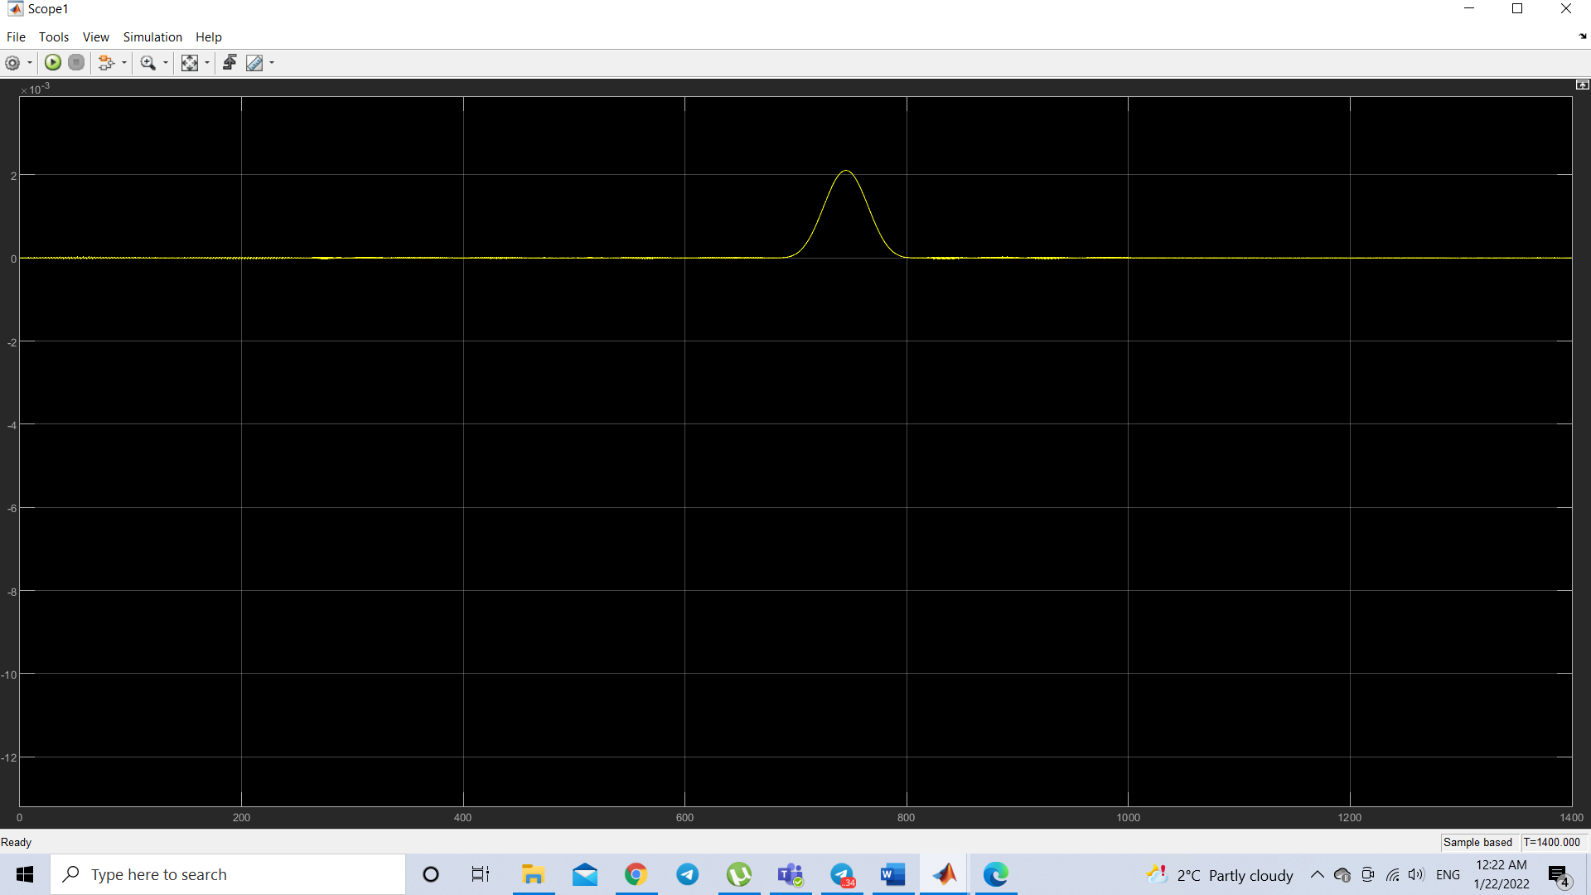

**Fig 20: Error comparison between target and real position along x-axis**

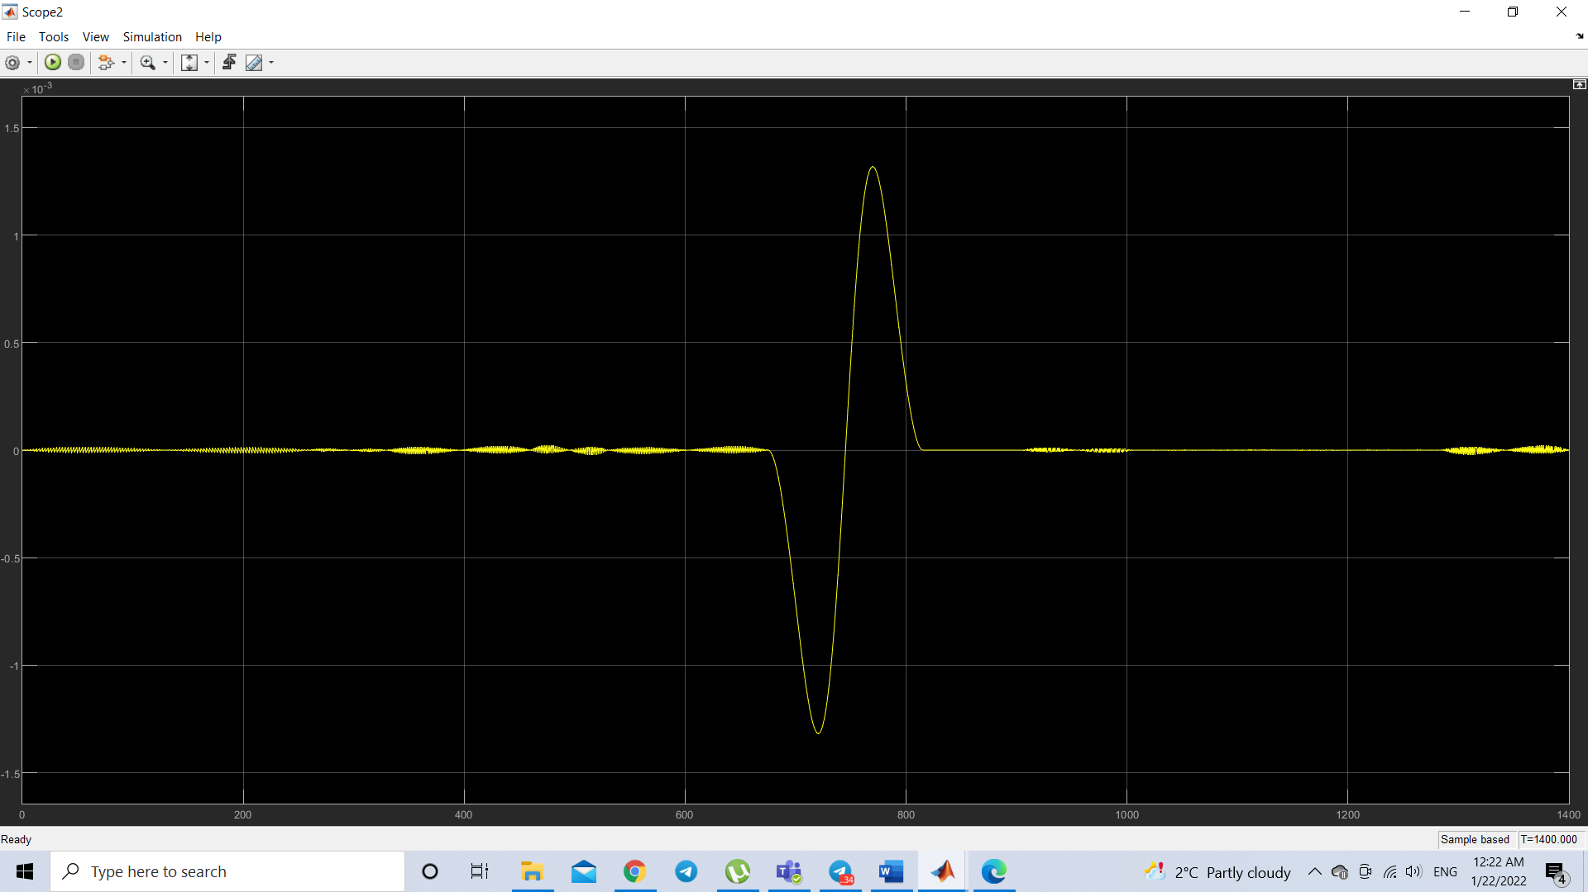

**Fig21: Error comparison between target and real position along y-axis**

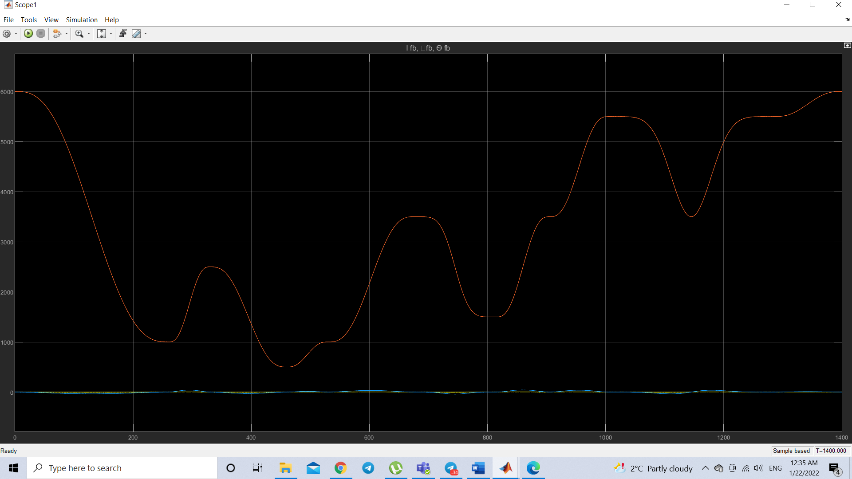

**Fig22: Behavior of the position, current, speed of the motor on the x axis.**

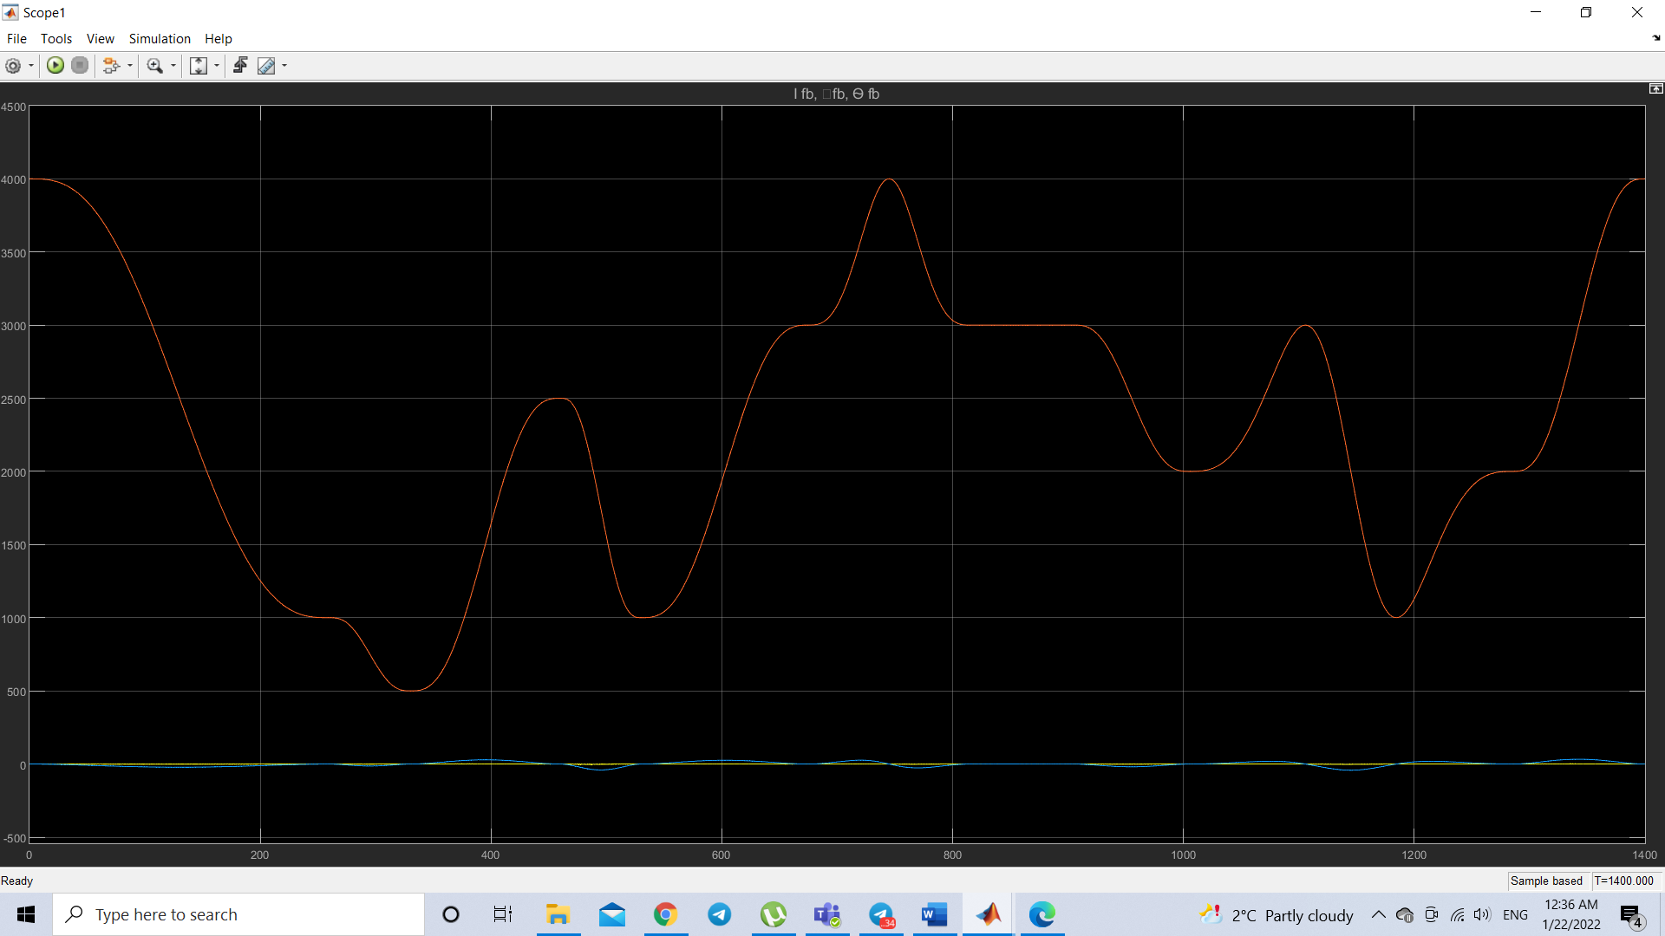

**Fig23: Behavior of the position, current, speed of the motor on the y axis.**

**11. Final result of the cut**

The final result of the cut is observed in the following animation made with Matlab, where the lines connecting the figures are defined as the movement of the laser head without making any cut.

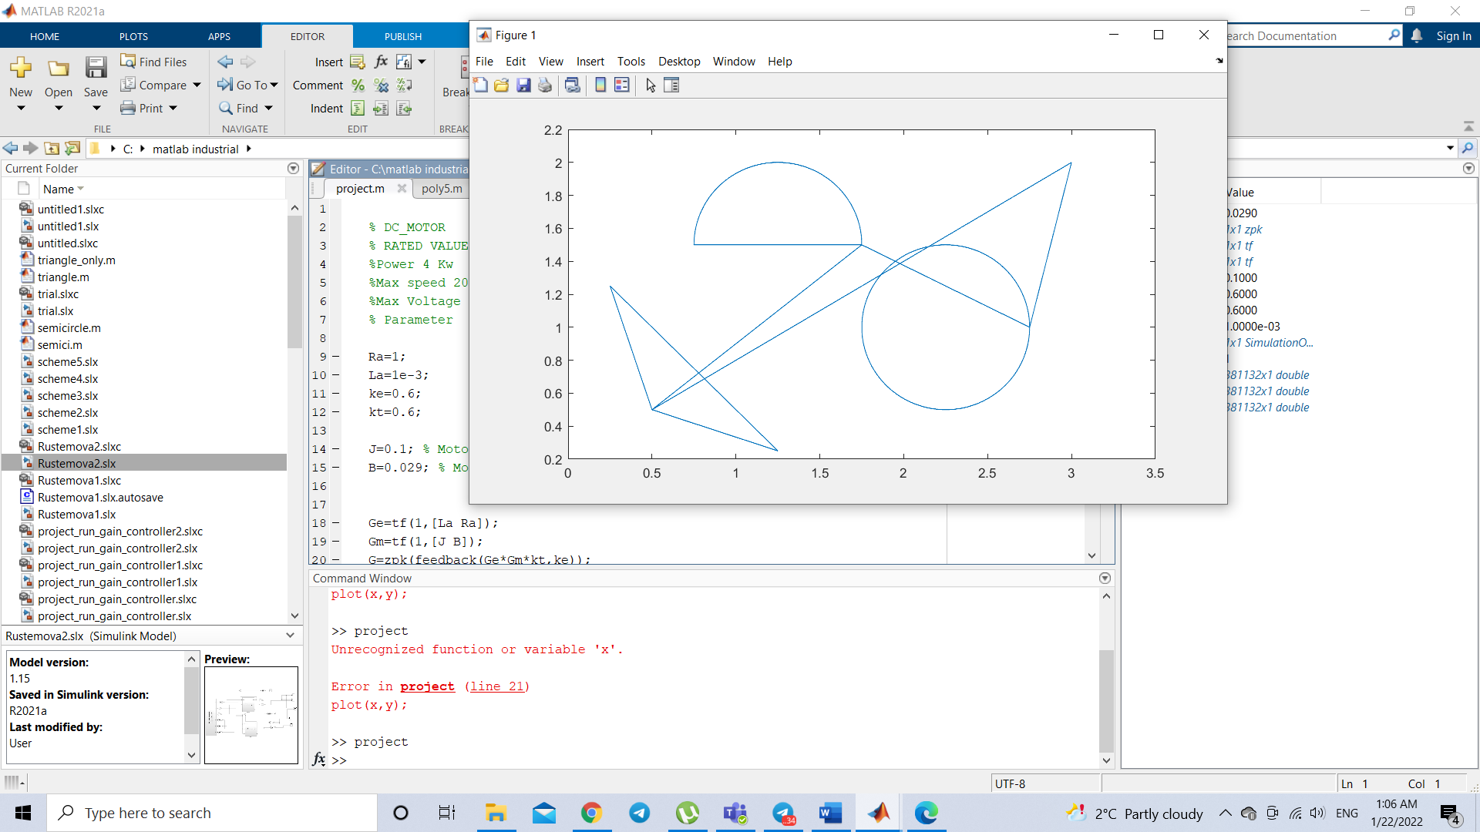

**CONCLUSION**

In the following work, the control of a laser cutting machine has been carried out, with the aim of extracting certain figures already assigned from a rectangular piece of earthenware. Therefore, the control problem has focused on planning the trajectory through polynomial functions, in this case through a fifth-order polynomial. Cut was implemented in two ways: classical and inverse model methods. To carry out the cut, a control action was implemented on two motors of identical characteristics located on each of the axes of the cutting machine, to which the adjustment parameters of each controller were calculated in the three loops made (current, speed, position). The control action has been implemented using the MATLAB environment and then the Simulink software, the final results were successful, obtaining a small error between the output and the setpoint set to the controller. Finally, the cutting machine performs the programmed cut.

**BIBLIOGRAPHY**

1. Prof Pietro M. Muraca, Notes from the Industrial Automation Course.

2. K.Ogata. Modern Control Engineering, 5ta Edition