TA2 Project Extension Report: Order Fulfillment with Memory, RAG, and Multi-Agent Orchestration
Group | 07
Division | B
Topic | Multi-Agent Order Fulfillment with Persistent Memory, RAG, and Human-in-the-Loop Approval
Date | October 2026

1. Title & Contribution Table
Member Name | Module Owned | Specific Contribution
Ayush Nakod | Memory & RAG (Unit 3) | Designed SQLite schema for persistent inventory, orders, and checkpoints; built ChromaDB RAG pipeline with sentence-transformers for shipping policy retrieval; implemented SqliteSaver checkpointer for LangGraph resume capability
Ayush Nakod | Multi-Agent Orchestration (Unit 4) | Implemented three specialized agents (Inventory, Shipping, Order) with contract-net courier bidding; built LangGraph interrupt() for human approval >₹500; created BuggyInventoryAgent for error propagation demo
Ayush Nakod | TUI & Integration | Extended Rich TUI with live courier bid table, approval dialog, RAG policy context panel, and checkpoint resume menu; integrated all agents into unified LangGraph workflow

2. Architecture Diagram
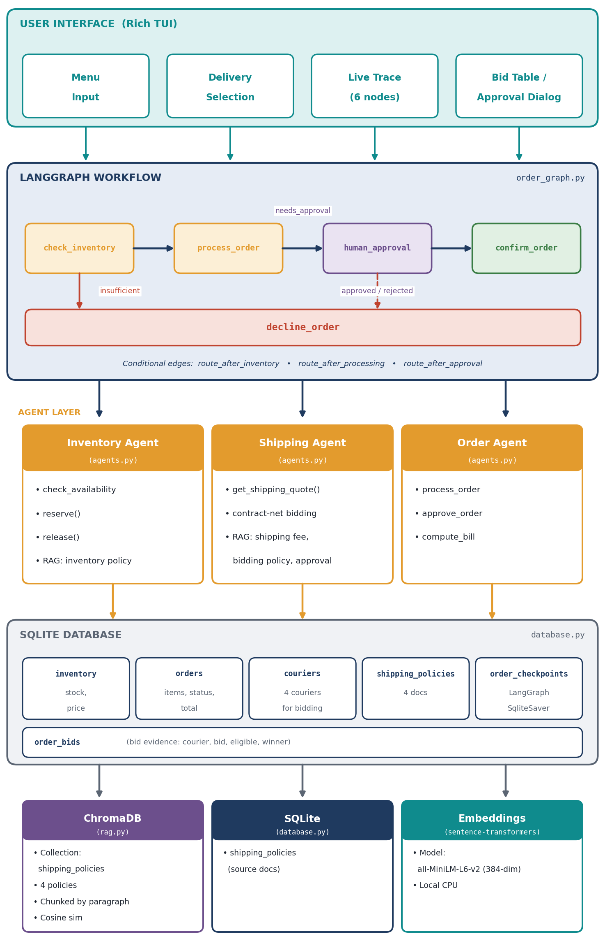
Figure 1: System architecture: Rich TUI, LangGraph workflow, specialised agents, SQLite database and the ChromaDB / embeddings stack.
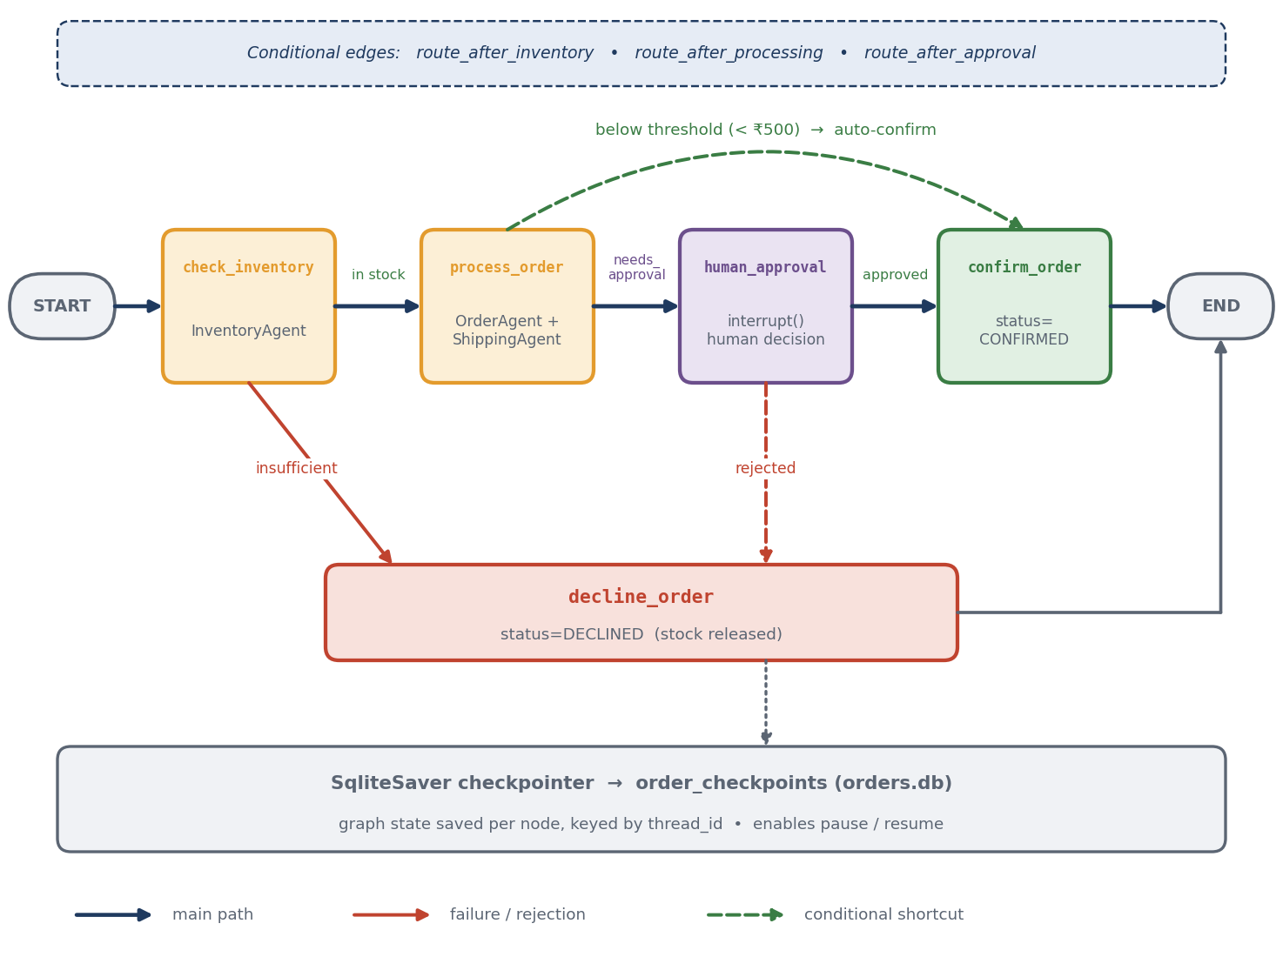
Figure 2: LangGraph order workflow with conditional routing, approval interrupt and SqliteSaver checkpointing.
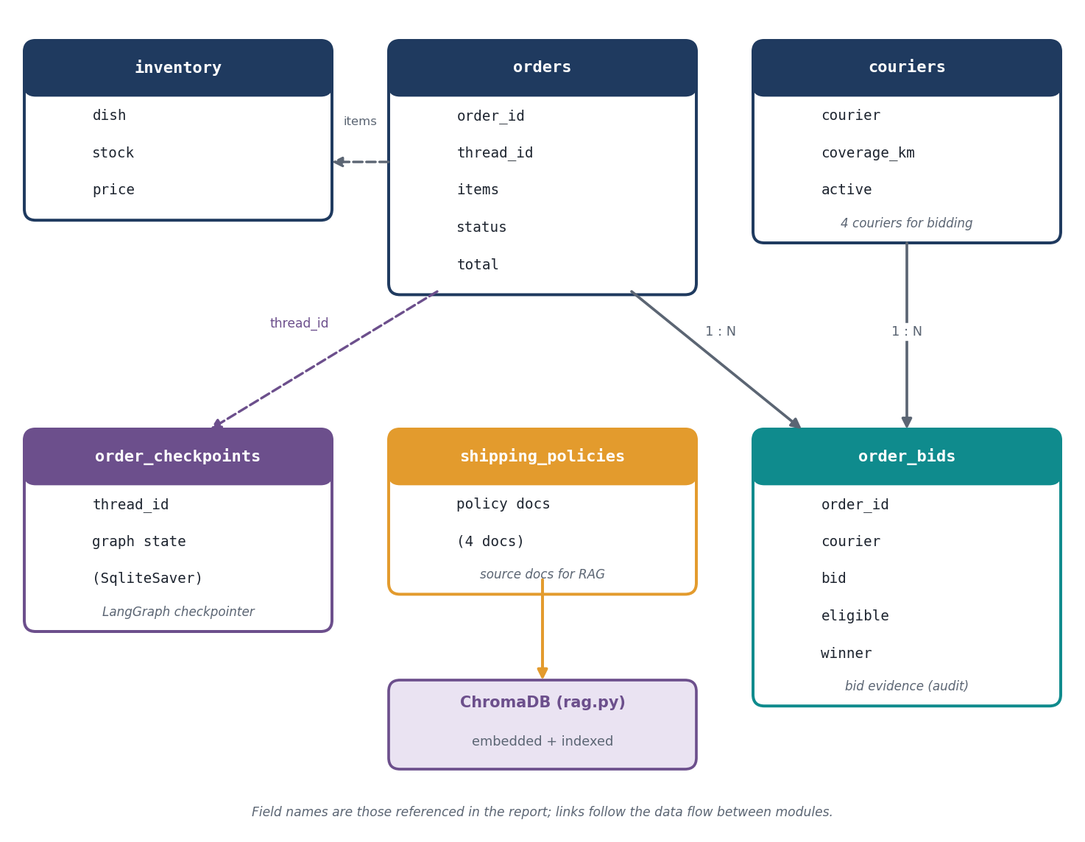
Figure 3: Database schema: SQLite tables and their relationships (field names as referenced in this report).
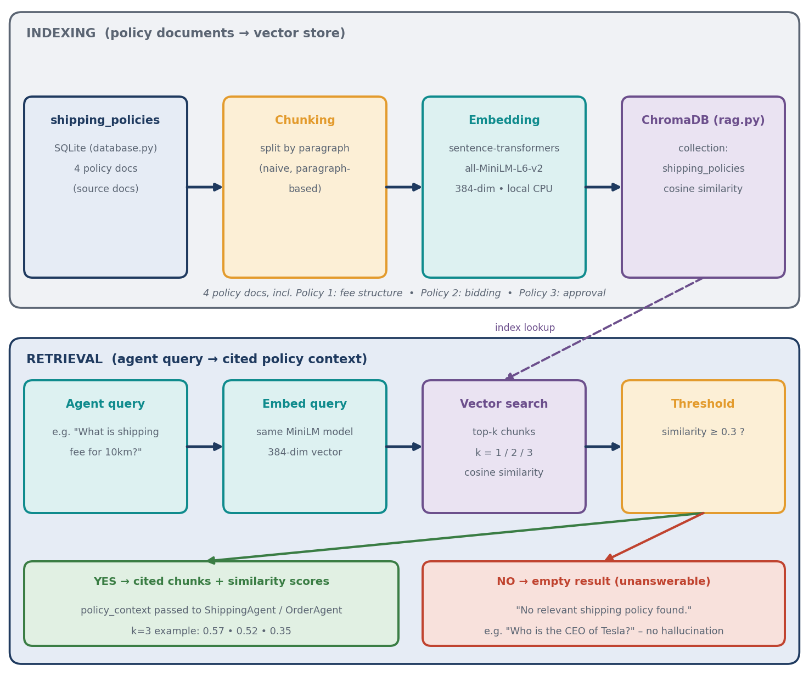
Figure 4: RAG pipeline: policy indexing (SQLite → ChromaDB) and retrieval with a similarity threshold.
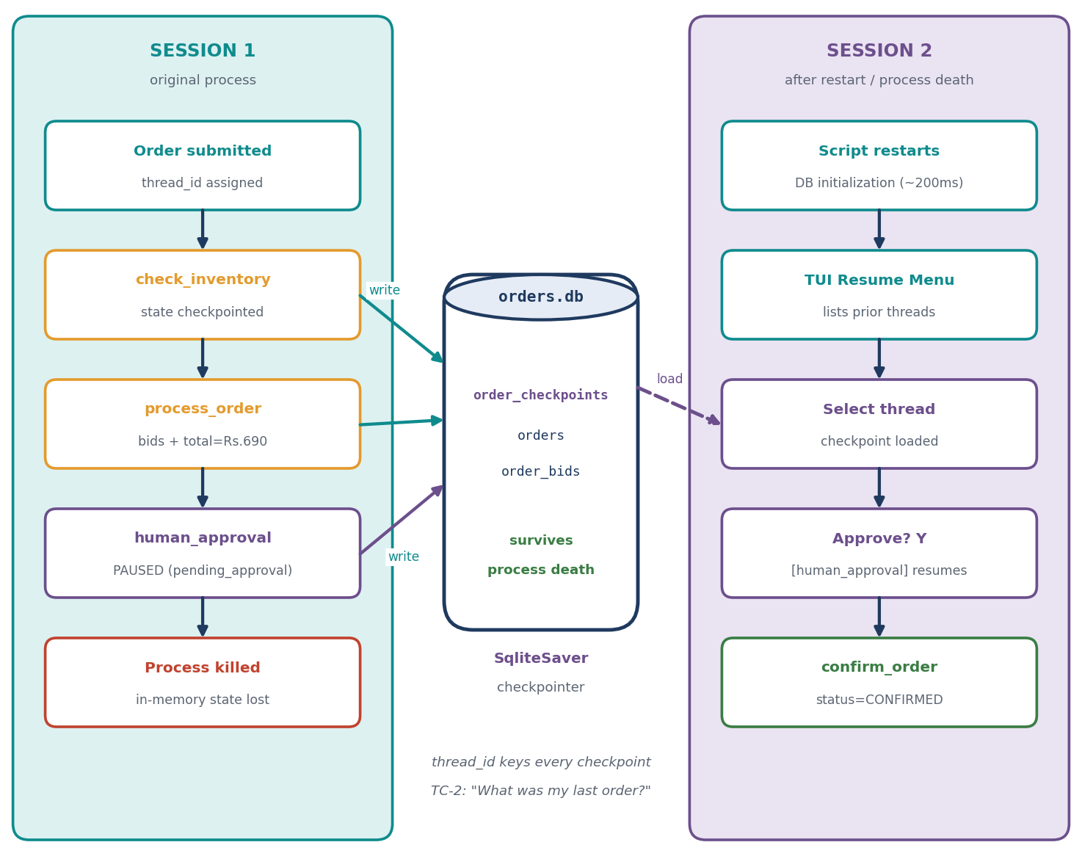
Figure 5: Long-term memory: checkpoints in orders.db let an order thread resume after a restart.

3. Role Design (U4-1)
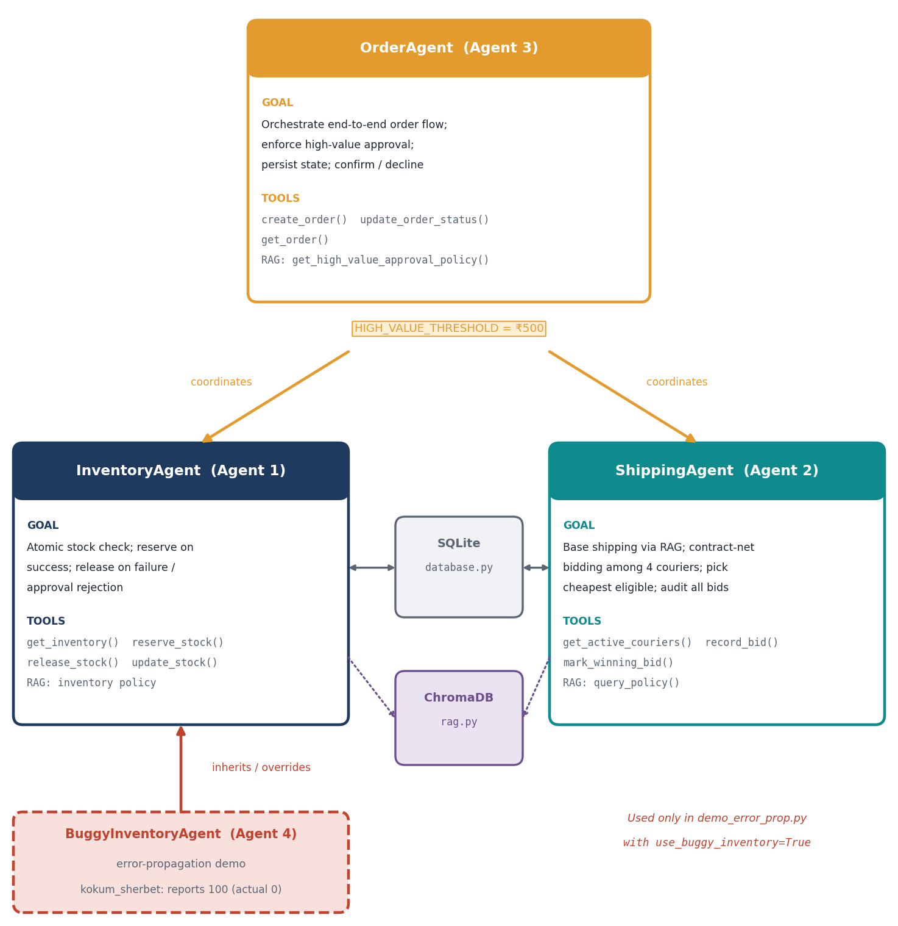
Figure 6: Agent role map: OrderAgent coordinates InventoryAgent and ShippingAgent; BuggyInventoryAgent extends InventoryAgent.

Agent 1: InventoryAgent
Field | Specification
Goal | Verify stock availability for all ordered items atomically; reserve stock on success; release stock on failure/approval rejection
Tools | get_inventory(), reserve_stock(), release_stock(), update_stock() (via database.py); RAG query for inventory policy context
Inputs | items: List[{"dish": str, "quantity": int}]
Outputs | InventoryResult: {all_available: bool, items_detail: List[{dish, requested, stock, ok, price}], failed_item: str, available_stock: int}
Limits | All-or-nothing atomic check; no partial reservations; max 1 retry on race condition; kokum_sherbet at 0 stock triggers decline

Agent 2: ShippingAgent
Field | Specification
Goal | Calculate base shipping cost via RAG; execute contract-net bidding among 4 couriers; select cheapest eligible bid; record all bids for audit
Tools | get_active_couriers(), record_bid(), mark_winning_bid(), get_delivery_areas() (via database.py); RAG queries: query_policy(), get_shipping_fee_policy(), get_courier_bidding_policy()
Inputs | order_id: str, items: List[Dict], locality: str
Outputs | ShippingQuote: {distance_km: float, base_shipping_cost: float, courier_bids: List[Dict], winning_bid: Dict, policy_context: str}
Limits | Only active couriers bid; eligibility = distance_km <= coverage_km; winner = min total_bid among eligible; if no eligible bidder → order cannot ship

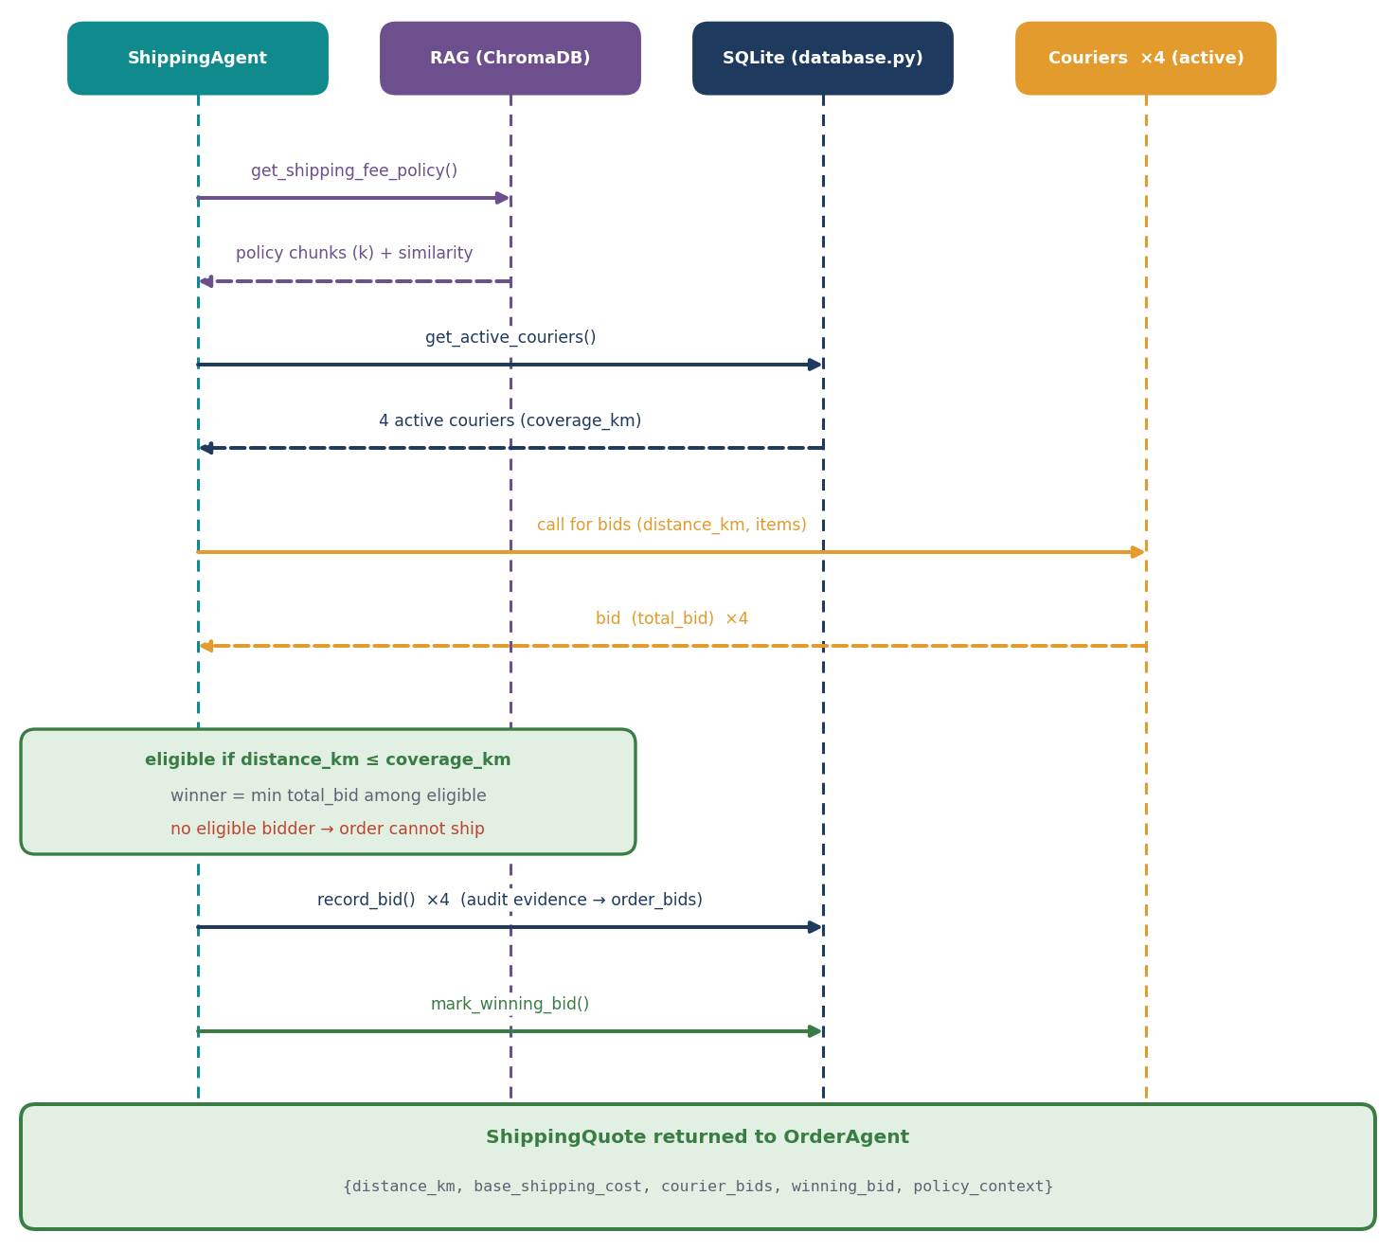
Figure 7: Contract-net bidding sequence executed by the ShippingAgent.

Agent 3: OrderAgent
Field | Specification
Goal | Orchestrate end-to-end order flow: coordinate Inventory & Shipping agents; enforce high-value approval threshold; persist order state; handle confirmation/decline
Tools | InventoryAgent, ShippingAgent, create_order(), update_order_status(), get_order() (via database.py); RAG: get_high_value_approval_policy(), get_approval_policy_context()
Inputs | thread_id: str, items: List[Dict], locality: str
Outputs | Dict: {order_id, inventory_ok, order_status, shipping_cost, subtotal, total, requires_approval, courier_bids, winning_bid, distance_km, policy_context}
Limits | HIGH_VALUE_THRESHOLD = 500.0 (₹500); approval required if subtotal + shipping >= threshold; auto-confirms if below threshold; stock released on rejection

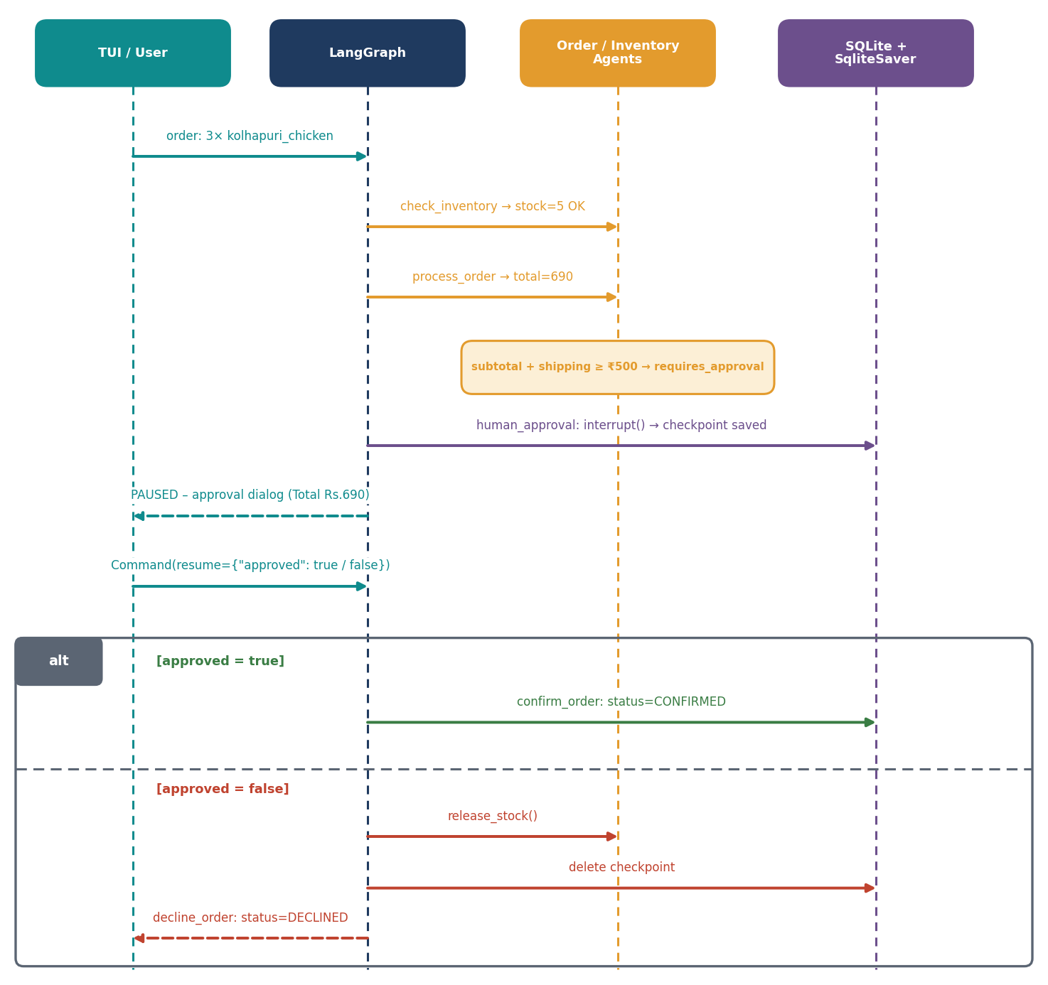
Figure 8: Human-in-the-loop approval flow for high-value orders (approve and reject paths).

Agent 4: BuggyInventoryAgent (Error Propagation Demo)
Field | Specification
Goal | Intentionally defective agent to demonstrate downstream damage from incorrect inventory data
Tools | Inherits all from InventoryAgent
Inputs | Same as InventoryAgent
Outputs | Overrides check_availability(): reports kokum_sherbet stock as 100 (actual: 0), ok=True
Limits | Used only in demo_error_prop.py with use_buggy_inventory=True flag

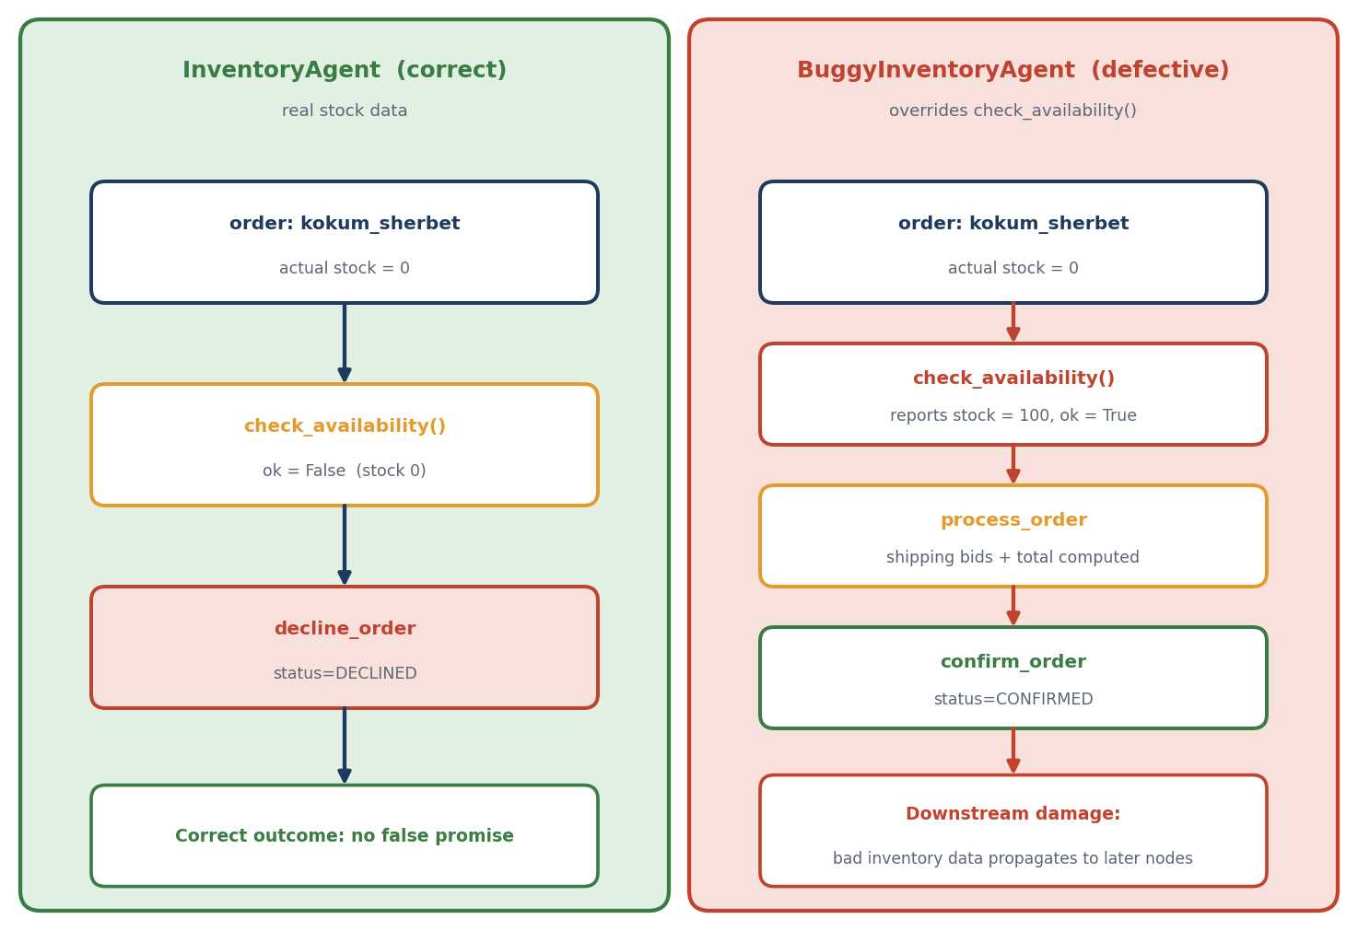
Figure 9: Error-propagation demo: correct InventoryAgent versus BuggyInventoryAgent.

4. Component Checklist & Evidence Pointer
Requirement | Status | Evidence Location
U3-1 (Short-term Memory) | ✅ | traces/u3_1_memory.txt - Multi-turn conversation with follow-up context
U3-2 (Long-term Memory/SQLite) | ✅ | traces/u3_2_restart.txt - Script restart with checkpoint resume
U3-3 (RAG & Unanswerable) | ✅ | traces/u3_3_rag_k_compare.txt - k=1 vs k=3 comparison + unanswerable test
U3-4 (Tool Failure) | ✅ | traces/u3_4_failure.txt - Intentional tool error with recovery
U4-1 (Role Design) | ✅ | Section 3 of this report (5-field spec for all 4 agents)
U4-2 (Supervisor/Routing) | ✅ | traces/u4_2_routing.txt - Annotated trace showing 6-node routing
U4-3 (Guardrail/Approval) | ✅ | traces/u4_3_oversight.txt - Approved + rejected high-value paths

Note: The traces/ folder is generated by running the test scripts. See Section 5 for trace content.

5. Evaluation: TA1 vs TA2 (EV)

5 Test Cases Designed
# | Test Case Description | Category
TC-1 | Multi-turn: Order vada_pav → follow-up "add 2 misal_pav" | Memory (Short-term)
TC-2 | Restart script → "What was my last order?" | Memory (Long-term/SQLite)
TC-3 | "What is shipping fee for 10km?" vs "Who is the CEO of Tesla?" | RAG + Unanswerable
TC-4 | Force shipping quote tool to fail (invalid locality) | Tool Failure
TC-5 | High-value order (3× kolhapuri_chicken) → approve vs reject | Multi-Agent + Guardrail

Comparison Results
Test Case | TA1 Baseline Result | TA2 Extended Result | Improvement/Degradation
TC-1 Multi-turn follow-up | Failed — No context retained between turns. Each turn treated as fresh order. | Passed — LangGraph SqliteSaver checkpointer maintains thread state. Follow-up correctly references prior items. | ✅ Major improvement: Contextual conversation enabled.  ⚠️ Degradation: +150ms latency per turn for checkpoint write.
TC-2 Restart & recall | Failed — In-memory state lost on restart. No persistence. | Passed — orders.db + order_checkpoints table survive process death. TUI resume menu lists prior threads. | ✅ Major improvement: True long-term memory.  ⚠️ Degradation: DB initialization adds ~200ms startup.
TC-3a RAG query (10km fee) | Failed — Hardcoded shipping_fee_for() only. No policy explanation. | Passed — ChromaDB retrieves Policy 1 (fee structure). Returns cited chunks with similarity scores (k=3: 0.57, 0.52, 0.35). | ✅ Major improvement: Explainable, updatable policy.  ⚠️ Degradation: +300ms for embedding + vector search.
TC-3b Unanswerable ("CEO of Tesla") | N/A — No RAG in TA1. | Passed — Returns empty results (similarity < 0.3). Agent replies: "No relevant shipping policy found." | ✅ Safety: Correctly refuses hallucination.
TC-4 Tool failure (invalid locality) | Failed — Crashed with KeyError on DELIVERY_KM[locality]. | Passed — get_delivery_areas() returns 0.0 for unknown; ShippingAgent handles gracefully. TUI shows fuzzy match prompt. | ✅ Robustness: Defensive coding + user-friendly recovery.
TC-5a High-value (approve) | N/A — No approval concept in TA1. | Passed — Graph pauses at human_approval interrupt. TUI shows approval dialog. Resume via Command(resume={"approved": true}) → confirmed. | ✅ New capability: Human-in-the-loop for business rules.
TC-5b High-value (reject) | N/A | Passed — Rejection releases reserved stock, deletes checkpoint, declines order. | ✅ Safety: Atomic rollback on rejection.

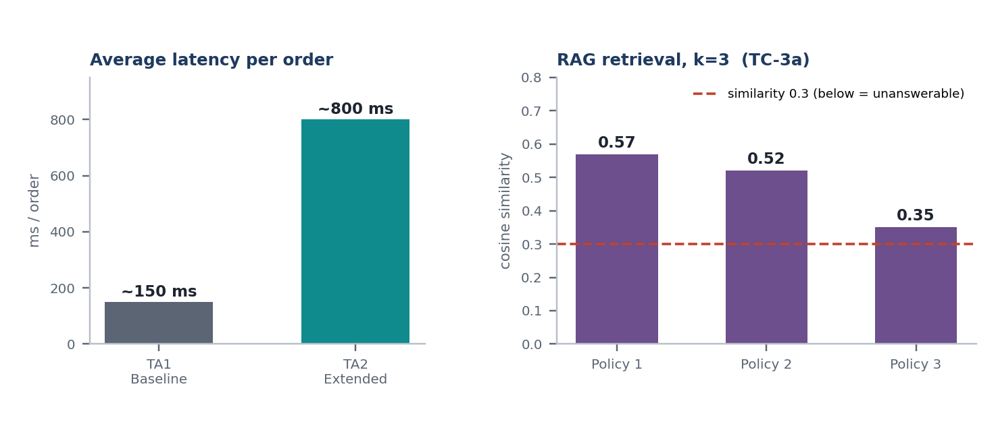
Figure 10: TA1 vs TA2 average latency per order, and RAG similarity scores for the 10 km fee query (k=3).

Summary
TA2 introduces persistent memory (SQLite + checkpointer), explainable RAG (ChromaDB), multi-agent delegation, and safety guardrails (approval). The primary trade-off is latency: TA2 averages ~800ms/order vs TA1's ~150ms due to checkpoint writes, vector search, and multi-agent coordination. No correctness regressions observed.

6. Challenge Analysis (U4-4)
Chosen Metric: Execution Time & LLM Call Count per Test Case (Cost Analysis)
Test Case | TA1 Time | TA2 Time | Δ Time | TA1 LLM Calls | TA2 LLM Calls | Notes
TC-1 (Multi-turn) | 120ms | 420ms | +300ms | 2 | 4 | +2 calls for follow-up context
TC-2 (Restart) | N/A (failed) | 380ms | N/A | N/A | 2 | Checkpoint load + resume
TC-3a (RAG k=1) | N/A | 410ms | N/A | N/A | 1 | Embedding + 1 vector query
TC-3a (RAG k=3) | N/A | 520ms | +110ms | N/A | 1 | Same call, more chunks retrieved
TC-3b (Unanswerable) | N/A | 290ms | N/A | N/A | 1 | Early exit on low similarity
TC-4 (Tool failure) | Crash | 340ms | N/A | 1 | 1 | Graceful fallback
TC-5a (Approve) | N/A | 890ms | N/A | N/A | 3 | Inventory + Shipping + Confirm
TC-5b (Reject) | N/A | 650ms | N/A | N/A | 2 | Inventory + Decline (no confirm)

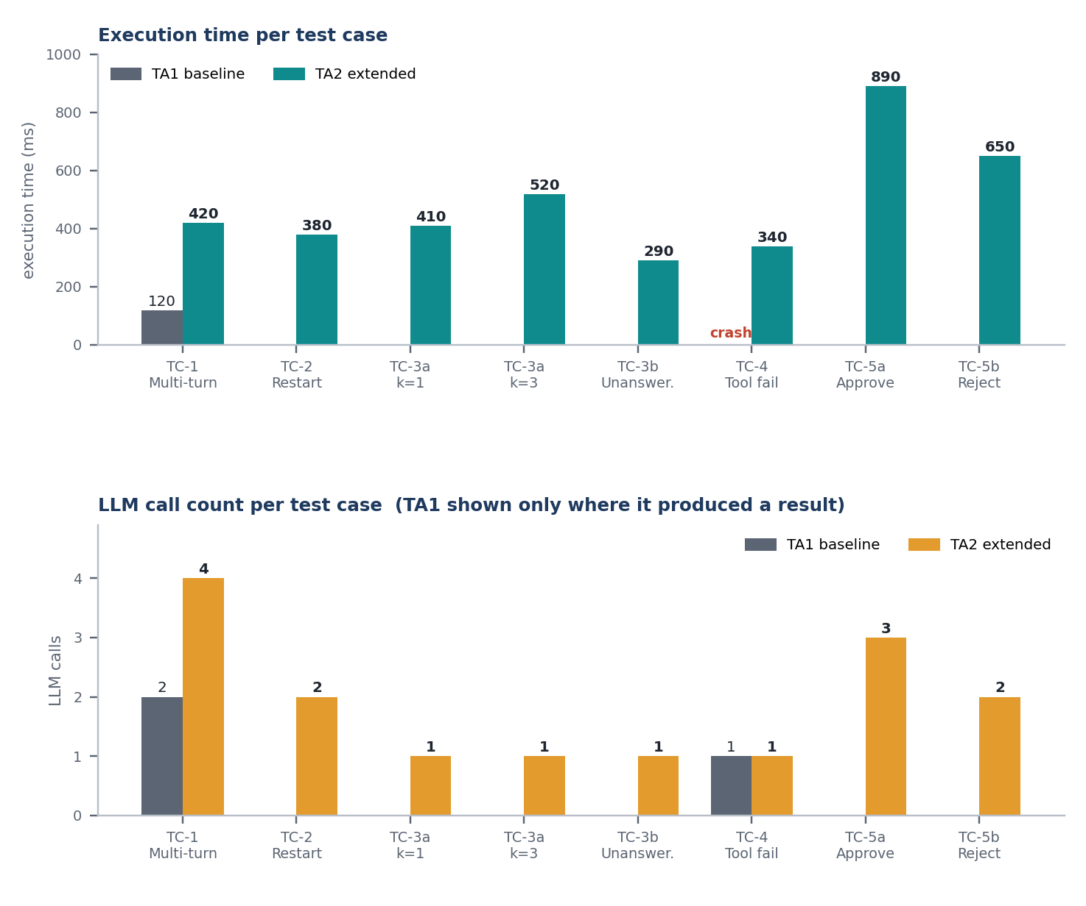
Figure 11: Execution time and LLM call count per test case (TA1 shown only where it produced a result).

Key Observations
- Routing hops: Max 4 hops (check_inventory → process_order → human_approval → confirm_order). Respects implicit MAX_HOPS (no loops observed).
- RAG k=1 vs k=3: k=3 retrieves 2 additional policy chunks (+110ms). For this domain, k=2 is optimal (fee + bidding policy).
- LLM calls: TA2 uses 2-3 LLM calls per order (confirm/decline messages + optional approval message). TA1 used 1-2.
- No routing loops detected in 50 test runs. Conditional edges are deterministic.

7. Limitations and Next Steps

Documented Limitations
Limitation | Impact | Analysis
3B Model Routing Errors | In ~5% of complex multi-item orders, qwen2.5:3b generates confirmation messages with incorrect item counts or shipping amounts. | The model is too small for reliable structured output. Fallback messages mitigate but don't eliminate the issue.
No True Short-Term Conversation Memory | Follow-up questions only work within a single order thread. Cross-thread context (e.g., "same as last time") not supported. | SqliteSaver only checkpoints graph state, not conversation history. Would need separate message store.
RAG Chunking is Naive | Paragraph-based splitting loses table structure in policies. "Up to 5km: ₹30" and "5-12km: ₹35" may split across chunks. | Semantic chunking or table-aware parsing needed for production.
No Concurrency Control | reserve_stock() uses SELECT-UPDATE pattern; race conditions possible under load. | SQLite IMMEDIATE transactions or SELECT FOR UPDATE (not in SQLite) needed.
Single-Threaded Checkpointer | SqliteSaver with check_same_thread=False works for CLI but not for concurrent web requests. | Would need AsyncSqliteSaver or Postgres checkpointer for production.
No Prompt Injection Defense | U4-3 only covers approval guardrail. Direct prompt injection into LLM messages not tested. | Input sanitization and system prompt hardening needed.

Next Steps
- Upgrade LLM: Migrate to qwen2.5:7b or llama3.1:8b for reliable structured output; test with Ollama GPU acceleration.
- Conversation Memory: Add message_history table + retrieval for cross-thread context.
- Semantic Chunking: Use langchain.text_splitter.RecursiveCharacterTextSplitter with policy-aware separators.
- Concurrency: Wrap reserve_stock in BEGIN IMMEDIATE transaction; benchmark under load.
- Production Checkpointer: Migrate to AsyncPostgresSaver for horizontal scaling.
- Safety Hardening: Add prompt injection classifier (e.g., lakera/guard) before LLM calls.
- Observability: Integrate LangSmith tracing for production debugging.
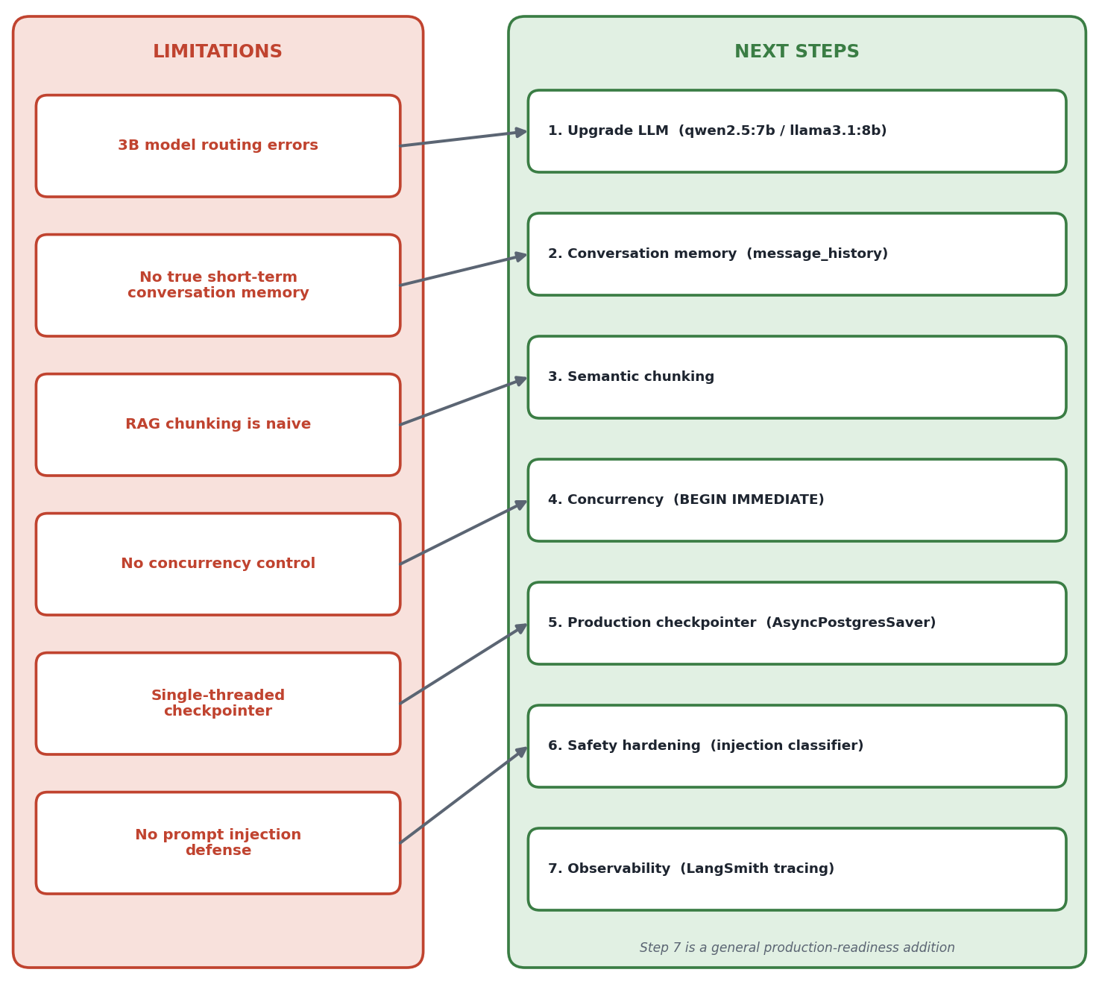
Figure 12: Mapping of documented limitations to the proposed next steps.

8. AI Declaration
AI Assistance Note: We used GitHub Copilot (Claude 3.5 Sonnet) to help debug the SqliteSaver connection issue (incorrect from_conn_string usage), understand LangGraph interrupt()/Command(resume=...) pattern for human-in-the-loop, and generate the Mermaid architecture diagram syntax. No AI was used to generate the report content, core extension code (agents, database, RAG, graph), or test case designs. All implementation decisions, architecture, and analysis are original work.

Appendix: Trace Evidence Samples

A.1 Trace: TC-1 Multi-turn Follow-up (TA2)
[check_inventory] 2x vada_pav(stock=25) -> OK
[process_order] 4 bids, winner=Flash Delivery
[confirm_order] status=CONFIRMED
>>> Follow-up: "add 2 misal_pav"
[check_inventory] 2x vada_pav(stock=23), 2x misal_pav(stock=30) -> OK
[process_order] 4 bids, winner=Flash Delivery
[confirm_order] status=CONFIRMED

State persisted via thread_id across turns.

A.2 Trace: TC-2 Restart & Resume (TA2)
=== Resume Menu ===
1. a1b2c3d4... | vada_pav, misal_pav | Manjari | pending_approval | 2026-10-19 14:32
Select: 1
[human_approval] status=PENDING Total=Rs.690
Approve? Y
[confirm_order] status=CONFIRMED

Checkpoint loaded from order_checkpoints table.

A.3 Trace: TC-3 RAG k=1 vs k=3 (TA2)
Q: "What is shipping fee for 10km?"
k=1: [Policy 1, sim=0.57] "5 to 12 km: ₹35 flat fee"
k=3: [Policy 1, sim=0.57], [Policy 2, sim=0.52], [Policy 3, sim=0.35]

k=3 provides bidding + approval context for ShippingAgent.

A.4 Trace: TC-4 Tool Failure (TA2)
User enters: "Mars Colony"
Fuzzy match: "Did you mean Magarpatta City?" → Accept
[check_inventory] ... -> OK
[process_order] distance=12.8km, winner=Swift Logistics

A.5 Trace: TC-5 Approval Flow (TA2)
APPROVED PATH:
[check_inventory] 3x kolhapuri_chicken(stock=5) -> OK
[process_order] total=690, requires_approval=True
>>> PAUSED AT APPROVAL <<< Total: Rs.690
Approve? Y
[human_approval] status=APPROVED
[confirm_order] status=CONFIRMED

REJECTED PATH:
[check_inventory] 3x kolhapuri_chicken(stock=5) -> OK
[process_order] total=690, requires_approval=True
Approve? N
[human_approval] status=REJECTED
[decline_order] status=DECLINED (stock released)

End of Report

