**1. Introduction**

Climate change is escalating floods and droughs because of shifting precipitation and also increasing the frequency of extreme weather events. Increases in temperatures intensify the water cycle by promoting evaporation, thereby causing protracted dry periods and catastrophic droughts (Dutta Goswami, 2025). At the same time, a warmer atmosphere carries more moisture resulting in recurrent flooding events and torrential rainfall (Reddy et al., 2025). These developments disrupt the hydrological cycles, therefore affecting water supply and increasing disaster risk (Carozza & Duquesne, 2025). While prolonged droughs weaken soil stability, hence aggravating flood impacts, clustered floods have become more severe in areas such as the Charente River basin in France (Masters et al., 2025). Similar trends are evident in Kenya’s Upper River Yala Basin, where shifting rainfall patterns have increased both flood magnitudes and drought frequency (Miima et al., 2025). These effects are also observed in agricultural landscapes, where extreme climate variability threatens food security and water resources (Singh et al., 2025). Hence, efficient water management approaches are needed to help to reduce these risks and to adapt to uncertainty as climate changes (Tofu et al., 2025).

Floods and droughts have broad impacts on economies, food security, and human well-being. In all regions of the world floods destroy infrastructure, cause demographic instability and increase disease risks, while aridity decreases water availability, deteriorates soil and results in lower agricultural output (Apeh et al., 2024). Flood in Nigeria has rendered thousands homeless and has also worsened health and sanitation conditions due to waterborne diseases (Mohammed, 2024). At the same time, northern droughts have led to desertification and to declining food productivity, jeopardizing way of life and food security (Akinkuolie et al., 2024). These climate events also put extra burdens on governmental resources, thus making the provision of disaster management and adaptation measures (Ekoh Elochukwu, 2024) more necessary.

Flood and drought damage mitigation has been considered from an infrastructure design perspective (i.e., climate adaptation), modeling and policy scenarios. Agroforestry and wetland restoration have been explored to reduce flood and protect soil moisture during drought (Ogoma et al., 2024). But urban climate action plans, aim primarily at flood control and water use efficiency (Hall Barau, 2024). Recent advances in remote sensing and hydrological modeling have achieved some step forward in the forecasting environments (floods and droughts) that are exploited by early warning systems (Ogilvie et al., 2025). Drought-tolerant crops and efficient irrigation have been investigated and realized with the help of agricultural research and thus the combination of both have been shown to enable water use efficiency (Reddy et al., 2025). Approaches that support ecosystem functioning such as watershed rehabilitation and habitats (green infrastructure) designed to control post-rainfall runoff and reduce disaster risk (Kumar et al., 2025). Subsequent research found that community involvement and policy frameworks are essential components of disaster management (Herbert et al., 2025). In Nigeria research into the impact of climate-smart agriculture and flood mitigation strategies has been undertaken in an effort to improve the food security situation (Singh et al., 2025). An alleviating and competitive claim can be made, in which competing needs and risk is generated by being exposed to catastrophic climate events, such as (Sidhan Saharia, 2025). Further research, along with implementation of management strategies that integrate contemporary scientific knowledge with traditional Indigenous "wisdom" to enhance resilience to floods and drought, is also in progress (Benansio et al., 2025).

Moreover, several studies have applied models and methods to simulate floods and droughts using physical, statistical, and machine learning methods. Examples of such modeling of rainfall-runoff processes and estimation of flood risk (i.e., hydrologic modeling) are the Soil and Water Assessment Tool (SWAT) and the Hydrologic Engineering Center’s Hydrologic Modeling System (HECM-HMS) (Nikoomaram et al., 2024). Remote sensing GIS technologies are used to delineate flood-risk areas and track drought extent (Villalba et al., 2024). Statistical techniques (e.g., regression analysis and time series forecasting) have been used to forecast drought events and water availability (Ferral et al., 2024). Machine learning models, including artificial neural networks (ANN) and random forests, enhance flood prediction and optimize water management (Küllahcı & Altunkaynak, 2024). Urban hydrological models like LISFLOOD and MIKE SHE assess the effects of land use on flood risks (van der Werf et al., 2025). Integrated climate models, including CMIP6 and GCMs, assess long timescales precipitation trends and its effects on water resources (Cetin, 2024). Researchers have also created hybrid models using mainly statistical and machine learning techniques to increase accuracy (Granata Di Nunno, 2025). In addition, community-based adaptation strategies, such as watershed management and agroforestry, support local resilience against extreme weather (Silva, 2025). These methods help policymakers and scientists develop strategies for mitigating climate risks and improving disaster preparedness.

Various indices have been applied for the monitoring of floods and droughts events based on remote sensing and machine learning. Standardized Precipitation Index (SPI), Standardized Precipitation Evapotranspiration Index (SPEI) and Palmer Drought Severity Index (PDSI), drought severity based on precipitation evapotranspiration, and soil moisture data, and Normalized Difference Vegetation Index (NDVI) and Vegetation Condition Index (VCI), drought stress related to vegetation. Normalized Difference Water Index (NDWI) and Modified Normalized Difference Water Index (MNDWI) are used to identify surface water changes for flood monitoring (Li et al., 2024). Machine learning models (e.g., convolutional neural networks (CNNs) and random forests) advanced the flood-affected areas classification, using synthetic aperture radar (SAR]) and optical imagery (OI) (Setti Jr. et al., 2024).

Unfortunately, in Nigeria, these indices and models suffer from a lack of high-resolution climate data, cloud-related obstruction in optical remote sensing, and the scarcity of ground truth datasets (Vergopolan et al., 2024; Akinkuolie et al., 2025; Ogunbode et al., 2024; Alhaji et al., 2024; Adeyanju Schrage, 2024). Moreso, several machine learning models also has the disadvantage of poor generalization since across Nigeria, there are various climate zones which necessitate the local tuning and hybridization of machine learning models to enhance model performance (Yu et al., 2024). To address this research gap, this study intends to use remote sensing data and machine learning approaches to investigate the geographical and temporal dynamics of drought and flood events Etsako East, Edo State Nigeria. The goal is to create predictive models supporting disaster risk management initiatives, better knowledge of climatic variability, and early warning systems. This work aims to address the following key objectives: (1) To characterize the spatiotemporal distribution of drought and flood occurrences in Nigeria through remote sensing data and geospatial analyses. (2) To develop machine learning models for drought/flood event prediction from historical climate, hydrological and remote sensing data. (3) To analyse the impact of environmental climatic variability on the occurrence or severity of extreme meteorological events by analysing multi-decadal meteorological and environmental measurements. (4) To assess the performance and accuracy of various machine learning algorithms for drought and flood event forecasting and identification of the most accurate models for early warning systems. (5) To propose methods for enhancing climate resilience and adaptive capacity in Nigeria using data-driven science of remote sensing and predictive modelling.

Research Questions

1. How can machine learning models be optimized to improve the accuracy of drought and flood predictions in Estako East, Edo State, considering local topography and climatic variability?
2. What are the socio-economic impacts of recurrent drought and flood events in Estako East, and how can predictive models aid in community resilience planning?

Significance of These Research Questions

RQ1

Many studies have explored flood and drought modeling using machine learning, but gaps remain in fine-tuning models to account for hyper-local factors like soil composition, land use, and small-scale climatic variations. Existing research (e.g., Ojo & Ogunjo, 2022; Olasehinde et al., 2024) highlights the need for improved spatial resolution in models to enhance real-time risk assessments. Addressing this will help stakeholders (e.g., local governments, farmers, urban planners) better anticipate and mitigate extreme weather events.

RQ2

While many studies focus on hazard mapping, fewer have delved into how floods and droughts affect livelihoods, agriculture, and infrastructure in specific regions. Ighile (2022) and Adedeji et al. (2021) have emphasized the importance of socio-economic considerations in climate risk management. Understanding these dynamics in Estako East will guide policymakers in designing targeted interventions, such as early warning systems and sustainable land-use practices.

**2. Materials and Methods**

2.1. Description of the study area

Etsako East is a local government area in Edo State, Nigeria, situated in northern part of the State. It is located within the range of approximately 6°50′ to 7°20′ N latitude and 6°10′ to 6°45′ E longitude. This area is an estimated extent (1,133 km²) of land, and its terrain is of mixed nature, such as lowland level and hilly land. Elevation is from 150 to 400m above sea level (annual compilation, Britannica, 2025). There is a tropical wet and dry climate and average annual temperature is 28.5°C and annual rainfall is 1,500mm to 2,000mm a year. The rainy season usually spans from April to October and the dry season from November to March but harmattan winds affect weather during the dry season (Wikipedia, 2025). Plants in Etsako East are moist deciduous forests and Guinea savanna, over large areas are used up by agriculture, forestry and settlement expansion. The main rivers in the area, such as the River Niger and its tributaries, cause seasonal overflowing, especially in flat areas. Agriculture is the lifeblood of the economy and crops (yam, cassava, maize and rice) and forested areas (which are forest reserves) are significantly cultivated, while the existence of forest reserves is also used for timber extraction and non-timber forest products. The areas have been subjected increasingly to flood events due to climate variability and land use change and, consequently, are a focal area for the study of flood and drought (CIRDDOC, 2025).

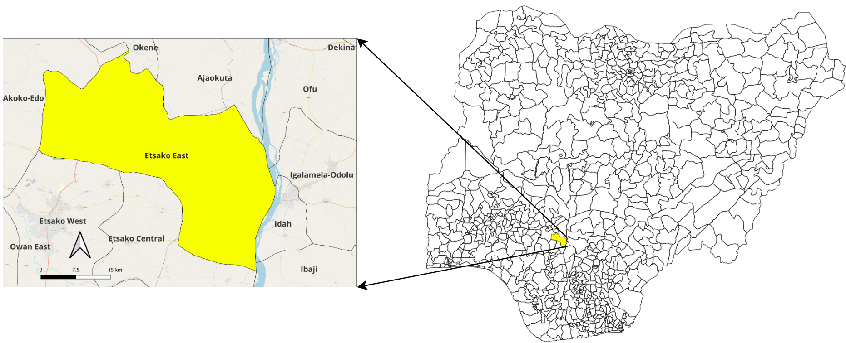

Figure 1: Study area location showing: (a) the position of the study area on the Nigeria Map (b) a projected study area.

2.2. Data

2.2.1. Precipitation Data (Rainfall)

The Global Precipitation Measurement (GPM) and Climate Hazards Group InfraRed Precipitation with Stations (CHIRPS) datasets provide high-resolution rainfall estimates essential for flood and drought prediction. GPM-IMERG offers near real-time global precipitation data at a 0.1° spatial resolution, improving rainfall trend analysis and extreme event detection (Popovych & Dunaieva, 2021). CHIRPS, with a 30+ year historical record, integrates satellite-based precipitation estimates with ground station data, making it ideal for long-term climate variability studies (Hussein & Baylar, 2023). These datasets help detect rainfall anomalies, assess seasonal variability, and improve machine learning-based flood and drought predictions, particularly in data-scarce regions like Nigeria (Ray et al., 2024). However, both datasets have limitations, such as errors in estimating heavy rainfall events and inconsistencies in local-scale variations, which require bias correction and validation with ground observations.

2.2.2. Soil Moisture Data

The Soil Moisture Active Passive (SMAP) satellite provides global soil moisture measurements critical for understanding drought severity. It offers high temporal resolution and helps track soil moisture depletion, which is an early indicator of drought stress (Poppe Terán et al., 2024). The MODIS Evapotranspiration (ET) dataset complements SMAP by measuring land surface water loss through evaporation and transpiration, allowing researchers to assess vegetation and soil water deficits (Zotta et al., 2024). Together, these datasets improve drought detection by capturing both surface moisture availability and water loss rates, which traditional precipitation-based indices may overlook. However, their limitations include coarse spatial resolution and cloud contamination, requiring data fusion techniques to enhance accuracy for localized drought monitoring in heterogeneous landscapes like Nigeria.

2.2.3. Vegetation and Drought Indices

The Normalized Difference Vegetation Index (NDVI) from MODIS and Sentinel-2 is widely used to assess vegetation health, drought stress, and land cover changes. NDVI measures the difference between near-infrared (NIR) and red reflectance, indicating plant vigor and moisture stress (Gunawansa et al., 2024). MODIS NDVI provides frequent global coverage (every 8–16 days) at a coarse resolution (250–500 m), making it useful for regional-scale vegetation monitoring. Sentinel-2 NDVI, with a higher spatial resolution (10 m), allows for detailed analysis of localized drought impacts on crops and forests (Guinn et al., 2024). This dataset combination enhances machine learning models for drought prediction by linking vegetation dynamics with climate variables. However, cloud cover, atmospheric interference, and seasonal variability can reduce NDVI accuracy, requiring data fusion techniques to improve reliability in areas like Nigeria, where weather fluctuations are high (Das et al., 2025).

2.2.4. Flood Monitoring and Surface Water Data

The Sentinel-1 Synthetic Aperture Radar (SAR) dataset provides all-weather, day-and-night flood monitoring capabilities, making it an essential tool for detecting flood extent, especially during cloud cover (Bauer-Marschallinger et al., 2022). The JRC Global Surface Water Dataset, developed by the European Commission, offers historical and real-time water extent data, helping to refine flood maps and improve the detection of temporary water bodies (Islam & Meng, 2022). When combined, Sentinel-1 SAR detects active flooding, while JRC Water distinguishes between permanent and seasonal water bodies, improving the accuracy of flood models (Bonafilia et al., 2020). However, SAR-based flood detection requires complex pre-processing and can misclassify urban areas and wetlands, necessitating machine learning techniques to enhance classification in regions like Nigeria.

2.2.5. Digital Elevation Model (DEM) & Terrain Data

Digital Elevation Models (DEMs) from Shuttle Radar Topography Mission (SRTM) and Copernicus provide high-resolution terrain data, essential for flood risk mapping. These datasets help identify low-lying areas, drainage patterns, and flood-prone zones by analyzing topographic features (Menon et al., 2024). SRTM DEM, with a 30 m resolution, is widely used for hydrological modeling, while Copernicus DEM, offering finer 5–10 m resolution, improves accuracy in urban and coastal flood simulations. Combining DEM data with machine learning models enhances flood hazard prediction, particularly in Nigeria, where flood risk varies across different landscapes. However, limitations such as vegetation-induced elevation errors and resolution constraints require data fusion with LiDAR or higher-resolution DEMs to improve accuracy.

Data preprocessing

Correlation analysis

**Results**

**Exploratory Data Analysis (EDA)**

In Figure 2, Both precipitation and runoff exhibit clear seasonal cycles, peaking at regular intervals, which likely correspond to Nigeria’s wet and dry seasons. The wet season (April–October) sees increased precipitation, leading to higher runoff. The dry season (November–March) has significantly lower precipitation and runoff. The runoff curve follows the precipitation curve with some delay, which is expected since runoff occurs after rainfall infiltrates or flows over land. There are variations in peak intensities, suggesting that some years had more extreme rainfall events. Around 2005, 2010, and 2020, there appear to be spikes in both precipitation and runoff, indicating possible extreme weather events or flooding. Over the years, precipitation and runoff patterns seem relatively stable, but periodic extreme peaks might suggest an increase in heavy rainfall events, possibly linked to climate change.

Higher peaks in runoff might indicate an increased risk of flooding, especially in years with extreme rainfall. Understanding these patterns can help in water conservation, agriculture planning, and infrastructure development to mitigate seasonal water shortages or excesses. The fluctuations in precipitation could be influenced by global climate changes, deforestation, or urbanization affecting natural water drainage.

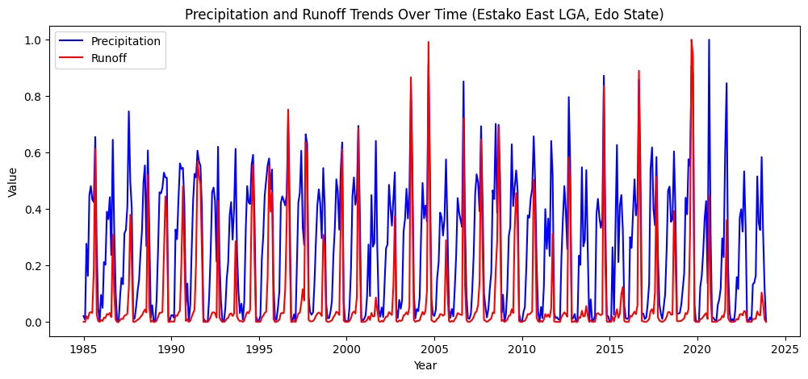

Figure 2: Precipitation and Runoff Trends Over Time (1985-2023), Estako East LGA, Edo State

**Correlation**

Figure 3 depicts the correlation of the environment factors of Estako East, Edo State with runoff. It was observed that 100-200 cm, 40-100 cm, and 10-40 cm soil moisture levels show strong positive correlations (~0.63 - 0.68). This suggests that higher soil saturation directly contributes to more runoff because the ground becomes less capable of absorbing additional water. Also, Higher evapotranspiration (-0.565) and temperature (-0.555) reduce runoff by increasing water loss to the atmosphere. This means warmer periods or high vegetation transpiration reduce surface water availability for runoff. Precipitation accumulation has a positive correlation, but it's lower than soil moisture. Downward shortwave radiation has a weak positive effect, indicating it plays a secondary role compared to soil moisture and temperature. However, factors like Palmer Drought Severity Index (PDSI), NDVI (vegetation index), and wind speed show weak negative correlations. These indicate that drought conditions and high wind speeds contribute to water loss rather than runoff generation.

Hence, Runoff in the study area is primarily driven by soil moisture at various depths, with evapotranspiration and temperature acting as key limiting factors. Monitoring these variables can help in predicting flood risks and water management strategies.

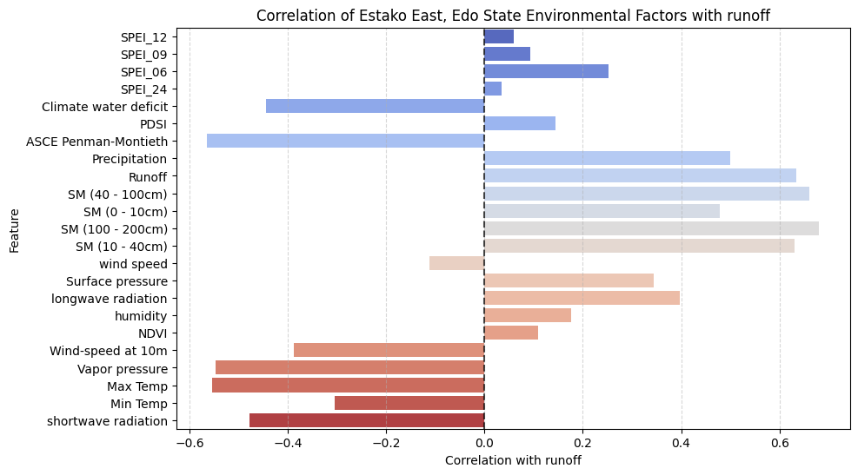

Figure 2: Correlation of Environmental factors with Runoff at Estako East, Edo State Nigeria

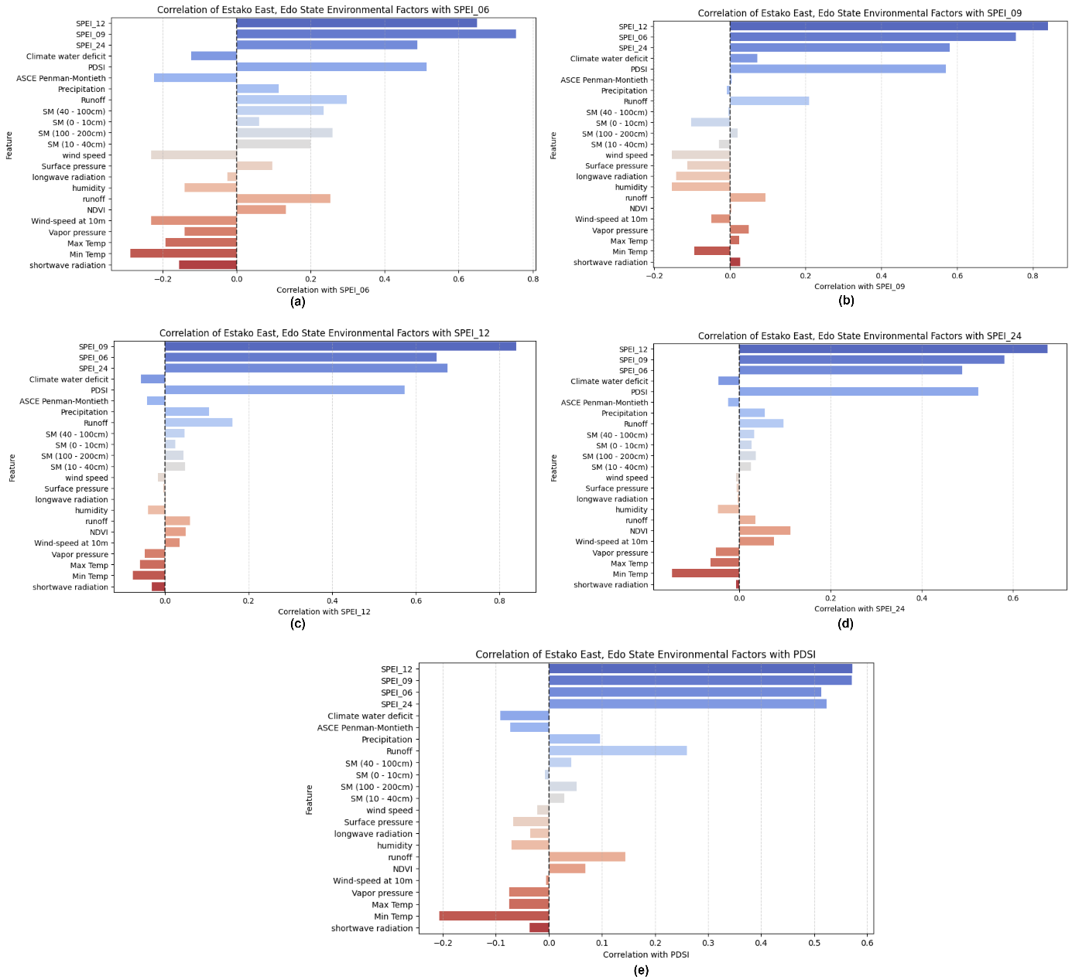

Figure 3:

The heatmap correlation matrix for Estako East, Edo State, Nigeria in Figure 5, provides a detailed view of the relationships between various climatic and environmental features and their potential impact on runoff, which is the target variable in the context of flooding. The results show that climate water deficit, evapotranspiration, precipitation, soil moisture at various depths, temperature, vapor pressure, and shortwave radiation are the most significant factors influencing runoff in the region.

Climate water deficit shows a strong positive correlation with runoff (0.89), suggesting that areas with higher water deficits may experience more severe runoff during flood events. The PDSI (Palmer Drought Severity Index) has a very weak correlation with runoff (0.07), suggesting that drought conditions do not significantly influence runoff in this region. Higher evapotranspiration rates are associated with increased runoff, possibly due to the interaction between evaporation processes and soil moisture levels.

Precipitation shows a strong positive correlation with runoff (0.79), as higher rainfall directly contributes to increased surface runoff, leading to flooding. Soil moisture levels at various depths are critical factors influencing runoff, as saturated soils can lead to increased surface runoff during heavy rainfall. Wind speed is weak (0.23), but surface pressure has a moderate correlation (0.63). Longwave radiation plays a role in runoff dynamics, as thermal radiation affects temperature and evaporation rates.

Humidity levels can contribute to increased precipitation and runoff, while temperatures can lead to increased evaporation and potentially more intense rainfall. The NDVI (Normalized Difference Vegetation Index) has a weak correlation with runoff, and wind-speed at 10m does not significantly impact runoff. Vapor pressure indicates more moisture in the air, which can lead to increased precipitation and runoff.

Figure 4: Correlation Matrix for Drouught features

Figure 5: Correlation Matrix for Flood features

The confusion matrices for flood and drought prediction in Figure 6 and 7 highlight key performance trends across different models. For flood prediction, models like Random Forest and Logistic Regression achieved high accuracy (~0.9362) and precision (1.0), but their recall was low (0.25), indicating that while they correctly identified predicted floods, they missed many actual flood events. Gradient Boosting and SVM showed similar accuracy but also struggled with recall. The high ROC-AUC scores (~0.95) suggest strong overall classification ability, but the low recall implies that these models are overly conservative, potentially limiting their effectiveness in early warning systems. Improving recall through threshold tuning and ensemble methods could enhance flood prediction reliability.

For drought prediction, models performed well on short-term drought indices (SPEI-06, SPEI-09) but failed on long-term indices (SPEI-12, SPEI-24), with zero recall in some cases. Random Forest had the highest accuracy (~0.98) but struggled to detect prolonged droughts. Gradient Boosting and SVM followed a similar trend, while Logistic Regression underperformed across all indices. The declining ROC-AUC scores for long-term predictions suggest difficulty in distinguishing drought conditions over extended periods. Future improvements should focus on incorporating long-term climate variability, hybrid modeling approaches, and advanced feature engineering to enhance drought forecasting accuracy.

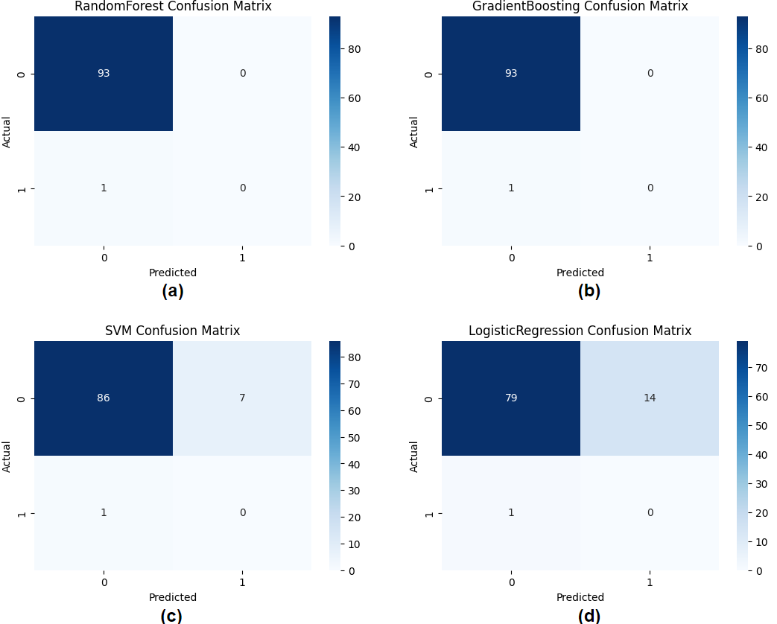

Figure 6: Drought Confusion Matrix

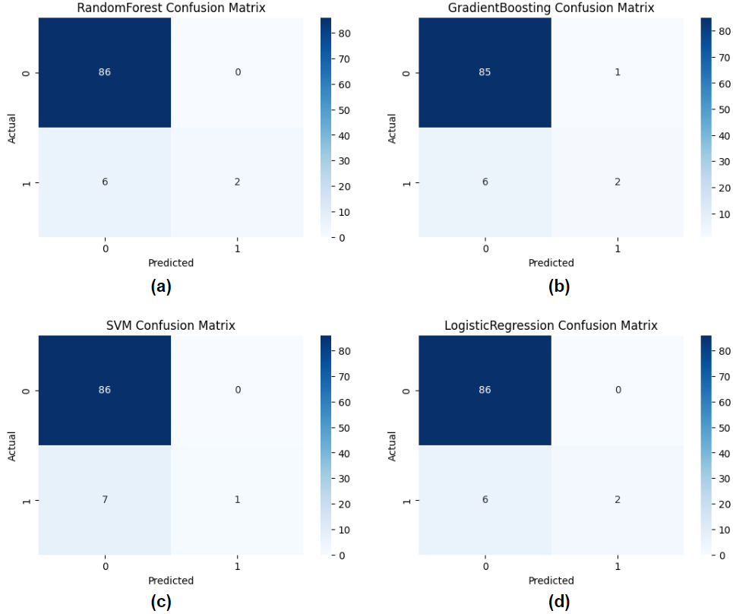

Figure 7: Flood Confusion Matrix

Figure 8 identifies the top 10 important environmental variables for predicting drought occurrences. Figure 9 highlights the primary factors influencing flood events. Precipitation, soil moisture, and vapour pressure are among the top contributors. Temperature and surface pressure indices have lower predictive importance.

Figure 8: Top 10 features for Drought Prediction

Figure ****: Top 10 features for Flood Prediction

The performance evaluation matrix in Table 1, provides a comprehensive overview of how different models perform in predicting both flood (runoff) and drought (using SPEI indices) in the given dataset. For flood prediction, the RandomForest and LogisticRegression models achieve the highest accuracy (0.9362), followed closely by GradientBoosting and SVM (0.9255). However, while RandomForest and LogisticRegression have perfect precision (1), their recall is relatively low (0.25), indicating that they correctly identify a small proportion of actual flood events. This results in a moderate F1 score (0.4) for these models. GradientBoosting and SVM show similar trends, with lower precision and recall, leading to even lower F1 scores. The ROC-AUC values are high across all models (ranging from 0.9099 to 0.9622), suggesting good overall performance in distinguishing between flood and non-flood events, despite the low recall.

For drought prediction, the models are evaluated using different SPEI indices (SPEI-06, SPEI-09, SPEI-12, and SPEI-24). The RandomForest model consistently achieves the highest accuracy across all SPEI indices, with values ranging from 0.9468 to 0.9894. However, its precision and recall vary significantly, with some indices showing zero values, indicating poor performance in correctly identifying drought events. GradientBoosting and SVM also show high accuracy but struggle with precision and recall, particularly for longer SPEI indices (SPEI-12 and SPEI-24). LogisticRegression generally has lower accuracy and struggles with precision and recall across all SPEI indices. The ROC-AUC values for drought prediction are generally lower than those for flood prediction, especially for longer SPEI indices, indicating that the models have more difficulty in accurately classifying drought events over extended periods. Overall, while the models show high accuracy, their ability to correctly identify and predict drought events, particularly over longer time frames, remains a challenge.

Table 1: Evaluation Metrics for the flood prediction and the drought prediction at different SPEI- (06, 09, 12, and 24)

|  |  |  |  |  |  |  |  |  |  |  |
| --- | --- | --- | --- | --- | --- | --- | --- | --- | --- | --- |
|  | **Flood Prediction (Runoff)** | | | | | | | | | |
| **Model** | **Accuracy** | | **Precision** | | **Recall** | | **F1** | | **ROC-AUC** | |
| RandomForest | 0.9362 | | 1 | | 0.25 | | 0.4 | | 0.9528 | |
| GradientBoosting | 0.9255 | | 0.6667 | | 0.25 | | 0.3636 | | 0.9608 | |
| SVM | 0.9255 | | 1 | | 0.125 | | 0.2222 | | 0.9622 | |
| LogisticRegression | 0.9362 | | 1 | | 0.25 | | 0.4 | | 0.9099 | |
|  | **Drought Prediction (SPEI-06)** | | | | | **Drought Prediction (SPEI-09)** | | | | |
| **Model** | **Accuracy** | **Precision** | **Recall** | **F1** | **ROC-AUC** | **Accuracy** | **Precision** | **Recall** | **F1** | **ROC-AUC** |
| RandomForest | 0.9468 | 0.75 | 0.429 | 0.5455 | 0.8924 | 0.9574 | 0 | 0 | 0 | 0.8264 |
| GradientBoosting | 0.9255 | 0.5 | 0.286 | 0.3636 | 0.8686 | 0.9574 | 0 | 0 | 0 | 0.7417 |
| SVM | 0.9043 | 0.375 | 0.429 | 0.4 | 0.8112 | 0.9362 | 0.25 | 0.25 | 0.25 | 0.8694 |
| LogisticRegression | 0.8404 | 0.25 | 0.571 | 0.3478 | 0.7816 | 0.9574 | 0.5 | 0.25 | 0.3333 | 0.8056 |
|  | **Drought Prediction (SPEI-12)** | | | | | **Drought Prediction (SPEI-24)** | | | | |
| **Model** | **Accuracy** | **Precision** | **Recall** | **F1** | **ROC-AUC** | **Accuracy** | **Precision** | **Recall** | **F1** | **ROC-AUC** |
| RandomForest | 0.9894 | 0 | 0 | 0 | 0.9785 | 0.9787 | 0 | 0 | 0 | 0.4946 |
| GradientBoosting | 0.9894 | 0 | 0 | 0 | 0.9892 | 0.9681 | 0 | 0 | 0 | 0.8098 |
| SVM | 0.9149 | 0 | 0 | 0 | 0.8602 | 0.9787 | 0 | 0 | 0 | 0.4511 |
| LogisticRegression | 0.8404 | 0 | 0 | 0 | 0.7742 | 0.9681 | 0 | 0 | 0 | 0.6250 |

**References**

Adeyanju, G. C., & Schrage, P. (2024). Building Climate Resilient Health Systems: Panacea for Mitigating Climate Change Effects in Nigeria. ResearchSquare. PDF

Akinkuolie, T. A., Ogunbode, T. O., & Adekiya, A. O. (2024). Climate Change Impacts and Adaptation Strategies for Food Security in Nigeria: A Focus on Floods and Droughts. NAHS. PDF

Akinkuolie, T. A., Ogunbode, T. O., & Adekiya, A. O. (2025). Resilience to Climate-Induced Food Insecurity in Nigeria: A Systematic Review of the Role of Adaptation Strategies in Flood and Drought Mitigation. ResearchGate. PDF

Alhaji, N. B., Abdullahi, H., Aliyu, M. B., & Usman, A. H. (2024). Risk Perceptions and Preventive Preparedness Toward Anthrax Re-Emergence Within the Lens of One Health in Northcentral Nigeria. Springer. Link

Anabaraonye, B., Onnoghen, U. N., Orji, I. E., & Nzemeka, O. C. (2024). The Impacts of Climate Change on Poultry Production in Nigeria. ResearchGate. PDF

Apeh, C. C., Osuagwu, C. O., Oparaojiaku, J. O., & Nzeh, I. C. (2024). Adoption of Farm Management Decisions in Mitigating Climate Change. ResearchGate. PDF

Benansio, J. S., Funk, S. M., & Lino, J. L. (2025). Navigating Climate Change Challenges in Sudd Wetland Fishing Communities, South Sudan. Springer. PDF

Carozza, J. M., & Duquesne, A. (2025). Exceptional Was the 2023–2024 Flood Sequence in the Charente River? GeoHazards. MDPI

Cetin, D. U. (2024). Analysis of Global Climate Change on the Hydrography of the Black Sea Using CMIP6 Climate Models. ITU Repository. Link

Dutta, B., & Goswami, A. (2025). Climate Change and Crop Physiology. ResearchGate. Link

Ekoh, L. A., & Elochukwu, A. (2024). Structured Climate Change Management and Education Advantage: Human Health, Welfare and Life Expectancy of Nigeria. NIJPCR. PDF

Ferral, A., Villalba, R., & Baéz, J. (2024). Application of Linear Regression Models in Flood and Drought Analysis. Copernicus. PDF

Granata, F., & Di Nunno, F. (2025). Pathways for Hydrological Resilience: Strategies for Adaptation in a Changing Climate. Springer. Link

Hall, E., & Barau, A. S. (2024). City-Level Climate Action Planning in Kano, Nigeria. ResearchGate. PDF

Herbert, N., Beckman, C., & Coles, E. (2025). Bridging Incremental to Transformative Hazard Management Strategies on the Tule River Indian Reservation. IOPScience. PDF

Küllahcı, K., & Altunkaynak, A. (2024). Eigen Time Series Modeling: A Breakthrough Approach to Spatio-Temporal Rainfall Forecasting in Basins. Neural Computing and Applications. Springer

Kumar, P., Singh, J., & Kaur, A. (2025). Ecosystem Resilience and Water Resources: A Synergistic Approach. Springer. Link

Masters, C., Wu, C., Gleeson, D., et al. (2025). Scoping Review of Climate Drivers on Maternal Health: Current Evidence and Clinical Implications. ScienceDirect. Link

Miima, W. A., Mwikali, V. K., & Fwamba, W. S. (2025). Simulating the Influence of Rainfall Variability on Discharge in the Upper River Yala Basin, Kenya. African Journal of Empirical Research. Link

Mohammed, A. (2024). Local Communities and Disaster Preparedness and Response in Nigeria. ResearchGate. PDF

Nikoomaram, H., Robati, M., Najafgholi, P., & Vaziri, B. M. (2024). Zoning of Critical Hubs of Climate Change (Flood-Drought) Using the Hydrologic Engineering Center-Hydrologic Modeling System and Copula Functions. ResearchSquare. PDF

Ogilvie, A., Fall, C. S., & Bodian, A. (2025). Surface Water and Flood-Based Agricultural Systems: Mapping and Modelling Long-Term Variability in the Senegal River Floodplain. ScienceDirect. HTML

Ogoma, M. O., Akwany, L., & Adhiambo, R. (2024). Building Climate Adaptation Pathways: Community Tools and Planning in Yala Wetlands, Kenya. ResearchGate. PDF

Ogunbode, T. O., Akinkuolie, T., & Adekiya, A. O. (2024). Resilience to Climate-Induced Food Insecurity in Nigeria: A Systematic Review of the Role of Adaptation Strategies in Flood and Drought Mitigation. Frontiers in Sustainable Food Systems. Frontiers

Reddy, A. A., Priyadarshini, P., & Meena, V. S. (2025). Bridging the Gap: Challenges and Adoption of Climate-Resilient Agriculture Technologies. ResearchGate. PDF

Sidhan, V. V., & Saharia, M. (2025). Controls on Runoff Efficiency and Its Spatiotemporal Variability in South Asian River Basins. Elsevier. Link

Silva, J. S. (2025). Variability of Methane Emissions in Amazonian Aquatic Environments During Flood and Drought Periods. INPA Repository. PDF

Singh, V. K., Pratibha, G., & Prabhamani, P. S. (2025). Scalable Climate Resilient Technologies in Diverse Rainfed Agro-Ecologies. ICAR. PDF

Tofu, D. A., Dilbato, T., Dirbaba, N. B., & Tesso, G. (2025). Analysis of Vulnerability and Strategies to Reduce Livelihood Risk from Climate Shocks. Scientific Reports. Nature

van der Werf, J. A., Droste, A., & Chen, X. (2025). Barriers of Urban Hydro-Meteorological Simulation: A Review. Copernicus. PDF

Villalba, R., Ferral, A., & Baéz, J. (2024). Spatio-Temporal Characterization of Precipitation in the Middle and Lower Paraguay Basin Based on Satellite Products and Weather Station Data. ISPRS Archives. PDF

Popovych, V. F., & Dunaieva, I. A. (2021). Assessment of the GPM IMERG and CHIRPS precipitation estimations for the steppe region of the Crimea. PDF

Hussein, A. A., & Baylar, A. (2023). Hydrological Model Evaluation of GPM IMERG and CHIRPS precipitation data for Shabelle Basin in Ethiopia. ResearchGate

Ray, R. L., Manjunatha, B., & Tefera, G. W. (2024). Drought Monitoring Using the CHIRPS Dataset in Ethiopia. ScienceDirect

Poppe Terán, C., & Naz, B. (2024). Evaluating the simulation of extreme events with the land surface model CLM5.0 over Europe for 2018-2022: comparison with in situ and remotely sensed data. EGU

Zotta, R. M., & Moesinger, L. (2024). VODCA v2: Multi-sensor, multi-frequency vegetation optical depth data for long-term canopy dynamics and biomass monitoring. Copernicus

Gunawansa, T. D., Perera, K., & Apan, A. (2024). Identifying Human-Elephant Conflict Hotspots Using NDVI from MODIS and Sentinel-2. ScienceDirect

Guinn, N. K., Glennie, C., Liuzzo, M., & Giuffrida, G. (2024). Monitoring Vegetation Health Using NDVI from MODIS, Sentinel-2, and Landsat-8. SSRN

Das, S., Bikram, P., & Biswas, A. (2025). Multilayer Deep Learning for Predicting Vegetation Condition Using NDVI and Other Spectral Indices. ScienceDirect

Bauer-Marschallinger, B., Tupas, M. E., & Roth, F. (2022). Satellite-Based Flood Mapping Through Bayesian Inference from a Sentinel-1 SAR Datacube. MDPI

Islam, M. T., & Meng, Q. (2022). An Exploratory Study of Sentinel-1 SAR for Rapid Urban Flood Mapping on Google Earth Engine. ScienceDirect

Bonafilia, D., & Tellman, B. (2020). Sen1Floods11: A Georeferenced Dataset to Train and Test Deep Learning Flood Algorithms for Sentinel-1. CVF

Menon, N., Parastoo, S., & Adriaensen, R. (2024). Flood Inundation Mapping Using SRTM and Copernicus DEM: A Comparative Study of Machine Learning and Deep Learning Approaches. Copernicus

Britannica (2025). Edo State, Nigeria – Geography and Climate. Retrieved from Britannica.com

Wikipedia (2025). Edo State – Climate and Topography. Retrieved from Wikipedia.org

CIRDDOC (2025). Edo State Geographical Description. Retrieved from CIRDDOC

Ighile, E.H. (2022). An assessment of the impacts of land use and socio-economic changes on flooding risks in Nigeria.

Ojo, O.S., & Ogunjo, S.T. (2022). Machine learning models for prediction of rainfall over Nigeria.

Olasehinde, D.A., et al. (2024). Integrating multimodal ensemble and spatiotemporal analysis for enhanced climate modeling in Nigeria.

Adedeji, O., Olusola, A., & Babamaaji, R. (2021). An assessment of flood event along Lower Niger using Sentinel-1 imagery.