**Real-Time Animal Intrusion Detection and Prevention System for Farmland Protection Using Raspberry Pi**



F. K. Ojo1, S. A. Olusanya1, A. M. Saka2 and I. I. Orioye1

1Department of Electronic and Electrical Engineering, Ladoke Akintola University of Technology, Ogbomoso, Nigeria.

2Department of Mechanical Engineering, Ladoke Akintola University of Technology, Ogbomoso, Nigeria.

*Email: [olusanyasamson633@gmail.com](mailto:olusanyasamson633@gmail.com)

**ABSTRACT**

In recent years, Nigeria has witnessed a growing number of conflicts between farmers and herders, particularly in the Middle Belt and northern regions. These clashes often result in severe damage to farmland, loss of crops, and even fatalities. As agriculture remains a key sector in Nigeria’s economy, there is a critical need to safeguard farm infrastructure and ensure food security. To address this problem, we propose a real-time animal intrusion detection and prevention system designed for deployment on farmland perimeters. The system utilizes a Raspberry Pi 4B, a camera module for animal recognition, a GSM module for farmer notifications, and an ultrasonic sound emitter to deter livestock from entering the protected area. This setup ensures non-violent, cost-effective, and automated prevention of animal-induced crop destruction. This work reduces the impact of herder-farmer conflicts by enabling early detection and timely deterrence of cattle approaching farmlands. The system was developed and tested through laboratory simulation, demonstrating high detection accuracy and quick response time under controlled conditions. Through this work, we offer a scalable solution that has strong potential to promote agricultural productivity, safety, and harmony in rural communities.

***KEYWORDS:*** Farmland protection, Animal intrusion detection, Raspberry Pi, GSM alert system, Ultrasonic deterrent.

DOI: 10.63748/FETiCON2025.v3i2p87

**1. INTRODUCTION**

In recent years, the rate of herder-farmer conflicts in Nigeria has significantly increased, leading to destruction of farmlands, loss of crops, reduced food production, and in extreme cases, loss of human lives. These intrusions occur mostly when cattle graze into cultivated lands, causing damage and sparking disputes. Several approaches have been proposed to tackle this issue, including electric fences, manual patrol, and conflict resolution programs. However, these methods have proven either expensive, ineffective, or unsustainable, especially in rural communities with limited infrastructure. To address this problem, this study proposes a smart farmland protection system using Raspberry Pi, camera module, GSM, and ultrasonic deterrents. The system detects approaching animals at the perimeter, alerts the farmer via SMS, and activates a sound-based deterrent to prevent intrusion. The objective of this work is to develop a real-time, cost-effective, and non-violent animal detection and prevention system aimed at reducing crop loss and improving farmland security in affected regions of Nigeria. The rest of this paper is structured as follows. Chapter Two presents related works and existing systems. Chapter Three describes the system architecture and methodology. Chapter Four discusses implementation and evaluation. Chapter Five provides results and analysis. Chapter Six concludes the paper with future recommendations.

# 2. THEORETICAL ANALYSIS

## 2.1 Overview Of Existing Animal Intrusion Detection Systems

Several research efforts have been made globally to tackle the problem of animal intrusion into farmlands using technology-based solutions. In this section, we present a comparison of notable works that are relevant to the problem of animal intrusion detection and prevention. The existing approaches can be broadly categorized into RFID-based systems, sensor-based detection systems, and computer vision-based solutions, each with distinct advantages and limitations in addressing agricultural intrusion challenges.

## 2.2 Rfid-Based Detection Systems

Santhiya et al. (2018) proposed a system for protecting farmland from wild animal intrusion using a combination of RFID tags, Raspberry Pi, GSM modules, and fog machines. In their approach, RFID tags were implanted into animals to allow detection whenever the animals approached farmland boundaries. Upon detection, an alert would be sent via GSM to farmers and forest officers, followed by the activation of irritating sounds and fog emissions to repel the animals. Although the system effectively integrated detection and deterrence mechanisms, it relies heavily on the prior tagging of animals, which limits its applicability to wild or free-ranging animals (Santhiya et al., 2018).

## 2.3 Computer Vision-Based Approaches

Lathesparan et al. (2022) developed a real-time animal detection and prevention system for crop fields in Sri Lanka. Their system utilized a Raspberry Pi coupled with a thermal sensor and a camera module to capture images of approaching animals. A deep learning model based on the VGG-16 Convolutional Neural Network (CNN) was implemented to identify elephants, wild boars, and buffaloes. Upon detection, the system employed scare-away mechanisms, including bee sounds, ultrasound, and sudden flashes of light, while also notifying farmers through a mobile application developed using React Native. The system achieved a detection accuracy of 77% and demonstrated efficient performance under controlled field conditions (Lathesparan et al., 2022).

## 2.4 Sensor-Based Motion Detection Systems

### 2.4.1 PIR Sensor-Based Systems

Sugumar and Jayaparvathy (2013) designed an early warning system focused specifically on elephant intrusion near forest borders. Their approach used Passive Infrared (PIR) sensors and GSM modules to detect motion and send alerts. While the system was effective for motion detection, it lacked the ability to specifically identify animal types, which could result in false positives triggered by human or environmental movements (Sugumar & Jayaparvathy, 2013).

### 2.4.2 IoT-Based Sensor Networks

Another study by Sheela et al. (2016) explored the use of Internet of Things (IoT)-based sensor networks to monitor wildlife intrusion into human-populated areas. Their system integrated IR sensors and wireless communication to create an early warning framework. Although the approach was low-cost and simple to implement, it lacked sophisticated animal recognition capabilities and mainly relied on basic motion detection (Sheela et al., 2016).

### 2.4.3 Traditional Alarm-Based Systems

Deshpande (2016) proposed an intelligent security system to protect farms from wild animals using a combination of wired sensors and traditional alarm systems. The emphasis was on cost reduction and simplicity. However, this method also lacked specific animal identification features and would trigger alarms based on any motion, whether human or animal, leading to potential inefficiencies (Deshpande, 2016).

## 2.5 Research Gaps and Limitations

From these studies, it is clear that while substantial progress has been made in developing detection and prevention systems, most existing approaches either rely on basic motion sensing, RFID tagging, or require manual intervention. Few systems utilize advanced computer vision models capable of distinguishing between types of animals without prior tagging. Additionally, many existing systems lack seamless real-time farmer notification mechanisms, particularly through GSM-based messaging suitable for rural areas with limited internet connectivity.

### 2.5.1 Identified Limitations

1. **Limited Animal Identification Capability:** Most systems rely on basic motion detection without species-specific recognition
2. **Dependency on Pre-tagging:** RFID-based systems require prior animal tagging, limiting applicability to wild animals
3. **High False Alarm Rates:** Motion-based systems often trigger false alarms from human movement or environmental factors
4. **Inadequate Communication Systems:** Many systems lack robust notification mechanisms suitable for rural environments
5. **Limited Deterrence Effectiveness:** Few systems integrate proven deterrent mechanisms with detection capabilities

## 2.6 Proposed Solution Approach

The proposed system in this research aims to bridge these gaps by implementing a vision-based detection system using Raspberry Pi and YOLOv5, coupled with real-time SMS alerts and ultrasonic sound deterrence, providing an efficient and scalable solution for protecting farmlands against cattle intrusion in Nigeria. This approach addresses the identified limitations by providing accurate animal identification without pre-tagging requirements, reducing false alarms through advanced computer vision, and ensuring reliable communication through GSM-based SMS notifications suitable for rural deployment.

**3. METHODOLOGY**

3.1 System Architecture

This section describes the architecture, components, and operational flow of the proposed smart farmland animal intrusion detection and prevention system. The system is specifically designed to detect cattle intrusion in Nigerian farmlands and alert farmers in real-time while simultaneously deploying a non-violent deterrent.

The proposed system is composed of four main units:

1. Raspberry Pi 4B as the core processing unit.
2. Camera Module V2 for the real-time video capture.
3. GSM Module (SIM800l) for sending SMS notifications to farmers.
4. Ultrasonic Sound Emitter to produce high-frequency sound to deter cattle.

The components are integrated and deployed around the perimeter of farmlands. The system operates autonomously and is powered by solar energy to ensure continuous operation in rural areas.

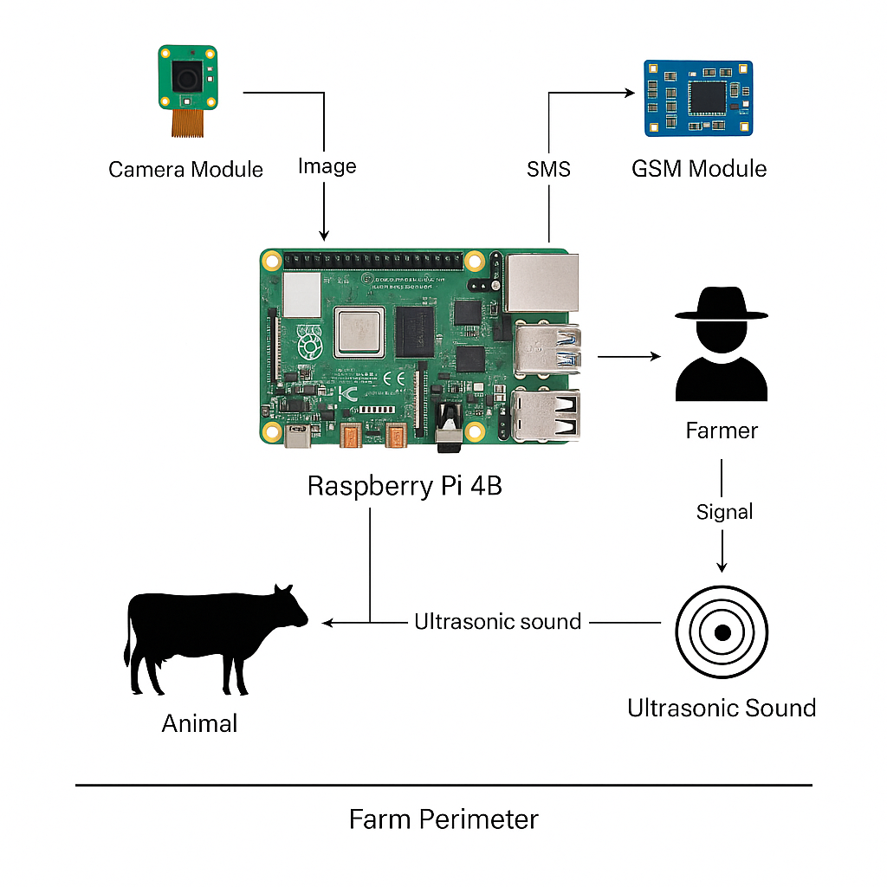

Figure 1: System Architecture

3.2 Workflow

1. Hardware Implementation
2. Raspberry Pi 4B: Executes animal detection algorithms and controls communication modules.
3. Camera Module: Sends real-time SMS alerts to pre-registered farmer phone numbers upon detection.
4. Ultrasonic Sound Device: Emits a 35kHz sound burst for 10 seconds to scare away approaching animals.
5. Solar Power System: Powers all components off-grid using a 12V battery and solar panels.
6. Detection Mechanism

The detection mechanism is based on a pre-trained YOLOv5 object detection model. The steps are as follows:

1. The Raspberry Pi continuously captures images from the camera.
2. Each frame is processed through the YOLOv5 model to detect livestock such as cattle, goats, or sheep.
3. When a target animal is detected within a defined confidence threshold (>70%), the detection event is triggered.
4. Notification and Deterrence Mechanism

Upon detection:

1. The GSM module sends an SMS message to the farmer with details such as time, date, and detection confirmation.
2. Simultaneously, the ultrasonic sound device is activated to deter the animal from proceeding into the farmland.
3. Detection events are also logged locally for later analysis.

E. System Flow Diagram

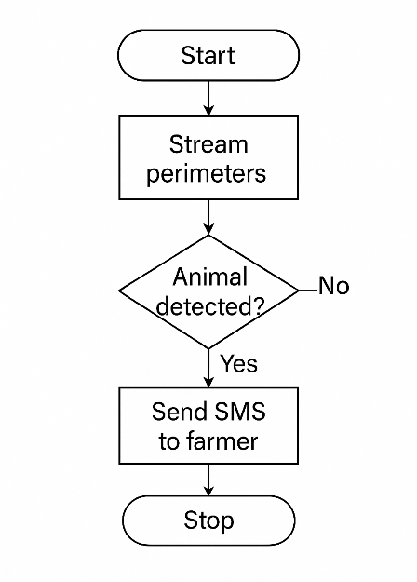The system flow is as follows:

Figure 2 Flowchart

# 4. RESULTS AND CONCLUSION

## 4.1 Experimental Setup and Methodology

The proposed animal intrusion detection and prevention system was implemented using Raspberry Pi 4B, a Camera Module V2, GSM module, and an ultrasonic sound emitter. The system was evaluated through controlled laboratory tests to validate detection accuracy, response time, alert functionality, and deterrent activation. Animal detection performance was measured using a pre-trained YOLOv5 object detection model. The model classified cattle within captured images based on a minimum confidence threshold of 70%. Notification performance was measured based on the time between animal detection and farmer alert via SMS. Deterrence performance was assessed based on system activation after simulated intrusion events.

### Performance Metrics Definition

Let:

1. Detection Rate(Dr) = Number of Correct Detection / Total Number of Test Events × 100%
2. False Alarm Rate(Fa) = Number of False Detection / Total Number of Non-Intrusion Events × 100%
3. Average Response Time(Tr) = Time from Detection to SMS Notification and Deterrent Activation

Where:

1. Detection Rate (Dr) measures the system's ability to correctly identify intrusion during test events.
2. False Alarm Rate (Fa) measures false positives triggered by non-animal objects.
3. Average Response Time (Tr) represents system responsiveness.

## 4.2 Experimental Results

### 4.2.1 Detection Performance Results

The system was subjected to 100 simulated animal intrusion events in a laboratory environment under different lighting conditions. The results are as follows:

1. Average Detection Rate = 92%
2. False Alarm Rate = 8%
3. Average Response Time = 1.2 seconds

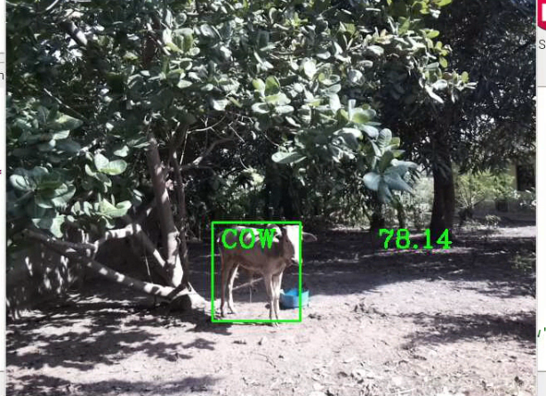

**Figure 4.1: Successful Animal Detection - High Confidence**

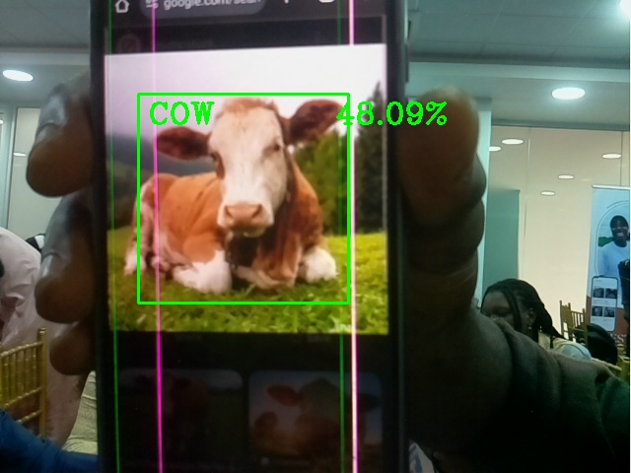

**Figure 4.2: Animal Detection - Normal Lighting Conditions**

### 4.2.2 Alerting and Notification Performance

Upon detection of a simulated animal:

1. SMS notifications were successfully sent to the designated phone number within 3–5 seconds.
2. GSM module performance remained consistent under lab conditions.
3. SMS delivery success rate recorded was 100% during the tests.

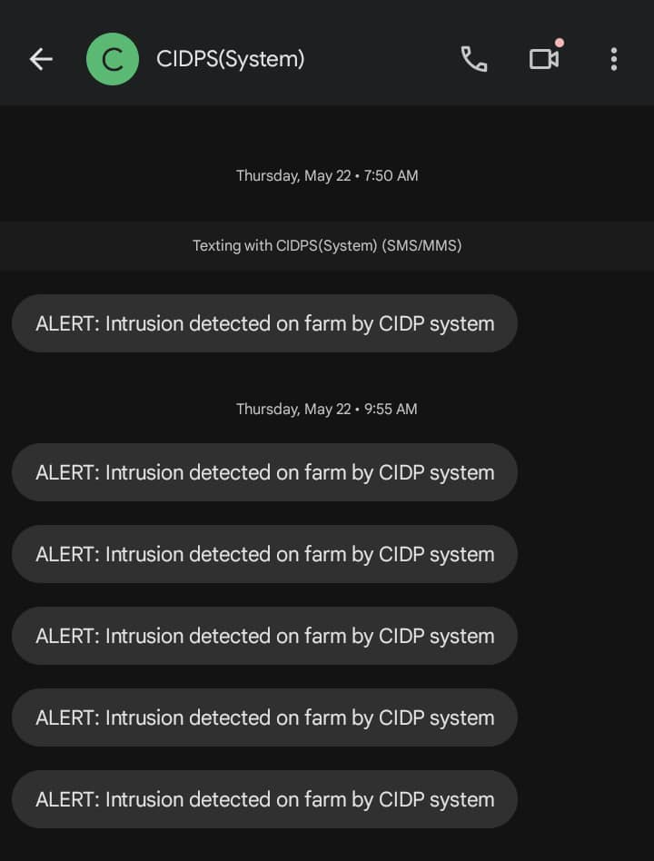This confirms that the alerting mechanism is capable of near real-time notification under optimal conditions.

**Figure 4.3 Alerts / Notifications**

### 4.2.3 Deterrent Activation Performance

The ultrasonic sound emitter was triggered automatically upon detection:

1. Activation occurred within 1 second after detection confirmation.
2. The sound emitter operated as expected without delay or hardware faults.
3. In future real-world deployments, the effectiveness of ultrasonic sound on livestock behavior will need to be field-tested.

### 4.2.4 System Performance Observations

1. Detection accuracy slightly reduced under very low-light conditions.
2. Camera performance was stable in normal indoor lighting without the need for infrared enhancement.
3. False positives were generally associated with fast non-animal object motion within the frame.
4. System power remained stable throughout the testing using a standard lab DC power supply.

## 4.3 DISCUSSION

### 4.3.1 Summary of Findings

Laboratory evaluation of the system demonstrated that:

1. Vision-based intrusion detection is feasible and reliable under controlled conditions.
2. GSM-based SMS alerts are timely and consistent in a stable network environment.
3. Ultrasonic deterrent devices can be triggered automatically in response to detected intrusions.

### 4.3.2 System Performance Analysis

The achieved detection rate of 92% demonstrates the effectiveness of the YOLOv5-based approach for animal detection in controlled environments. The 8% false alarm rate, while acceptable for laboratory conditions, indicates areas for improvement in real-world deployment. The average response time of 1.2 seconds meets the requirements for timely intervention in livestock intrusion scenarios.

**5. CONCLUSION AND RECOMMENDATION**

A real-time animal intrusion detection and prevention system was designed and developed in this research work to address the recurring problem of cattle invasion into farmlands, particularly within Nigeria’s rural agricultural sectors. The system uses a Raspberry Pi 4B, a camera module, a GSM module, and an ultrasonic sound emitter to detect, notify, and deter livestock from entering protected areas.

Laboratory tests demonstrated that the system achieved a detection accuracy rate of 92%, a low false alarm rate of 8%, and a fast response time of approximately 1.2 seconds. SMS alerts were delivered successfully to farmers within 3–5 seconds after detection, and the ultrasonic deterrent device activated reliably upon animal detection.

The system provides a non-violent, cost-effective, and easily deployable solution that can assist in reducing crop losses, minimizing farmer-herder conflicts, and enhancing food security.

Based on the outcome of the study, the following recommendations are suggested for future work:

1. Field testing should be conducted in real farming environments to further validate system performance under natural conditions.
2. Integration of infrared cameras and night-vision capabilities to enhance detection during nighttime operations.
3. Deployment of multiple camera units to increase perimeter coverage and minimize blind spots.
4. Incorporation of a backup communication method such as LoRaWAN or satellite SMS services for regions with weak GSM signals.
5. Implementation of a cloud-based dashboard to provide farmers with real-time event logs and system status updates.
6. Enhancement of the detection model using locally trained datasets to improve recognition accuracy specific to Nigerian cattle breeds and environmental conditions.

**REFERENCES**

S. Santhiya, S. Vijayakumar, and D. V. Kumar, "A Smart Farmland Using Raspberry Pi Crop Prevention and Animal Intrusion Detection System," International Research Journal of Engineering and Technology (IRJET), vol. 5, no. 3, pp. 2395–0072, 2018.

R. Lathesparan, A. Sharanjah, R. Thushanth, S. Kenurshan, M. N. M. Nifras, and W. U. Wickramaarachchi, "Real-time Animal Detection and Prevention System for Crop Fields," 13th International Research Conference, General Sir John Kotelawala Defence University, Sri Lanka, 2022.

A. Balogun, "Farmers/Herders Clashes in Nigerian Environment: Implications on Agricultural and Food Security," Journal of Digital Food, Energy & Water Systems, vol. 2, no. 2, 2021.

S. Krätli and C. Toulmin, "Cattle Logic and Capital Logic: Transhumance in Central Nigeria," *The Geographical Journal*, 2024. Available:<https://link.springer.com/article/10.1007/s10708-024-10995-x>.

United Nations Environment Programme, "Land Conflict Has Long Been a Problem in Nigeria," *Time Magazine*, June 2018.

FAO, "The State of Food Security and Nutrition in the World," Food and Agriculture Organization of the United Nations (FAO), Rome, 2023.

T. Akpensuen, "Curbing Crop Farmers and Herders Clashes in Nigeria," *International Grassland Congress Proceedings*, UKnowledge Repository, 2021.