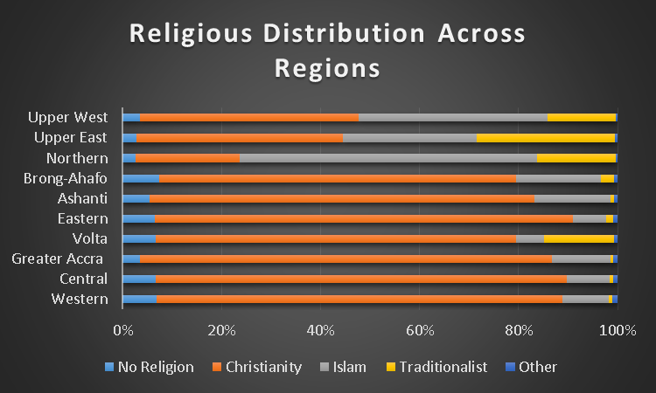

The above graph shows the distribution of both males and females across the ten regions. From the graph, it shows that Christians are mainly distributed in the southern part of Ghana and Moslems are mostly located in the northern part. It is therefore not surprising that you have many MP`s in the south being Christians and many MP`s in northern Ghana being Moslems. Distribution of MP`s religion, the of the constituency and region are shown other graphs in tableau.

Below represents distribution of males and females religion across the regions. It follows the same correlation as the total distribution.

