# **The Environmental Cost of Transistor Technology**

As technology evolves, its contributions to global carbon emissions and climate change become more pronounced. As human activities continue to emit more CO2, more of the sun's heat is being trapped, causing a plethora of environmental changes.   
  
A technological advancement greatly impacting our environment is Transistors. Transistors are semi-conductor devices that can amplify or switch electronic signals [6]. Therefore, they serve as the fundamental building blocks of modern electronics, enabling the creation of smaller, more efficient, and more powerful devices. They are found in virtually every electronic device we use today. As stated by the Computer History Timeline [7], The Manchester TC developed by Richard Grimsdale and Douglas Webb in 1953, was one of the first computers to use transistors instead of vacuum tubes [8]. By 1971, Intel's 4004 became the world's first commercially available microprocessor. **It integrated 2,250 transistors onto a single chip** [9].



These innovations led to the discovery of several more efficient and powerful transistors. An example being the insulated gate bipolar transistor [17]. This transistor can manage much higher voltages and currents than standard and is more energy-efficient than standard transistors.

Transistors have impacted the environment both positively and negatively. A study by Robin Mitchell [10] shows that, Transistor **advancements have created more efficient electronic devices, reducing power consumptions**. The study also covers miniaturisation; this describes **smaller transistors enabling the creation of compact but** A graph with numbers and lines
**powerful devices**, potentially reducing material usage. Transistors are also crucial for renewable energy systems/vehicles supporting the transition to cleaner energy sources [11].

In terms of negative impacts; a study by Van Yken et al. confirms that rapid technological advancement (which involves the rapid advancement of transistor technology) has contributed to **an increased e-waste generation**. Additionally, according to an article by Pádraig Belton [12], **chip manufacturing requires huge amounts of energy and water - and creates hazardous waste**.

Fundamentally, transistor production generates significant CO2 emissions, especially as transistors are primarily made from silicon.

I personally feel that the technological advancement of transistors has impacted the environment more negatively than it has positively. Technology is fast-evolving and has become integral to daily life. Separate technological advancements (such as AI) rely on electronic devices. Transistors are embedded in nearly all integrated circuits, which are a part of every electronic device [14]. This is aside from all the e-waste due to **humans no longer using devices until they are obsolete**.

The original dataset is primarily attributed to Moore’s Law which predicts the doubling of transistors on a microchip approximately every two years. This scatter plot visualises the increase in transistors counted per microprocessor over the years. Each table row/dot represents a different microprocessor (e.g. ARM6, Intel4040, Apple M3 Max).

The plot highlights **an exponential growth that suggests an increased use of transistors over the years.**

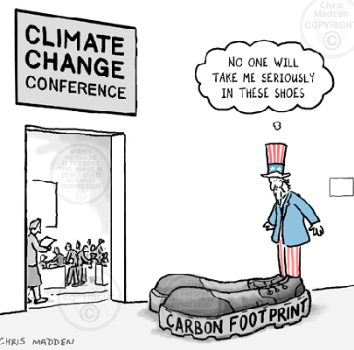Research and market reports [16] highlight countries with a high usage of integrated-gate bipolar transistors and a lower usage of IGBTS. Following a subset of the general country emissions dataset, this scatter plot highlights a primary increase in CO2 emissions over years. The plot also, importantly, **shows more CO2 emission within countries with a high IGBT Usage compared to those with a Low IGBT Usage**.

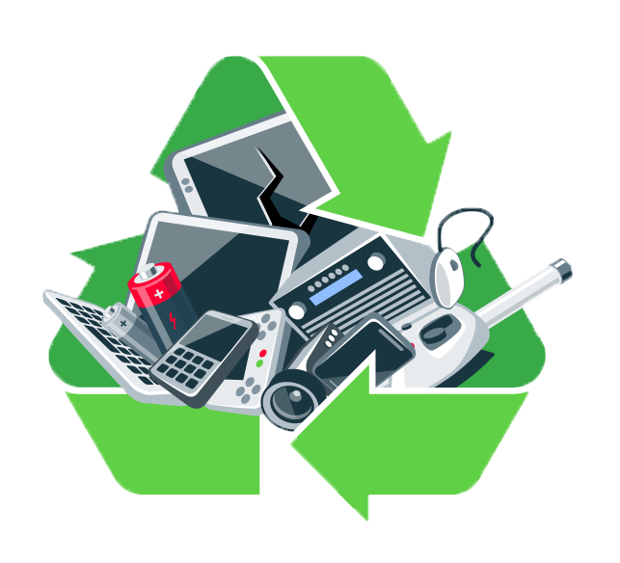My data analysis confirms claims on the technological advancement of transistors impacting the environment more negatively than positive. Despite the positive contributions that transistors have had on promoting more efficient electronic devices, the data clearly shows a remaining exponential increase in CO2 emissions.   
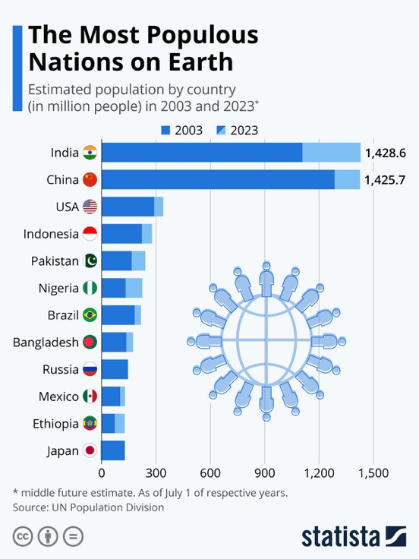

A limitation to my data analysis could be that the correlation between IGBT usage and emissions may not imply causation as other factors could influence a country’s emission levels. For example, some countries have heavy manufacturing sectors, population densities vary etc.

A good and easy way to reduce CO2 emissions connected to transistor technologies would be recycling programs for electronic waste. Recycling can be used to recover valuable materials from old devices, reducing the need for new raw material and therefore reducing manufacturing emissions.

**Equality and online access**

The internet is often assumed to be globally accessible, enabling seamless communication and innovation. However, this assumption is challenged by disparities in internet access worldwide. A report by Simon Kemp highlighted that **as of October 2024, only 67.5% of the global population had access to the internet** [1].

Limited infrastructure, economic constraints, censorship, and digital literacy are key contributors to this disparity. This significantly affects technological diffusion, the rate at which societies adopt new technologies. This disparity creates a digital divide, particularly evident in blockchain technology.

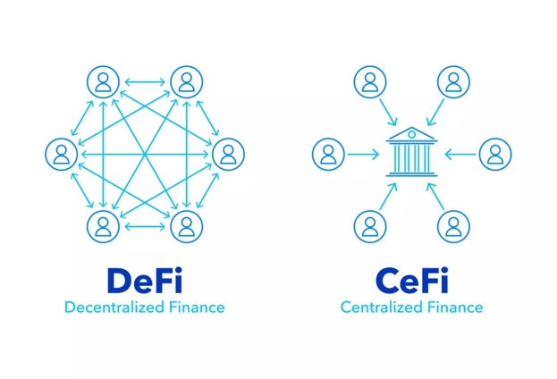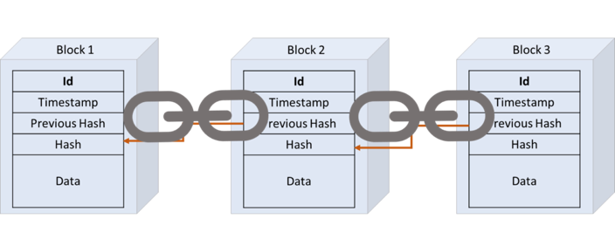Blockchain revolutionises the secure storing of immutable data. The key advantages blockchain provides are its security and transparency.

Image representing Blockchain

Unlike conventional databases which rely on vulnerable CRUD operations: create, read, update, destroy [4], blockchain stores data in a linear chain of cryptographically linked blocks across a decentralized network [2]. Consensus algorithms such as Proof of Work (PoW) and Proof of State (PoS), are used to ensure data integrity [3]. This eliminates risks of tampering as updates are impossible without consensus from the entire network [5]. Blockchain’s transparency also enables it to be a ledger as it keeps a permanent, time-stamped record of every transaction on its network [6]. This is particularly useful for industries such as finance, healthcare, and supply chain management.

Decentralised Finance (DeFi) is a key example of the transformative potential of blockchain. DeFi leverages blockchain technology to offer financial services whilst eliminating intermediaries such as banks. This reduces transaction costs, promoting financial inclusion as regions with unreliable traditional financial infrastructures are still provided with banking services. [7]. Whilst Decentralised Finance is accessible in theory, a limitation is its requirement of digital literacy. Many potential users in underdeveloped regions may lack the digital literacy needed to utilise decentralised applications, undermining the inclusivity from its affordability.

Blockchain can be seen as a technology with deterministic traits through how it introduces new systems such as Decentralised Finance which challenge traditional banking systems. However, the adoption of Blockchain is strongly influenced by societal factors, including governance, regulation, and education. Blockchain, in this sense, operates within both technological 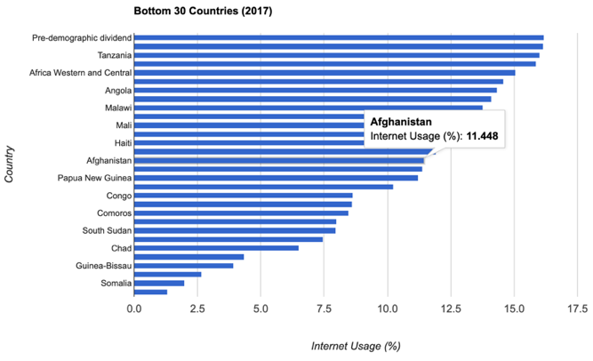determinism and social constructivism. It has the potential to reshape industries, but whether it does so, and to what extent, depends heavily on social, economic, and political conditions.

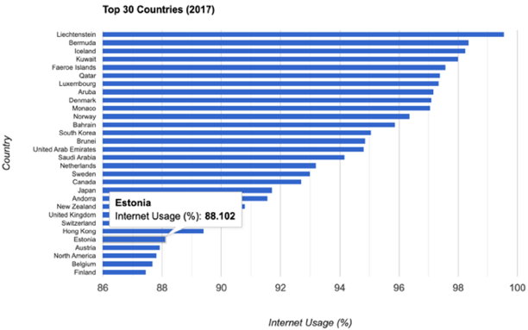Using the dataset on internet usage, I analysed disparities between countries in the top and bottom 30 for 2017, focusing on Estonia and Afghanistan respectively.

**Estonia, with an 88.10% internet usage rate**, is regarded as a global pioneer in blockchain technology.

**Estonia has integrated blockchain across multiple sectors, such as e-governance, healthcare, and its e-Residency program** [8][9].

Estonia's robust digital infrastructure enables seamless blockchain adoption, reinforcing its status as a technological leader.

Conversely, **Afghanistan, with an only 11.45% internet usage**, reflects its limited blockchain adoption. The **ban of all form of cryptocurrency by the Taliban in August 2022** and the lack of digital infrastructure highlights how limited infrastructure and restrictive governance hinders blockchain adoption [10].

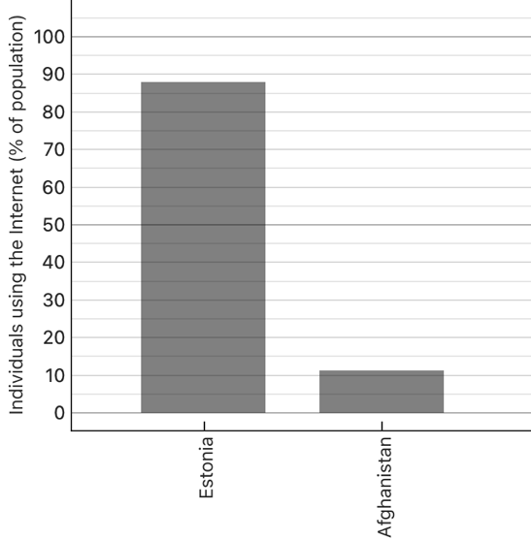

Afghanistan

Estonia

Conclusions could suggest Estonia’s high internet connectivity supports its advanced digital ecosystem and blockchain use, whilst Afghanistan's limited internet and infrastructure exacerbates its exclusion from blockchain development. While internet access is the fundamental enabler, education and governance also play pivotal roles. Although the dataset provides valuable insights, there is a **lack of data beyond 2017**. This limits the reliability of assessing current trends. Future analyses would benefit from more recent data, capturing changes in internet access and effects towards blockchain adoption. It is also recognised even if Afghanistan were to have improved internet access, restrictive policies would remain a significant barrier.

With only **67.5% of the population connected in 2024**, global internet accessibility is far from a reality. This disparity has direct impacts on blockchain adoption. Estonia and Afghanistan exemplify how internet access, combined with governance and societal factors, shapes the extent to which countries can adopt blockchain. Addressing global internet inequalities is essential for reducing digital divide and enabling innovations such as Blockchain.

**AI and the digital divide.**

Artificial Intelligence (AI) is a transformative technology simulating human intelligence and reshaping global industries [1]. AI has the potential to transform the productivity and GDP of the global economy, evident through a predicted **14% increase in global GDP by 2030** [2]. However, the development and application of AI remain unequal across the world, introducing significant risks regarding equity and representation.

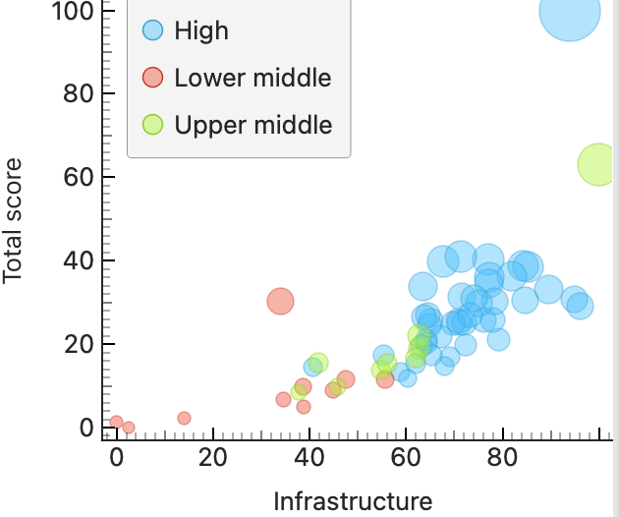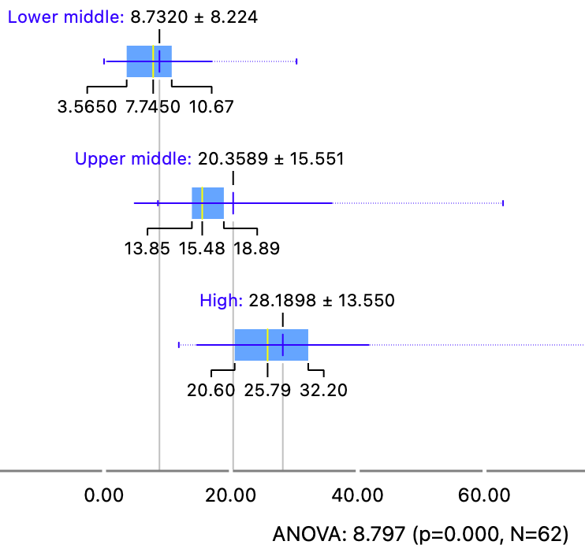

Analysis of the dataset revealed significant global disparities in AI development. The box plot visualisation highlights contrasting mean global AI score, with **lower income countries averaging approximately 8.73 compared to high income countries with 28.2.** This highlights a systemic imbalance where wealthier countries such as the United States, consistently outperform across all metrics such as talent, infrastructure, and research, leaving lower-income countries underrepresented in AI development.

Further analysis of the scatter graph revealed a strong correlation between development, income levels and global AI scores. This illustrates how higher income countries can invest in development toward AI. Conversely, lower income countries which are constrained by limited income and resources, often depend on external AI systems. This introduces bias in AI systems as algorithms and datasets generated in wealthy countries may reproduce biases when applied in developing countries, due to their lack of sensitivity and diversity [3].

These imbalances are particularly concerning in critical fields such healthcare. With data being the foundation of AI systems, when these datasets predominantly originate from high-income nations, they often fail to reflect the diversity of global populations and representation. This can lead to healthcare AI systems that are harmful when applied to underrepresented groups, such as people of colour in lower-income regions as they may produce incorrect health assessments [4].

An AI-tool showing evidence of AI-bias is the ‘clinical risk prediction algorithm’ (an example being that of the healthcare company ‘Optum’[8]). This algorithm is used within healthcare to analyse patient data and assist patients based on urgency. It is used A graph of different colored lines
widely in the US healthcare system. A study by Z. Obermeyer [6], highlights a significant underestimation in health needs of black patients compared to white patients with similar health conditions.

**The** **bias stems from the algorithm using health costs as a proxy for health needs**. Less money is spent on black patients who have the same level of need. However, this is due to many factors such as historical discrimination and systemic inequalities leading to a distrust of the healthcare system within black communities. Also, socioeconomic disparities; black patients may have lower incomes on average, therefore spending less. Despite these external factors contributing to less money spent on black patients, the **algorithm falsely concludes that black patients are healthier than equally sick white patients.**

According to Z.Obermeyer [6], the algorithm reduces the number of black patients identified for extra-care by more than half, potentially allowing health problems to progress and further perpetuating racial health disparities.

Analysing AI-biases, most focus on whether there are AI-biases in the model’s algorithm. A study by Otis, Delecourt, Cranney, and Koning [7], tries to understand if there are biases/gaps in the way that humans with different genders use/develop AI. It found that across many countries, **women use generative AI tools less than men.**

This study prompted me to explore the correlation between AI readiness/development within countries considered to have a majority demographic of ‘people-of-colour’ and those considered to have one of ‘non-people-of-colour’.   
  
The plot shows that **countries with a majority demographic of POC tend to use/develop AI less than NON-POC countries.** This supports claims of racial-bias by suggesting representational harms caused by lack of perspective in development.

Addressing these biases requires diverse teams to bring a broader range of perspectives and experiences. A solution proposed in a Padlet suggests involving more diverse teams in testing software for racial biases before release. This approach could identify and mitigate biases, ensuring AI advancements serve everyone equitably.

**References  
  
Sector 1: The Environmental Cost of Transistor Technology**

 [1] S. Baxi, "Impact of Digitalization on Carbon Footprints," LinkedIn, 2021. [Online]. Available: <https://www.linkedin.com/pulse/impact-digitalization-carbon-footprints-sahil-baxi-0nawf/>. [Accessed: Dec. 8, 2024].

 [2] United Nations, "Climate Change: Causes and Effects," UN.org. [Online]. Available: <https://www.un.org/en/climatechange/science/causes-effects-climate-change>. [Accessed: Dec. 8, 2024].

 [3] A. M. B. Z. T. H. A. Z. H. A. M. T. H. M., "ICT Global Emissions Footprint," Electronics Silent Spring, 2015. [Online]. Available: <https://www.electronicsilentspring.com/wp-content/uploads/2015/02/ICT-Global-Emissions-Footprint-Online-version.pdf>. [Accessed: Dec. 8, 2024].

 [4] World Economic Forum, "How Digital Solutions Can Reduce Global Emissions," 2022. [Online]. Available: <https://www.weforum.org/stories/2022/05/how-digital-solutions-can-reduce-global-emissions/#:~:text=Analysis%20by%20Accenture%2C%20in%20collaboration,energy%2C%20materials%20and%20mobility%20industries>. [Accessed: Dec. 8, 2024].

[5] COP29, "Home," COP29.az. [Online]. Available: <https://cop29.az/en/home>. [Accessed: Dec. 8, 2024].

[6] E.Moraguez, "The History and Evolution of Transistor Technology," InfoTransistor.com. [Online]. Available: <https://www.infotransistor.com/the-history-and-evolution-of-transistor-technology/>. [Accessed: Dec. 8, 2024].

[7] Computer History Museum, "Timeline of Computing History," 1953. [Online]. Available: <https://www.computerhistory.org/timeline/1953/#169ebbe2ad45559efbc6eb35720bfc24>. [Accessed: Dec. 8, 2024].

[8] J. M. Norman, "History of Information," "The History of Information," 2021. [Online]. Available: <https://www.historyofinformation.com/detail.php?entryid=4074>. [Accessed: Dec. 8, 2024].

[9] Computer History Museum, "Timeline of Computing History," 1971. [Online]. Available: <https://www.computerhistory.org/timeline/1971/#169ebbe2ad45559efbc6eb35720a2e7b>. [Accessed: Dec. 8, 2024].

[10] R. Mitchell, Electropages, "New Transistor Design Promises Faster Speeds and Durability," Oct. 2024. [Online]. Available: <https://www.electropages.com/blog/2024/10/new-transistor-design-promises-faster-speeds-and-durability>. [Accessed: Dec. 8, 2024].

[11] R. Mitchell, Electropages, "Indian Researchers Develop Transistor Using Single Molecule for Faster Electronics," Oct. 2024. [Online]. Available: <https://www.electropages.com/blog/2024/10/indian-researchers-develop-transistor-using-single-molecule-faster-electronics>. [Accessed: Dec. 8, 2024].

[12] P. Belton, The Guardian, "Semiconductor Silicon Chips and Their Carbon Footprint," Sep. 2021. [Online].Available: <https://www.theguardian.com/environment/2021/sep/18/semiconductor-silicon-chips-carbon-footprint-climate>. [Accessed: Dec. 8, 2024].

[13] J. C. Hess, Interface Europe, "Chip Production's Ecological Footprint," 2021. [Online]. Available: <https://www.interface-eu.org/publications/chip-productions-ecological-footprint/>. [Accessed: Dec. 9, 2024].

[14] C. Hashemi-Pour, TechTarget, "Transistor Definition," TechTarget.com. [Online]. Available: <https://www.techtarget.com/whatis/definition/transistor/>. [Accessed: Dec. 8, 2024].

[15] Wikipedia, "Transistor Count," Wikipedia.org. [Online]. Available: <https://en.wikipedia.org/wiki/Transistor_count/>. [Accessed: Dec. 8, 2024].

[16] Information Technology: Latest News, Press Releases, and More, "IGBT Market Research Report Regional Analysis," LinkedIn.com, Oct. 2023. [Online]. Available: <https://www.linkedin.com/pulse/igbt-market-research-report-regional-jwppf/>. [Accessed: Dec. 8, 2024].

[17] M. M. Ali Bhatti, "IGBT: The semiconductor transistor that could transform the energy sector," Wired Middle East, 2023. [Online]. Available: <https://wired.me/technology/igbt-semiconductor-transistor/>. [Accessed: Dec. 9, 2024].

**Sector 2: Equality and Online Access**

[1] S. Kemp, “Digital 2024 October Global Statshot Report.” Accessed: Dec. 2, 2024. [Online.] Available: <https://datareportal.com/reports/digital-2024-october-global-statshot>

[2] A. Hayes, “Blockchain Facts: What Is It, How It Works, and How It Can Be Used” Investopedia. Accessed Dec. 5th, 2024. [Online.] Available: <https://www.investopedia.com/terms/b/blockchain.asp#toc-what-is-a-blockchain>

[3] D. Mingxiao, M. Xiaofeng, Z. Zhe, W. Xiangwei and C. Qijun, "A review on consensus algorithm of blockchain," 2017 IEEE International Conference on Systems, Man, and Cybernetics (SMC), Banff, AB, Canada, 2017, pp. 2567-2572, doi: 10.1109/SMC.2017.8123011.

[4] A. Sharif, “What is CRUD?” CrowdStrike. Accessed Dec.2, 2024. [Online.] Available: <https://www.crowdstrike.com/en-us/cybersecurity-101/observability/crud/>

[5] Veera Budhi, “Advantages And Disadvantages Of Blockchain Technology” Forbes. Accessed Dec. 2, 2024. [Online.] Available: <https://www.forbes.com/councils/forbestechcouncil/2022/10/20/advantages-and-disadvantages-of-blockchain-technology/> 

[6] S. Seth, “What Is a Cryptocurrency Public Ledger? How It Works and Risks” Investopedia. Accessed Dec. 7, 2024. [Online] Available: <https://www.investopedia.com/tech/what-cryptocurrency-public-ledger/>

[7] R. Auer, B. Haslhofer, S. Kitzler, P. Saggese, F. Victor. (Jan 2023). “The Technology of Decentralized Finance (DeFi)” BIS. Accessed Dec. 8, 2024. [Online] Available: <https://www.bis.org/publ/work1066.pdf>

[8] J. Käi, “Estonia is at the forefront of the world's crypto scene” GrantThornton. Accessed Dec. 8, 2024. [Online] Available: <https://www.grantthornton.ee/en/insights1/estonia-is-at-the-forefront-of-the-worlds-crypto-scene/>

**Sector 3: AI and the Digital Divide**

[1] C. Stryker and E. Kavlakoglu. “What is artificial intelligence (AI)?” IBM.com Accessed: Dec. 10, 2024. [Online.] Available: <https://www.ibm.com/topics/artificial-intelligence>

[2] PWC, “Sizing the prize” pwc.com Accessed: Dec, 10. 2024. [Online.] Available: <https://www.pwc.com/gx/en/issues/analytics/assets/pwc-ai-analysis-sizing-the-prize-report.pdf>

[3] Robert Muggah, “Artificial Intelligence Will Entrench Global Inequality” foreignpolicy.com Accessed: Dec. 10, 2024. [Online.] Available: <https://foreignpolicy.com/2023/05/29/ai-regulation-global-south-artificial-intelligence/>

[4] M. Moncusí, F. Allery, A. Delmestri, et al. “Ethnicity data resource in population-wide health records: completeness, coverage and granularity of diversity.” Sci Data 11, 221 (2024). Accessed: Dec, 10. 2024. [Online.] Available: <https://doi.org/10.1038/s41597-024-02958-1>

[6]  N. G. Otis, S. Delecourt, K. Cranney, and R. Koning, "Global Evidence on Gender Gaps and Generative AI," Harvard Business School Working Paper, no. 25-023, 2024. [Online]. Available: <https://www.hbs.edu/ris/Publication%20Files/25-023_d09f0b39-4d4b-4828-b13e-df5dce799de0.pdf>. [Accessed: Dec. 13, 2024].

 [7] Z. Obermeyer, B. Powers, C. Vogeli, and S. Mullainathan, "Dissecting racial bias in an algorithm used to manage the health of populations," Science, vol. 366, no. 6464, pp. 447-453, Oct. 2019. [Online]. Available: <https://www.science.org/doi/10.1126/science.aax2342>. [Accessed: Dec. 13, 2024].

[8] J. Buolamwini and T. Gebru, "Gender Shades: Intersectional Accuracy Disparities in Commercial Gender Classification," The Guardian, Oct. 25, 2019. [Online]. Available: <https://www.theguardian.com/society/2019/oct/25/healthcare-algorithm-racial-biases-optum>. [Accessed: Dec. 13, 2024].