# Wash Watcher

Watch your washing with ease!

Group 12 Project

## Project Description

One main issue that university students face is the lack of ease when trying to do washing. Current systems available to students living in university accommodation, such as Circuit, do not present the options to check machine availability nor the time left on all in-use machines.

Our system aims to combat these issues by creating a student oriented experience that allows machines to be filtered by area and displays which machines are the closest available to the student. The students will also have the option to see which nearby machines are in use, and how long they have left until their cycle is completed. The aim of this is to prevent students wasting their time travelling to certain machines only to find out they can’t use them, which in turn improves efficiency.

Other perks of our system are how it displays prices, settings, and which machines are out of order. These features allow students to be more prepared before doing their washes so that less time can be spent at the actual machines resulting in the crowdedness of the wash rooms to reduce. Another feature that these pre existing systems lack is security. We aim to implement secure features within our Wash Watcher system to prevent theft. This will prevent potential theft of the student’s laundry since only the current user of the machine can open the door once the cycle has finished, aiming to provide a stress-free process.

The primary external stakeholders would be students, as this is our target audience. However, other stakeholders include universities and private student accommodation companies who would put our system in place.

## Quantitative and Qualitative Analysis

### Data Gathering

As a group, we decided to create a Google Forms questionnaire to collect information from students who currently use laundry services *(See Appendix A)*. The questionnaire contains 12 questions; the first 9 take a quantitative approach by asking students to rate existing and possible future system features on how useful they are, as well as questions about their current laundry service; the last 3 questions take a qualitative approach by asking open-ended questions on the student’s opinions on current features and what could be added as an improvement to the service. The questionnaire was distributed to students through social media and Whatsapp group chats.

Questions 1 to 6 ask about specific features we thought might be beneficial to have in our system. Question 1 asks how useful the student would find an “available machines” feature, which would display the current machines not in use, as well as the status of machines that are in use (e.g. time left). Question 2 asks how useful a “price display” feature would be, which would display the price of each specific wash setting to the user on the app. It can sometimes be difficult to understand the difference between each wash setting, so for question 3 we asked how useful the student would find a “settings display” feature which would give an explanation of each wash setting. Question 4 asks how useful a “wash times” feature would be to the student, which would display the timings of each wash setting. One of our initial ideas for a feature of the app was to have a “filter by location” feature, allowing the user to view availability of laundry rooms (that use the app) in the area of the user’s selected location. The usefulness of this feature is asked in question 5.

Next, question 6 asks the student how useful an “out of order machine display” feature could be, which would inform the user of any machines that are out of order in their chosen laundry room. We decided this could be helpful as it tells the users that a laundry room has less available machines than usual. This then made us wonder how many students struggle to find available machines in their laundry room, which we asked about in question 7. Something not many current laundry services take into account is the safety of a user’s washing when they are away from the machine. Because of that, question 8 was about how safe users feel leaving their washing in the machine. Finally, based on our group’s personal experiences with the machines, we decided to add question 9 which asks the students if the timing system within their current laundry app is accurate.

Beginning the qualitative section, question 10 asks the student for any specific features that they like about the current system they are using, whereas question 11 goes on to ask if there are any features they currently dislike. Question 12 asks the student about what features they feel could be added to a laundry app to improve it further so that we can gather ideas that we might not have come up with as a group.

To finish off the form we added a consent section *(See Appendix B)* so that participants are aware that their responses will be shared with the university and us anonymously. We also did this to protect both the university and ourselves in the case we receive claims that the responses were being used improperly.

### Data Analysis

Below are pie charts constructed from the answers of questions 1 to 6 asking how useful a specific feature is.

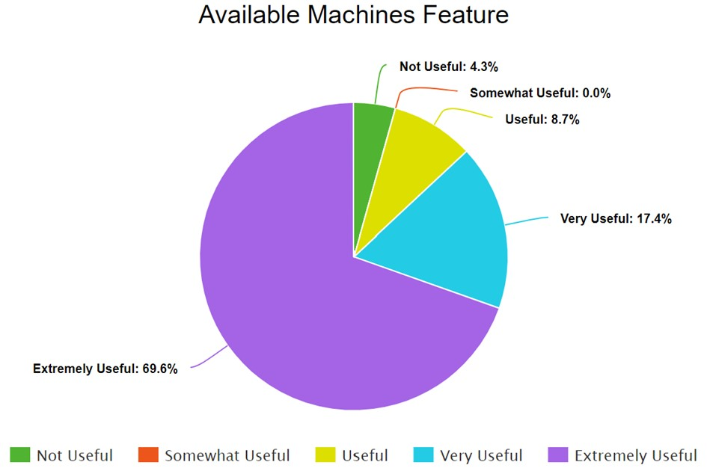Figure 1 highlights how 69.6% of respondents would find an “available machines” feature extremely useful, while 17.4% of the responses thought the feature would be very useful. This data led us to create our first essential requirement FR1.

Figure 1: Responses to Question 1: “How useful would you find an ‘available machines’ feature?”

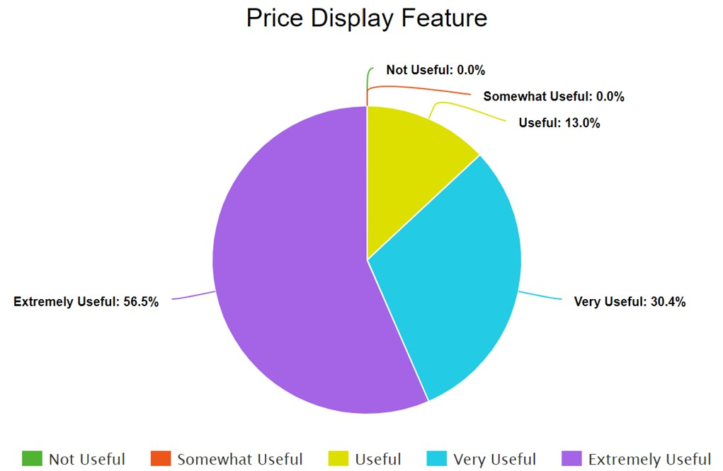Figure 2 depicts how useful a “price display” feature would be to students, with 56.5% labelling it an extremely useful feature, and 30.4% labelling it a very useful feature. This prompted us to create requirement FR2.

Figure 2: Responses to Question 2: “How useful would you find a ‘price display’ feature?”

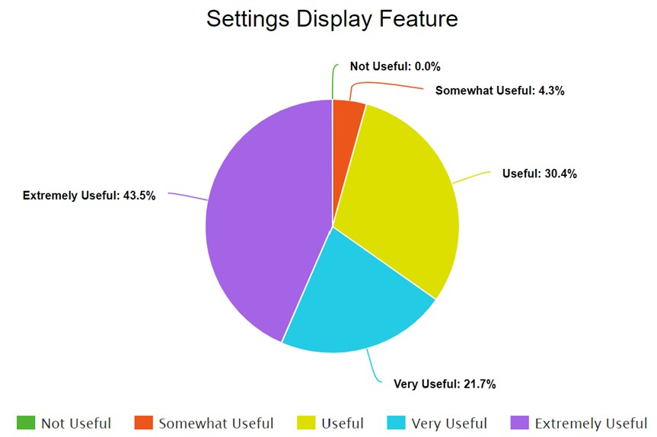Figure 3 shows how 43.5% and

21.7% of students would find a “settings display” feature extremely useful and very useful, hence the requirement FR4.

Figure 3: Responses to Question 3: “How useful would you find a ‘settings display’ feature?”

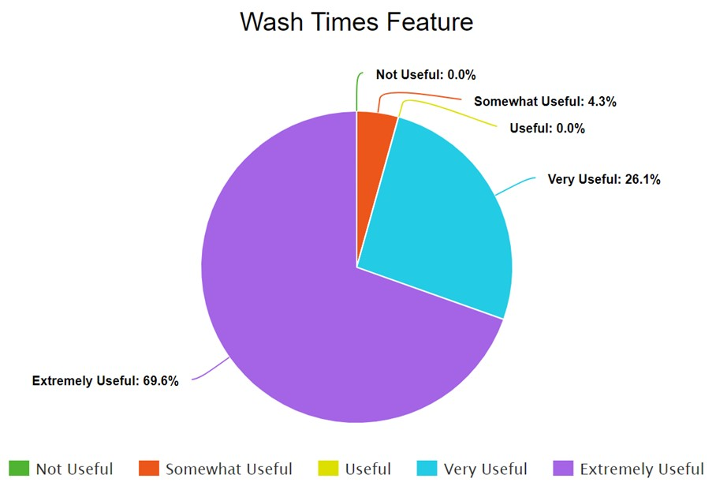Figure 4 displays how 16 out of 23 respondents would find a feature that displays wash times extremely useful, with 6 out of the 23 respondents also finding it a very useful feature. This prompted us to create requirement FR5.

Figure 4: Responses to Question 4: “How useful would you find a ‘wash times’ feature?”

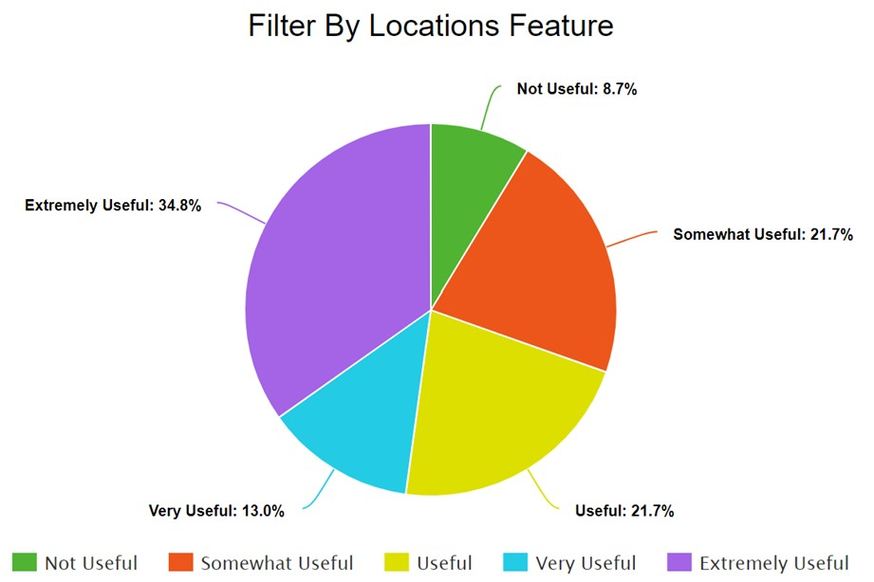Figure 5 highlights how while 2 out of 23 respondents wouldn’t find a “filter by locations” feature useful, 21 out of 23 respondents would still find this feature at a degree of usefulness, with the majority (34.8%) finding the feature extremely useful. This led us on to create FR13.

Figure 5: Responses to Question 5: “How useful would you find a ‘filter by locations’ feature?”

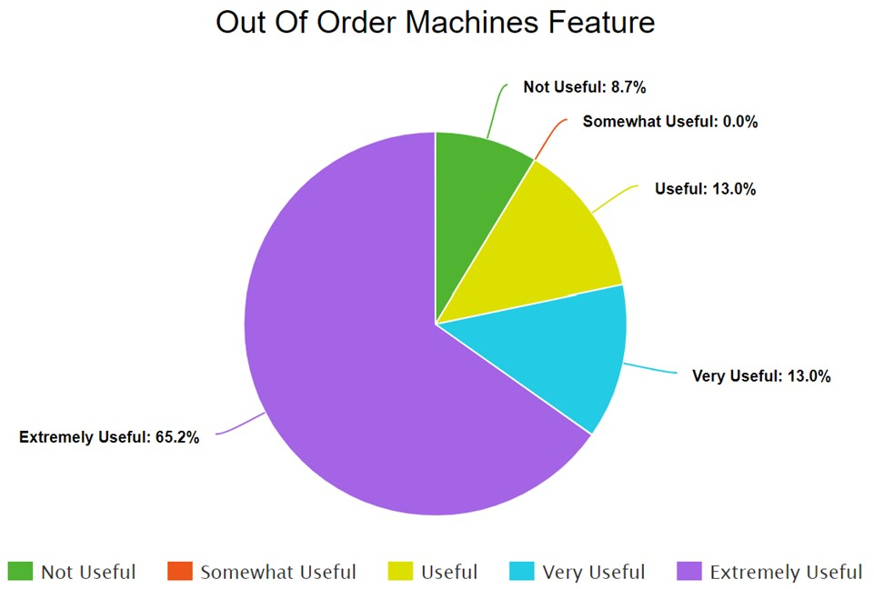Figure 6 also shows that 2 out of 23 respondents would not find an “out of order machines” feature useful, but on the contrary 15 out of 23 respondents would find such feature extremely useful, hence the requirement FR10.

Figure 6: Responses to Question 6: “How useful would you find a “out of order machines” feature useful?

Question 7 asks: “How often is there a free machine in your laundry room?”. With the scale being from “Never”(1) to “All the time” (5), the average of all responses from this question came to roughly 2.7, with 2 respondents choosing “Never” and 0 respondents choosing “All the time”. This reinforces the need for requirements FR1 which states that the system must show available machines, and NFR16 which states that the app could send a notification to users when a machine has become free. These requirements would help students plan ahead and inform users of machine availability.

Question 8 asks: “Is your washing safe in the machine whilst you're away from it?”. The scale for this question ranged from “Unsafe”(1) to “Safe”(5). The average response from this question turned out to be 3.5, with 12 out of 23 respondents choosing options 3 or 4. With only 6 out of 23 respondents claiming their washing was safe in the machine, this prompted requirement NFR2 to be created, adding a layer of security to the laundry service.

Question 9 asks: “Is the timing system inside of your laundry app accurate?”. Only 1 out of 23 respondents replied “Yes”, while 22 respondents replied with “No”, highlighting a big issue with the current laundry services. This is the reason requirements FR5 and NFR1 were created, explaining how the system not only has to display the time left on the user’s machine, but also how the display times must be accurate.

Question 10 is the start of the qualitative questions, with this question asking: “Are there any specific features you like about the current systems?”. With the majority of respondents leaving this question unanswered, one respondent stated how they like the feature of being able to check their balance on the app, hence the requirement FR11. Another stated how they liked how easy it is to connect to a machine using their device, leading us to create requirements NFR10 and NFR11, stating how our system should be able to connect with a variety of devices.

Question 11 asks: “Are there any specific features you dislike about the current system?”. 6 respondents out of 23 mentioned how inaccurate the timing system of their current laundry service is, which reinforces the need for requirements FR5 and NFR1 again. One respondent stated that they dislike the user interface of their current service, leading us to create requirement NFR14. Another respondent stated how they dislike not being able to view which machines are currently in use and if there are any available machines before they enter the laundry room, emphasising the need for requirement FR1. A further respondent wrote that they disliked how expensive their current laundry service is, prompting us to create requirement NFR18.

Lastly, question 12 asks: “What could be added to a laundry app to improve it further (that we have not already listed previously)?”. 3 respondents mentioned having an improved and more accurate timing system (NFR1). 1 user wrote how they would like to be able to use promotions and discounts (NFR18), while another user wrote how they would like to be notified if a machine has been unloaded, which resulted in us creating NFR16, notifying users of a machine that has become available.

## Written Requirements

### Functional Requirements

FR1: The system must show available machines in the location specified

FR2: The system must display the cost of doing a singular wash

FR3: The users must be able to top-up the balance in their account

FR4: The system must display the available washing settings that the machine can do

FR5: The system must display the time left on the user’s machine

FR6: Each wash setting should come with a brief description of its use

FR7: Each wash setting should state what kind of wash they are best suited for

FR8: The system should send a push notification when there is 10 minutes left of their cycle

FR9: The system should send a push notification when their wash cycle is complete

FR10: The system should send an alert to university maintenance staff when a machine becomes out-of-order

FR11: The user should be able to view their account balance

FR12: The app should have a customisable user profile feature

FR13: The user should be able to input their location if they don’t have location services turned on

FR14: The app should have a customer support feature that allows users to report issues with washing machines

FR15: The user could be able to increase the time left on the wash remotely

FR16: The user could receive email confirmation, such as an invoice, when money has been added to their account

FR17: The users could be allowed to provide feedback on the performance of the machine

FR18: The users could be able to request specific language support for international students

### Non-Functional Requirements

NFR1: The displayed times must be accurate to the nearest 5 seconds

NFR2: The system must have scan-in/scan-out QR code on the machine

NFR3: The system must only allow secure bank transfers

NFR4: The system must encrypt all data, including bank details

NFR5: Each location of the machines must be accurate to the nearest 5 metres.

NFR6: The system must be able to handle the traffic of at least 100,000 students

NFR7: The app must be accessible to all users regardless of abilities or disabilities

NFR8: The app must comply with all updated data privacy laws

NFR9: The system should be able to handle the data of around 1 million students

NFR10: The app should be compatible with a variety of different phone operating systems

NFR11: The app should be compatible with older generations of phones

NFR12: The app should aim to have at least 99% uptime each month

NFR13: The app should have clear, descriptive labelling

NFR14: The UI should be simple to understand

NFR15: The app could be less than 80 Mb in size

NFR16: The app could send a notification to users when a machine has become free

NFR17: The app could offer additional services such as dry-cleaning or ironing via partnerships with local services.

NFR18: The app could offer promotions and discounts to students that reduces the cost of their washing

## Use Case UML Diagram and Description

### Use Case Diagram

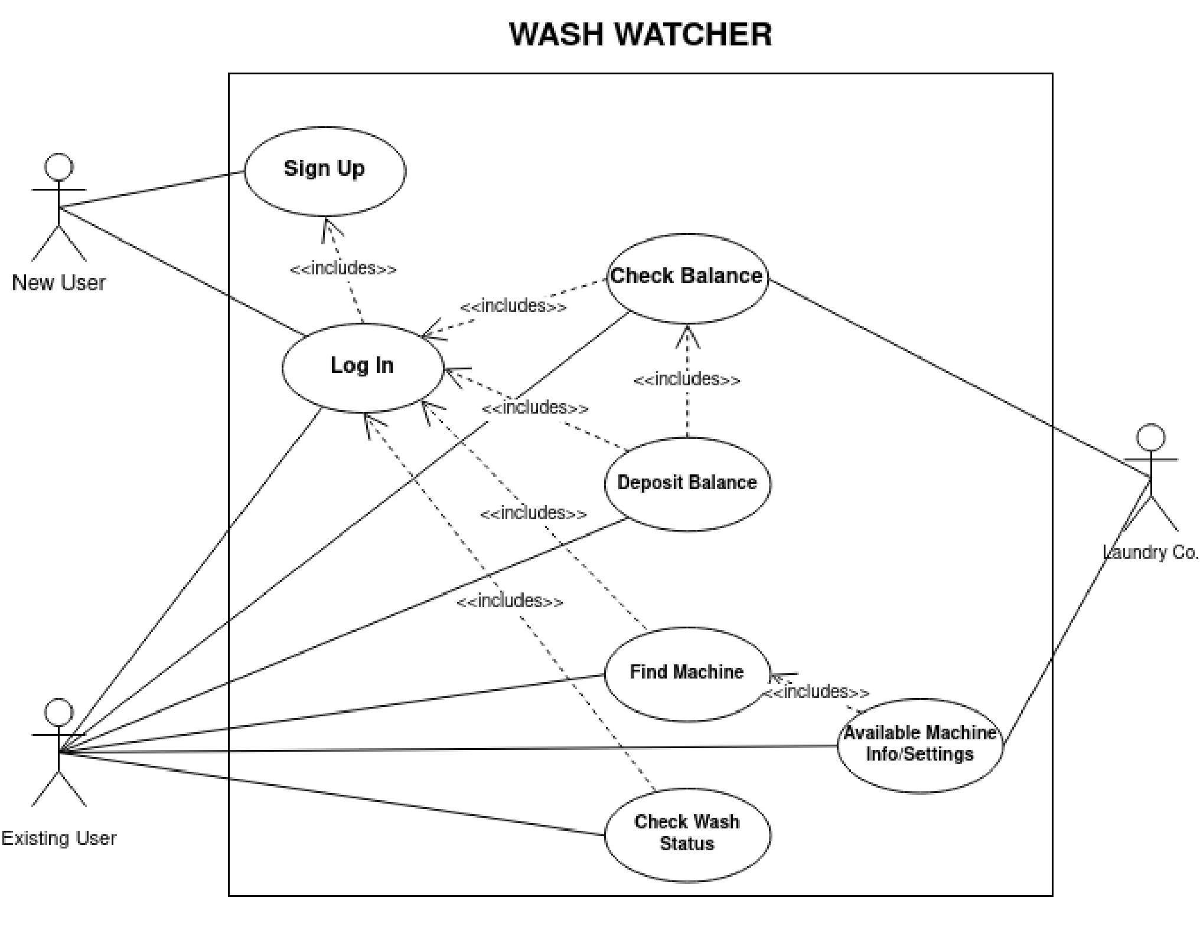

### Use Case Descriptions

**Use case:** Login

**Author:** James Benoist

**Date:** 18/02/22

**Purpose:** Allows the user to log in to their account when they launch the app

**Related Requirements:**

* FR12: The app should have a customisable user profile feature
* The user must provide their email address and password representing their account saved on the Wash Watcher System.

**Actors:**

**Primary:** New User, Existing User

**Typical flow of events:**

1. The user opens the app as is presented with a login screen.
2. a. Given that they have already signed up to a Wash Watcher account, they enter their login details that consist of their email address and password
3. a. The user’s credentials are validated allowing them to access their balance, check machines in the area and check the status of any wash cycles started under their account.

**Alternative event flows**:

**Alternative scenario 1**:

* 1. b. Given the user has never signed up for Wash Watcher before, they pick the ‘SignUp’ option.
  2. The user enters their email address as well as a password, this will be stored on the Wash Watcher server.
  3. **Repeat steps of typical flow 2-3**

**Alternative scenario 2:**

* 1. b. The user’s credentials are rejected, they are not allowed access to the features of Wash Watcher.
  2. The user can attempt to enter credentials again.

**Use case:** Check Balance (User side)

**Author:** James Benoist

**Date:** 18/02/22

**Purpose:** Allowing the user to check their balance whilst also allowing them to make a balance deposit if needed.

**Related Requirements:**

* FR11: The user should be able to view their account balance
* FR3: The users must be able to top-up the balance in their account
* NFR3: The system must only allow secure bank transfers

**Actors:**

**Primary:** Existing User **Secondary:** Bank

**Typical flow of events:**

1. After entering the app the user can check their balance. They do this by selecting the ‘Check Balance’ section.
2. Displayed is the balance of the user. If the user in question has just signed up, their balance will display as ‘£0.00’.
3. a. The user exits the balance check.

**Alternative event flows:**

**Alternative scenario:**

* 1. b. The user decides to deposit some money into their balance to use later.
  2. The user enters the amount to be deposited into the balance and is given options for payment (credit, debit, Paypal, etc)
  3. After the payment is processed the account balance is instantly updated and viewable.

**Use case:** Check Balance (Laundry Co. side)

**Author:** James Benoist

**Date:** 18/02/22

**Purpose:** Allows the system to check the balance of the user after taking a request from the company to withdraw money from it.

**Related Requirements:**

* NFR3: The system must only allow secure bank transfers
* If the user does not have enough money in their balance, the system will not allow them to use machines.

**Actors:**

**Primary:** Generic laundry company that has incorporated Wash Watcher into their system

**Secondary:** Existing User

**Typical flow of events:**

1. The company received a request to use one of the machines for a cycle by a specific Wash Watcher user.
2. The company checks the users current balance stored within the system to see if said user has sufficient funds for their desired wash.
3. a. The user's balance is greater than the required amount to do their selected cycle and the request is accepted.

**Alternative event flows:**

**Alternative scenario 1:**

* 1. b. The user’s balance is not greater than the required amount to do their selected cycle and the request is rejected.
  2. The user is informed about this rejected request.
  3. They are directed to the account balance section, where they can make a deposit.

**Use case:** Find Machine (existing user side)

**Author:** Amrisa Aujla

**Date:** 22/02/22

**Purpose:** This allows the user to find available nearby machines that they can then use.

**Related Requirements:**

1. The user will need to allow the app to have their location settings. This is the only way the app is allowed to search for the nearest available machines**.**
2. FR1: The system must show available machines in the location specified
3. FR13: The user should be able to input their location if they don’t have location services turned on
4. NFR5: Each location of the machines must be accurate to the nearest 5 metres.

**Actors:**

**Primary:** Existing user

**Secondary**: Settings app on their phone

**Typical flow of events:**

1. The user opens the app for the first time
2. It asks the user for their location settings. It will give 3 options: allow, allow only while using the app and don’t allow.
3. a. The user allows their location to be shared.
4. The apps accessibility to their precise location allows for the user to have access to the nearest available machines, to their current location

**Alternative event flows:**

**Alternative scenario 1:**

* 1. b. The user does not allow access to their location.
  2. The app cannot show the user the nearest available machines
  3. The user can still use the app, however not with the location feature

**Alternative scenario 2:**

* 1. c. at first the user denies access
  2. The user changes their their mind later on
  3. They will have to go on to the secondary actor (their phone settings), and change this setting to allow access.
  4. The user can then access all the nearest available machines to their current location

**Use case:** Check wash status (existing user side)

**Author:** Amrisa Aujla

**Date:** 22/02/22

**Purpose:** This allows the user to see what the status of their wash is, so the user knows how much time they have left until their wash finishes.

**Related Requirements:**

1. FR8: The system should send a push notification when there is 10 minutes left of their cycle
2. FR5: The system must display the time left on the user’s machine

**Actors:**

**Primary:** Existing user

**Secondary:** Washer system

**Typical flow of events:**

* 1. The user starts the wash and clicks on the section of the app which displays the wash status
  2. The user can read the wash status, with the time left clearly displayed
  3. When the users wash is 10 minutes to finishing there app will send out a notification to alert user
  4. The status will show completed when the time runs out

**Use Case:** Available Machines Information (company**)**

**Author:** Ayomide Balogun

**Date:** 22/02/22

**Purpose:** Allows the system to know the personalised settings/wash type availability of machines (at a local base), that are in service or temporarily out of service.

**Related requirements:** The system must be able to individually differentiate machines down to its available internal functions. The system should also be able to mutate settings and display a machine's personalised settings alongside the particular available/non-available machine.

**Actors involved: Primary:** Washer System

**Secondary:** Existing User

**Priority:** Washing machine availability information is interlinked to one of primary uses of the application - finding machines. This is because once a machine is found, a machine is only useful if the washer type & settings match that desired by the user e.g. dryer>washer. The company must allow the application to be serviceable to users.

**Typical flow of events:**

1. The system stores information on each individual washer such as washer type and its available features.
2. The system observes which machines are available in specific local areas.
3. The system displays this information on the application for the user to see.
4. The user logs into their account and selects a local laundry area of their choice.
5. The user is then able to view/find machines alongside the ‘available’ settings for the machine.

**Alternative flow of events:**

1. The system displays information on unavailable machines for the user to see.
2. The user is able to view unavailable machines with the machine type and settings (viewing settings/types of unavailable machines may explain imbalance of machine types as it is now known to the user which type of machines are unavailable).

**Use case:** Available machine info/settings (User)

**Author:** Tayo Ayeni

**Date:** 24/02/22

**Purpose:** This feature allows the user to view all the available settings and information of machines in the area allowing users to plan what washing type they could use before the arrive at the machine

**Related Requirements:**

1. FR4: The system must display the available washing settings that the machine can do
2. FR6: Each wash setting should come with a brief description of its use
3. FR7: Each wash setting should state what kind of wash they are best suited for

**Actors:**

**Primary:** Existing user

**Typical flow of events:**

1. The user selects an available machine in the area.
2. The user can then view the selected machine’s settings and information.

## Appendix

### Appendix A - Questionnaire to collect data from students

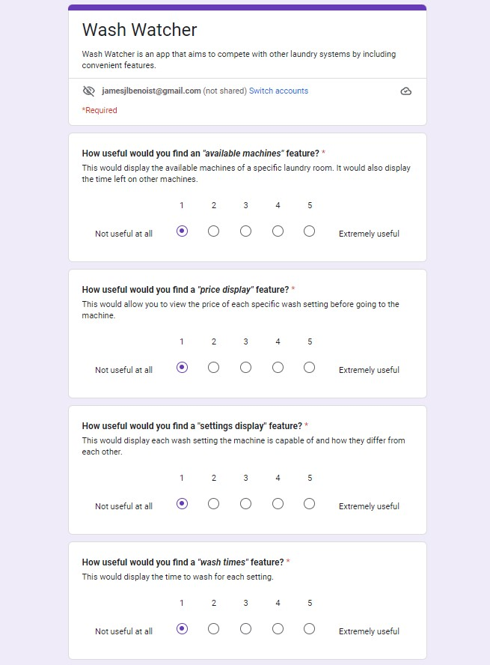

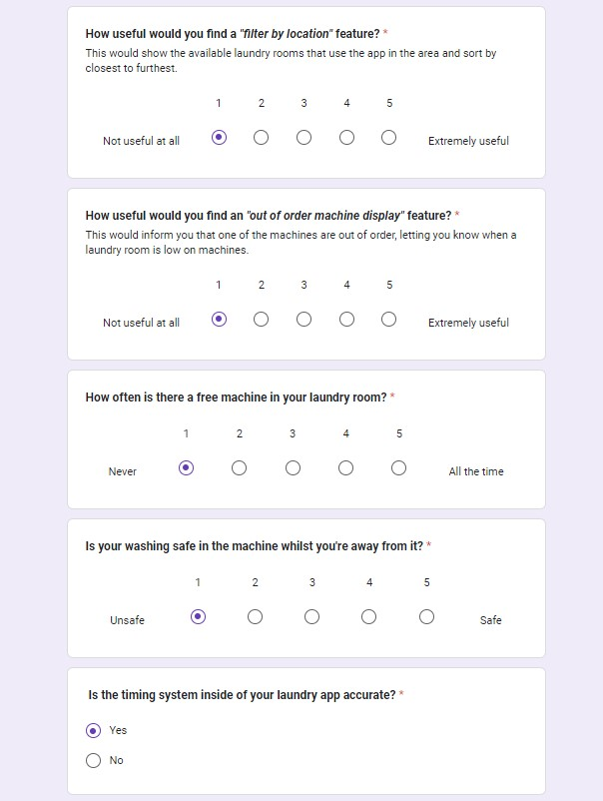

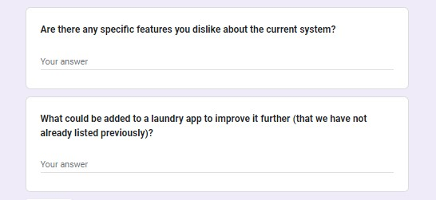

### Appendix B - Consent Form on questionnaire

