**Deployment**

We will be deploying the model to the Heroku cloud platform.

**Now let’s look at the project folder structure:**

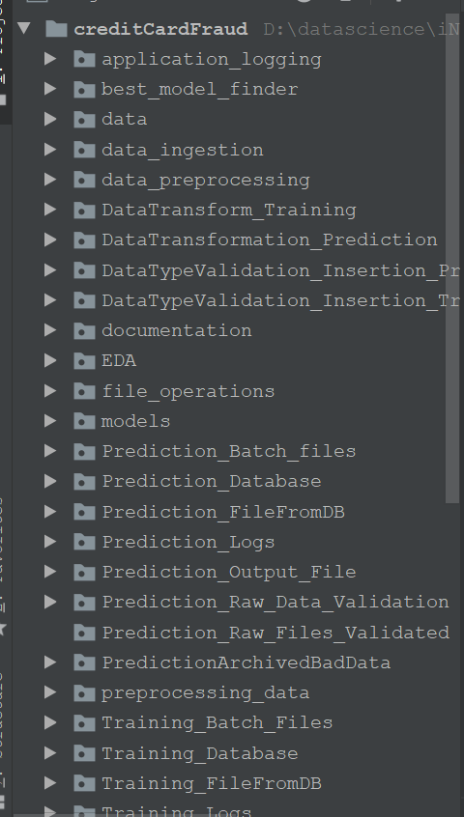

**Steps before cloud deployment:**

We need to change our code a bit so that it works unhindered on the cloud, as well.

1. Add a file called ‘Procfile’. This folder contains the command to run the flask application once deployed on the server:

web: gunicornapp:app

Here, the keyword ‘web’ specifies that the application is a web application. And the part ‘app:app’ instructs the program to look for a flask application called ‘app’ inside the ‘app.py’ file. [Gunicorn](https://en.wikipedia.org/wiki/Gunicorn) is a Web Server Gateway Interface (WSGI) HTTP server for Python.

1. Open a command prompt window Enter the command ‘pip freeze > requirements.txt’. This command generates the ‘requirements.txt’ file.

requirements.txt helps the Heroku cloud app to install all the dependencies before starting the webserver.

**Deployment to Heroku:**

* Go to Heroku.com and create an account and login.
* Click on new(inside the red box) to create a new app.

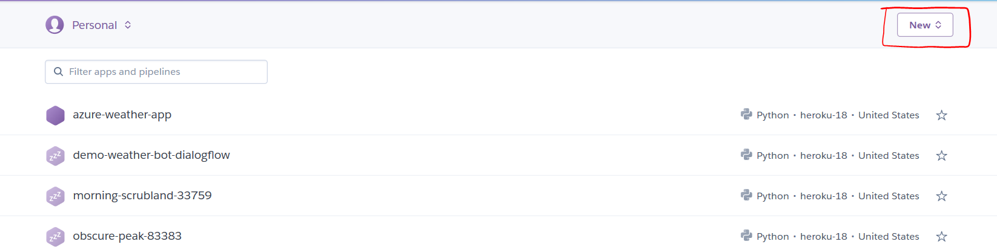

* Give the name of the app and click ‘create app’.

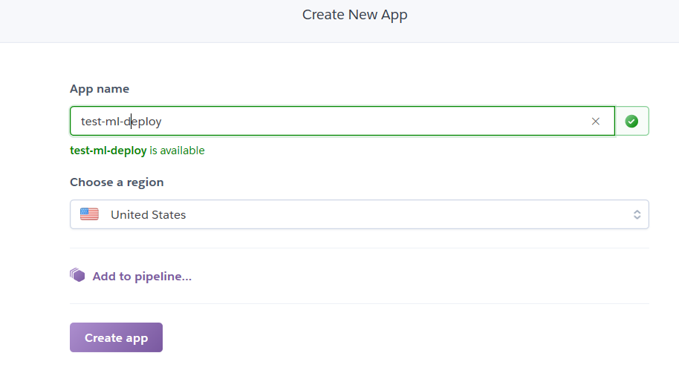

* After app creation, the ‘deploy’ section has all the deployment steps mentioned.
* We’ll download and install the Heroku CLI from the Heroku website: <https://devcenter.heroku.com/articles/heroku-cli>.
* Git also needs to be installed in your computer.
* After installing the Heroku CLI, Open a command prompt window and navigate to your project folder.
* Type the command ‘heroku login’ to login to your heroku account

It opens up a webpage to login to Heroku.

* Before deploying the code to the Heroku cloud, we need to commit the changes to the local git repository.
* Type the command ‘git initto initialize a local git repository
* Enter the command herokugit:remote<remote repo name> to connect local git repo to the remote repo.
* Enter the command ‘git status’ to see the uncommitted changes
* Enter the command ‘git add .’ to add the uncommitted changes to the local repository.
* Enter the command ‘git commit -am "make it better"’ to commit the changes to the local repository.
* Enter the command ‘git push heroku master’ to push the code to the heroku cloud.
* After deployment, heroku gives you the URL to hit the web API.

Once your application is deployed successfully, enter the command ‘heroku logs --tail’ to see the logs.