**Deployment**

We will be deploying the model to the **GCP** platform.

This is a workflow diagram for the prediction of using the trained model.

**Now let’s see the forest type classifier project folder structure.**

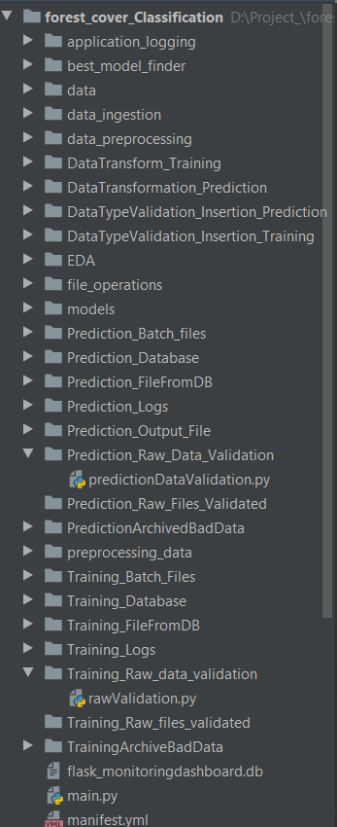

**requirements.txt** file consists of all the packages that you need to deploy the app in the cloud.

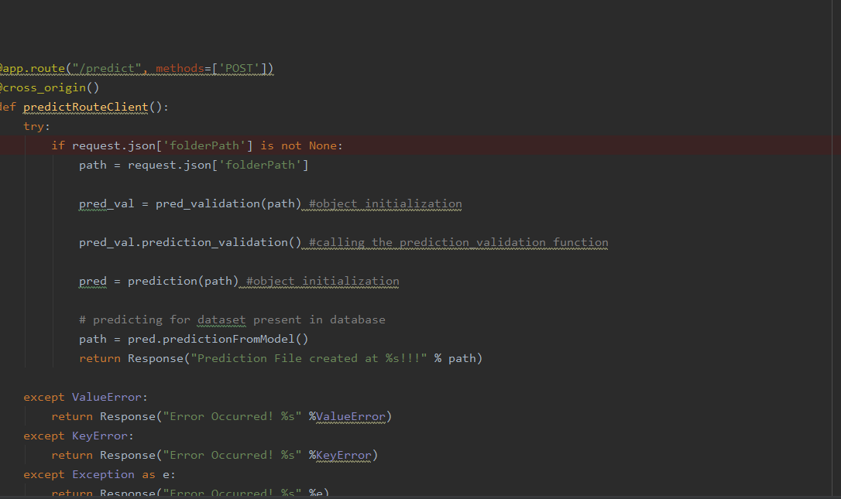

**main.py** is the entry point of our application, where the flask server starts. Here we will be decoding a base64 to an image, and then we will be making predictions.

* Go to <https://cloud.google.com/> and create an account if already haven’t created one. Then go to the console of your account.
* Go to *IAM and admin*(highlighted) and click *manage resources*.

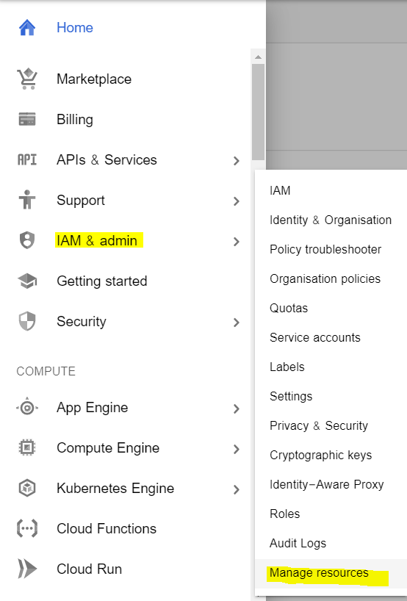

* Click *CREATE PROJECT* to create a new project for deployment.
* Once the project gets created, select *App Engine* and select *Dashboard.*

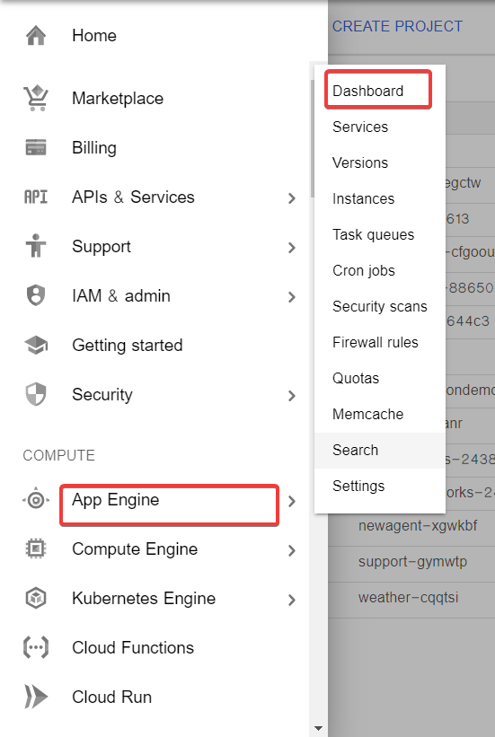

* Go to <https://dl.google.com/dl/cloudsdk/channels/rapid/GoogleCloudSDKInstaller.exe>to download the google cloud SDK to your machine.
* Click *Start Tutorial* on the screen and select Python app and click start.

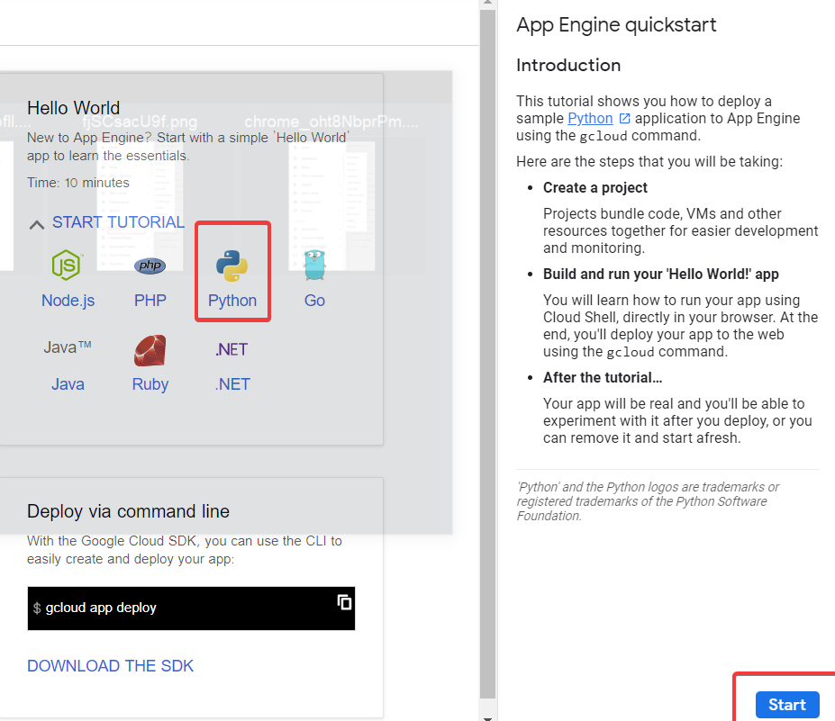

* Check whether the correct project name is displayed and then click next.

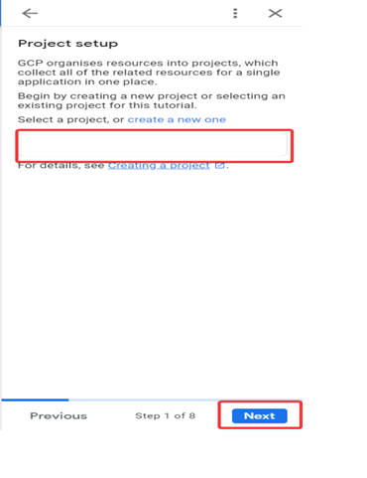

* Create a file ‘app.yaml’ and put ‘runtime: python37’ in that file.
* Create a ‘requirements.txt’ file by opening the command prompt/anaconda prompt, navigate to the project folder and enter the command ‘pip freeze > requirements.txt’.

It is recommended to use separate environments for different projects.

* Your python application file should be called ‘main.py’. It is a GCP specific requirement.
* Open gcloudshell , navigate to the project folder and enter the command *gcloudinit* to initialise the gcloud context.
* It asks you to select from the list of available projects.

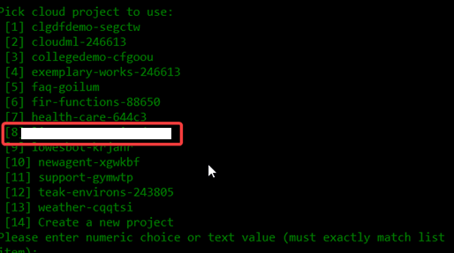

* Once the project name is selected, enter the command gcloud app deploy app.yaml --project <project name>.
* After executing the above command, GCP will ask you to enter the region for your application. Choose the appropriate one.
* GCP will ask for the services to be deployed. Enter ‘y’ to deploy the services.
* And then it will give you the link for your app.