requirements.txt file consists of all the packages that you need to deploy the app in the cloud.

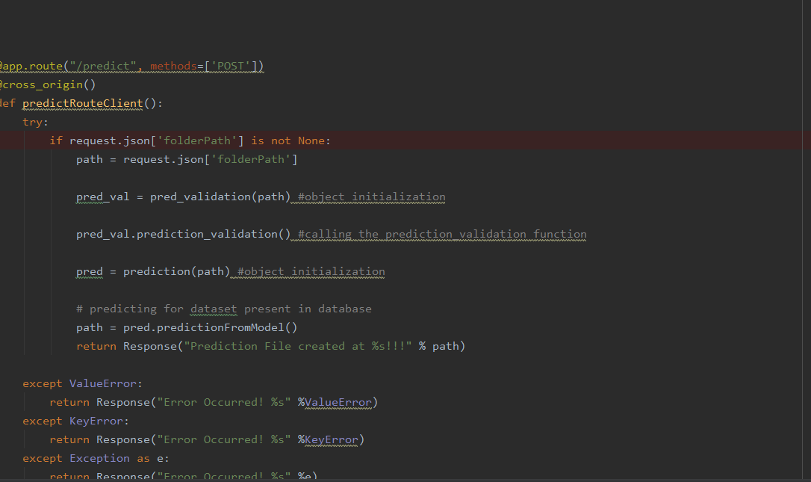

main.py is the entry point of our application, where the flask server starts. Here we will be decoding a base64 to an image, and then we will be making predictions.

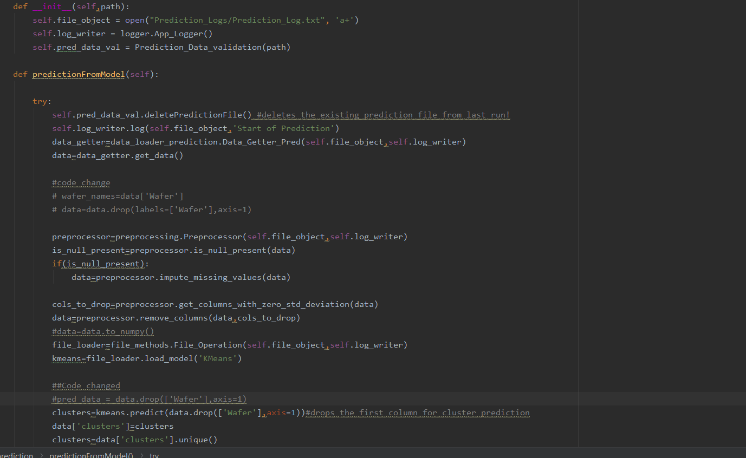
This is the obj.py file where the predictions take place based on the image we are giving input to the model.
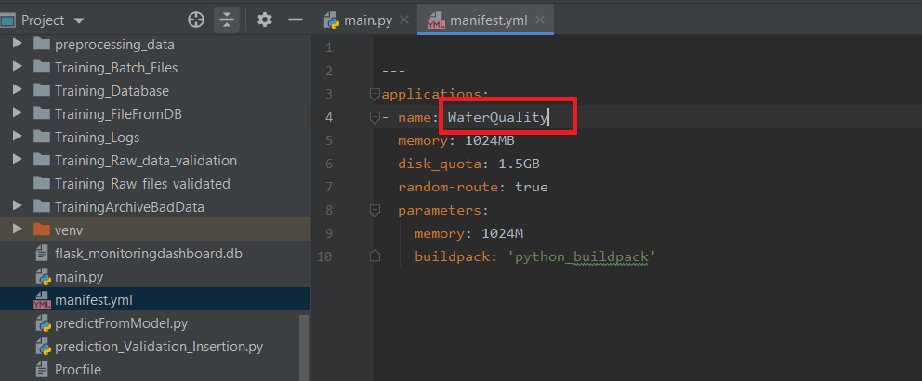
manifest.yml:- This file contains the instance configuration, app name, and buildpack language.

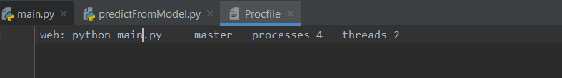
Procfile :- It contains the entry point of the app.

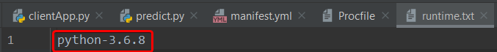
runtime.txt:- It contains the Python version number.

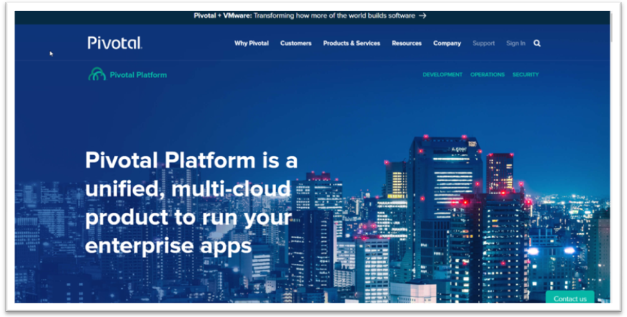
Visit the official website https://pivotal.io/platform.
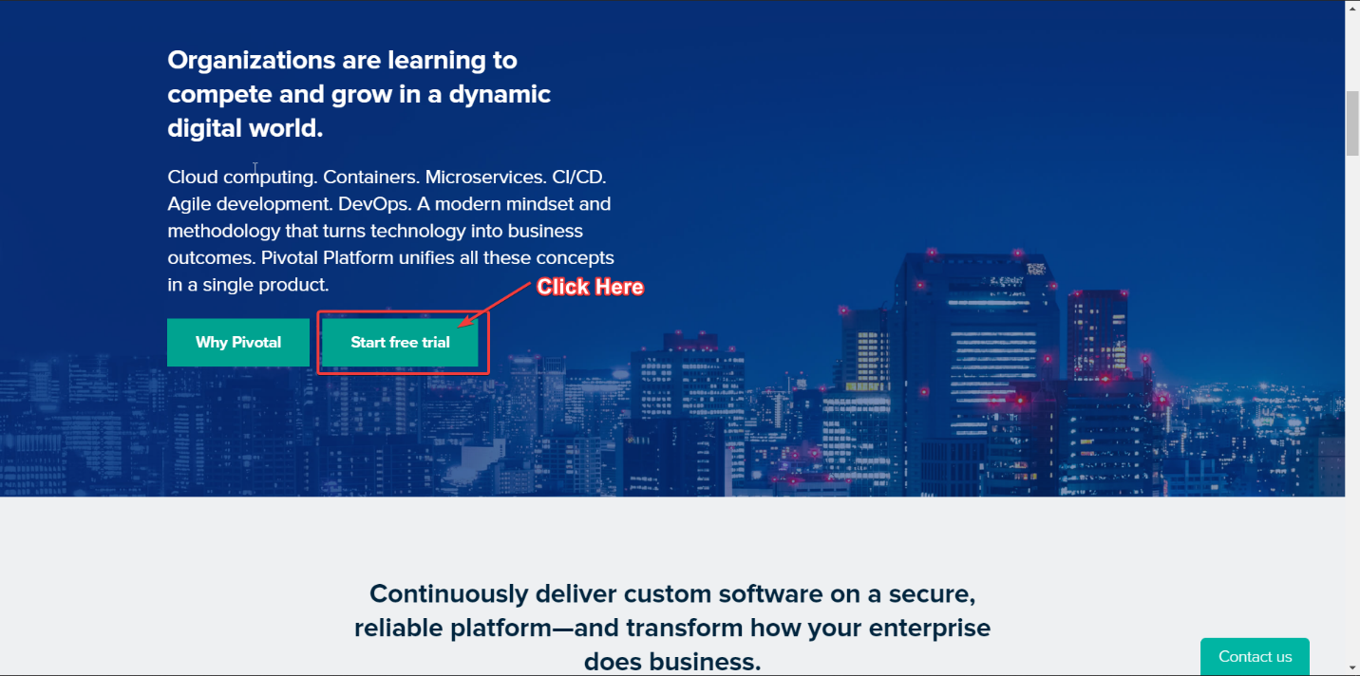
Scroll Down to see the Start Trial Button

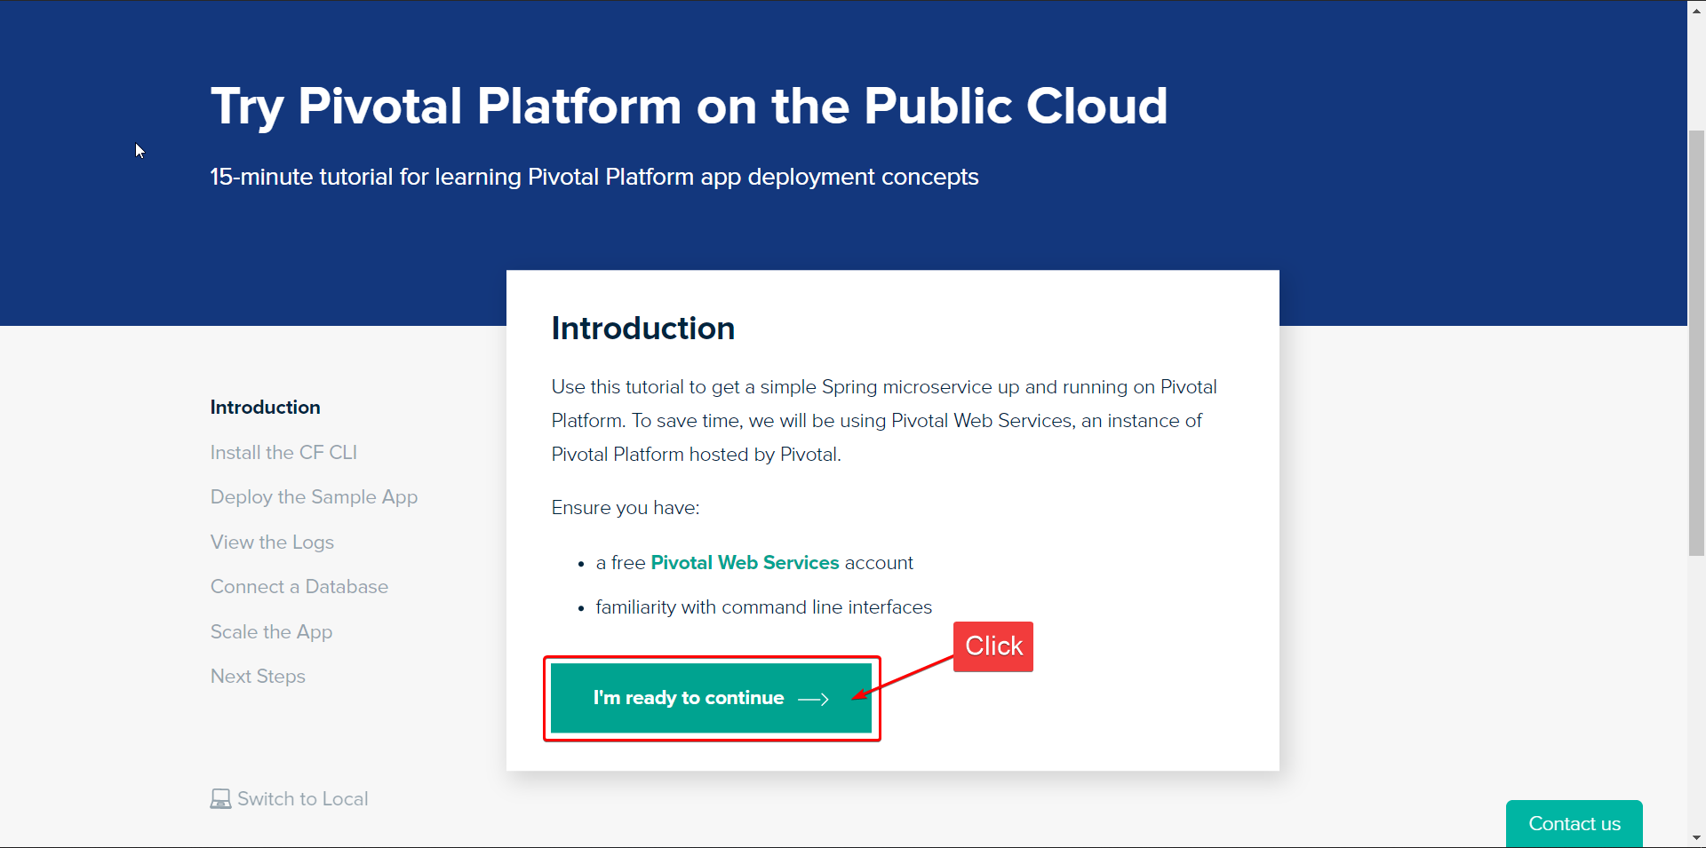
Click on the start trial button and the next interface will open. Then I will click on I’m ready to continue

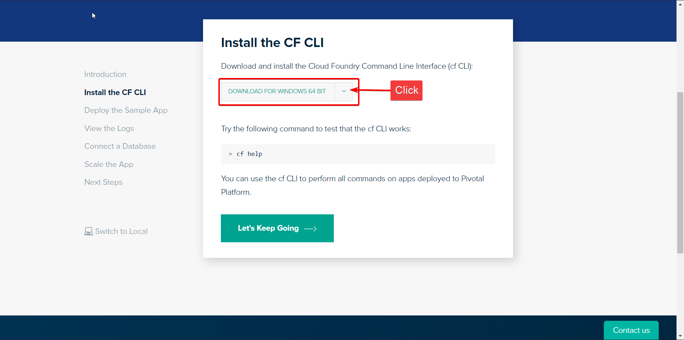
Click on Download for Windows 64 bit, and then zip file will be downloaded. Keep it for future uses.
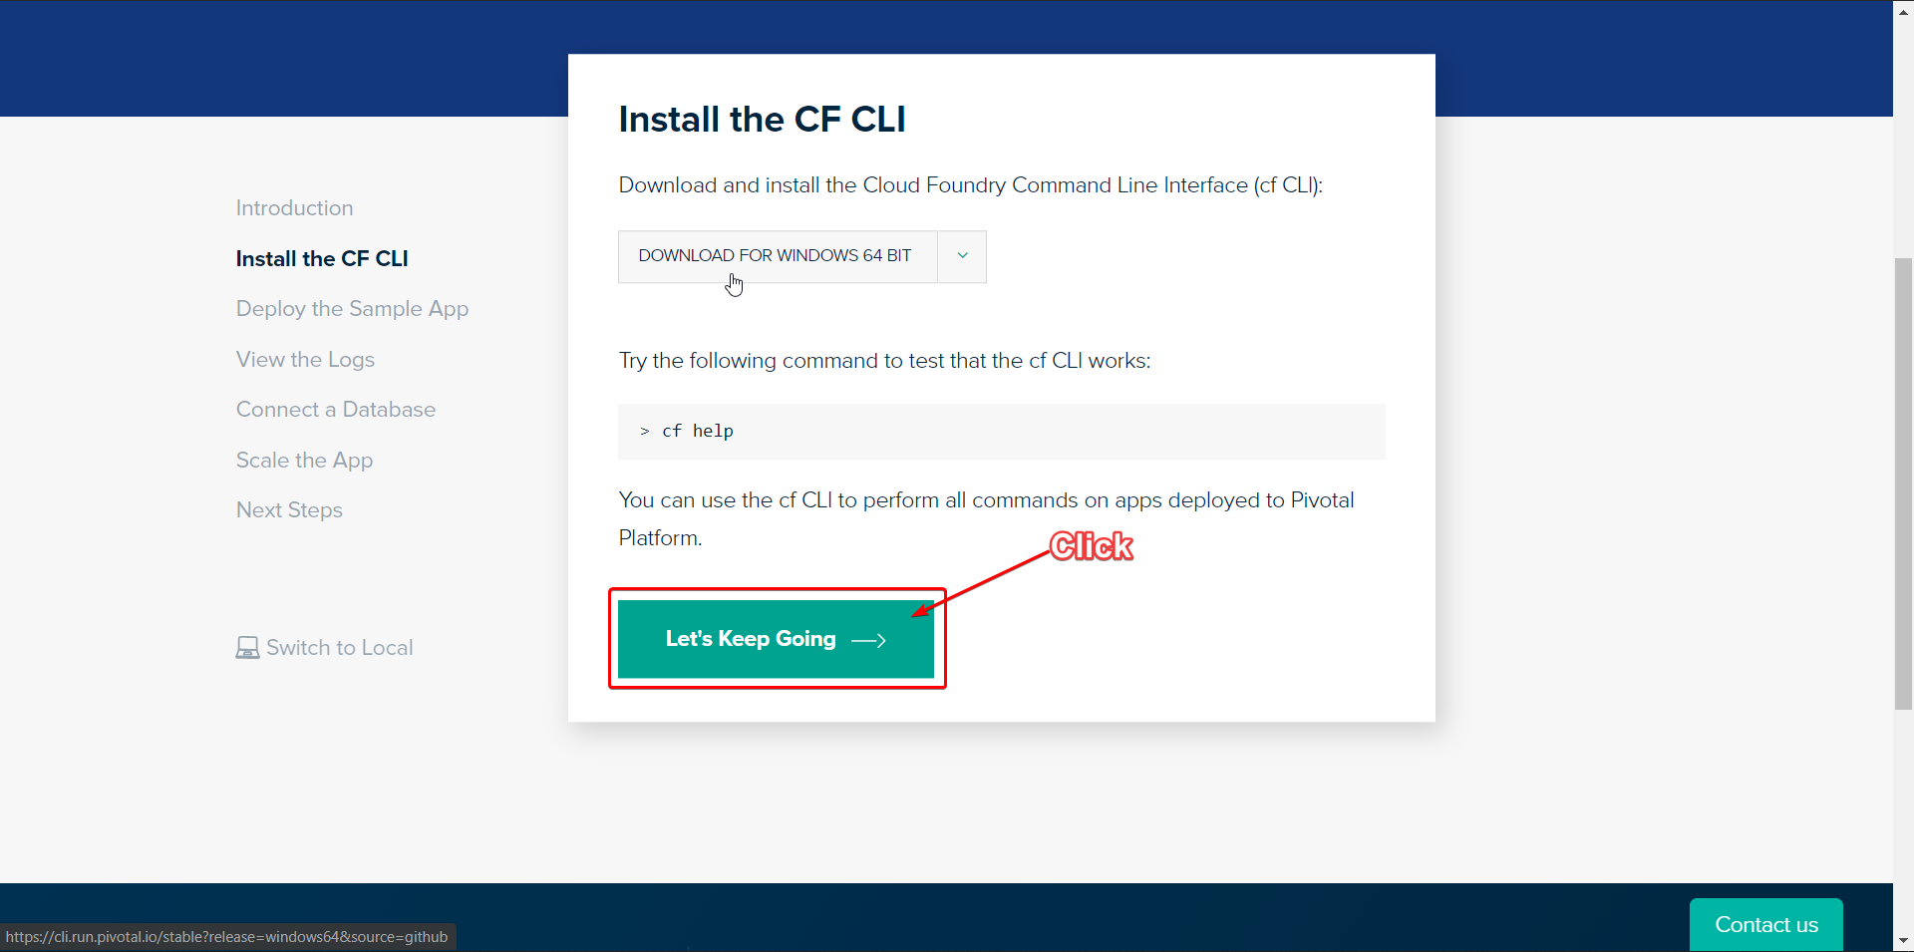
Now click on Let’s Keep Going
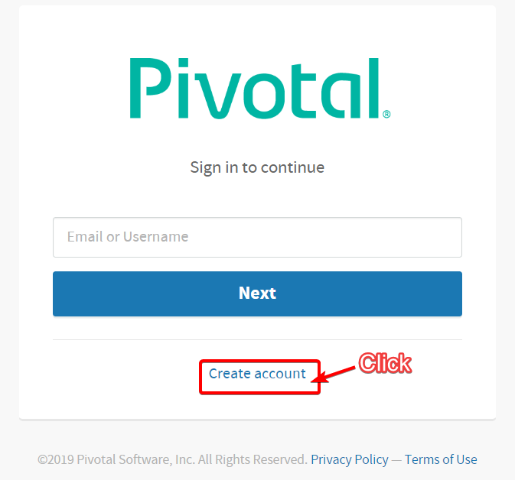
Click on Create Your Account
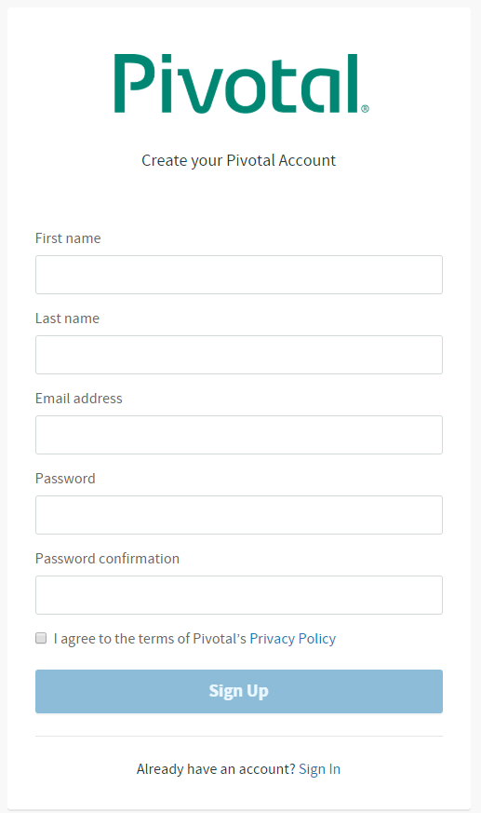
Fill Up your Details For registration
Do the email verification
Then login in again

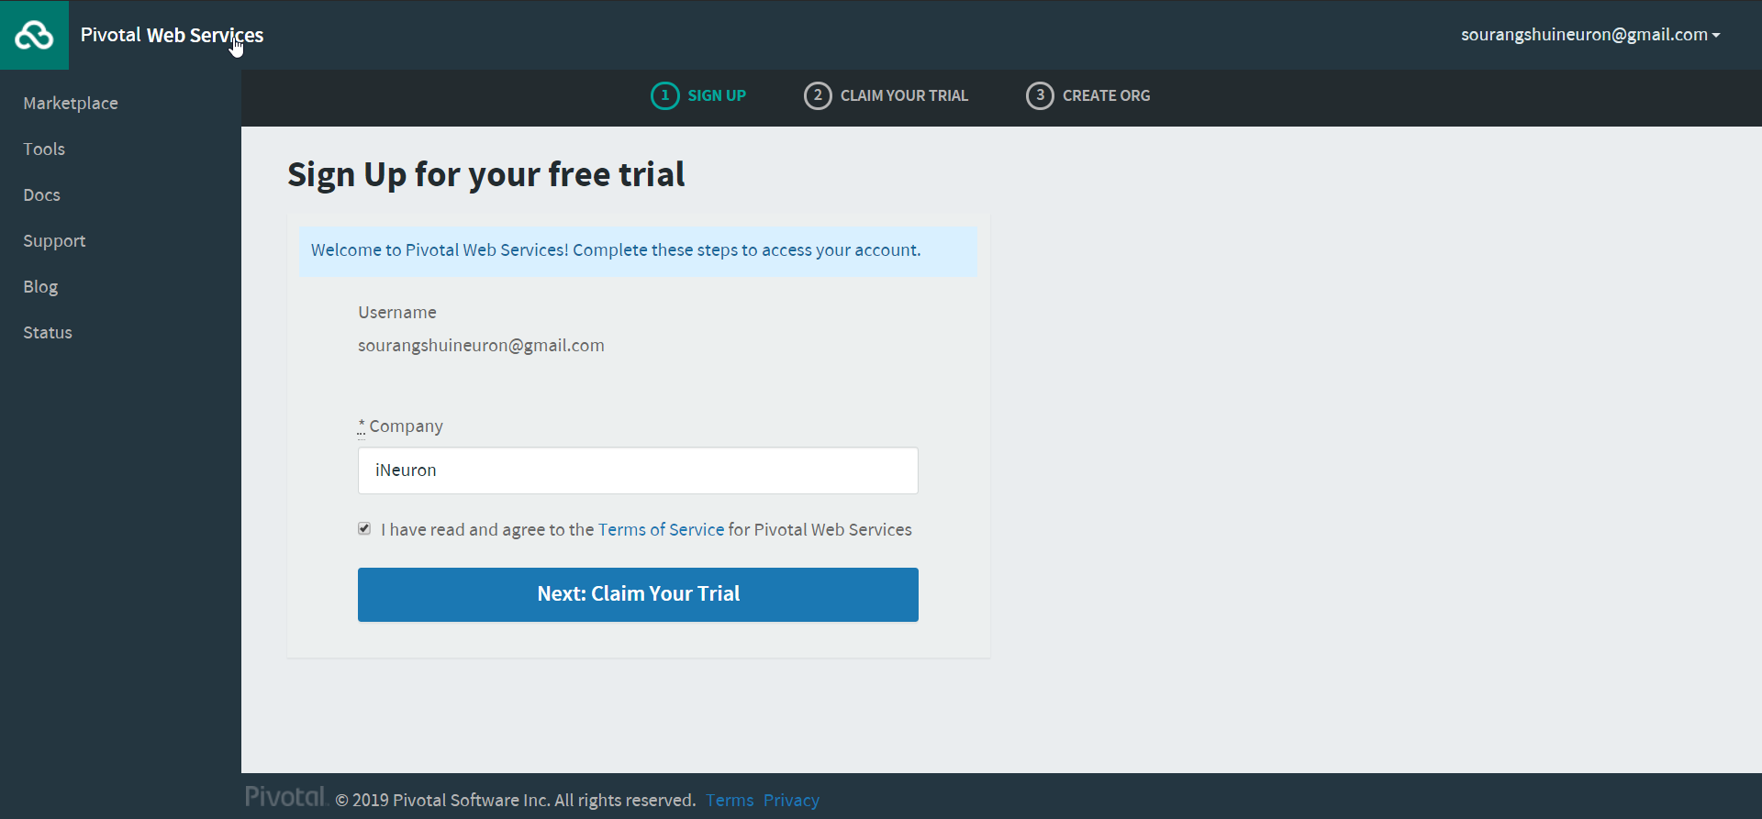
After logging you will see this screen below and start your free trial.
Write any Company or which one you prefer
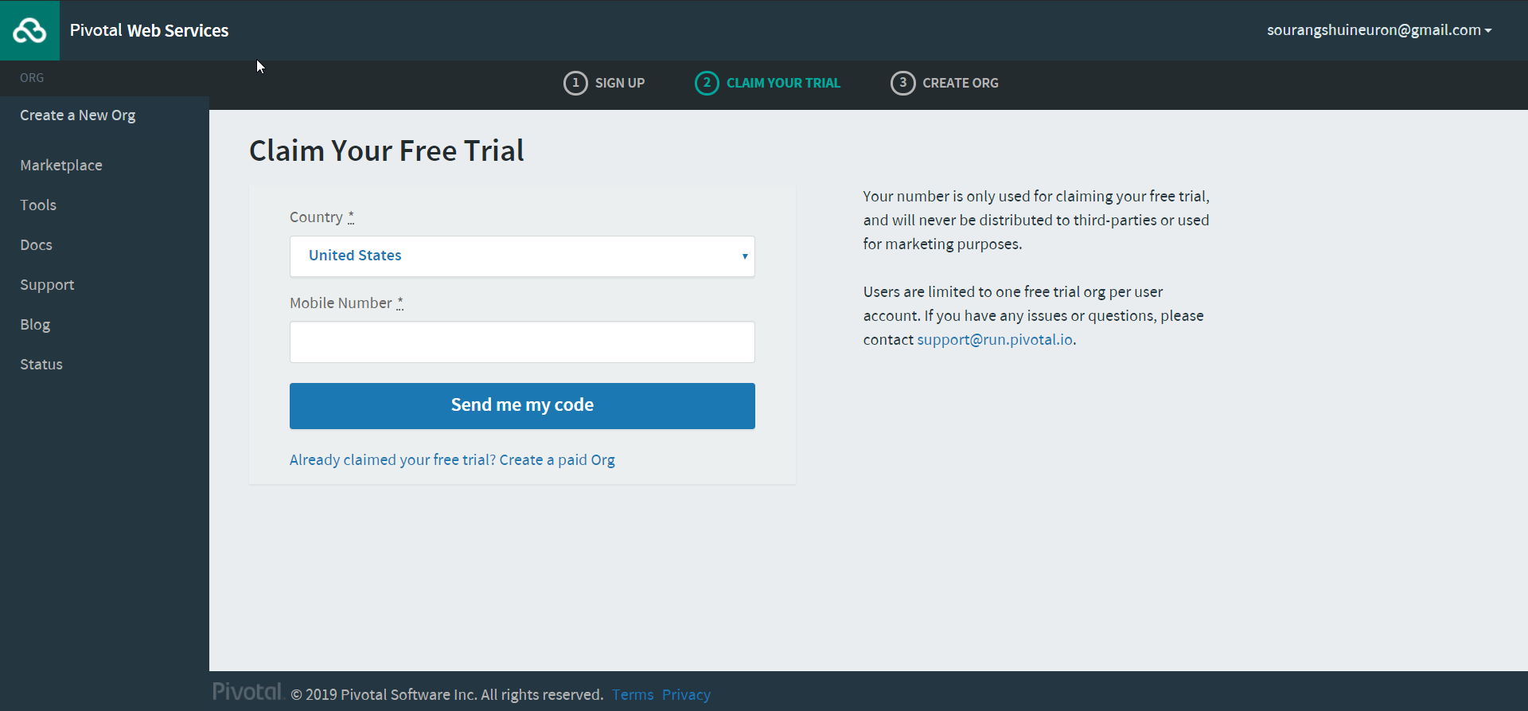
Enter your Mobile Number for Verification

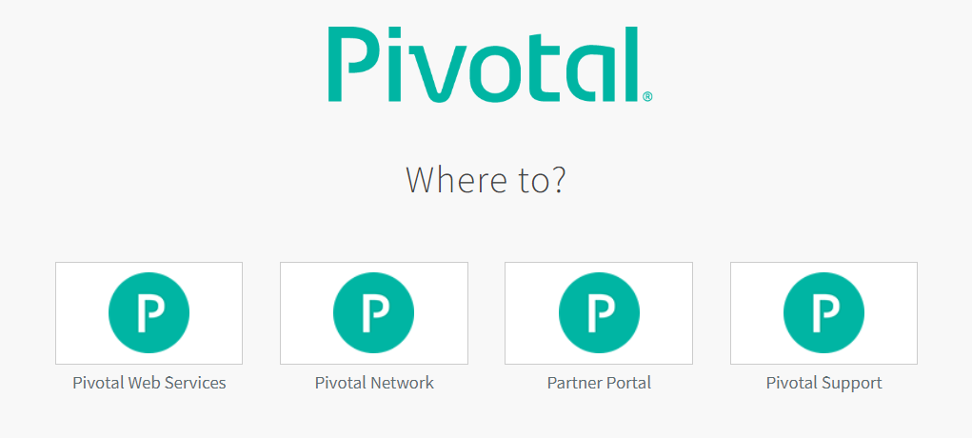
Click on Pivotal Web Services

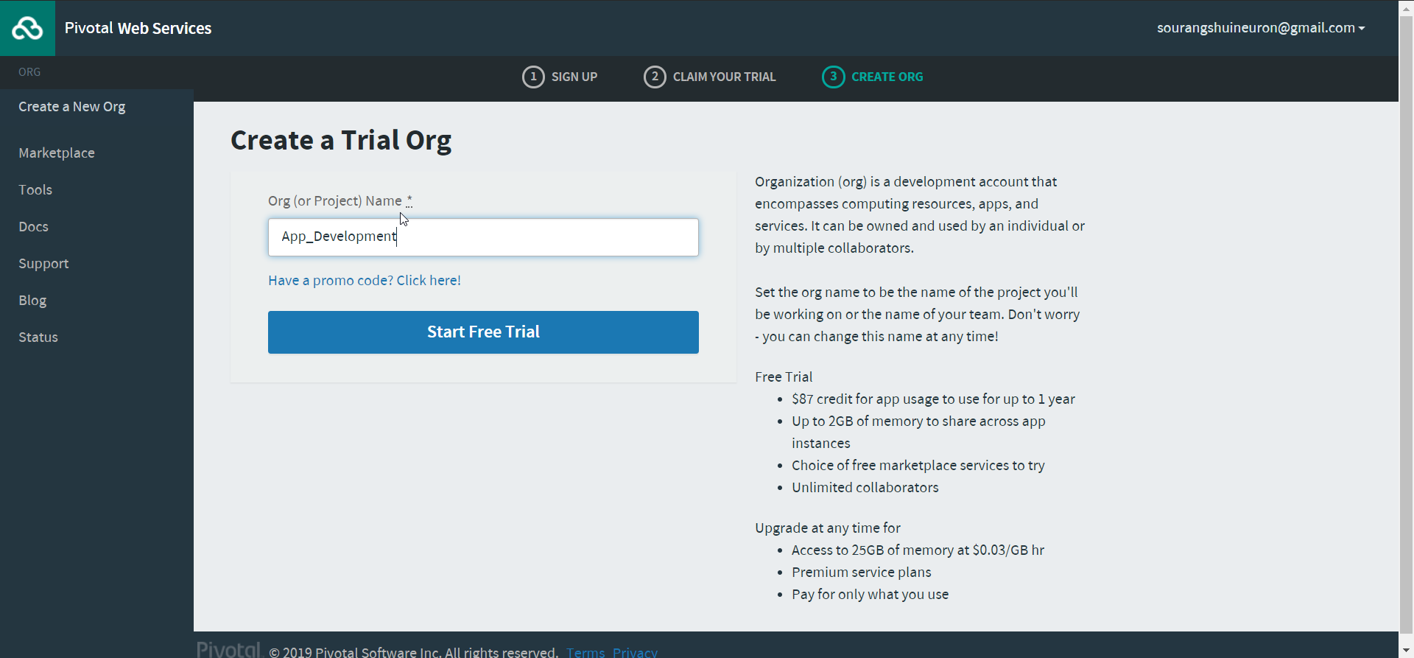
Give any Org name

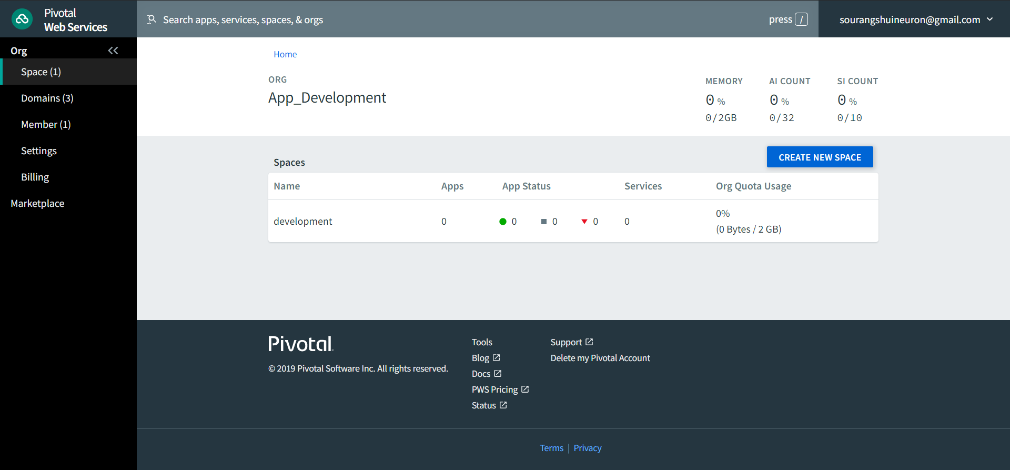
Now you are inside your Org, and by default, development space is created in your org. You can push your apps here.
The cloud signup process is done, and the setup is ready for us to push the app.

Previously you have downloaded the CLI.zip file. Unzip the file and install the .exe file with admin rights.
After a successful installation, you can verify by opening your CMD and type cf.
Then you will get a screen which is shown below
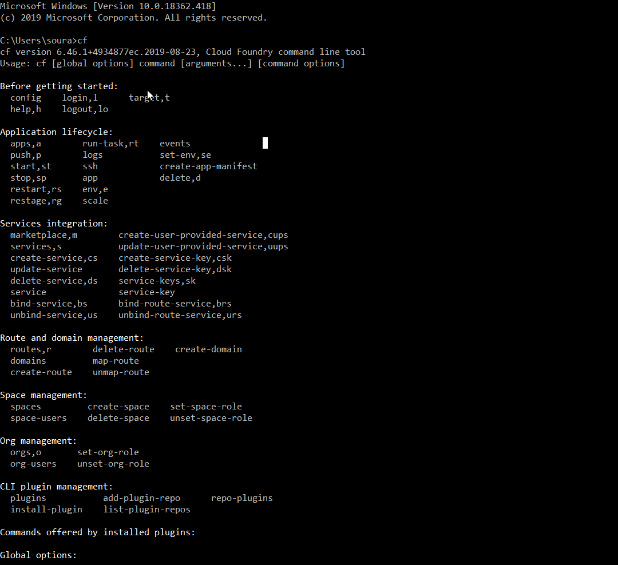

If you see this screen in your CMD, the installation is successful.
Now type the command to login via cf-cli
cf login -ahttps://api.run.pivotal.io
Next, enter your email and password. Now you are ready to push your app.
Now let’s go to the app which we have built.

Navigate to the project folder after downloading from the given below link:-
Then write cf push in the terminal.
After the app is successfully deployed in the cloud, you will see the screen below with the route.

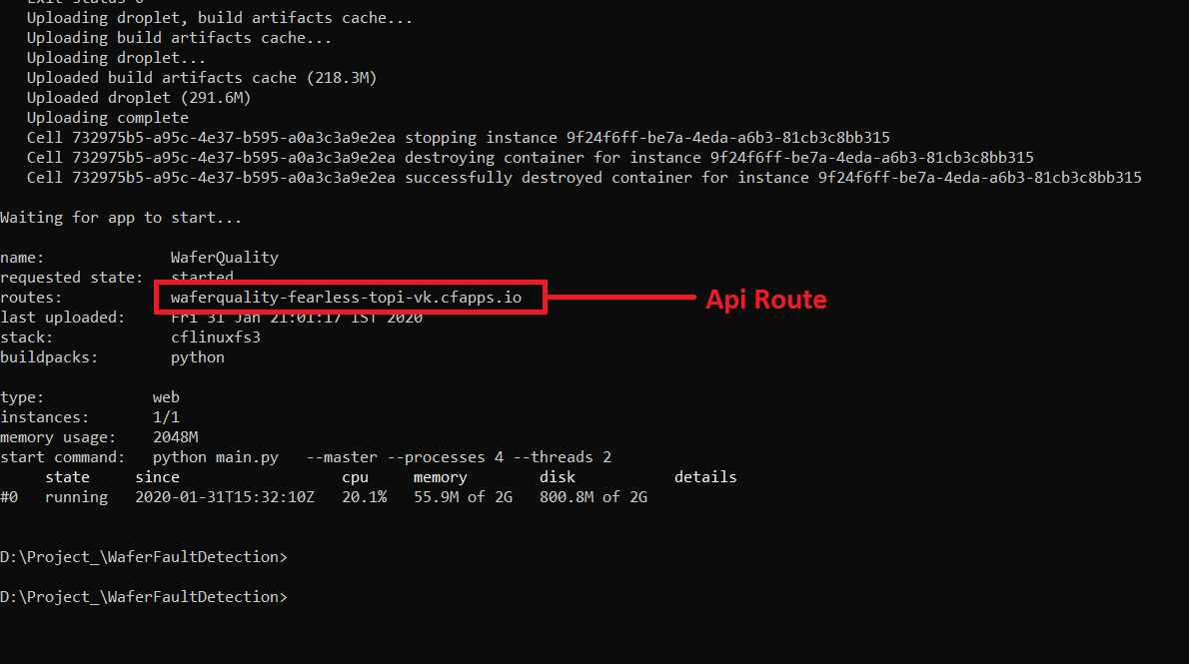
Finally, the app is pushed in the cloud.
Lets Open Postman and see the result.

