Personal Data (ID) Goup Leader:

Member 1:

Member 2:

Member 3:

Member 4:
Assignment
Rafi Mohammed Ayon 2601299

Beckham Lim 2600600
Wong Hao Yi 2600810
Kenneth Chua Jun Jie 2503748

Part 1 - Program Component (60%)
Part 2 - Report (40%)
Total Mark:
Submission Status
No submission | Late submission | No C++ source | No text file | No report | No issue

Part 1 - Program Component (60%)

Components | Remarks | Max. Marks | Mark Scale Allocated | Mark  Obtained
Menu and main program |  | 10
Read from file (building the arrays of structures) |  | 4
User, System, and File Update: Tracking |  | 8
User, System, and File Update: Review |  | 8
Creative Features |  | 10
Program Style: Indent Style/Blank Line |  | 5
Program Style: Identifier Names |  | 5
Presentation, including Q&A |  | 10

Part 2 - Report and other components (40%)

Components | Remarks | Max. Marks | Mark Scale Allocated | Mark  Obtained
Solution Design |  | 10
Structure Chart |  | 10
Flowchart/Pseudocode |  | 10
Sample text file(s) |  | 5
Screenshots and test cases |  | 5
Total: |  | 40

1.0 Proposed solution to the problem
Accommodation for UTAR students is often managed through scattered channels and manual communication, with the current available accommodation system for UTAR students in Sungai Long campus is mainly for property listing and viewing only, making it difficult for students and property owners to stay organised.
To address this problem, this proposed solution of a systematic UTAR Accommodation Management System is designed to provide a centralised platform for students and property owners to manage the process of campus accommodation, including facilitating students searching for available properties, shortlisting suitable accommodations, communication between students and property owners regarding accommodation enquiries, and students’ submission for rental applications. Property owners, in turn, can register and log in to create and manage their property listings, respond to student enquiries, and oversee incoming rental applications. By consolidating these functions within a single system, the platform streamlines interactions between both parties throughout the accommodation-seeking process.

The system is engineered using C++ Language and is designed to store user and accommodation information in text files (.txt). This allows information such as student details, owner details, property listings, enquiries, accommodation shortlists and rental application to be saved and retrieved whenever the system is used again.

1.1 System Overview
The UTAR Accommodation Management System integrates three main modules: Accommodation Listing & Searching, Communication & Enquiry, and Rental Management & Analytics.

Module 1: Accommodation Listing & Searching
The Accommodation Listing & Searching Module is responsible for student and owner information as well as accommodation listings. Students can register and log in, view and update their profiles, search for properties using keywords such as accommodation ID, room type or address, and shortlist properties they are interested in. Property owners can register and log in, manage their profiles, and manage their property listings by adding, updating, deleting and viewing properties. Property owners are authorized to modify property information such as the property ID, home name, room type, address, rental price, description and accommodation distance from UTAR.

The system uses text files (txt) as its data storage method to store information input by users. For example, Student registration details are stored in student.txt, while property owner information is stored in owner.txt. In addition, accommodation details such as Property ID, owner username, home name, room type, address, rental price, description and distance from UTAR are stored in property.txt. The system also uses shortlist.txt to record the properties shortlisted by students.

Module 2: Communication & Enquiry
The Communication & Enquiry Module allows students and property owners to communicate through the system regarding accommodation properties. Both students and owners are required to log in through their username and password to access the communications and enquiry function. After successful login, students are able to submit enquiries by providing information such as the property ID and their message. The enquiries are recorded together with the student username, owner username, enquiry ID and property ID. Property owners can log in with their authorized username and password to view and reply to enquiries related to their own. The enquiry records and replies are stored in ‘communication.txt’, allowing the communication history to be retained and accessed by the system.

Module 3: Communication & Enquiry
The Rental Management & Analytics Module manages rental applications and provides useful statistics about the accommodation listings. For rental management, students can select a property using its Property ID and enter their requested start date. The system identifies the property's owner and creates a rental application containing the application ID, student username, owner username, Property ID, requested start date and application status. The application is initially recorded as "Pending" and stored in ‘rental_applications.txt’, allowing the application information to be retrieved later.
The analytics section provides an overview of the accommodation data by calculating the total number of listings, average rental price, property type breakdown, distance from UTAR and shortlist statistics. These statistics are generated from the property and shortlist records stored in the system, giving users a simple overview of the available accommodation and student interest in the properties.

2.0 Structure Chart
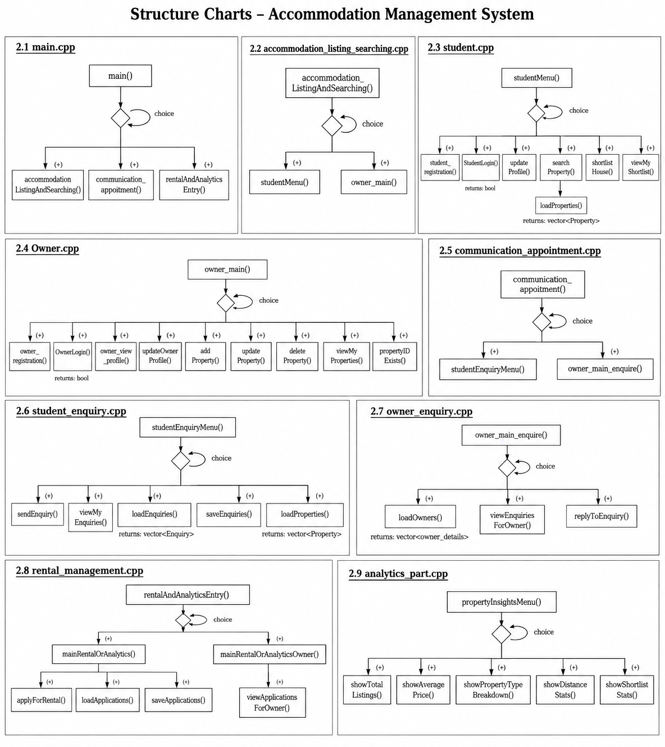

3.0 Pseudocodes
main ()
START
Declare choice as string
Do
Print "
Welcome to UTAR Accommodation Management System
===================================================
1. Accommodation Listing & Searching (Student)
2. Communication with Owner / Students
3. Rental Management
4. Owner Menu
5. Exit
"
Print "Enter your option: "
Read choice
If choice == "1" THEN
Call accommodationListingAndSearching()
Else If choice == "2" THEN
Call communication_appoitment()
Else If choice == "3" THEN
Call rentalAndAnalyticsEntry()
Else If choice == "4" THEN
Call owner_main()
Else If choice == "5" THEN
Print "Exiting..."
Else
Print "Invalid choice."
End If
While choice != "5"
Return 0
END

studentMenu ()
START
Declare Static students As Vector of acoomendation_listing_searching
Declare Static loggedInStudent As acoomendation_listing_searching
Declare choice As String
Do
Print "#########################"
Print " Student Menu"
Print "########################"
Print "1. Student Registration"
Print "2. Student Login"
Print "3. View Profile"
Print "4. Update Profile"
Print "5. Search Property"
Print "6. Shortlist House"
Print "7. Back to Main Menu"
Print "Enter your choice: "
Read choice
If choice == "1" Then
Call student_registration()
Else If choice == "2" Then
students = Call loadStudents()
Call StudentLogin(students, loggedInStudent)
Else If choice == "3" Then
Call ProfileView(loggedInStudent)
Else If choice == "4" Then
Call updateProfile()
Else If choice == "5" Then
Call searchProperty()
Else If choice == "6" Then
Call shortlistHouse(loggedInStudent.userName)
Else If choice == "7" Then
Print "Returning to the main menu..."
Else
Print "Invalid choice."
End If

While choice != "7"
END

student_registration ()
START
Declare s As acoomendation_listing_searching
Print " Enter your name : "
Read s.name
If Not Call checkName(s.name) Then
Print "please put the valid name"
Return
End If
Print " Enter your email : "
Read s.email
Print "Enter you User Name : "
Read s.userName
Print "Enter your Password : "
Read s.password
Declare validPhoneNumber As Boolean
Do
Print "Enter your Phone Number: "
Read s.phoneNumber
validPhoneNumber = True
For Each digit In s.phoneNumber Do
If Not IsDigit(digit) Then
validPhoneNumber = False
Break
End If
End For
If Not validPhoneNumber Then
Print "Invalid phone number. Please enter numbers only."
End If
While Not validPhoneNumber
Execute System Command "mkdir \"accomendation listing and search\\data\" 2> nul"
Open File "accomendation listing and search/data/student.txt" For Append As studentFile
If Not studentFile.isOpen() Then
Print "ERROR: Could not open data/student.txt for writing. Registration was NOT saved."
Return
End If
Write "Name : " + s.name To studentFile
Write "Email : " + s.email To studentFile
Write "User name : " + s.userName To studentFile
Write "PassWord : " + s.password To studentFile
Write "Phone Number : " + s.phoneNumber To studentFile
Write "----------------------" To studentFile
Close studentFile
Print "Your details added Successfully"
End

StudentLogin(students, loggedInStudent)
START
Declare inputUserName As String
Declare inputPassword As String
Print "Please Enter you user name and Password :"
Print "Enter your username: "
Read inputUserName
Print "Enter your password: "
Read inputPassword
For Each student In students Do
If student.userName == inputUserName And student.password == inputPassword Then
loggedInStudent = student
Print "\nLogin successful!"
Return True
End If
End For
Print "\nInvalid username or password."
Return False
End

updateProfile()
START
Declare username As String
Declare choice As String
Declare newName As String
Declare newEmail As String
Declare newPhone As String
Declare newPassword As String
Print "\n========== Update Profile =========="
Print "Enter your username: "
Read username
Print "\n1. Update Name"
Print "2. Update Email"
Print "3. Update Phone Number"
Print "4. Update Password"
Print "Enter your choice: "
Read choice
If choice == "1" Then
Print "Enter new name: "
Read newName
Else If choice == "2" Then
Print "Enter new email: "
Read newEmail
Else If choice == "3" Then
Print "Enter new phone number: "
Read newPhone
Else If choice == "4" Then
Print "Enter new password: "
Read newPassword
Else
Print "Invalid choice."
Return
End If
Open File "accomendation listing and search/data/student.txt" For Input As studentFile
If Not studentFile.isOpen() Then
Print "ERROR: student.txt not found. Nothing to update."
Return
End If
Open File "accomendation listing and search/data/temp.txt" For Output As tempFile
Declare line As String
Declare updated As Boolean = False
Declare block As Vector of String

While Read Line line From studentFile
If line == "----------------------" Then
Declare isTargetStudent As Boolean = False
For Each blockLine In block Do
If blockLine == "User name : " + username Then
isTargetStudent = True
Break
End If
End For
If isTargetStudent Then
For i = 0 To block.size() - 1 Do
If choice == "1" And block[i].find("Name : ") == 0 Then
block[i] = "Name : " + newName
updated = True
Else If choice == "2" And block[i].find("Email : ") == 0 Then
block[i] = "Email : " + newEmail
updated = True
Else If choice == "3" And block[i].find("Phone Number : ") == 0 Then
block[i] = "Phone Number : " + newPhone
updated = True
Else If choice == "4" And block[i].find("PassWord : ") == 0 Then
block[i] = "PassWord : " + newPassword
updated = True
End If
End For
End If

For Each blockLine In block Do
Write blockLine To tempFile
End For
Write "----------------------" To tempFile
Clear block
Else
Append line To block
End If
End While
Close studentFile
Close tempFile
Remove File "accomendation listing and search/data/student.txt"
Rename File "accomendation listing and search/data/temp.txt" To "accomendation listing and search/data/student.txt"
If updated Then
Print "Profile updated successfully!"
Else
Print "Student username not found."
End If
End

searchProperty ()
START
Declare keyword As String
Print "\n========== Search Property =========="
Print "Enter keyword (matches Home Name, Room Type, or Address): "
Ignore Input Buffer
Read Line keyword From Input
Open File "accomendation listing and search/data/property.txt" For Input As propertyFile
If Not propertyFile.isOpen() Then
Print "ERROR: property.txt not found."
Return
End If
Declare line As String
Declare block As Vector of String
Declare foundAny As Boolean = False
While Read Line line From propertyFile
If line == "----------------------" Then
Declare isMatch As Boolean = False
For Each blockLine In block Do
Declare isSearchableField As Boolean =
blockLine.find("Home Name : ") == 0 Or
blockLine.find("Room Type : ") == 0 Or
blockLine.find("Address : ") == 0
If isSearchableField And blockLine.find(keyword) != String.NOT_FOUND Then
isMatch = True
Break
End If
End For
If isMatch Then
For Each blockLine In block Do
Print blockLine
End For
Print "----------------------"
foundAny = True
End If
Clear block
Else
Append line To block
End If
End While
Close propertyFile
If Not foundAny Then
Print "No properties matched your search."
End If
END

owner_main ()
START
Declare choice As String
Declare Static owners As Vector of owner_details
Declare Static ownerLogin As owner_details
Do
Print "#########################"
Print " Owner Menu"
Print "#########################"
Print "1. Owner Registration"
Print "2. Owner Login"
Print "3. View Profile"
Print "4. Update Profile"
Print "5. Add Property"
Print "6. Update Property"
Print "7. Delete Property"
Print "8. View My Properties"
Print "9. Back to Main Menu"
Print "Enter your choice: "
Read choice
If choice == "1" Then
Call owner_registration()
Else If choice == "2" Then
owners = Call loadOwners()
Call OwnerLogin(owners, ownerLogin)
Else If choice == "3" Then
Call owner_view_profile(ownerLogin)
Else If choice == "4" Then
Call updateOwnerProfile(ownerLogin.OwnerUserName)
Else If choice == "5" Then
Call addProperty(ownerLogin.OwnerUserName)
Else If choice == "6" Then
Call updateProperty(ownerLogin.OwnerUserName)
Else If choice == "7" Then
Call deleteProperty(ownerLogin.OwnerUserName)
Else If choice == "8" Then
Call viewMyProperties(ownerLogin.OwnerUserName)
Else If choice == "9" Then
Print "Returning to the main menu..."
Else
Print "Invalid choice."
End If
While choice != "9"
END

owner_registration ()
START
Declare o As owner_details
Print "Enter your name: "
Read o.name
Print "Enter your email: "
Read o.email
Print "Enter your phone number: "
Read o.OwnerphoneNumber
Ignore Input Buffer
Print "Enter your address: "
Read Line o.owner_address From Input
Print "Enter your username: "
Read o.OwnerUserName
Print "Enter your password: "
Read o.OwnerPassWord
Execute System Command "mkdir \"accomendation listing and search\\data\" 2> nul"
Open File "accomendation listing and search/data/owner.txt" For Append As ownerFile
If Not ownerFile.isOpen() Then
Print "ERROR: Could not open owner.txt for writing. Registration was NOT saved."
Return
End If
Write "Name : " + o.name To ownerFile
Write "Email : " + o.email To ownerFile
Write "Phone Number : " + o.OwnerphoneNumber To ownerFile
Write "Address : " + o.owner_address To ownerFile
Write "User name : " + o.OwnerUserName To ownerFile
Write "PassWord : " + o.OwnerPassWord To ownerFile
Write "----------------------" To ownerFile
Close ownerFile
Print "Your details added successfully!"
END

addProperty(ownerUsername)
START
Declare propertyID, homeName, room, roomType, address, price, description As String
Print "\n========== Add Property =========="
Print "Enter Property ID: "
Ignore Input Buffer
Read Line propertyID From Input
Print "Enter Home Name: "
Read Line homeName From Input
Print "Enter Room (e.g. Room 4B): "
Read Line room From Input
Print "Enter Room Type (e.g. Single Room / Master Room / Shared Room): "
Read Line roomType From Input
Print "Enter Address: "
Read Line address From Input
Print "Enter Price (e.g. RM 200): "
Read Line price From Input
Print "Enter Description: "
Read Line description From Input
Execute System Command "mkdir \"accomendation listing and search\\data\" 2> nul"
Open File "accomendation listing and search/data/property.txt" For Append As propertyFile
If Not propertyFile.isOpen() Then
Print "ERROR: Could not open property.txt to add new property."
Return
End If
Write "Property ID : " + propertyID To propertyFile
Write "Owner Username : " + ownerUsername To propertyFile
Write "Home Name : " + homeName To propertyFile
Write "Room : " + room To propertyFile
Write "Room Type : " + roomType To propertyFile
Write "Address : " + address To propertyFile
Write "Price : " + price To propertyFile
Write "Description : " + description To propertyFile
Write "----------------------" To propertyFile
Close propertyFile
Print "\nProperty added successfully!"
END

deleteProperty(ownerUsername)
START
Declare propertyID As String
Print "\n========== Delete Property =========="
Print "Enter the Property ID to delete: "
Read propertyID
Open File "accomendation listing and search/data/property.txt" For Input As propertyFile
If Not propertyFile.isOpen() Then
Print "ERROR: property.txt not found."
Return
End If
Open File "accomendation listing and search/data/temp_property.txt" For Output As tempFile
Declare line As String
Declare deleted As Boolean = False
Declare block As Vector of String
While Read Line line From propertyFile
If line == "----------------------" Then
Declare isTargetProperty As Boolean = False
Declare isMyProperty As Boolean = False
For Each blockLine In block Do
If blockLine == "Property ID : " + propertyID Then
isTargetProperty = True
End If
If blockLine == "Owner Username : " + ownerUsername Then
isMyProperty = True
End If
End For
If isTargetProperty And isMyProperty Then
deleted = True
Else
For Each blockLine In block Do
Write blockLine To tempFile
End For
Write "----------------------" To tempFile
End If
Clear block
Else
Append line To block
End If
End While
Close propertyFile
Close tempFile
Remove File "accomendation listing and search/data/property.txt"
Rename File "accomendation listing and search/data/temp_property.txt" To "accomendation listing and search/data/property.txt"
If deleted Then
Print "\nProperty deleted successfully!"
Else
Print "\nProperty not found, or it doesn't belong to you."
End If
END

4.0 Sample Output
Main menu
[Module selection options display]
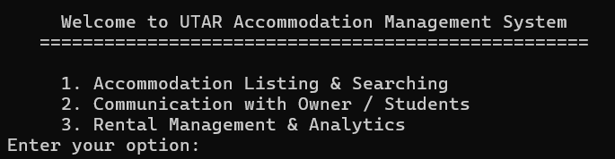

[Display “Invalid choice” when a valid option (1-3) is not entered]
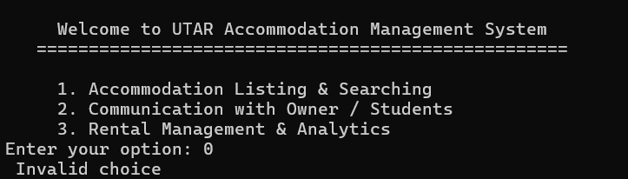

Accommodation Listing
[Display “Accommodation Listing” page when option 1 is entered]
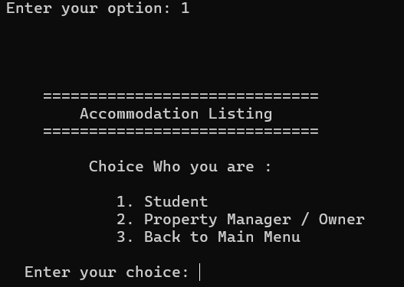

User is Student
[Display “Student Menu” when option 1 is entered]
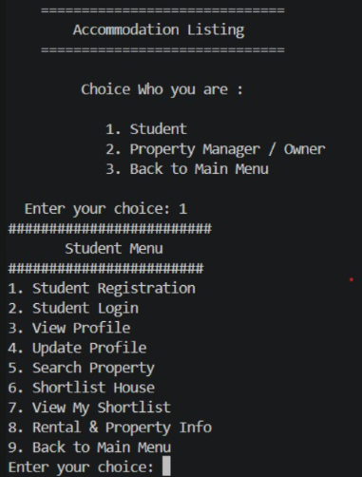

[Display “Invalid choice” when a valid option (1-9) is not entered]
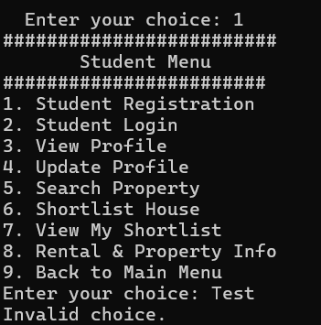

[Registration (Student)]
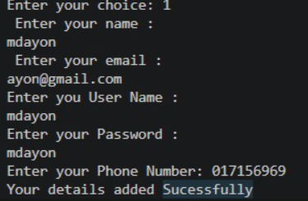

[Invalid phone number entered during student registration]
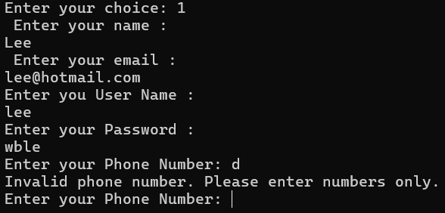

[Login (Student)]
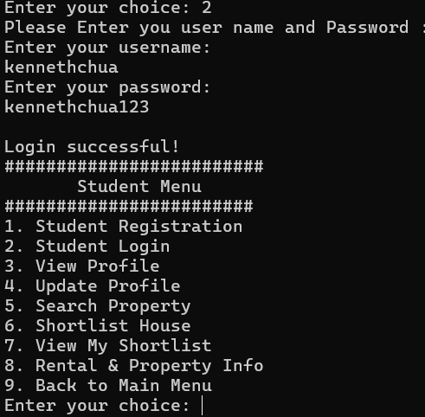

[Unregistered Student Username or password entered in Login]
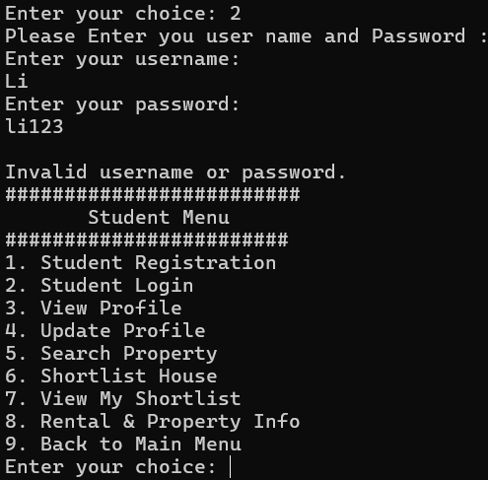

[View Profile (Student)]
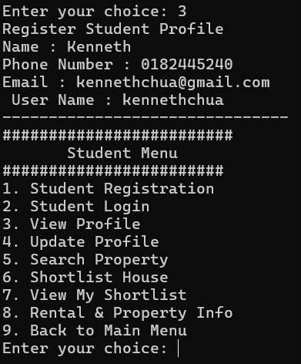

[Update Profile (Student)]
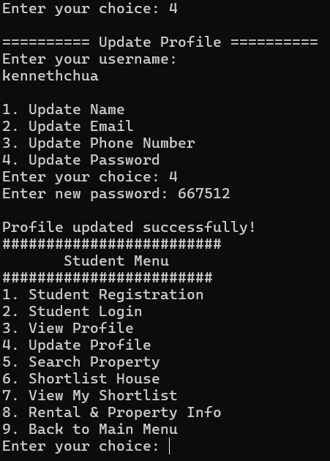

[Search Property (Student)]
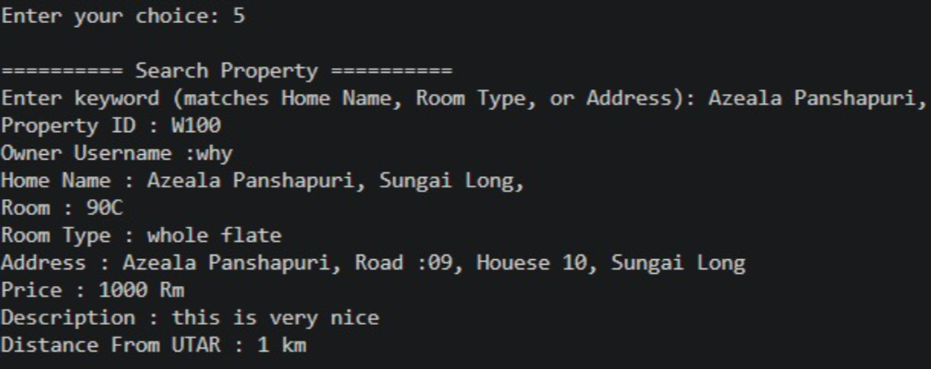

[Shortlist House]
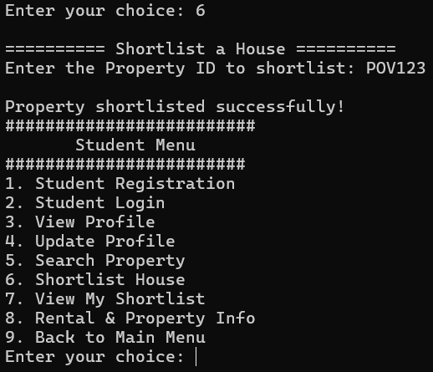

[Display “Property ID doesn’t exist. Please check and try again” when invalid Property ID entered]
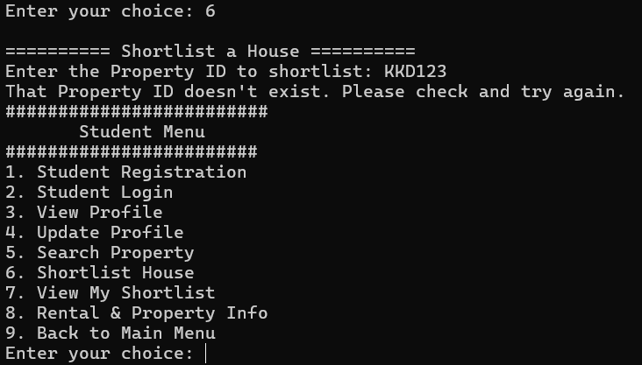

[View shortlisted properties]
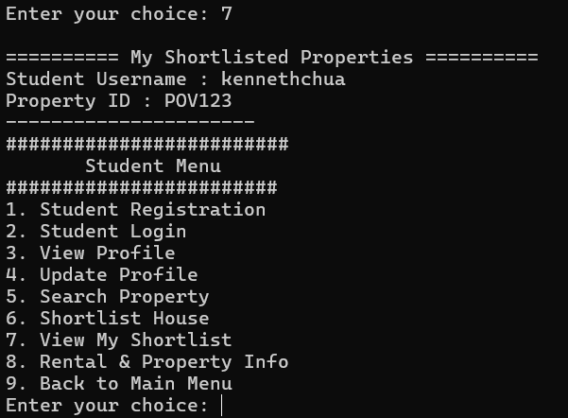

[No Properties shortlisted]
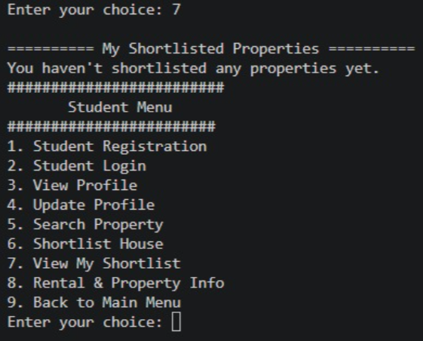

[Return to Main Menu]
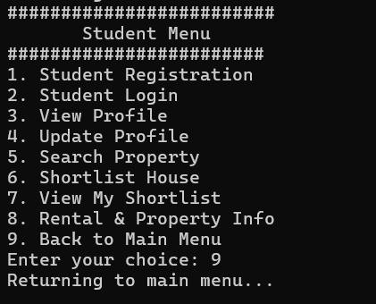

User is Owner
[Login (Owner)]
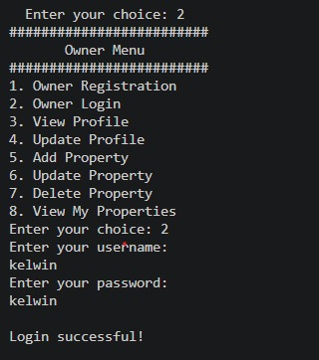

[Unregistered Owner Username or password entered in Login]
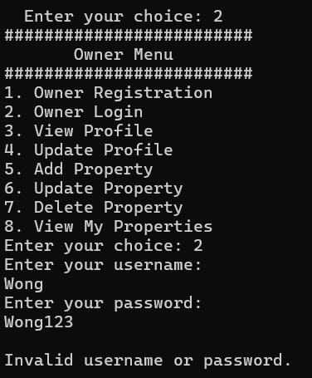

[View Profile (Owner)]
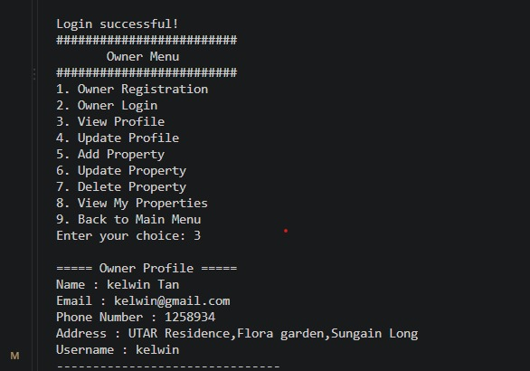

[Add Property]
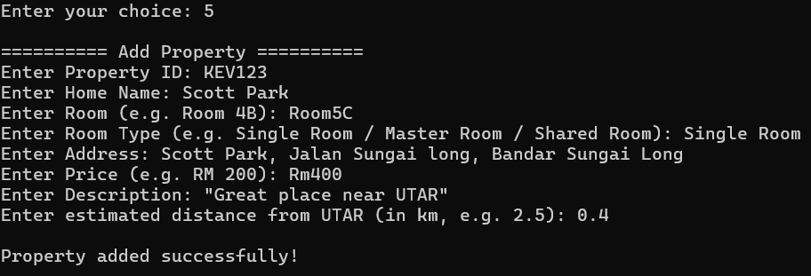
[Update Property]
Room number is updated by the owner
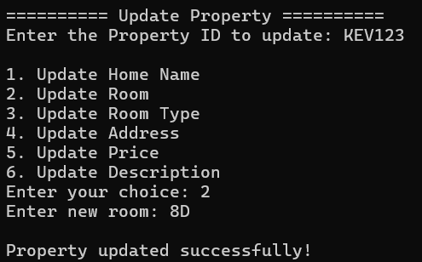

[Delete Property]
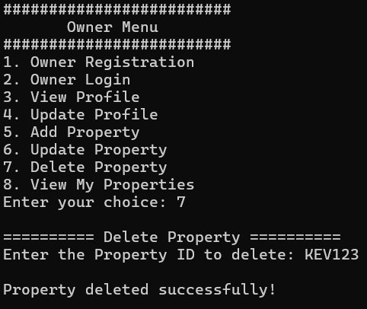

[Invalid Property ID for Property deletion entered]
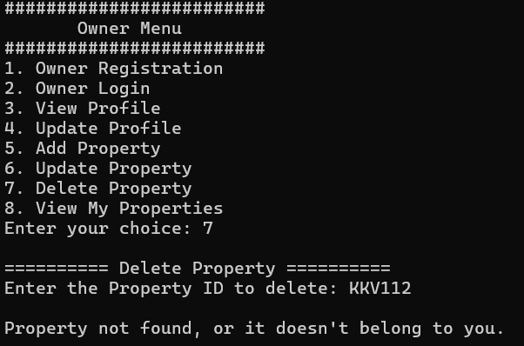

[View Property]
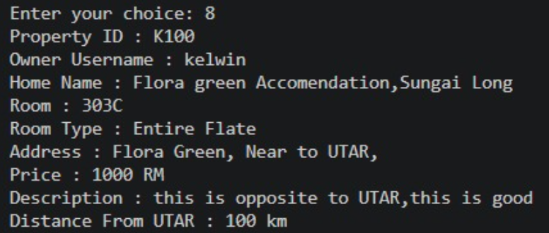

Communication & Enquiry
[User Login]
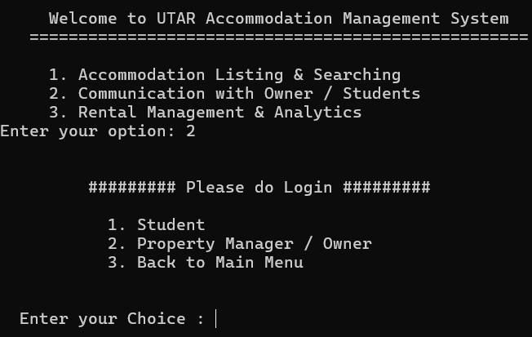

User is student
[Login (Student)]
Display Student Enquiry Menu when Student Login is successful
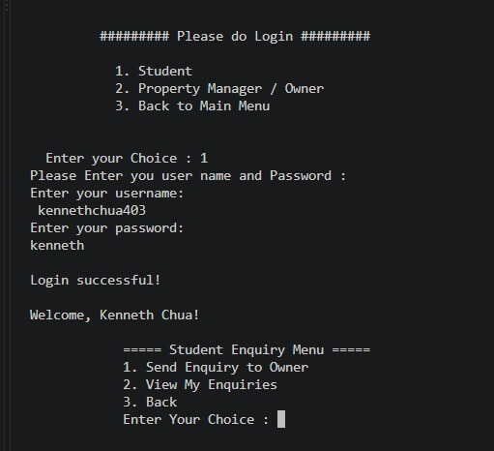

[Student Login unsuccessful]
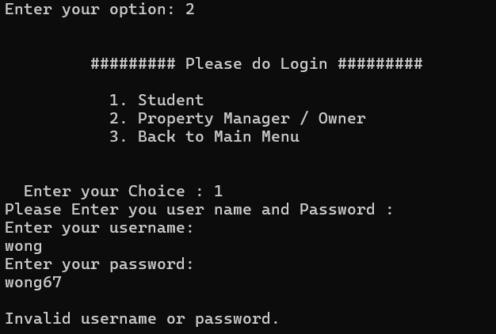

[Send Enquiry to Owner]
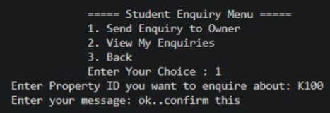

[Invalid property ID for sending enquiry entered]
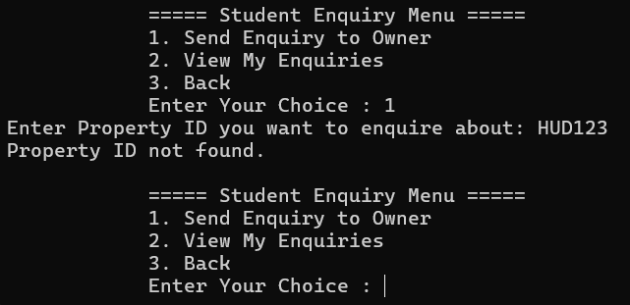

[View Enquiries sent]
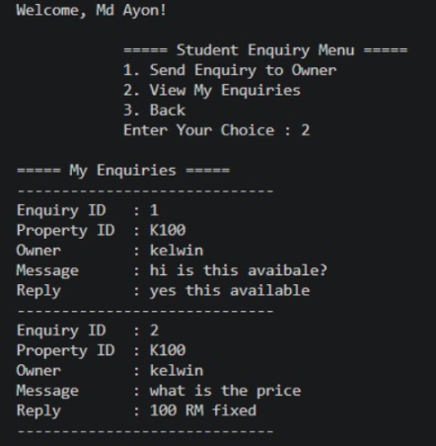
User is Owner
[Login (Owner)]
Display Owner Enquiry Meny when owner login is successful
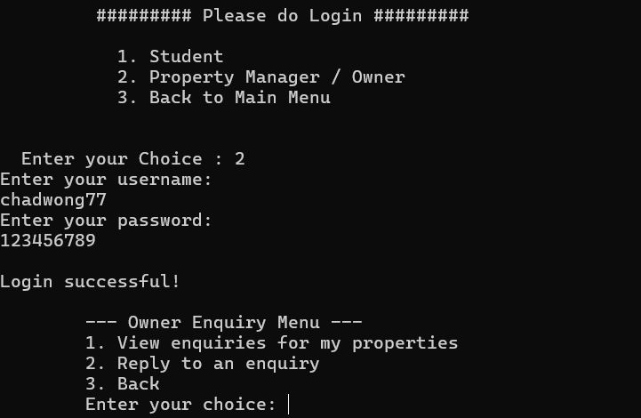

[Invalid username and password entered (owner)]
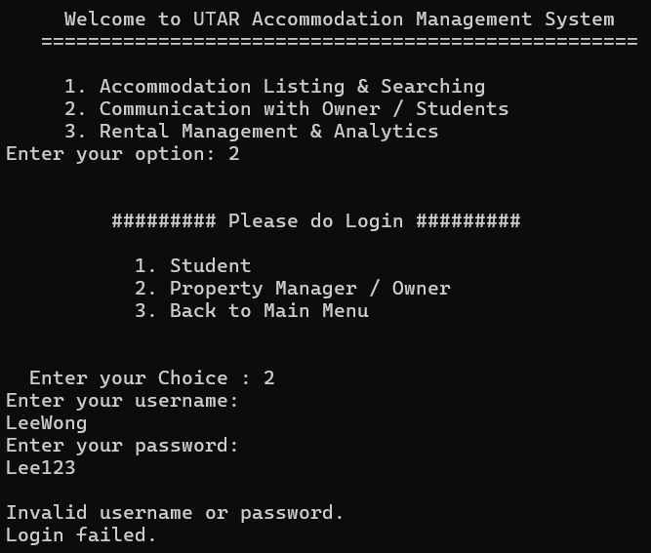

[View Enquiries for Owner’s properties]
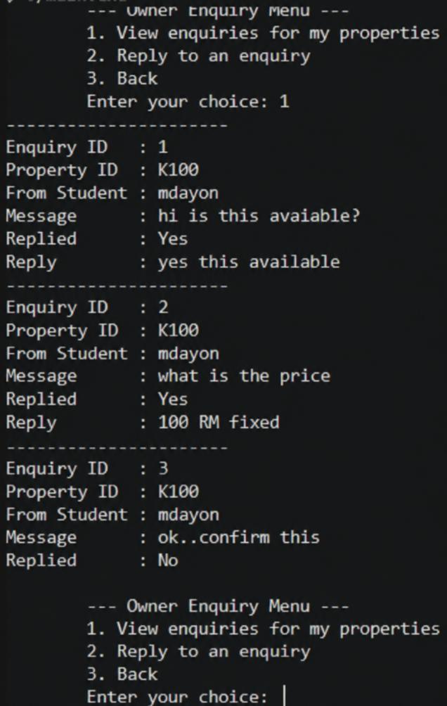
[No enquiries found]
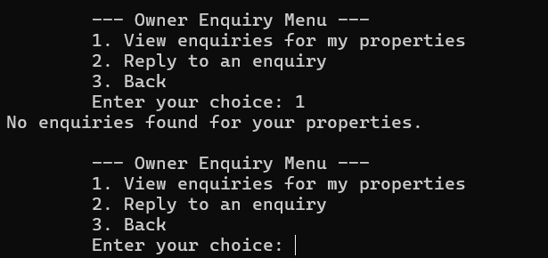

[Owner reply to a student’s enquiry]
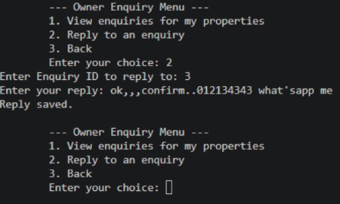
[Invalid enquiry ID]
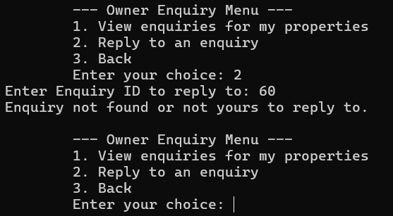

Rental Management & Analytics
User is Owner
[Display Rental & Property Info (Owner) menu when owner login successful]
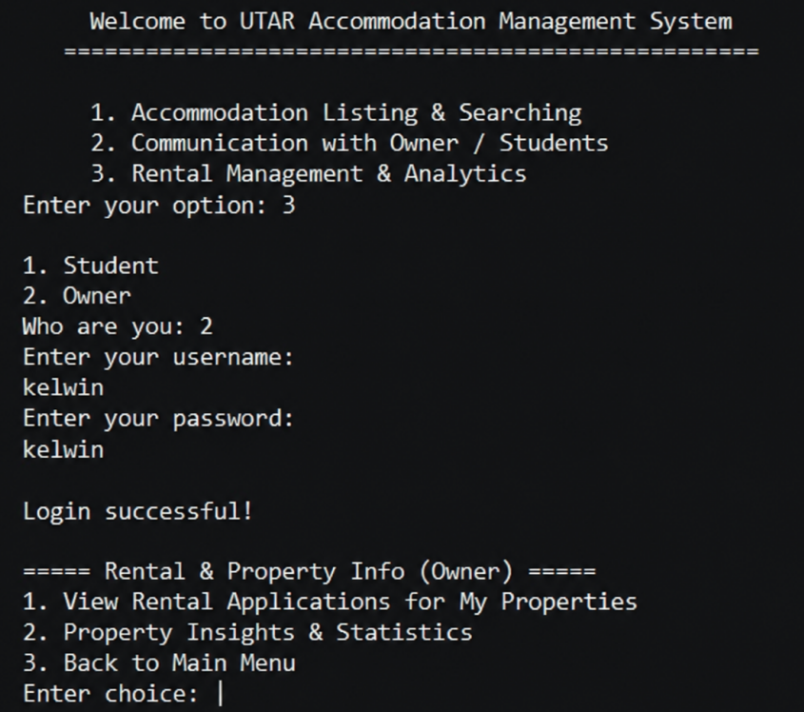

[View Rental & Application for owner’s properties menu]
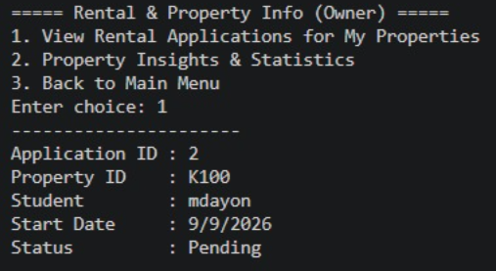

User is student
[Display Rental & Property Info menu when student login successful]
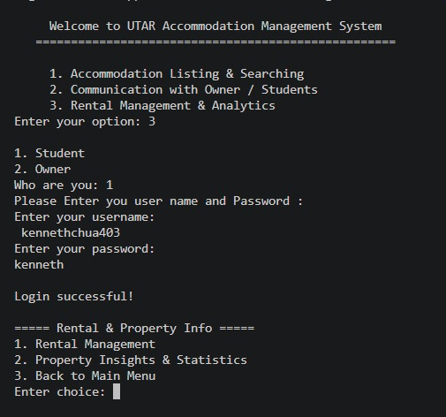

[Student’s rental application]
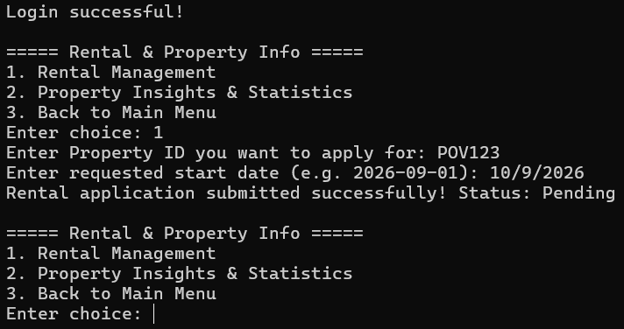
User is Both Owner and Student
[Display Property Insights & Statistics menu]
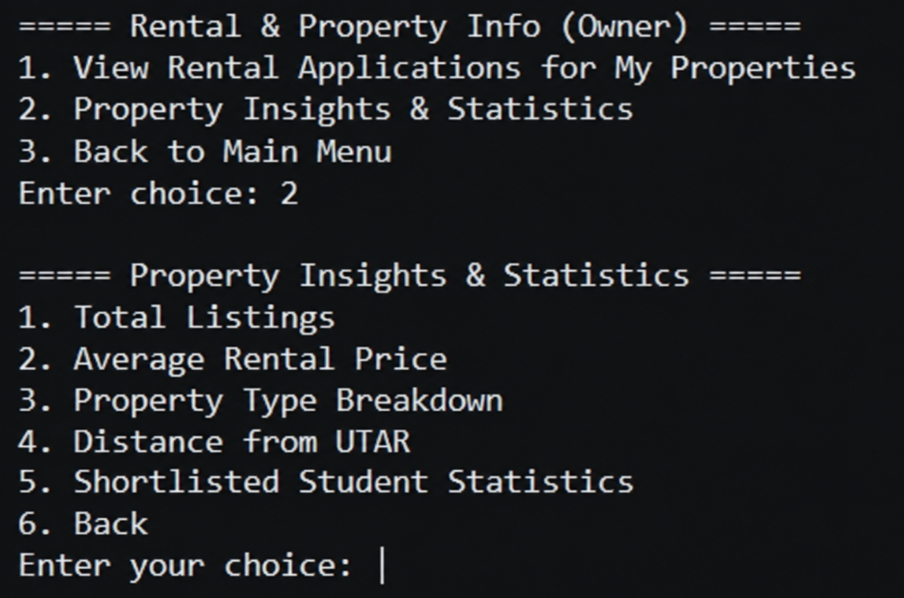

[Total Listings]
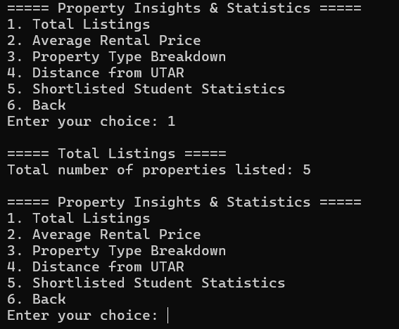

[Average Rental Price]
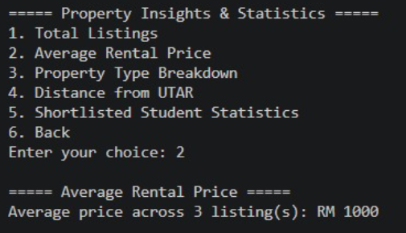

[Property Type Breakdown]
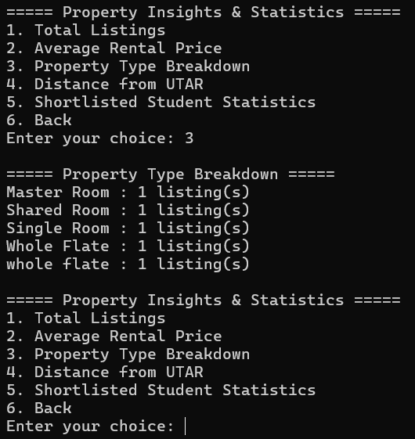

[Distance From UTAR]
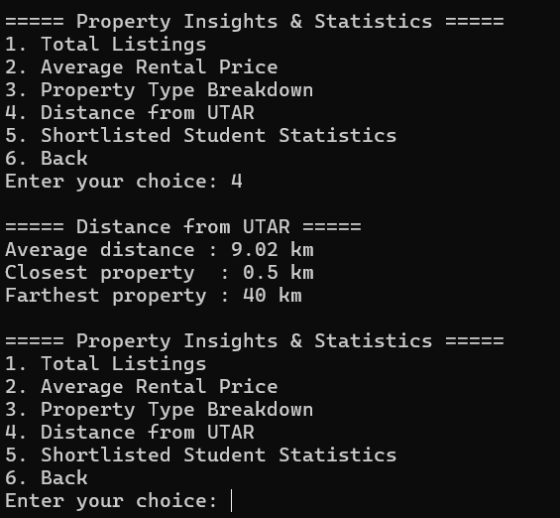

[Shortlisted Student Statistics]
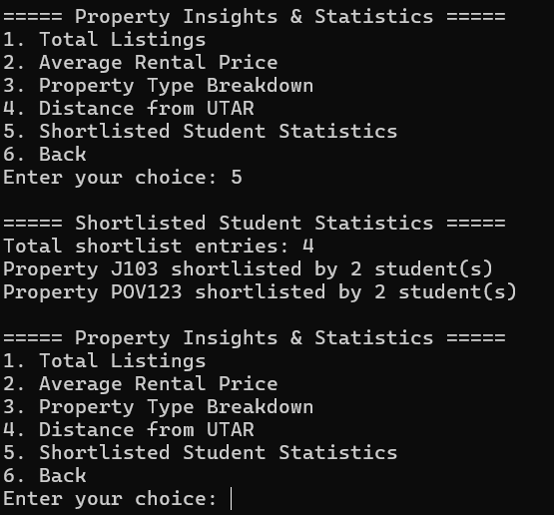

5.0 Sample Input
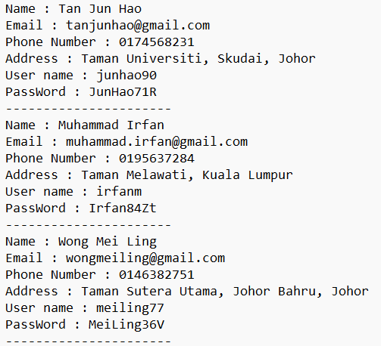
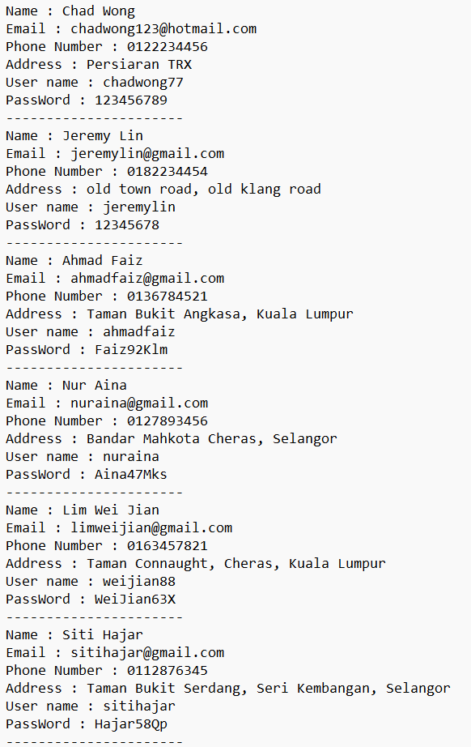
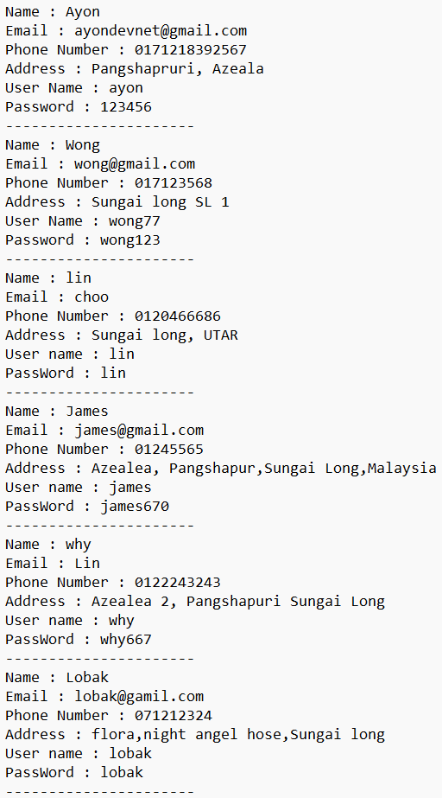
Owner.txt

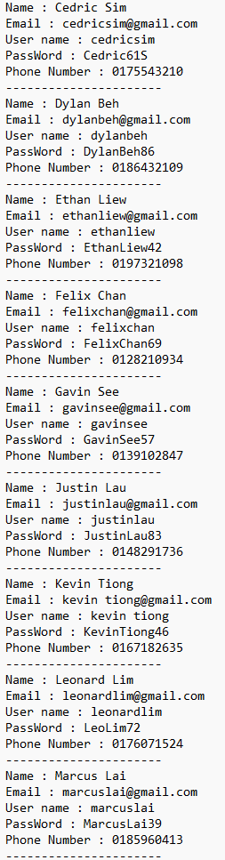
Student.txt
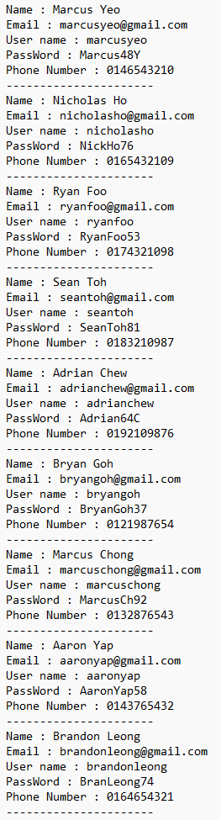
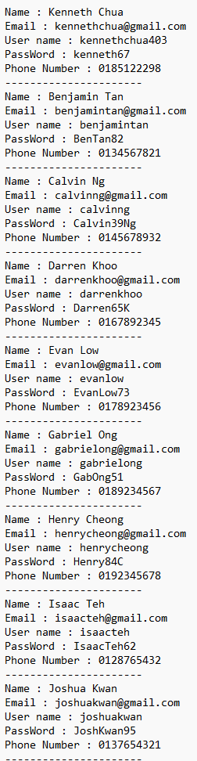

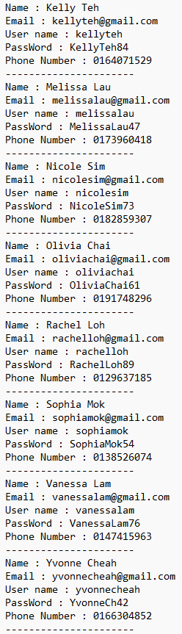
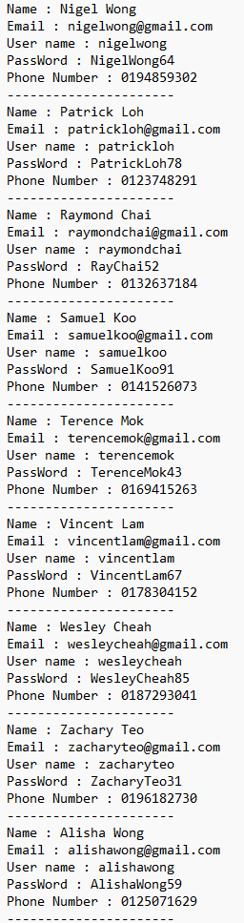
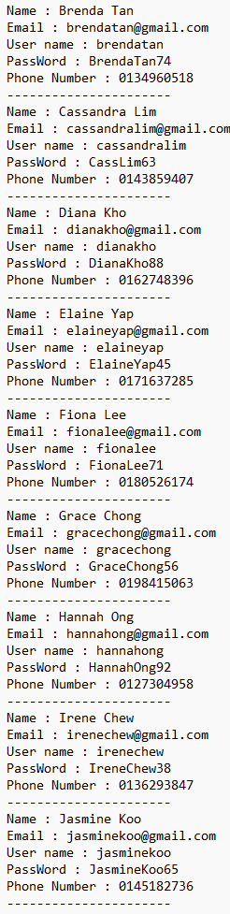

Property.txt
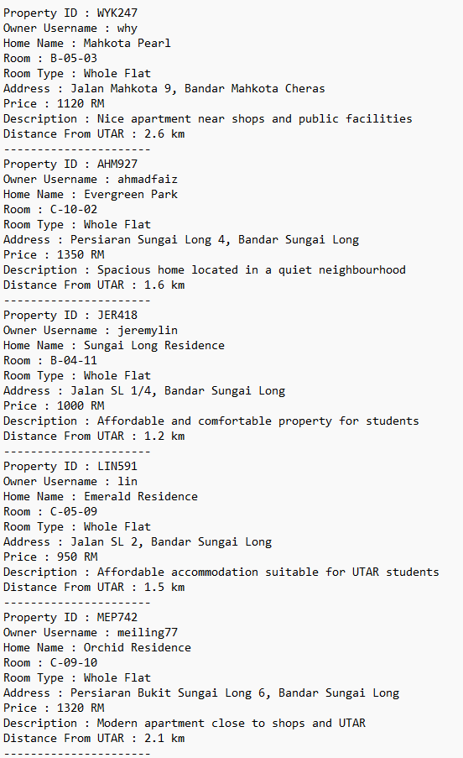

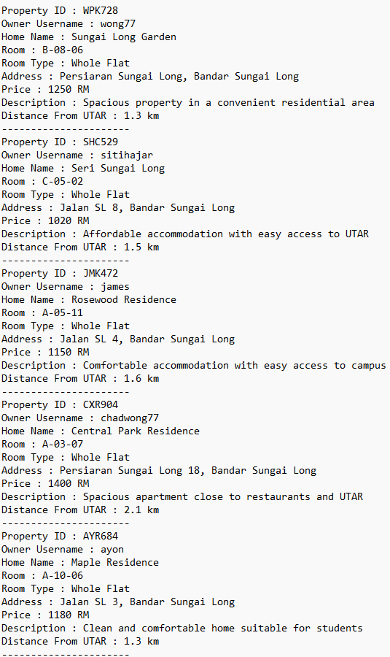

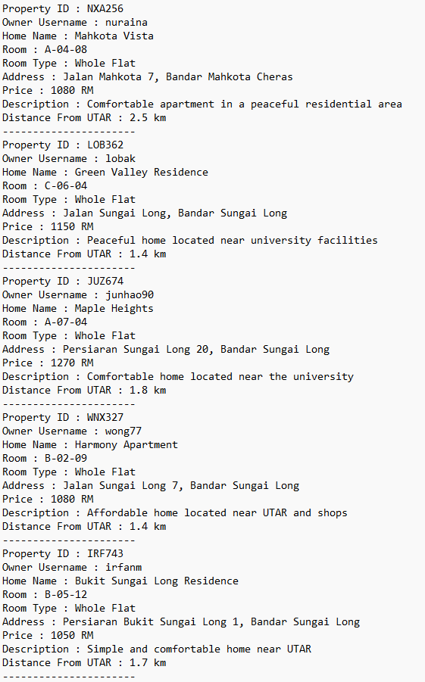

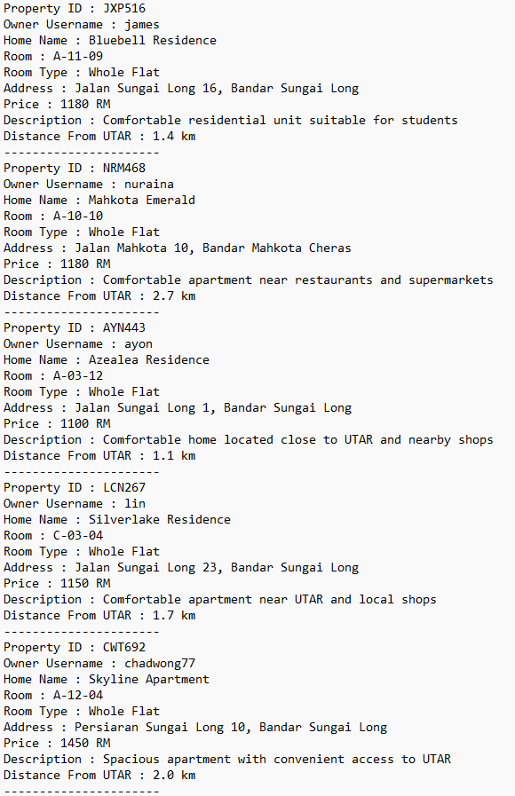

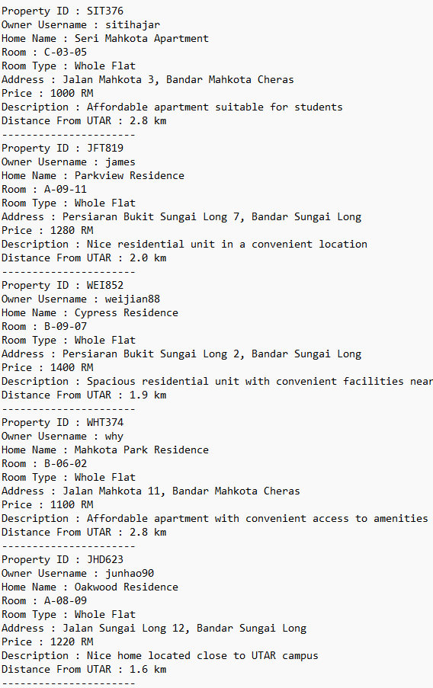

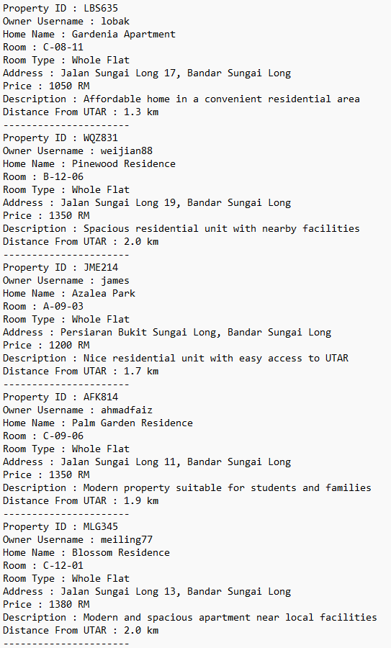

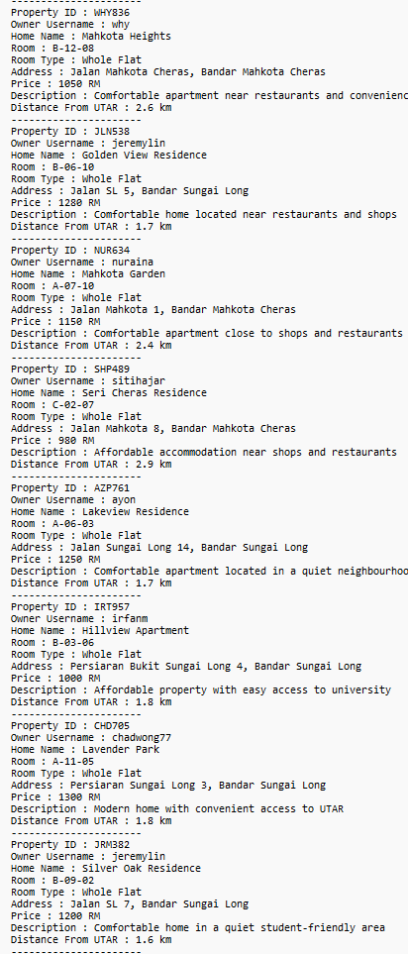
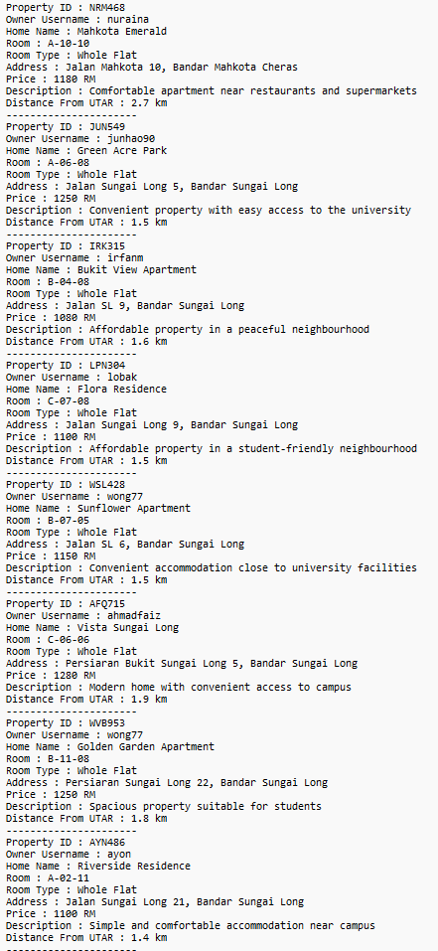
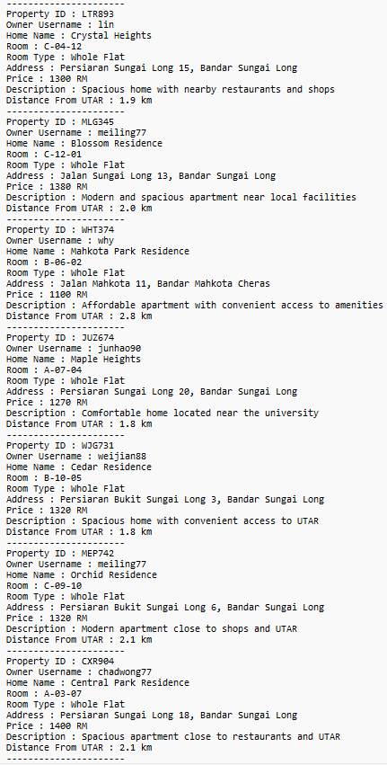

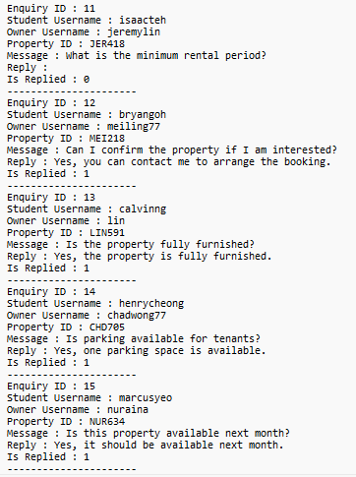
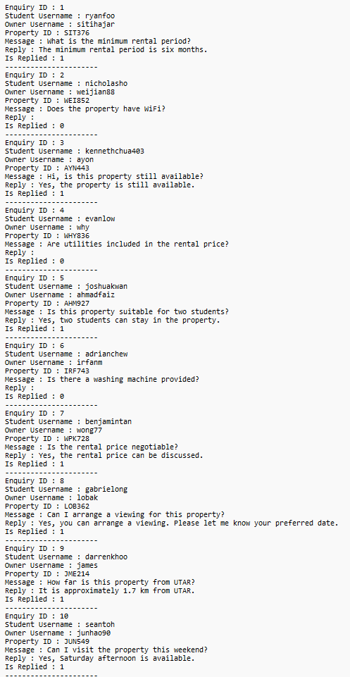
Communication.txt

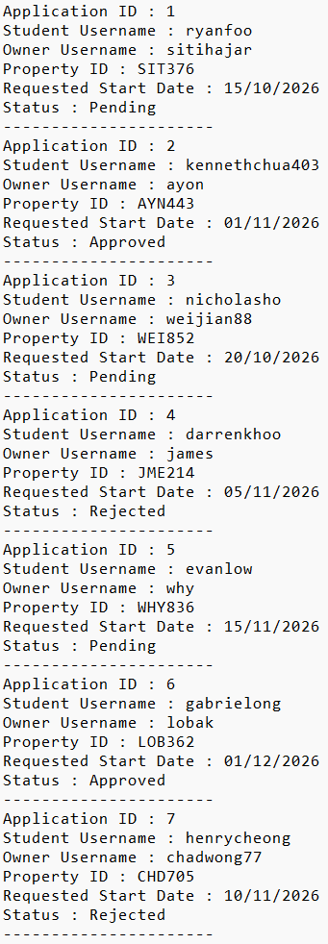
rental_application.txt
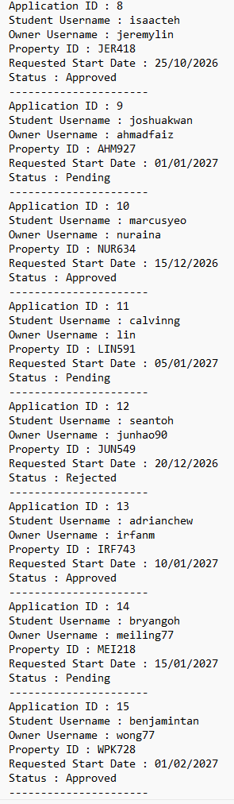

shortlist.txt
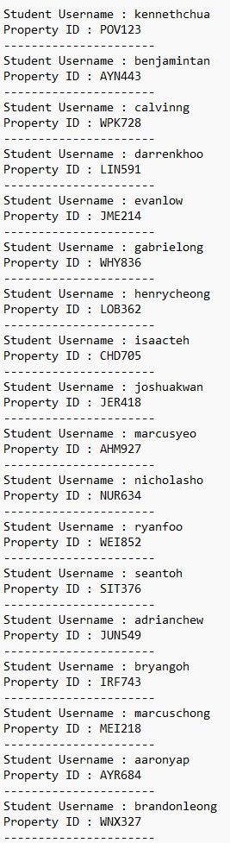
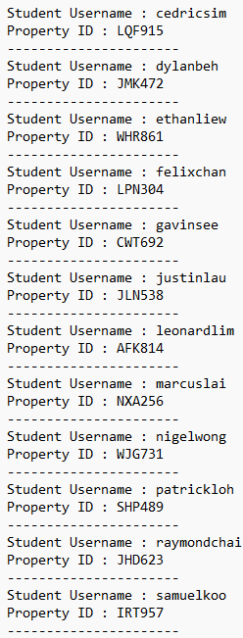

6.0 Table of Contributions
No. | Task
Rafi Ayon | -Oversaw the development and integration of all team members’ code into a single functional system, ensuring compatibility and proper overall functionality.  -Coding of Accommodation & Listing Module, Rental Management & Analytics module, and Communication & Enquiry Module  -Coding of the system’s header files (accommodation.h)
Wong Hao Yi | -Coding of Accommodation & Listing Module (Owner.cpp, acoomendation_listing_searching.cpp, student.cpp)  -Coding of main.cpp  -Designing of Structure Chart  -Designing of pseudocode
Backham Lim | -Coded Rental Management & Analytics module (analytics_part.cpp, main_Rental_analysisarea.cpp, rental_management.cpp)  -Sample input of data  -Sample output screenshots  -Designing pseudocode
Kenneth Chua | -Coded Communication & Enquiry Module (communication_appoitment.cpp, owner_enquiry.cpp, student_enquiry.cpp)  -Proposed solution to the Problem  -Sample input of data  -Sample output screenshots

Collaboration through GitHub:
Our team used GitHub to collaborate and integrate our code throughout the development of the assignment. Each of the four members contributed their code through the repository, allowing all members to view and track each other’s contributions. This helped us coordinate our work, manage different modules, and integrate the individual components into a single system. The GitHub repository containing our assignment can be accessed through the link provided below.
https://github.com/AyonDevStack/UTAR_accomendation_managment_system.git

