**Part 1**

# Tutorial 1 – Personal Development Plan

|  |  |  |  |  |
| --- | --- | --- | --- | --- |
| **University *of* Greenwich** | | | **DEVELOPMENT PLAN** | |
| **Name** | Mohaamed Aayoob Min | | **Date: 18.01.2020** | |
| **Objectives to be Achieved** Note what are your aims to be achieved | **Success Criteria** Note how you’ll know you have succeeded. What will you do differently? What new knowledge will you have? | **Action** The action(s) you will undertake to reach the aim | **By When** | **Impact and Further Action** Note the impact the development has had and the further action you need to take - you complete this section after you have completed an action point to note and evaluate your success. |
| Collaboration Skill | I wish to improve my collaboration skill, I like to work alone and working in a group gives me frustration when tasks are not done or if things don’t go the way I want. I tend to do my own work and not pay attention to what my peers say.    I will know I have succeeded when I have collaborated with my group by making a presentation and working together on that position.  I will try and listen to my peers and pay attention to what they are talking about and focus on working together with them.  I will gain a better understanding on working together and this is essential in the future as I would have to work with other people. | I will collaborate with my group in the future ask more questions and speak to them about the work and give my own opinion, instead of working alone. | I would like to achieve this goal by 20.02.2020 as I would like to allow myself more time to work and gain a good understanding on working with each other. | I have been enjoying working with my group to collaborate and it has made more impact than expected as I am able to get feedback and have other opinions. In addition, I was able to share information and get information from my group which has broaden my mind. |
| Communication Skill | I am an introverted person and I don’t like to speak to other people that I do not know. I am very shy and won’t be able to talk to people I am not comfortable with. I wish to improve myself and speak more to other people and communicate with them to gain information.  I will know I have succeeded when I am able to present a presentation and ask questions to the audience.  I will try and communicate more with other people I do not know and try and share information and communicate more efficiently with them.  I will be able to communicate with more people and this would help me out in the future. | I will try and communicate with more people and try to be comfortable with other people and initiate to communicate with others. | I would like to achieve the goal by 07.02.2020 as I would like to try and communicate with other people. | I have started to talk more to other people however, due to my personality it has been very difficult. I have been more open, but I have not achieved my goal and would need more time to achieve this objective. |
| Time Management | I would like to improve on managing my time as I have no schedule and a bit lazy therefore, I wish to make a schedule to follow and improve myself.  I will know I have succeeded when I have made the schedule and followed the plan.  I will follow the schedule that I have make and follow it accordingly, as this will help me manage my time better.  I will be able to manage my time better and help relieve more stress as I would not be doing work last minute. | I will make a plan and follow the plan and manage my time better. I will follow the plan accordingly and try to attend everything on the schedule. | I would like to start the schedule by 22.01.2020 and follow it accordingly till 03.04.2020 and make sure that I will attend everything. | I have made a plan and have tried following it according to plan however, there were some things that I missed in the schedules and this indicates that I have not achieved it yet but I have attended a lot of things and my time management has gotten better. |

**Careers Goals Evidence**

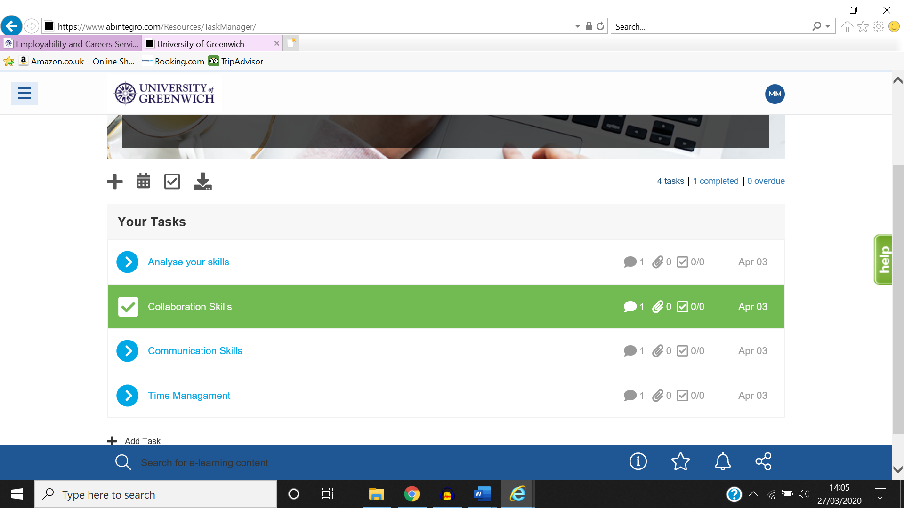

**Set Job Alerts**

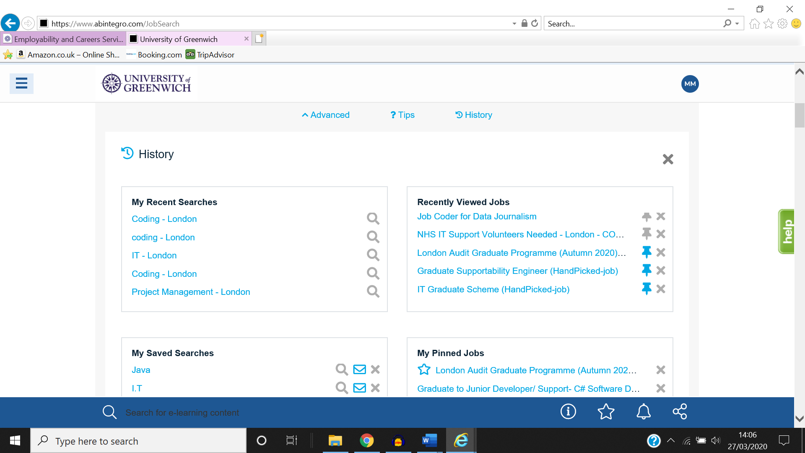

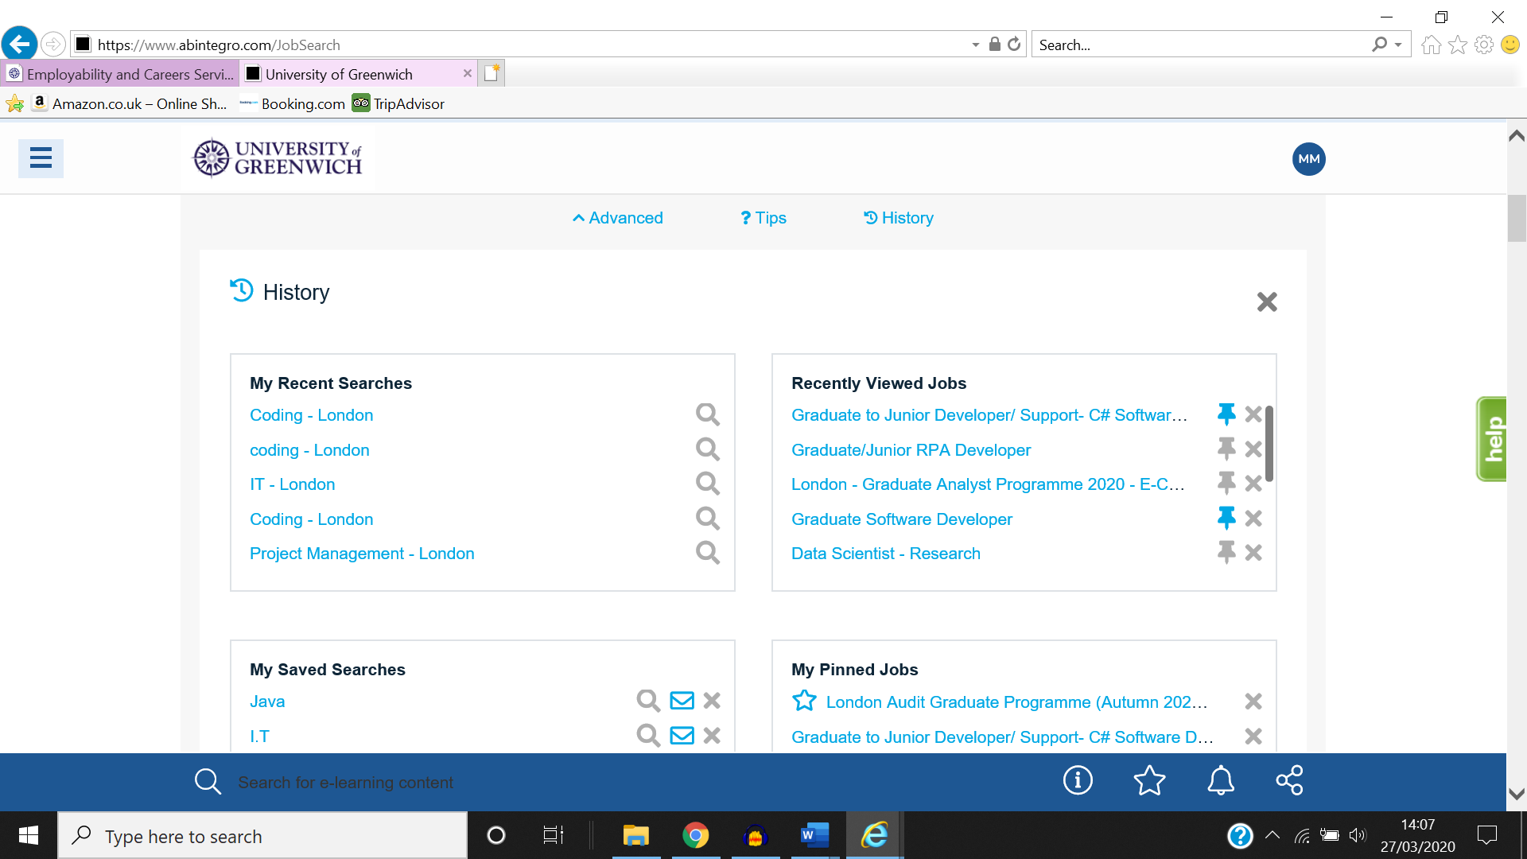

**CV**

Mohaamed Min

ayoobmohammed14@gmail.com

07427904824 | am5562z@gre.ac.uk

**PROFILE**

I am a first year Software Engineering student, I am enthusiastic and dependable when working. I have great collaboration skills and I am able to plan ahead as to keep myself from falling behind. I have basic understanding skills in Python and software engineering. Able to use Microsoft Office and understand HTML. I have had my work experience in Sickle cell and Thalassemia centre and have experience in inputting information and extracting information from excel o database.

**EDUCATION & QUALIFICATIONS**

Newham Sixth Form College - BTEC Level 3 Organisational System Security - Distinction

E-Commerce - Distinction

Database Design - Distinction

Data Analysis and Design - Distinction

Installing and Upgrading Software - Distinction

Web Animation for Interactive Media - Distinction

Multimedia Design - Distinction

Impact of the Use of it on Business Systems - Merit

Project Planning with IT - Merit

Website Production - Merit

Digital Graphics - Merit

Communication and Employability Skills for IT - Pass

Computer Systems - Pass

Information Systems - Pass

System Analysis and Design - Pass

Client-Side Customisation of Web Pages - Pass

Business Resources - Pass

Spreadsheet Modelling - Pass

2018

Forest Gate Community School - GCSE Mathematics A (Linear) - B

ICT - B

Statistics - B

Science - C

Additional Science - C

Religious Stud - B

English Language - C

English Literature- C

Religious Stud - A

Applied Business - D

BTEC Sport - Level 2 Pass

ECDL - Distinction

2016

**WORK EXPERIENCE**

**Database | Sickle Cell and Thalassemia Centre Jan 2017 to Jan 2017**

Sickle Cell and Thalassemia Centre is a company which treats these diseases. The company focusses on treating patients and database on the patients.

* The responsibilities that I had as an employee at Sickle Cell and Thalassemia Centre was:
* To extract information from Excel and input them into Access.
* I had to sort out information
* I was able to perform well as it was simple and easy to understand as I had studied to use Access and Excel before.

**Employee | John Lewis Jan 2015 to Jan 2015**

John Lewis is a large company, provides experience in retail.

* The responsibilities that I was given was:
* To collect parcels for customers and give it to the customers.
* To fold clothes and pick up items on the floor
* To put items back to the place that they belong.
* I was able to collaborate with my peers and it made it easier for us. We communicated with each other and was able to complete tasks given to us faster.

**ADDITIONAL INFORMATION**

Languages – English

Technical skills

* MS Office
* MS Office
* Python

**REFERENCES**

G Tomlin | John Lewis

**GitHub share link**

**Part 2 Research**

What I have chosen to write my article is on controversial AI on retail services. For many years retail has been a very big market, it provides many essential needs for people around the world. Retail has been constantly evolving and growing. Retail will continue to expand, and I have come up with an idea on what can be improved in retail. My idea is for customers to try out clothes in the fitting room without actually needing to try on the clothes. The customers would be able to scan their body and they would be able to scan the dress and there would be a holographic display on them to show them how they would look.

The customers would be able to go into the fitting room with their clothes on. There will be a scanner to scan the body and all of this would be under tight security and customers can use it with relief. There will be a hologram on the mirror showing an exact replica of the customer. Customers can then scan the barcode for the clothes they want to try out. The clothes will then be displayed on the customer by a hologram. The customer will not have to take the clothes off for privacy and it will be displayed on top of the customers. The customer will be able to see it on the mirror and also be able to see the clothes on the replica of them. In addition, there will be an advanced feature where the customer can be able to write down their height and sizes instead of using the scanner if customers are uncomfortable with it. To make this possible I would require AR height measurement and coding to make the hologram. I would also need a program where customers can choose what they want to input for their height and sizes. Lastly, there will be information on the clothes they have picked out and they will be able to choose the sizes that they want and will be able to make their decisions there and allow them to purchase the item if they want to there. HoloLens are required for AR as well.

**What is Augmented Reality (AR)?**

Augmented Reality seems to be a futuristic technology however, it has been here from 1990. Augmented Reality is different from Virtual Reality, it is similar however, there is a difference. Virtual Reality is a different world where you experience things, however, Augment Reality is in the real world and is an advanced technology where you can use it to help you navigate paths using computer generated information. A goggle can be worn to help with that, and this will help you see things which are enhanced. Augmented Reality is another version where it similar to the environment of the real world. The objects that are in the Augmented Reality are enhanced by computer information. Augmented Reality is widely used and is an advantage as there are online and can be used in shops.

**Advantages and Disadvantages of AR**

There are many advantages of Augmented Reality, activities can be easier when AR is used, it would allow the user to be more effective and efficient when doing these activities. AR finds the best solution for the outcome to be achieved. With AR people are able to access information and AR would help pick relevant information and would stop time wasting and save time. It is beneficial for people to use AR technology and AR can be used in the real world, moreover, it increases human perceptions and enhances them. In addition, with Augmented Reality information can be accessed anywhere at any time and is very useful. This is beneficial as access to information is valuable. In addition, it will only show relevant information of a topic when searched therefore, it saves a lot of time and extremely capable.

There are also disadvantages to using AR and one of the most troublesome issue that AR has is privacy issues. Privacy is one of the main problems and is targeted by hackers. It can be targeted and there maybe cyber-attacks, this could leak information on users or information stored on it. This can be a threat if information’s are leaked, and this is one of AR’s weakness. Another disadvantage of AR is that implementing the software and hardware is very costly. It is extremely expensive and not many are willing to invest in AR as only military or rich merchants would invest on it. Another disadvantage is that with the capabilities of AR it will restrict an individual’s life, AR is very reliable and therefore, many people may make choices given by the AR and would not be thinking what they can do and this can restrict a person. In addition, constant use of AR can be a threat to your eyesight and health and can make you eyesight decrease if it is used constantly. Maintaining AR is extremely expensive and cost a fortune, and is also expensive to make AR.

AR has come a long way; however, one main issue is privacy as many people believes that they are being recorded and some are concerned that conversations are recorded and listened. This is a huge blow to AR as it is extremely beneficial and the threat that cyber-attacks pose to AR has also increased its disadvantage.

In conclusion, I believe that there are more advantages to AR than there is to its disadvantages. AR would allow us to increase our mind and make it sharp. AR can help us out and allow us to be efficient and stop time wasting. It may be expensive however, the benefits it brings outweighs its costs. In my opinion AR would bring a new side to the world and this would increase the capabilities everywhere around the world.

**AR currently used**

One AR which is being used currently is a navigation through the airport where they guide customers to their desired location, this is beneficial to people as this will improve traffic flow. This will allow people to be aware where to head and would stop confusion and less human traffic.

Another app that uses AR is Google Maps, Google have made this feature available in 2018, where users across the world can use it to guide throughout the world on the destination that they want to use. The destination can be entered, and users have to enable GPS as to allow the app to see where the users are. Then it will guide users to their desired location by showing how to reach their desired location. In case the users make a wrong turn, the AR improvises and shows another way they can reach there following the routes that they have taken. Google AR is massive as it has routes around the world and can be used around the worlds. Codes implemented in to make that are millions of lines.

Sephora Virtual Artist allows customer to try out makeup on their digital face, to show how they would look and also to show what the makeup would allow you to look like. This is another one currently used and it shows what the makeup looks like and what it would look like on your face once it is applied on It digitally, this allows the company to save money as there will be less shrink (tester products). Tester products would not be required and this would help save company a lot of money in addition, some customers try on products even if it is not a tester and because of hygiene companies are not allowed to sell the product and this will help reduce the losses that the company may accumulate.

In addition, google lens is another augmented reality which can be used by people. One of the feature Google Lens has is a scanner, and when it is scanned it will show what it is. In addition, Google lens allow you to scan and translate text, this saves time as users can just translate the text instead of having to find out what it may have said. Moreover, users can find out the animals and its species or plants. Google has made it more convenient for users to experience life and if users need information on it, they will get relevant information quickly. Google Lens is often used when travelling, it can be used to locate landmark to finding out what animal or plant it may be. Google Lens is easy and simple to use yet very efficient. It allows users to find information on what they want. It has many features and these features has its own uses in giving out information. Google Lens is extremely capable, and users can gather information about what they want by scanning it.

In conclusion, these are augmented reality that are currently being used, they are very costly, however they have enhanced people’s life and can be used in the real world. In addition, it has been very beneficial as millions of people uses Augmented reality in everyday life now. Moreover, it has made it easier for people to understand language they aren’t able to understand. AR has been evolving and will continue to evolve constantly and will continue to grow.

**What is HoloLens?**

HoloLens are lens which can be worn and is an AR which shows allow you to blend into the real world using it. HoloLens is an example and shows how far AR has come and therefore, the idea to make Holographic clothes onto people is not an impossible idea. Microsoft made HoloLens and it has many optical sensors to understand the surroundings. It has camera to pick up motions and has speakers to simulate the sound.

**Future of AR**

AR is constantly growing and is always evolving. AR has come a long way, and AR in retail will have a future as customers will be able to save time from not trying on the clothes. They would be able to see how the clothes would look like and how it would look on them. This is a simple way to save time and be more efficient as customers would not have to wait in lines now to go and try clothes on as it would be faster and more efficient for customers. In addition, it will be extremely simple and easy to use for customers. Customers would have to use AR for height and body measurements, and customers can manually type in measurements and scan the code for the clothes and the holographic display will show them how they would look. AR in retail will have a long future as this is the best way for customers to try as it saves time and also customers would not have to take off their clothes to try on other clothes, this will stop privacy invasion and would be safest method.

Ultimately, I believe that AR will have a future and would still be used in the future as it is mainly flawless and would save company and customers time and allow the company to grow. There is a disadvantage as it may be costly but with investment it will bring benefits to companies and it would help out companies in the long run.

Reference

AR: <https://en.wikipedia.org/wiki/Augmented_reality>

AR: <https://thinkmobiles.com/blog/what-is-augmented-reality/>

AR: <https://www.livescience.com/34843-augmented-reality.html>

AR Advantages and Disadvantages: <https://assignmenthelp4me.com/discussions/what-are-the-advantages-and-disadvantages-of-augmented-reality.html>

AR Advantages and Disadvantages: <https://www.panono.com/en/blog/blog-posts/augmented-reality-ar-virtual-reality-vr-different-areas-of-application-advantages-and-disadvantages/>

AR Advantages and Disadvantages: <https://theappsolutions.com/blog/development/ar-benefits-for-business/>

AR Advantages and Disadvantages: <https://www.konsyse.com/articles/the-pros-and-cons-of-augmented-reality/>

AR currently used: <https://www.forbes.com/sites/bernardmarr/2018/07/30/9-powerful-real-world-applications-of-augmented-reality-ar-today/#6e6a74142fe9>

AR currently used: <https://www.inc.com/james-paine/10-real-use-cases-for-augmented-reality.html>

Google Maps: <https://www.makeuseof.com/tag/google-maps-augmented-reality-directions/>

Google Lens: <https://lens.google.com/>

Google Lens: <https://www.wired.com/story/google-lens-augmented-reality-future-of-learning/>

HoloLens: <https://www.gvsu.edu/cms4/asset/7E70FBB5-0BBC-EF4C-A56CBB9121AECA7F/7_things_about_microsoft_hololens.pdf>