Project Report

Project Name: Water level indicator using 7-segment Display

Name: Umer Tahir Name: Ayoob Haroon

Roll no: 20i-0446 Roll no: 20i-0777

1. Introduction:

A water level indicator is a system that relays

information back to control panel of a circuit to indicate which level has the water. There are 9 different levels from 0-9 which are measured

using wires placed inside the tank. These wires relays information back to the logic circuit

designed and displays the current level of water on the 7-Segment display. Circuit is designed on the basis of truth table, K-map and full adder circuit. The purpose of a water level indicator is to gauge and manage water levels in water

tank. The circuit is also programmed to

automatically turn on a water pump once water level gets too low and refill the water back to

adequate level. Water level indicator works by using the sensor wires to indicate water levels in a storage tank.

1. Working:

This project is designed to indicate the different levels of water stored in the tank from 0(Low)- 9(High). Expressions for the output of the required circuit is solved below with the help of K-map. 10 wires are connected inside the tank which work as sensors. These sensors are connected with NOT gates with high resistances. The output of this NOT gate is connected with more gates derived through experiment. Circuit is divided into two parts; first 6 levels are solved by using 6-variable K-

map and the output of these connected to the inputs of full adder (IC# 7483) as A0, A1, A2, A3 and B0, B1, B2, B3 are considered as 0, now further 3 levels (7-9) are solved by adding ones into the binary bits of sixth level by connecting with the second input of Full adder as B0, B1, B2, B3. The outputs of Full adder is than connected with inputs of 7 Segment Decoder

(IC# 7448) that are A( 1st bit), B( 2nd bit) , C (3rd bit) and D (ground).The outputs of 7-Segment

Decoder (IC# 7448) are connected with the cathode 7-segment Display. When there is no water in the tank, 0 level (Empty) is shown on the 7-segment Display and motor will turn ON. When water level increases and touches the first sensor, 7-segment Display button will

display 1st level on it indicating that water is within the tank. As the water level continues to rise, level increases on the 7-segment Display. When the water is full in the tank, 7-Segment will Display the Level 9 on it and motor will

turns off.

* Truth Table:

For displaying 9 levels, 9 variable k-map become very complex. So, it is divided into 2 parts by

using Full adder:

Truth table for first 6 - variables:

|  |  |  |  |  |  |  |  |  |
| --- | --- | --- | --- | --- | --- | --- | --- | --- |
| A | **B** | **C** | **D** | **E** | **F** | **A2** | **A1** | **A0** |
| 0 | 0 | 0 | 0 | 0 | 0 | 0 | 0 | 0 |
| 1 | 0 | 0 | 0 | 0 | 0 | 0 | 0 | 1 |
| 1 | 1 | 0 | 0 | 0 | 0 | 0 | 1 | 0 |
| 1 | 1 | 1 | 0 | 0 | 0 | 0 | 1 | 1 |
| 1 | 1 | 1 | 1 | 0 | 0 | 1 | 0 | 0 |
| 1 | 1 | 1 | 1 | 1 | 0 | 1 | 0 | 1 |
| 1 | 1 | 1 | 1 | 1 | 1 | 1 | 1 | 0 |

* + Expressions and there Circuits: Below expressions are derived through K-map and it will become the First input of Full Adder IC# 7483:

A3 = Ground A2 = D:

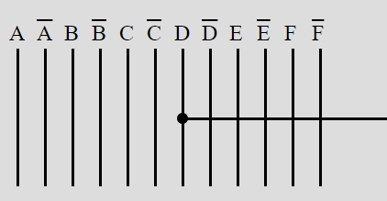

A1 = F+CD’:

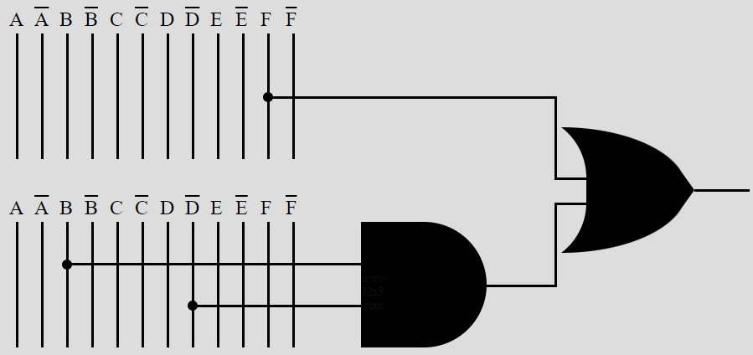

A0 = EF’ + CD’ +AB’:

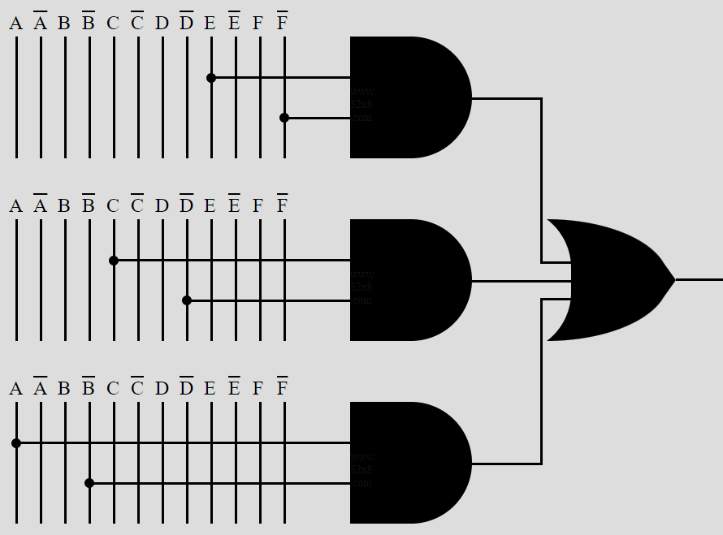

Truth Table for next three levels (7-9):

|  |  |  |  |  |  |
| --- | --- | --- | --- | --- | --- |
| **G** | **H** | **I** | **B 2** | **B 1** | **B 0** |
| 0 | 0 | 0 | 0 | 0 | 0 |
| 1 | 0 | 0 | 0 | 0 | 1 |
| 1 | 1 | 0 | 0 | 1 | 0 |
| 1 | 1 | 1 | 0 | 1 | 1 |

* + Expressions:

Expression for above truth table is derived through using 3 – variables k-map and it

became the 2nd input for full adder IC# 7483.

Full Adder adds the both input and provides the required output to 7-segment Decoder.

B3 = Ground B2 = Ground B1 = H

B0 = I + GH’

* Components:

Following are the required components used:

* NOT gate (IC # 7404)
* AND gate (IC # 7408)
* OR gate (IC # 7432)
* 4 bit Full Adder (IC# 7483)
* 7-Segment Decoder (7448)
* 7-Segment Display (Common Cathode)
* High resistance (1 MΩ)
* Low resistance (222 Ω)
* Battery (9 volts)
* PCB
* Wires and Tools
* Bread Board
* Vero board
* Stainless steel probe sensors
* Connectors

Sensor used in water level indicator is stainless steel probe sensors. It prevent rusting, fouling and deteriorating due to poor water quality.

* Specifications:

Water Level Indicator displays the current Level of the water on the 7-Segment Display precisely and also turns water Pump ON and OFF

according to the level of water, which avoids overflowing.

* Applications of Water Level Indicator: Applications and uses of water level indicator includes:
* Hotels
* Home apartments
* Commercial Complexes
* Factories
* Where cooling towers are used
* Residential and commercial swimming pools
* In vehicle as fuel level indicator
* Single phase motors
* Three phase motors
* Bore wells
* Open wells
* Used to start and stop water pumps
* Benefits of Water Level Indicator:

Benefits of Water Level Indicator are:

* Easy to install
* Very little maintenance
* Compact design
* Saves money by using less water and electricity
* Can help avoid seepage of walls and roofs due to tanks overflowing
* Consumes very less energy, perfect for continuous operation
* Shows incitation of water level in any type of tank.
* Importance of Water Level Indicator:

Water level indicators are important for many different industries. For example, cooling

towers use water level indicators to monitor water levels in a tank and make corrective

actions based on the level of water. Without Water level indicators, you have to manually check whether enough water is in a tank, and

should your tank ever go empty. It allows you to remotely monitor water levels and make corrective actions automatically so you can focus on more important issues.

* Advantages:

Water Level Indicator advantages include:

* Power Saver
* Money Saver
* Automatic
* Water Maximization
* Reliable Electronic Design
* Disadvantages:

Water Level Indicator disadvantages include:

* Water level controls need to replace by every 3 years.
* The rust, foul and deteriorate.
* No Warranty and Guarantee
* No LED indicator lights.
* Most float switches are outdated
* Block Diagram:

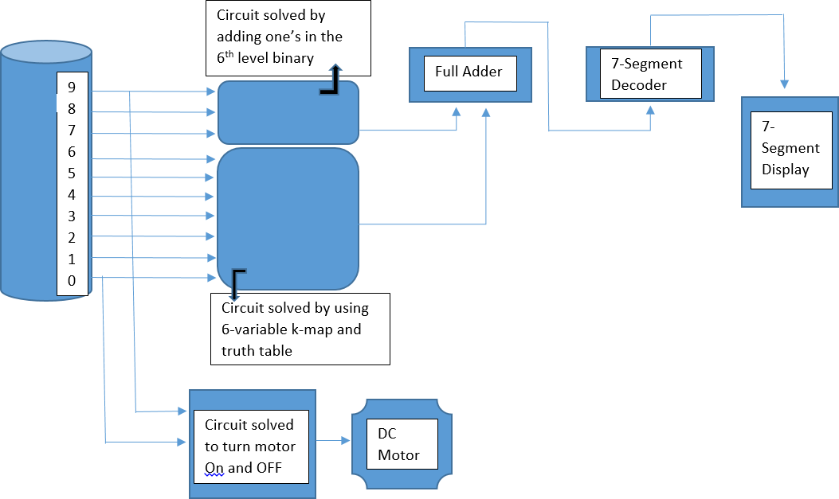

* Designed Circuit:

Circuit is designed on Proteus 8.11. By drawing the block diagram and flow chart. It became easy to

design on proteus. All Components were found and connected easily. Circuit run successfully according to the desired results.

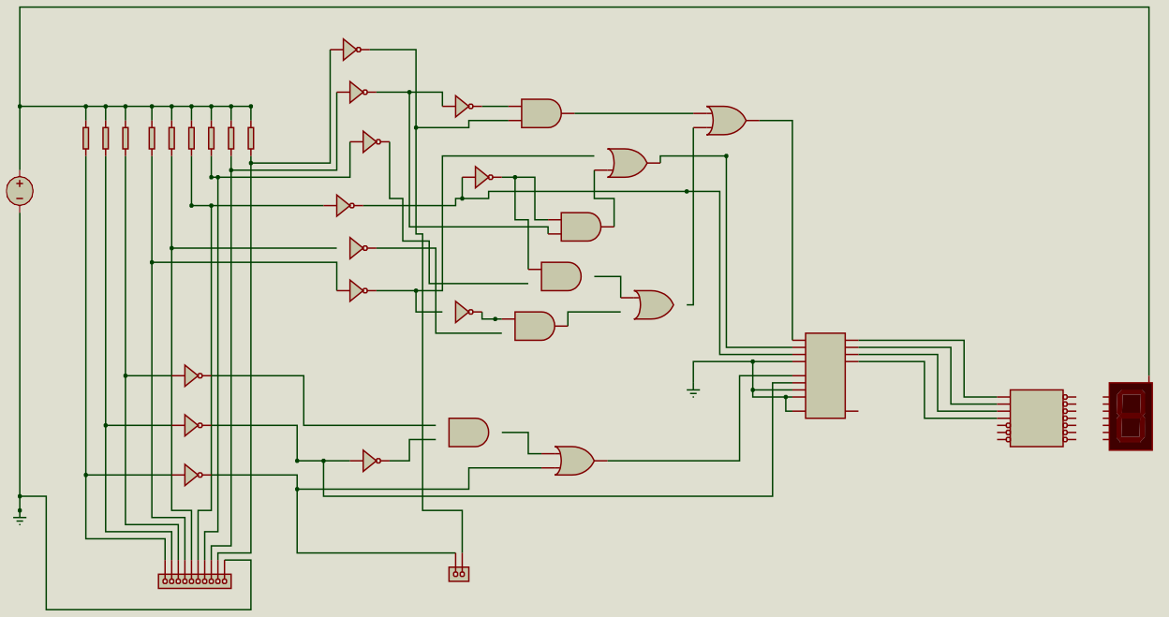

U2:A

1 2

7404

U2:B

3 4

7404

U4:A

1 2

U11:C

9

U5:B

8

7404

10

4

5

6

R9 R8 R7 R6 R5 R4 R3 R2 R1

560k 560k 560k 560k 560k 560k 560k 560k 560k

U2:C

5 6

7408

7432

7404

U4:B

3 4

U5:C

9

10

8

VCC

5V

7432

U2:D

13 12

7404

U11:D

7404

12

11

U2:E

11 10

13

7408

U11:B

7404

U2:F

9 8

4

6

5

U5:A

7404

U4:C

5 6

7408

1

U11:A

3

2

1

7404

3

7432

2

7408

U3:A

1 2

U3:B

3 4

U6

10 A1

8 A2

3 A3

1 A4

11 B1

7 B2

4 B3

16 B4

13 C0 7483

S1 9

S2 6

S3 2

S4 15

U1

7404

C4 14

7404

U7:A

1

2

3

U5:D

7

1

2

6

4

5

3

13 A1

12 B1

11 C1

10 D1

9 E1 15 G1 14 F1

U3:C

5 6

U3:D

13 12

7408

12

7447

11

13

C1

7SEG-COM-ANODE

7404

7432

7404

J1

26631001RP2

J2

26630201RP2

1. QA
2. QB
3. QC
4. QD

BI/RBO QE

RBI QF

LT QG

CA1

* PCB Layout Design:

10

9

8

7

6

5

4

3

2

1

2

1

After completing Schematic design, next step is draw its PCB layout. All footprints were available, if any component’s footprint is not available it can be designed easily by following its pin configuration. After drawing board edges and placing components, PCB layout is completed by auto routing. Name, roll

number and University logo is placed on PCB layout after completing auto routing.

