Octiba Nima

Topic
We were given a data set containing information about a set of houses and the respective prices split into features. Some of these features might be predictive of the house prices. Our goal is use the features to create a prediction model by using algorithm for feature selection using a genetic algorithm and neural network for creating the model. This model predicts house prices given a set of features. We compare the accuracy of the prediction both with and without feature selection.

Process
Before start the implementation, we agreed on an architecture of the project. We split the project into modules.

Architecture

The data cleaning
Reads raw data from the given file and clean the data, meaning handling missing values, detect and potentially remove noise, engineering potentially useful new features and converting data to a format readable by the next modules, the genetic algorithm (GA) and the artificial neural network (ANN).

Genetic Algorithm
The GA recievs data from the data cleaning module. It uses the ANN to determine which features (alone and in combination with others) are the most predictive of the house prices.

Artificial Neural Network
The ann's job is to create a model optimized to predict house prices based on a selection of features. In the creation of the model, the neural network will use training data, and the corresponding house price. When the ann predicts prices it only uses features.

Version control
We utilized GitHub for version control and work flow. This allow us to work simultaneously on the same project with limited conflicts. We created a master branch for the project, and an individual branch per person. When we created useful changes to a branch, we pushed the changed branch to the master.

Contributions
 | Main responsibility | Contributors
Data cleaning | Renny, Febrianti
Genetic algorithm | Nils | Renny
Artificial neural network | Markus | Nils
Visualization | Markus, Renny | Febrianti
Documentation | Everyone

Modules

The Data Cleansing

Drop columns which are not useful

PID and Order
PID and Order have unique values and functioned more like index of records rather than contributing as useable features. Therefore PID and Order are removed.

Handling Missing Values

Filling in the missing value and convert to numerical category based on the rank of the mean of SalePrice
By looking at the data description file, we see that the values for some of the columns are Nan due to “no facilities” available. Therefore, we change the Nan values to string “NA”, so we can categorize them properly. After filling missing values with string “NA”, we converted the values to numerical category and ranked based on mean values of SalePrice. For example: starting from 0 for the category which have lowest mean SalePrice.
This applies to below columns: 'Alley','FireplaceQu','GarageFinish','GarageType','GarageQual','GarageCond','PoolQC','Fence','BsmtQual','BsmtCond','BsmtExposure','BsmtFinType1','BsmtFinType2'

Garage Cars and Garage Area
Same as above, the Nan values means no facility available, therefore as this is numerical, fill in Nans for both columns with 0.
The rest of the missing values (Nan) will be handled on later stage (section 5)

Cleanse inconsistency of paired features

MasVnrType and MasVnrArea
Fill in the missing value Nan in MasVnrType with string ‘None’, as there is a category called ‘None’. Fill in the missing value (Nan) in MasVnrArea with 0 since the category in MasVnrType is ‘None’
Both records comes as a pair and therefore there has to be consistency between those two features, such as 'None' values in MasVnrType should have zero values in MasVnrArea. However we found several records that do not meet expectation as below:
For those records, we did the following, where MasVnrType equals to 'None':
- Replace value '1' in MasVnrArea to '0' assuming that it's a typo
- Replace 'None' in MasVnrType to most common values (mode) which have MasVnrArea not equal to zero.

Cleanse Categorical features

Convert to numerical features based on mean of SalePrice
In converting features to numerical, there are some features that are converted and ranked based on mean values of SalePrice. This has been done in section 2.1 above. By doing this we obtain the actual rank of feature and not based on sorted values with no ranks/orders.
Features that are converted using this approach are:
'Alley','FireplaceQu','GarageFinish','GarageType','GarageQual','GarageCond','PoolQC','Fence','BsmtQual','BsmtCond','BsmtExposure','BsmtFinType1','BsmtFinType2'

Convert to numerical features, with ranking based on common understanding
There are some features which are converted to numerical ranks based on common understanding, for example:
Excellent | 5
Good | 4
Typical/Average | 3
Fair | 2
Poor | 1

Features that are converted using this approach are:
'ExterQual','ExterCond','Functional','SaleCondition', 'HeatingQC','LotShape','Utilities', 'HeatingQC', 'KitchenQual'
Conversion of features done by defining ranks manually and replace the categorical values with predefined ranks.

Convert to numerical features, without ranking
All other features which are not unit numbers (feet, years, values) are converted to numerical values based on sequence of appearance, due to the features cannot be categorized based on rank. For example, first unique value found is set to '0', and so on.

Fill Nan values with median values
After all conversion is done, main dataframe is now filled with numeric values. In this case, values which indicates that there's no features available (for example: no basement, no fence, etc) are already converted to numerical features. At this stage, Nan and null values can be treated as missing data and have to be removed or filled in. we only have columns with missing values which are originally numeric columns (such as LotFrontage and GarageYrBlt)
For this we decided to set those Nan and null values with median values of features/columns.

Check Correlation by heatmap
Main Dataframe have all numerical values, so we can do heatmap to analyse the correlation.
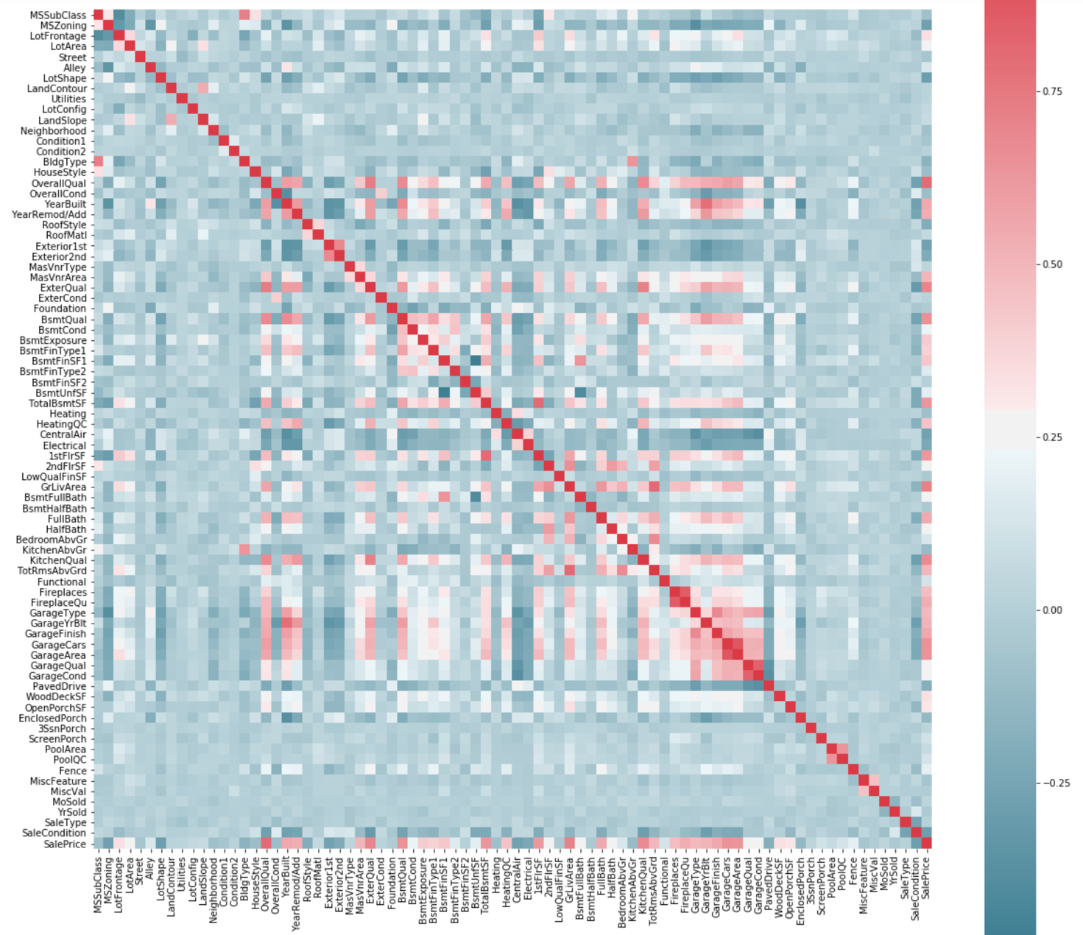

Remove outliers
By checking almost all columns against the SalePrice (especially the ones which have fairly good correlation with SalePrice), we remove some rows which we considered as outliers as follows:

Remove outliers in GrLivArea
From the scattered plot, we can see there are 3 records which have very large grLivArea but with low price. We considered this as noise and remove the records.
T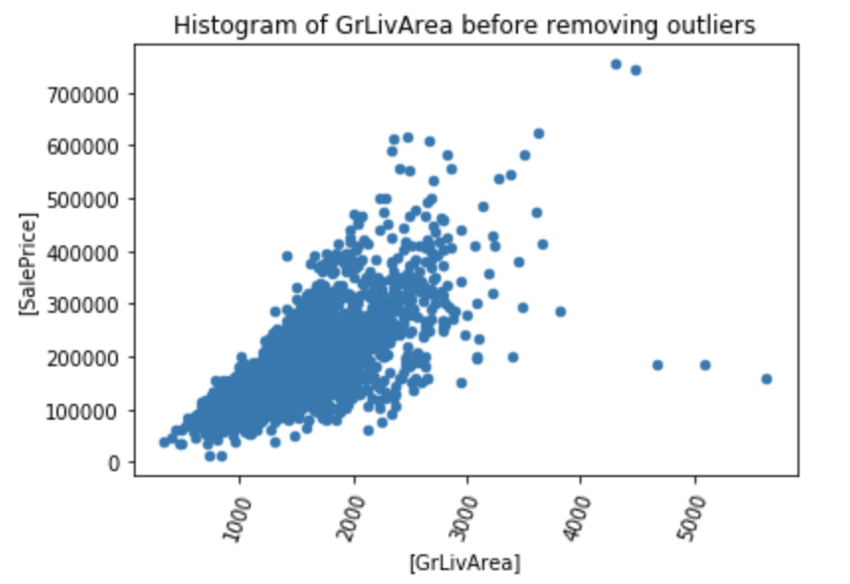

Remove outliers in TotRmsAbvGrd
From the scatter plot, we can see there are 2 records which have high number of TotRmsAbvGrd but with low price. We considered this as noise and remove the records.

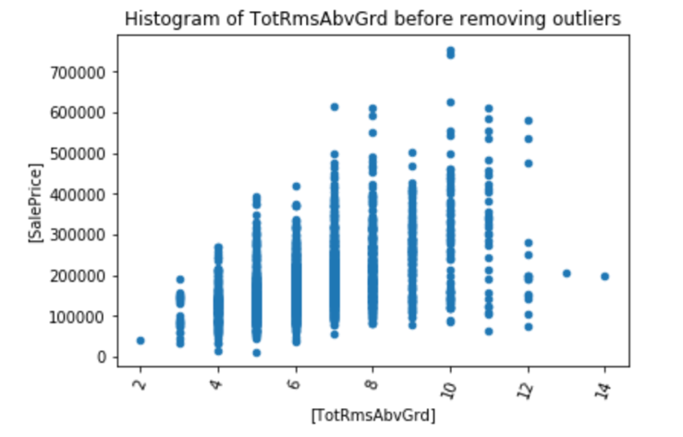

Remove outliers in GarageYrBlt
There is 1 record scattered which has value greater than year 2200. We assume that this is a typo and update the value directly.
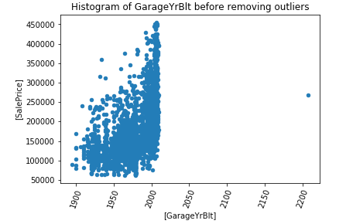

Remove outliers in LotFrontage
There are 2 records scattered which has value greater than 300, we assume that this is a typo and update the value directly.
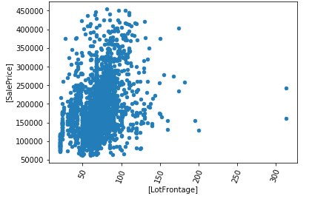

Remove outliers in LotArea
There are 4 records scattered which have values grater than 100000, we assume that this is a noise and remove the records.
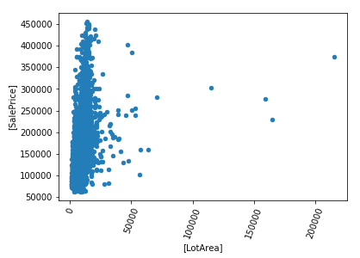

Remove outliers in Electrical
There is 1 record scattered, we assume that this is a noise and remove the record.
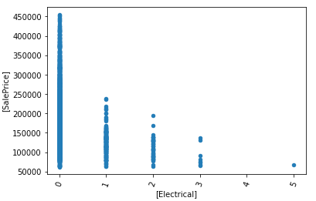

Remove outliers, low frequency records (only 1 occurance in a feature)
We firstly identify features that we want to check. For each of those features, we identify unique values and its occurances. We then remove records with only 1 occurance. For example:
Output:
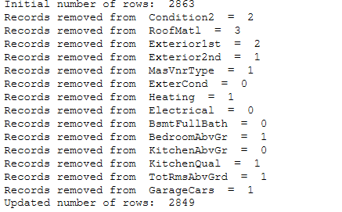

Remove Utilities column
There 2 records scattered, we assume that this is a noise. After removing these 2 records we realized that we are left with only 1 constant values, this means that we can delete this column as no combination with other features will make any difference.

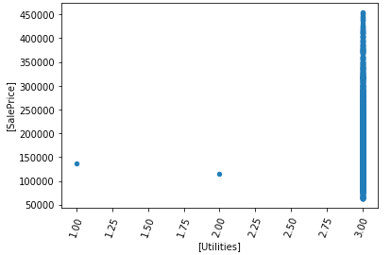
Feature engineering

Create new feature, TotalSize
A new feature 'TotalSize' is created by adding 'TotalBsmtSF' and 'GrLivArea'. The new feature has high correlation, therefore we decided to keep it.
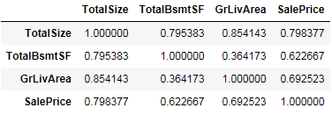

Create new feature, HouseAge
A new feature 'HouseAge' is created by substracting 'YrSold' and 'YearBuilt'. The new feature has high correlation, therefore we decided to keep it.
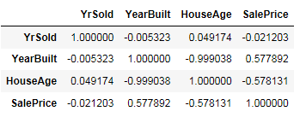

Create new feature, Remodeled
A new feature 'Remodeled' with values 0 or 1, is created. It is to indicate whether the house has been remodeled. If the year of Remodel/Add is the same as the built year then set to 0, else set to 1.
Correlation with SalePrice = -0.048780455143836346

Create new feature, TotalBathroom
A new feature 'TotalBathroom' is created to identify number of bathrooms in a house. Equation used:
TotalBathroom = BsmtFullBath + BsmtHalfBath/2 + FullBath +HalfBath/2.
Correlation with SalePrice = 0.6278618532482679, it is quite high, so we keep it.

Create new feature, TtlGarageQ
A new feature 'TtlGarageQ' is created by adding 'GarageFinish', 'GarageQual', 'GarageCond'. The new feature has high correlation, therefore we decided to keep it.
Correlation with SalePrice = 0.46749083968684624, it is quite high, so we keep it.

Correlation matrix
Based on correlation matrix below (in absolute value format), we found out that 'Condition2' and 'Foundation' has very low correlation with SalePrice. We then decided to remove these 2 features.

 | SalePrice
Condition2 | 0,005178
Foundation | 0,006708
BsmtFinSF2 | 0,012175
SaleType | 0,014724
ExterCond | 0,015097
MiscVal | 0,017329
LandContour | 0,019434
YrSold | 0,021203
PoolArea | 0,032744
LotConfig | 0,039431
3SsnPorch | 0,041126
PoolQC | 0,046149

Then the final correlation matrix is

Features | SalePrice
MSSubClass | -0,08687556
MSZoning | -0,273946525
LotFrontage | 0,342748019
LotArea | 0,313301288
Street | -0,051068051
Alley | 0,143739788
LotShape | -0,308425987
LandContour | 0,01943395
LotConfig | 0,039430715
LandSlope | 0,054658392
Neighborhood | -0,059285842
Condition1 | -0,072309077
BldgType | -0,173540601
HouseStyle | -0,116479349
OverallQual | 0,801045664
OverallCond | -0,135841033
YearBuilt | 0,577891676
YearRemod/Add | 0,544679344
RoofStyle | -0,168261539
RoofMatl | 0,049420352
Exterior1st | -0,287515756
Exterior2nd | -0,238382548
MasVnrType | 0,055619764
MasVnrArea | 0,451791022
ExterQual | 0,692194521
ExterCond | -0,015096714
BsmtQual | 0,648993106
BsmtCond | 0,218309403
BsmtExposure | 0,377821455
BsmtFinType1 | 0,405919363
BsmtFinSF1 | 0,401395178
BsmtFinType2 | 0,160897074
BsmtFinSF2 | -0,012175387
BsmtUnfSF | 0,18871186
TotalBsmtSF | 0,622674357
Heating | -0,078178537
HeatingQC | 0,454194081
CentralAir | -0,245046096
Electrical | -0,231132156
1stFlrSF | 0,606733003
2ndFlrSF | 0,257118162
LowQualFinSF | -0,060608504
GrLivArea | 0,696000418
BsmtFullBath | 0,260213257
BsmtHalfBath | -0,046565474
FullBath | 0,544964572
HalfBath | 0,271610567
BedroomAbvGr | 0,127603251
KitchenAbvGr | -0,128198886
KitchenQual | 0,668851975
TotRmsAbvGrd | 0,468721054
Functional | 0,106572668
Fireplaces | 0,458359415
FireplaceQu | 0,538673648
GarageType | 0,508235802
GarageYrBlt | 0,529060872
GarageFinish | 0,563474619
GarageCars | 0,655607279
GarageArea | 0,642574725
GarageQual | 0,279609445
GarageCond | 0,275148016
PavedDrive | -0,161857379
WoodDeckSF | 0,322103707
OpenPorchSF | 0,330537129
EnclosedPorch | -0,125376143
3SsnPorch | 0,041125711
ScreenPorch | 0,069540713
PoolArea | 0,032743829
PoolQC | 0,046149302
Fence | 0,209093135
MiscFeature | -0,060576626
MiscVal | -0,0173292
MoSold | 0,050918594
YrSold | -0,021202539
SaleType | 0,014723511
SaleCondition | -0,27857661
TotalSize | 0,800889202
HouseAge | -0,578130625
Remodeled | -0,048780455
TotalBathroom | 0,627385278
TtlGarageQ | 0,470164486

Normalization
Normalization is done by substracting with the mean and dividing by the standard deviation, for all features except SalePrice (the target feature). This normalization is optional. In the function, this can be deactivated and normalization can be done in the later stage after splitting the data for the ANN by using a standard scalar from scikit learn.

ANN module
The purpose of the ANN module is to learn based on features how to predict prices of houses. In the first part of the problem, when we find what features and combinations of features that contributes the most to good predictions of house prices. The ANN module is used by the GA module to get scores for how useful combinations of features are at predicting. In the second part of the problem, when we already have a good selection of features, we use the ANN module to learn the trends in the training data set containing only the selected features, for future house price predictions. Lastly, after the learning is done, the ANN's ability to make predictions is tested using the test training data. Our first attempt at the ANN module was to make our own custom bare bone artificial neural network.

The data structure
The Neural network datastructure, and methods for manipulating the network can be found at octiba/ann_module/neural_network.py. The neural network datastructure consists of input nodes, hidden layers of nodes, and output nodes. In our case only one output node is nessesary as the only predicting value is the houses price. Between each layer, there is connections between each node of one layer, to each node of a second layer. Each connection, has an associated weight, a factor, that is multiplied with the value of the first node, before being summarized together with the result from the other weights into the nodes of the second layer. We also introduce a constant node at each layer but the last, that always hold a value of 1. Without this node, the network would be unable to do translations of outputs from one layer to the next, but only scaling.
Since the transition of values from one layer to the next is a linear combination of data, the weights are represented as matrices and the transition as matrix multiplications. The transition from one layer to the next is done by having the data of the first layer as a horizontal vector, multiply this with a matrix, resulting in a second vector representing the resulting values of the second layer. The matrix must have a number of rows, matching the number of nodes from the first layer, and number of columns matching the number of nodes in the second layer. Each transition from one layer to the next, is done through matrix multiplication.
The process of linearly combining data from one layer to the next can be found in octiba/ann_module/neural_network.py under the method getOutput(). Since when training the neural network, we often want to send multiple sets of inputs to calculate multiple sets of outputs, this method is calculating the matrix multiplications with all the sets of input data at the same time. This optimizes the process, as it reduces the number of operations done in python and moves more of the work load to numpy, which is better optimized.
Since as sequence of linear combinations could be concatenated into one linear combination, we need to apply a non linear function to each layer of nodes between the linear combinations to retain complexity. Without enough complexity, the network won't remember the trends. The activation functions we used was ReLU [2].

The learning
Each number in the matrices in the neural network data structure represents one weight from one node to another. The combinations of different weights, gives neural networks that predict different prices to different values of the features. To find the weights that produces the best results we try different approaches. One approach is to begin with random weights and then by iteration change the wights randomly and see if the mean square error between the predicted and the real prices is reduced or not. If the adjusted weights give a prediction better than before, the new weights will be the new anchor where mutations will be generated around. This process is repeated until the predictions stop improving.
The random approach often leads to the optimization process being slow, as many of the steps (moves from the current weights to the mutated weights) to reach a minimum error is in the wrong direction and will be discarded. Another problem is that a low mutation rate (the maximum step length) will give a slow motion towards the closest minimum, but a large mutation rate could lead to steps so large that the minimum is missed, which also slow down the optimization process. An improvement to this is to introduce a set of velocity matrices. These matrices are initialized as 0 and have the same sizes as the weight matrices. When a successful mutation occurs, the velocity matrices are increased by the last successful mutation. When a network is mutated, the velocity matrices are added to the mutated matrices. The idea is that if one mutation is in the right direction, the next attempt should investigate further in that direction. If a mutation is not successful, the velocities are reduces by a factor. The mutation of the neural network can be found in octiba/ann_module/neural_network.py in the method mutate(). The methods controlling the increment and decrement of the velocities can be found in the same file and are called accelerate(...) and deAccelerate(). These methods are used in the ANNModule's classes' getWeights(...) method. The class if found at octiba/ann_module/ann_module.py. The mutation rate itself is also reduced as a minimum is approached, since the steps need to be more precise.

The activation function
The ReLU function is the activation function that seemed to give the best results the fastest. The ReLU function is simply a max(x,0) function where x is the input. In the first implementation of the ReLU a smooth version was used. The idea behind using a smooth version of the ReLU, is that it would help the neural network in its learning process If a max(x,0) is used, we thought we could end up with the same error value for similar but different weights. By smoothing the activation function the fitness as a function of the weights as variables and data as parameters, would get more smooth. Since the mutation approach is dependent on better scores in a small search area, we thought that the algorithm could get stuck. We tried both f_1(x) = log(1+exp(x*s))/s and f_2(x) = (x+sqrt(x^2+1.5/s^2))/2, where s is the smoothness factor. F_1 was found here: [2]. F_2 we made since it required less operations (only a square root compared to log and exponent), but both functions gave much worse performance than using a simple max(x,0). We eventually abandoned F_1 and f_2 as experiments showed that the algorithm wouldn't get stuck even when using the max(x,0) activation function. This might be due to the high complexity of the fitness function due to the large amounts of data.

Local minimums
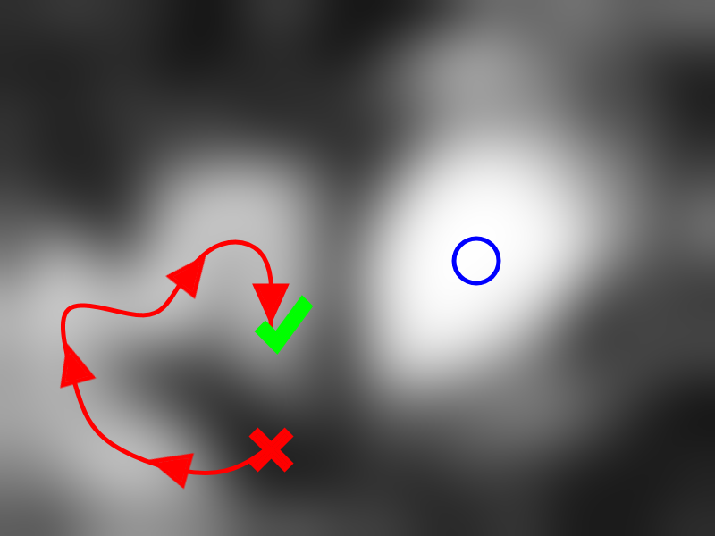
The idea behind the evolutionary approach to find the best solution by searching the same area, and slowly moving along a solution surface to find the minimum error, is that this surface is somewhat smooth. That is, where there is a solution, there is probably a better one nearby, and an even better one near that and so on. This reduces the problem of finding the right combinations of weights from searching within a space with as many dimensions as number of weights, to simply follow a curve from the first guessed weights to a minimum where the curve always points in the direction of the steepest slope (slope towards the lowest mean squared error). The process of finding a local minimum is illustrated in the figure above. The red x is the first random combination of weights. The horizontal and vertical location of the x, is the values of two of the weights. The darkness represents the error. The brighter a point is, the less the error is. The purpose of the algorithm is to find the brightest spot. In the red x, the solution is not optimal, so the weights are changed to approach a brighter (less error) area. The slope is the largest in the direction of the red arrows. Eventually a local minimum is found (the green marker). Unfortunately, this point is not the smallest minimum, that would be the blue circle. For the weights to change so that the blue circle is found, the dark area has to be traversed. The algorithm as it is now, would be reluctant to move across dark areas, so the global minimum would not be found. One approach to reduce this problem, is making multiple attempts at finding minimums, starting at many random points, and then choosing the solution with the smallest error.

Over-fitting
The data set was split into a training data set and a testing data set. When running the neural network fitting algorithm, the training set was used, and it was then tested on the testing set. The reason for the splitting is that if a network of enough complexity is trained for a sufficiently long time on any data set, even if there is no underlying pattern in the data, a neural network will be produced that can make better than random predictions. The reason for this is that the network learns to remember individual combinations of inputs and outputs instead of the trends. When we now try to use this algorithm to make predictions on the test data set, the result will be inaccurate. One way to prevent over-fitting, is to have a lot of data, so that the error will be reduced more if the complexity of the neural network is used to remember trends, rather than individuals. Another method is to reduce the complexity of the network, with the same effect.
As we experimented with different number of nodes and different numbers of layers, we found that we needed about three layers with 9, 5 and 3 layers to predict the prices fairly well on the training set, but the scores for the test set where pretty bad. This meant that a lot of the complexity in the network was spent on remember individuals rather than trends. We found that we needed to reduce the number of hidden layers to zero before the score for the testing set were maximized. Reducing the neural network to a simple linear combination. The mean error for the predictor ended up somewhere round 2500. We also tried to during feature selection only use the 6 most significant features to make predictions. Using less features led to using 3 hidden layers giving better results than zero hidden layers. We believe this is due to the over-fitting being as lesser problem when there is less noise from insignificant features. The error ended up being about the same.

Genetic Algorithm

Implementation of GA class
We decided to make a GA class loosely based on the Travelling Salesman example in the slides about GA. We then adapted the chromosome to fit our purpose of feature selection. A binary string of 0 and 1 representing if a feature is turned on or off. To translate the chromosome we take the features out of the Pandas DataFrame.columns list and store the ones corresponding to the 1s in the chromosome in a list to return.

To get the fitness score of our population we used scikit-learns MLPRegressor and ran a shallow model to predict prices, this we compared to the y_test and calculated a MSE. The MSE we reversed by rooting it and we then take the max score of the population and subtract each score from that. The worst score will then be zero and the better the score the higher the number. We then square root it again to make good scores more similar to eachother and bad scores increasingly bad.

We also implemented the fitness function to make use of the score function in MLPRegressor. This returns a number that can be negative and up to 1. 1 being a perfect score. We minmax scaled this score to get a number we could use for fitness scoring. The fitness score should be a high number for well fit individuals and smaller as they are worse. This is because the fitness score is used for probabilities.

To select parents from the population to the mating pool we use the fitness score of the population and we implemented three different selection algorithms. The default was a pure roulette with fitness score as probability (fitness/fitness.sum()). Then we had a modified roulette with elitism, this subtract the number of individuals reserved for the elite from the roulette selection (population size - elite is roulette selected). And last we implemented a exponential rank selection algorithm. Here we first sort the fitness scores from best to worst and we then based on a constant c between 0 and 1 give them a probability based on rank in the sorted list. Higher the constant less dramatic the fall in score based on location on the rank.

For the evolve function depending on wether there is elitism applied we reserve a certain amount of spots in the new population for the n best individuals from the previous genereation. This number n is based on the percentage of population reserved for the elite. Then the rest of the spots are selected from the mating pool and applied crossover and mutation at set rates.

For crossover we have two different implementations. One is using mating with random mate in mating pool, the other is a sequenced coupling of the parents in the mating pool. The former can mate with the same individuals more then once because the selection is random. The crossover method itself is also two different implementations, the default is multipoint crossover with random locations of the the points and the other is uniform method which generates a list of boolean values deciding which of the genes in the chromosome goes to which child.

Mutation is implemented so that it generates a vector of boolean values with True/False acording to mutation rates. The vector is then logically xor'ed with the child creating the mutations.

The GA loop
The GA needs to be run in a loop for n_generations. In this loop the populations chromosomes is first translated into features. Then we score the population using the fitness function. Parents are then selected for the mating pool based on the fitness scores and the population evolves. Repeat for n_generations. For each generation we store the best scoring individuals MSE score, the feature selections and predictions in a list outside the loop for visualization of the evolution.

Problem, parameter values, what to set?
The GA can be set up with many parameter values that all affect the evolution in different ways. What initial feature activation rate should be set? Should there be high or low crossover rates. What mutation rate should we use and what parameters affect other parameters? These were questions we asked early and we tried to come up with some solutions other then just randomly trying different settings.

Parameter sweeps
The first way of attacking the parameter settings problem was to do basic sweeps of parameter value ranges. We first set a common baseline of parameter values and then systematicly changed one and one parameters value from a given range. This produced a lot of data that we then put together into a DataFrame with multiindex with hierarchy: Parameter, Parameter Value and Generation.
As said this produced a lot of data and we thought it tough to really get any sense of it. But we did get a lot of feature selections and we did a heatmap of most common features appearing together wich gave some good insights into what features were central.

Meta-GA
Second way of attacking the problem with parameters was to use the same method we were using for the feature selection, but now for the parameter values. We made a second implementation of the GA class with adapted chromosome, fitness function and mutation implementation. The population would then be consisting of feature selection GAs each set with different parameter values. The fitness score is based upon the final MAPE score of the feature selection GA and mutation is done within the parameter ranges.
The way we implemented the new chromosome was to give the meta GA a list of np.arrays of parameter value ranges. This lists indexes is set to each parameter. A chromosome is then built up of indexes in the corresponding parameter value range np.array. This way a population can be set up with many different combinations of parameter values and with evolution good combinations would prevail.
This is probably the best way of deciding on parameter values, but it is very time consuming and we did not have the time to do a proper run of this method. But the implementation works and just needs someone who have a couple days worth of computing time to run it. We ran it with a small population and few generations just to get some numbers.

Conclusion
Our goal was to find the best predictive features of the houses prices. We hoped that by removing noise (removing unnesesary features), we could reduce the overall mean absolute percentage error (MAPE) score, due to a reduction in overfitting. Without feature selection, we got a score of 8%. With feature selection, we got 8%. Reducing the number of feature increased the error. The number of features we ended up with is around 40. These are probably the best combination of features for predicting house prices. The reason the score did not improve, might be due to some of the removed features, might still have a vague predictive power, and this loss in information cancel the reduced overfitting.

Sources
[1]: https://www.youtube.com/watch?v=aircAruvnKk&list=PLZHQObOWTQDNU6R1_67000Dx_ZCJB-3pi
[2]: https://en.wikipedia.org/wiki/Rectifier_(neural_networks)
[3]: https:/https://www.kaggle.com/datalana/data-cleansing-with-ames-housing-dataset /www.kaggle.com/datalana/data-cleansing-with-ames-housing-dataset

Applying small mutations and do error testing to see if the error is smaller.
Combination of values for the weights that minimizes the error.
The solution surface is a surface of the mean square error function where the weights are the variables and the data sets are parameters.

