Advisor orchestration — sequence flows, runtime model, and deployment options
This document summarizes how the application behaves end-to-end, how it should run in production (especially scheduling), and how Railway compares to AWS for hosting this workload.

1. Architecture overview
The service is a FastAPI application (main.py) that orchestrates:
- MongoDB (shared): advisors, yesterday’s calls, NAC feedback, coaching payloads.
- Supabase (per concept): separate projects for People Manager vs T&B — users/meetings lookups and daily_coach_tracking persistence.
- VAPI: outbound voice calls with daily_payload in assistant overrides.
- OpenAI: recall-time classification of transcript vs voicemail vs no-response.
Scheduling is handled by APScheduler inside the FastAPI lifespan when ENABLE_SCHEDULER is enabled. Alternatively, operators can trigger the same pipelines via HTTP (POST /run-all, /run/{concept}, etc.).

2. Sequence diagrams

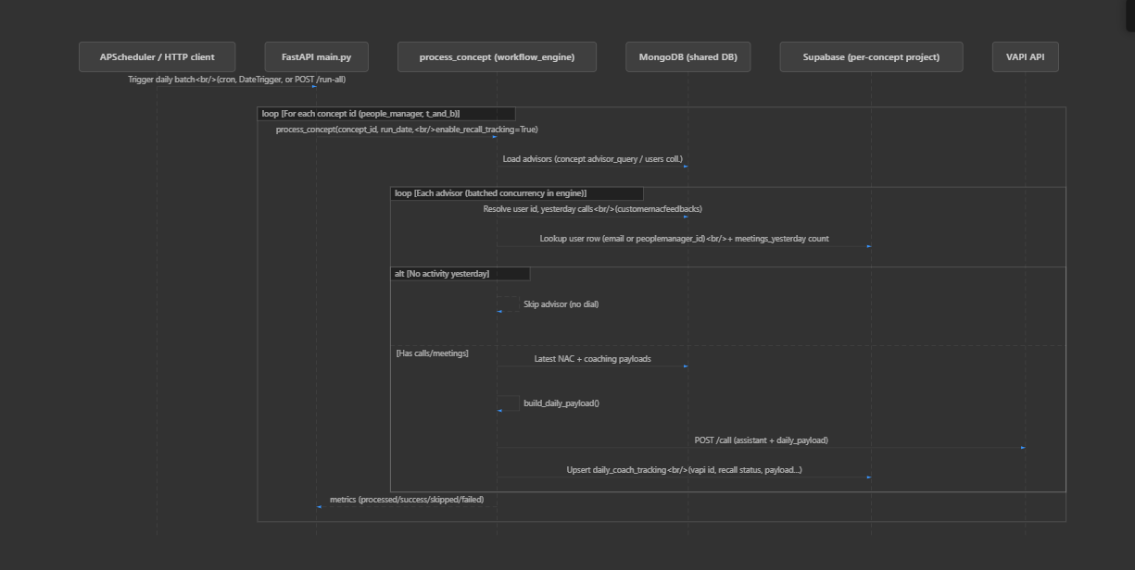2.1 Daily batch (all concepts)
Triggered by:
- Cron (DAILY_CRON) or one-shot delay (SCHEDULER_DAILY_FIRST_RUN_DELAY_SECONDS), or
- HTTP POST /run-all / concept routes (same underlying workflow).
(Diagram / code)
sequenceDiagram
autonumber
participant Sched as APScheduler / HTTP client
participant Main as FastAPI main.py
participant PC as process_concept (workflow_engine)
participant Mongo as MongoDB (shared DB)
participant SB as Supabase (per-concept project)
participant VAPI as VAPI API

Sched->>Main: Daily trigger (cron / date / POST)
loop For each concept (e.g. people_manager, t_and_b)
Main->>PC: process_concept(concept_id, run_date, enable_recall_tracking=True)
PC->>Mongo: Load advisors matching concept
loop Each advisor (engine may batch concurrently)
PC->>Mongo: Yesterday calls + user linkage
PC->>SB: Advisor row + meetings count (concept-specific lookup)
alt No calls/meetings yesterday
PC-->>PC: Skip advisor
else Activity present
PC->>Mongo: Latest NAC + coaching
PC->>PC: build_daily_payload()
PC->>VAPI: POST /call
PC->>SB: Upsert daily_coach_tracking (when recall tracking enabled)
end
end
PC-->>Main: Metrics (processed / success / skipped / failed)
end

2.2 Recall poll (per concept)
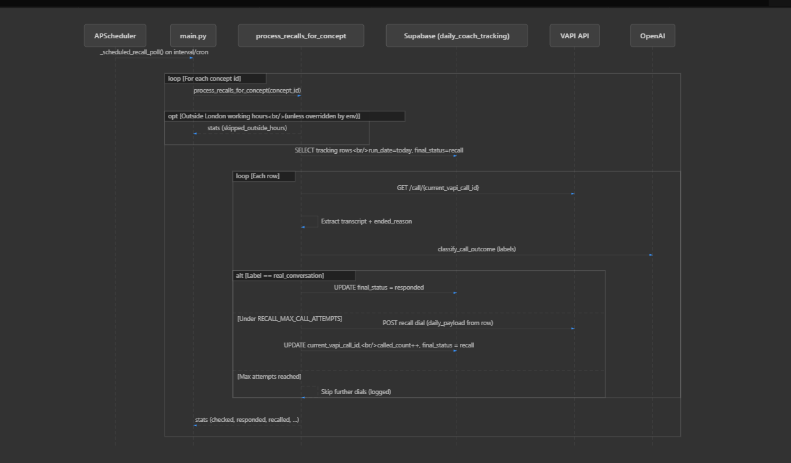
Runs on interval (RECALL_POLL_INTERVAL_SECONDS) or cron (RECALL_POLL_CRON) when interval is unset. Skips outside London working hours unless overridden by environment.
(Diagram / code)
sequenceDiagram
autonumber
participant Sched as APScheduler
participant Main as main.py
participant PR as process_recalls_for_concept
participant SB as Supabase daily_coach_tracking
participant VAPI as VAPI API
participant OAI as OpenAI

Sched->>Main: Recall tick (interval or cron)
loop For each concept id
Main->>PR: process_recalls_for_concept(concept_id)
opt Outside London hours (unless env override)
PR-->>Main: Skip poll (logged)
end
PR->>SB: Rows for today with final_status = recall
loop Each row
PR->>VAPI: GET /call/{current_vapi_call_id}
PR->>PR: Extract transcript + ended_reason
PR->>OAI: classify_call_outcome
alt real_conversation
PR->>SB: UPDATE final_status = responded
else Under max recall attempts
PR->>VAPI: POST recall dial
PR->>SB: UPDATE new call id, called_count, recall state
else Max attempts
PR-->>PR: No further dial (logged)
end
end
PR-->>Main: Stats (checked, responded, recalled, failed, …)
end

3. How the application should run (production checklist)

3.1 Process model
- Use one long-lived process (container/VM) with the scheduler enabled, or split later into “API-only” vs “scheduler worker” replicas.
- Do not run multiple identical replicas all with ENABLE_SCHEDULER=1 without coordination: each replica would register the same APScheduler jobs and can duplicate daily runs and recall polls.
Recommended: a single replica (or explicitly one “scheduler” service) running the full app with ENABLE_SCHEDULER=1.

3.2 Environment (example for 09:00 London daily + recall every 30 minutes)
Variable | Example | Notes
ENABLE_SCHEDULER | 1 | Starts APScheduler in lifespan
SCHEDULER_TZ | Europe/London | Timezone for cron triggers
DAILY_CRON | 0 9 * * * | Five fields: minute hour day month day-of-week — 09:00 London
RECALL_POLL_INTERVAL_SECONDS | 1800 | 30 minutes (overrides cron if set)
Or RECALL_POLL_CRON | */30 * * * * | Only used when interval is not set
Optional: SCHEDULER_SKIP_DAILY_CRON, SCHEDULER_DAILY_FIRST_RUN_DELAY_SECONDS (tests or delayed first batch), RECALL_MAX_CALL_ATTEMPTS, London hours override for recall.

3.3 Secrets and multi-tenant data
- Per concept Supabase: PM_SUPABASE_*, TB_SUPABASE_* (URLs and service_role keys).
- Server-side automation must use service_role for the relevant project — not the publishable anon key — or writes to daily_coach_tracking can fail with permission errors.
- VAPI, OpenAI, Mongo URIs — store in platform secret manager / env, not in images.

3.4 OS-level cron vs in-app scheduler
You typically do not need Linux cron in addition to APScheduler for the same jobs: the app already schedules daily and recall intervals. External cron is useful only if you remove in-process scheduling and trigger HTTP endpoints instead (different architecture).

4. Railway vs AWS (for this app)
Neither platform is universally “better”; the choice depends on operational maturity and existing cloud footprint.
Dimension | Railway | AWS (e.g. ECS Fargate, EC2, EventBridge)
Time to first deploy | Very fast: connect repo, env vars, deploy | Slower: accounts, VPC, IAM, pipelines, load balancers
Operational complexity | Low: PaaS manages much of runtime | Higher: you own more of networking, scaling, IAM
Fit for this scheduler | Good: run one always-on web/worker service, ENABLE_SCHEDULER=1 | Good: run one task/service for scheduler; same caveats on replica count
Scaling HTTP | Add replicas carefully if scheduler runs on same service | Same; often split API (N replicas) vs scheduler (1 replica)
Enterprise / compliance | Adequate for many teams; check policies | Strong: VPC, private subnets, KMS, audit, enterprise support
Cost predictability | Simple plans; watch always-on usage | Fine-grained; can be cheaper at scale with rightsizing
Integrations | Straightforward for small/medium stacks | Deep: RDS, Secrets Manager, EventBridge, Lambda, etc.
Practical guidance
- Choose Railway (or similar PaaS: Fly.io, Render) if the priority is minimum friction and a single-region deployment with one instance running the scheduler.
- Choose AWS if you already standardize on AWS, need VPC isolation, private database connectivity, strict IAM, or expect to grow into EventBridge-triggered jobs and multi-service layouts.
For 09:00 daily + 30-minute recall, both platforms only require a stable 24/7 container and correct environment variables; the scheduling behavior is defined by the application, not by the host brand.

5. Document maintenance
- When main.py or workflow_engine.py changes job registration or recall rules, update Section 2 and Section 3 accordingly.
- Sequence diagrams are illustrative; refer to source for exact field names and edge cases (e.g. max recall attempts, London hours gate).

