# About Dataset

* This bar plot illustrates the distribution of Airbnb user destinations, namely: 'US', 'FR', 'CA', 'GB', 'ES', 'IT', 'PT', 'NL','DE', 'AU', and 'NDF' (no destination found).
* The analysis of the bar plot indicates that a significant portion of users have not yet made any bookings. Among the users who have made bookings, the 'US' (United States) emerges as the most popular destination. This observation can be attributed to the fact that the United States has the highest number of listings available on Airbnb compared to other destinations.

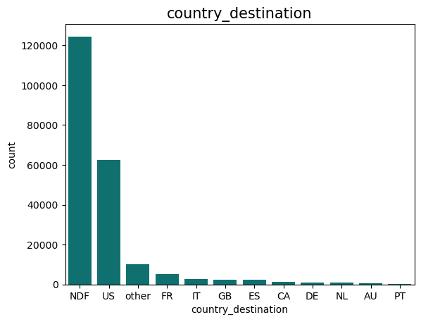

* This graph represents the gender distribution of users. It is evident from the plot that a lot of users have not specified their gender during the signup process. This absence of gender specification may be attributed to various factors, such as user privacy preferences or a desire to keep personal information undisclosed

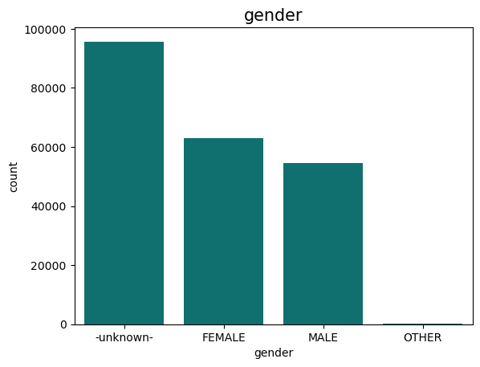

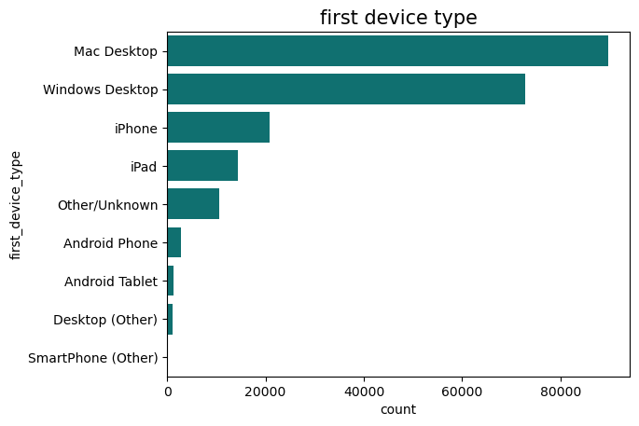

* This graph illustrates the distribution of devices that users have used for signing up. It is notable that the majority of them have used Mac the Windows Desktop. Following closely in popularity are iPhone and iPad devices.
* The graph represents the age distribution of users, giving a normal result where the majority of users fall within the age range of 18 to 50 years. This age distribution aligns with general trends in online services, as individuals within this age range are more likely to be active and engaged in digital platforms such as airbnb.

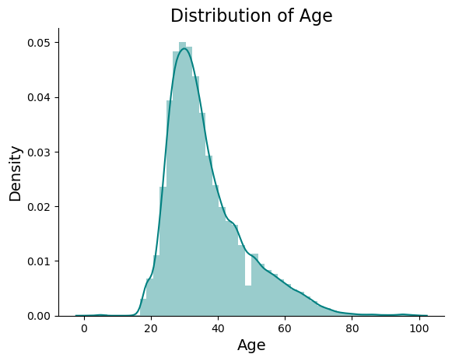

* The histogram represents the browser preferences of users during the signup process, revealing the prevalence the well-known browser such as Chrome, Safari, and Firefox.

