# About Dataset

* This bar plot visualizes the distribution of destinations chosen by Airbnb users, including 'US', 'FR', 'CA', 'GB', 'ES', 'IT', 'PT', 'NL', 'DE', 'AU', and 'NDF' (representing no destination found).
* The analysis of this plot reveals two main insights. Firstly, a significant portion of users have yet to finalize their bookings, as indicated by the 'NDF' category. Secondly, among users who have made bookings, the 'US' (United States) stands out as the most favored destination. This trend is likely due to the United States having the highest number of available listings on Airbnb compared to other destinations.

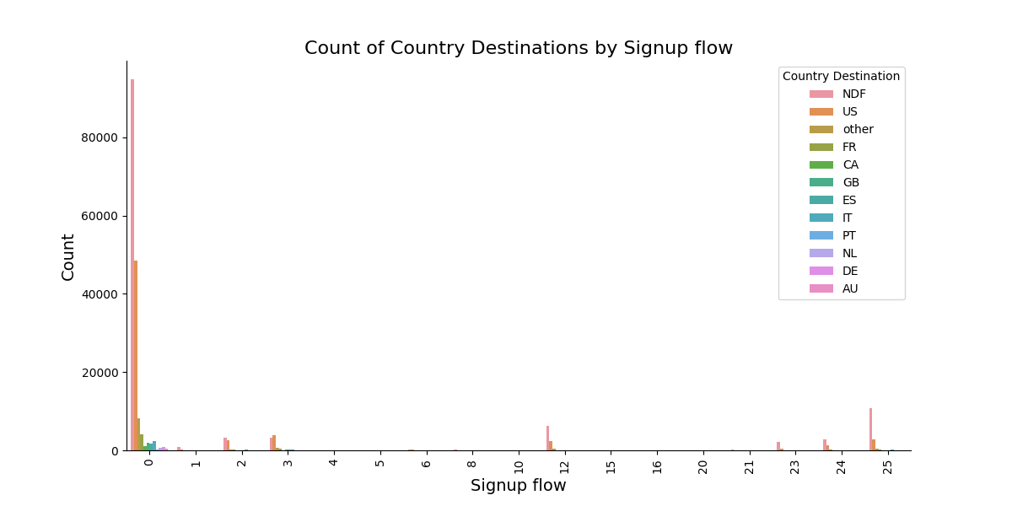

* This graph produces a bar chart depicting the count of destinations for training users based on different enrollment flows. Each bar on the chart represents the number of users who have opted for a specific signup method, with each bar section colored according to their respective country destination. This visualization enables the observation of destination patterns influenced by choices in enrollment flows.

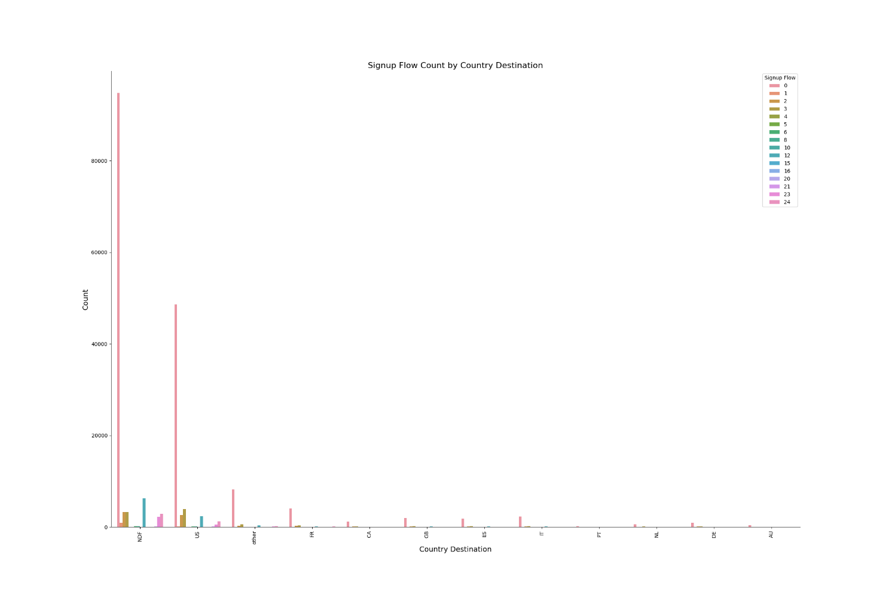

* The graph generates a detailed visualization that highlights the count of different signup flows for various country destinations, taking into consideration a filtering condition. Specifically, the code filters out data where the signup flow value is less than 25. Each bar in the plot indicates the number of users linked to a specific country destination. These bars are color-coded to reflect different signup flows. By incorporating this filtering condition, the visualization provides insights into the distribution of signup flows across diverse country destinations, while focusing on a subset of signup flow values.

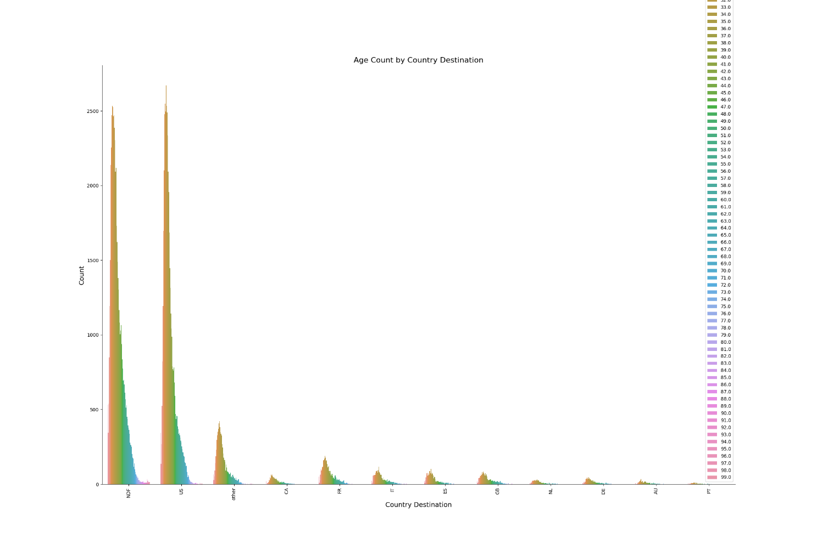

* The graph creates a detailed visualization that displays the count of users' age ranges linked to diverse country destinations. It ensures that only realistic age values, specifically those greater than 18 and less than 100, are considered. Each bar within the graph corresponds to the quantity of users belonging to a specific age group. The bars are color-coded to differentiate between different age ranges. This visualization facilitates an understanding of how age distributions are distributed across various country destinations, while adhering to the stipulated age range constraint.