CMPS 403 L01 Project Report

Fall 2025

Yahya Taha – 202103476
Mahmoud Al-Qudeimat – 202204636
Ayoub Abdoun – 202111262
Omar Qutb – 202106170

Project Part I – Multi-Agent Search

Q1: Minimax
python pacman.py -p MinimaxAgent -l smallClassic -a depth=1


python pacman.py -p MinimaxAgent -l minimaxClassic -a depth=4


python pacman.py -p MinimaxAgent -l trappedClassic -a depth=3


Q2: Expectimax
python pacman.py -p ExpectimaxAgent -l smallClassic -a depth=1


python pacman.py -p ExpectimaxAgent -l minimaxClassic -a depth=2


python pacman.py -p ExpectimaxAgent -l minimaxClassic -a depth=3


python pacman.py -p ExpectimaxAgent -l trappedClassic -a depth=3 -q -n 10
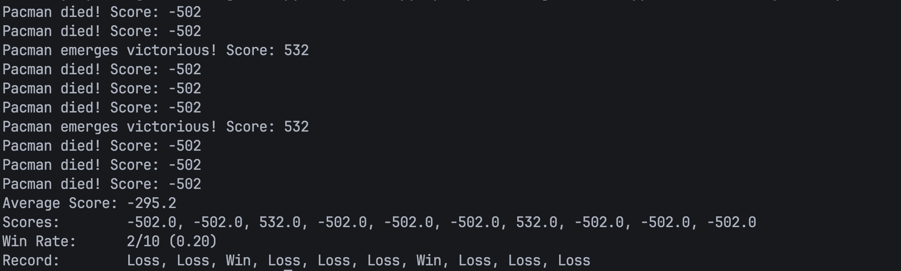

python pacman.py -p AlphaBetaAgent -l trappedClassic -a depth=3 -q -n 10
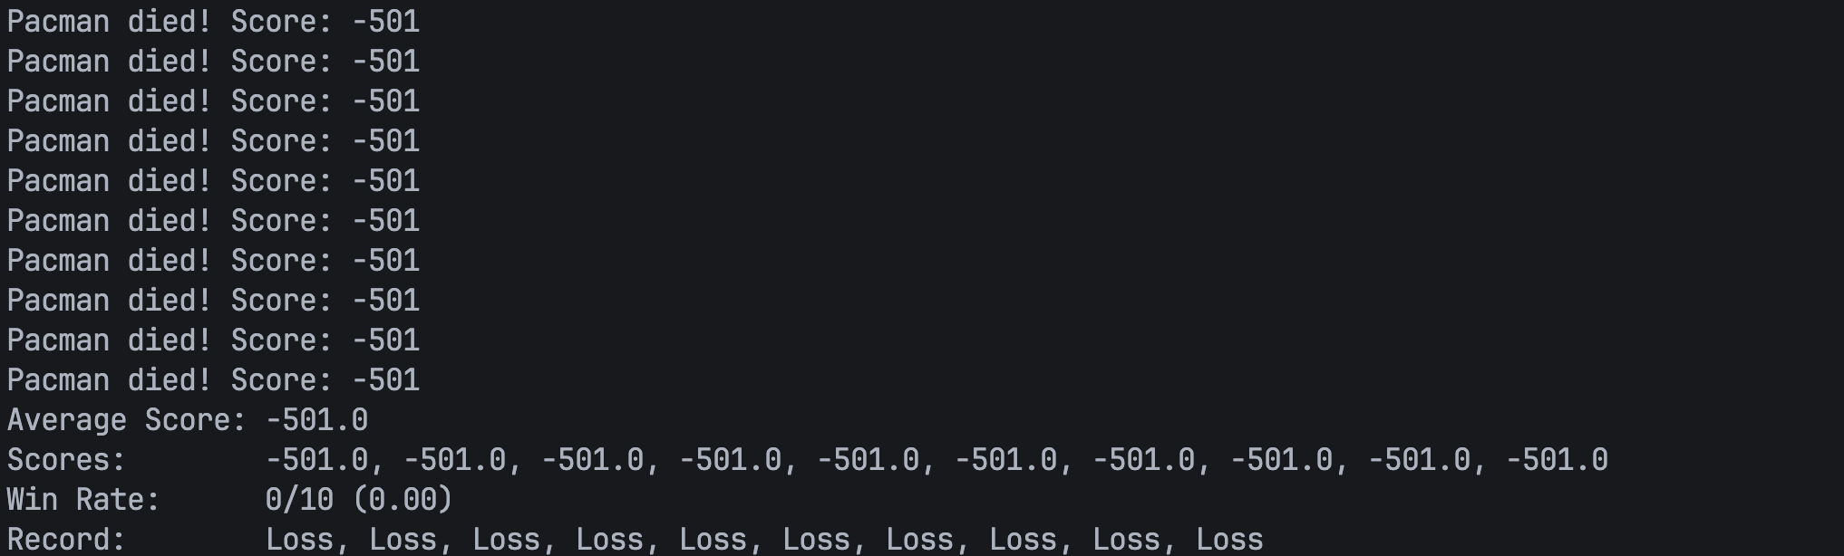

Project Part II – Solving the N-Queens Problem Using Constraint Satisfaction Techniques
Run: python nQueensCSPs.py 4 8 16 32

Problem Formulation as a CSP
We formulate the N-Queens problem as a Constraint Satisfaction Problem (CSP).
Variables:
We define one variable per column of the board: X0, X1, ..., XN−1, where Xc is the row index of the queen in column c.
Domains:
- Each variable can take any valid row index:
- D(Xc) = {0, 1, ..., N−1} for all columns.
- This ensures that each column contains exactly one queen.
Constraints:
- For any two columns i ≠ j with rows ri, rj:
- Row constraint: ri ≠ rj
- Diagonal constraint: |ri − rj| ≠ |i − j|
A complete assignment is a valid solution if and only if all binary constraints between variable pairs are satisfied.

Description of Each Method
1. Naïve Enumeration
Tries all N^N possible assignments. No pruning. Checks conflicts only after completing a full board. Simple but extremely slow for larger N.
2. Backtracking + Forward Checking (MRV)
Uses backtracking search with Minimum Remaining Values (MRV) to choose the most constrained column first. Forward checking removes inconsistent rows after each assignment. Highly efficient for small and medium N.
3. Backtracking + AC-3 (MRV)
Extends backtracking with arc consistency (AC-3). After assigning a queen, AC-3 enforces stronger consistency across domains. Fewer explored nodes but more expensive per step.
4. Min-Conflicts Local Search
Starts with a random full assignment and repeatedly moves a conflicted queen to reduce conflicts. Extremely fast and scales well, but incomplete—does not guarantee a solution within a fixed number of steps.

Performance Comparison

Runtime (seconds)
N | Naïve | BT + FC | BT + AC-3 | Min-Conflicts
4 | 0.000140 | 0.000081 | 0.000116 | 0.000021
8 | 6.649396 | 0.000729 | 0.001227 | 0.000529
16 | Skipped | 0.000420 | 0.006324 | 0.001458
32 | Skipped | 0.001982 | Skipped | 0.008460

Explored Nodes
N | Naïve | BT + FC | BT + AC-3 | Min-Conflicts
4 | 340 | 8 | 5 | 12
8 | 19,173,960 | 75 | 20 | 488
16 | Skipped | 44 | 21 | 720
32 | Skipped | 89 | Skipped | 2,080

Discussion of Advantages and Limitations
Naïve Enumeration:
- Advantage: Very simple and finds all solutions.
- Limitation: Quickly becomes unusable (N=8 takes ~6.65 seconds).
Backtracking + Forward Checking:
- Advantage: Strong pruning and low runtime, complete search.
- Limitation: Only partial consistency; still scales with complexity.
Backtracking + AC-3:
- Advantage: Strongest pruning and few explored nodes.
- Limitation: AC-3 overhead makes it slower overall for mid-sized N.
Min-Conflicts:
- Advantage: Fastest method, excellent scalability even at N=32.
- Limitation: Incomplete—no guarantee of solution if step limit too small.

