Patent Novelty Search
LangGraph Multi-Agent Architecture
Technical Migration Plan & Proposal
Prepared for the project team • 18 July 2026

1. Executive Summary
We propose re-architecting the patent novelty-search backend from a single linear pipeline into a modular, multi-agent workflow orchestrated with LangGraph. The new design adds semantic (vector) search via Qdrant, reciprocal-rank result fusion, and an LLM validation gate — while continuing to use our existing Llama LLM. A PostgreSQL layer introduces caching and durable search history.
Two strict product decisions shape this design. First, a zero-tolerance failure policy: the system must never present fabricated or degraded-but-unlabeled output as if it were genuine — any component failure surfaces as a clear error instead. Second, USPTO is out of scope, since we do not have access to its API; EPO and Google Patents remain the two data sources.
The migration is staged and feature-flagged, so the current product keeps working at every step and the user-facing live-progress experience is preserved unchanged. This document summarizes the target architecture, the key technical decisions, and a four-phase delivery roadmap the team can review and approve.

2. Current State — Why Change
Today a single linear function orchestrates four steps — understand → keyword search → rank → explain — streaming progress to the UI over Server-Sent Events. It works, but it has structural limits:
- Shallow matching: ranking is lexical (TF-IDF) only, so it misses semantically similar prior art that uses different wording.
- No memory: every search re-fetches live from external APIs; nothing is cached or retained, and search history is lost on refresh.
- Monolithic: a hard-coded control flow makes it hard to add, reorder, parallelize, or gate steps.
- Silent degradation: when a step fails today, the system quietly substitutes placeholder output (a generic explanation, a fabricated score) instead of surfacing the failure.
- Data sources: only Google Patents and EPO are wired; USPTO was evaluated but is not available to us (no API access).

3. Target Architecture

3.1 System Layers
A clean separation of concerns from the user interface down to the external patent sources:
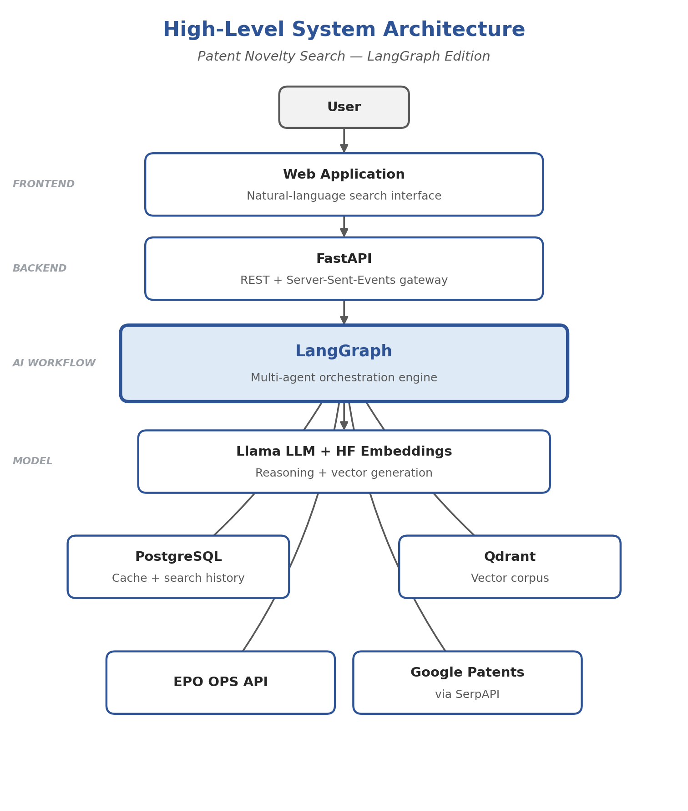
Figure 1. High-level system architecture — request path (top) and the layers LangGraph coordinates (bottom).
Layer | Technology | Responsibility
Frontend | React + Vite | Natural-language search UI, live progress, report
Backend / API | FastAPI | REST + Server-Sent-Events streaming gateway
AI Workflow | LangGraph | Multi-agent orchestration over a shared state
Model | Llama 3.1 (LLM) + HuggingFace embeddings | Reasoning + vector generation
Persistence | PostgreSQL + Qdrant | Relational cache / history + vector corpus
Data Sources | EPO + Google Patents | Live patent retrieval

3.2 Multi-Agent Workflow
Nine cooperating agents read from and write to a shared graph state. Keyword and semantic search run in parallel and converge at fusion:
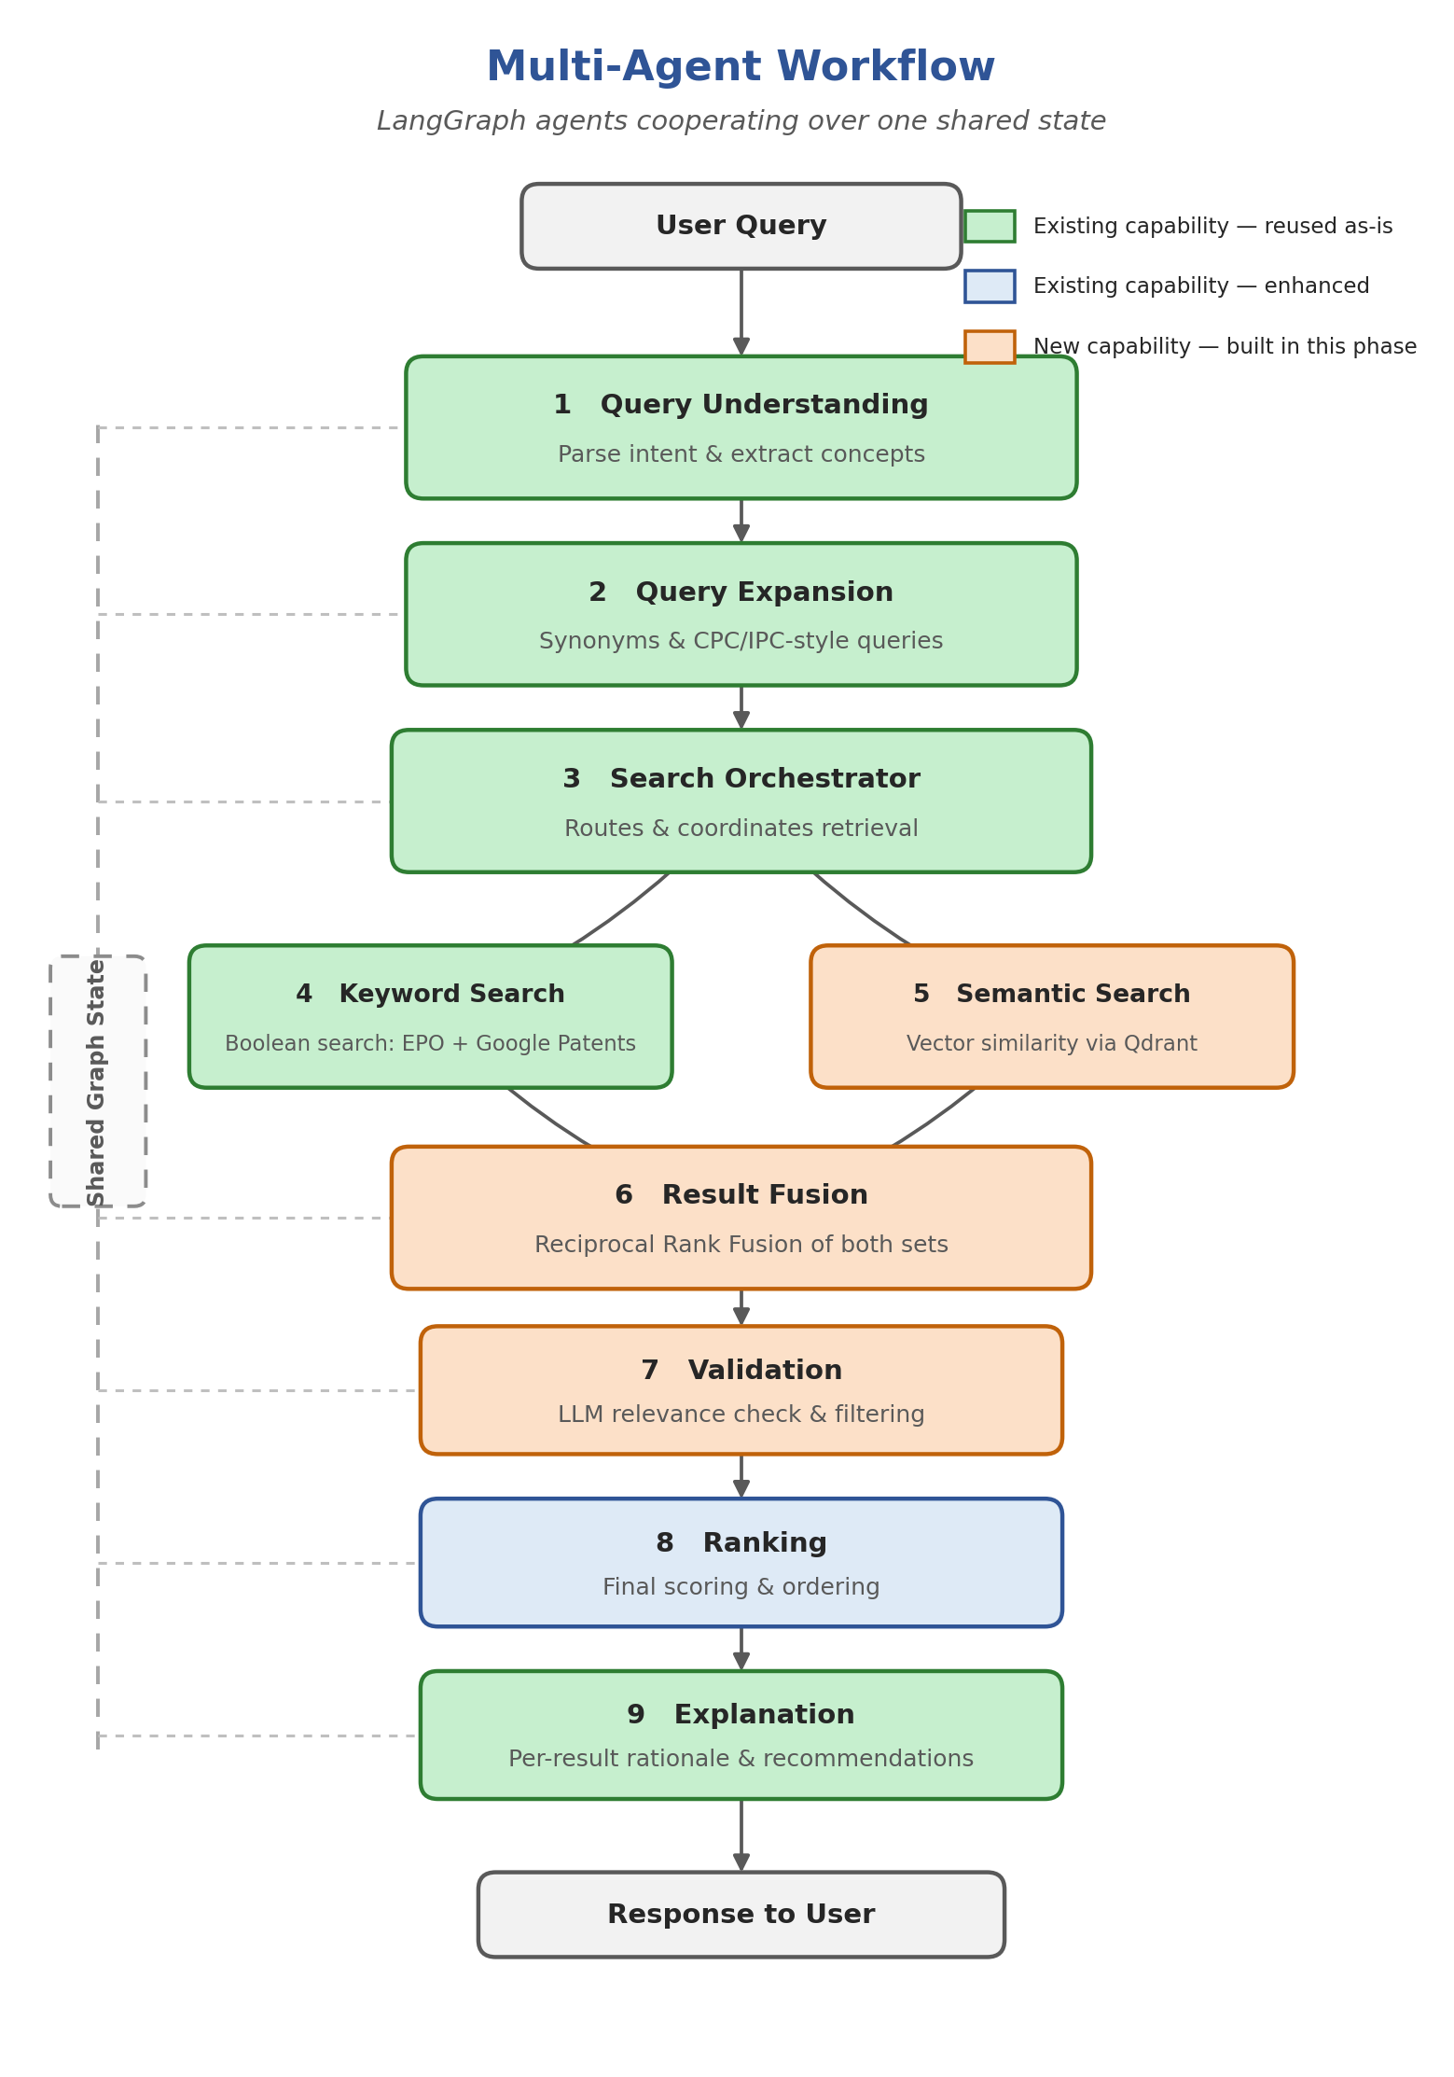
Figure 2. The nine-agent LangGraph workflow. Green = reused as-is, blue = reused and enhanced, orange = newly built.
# | Agent | Role | Status
1 | Query Understanding | Parse intent, extract technical concepts | Exists (Llama)
2 | Query Expansion | Generate synonyms and alternate queries | Exists (Llama)
3 | Search Orchestrator | Route and coordinate retrieval | Exists
4 | Keyword Search | Boolean search via EPO + Google Patents | Exists
5 | Semantic Search | Vector similarity via Qdrant | New
6 | Result Fusion | Reciprocal Rank Fusion of both result sets | New
7 | Validation | LLM relevance check and filtering | New
8 | Ranking | Final scoring and ordering | Exists → embeddings
9 | Explanation | Per-result rationale + recommendations | Exists (Llama)

Green = already implemented and reused. Orange = new build. Blue = existing, enhanced with embeddings.

4. Data Integrity — Zero-Tolerance Failure Policy
This is a strict constraint on every phase of this migration, not a suggestion: no agent may ever invent a result. If an agent cannot produce a genuine output, the request fails with a clear error rather than continuing on fabricated or degraded data. We would rather show the user nothing than show them something untrue.
Concretely, this removes behaviors that exist in the system today:
What's being removed today | Replaced with
A fabricated similarity score is shown when the real computed similarity is exactly zero | The true score is always shown, however low — never an invented number
A generic placeholder explanation and canned recommendations are shown when the AI call fails | The request fails with a clear error instead of a fake explanation
A crude substitute search query is used silently when query understanding fails | The request fails with a clear error instead of proceeding on a guess
The search continues with partial results if one data source fails while another succeeds | The request fails with a clear error rather than silently returning fewer results than intended

One consequence worth flagging to the team: in the migration's first phase, “parity” between the old and new pipeline applies to the happy path only. The new pipeline is intentionally stricter on failure than the pipeline it replaces — that strictness is the point of this change, not a regression.

5. Key Technical Decisions
Decision | Choice | Rationale
LLM | Keep Llama 3.1 (via HF router) | Proven and already integrated; no vendor switch
Embeddings | HuggingFace-hosted model (same token) | Adds semantic search with no new infra or keys
Vector corpus | Grow Qdrant from live search results | Fits the current live-fetch model; no bulk ingestion
Rollout | Graph-first, behind a feature flag | De-risks; legacy pipeline stays available
Failure handling | Zero tolerance — any failure errors the request | No illusion results; see Section 4
Data sources | EPO + Google Patents only (USPTO dropped) | No USPTO API access is available to us
Gemini (initial sketch) | Not adopted | Team standardizes on Llama; avoids extra cloud dependency

6. What We Reuse vs. Build
Most of the reasoning layer already exists and is reused as-is; the new work is concentrated in retrieval intelligence and persistence. A few reused components are also being tightened up to remove the fallback behavior described in Section 4.
Reuse — already built | Build — new
Llama LLM client | LangGraph StateGraph + agent nodes
Query understanding & expansion | Semantic Search Agent (Qdrant)
Keyword search (Google, EPO) | HuggingFace embeddings client
Lexical ranking (Phase-1 baseline) | Reciprocal Rank Fusion
Explanation & recommendations *(fallback removed)* | Validation Agent
Live SSE streaming transport | PostgreSQL persistence + history API

7. Phased Delivery Roadmap
Each phase is independently shippable. Phase 1 is the recommended first milestone: it delivers the new engine at behavioral parity, with no user-visible change and instant rollback via the feature flag.

Phase 0 — Foundations
- Goal: Prepare the ground without changing behavior.
- Scope: Add LangGraph and Qdrant client dependencies, configuration and the pipeline feature flag, and local Docker for Qdrant + PostgreSQL.
- Outcome: Environment ready; nothing user-facing changes.

Phase 1 — LangGraph Engine (parity) ★ ship first
- Goal: Re-express the current pipeline as a LangGraph multi-agent graph using today's tools, and remove the fallback behavior described in Section 4.
- Scope: Wrap understanding, keyword search, ranking and explanation as graph nodes; both pipelines emit identical streaming events on the happy path; switch via the flag.
- Outcome: Same product on success, stricter and more honest on failure, new modular engine.

Phase 2 — PostgreSQL Persistence
- Goal: Give the system memory.
- Scope: Cache fetched patents and persist each search run and its report.
- Outcome: Faster repeat searches and durable history that survives refresh.

Phase 3 — Semantic Intelligence
- Goal: Deliver the full multi-agent experience and materially better results.
- Scope: HuggingFace embeddings + Qdrant semantic search (corpus grows per search), Reciprocal Rank Fusion, LLM Validation gate, and embedding-based ranking — all governed by the same zero-tolerance failure policy.
- Outcome: Higher recall and precision, plus the complete nine-agent workflow.

Roadmap at a Glance
Phase | Focus | User-visible change | Risk
0 | Foundations | None | Low
1 | LangGraph engine (parity + strict failures) | None on success; clear errors replace silent fallback | Low
2 | PostgreSQL persistence | Durable history, faster repeats | Medium
3 | Semantic + Fusion + Validation | Better results, richer progress | Medium

8. Critical Constraint — Preserving the Live Experience
The frontend consumes a live Server-Sent-Events stream that drives a progress checklist and the final report. The migration preserves this contract exactly. In Phase 1 the legacy and LangGraph pipelines emit byte-identical events on the happy path, so the UI needs zero changes and we can flip between them via the feature flag. Only in Phase 3 do we extend the progress vocabulary to surface the new agents, updating the UI in lockstep. On failure, the new pipeline diverges from legacy by design (Section 4): it emits a clean error event rather than legacy's silent fallback.

9. Risks & Mitigations
Risk | Mitigation
Behavior drift between old and new pipeline | Phase-1 parity test diffs streaming output on the happy path; feature flag enables instant rollback
A single external dependency failure (LLM, one search provider, Qdrant, embeddings) now fails the whole request instead of degrading | This is the intended effect of the zero-tolerance policy; mitigated by monitoring/alerting on error rates and by each dependency being independently reliable in practice
Embedding API latency or rate limits | Cache embeddings in PostgreSQL; batch requests to reduce call volume; on failure the request errors cleanly rather than degrading silently
Qdrant or database unavailable | Request fails cleanly with a clear error; services are containerized for local dev to minimize this in practice
Scope creep | Strict phase gates; each phase independently shippable
Cost of hosted embeddings | Reuse the existing HuggingFace token; cache to avoid re-embedding

10. Verification — Definition of Done
- Parity: identical streaming output between the legacy and LangGraph pipelines on a sample invention's happy path.
- End-to-end: the UI progress checklist advances and the report renders correctly end to end.
- Semantic: a repeated query retrieves patents indexed by earlier searches (corpus growth); fused ordering differs from keyword-only.
- Persistence: search history survives a backend restart.
- Zero-tolerance: an LLM failure, a single search-provider failure, a Qdrant/embeddings outage, and a zero-similarity result each produce one clean error or a truthful score — never fabricated output (Section 4).
- Automated: automated tests cover node logic, fusion math, and the embeddings client, including failure-path tests for every case above.

11. Next Steps
- approve the phased approach, with Phase 1 as the first deliverable.
- provision local Qdrant + PostgreSQL (Docker) and confirm the HuggingFace embedding model choice.
- begin Phase 0 / Phase 1 implementation.

Appendix A — Architecture Diagrams (Full Size)
Larger versions of Figures 1 and 2 for printing or projecting during team discussion.

Diagram 1 — High-Level System Architecture
Figure 1 (full size). High-level system architecture.

Diagram 2 — Multi-Agent Workflow
Figure 2 (full size). The nine-agent LangGraph workflow.

