**Project 2:**

**The Wumpus game.**

Team Members: Ayoub Maimmadi, Hamza Ammad

1. **Room(X,Y)** indicates the room in position (x,y). We indicated the room locations.

b. **Breeze(Room(X,Y))** there is a breeze in room Room(X,Y). We indicated the actual Breezes room locations in the knowledge base

 c. **Pit((Room(X,Y))** there is a pit in a room(A,B) adjacent to Room(X,Y) where Room(X,Y) is

abreezes’

d. **Wumpus(R(X,Y)** the Wumpus in a room R(X,Y) adjacent to stench in room(A,B)



e. **Stench(Room(X,Y))** room R(X,Y) stenches in Room(X,Y). We also indicated the stenchs’ room locations in the knowledge base.

we also tried to generate the stench and breeze locations given the pit and Wumpus locations

f. **Gold(Room(X,Y)):** gold locations is indicated as in the same room where glitter is located

g**. adjacent(room(X,Y),room(A,B)):** means room R(X,Y) is adjacent to room R(A,B) . we found an alternative to implement the adjacency between rooms

h. **Safe(R(X,Y)):** to check if a candidate room R(X,Y) to adjacent to a given starting position is safe, meaning there is no Wumpus nor pit in that candidate room.

the implementation of candidate, no_wumpus and no_pit:

i. **GrabGold** is to grab the gold in the indicated current position only if there is gold in that position :

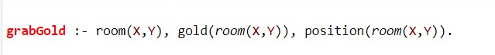

**j. ShootWumpus(R(X,Y)):** shoot the Wumpus in room R(X,Y) only from adjacent rooms: if the current position in an adjacent room of the Wumpus’s position(where there is a stench), hence the agent can shoot the Wumpus.

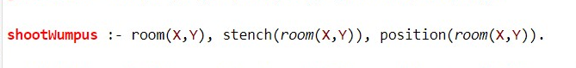

TESTS:

The agent can move to either room(1,2) or room(2,1) given the current position

The agent can grab gold in that current position

The agent can’t gold

The agent is in an adjacent position to shoot the Wumpus given position (1,2)

**PERFORMANCE RATE AND LIMITATIONS :**

ShootWumpus and grabGold have a 100% accuracy with the different parameters used for testing. However, safe position is not really accurate, since it comsiders all positions adjacent to the breeze as pits which not necessarily true. Consequently, it considers room (2,2), (2,4) and (4,2) as pits which is not true, 3/16 positions are wrong.

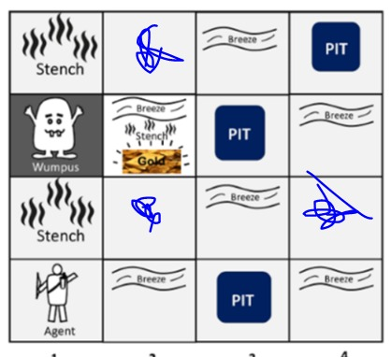

A way to improve this code is through remembering the visited positions, for example when the agent visited the position (1,2) where there is a stench, the agent should record it and hence considering position (2,2) as not a pit since it is adjacent to a breeze.