WGUPS Routing Program
C950 - Data Structures and Algorithms II
Task 2
Student ID: 012114667
Ayoub El Bahi

A. Hash Table
My program uses a custom chaining hash table that I wrote in `hash_table.py`. I did not use any outside library to store the package data. Instead, I created a list of buckets, and each bucket stores a list of `[key, value]` pairs. The key is the package ID, and the value is the full package object.
The `insert()` function takes the package ID as input, calculates the bucket index, and then stores the package in that bucket. If the package ID is already there, the function updates the value. If not, it appends a new pair. This allows the table to handle collisions correctly while keeping the structure simple.
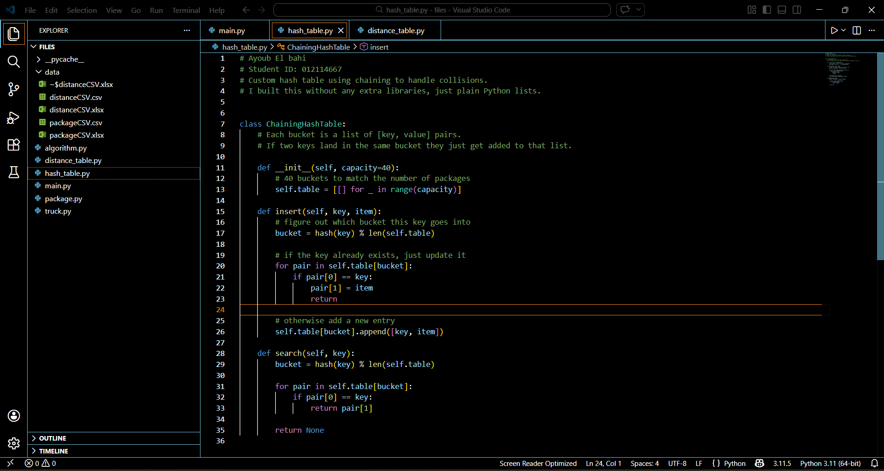
Figure 1. Hash table code (class name: ChainingHashTable).

B. Look-Up Function
The look-up function in my program is the `search()` method in `hash_table.py`, as you can see on A's screenshot. It takes a package ID as input, calculates the correct bucket, and checks the items in that bucket until it finds the matching key. Once the key is found, it returns the package object. The returned object includes all required fields: the delivery address, delivery city, delivery zip code, delivery deadline, package weight, delivery status, and delivery time. I use this function in several places in the program, including the delivery algorithm and the user menu, so the same lookup logic is reused throughout the solution.

C. Original Program
My solution is organized into separate Python files so each part of the program has one job. `main.py` loads the data, creates the trucks, runs the simulation, and shows the user menu. `hash_table.py` stores the package data. `package.py` holds each package's fields and time-based status logic. `truck.py` stores truck information such as location, mileage, departure time, and packages. `distance_table.py` reads the CSV distance data and returns miles between addresses. `algorithm.py` contains the package delivery algorithm.
The program is original, runs successfully in my testing, and delivers all 40 packages while staying under the 140-mile limit. Based on the completed run that I included in the screenshots (D section), the combined distance traveled by all trucks is about 122.00 miles.

C2. Process and Flow Comments
I included comments across the program to explain both the process and the flow. In `main.py`, I explain why the trucks are loaded the way they are and why Truck 2 leaves later than Truck 1. In `algorithm.py`, I commented on the nearest-neighbor loop, so it is clear how the next package is chosen, how mileage is updated, and how the delivery time is recorded. In `package.py`, I explain the special display logic for package 9. In `distance_table.py`, I explain why the mirrored distance lookup works when one half of the table is blank.
In the Hash table code as shown in section A, comments describe how each bucket holds a list of key-value pairs, and when two keys hash to the same bucket, they simply get added to that list rather than using complex rehashing. The __init__ comment notes that 40 buckets were chosen to match the number of packages, showing intentional design. The insert method comments walk through the three-step process: finding the right bucket with the hash function, checking for an existing key to update it, and adding a new pair when the key isn't found. These comments help explain both the collision handling mechanism and the flow of operations through the hash table.
I tried to keep the comments practical. Instead of commenting on every single line, I focused on the parts that help a reader understand the decisions I made and the order the program follows.

D. Interface
I used a text-based menu because it is simple and easy to understand. The supervisor can choose to view all packages at a specific time, look up one package by ID, view mileage, or exit the program. The menu is direct, and the prompts tell the user exactly what to enter.
When the user chooses the all-packages option, the program prints a table showing the package ID, address, deadline, weight, truck, status, and delivery time. The status is shown as “At Hub”, “En route”, or “Delivered”. When the user chooses the single-package option, the program prints a detailed view for one package with the same required information. The mileage option shows each truck's miles and the overall total.
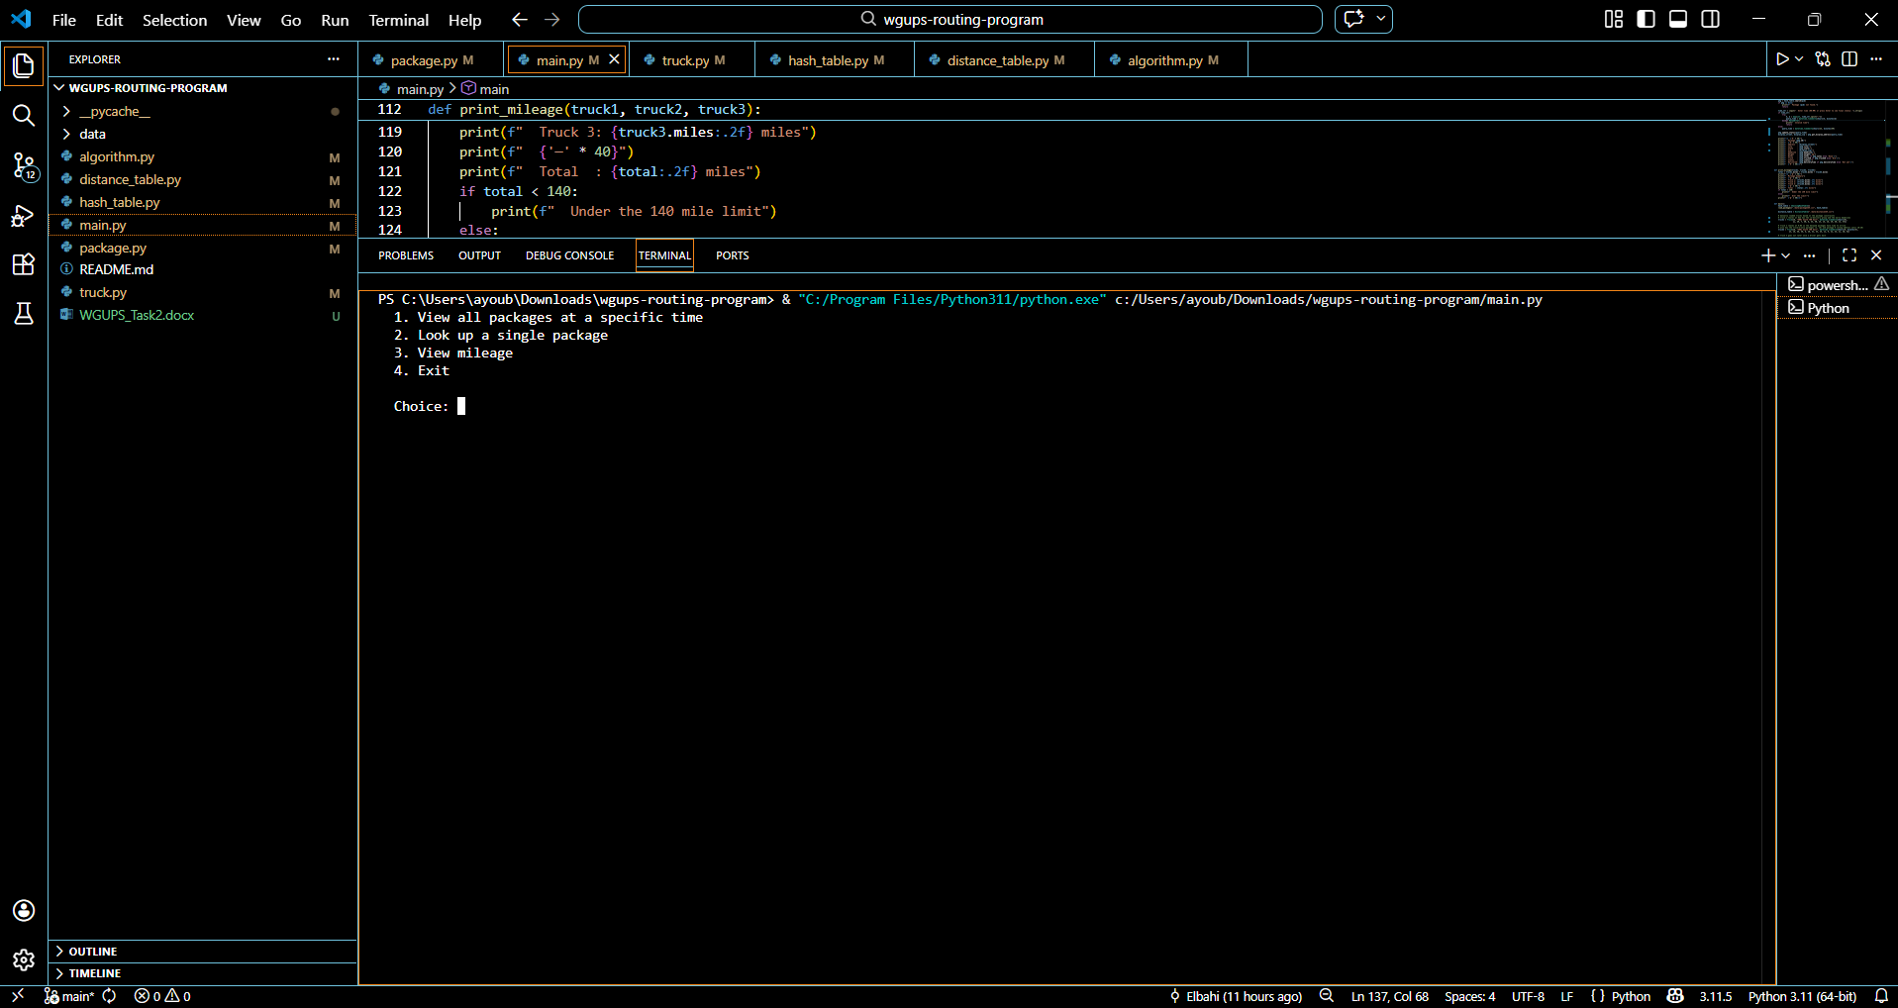
Figure 2. Text-based interface used to check package status and truck mileage.

D1. First Status Check
The screenshot below shows the first required status check taken during the time window between 8:35 a.m. and 9:25 a.m. It shows the package statuses for the trucks during the morning delivery period.
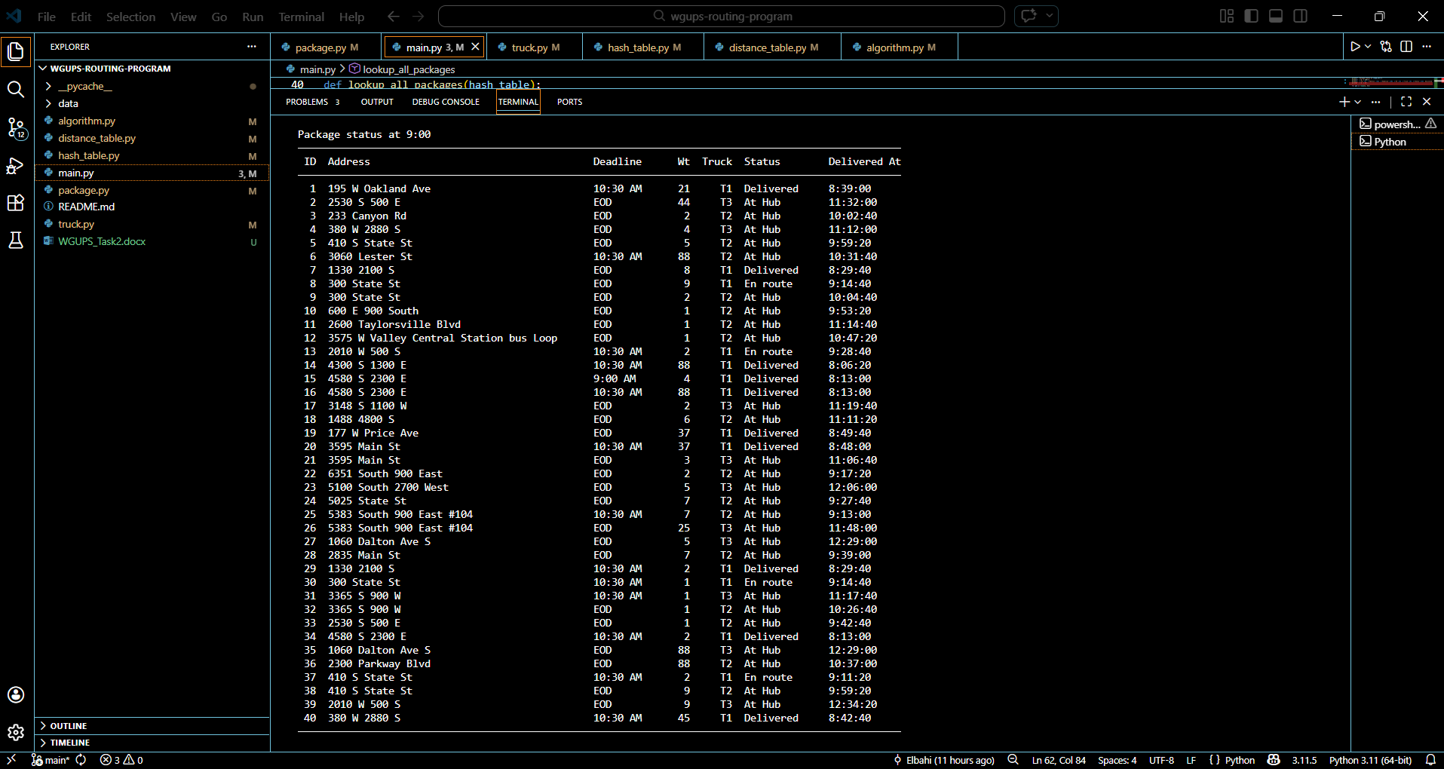
Figure 3. Status of packages at a time between 8:35 a.m. and 9:25 a.m.

D2. Second Status Check
The next screenshot shows the second required status check taken during the time window between 9:35 a.m. and 10:25 a.m.
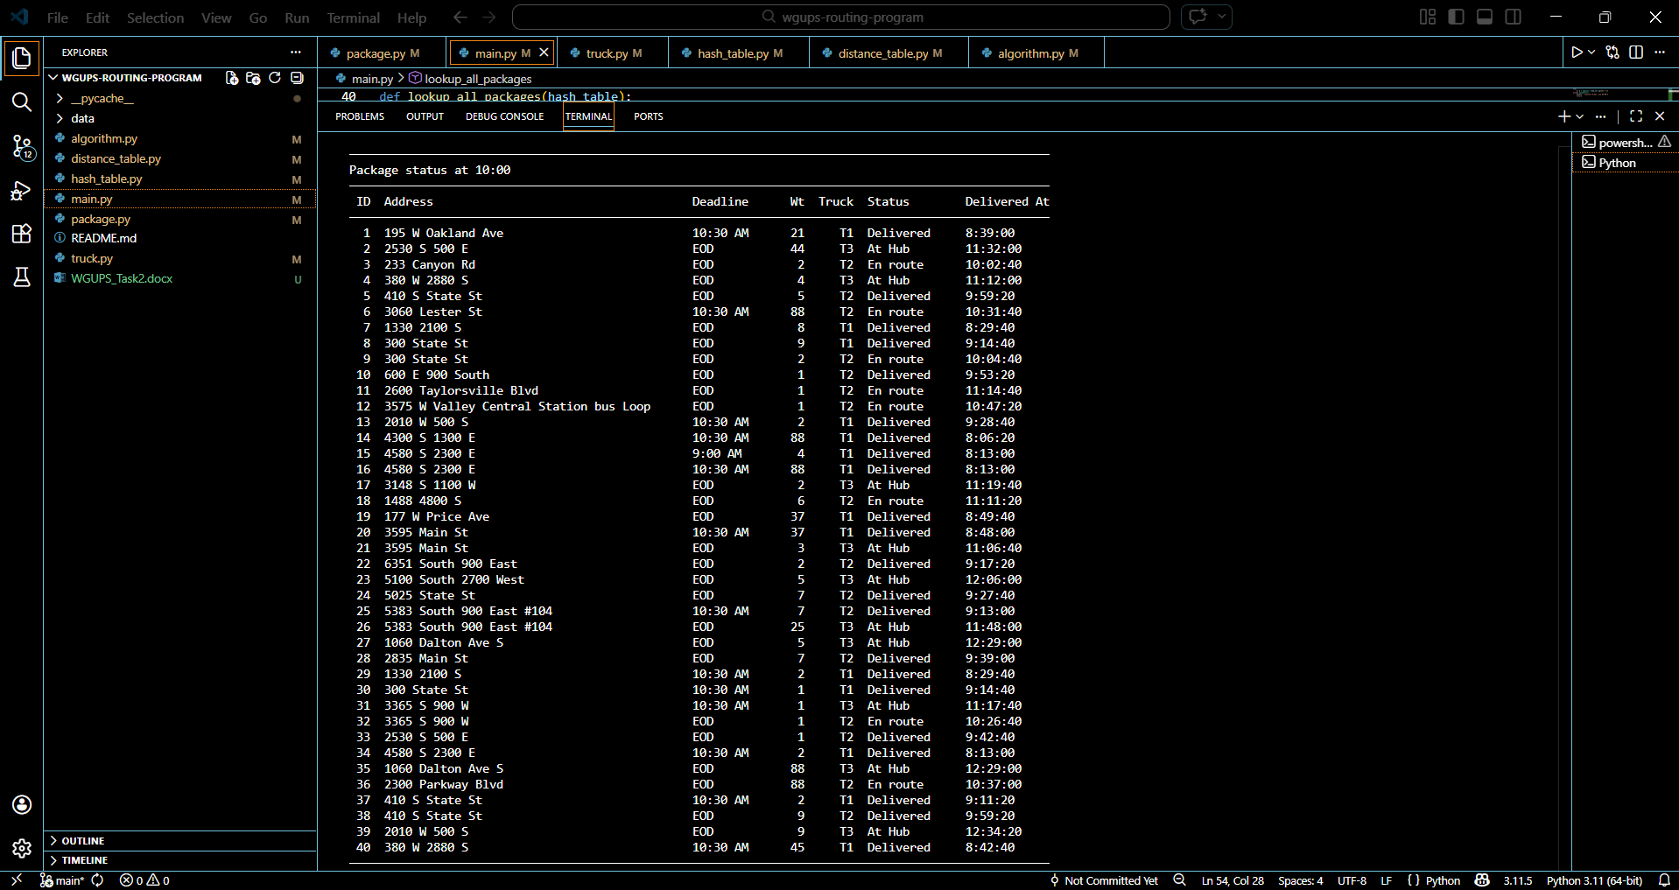
Figure 4. Status of packages at a time between 9:35 a.m. and 10:25 a.m.

D3. Third Status Check
The screenshot below shows the third required status check taken during the time window between 12:03 p.m. and 1:12 p.m.
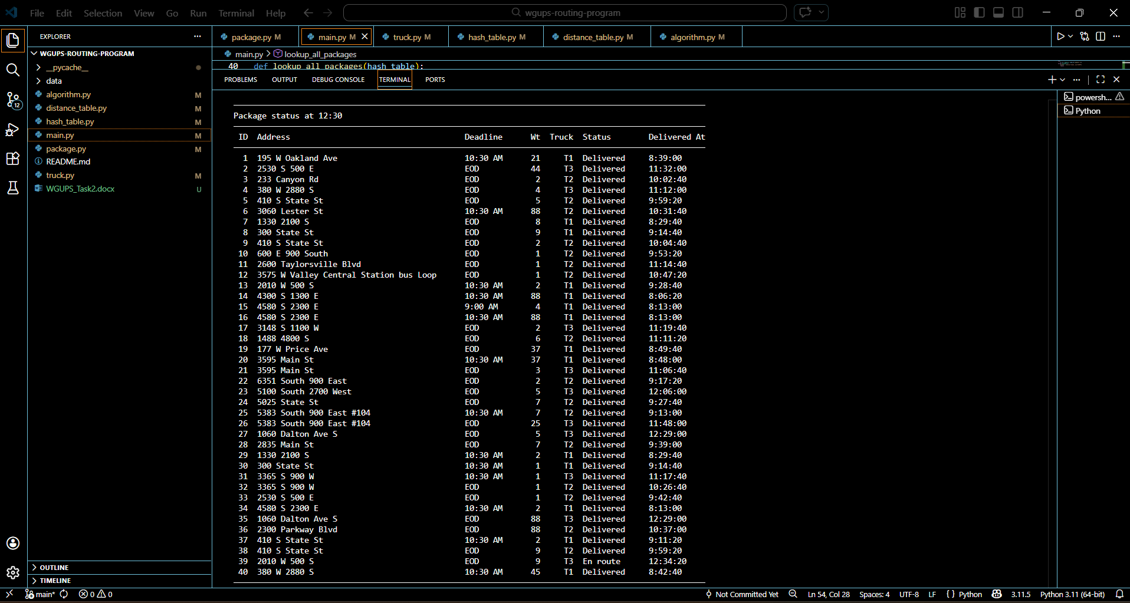
Figure 5. Status of packages at a time between 12:03 p.m. and 1:12 p.m.

E. Screenshots of Code Execution
The following screenshot shows a successful run of the program and includes the total mileage traveled by all three trucks. The run is complete and does not show runtime errors or warnings.
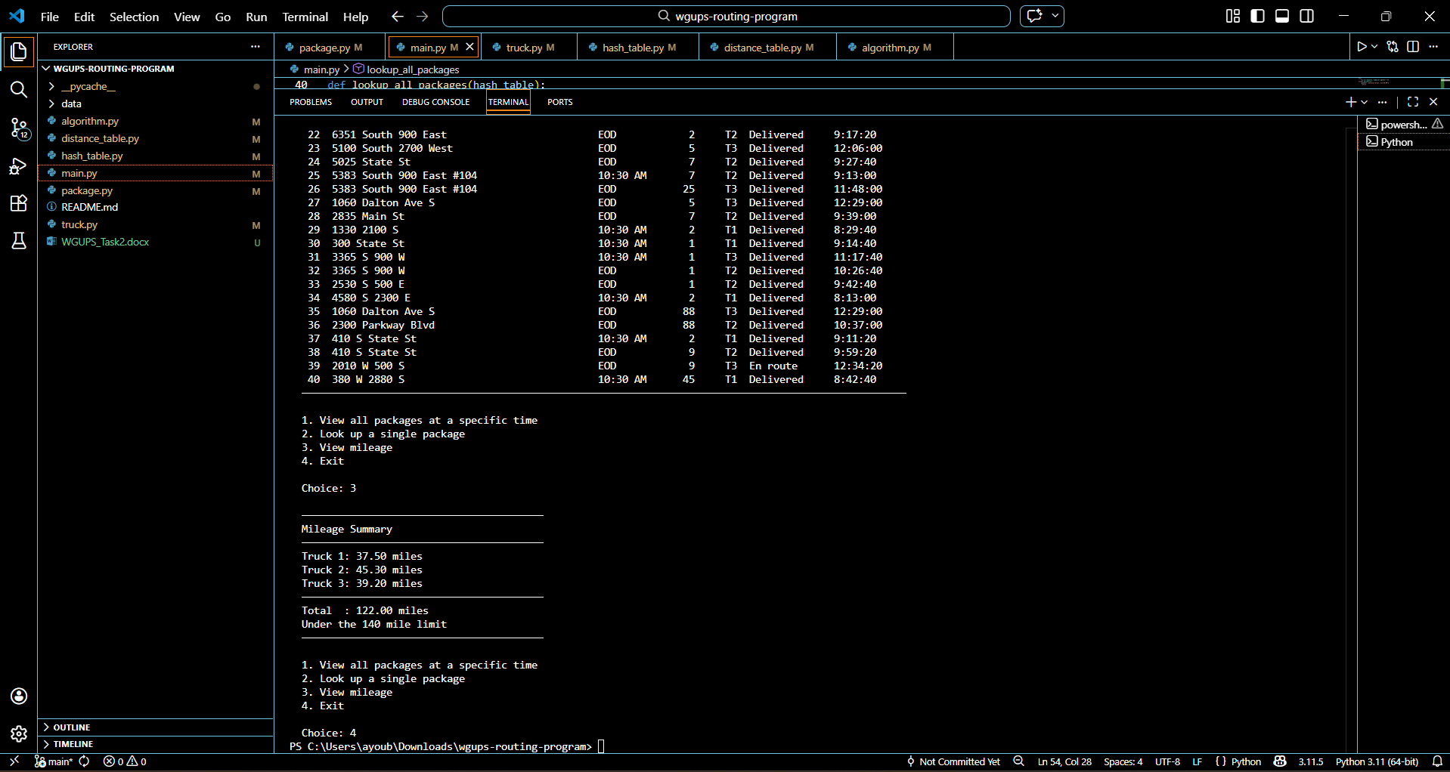
Figure 6. Completed program execution showing the total mileage traveled by all trucks.

F. Algorithm Justification

F1. Strengths of the Chosen Algorithm
The algorithm I used is a nearest-neighbor greedy algorithm. For each truck, the program looks at the truck's current location and chooses the closest undelivered package. That process repeats until the truck has delivered every package assigned to it.
One strength of this algorithm is that it is simple to implement and easy to follow. That matters in this project because the code has to be readable and explainable. The logic is straightforward, so it is easier to debug, test, and maintain.
A second strength is that it performs well enough for this specific delivery problem. Even though nearest neighbor does not guarantee the mathematically shortest possible route, it produced a route that stayed under the 140-mile requirement in my program. For this project, this makes it a practical solution.
A third strength is speed. The algorithm makes local decisions and does not need complicated optimization steps, so it can generate results quickly for the number of packages used in this assignment.

F2. Verification That the Algorithm Meets the Scenario Requirements
Based on my completed program run, the algorithm meets the scenario requirements. All 40 packages are delivered, and the total mileage is under 140 miles. My output shows a combined total of about 122.00 miles, which stays inside the required limit.
The truck loading plan also respects the stated package constraints. Delayed packages are not sent out before they arrive, the truck-specific packages are assigned to the correct truck, and the grouped packages are kept together. The interface lets the user check package status at any time, and the status includes the delivery time. No truck carries more than 16 packages — Truck 1 has 14, Truck 2 has 16, and Truck 3 has 10. Packages 3, 18, 36, and 38 are assigned only to Truck 2 as required by their notes. Packages 6, 25, 28, and 32 are on Truck 2, which departs at 9:05 AM, so they are never dispatched before arriving at the hub. Package 9 is assigned to Truck 2 and is not delivered until after 10:20 AM, when the corrected address becomes available. The co-delivery group (packages 13, 14, 15, 16, 19, 20) all ride on Truck 1 together.
The program also tracks truck mileage separately and then combines the totals, which lets the supervisor verify both the route progress and the final mileage requirement.

F3. Two Other Possible Algorithms
Two other named algorithms that could also be used for this problem are the Clarke-Wright Savings algorithm and the 2-opt improvement algorithm.
The Clarke-Wright Savings algorithm is different from nearest neighbor because it does not choose the next closest stop for one delivery at a time. Instead, it starts by treating deliveries as separate routes and then merges routes based on how much distance is saved by combining them. That makes it more global in its decision-making than my greedy step-by-step method.
The 2-opt algorithm is also different from my solution. Nearest neighbor builds one route forward and keeps going until all stops are assigned. In contrast, 2-opt starts with an existing route and then improves it by swapping route segments to reduce total distance. In other words, nearest neighbor constructs the route, while 2-opt is more of a route-improvement method.

G. What I Would Do Differently
If I did this project again, the biggest change I would make would be to automate the truck loading process. In my current solution, I manually assign packages to trucks in `main.py` based on the notes and deadline rules. That works for this project, but it would be better if the program could read the notes and make those decisions automatically.
I would create a loading function that checks package notes first, then deadline packages, and then fills the remaining truck space by location. That would make the program easier to reuse with a different package file or in another city.
I would also improve the time formatting in the interface. Right now, the program stores time in a way that works for the simulation, but I would make the output more user-friendly by formatting times in a cleaner 12-hour clock style for the supervisor.

H. Verification of the Data Structure
The data structure I used for package storage is a chaining hash table, and it meets the scenario requirements well. Each package has a unique ID, so using the package ID as the key makes lookups fast and direct. The program needs to repeatedly find package records during delivery and during status checks, so quick access is important. The table stores all 40 packages without any collisions causing data loss. Status updates during the simulation are reflected automatically because the Package object is stored by reference, so changes made during delivery are immediately visible in later look-up calls.
The structure also supports updates naturally. When a package status changes from At Hub to En route or Delivered, the package object stored in the hash table reflects that change. That means the program does not need to rebuild the table every time a status changes.

H1. Two Other Data Structures
Two other data structures that could meet the same requirements are a direct-address table and a binary search tree.

H1a. How Those Data Structures Are Different From My Solution
A direct-address table would store each package in a list position that matches the package ID. That would make lookup very fast, but it only works well when the keys stay in a small known range. My hash table is more flexible because it can still map keys into a smaller structure through hashing.
A binary search tree is different because it organizes data in a sorted tree structure instead of buckets. A balanced binary search tree would allow efficient lookup and also make sorted traversal easier. My hash table is usually faster for direct lookups, but it does not naturally keep the keys in order.

I. Sources
Cormen, T. H., Leiserson, C. E., Rivest, R. L., & Stein, C. (2022). Introduction to Algorithms (4th ed.). MIT Press.
Western Governors University. (n.d.). C950 Data Structures and Algorithms II course materials and task directions. https://learn.zybooks.com/zybook/WGUC950Template2023/chapter/6/section/1

