SNOWFLAKE
Artifacts & Snowflake Intelligence
Architect Session — Complete Reference Guide

From Conversations to Business Outputs

1. What is Snowflake Intelligence?
Snowflake Intelligence is Snowflake's ready-to-use agentic application with a conversational interface that helps business users discover and act on deep insights without writing SQL. It bridges the gap between valuable enterprise data and the people who need it, enabling users to move beyond stale dashboards and rigid pre-built reports.

1.1 The Paradigm Shift
Many organizations are gradually shifting analytical solutions toward generative BI (GenBI) platforms — a transition from Syntax to Semantics. Traditionally, business users searched for answers in pre-built, static reports that lacked context and real-time relevance. With Snowflake Intelligence, they can instead hold natural-language conversations with their data to find answers dynamically.

1.2 Key Capabilities
- Natural Language Interaction — Ask questions in plain English; receive deep, accurate insights.
- Unified Data Access — Analyzes both structured and unstructured enterprise data.
- Deep, Trustworthy Insights — Breaks down questions, selects the best tools, and provides full traceability to source data and queries.
- Built-in Visualization — Instantly generates and customizes charts (bar, line, pie, scatter, area, heatmap, box plot, faceted, dual-axis, etc.).
- Artifacts — Persistent chart and table objects that can be saved, shared, and revisited without regenerating.
- Seamless Governance — Automatically inherits all Snowflake data governance controls including row-access policies and column-level security.
- Full Administrative Control — Administrators control which users and teams see which data experiences.

1.3 Architecture Overview
Snowflake Intelligence operates on a layered agentic architecture:

Layer | Component | Role
UI Layer | Snowflake Intelligence Chat UI / iOS App | Conversational interface for business users
Orchestration | Cortex Agent API (LLM Orchestrator) | Interprets intent, selects tools, chains actions
Structured Data | Cortex Analyst + Semantic Views | Converts NL to SQL on business semantic models
Unstructured Data | Cortex Search | Returns relevant document text from unstructured sources
Custom Actions | User-Defined Functions / Stored Procedures | Execute business logic and workflows
Persistence | Artifacts Hub | Save, refresh, and share persistent insights

When a user asks a question, the flow is: User Input → Cortex Agent API → Orchestrator (LLM) → Tool Execution (Analyst / Search / Custom) → Reflection & Final Response with Charts / Tables.

2. Artifacts in Snowflake Intelligence — Deep Dive
Artifacts are a foundational feature introduced in Snowflake Intelligence to solve a critical gap: business users had great conversational AI answers in the chat, but no structured way to preserve, share, or reuse those outputs — especially for boardroom discussions, stakeholder reporting, or operational decision-making.
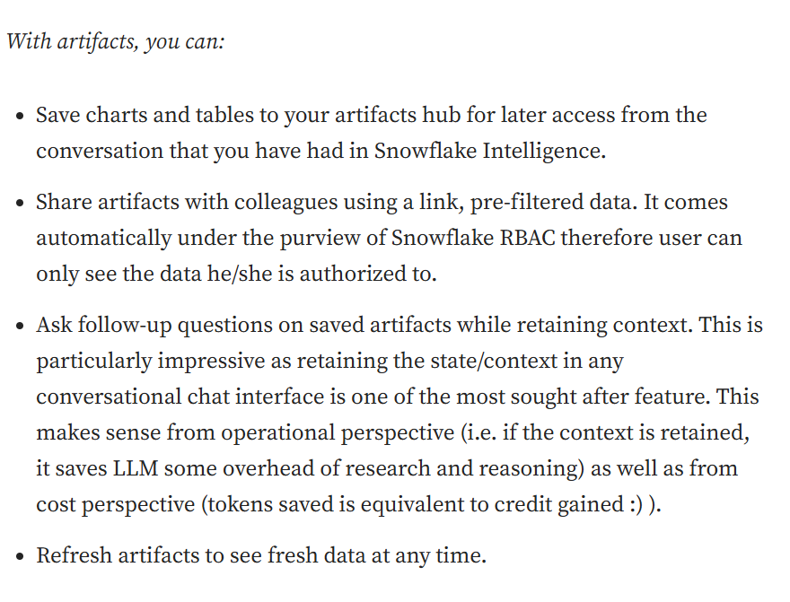
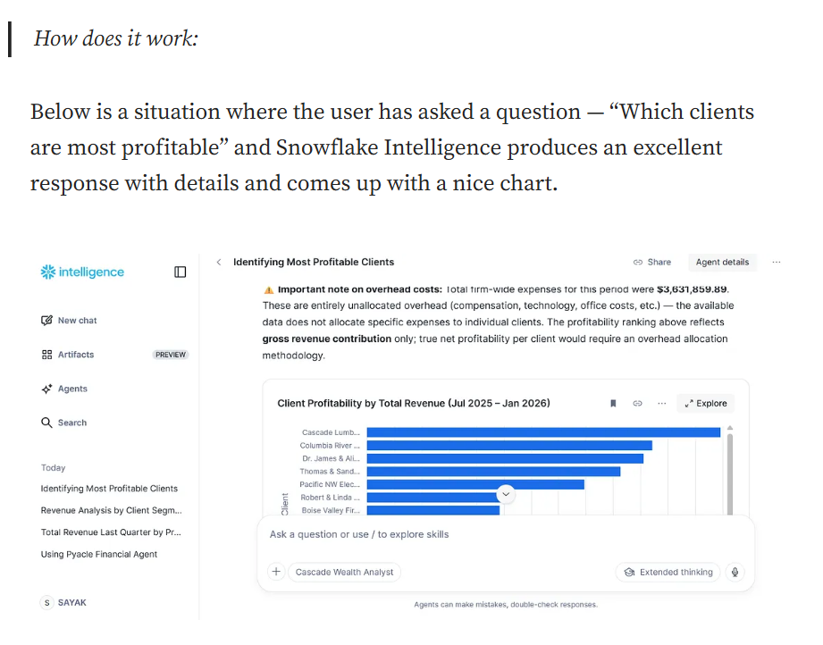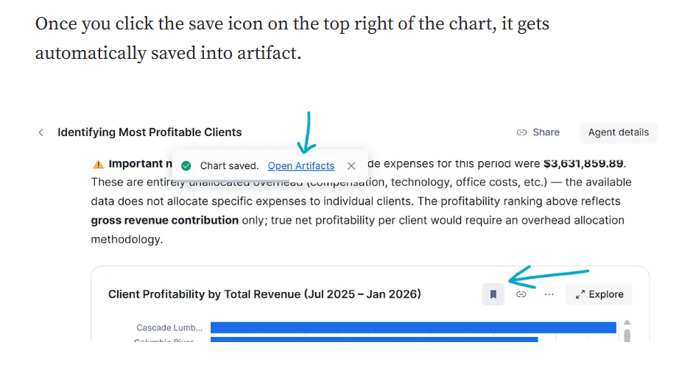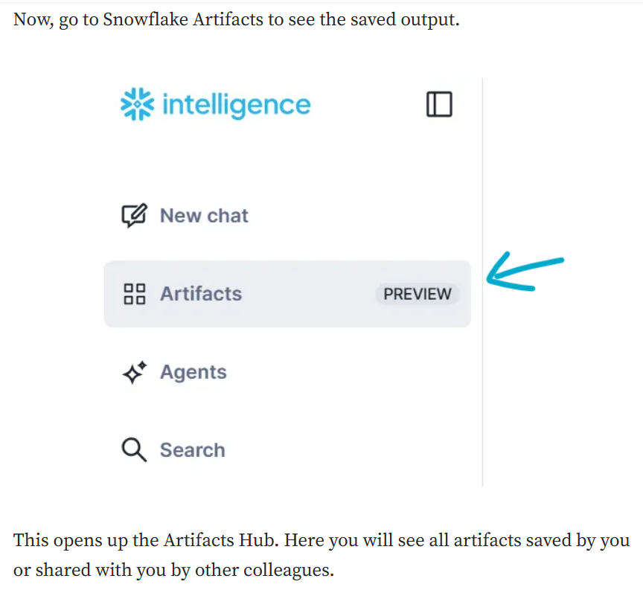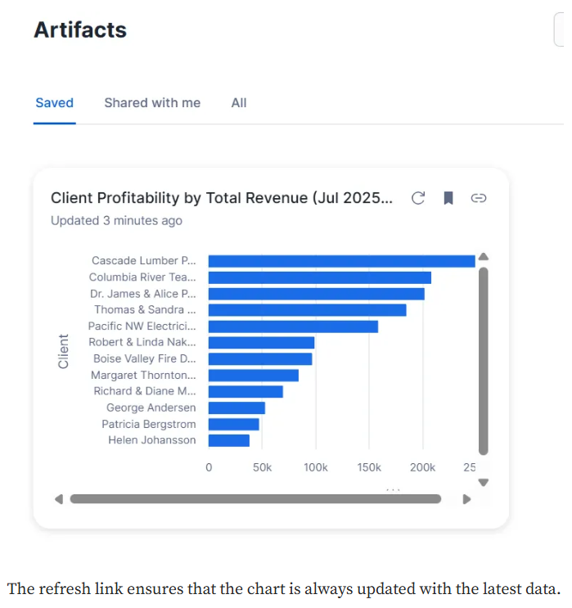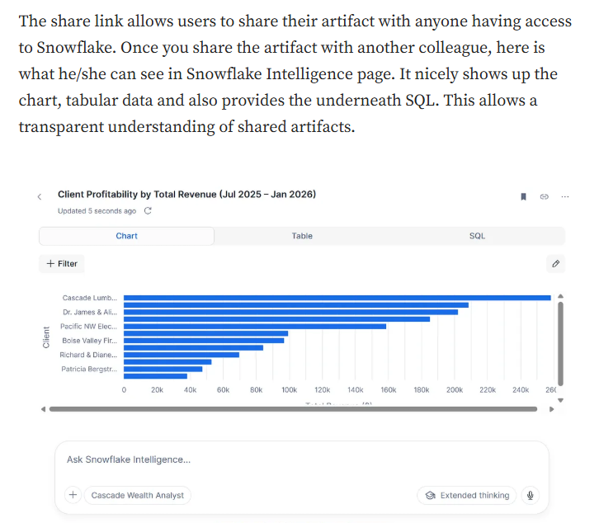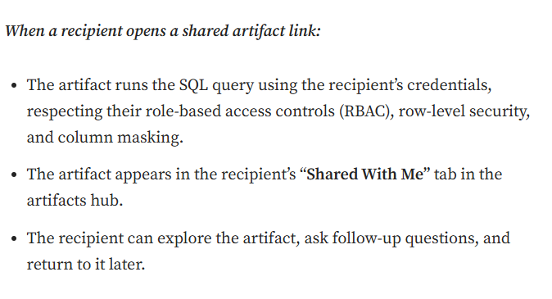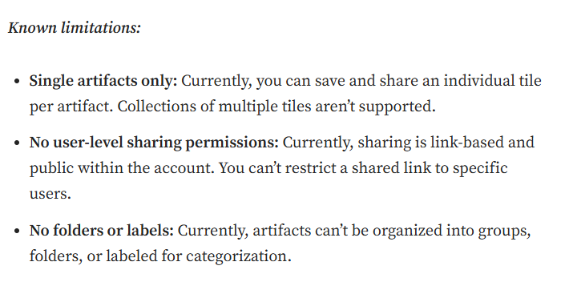

2.1 What is an Artifact?
An Artifact is a persistent representation of a chart or table generated by Snowflake Intelligence. It preserves the underlying SQL query, visualization settings, and a data snapshot so the insight can be revisited, refreshed with live data, and shared with colleagues — all without regenerating the analysis from scratch.

Core Definition
An Artifact = Persistent Query + Visualization Settings + Data Snapshot
It is NOT a static screenshot. It is a live, refreshable business output.
It is NOT just a dashboard tile. It retains full conversational context.
It IS governed by Snowflake RBAC — every user sees only their authorized data.

2.2 What You Can Do with Artifacts
- Save a chart or table from any Snowflake Intelligence conversation to your Artifacts Hub.
- Share with colleagues via a secure link — recipients see data through their own credentials (RBAC enforced).
- Refresh at any time to reload the latest data by re-running the original SQL query.
- Ask follow-up questions on a saved artifact — each follow-up starts a new conversation thread preserving context.
- Revisit and explore saved artifacts from the centralized Artifacts Hub.

2.3 Interactive Tables and Charts
When Snowflake Intelligence answers a question, it may return a chart, a table, or both. These are fully interactive:
- Sort and filter columns in tables without writing new queries.
- Search within table results.
- Resize columns and panels.
- In Explorer Mode, charts and tables are synced — interacting with one updates the other.
- Time windows default to rolling periods (e.g., last 30 days). Use explicit dates for fixed periods.

2.4 Saving an Artifact — Step by Step
- Ask a question in Snowflake Intelligence (e.g., "Which clients are most profitable?").
- Snowflake Intelligence responds with a chart and/or table.
- Click the Save icon on the top-right of the chart or table tile.
- The artifact is saved to your Artifacts Hub under the Saved tab.
- The artifact preserves: SQL query, visualization spec, data snapshot, and original conversation context.

2.5 Managing Artifacts — The Artifacts Hub
The Artifacts Hub is the central management console for all your artifacts. It contains two tabs:

Tab | Contents
Saved | All artifacts you have personally saved from conversations.
Shared with Me | Artifacts shared with you via link by other account users.

The Hub displays cached tile previews for fast loading. You can expand a tile to see full detail, search for artifacts by name, start a follow-up conversation, and manually trigger a refresh.
Auto-refresh occurs when you view an artifact more than 12 hours after your last view. Manual refresh is always available. Every refresh re-runs the original SQL using your current credentials.

2.6 Sharing Artifacts
You share an artifact by copying a link and distributing it through any communication channel — email, Slack, Teams, etc. Key behaviors:
- Sharing creates a pointer to the artifact, not a copy — both sharer and recipient interact with the same object.
- The recipient sees data filtered through their own Snowflake role, row-level security, and column masking (caller's-rights model).
- The artifact appears in the recipient's Shared with Me tab in their Artifacts Hub.
- Recipients can explore, refresh, follow up, and re-share the artifact.
- Recipients can save the shared artifact to their own Saved tab.

Revoking Access
The original creator can unshare an artifact at any time.
Unsharing immediately invalidates the link — no one can open it afterward.
Note: Admins cannot disable artifact sharing via SQL or UI — contact Snowflake Support to disable at account level.

3. Security, Governance & Access Control
Artifacts are built on Snowflake's robust security model. Every data interaction respects the current user's permissions at runtime — this is called the Caller's-Rights Model.
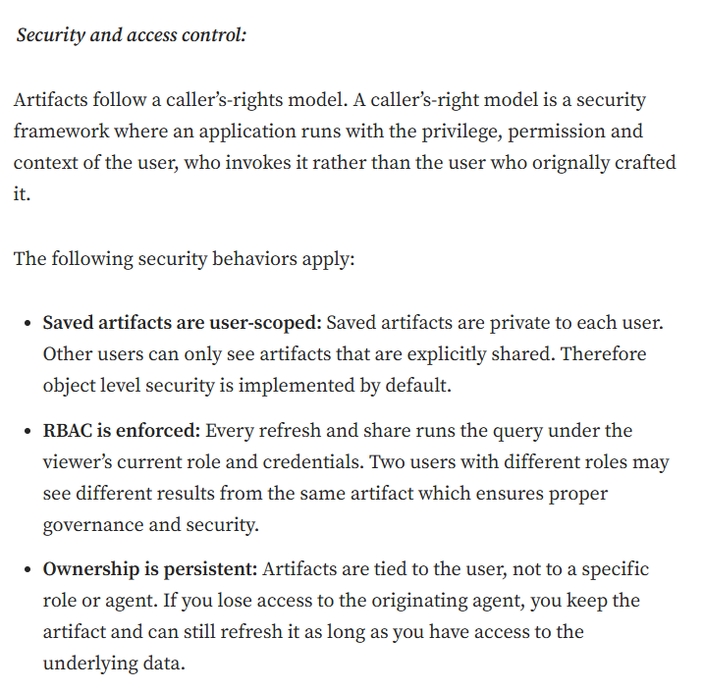

3.1 Caller's-Rights Model Explained
In the caller's-rights model, an application (the Artifact) runs with the privileges and context of the user who invokes it — not the user who originally created it. This means:
- Two users with different Snowflake roles viewing the same artifact may see different data results.
- Row-level security policies are automatically applied to every refresh and every shared view.
- Column masking (e.g., masking PII for non-privileged roles) is enforced on every query run.

3.2 Security Behaviors Summary

Security Behavior | Details
User-Scoped Saved Artifacts | Saved artifacts are private by default. Only the owner can see them unless explicitly shared.
RBAC Enforced on Every Run | Every refresh and share re-runs the underlying SQL under the viewer's current Snowflake role.
Persistent Ownership | Artifacts are tied to the user, not a specific role or agent. Losing agent access does not delete your artifact.
Link-Based Sharing | Sharing is link-based within the Snowflake account. Any account user with the link can open the artifact (subject to data access).
No Cross-Account Sharing | Artifact links are scoped to a single Snowflake account — external sharing is not supported.

3.3 Artifact Lifecycle — What Happens When Access Changes

Condition | What Happens
You lose agent access | You can still view and refresh the artifact. Follow-up questions with the original agent are unavailable.
You lose data access (underlying tables) | The last cached snapshot remains visible, but refresh is blocked.
Agent is deleted or modified | The artifact and saved query are unaffected. Follow-up questions use the current agent definition if available.
You delete the artifact | The artifact is permanently removed. No auto-deletion by Snowflake — artifacts persist until explicitly deleted.

4. Real-World Use Cases
Artifacts address a critical gap in the enterprise BI workflow — moving insights from ephemeral chat conversations to persistent, shareable, governed business outputs. Below are detailed real-world scenarios.

4.1 Finance & Revenue Operations

Use Case: Monthly Revenue Performance Review
Scenario: A CFO asks Snowflake Intelligence, "Show me revenue by region for the last quarter vs. the same quarter last year."
Action: The response generates a comparison bar chart. CFO saves it as an Artifact.
Value: The chart is shared with the Finance team via a link. Each member sees revenue only for their authorized region (RBAC). The artifact is refreshed monthly for ongoing reviews.
Benefit: Eliminates manual report recreation every month. Persistent, governed, always-fresh.

- Track monthly/quarterly P&L, revenue by product line, or expense trends.
- Share profitability insights with Board members — each sees only their authorized entity data.
- Replace static Excel dashboards with live, conversational, refreshable artifacts.

4.2 Sales & Customer Analytics

Use Case: Most Profitable Clients
Scenario: Sales Director asks, "Which clients are most profitable?" The agent produces a ranked table + scatter chart.
Action: Director saves the Artifact and shares with Account Managers.
Value: Each Account Manager sees only their own client portfolio (row-level security). They ask follow-up questions ("Show churn risk for my top 10 clients") independently.
Benefit: Self-service insight at scale, without data team bottlenecks.

- Customer lifetime value, churn analysis, upsell opportunity identification.
- Territory-based sales performance — each rep sees their own numbers from the same artifact.
- Pipeline health and forecast accuracy visualizations for weekly sales reviews.

4.3 Operations & Supply Chain
- Inventory turnover analysis with auto-refreshed charts for daily operations reviews.
- Supplier performance scorecards shared across procurement teams.
- Logistics KPIs (on-time delivery, cost per shipment) as persistent artifacts for shift handovers.

4.4 Marketing Analytics
- Campaign performance (impressions, CTR, conversion) artifacts refreshed post-campaign.
- Customer segmentation charts shared with product teams for roadmap decisions.
- Attribution model comparisons saved as artifacts for Marketing leadership reviews.

4.5 Healthcare & Life Sciences
- Patient outcome metrics shared across care teams with strict column masking on PII.
- Clinical trial data aggregations for researchers — each researcher sees their authorized cohort.
- Operational KPIs (bed occupancy, wait times) as live artifacts for hospital management.

4.6 Financial Services
- Portfolio performance dashboards refreshed daily — shared with relationship managers.
- Risk exposure summaries filtered by role (trader sees own book, risk manager sees all).
- Compliance reporting artifacts retained for audit trails.

4.7 Retail & E-Commerce
- Store-level sales performance — regional managers see only their stores from the same shared artifact.
- Inventory stock-out alerts and demand forecasting charts for supply chain teams.
- Customer basket analysis artifacts shared between merchandising and marketing teams.

4.8 Technology & SaaS
- Product usage telemetry charts (DAU, MAU, feature adoption) saved for weekly product reviews.
- Infrastructure cost analysis artifacts shared with engineering leadership.
- Customer support ticket trend analysis artifacts for Customer Success reviews.

Industry | Top Artifact Use Cases
Finance | Revenue review, P&L tracking, budget vs. actuals
Sales | Client profitability, pipeline health, territory performance
Operations | Inventory analysis, supplier scorecards, logistics KPIs
Marketing | Campaign performance, attribution, segmentation
Healthcare | Patient outcomes, clinical ops, compliance metrics
Retail | Store-level sales, inventory, basket analysis
Technology | Product telemetry, cost analysis, support trends

5. Practical Demonstration Inside Snowflake
This section provides a step-by-step guide to demonstrate Snowflake Intelligence Artifacts live inside a Snowflake environment during the architect session.

5.1 Prerequisites — Setup Checklist
- Snowflake account with Snowflake Intelligence enabled (Preview Feature — Open to all accounts).
- A virtual warehouse assigned to the Snowflake Intelligence agent.
- At least one configured agent with a Semantic Model (Cortex Analyst) or Cortex Search service.
- Sample data loaded (use Snowflake's SNOWFLAKE_SAMPLE_DATA or a custom dataset — see demo data below).
- Two user accounts to demonstrate RBAC-based artifact sharing.

5.2 Demo Dataset — Setup SQL
Run the following SQL in a Snowflake worksheet to create a simple sales dataset for the demo:

-- Step 1: Create database and schema
CREATE DATABASE IF NOT EXISTS DEMO_DB;
CREATE SCHEMA IF NOT EXISTS DEMO_DB.SALES;
-- Step 2: Create sales transactions table
CREATE OR REPLACE TABLE DEMO_DB.SALES.TRANSACTIONS (
TRANSACTION_ID VARCHAR,
CLIENT_NAME VARCHAR,
REGION VARCHAR,
PRODUCT_LINE VARCHAR,
SALE_AMOUNT NUMBER(18,2),
SALE_DATE DATE,
SALES_REP VARCHAR
);
-- Step 3: Insert sample data
INSERT INTO DEMO_DB.SALES.TRANSACTIONS VALUES
('T001','Acme Corp','North America','Cloud','125000','2025-01-15','Alice'),
('T002','Globex Ltd','Europe','Analytics','98000','2025-01-20','Bob'),
('T003','Initech','APAC','Cloud','210000','2025-02-10','Alice'),
('T004','Umbrella Co','North America','Analytics','175000','2025-02-25','Carol'),
('T005','Vandelay Ind','Europe','Cloud','88000','2025-03-05','Bob'),
('T006','Massive Dyn','APAC','Analytics','320000','2025-03-18','Carol'),
('T007','Acme Corp','North America','Cloud','145000','2025-04-02','Alice'),
('T008','Globex Ltd','Europe','Analytics','115000','2025-04-22','Bob');

5.3 Demo Scenario 1 — Saving Your First Artifact
Goal: Show how a business user saves a chart from a conversation.

- Navigate to Snowflake Intelligence from the left sidebar in Snowflake UI.
- Select your configured agent (or the default agent if set up).
- Type the question: "Which region has the highest total sales this year?"
- Snowflake Intelligence generates a bar chart with sales by region.
- Click the Save (bookmark/disk) icon on the top-right corner of the chart.
- The artifact is saved. Navigate to the Artifacts Hub to confirm it appears under Saved.

What to Highlight for the Audience
1. The SQL behind the chart is auto-generated — no SQL written by the user.
2. The chart is interactive — attendees can sort and filter right in the UI.
3. The save action takes one click — from conversation to persistent artifact instantly.
4. The artifact persists even if the chat thread is cleared.

5.4 Demo Scenario 2 — Sharing an Artifact and Observing RBAC
Goal: Demonstrate the caller's-rights model in action using two accounts.

- From Account A (full data access): Save the artifact from Scenario 1.
- Click Share on the artifact tile. Copy the shareable link.
- Send the link to Account B (restricted to North America region only via row-access policy).
- Account B opens the link. The artifact loads — but shows ONLY North America data.
- Account B can refresh the artifact — it re-runs the SQL under their credentials.
- Account B sees the artifact in their Shared with Me tab.

RBAC Setup SQL (Row-Level Security for Demo)
-- Create row access policy
CREATE ROW ACCESS POLICY DEMO_DB.SALES.REGION_POLICY
AS (REGION VARCHAR) RETURNS BOOLEAN ->
CURRENT_ROLE() = 'SYSADMIN'
OR REGION = CURRENT_USER();
-- Apply to table
ALTER TABLE DEMO_DB.SALES.TRANSACTIONS
ADD ROW ACCESS POLICY DEMO_DB.SALES.REGION_POLICY ON (REGION);

5.5 Demo Scenario 3 — Follow-Up Questions on a Saved Artifact
Goal: Show how context is retained when asking follow-up questions on an artifact.

- Open the saved artifact from the Artifacts Hub.
- Ask a follow-up: "Break down the top region's sales by product line."
- A new conversation thread opens — the artifact's context (query, data, original question) is automatically included.
- The agent returns a stacked bar chart without needing the user to re-explain the context.
- This new chart can also be saved as a new artifact.

Key Talking Point
Each follow-up conversation is private to the person asking — it does not affect the original artifact or the sharer's conversation.
The original conversation remains unchanged and private.
This enables collaborative, async investigation on the same data object.

5.6 Demo Scenario 4 — Manual Refresh
Goal: Demonstrate that artifacts always show live data, not stale snapshots.

- Open the saved artifact from the Hub.
- Run a SQL insert to add new data to the transactions table (simulate new sales coming in).
- Return to the artifact and click Refresh.
- The artifact re-runs the original SQL query and the chart updates with the new data.
- The cached snapshot is updated — all future views see the refreshed data.

-- Simulate new sales data arriving
INSERT INTO DEMO_DB.SALES.TRANSACTIONS VALUES
('T009','New Client A','North America','Cloud','500000','2025-05-01','Alice'),
('T010','New Client B','Europe','Analytics','450000','2025-05-03','Bob');

5.7 Demo Scenario 5 — Artifacts Hub Overview
Walk the audience through the Artifacts Hub features:
- Show the Saved and Shared with Me tabs.
- Demonstrate tile previews — fast-loading cached snapshots.
- Show how to search for artifacts by name.
- Demonstrate expanding an artifact to see the full chart, table, and underlying SQL.
- Show the auto-refresh indicator (last refreshed timestamp).

6. Current Limitations & Future Roadmap

6.1 Current Known Limitations (as of 2026)

Limitation | Details & Workaround
Single Artifact per Save | Only one chart or table tile can be saved per artifact. Collections of multiple tiles are not supported yet. Workaround: Save each tile as a separate artifact.
No User-Level Sharing Permissions | Sharing is link-based within the account. You cannot restrict a shared link to specific named users. Workaround: Use RBAC and row-access policies to control data visibility.
No Folders or Labels | Artifacts cannot be organized into folders, groups, or tagged for categorization. Workaround: Use clear, descriptive artifact names for discoverability via search.
No Cross-Account Sharing | Artifact links are scoped to a single Snowflake account. External stakeholders cannot access artifacts. Workaround: Export charts manually or use Snowflake Secure Data Sharing.
Geographic Map Charts Not Supported | Snowflake Intelligence does not support geographic map chart types in visualizations.
Preview Feature Availability | As of launch, some accounts may not yet have the Artifacts feature enabled. Check with your Snowflake account team.

6.2 What to Watch For (Anticipated Enhancements)
- Multi-tile artifacts — save a collection of charts and tables as a single shareable artifact.
- Folder and label organization in the Artifacts Hub.
- User-level sharing permissions — restrict who within the account can open a shared link.
- Artifact embedding — embed live artifact charts into other Snowflake apps or external portals.
- Artifact scheduling — auto-refresh and auto-share artifacts on a defined schedule.
- Geographic map chart support in Snowflake Intelligence visualizations.

7. Artifacts vs. Traditional BI — Key Differences
Understanding how Artifacts fit into the existing analytics ecosystem helps architects position the feature effectively.

Dimension | Traditional BI Dashboard | Snowflake Artifacts
Creation | BI developer builds dashboard from scratch using a BI tool (Tableau, Power BI, Looker) | Business user saves chart directly from a natural language conversation — no developer needed
Query Origin | Pre-defined query written by a developer | Auto-generated SQL from NL question by Cortex Analyst
Freshness | Scheduled refresh (hourly, daily) | On-demand refresh; auto-refresh after 12 hours
Governance | Managed in BI tool (separate permissions layer) | Inherited from Snowflake RBAC, row-level security, column masking — no separate config
Sharing | Dashboard link (may need BI tool license) | Snowflake account link — recipient uses their own Snowflake credentials
Personalization | Static for all viewers (or requires separate filtered versions) | Auto-personalized via caller's rights — each viewer sees their authorized data
Context Retention | No — each dashboard visit is stateless | Yes — follow-up questions retain original conversation context
Development Time | Days to weeks for a new report | Seconds — ask a question and save
Flexibility | Rigid — changing a chart requires developer work | Fluid — ask a new question, save as a new artifact

8. Suggested 2-Hour Session Agenda

Time | Topic
0:00 – 0:15 | Introduction: The GenBI Paradigm Shift — from Syntax to Semantics (Section 1)
0:15 – 0:35 | Snowflake Intelligence Architecture — Agents, Cortex Analyst, Cortex Search (Section 1.3)
0:35 – 0:55 | Artifacts Deep Dive — Concepts, Lifecycle, Security (Sections 2 & 3)
0:55 – 1:10 | Live Demo Part 1 — Saving first artifact, exploring the Artifacts Hub (Section 5.3)
1:10 – 1:25 | Live Demo Part 2 — Sharing + RBAC in action (Section 5.4)
1:25 – 1:35 | Live Demo Part 3 — Follow-ups and Refresh (Sections 5.5, 5.6)
1:35 – 1:50 | Real-World Use Cases by Industry (Section 4)
1:50 – 2:00 | Limitations, Roadmap, Q&A (Section 6)

9. Quick Reference — Artifacts Cheat Sheet

How to Save an Artifact
- Ask a question in Snowflake Intelligence.
- Locate the chart or table in the response.
- Click the Save icon (top-right of the tile).
- Find it in Artifacts Hub → Saved tab.

How to Share an Artifact
- Open the artifact in the Artifacts Hub.
- Click Share.
- Copy the link and send it via any channel.
- Recipient sees data through their own Snowflake role.

How to Revoke Access
- Open the artifact.
- Click Unshare.
- The link is immediately invalidated.

How to Refresh an Artifact
- Open the artifact.
- Click Refresh (or wait — auto-refresh triggers after 12 hours).
- The original SQL re-runs with your current credentials.

How to Ask a Follow-Up on an Artifact
- Open the artifact from the Hub.
- Type your follow-up question in the chat.
- A new conversation thread opens with the artifact's context included.
- Your follow-up is private — it does not affect the original conversation.

Key Things to Remember
Artifacts are user-scoped — private by default.
Sharing = link-based, no copy is created.
RBAC is always enforced — every viewer sees only their authorized data.
Follow-up conversations are private to the person asking.
Artifacts never auto-delete — you own them until you remove them.
Single tile per artifact currently — save each chart/table separately.

Supported Chart Types in Snowflake Intelligence
- Bar charts (grouped, stacked)
- Line charts
- Pie / donut charts
- Scatter plots
- Area charts
- Heatmaps
- Box plots
- Dual-axis and layered charts
- Faceted small-multiple charts
- Error bars with text annotations
- (Geographic map charts are NOT supported)

