SNOWFLAKE
ENTERPRISE TRAINING SERIES

DAY 2
Role-Based Access Control &
User Management

Enterprise-Grade Corporate Training | 4-Hour Session

Audience  All data roles: Freshers, DBAs, Analysts, Engineers, BI Developers | Format  Lecture + Hands-On Lab + Quiz Discussion + Q&A | Prerequisites  Day 1 Completion Snowflake Introduction and Architecture

Reference: Snowflake Official Documentation | docs.snowflake.com/en/user-guide/security-access-control-overview

TABLE OF CONTENTS
TABLE OF CONTENTS 1
SECTION 1: Session Agenda — 4-Hour Breakdown 1
SECTION 2: Day 1 Recap & Day 2 Introduction (15 Minutes) 1
2.1 Day 1 Quick Recap — Knowledge Check 1
2.2 Why Security & Access Control Matters 1
2.3 Day 2 Learning Goals 1
SECTION 3: Security Fundamentals & Snowflake's Security Model (25 Minutes) 1
3.1 The Snowflake Security Architecture 1
3.2 How Snowflake Security Differs from Traditional Databases 1
3.3 RBAC ……………………………………………………………………………………………………….1
3.4 Core Security Concepts 1
Securable Objects 1
Privileges 1
Discretionary Access Control (DAC) 1
SECTION 4: System Roles & Role Hierarchy (30 Minutes) 1
4.1 Snowflake System-Defined Roles 1
4.2 System Role Reference 1
4.3 Role Hierarchy & Privilege Inheritance — Deep Dive 1
How Inheritance Works 1
4.4 The Principle of Least Privilege 1
SECTION 5: Users, Custom Roles & the Privilege Model (30 Minutes) 1
5.1 User Management 1
Creating & Managing Users 1
5.2 Designing Custom Roles — Enterprise Pattern 1
The Standard Enterprise Role Design Pattern 1
Complete Role Hierarchy SQL — Enterprise Retail Example 1
5.3 The Complete Privilege Reference 1
Privileges by Object Type 1
Granting Privileges — Complete SQL Patterns 1
5.4 Assigning Roles to Users — Complete Patterns 1
SECTION 6: Authentication Methods (30 Minutes) 1
6.1 Authentication Overview 1
6.2 Method 1: Username & Password 1
6.3 Method 2: Multi-Factor Authentication (MFA) 1
6.4 Method 3: Single Sign-On (SSO) via SAML 2.0 1
SSO Architecture 1
6.5 Method 4: OAuth 2.0 for BI Tools 1
Snowflake Supports Two OAuth Flows 1
6.6 Method 5: Key-Pair Authentication (RSA) 1
How Key-Pair Authentication Works 1
SECTION 7: Hands-On Lab Part 1 — RBAC Design & Build (30 Minutes) 1
7.1 Lab Scenario: MediData Analytics Platform 1
7.2 Complete Lab SQL Script 1
SECTION 8: Network Policies & Data Governance (20 Minutes) 1
8.1 Network Policies 1
How Network Policies Work 1
8.2 Dynamic Data Masking (Enterprise+) 1
8.3 Row Access Policies (Enterprise+) 1
8.4 Access History & Auditing 1
SECTION 9: Hands-On Lab Part 2 — Enterprise Scenario (20 Minutes) 1
9.1 Reference Solution 1
SECTION 10: Quiz & Interview Questions 1
10.1 Multiple Choice Quiz — 5 Questions 1
10.2 Interview Questions & Model Answers 1
SECTION 11: FAQs & Troubleshooting 1
11.1 Frequently Asked Questions 1
11.2 Troubleshooting Guide 1
SECTION 12: Session Summary & RBAC Cheat Sheet 1
12.1 Day 2 Master Summary 1
12.2 RBAC Quick-Reference SQL Cheat Sheet 1
12.3 Enterprise Security Checklist 1
12.4 Next Steps & Day 3 Preview 1

SECTION 1: Session Agenda — 4-Hour Breakdown
This structured agenda covers every dimension of Snowflake RBAC and User Management, progressing from foundational concepts to advanced enterprise patterns, with hands-on exercises, real-world scenarios, quizzes, and interview preparation.

Time | Module | Topic | Activity Type | Duration
0:00–0:15 | Kickoff | Day 1 Recap & Day 2 Introduction | Discussion / Quiz | 15 min
0:15–0:40 | Module 1 | Security Fundamentals & Snowflake Model | Lecture | 25 min
0:40–1:10 | Module 2 | System Roles & Role Hierarchy | Lecture + Diagram | 30 min
1:10–1:20 | — | BREAK | — | 10 min
1:20–1:50 | Module 3 | Users, Custom Roles & Privilege Model | Lecture + SQL Demo | 30 min
1:50–2:20 | Module 4 | Authentication Methods | Lecture + Demo | 30 min
2:20–2:50 | Module 5 | Hands-On Lab Part 1: RBAC Design & Build | Hands-On | 30 min
2:50–3:00 | — | BREAK | — | 10 min
3:00–3:20 | Module 6 | Network Policies & Data Governance | Lecture + SQL | 20 min
3:20–3:40 | Module 7 | Hands-On Lab Part 2: Enterprise Scenario | Hands-On | 20 min
3:40–3:55 | Module 8 | Quiz, Scenarios & Interview Questions | Quiz / Q&A | 15 min
3:55–4:00 | Close | Summary, Cheat Sheet & Next Steps | Discussion | 5 min

Instructor Tip
Begin each module with a 1-minute 'why does this matter?' hook. RBAC mistakes are the #1 cause of Snowflake security incidents and cost overruns — frame every topic around real consequences.

SECTION 2: Day 1 Recap & Day 2 Introduction (15 Minutes)

2.1 Day 1 Quick Recap — Knowledge Check
Before diving into Day 2, let's anchor the key concepts from Day 1. Run this as a rapid-fire class discussion — call on participants randomly.

Question | Expected Answer
What are Snowflake's 3 architecture layers? | Cloud Services + Compute (Virtual Warehouses) + Database Storage
What is a micro-partition? | 50-500 MB immutable columnar storage unit with column-level metadata for pruning
What is a Virtual Warehouse? | Independent compute cluster; only costs credits when actively running
What is the Result Cache? | Cloud Services stores query results for 24 hours — zero compute on re-run
Name 3 Snowflake key features. | Time Travel, Zero-Copy Clone, Secure Data Sharing (many valid answers)

2.2 Why Security & Access Control Matters
Security is not an afterthought in Snowflake — it is the foundation. Every query, every data load, every warehouse start goes through Snowflake's security layer. Getting RBAC right from day one determines:
- Whether the right people can access the right data — and the wrong people cannot
- Whether regulatory compliance (GDPR, HIPAA, PCI-DSS, SOC 2) is achievable
- Whether cloud costs are controlled — access to large warehouses drives spend
- Whether audit trails exist for data access and changes
- Whether the platform scales securely as your organization grows

Real-World Warning
The most common Snowflake security mistake: giving ALL users the ACCOUNTADMIN role 'for convenience.' This is equivalent to giving every employee the master key to your building, the CFO password, and the server room access card — all at once.

2.3 Day 2 Learning Goals
By the end of this 4-hour session, participants will be able to:
- Explain Snowflake's security model and how it differs from traditional databases
- Understand all Snowflake system roles and their responsibilities
- Design a custom role hierarchy for an enterprise organization
- Create and manage users, roles, and privileges with SQL
- Configure all authentication methods including MFA, SSO, OAuth, and key-pair
- Implement Network Policies for IP-based access control
- Apply Dynamic Data Masking and Row Access Policies for data governance
- Troubleshoot access denied errors efficiently
- Audit role assignments and data access history
- Answer interview questions on Snowflake security confidently

SECTION 3: Security Fundamentals & Snowflake's Security Model (25 Minutes)

3.1 The Snowflake Security Architecture
Snowflake implements a comprehensive, defence-in-depth security model. Security controls exist at every layer — network, platform, data, and object. All of these work together to create an enterprise-grade security posture that meets the strictest regulatory requirements.

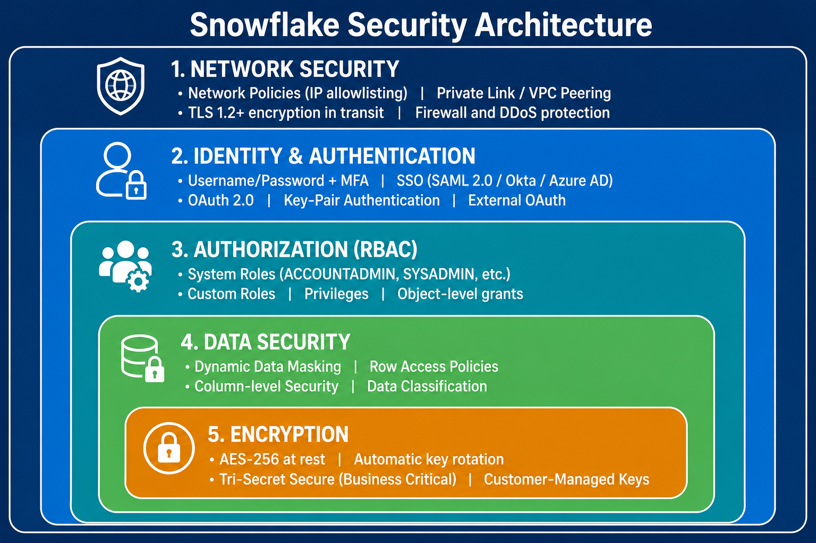

3.2 How Snowflake Security Differs from Traditional Databases
Dimension | Traditional DB (Oracle/SQL Server) | Snowflake
Access Control Model | Mix of roles and direct grants; often schema-level | Pure RBAC — all privileges via roles; never direct to users
User Authentication | DB-native passwords (often unmanaged) | Password + MFA + SSO + OAuth + Key-Pair — all natively supported
Encryption | Often optional or add-on license | AES-256 at rest + TLS in transit — always on, no exceptions
Network Access | Firewall rules at OS/network level | Built-in Network Policies within Snowflake itself
Audit Logging | Optional; separate audit tables | QUERY_HISTORY, ACCESS_HISTORY, LOGIN_HISTORY — always on
Column-Level Security | Expensive add-ons or views | Dynamic Data Masking — native, policy-based (Enterprise+)
Row-Level Security | Complex views or VPD | Row Access Policies — native, centrally managed (Enterprise+)
Data Sharing Security | No built-in sharing — ETL needed | Secure Data Sharing with governed access — no data copy

3.3 RBAC
Role-Based Access Control (RBAC) is a security method where access to systems is given based on a person’s job role. Instead of assigning permissions to each user individually, permissions are grouped into roles, and users get access by being assigned a role.
It was developed in the early 1990s to make managing access easier and more secure in large systems, and it is now widely used in industries like finance, healthcare, and government.

RBAC has three main parts:
- Roles: Groups of permissions based on job functions
- Permissions: Rules that allow actions like viewing or changing data
- Users: People assigned to roles, which decide what they can access
This system improves security, makes access management easier, and helps protect important data while keeping work efficient.

RBAC has several key benefits:
- Better security: Limits access to sensitive data and reduces unauthorized use
- Easier compliance: Helps meet rules like HIPAA, GDPR, and SOX with clear access records
- Simpler management: Changing roles automatically updates user permissions
- Time-saving: Reduces manual work for IT teams and speeds up onboarding
- Higher efficiency: Users get the right access quickly, improving productivity

How RBAC works:

RBAC works by giving users access based on their job roles.
- First, roles are created with specific permissions (what actions are allowed).
- Users are then assigned to these roles instead of receiving individual permissions.
- When a user logs in, the system checks their identity (authentication) and their role (authorization).
- If their role has the required permission, they are allowed to access the resource.
This makes access control simpler, more secure, and easier to manage.

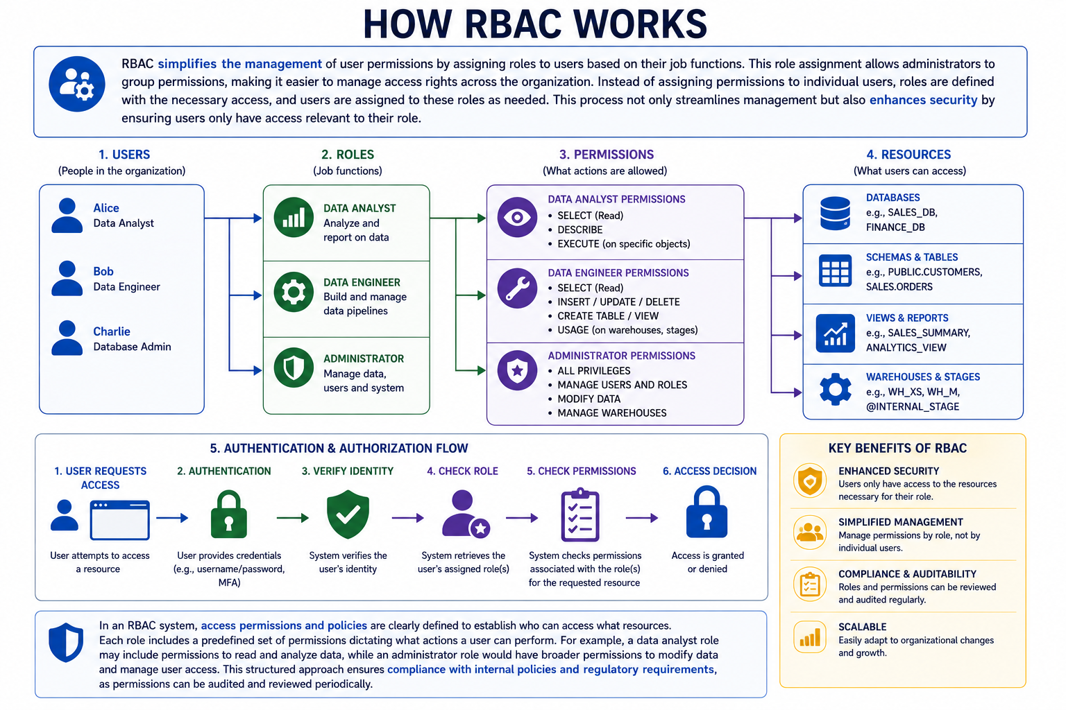

Primary Rules of RBAC
RBAC relies on three primary rules to function effectively, ensuring a structured and secure approach to managing user access. These rules establish a clear hierarchy for how permissions are granted.
1. Role assignment
Before a user can perform any actions or exercise permissions, they must first be assigned to one or more roles. This foundational rule ensures that no user has any privileges within the system unless they are explicitly given a role. It also provides a direct link between a user and their defined access rights.
2. Role authorization
Role authorization ensures that a user is explicitly permitted to hold the roles they are assigned. While role assignment gives a user their role, authorization acts as the security check that confirms they are allowed to use it. This step protects the system by blocking unauthorized access and reducing the risk of misuse.
3. Permission authorization
Permissions are not granted directly to users. Instead, they are exclusively granted through designated role assignments. This creates a clear, role-based relationship where a user’s access stems from their role, not their individual identity.

Examples of RBAC in real world:
- Corporate IT systems: Employees get access based on job roles (e.g., HR staff access employee records, finance staff access financial data). This improves security and reduces manual permission management.
- Cloud environments: Different roles control different levels of system access (e.g., admins manage servers, developers deploy apps). This prevents unauthorized changes.
- Healthcare: Access to patient data is limited by role (e.g., doctors can view and update records, receptionists can only view basic details), helping protect privacy and meet regulations like HIPAA.
- Financial services: Roles separate duties (e.g., traders execute trades, managers approve them, compliance officers review them), reducing fraud risk and supporting regulatory compliance.

Best practices for implementing RBAC:
- Define clear roles: Create roles that match job functions (e.g., data analyst, engineer, scientist) with appropriate permissions.
- Use least privilege: Give users only the minimum access they need to do their work.
- Regular updates: Review and update roles and permissions to reflect job changes or staff turnover.
- Good naming system: Use clear, consistent role names to avoid confusion.
- Monitor and audit: Track role changes and access logs to detect unusual activity.
- Automate alerts: Set up notifications for important changes in permissions or roles.

Challenges and considerations of RBAC:
- Role explosion: Too many roles can make the system complex and hard to manage. This can be reduced by simplifying roles and regularly cleaning up unused ones.
- Overlapping roles: Users with multiple roles may create permission conflicts or security risks, so role assignments must be carefully managed and reviewed.
- Compliance changes: Laws and regulations change over time, so RBAC systems need regular audits and updates to stay compliant.

RBAC vs IAM

While the terms RBAC and IAM (Identity and Access Management) are often used together, they refer to different concepts within the field of access control.
IAM (Identity and Access Management) is a full system that manages user identities, login security, and access throughout a user’s lifecycle (create, manage, and delete accounts).
RBAC (Role-Based Access Control) is a part of IAM that specifically controls access based on user roles.
In short: IAM is the whole system, and RBAC is one method used inside it.

Scope of control

IAM is a full system that manages a user’s entire identity lifecycle—from account creation to deletion. It includes verifying identity, logging in, and managing users over time.
RBAC is only part of IAM and focuses on access control, deciding what a user is allowed to do or access based on their role.

Authentication vs. authorization

IAM covers both authentication and authorization.
Authentication is the process of verifying who a user is (for example, with a username and password). Authorization is the process of determining what systems, data or resources that a user can access.

RBAC is a type of authorization model.

Flexibility of access :
- RBAC is simple but less flexible because access is based only on fixed roles. It works well for smaller organizations but may not handle complex or detailed access needs.
- IAM is more flexible and can use advanced methods like ABAC, where access depends on factors like role, location, or time.

User management approach :
- RBAC: Users are given roles, and each role has permissions. If a job changes, you just change the user’s role to update access.
- IAM: Manages the full user lifecycle, including automatically giving access when someone joins and removing it when they leave.

3.4 Core Security Concepts

Securable Objects
A securable object is anything in Snowflake that needs permissions/security.
Every object in Snowflake is securable:
Object Type | Examples | Key Privileges
Account-Level | Virtual Warehouse, Database, Resource Monitor | USAGE, MONITOR, MODIFY
Schema-Level | Table, View, Stage, File Format, Sequence | SELECT, INSERT, UPDATE, DELETE, TRUNCATE, REFERENCES
Other | User, Role, Integration, Network Policy | CREATE, MONITOR, USAGE, OWNERSHIP

Snowflake hierarchy
Organization
└── Account
└── Database
└── Schema
├── Table
├── View
├── Function
└── Stage
Real example
Company Account
└── SALES_DB
└── PUBLIC schema
├── CUSTOMERS table
├── ORDERS table
└── SALES_VIEW
- SALES_DB = database
- PUBLIC = schema
- CUSTOMERS = table
Every securable object resides within a logical container in a hierarchy of containers. The top-most container is the customer organization. Securable objects such as tables, views, functions, and stages are contained in a schema object, which are in turn contained in a database. All databases for your Snowflake account are contained in the account object. This hierarchy of objects and containers is illustrated below:
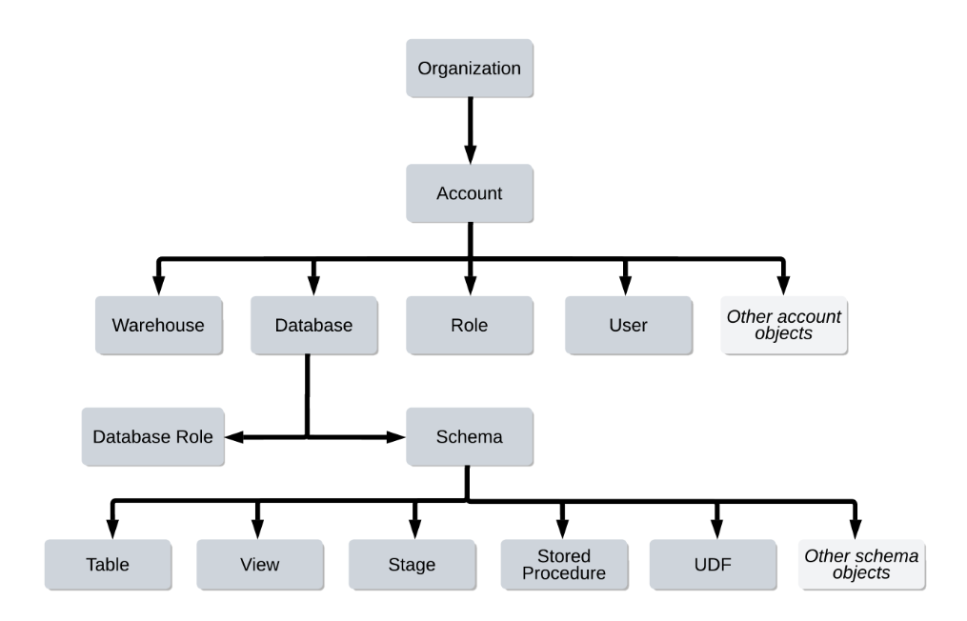

Every object has one owner role.
The owner:
- controls the object
- can grant permissions
- can modify/delete it
Usually, the role that creates the object becomes the owner automatically.
For example:
Suppose role ANALYST_ROLE creates a table:
CREATE TABLE CUSTOMERS (
ID INT,
NAME STRING
);
Here;
ANALYST_ROLE owns CUSTOMERS table
That role can:
- give SELECT access to others
- alter the table
- drop the table

Privileges
A Privilege is a defined level of access to a securable object. Privileges are granted to roles, never directly to users. Key privilege concepts:
- OWNERSHIP: The highest privilege — can grant/revoke all other privileges on the object; every object has exactly one owner role
If a role has OWNERSHIP on an object, it fully controls it.
For Example:
GRANT OWNERSHIP ON TABLE CUSTOMERS TO ROLE MANAGER_ROLE;
Now:
MANAGER_ROLE becomes the new owner
old owner loses ownership

- GRANT OPTION: Allows a role to grant its privileges to other roles (use carefully — creates privilege chains)
- Future Grants: Automatically grant privileges on objects created in the future within a schema or database
- Privilege Inheritance: When Role A is granted to Role B, Role B inherits ALL privileges of Role A
Privileges are permissions.
Privilege | Meaning
SELECT | Read data
INSERT | Add rows
UPDATE | Change rows
DELETE | Remove rows
USAGE | Access object
CREATE | Create objects
OWNERSHIP | Full control
For Example:
Suppose role REPORTING_ROLE gets:
GRANT SELECT ON TABLE CUSTOMERS TO ROLE REPORTING_ROLE;
Now users with that role can Read data
SELECT * FROM CUSTOMERS;
But they cannot:
- Delete rows
- Drop table
- Change structure

Snowflake’s approach to access control combines aspects from the following models:
- Discretionary Access Control (DAC): Each object has an owner, who can in turn grant access to that object.
- Role-based Access Control (RBAC): Access privileges are assigned to roles, which are in turn assigned to users.
- User-based Access Control (UBAC): Access privileges are assigned directly to users. Access control considers privileges assigned directly to users only when USE SECONDARY ROLE is set to ALL.
Several concepts key to understanding access control in Snowflake include:
- Securable object: An entity to which access can be granted. Unless allowed by a grant, access is denied.
- Role: An entity to which privileges can be granted.
- Privilege: A defined level of access to an object. Multiple distinct privileges may be used to control the granularity of access granted.
- User: A user identity recognized by Snowflake, whether associated with a person or service. A user is also an entity to which privileges can be granted.
- The following diagram illustrates how DAC, RBAC, and UBAC support appropriate privilege assignment on different securable objects. In this example, Role 1 has the OWNERSHIP privilege on both Object 1 and Object 2. In other words, Role 1 owns both objects. This illustrates DAC.
- Privileges on Object 1 can be granted to Role 2, which can then be granted to User 1 and User 2. In other words, User 1 and User 2 have access to Object 1, limited by these privileges, because both users are assigned Role 2. This part of the figure illustrates RBAC.
- Privileges on Object 2 can be granted directly to User 3 and User 4. This part of the figure illustrates how you can use UBAC to extend the Snowflake access control framework, providing a significant amount of both control and flexibility.
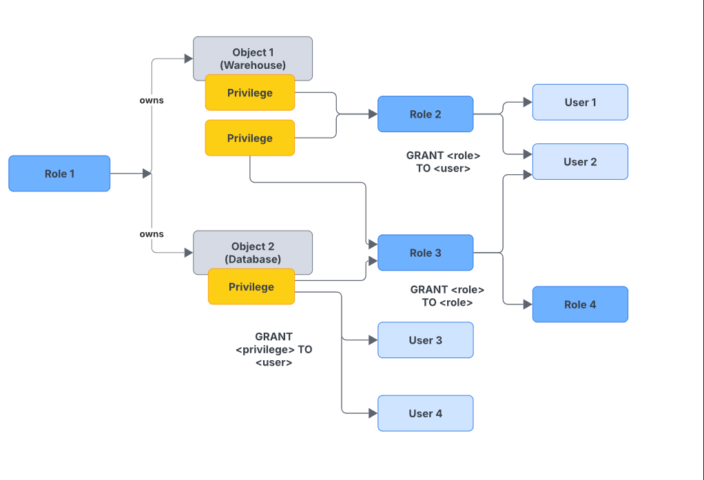

Discretionary Access Control (DAC)
Snowflake combines RBAC with DAC. Under DAC, each object has an owner (a role with OWNERSHIP privilege). The owner can grant privileges on that object to other roles. By default, the role that creates an object becomes its owner.

Key Principle
In Snowflake: PRIVILEGES flow to ROLES. ROLES flow to USERS. Users inherit privileges from their active role and all roles below it in the hierarchy. Understanding this flow is the foundation of everything in this session.

KEY TAKEAWAYS
- Snowflake security is defence-in-depth: Network → Auth → RBAC → Data → Encryption
- All data is encrypted at rest (AES-256) and in transit (TLS 1.2+) — always, no exceptions
- RBAC is Snowflake's core model: privileges → roles → users; never direct user grants
- Every object has an OWNER role — the creator's role by default
- Audit logging (Query History, Access History, Login History) is always active

SECTION 4: System Roles & Role Hierarchy (30 Minutes)

4.1 Snowflake System-Defined Roles
Snowflake provides five built-in system roles that form the foundation of access control in every Snowflake account. These roles are pre-created and cannot be deleted. Understanding their purpose and limitations is critical for any Snowflake administrator.

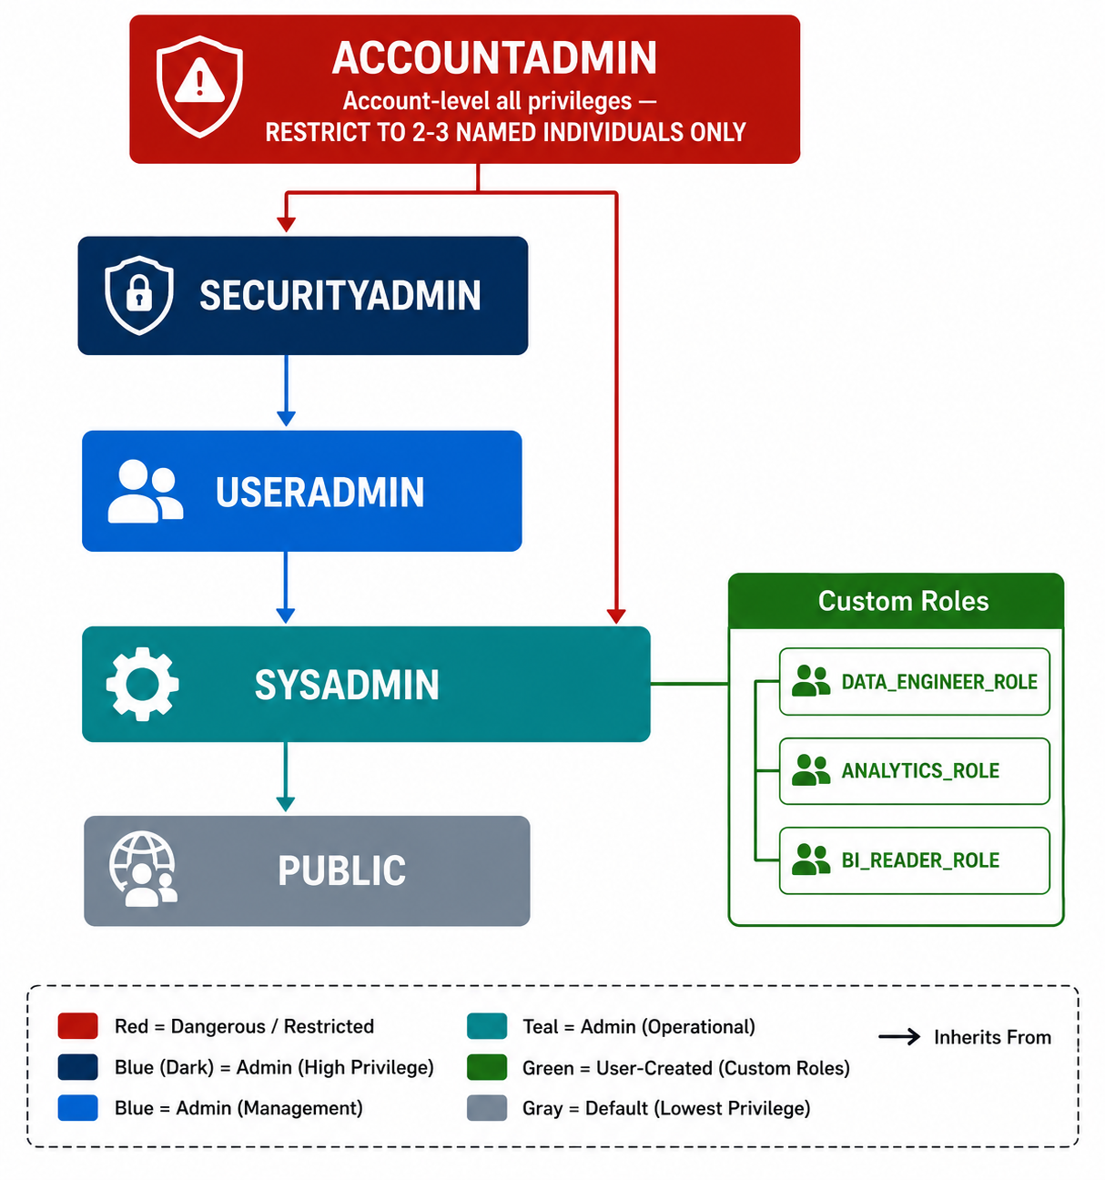

Role :
A role contains permissions (privileges).
Instead of giving permissions directly to users, Snowflake gives permissions to roles, and then roles are assigned to users.
Snowflake | Real World
Role | Job title
Privilege | Permission/access
User | Employee
For example:
- HR role → can access employee salary tables
- Analyst role → can view reports
- Admin role → can manage system settings

Suppose there is a role:
ANALYST_ROLE
This role has:
- SELECT on SALES table
- USAGE on SALES_DB
If user Ravi gets this role:
GRANT ROLE ANALYST_ROLE TO USER RAVI;
Now Ravi can read sales data.

One user can have multiple roles
A user can have many roles.
Example:
Ravi:
- ANALYST_ROLE
- DEVELOPER_ROLE
- FINANCE_ROLE
Ravi can switch roles depending on work.

Active role
At one time, one role is active in the session.
Example:
USE ROLE ANALYST_ROLE;
Now Ravi works as an analyst.
Later:
USE ROLE DEVELOPER_ROLE;
Now Ravi can do developer tasks.

System-defined roles
Snowflake already provides some built-in roles.
Examples:
- ACCOUNTADMIN
- SYSADMIN
- SECURITYADMIN
- USERADMIN
These:
- cannot be deleted
- have important admin permissions
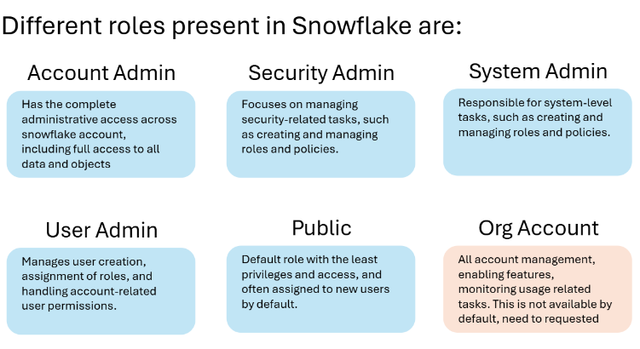

4.2 System Role Reference
Role | Level | Responsibilities | Who Should Have It | Common Mistake
ACCOUNTADMIN | Highest | Full account control: billing, account parameters, resource monitors, all other role privileges | Maximum 2-3 named senior architects/DBAs. NEVER service accounts. | Giving to all DBAs 'for convenience' — catastrophic security risk
SECURITYADMIN | High | Manage users and roles; grant/revoke any privilege on any object; manage network policies | Security team lead, cloud admin lead — 3-5 people maximum | Using it for day-to-day object creation — not its purpose
USERADMIN | Medium-High | Create and manage users and roles ONLY — no object privileges | IT admin team, helpdesk leads who manage access requests | Confusing with SECURITYADMIN — USERADMIN cannot grant object privileges
SYSADMIN | Medium | Create and manage databases, warehouses, schemas, tables, and other Snowflake objects | Data architects, senior data engineers — those who build the platform | Creating tables as SYSADMIN when custom roles should own objects
PUBLIC | Lowest | Default role for every user; minimal privileges (can use public schemas) | Auto-assigned to all users — no additional privileges should be granted | Granting SELECT on sensitive tables to PUBLIC — exposes data to everyone

Custom roles
Custom roles are roles created by your company for specific business needs.
Instead of using only built-in admin roles, companies create their own roles like:
- ANALYST_ROLE
- HR_ROLE
- DATA_ENGINEER_ROLE
This helps organize permissions cleanly and securely.

Who can create custom roles?
1. Account roles
Custom account roles can be created by:
- USERADMIN
- higher admin roles
- any role with CREATE ROLE privilege

Example
CREATE ROLE ANALYST_ROLE;
Now a new custom role exists.

2. Database roles
Database roles are specific to one database.
Only the database owner can create them.

Example
Suppose role DB_ADMIN_ROLE owns database SALES_DB.
Then it can create:
CREATE DATABASE ROLE SALES_DB.REPORTING_ROLE;

3. New roles have no access by default
When a role is created:
- it has NO permissions
- it is NOT assigned to users
- it is NOT connected to other roles
You must configure everything manually.

Example
After:
CREATE ROLE ANALYST_ROLE;
The role still:
- cannot access tables
- is not assigned to users
You must grant permissions:
GRANT SELECT ON TABLE SALES TO ROLE ANALYST_ROLE;
And assign role to user:
GRANT ROLE ANALYST_ROLE TO USER RAVI;

4. Recommended role hierarchy
Snowflake recommends creating a hierarchy of custom roles under SYSADMIN.
Because SYSADMIN should manage all objects in the account.

Recommended structure
SYSADMIN
↓
DATA_TEAM_ROLE
↓
ANALYST_ROLE
This means:
- SYSADMIN inherits all lower role permissions
- system admins can manage everything

5. Why is this important?
Suppose:
ANALYST_ROLE owns SALES tables
If ANALYST_ROLE is connected to SYSADMIN:
- SYSADMIN can manage those tables

But if not connected:
ANALYST_ROLE (separate)
SYSADMIN (separate)
Then:
- SYSADMIN cannot manage those objects
- This becomes a problem for administrators.

6. Who can still manage access then?
If SYSADMIN cannot access the objects, only roles with:
MANAGE GRANTS
can control permissions.
By default, this is usually:
- SECURITYADMIN

7. For Example
Imagine:
Snowflake | Real World
Role | Department
SYSADMIN | Building manager
Custom role | Team access group
Role hierarchy | Reporting structure

Good structure:
Company Admin
↓
IT Department
↓
Developers
Bad structure:
Developers isolated from admins
Then admins lose visibility/control.

Custom roles help companies organize permissions safely, and Snowflake recommends linking them under SYSADMIN so administrators can manage all account objects properly.

4.3 Role Hierarchy & Privilege Inheritance

The diagram shows how roles inherit permissions in a hierarchy. Database roles with specific permissions are assigned to custom account roles, which can then be assigned to higher-level custom roles. The system-defined SYSADMIN role sits at the top and automatically inherits permissions from these custom roles, making access management organized, secure, and easier to maintain.

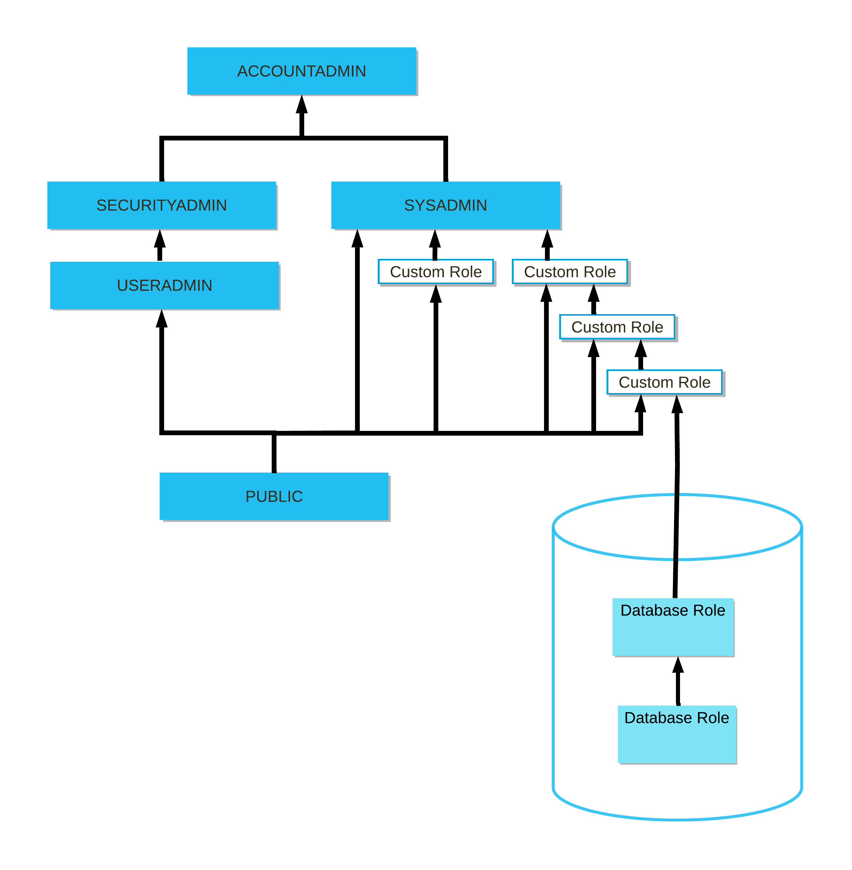

Note

ORGADMIN is a separate system role that manages operations at the organization level. This role is not included in the hierarchy of system roles.

For a more specific example of role hierarchy and privilege inheritance, consider the following scenario:

Role 3 has been granted to Role 2.

Role 2 has been granted to Role 1.

Role 1 has been granted to User 1.

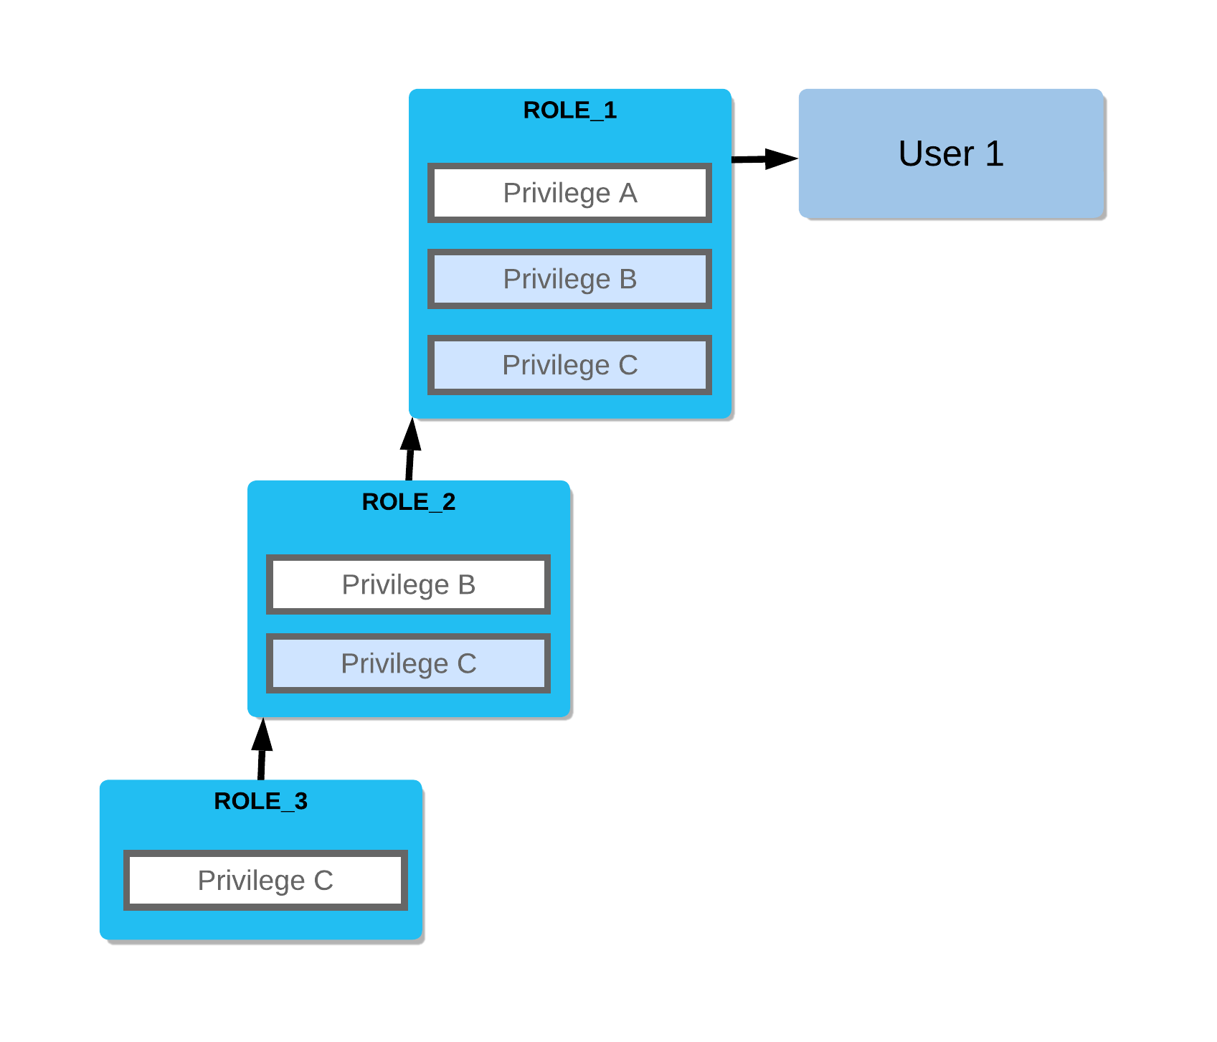

In this scenario:

Role 2 inherits Privilege C.

Role 1 inherits Privileges B and C.

User 1 has all three privileges.

Database roles and role hierarchies

The following limitations currently apply to database roles:

If a database role is granted to a share, then no other database roles can be granted to that database role. For example, if database role d1.r1 is granted to a share, then attempting to grant database role d1.r2 to d1.r1 is blocked.

In addition, if a database role is granted to another database role, the grantee database role cannot be granted to a share.

Database roles that are granted to a share can be granted to other database roles, as well as account roles.

Account roles cannot be granted to database roles in a role hierarchy.

How Inheritance Works
In Snowflake, role hierarchies are created by granting one role to another. When Role A is granted to Role B, Role B inherits ALL privileges of Role A. This is how the system roles work — ACCOUNTADMIN inherits everything from SECURITYADMIN and SYSADMIN.

-- Understanding inheritance with a concrete example:

-- Step 1: Create roles
CREATE ROLE READER_ROLE; -- Can SELECT on reporting tables
CREATE ROLE ANALYST_ROLE; -- Can also write to staging
CREATE ROLE SENIOR_ANALYST_ROLE; -- Can do everything ANALYST_ROLE does + more

SHOW ROLES;

-- Step 2: Grant privileges to READER_ROLE
GRANT USAGE ON DATABASE SALES_DB TO ROLE READER_ROLE;
GRANT USAGE ON SCHEMA SALES_DB.REPORTING TO ROLE READER_ROLE;
GRANT SELECT ON ALL TABLES IN SCHEMA SALES_DB.REPORTING TO ROLE READER_ROLE;

-- Step 3: Grant READER_ROLE to ANALYST_ROLE (inheritance!)
GRANT ROLE READER_ROLE TO ROLE ANALYST_ROLE;
-- ANALYST_ROLE now has all READER_ROLE privileges PLUS any additional grants

-- Step 4: Grant ANALYST_ROLE to SENIOR_ANALYST_ROLE (chain!)
GRANT ROLE ANALYST_ROLE TO ROLE SENIOR_ANALYST_ROLE;
-- SENIOR_ANALYST_ROLE now inherits from ANALYST_ROLE AND READER_ROLE

-- Step 5: ALWAYS grant custom roles to SYSADMIN for visibility
GRANT ROLE READER_ROLE TO ROLE SYSADMIN;
GRANT ROLE ANALYST_ROLE TO ROLE SYSADMIN;
GRANT ROLE SENIOR_ANALYST_ROLE TO ROLE SYSADMIN;

SHOW GRANTS OF ROLE ANALYST_ROLE;
SHOW GRANTS OF ROLE SENIOR_ANALYST_ROLE;
SHOW GRANTS OF ROLE READER_ROLE;

-- Snowflake role inheritance is not magic. It’s just role-to-role grants.
-- If Role A is granted to Role B, B gets everything A has—plus its own privileges.

Critical Best Practice
ALWAYS grant every custom role to SYSADMIN. This ensures SYSADMIN can always manage objects owned by custom roles. Forgetting this step means SYSADMIN cannot DROP or ALTER objects owned by those roles — a very common and painful mistake.

4.4 The Principle of Least Privilege
The Principle of Least Privilege (PoLP) states that every user, process, or service should have the minimum access necessary to perform its function — nothing more. This is the single most important security principle to apply in Snowflake.

Persona | What They Need | What They Should NOT Have
Junior Data Analyst | SELECT on specific reporting tables/views; USAGE on small analytics warehouse | INSERT/UPDATE/DELETE; access to raw/PII data; ACCOUNTADMIN; access to production ETL warehouse
BI Developer (Tableau) | SELECT on reporting schema views; USAGE on small reporting warehouse | Any write access; access to raw schema; ability to create database objects
Data Engineer | CREATE TABLE, INSERT, SELECT, UPDATE on staging/raw schemas; USAGE on ETL warehouse | ACCOUNTADMIN; SECURITYADMIN; production reporting schema write access
Service Account (ETL) | Specific INSERT/COPY privileges on target tables; USAGE on ETL warehouse | Any human-facing roles; SYSADMIN; ability to manage users/roles
DBA/Admin | SYSADMIN for object management; specific use-case roles | Using ACCOUNTADMIN for daily work; access to production data itself

KEY TAKEAWAYS
- 5 system roles: ACCOUNTADMIN > SECURITYADMIN > USERADMIN; SYSADMIN > PUBLIC
- Roles inherit ALL privileges of roles granted to them (transitive inheritance)
- ACCOUNTADMIN: maximum 2-3 named individuals — never service accounts, never daily use
- ALWAYS grant custom roles to SYSADMIN for administrative completeness
- Apply Principle of Least Privilege: minimum access required — nothing more

SECTION 5: Users, Custom Roles & the Privilege Model (30 Minutes)

5.1 User Management

Creating & Managing Users
Users are the human or service identities that connect to Snowflake. Each user has a default role, default warehouse, and default namespace (database/schema) that apply when they connect without specifying overrides.

-- =============================================
-- USER MANAGEMENT COMPLETE REFERENCE
-- =============================================

-- Create a regular analyst user
CREATE USER priya_sharma
PASSWORD = 'Temp@2025!'
LOGIN_NAME = 'priya.sharma@company.com'
DISPLAY_NAME = 'Priya Sharma'
FIRST_NAME = 'Priya'
LAST_NAME = 'Sharma'
EMAIL = 'priya.sharma@company.com'
DEFAULT_ROLE = ANALYTICS_READER
DEFAULT_WAREHOUSE = ANALYTICS_WH
DEFAULT_NAMESPACE = SALES_DB.REPORTING
MUST_CHANGE_PASSWORD = TRUE -- Force password change on first login
COMMENT = 'Senior Data Analyst - Finance Team';

-- Create a service account user (ETL pipeline)
CREATE USER svc_etl_pipeline
RSA_PUBLIC_KEY = '---- BEGIN PUBLIC KEY ----...' -- Key-pair auth
DEFAULT_ROLE = ETL_SERVICE_ROLE
DEFAULT_WAREHOUSE = ETL_WH
DISABLED = FALSE
COMMENT = 'Service account: dbt Cloud ETL pipeline. Owner: Data Eng Team';

-- Modify an existing user
ALTER USER priya_sharma SET DEFAULT_ROLE = SENIOR_ANALYST_ROLE;
ALTER USER priya_sharma SET DEFAULT_WAREHOUSE = LARGE_ANALYTICS_WH;
ALTER USER priya_sharma SET EMAIL = 'priya.sharma.new@company.com';

-- Disable a user (e.g., employee on leave)
ALTER USER priya_sharma SET DISABLED = TRUE;

-- Re-enable
ALTER USER priya_sharma SET DISABLED = FALSE;

-- Reset a user's password
ALTER USER priya_sharma RESET PASSWORD;

-- Force MFA enrollment
ALTER USER priya_sharma SET MINS_TO_ENFORCE_MFA = 0;

-- Drop a user (off-boarding)
DROP USER priya_sharma;

-- Useful inspection queries
SHOW USERS; -- All users in account
DESC USER priya_sharma; -- User details
SHOW GRANTS TO USER priya_sharma; -- Roles granted to this user

5.2 Designing Custom Roles — Enterprise Pattern

The Standard Enterprise Role Design Pattern
For most enterprise Snowflake deployments, adopt a layered role model with Functional Roles (what the person does) wrapping Data Access Roles (what data they can see). This provides granular control and easy management.

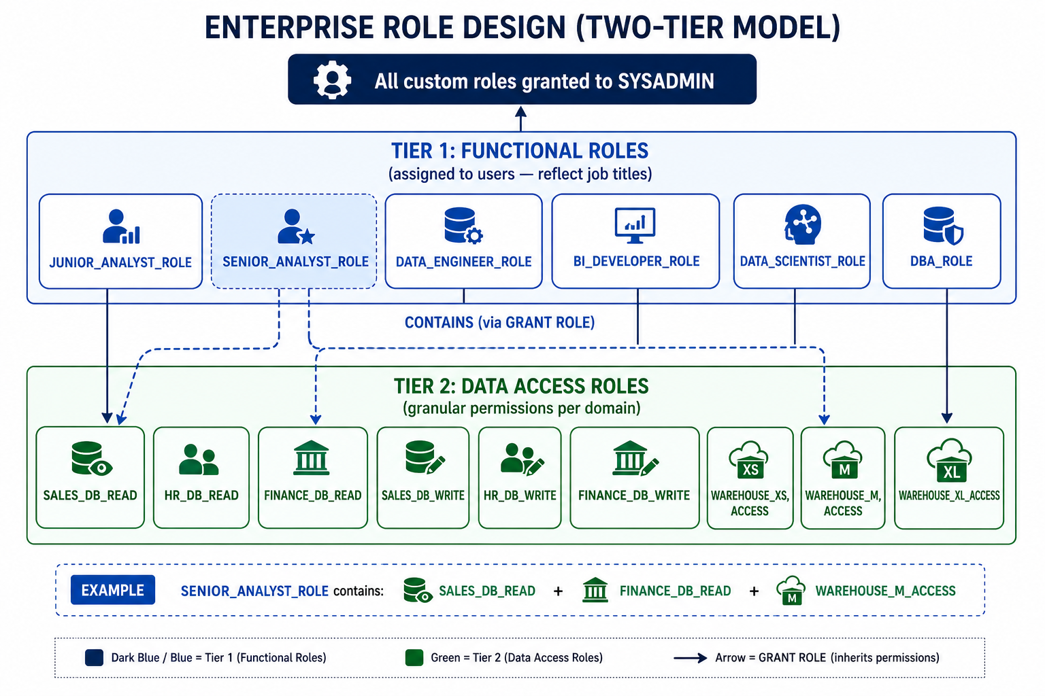

Complete Role Hierarchy SQL — Enterprise Retail Example
-- =============================================
-- ENTERPRISE RBAC DESIGN: RETAIL COMPANY
-- =============================================

USE ROLE SECURITYADMIN;

-- ─────────────────────────────────────────
-- TIER 2: DATA ACCESS ROLES (Granular)
-- ─────────────────────────────────────────

-- Database/Schema access roles
CREATE ROLE SALES_DB_READ COMMENT = 'SELECT on SALES_DB reporting schema';
CREATE ROLE SALES_DB_WRITE COMMENT = 'INSERT/UPDATE on SALES_DB staging schema';
CREATE ROLE HR_DB_READ COMMENT = 'SELECT on HR_DB (masked PII)';
CREATE ROLE FINANCE_DB_READ COMMENT = 'SELECT on FINANCE_DB reporting schema';
CREATE ROLE MARKETING_DB_READ COMMENT = 'SELECT on MARKETING_DB reporting schema';
CREATE ROLE RAW_DATA_READ COMMENT = 'SELECT on all RAW schemas — restricted';

-- Warehouse access roles
CREATE ROLE WH_XS_ACCESS COMMENT = 'USAGE on DEV_WH (X-Small)';
CREATE ROLE WH_SMALL_ACCESS COMMENT = 'USAGE on REPORTING_WH (Small)';
CREATE ROLE WH_MEDIUM_ACCESS COMMENT = 'USAGE on ANALYTICS_WH (Medium)';
CREATE ROLE WH_LARGE_ACCESS COMMENT = 'USAGE on ETL_WH (Large)';

-- ─────────────────────────────────────────
-- TIER 1: FUNCTIONAL ROLES (Assigned to Users)
-- ─────────────────────────────────────────

CREATE ROLE JUNIOR_ANALYST_ROLE COMMENT = 'Junior Analyst — read-only sales reporting';
CREATE ROLE SENIOR_ANALYST_ROLE COMMENT = 'Senior Analyst — read sales + finance';
CREATE ROLE BI_DEVELOPER_ROLE COMMENT = 'BI Dev — all reporting schemas read';
CREATE ROLE DATA_ENGINEER_ROLE COMMENT = 'Data Engineer — write access + ETL';
CREATE ROLE DATA_SCIENTIST_ROLE COMMENT = 'Data Scientist — analytics + raw read';
CREATE ROLE DBA_ADMIN_ROLE COMMENT = 'DBA — full object management';

-- ─────────────────────────────────────────
-- WIRE FUNCTIONAL → DATA ACCESS ROLES
-- ─────────────────────────────────────────

-- Junior Analyst: sales read + XS warehouse
GRANT ROLE SALES_DB_READ TO ROLE JUNIOR_ANALYST_ROLE;
GRANT ROLE WH_SMALL_ACCESS TO ROLE JUNIOR_ANALYST_ROLE;

-- Senior Analyst: sales + finance read + medium warehouse
GRANT ROLE SALES_DB_READ TO ROLE SENIOR_ANALYST_ROLE;
GRANT ROLE FINANCE_DB_READ TO ROLE SENIOR_ANALYST_ROLE;
GRANT ROLE MARKETING_DB_READ TO ROLE SENIOR_ANALYST_ROLE;
GRANT ROLE WH_MEDIUM_ACCESS TO ROLE SENIOR_ANALYST_ROLE;

-- BI Developer: all reporting + small warehouse
GRANT ROLE SALES_DB_READ TO ROLE BI_DEVELOPER_ROLE;
GRANT ROLE FINANCE_DB_READ TO ROLE BI_DEVELOPER_ROLE;
GRANT ROLE HR_DB_READ TO ROLE BI_DEVELOPER_ROLE;
GRANT ROLE MARKETING_DB_READ TO ROLE BI_DEVELOPER_ROLE;
GRANT ROLE WH_SMALL_ACCESS TO ROLE BI_DEVELOPER_ROLE;

-- Data Engineer: write access + large warehouse
GRANT ROLE SALES_DB_READ TO ROLE DATA_ENGINEER_ROLE;
GRANT ROLE SALES_DB_WRITE TO ROLE DATA_ENGINEER_ROLE;
GRANT ROLE WH_LARGE_ACCESS TO ROLE DATA_ENGINEER_ROLE;

-- Data Scientist: read everything including raw
GRANT ROLE SALES_DB_READ TO ROLE DATA_SCIENTIST_ROLE;
GRANT ROLE RAW_DATA_READ TO ROLE DATA_SCIENTIST_ROLE;
GRANT ROLE WH_MEDIUM_ACCESS TO ROLE DATA_SCIENTIST_ROLE;

-- ─────────────────────────────────────────
-- ALWAYS GRANT CUSTOM ROLES TO SYSADMIN
-- ─────────────────────────────────────────

GRANT ROLE SALES_DB_READ TO ROLE SYSADMIN;
GRANT ROLE SALES_DB_WRITE TO ROLE SYSADMIN;
GRANT ROLE HR_DB_READ TO ROLE SYSADMIN;
GRANT ROLE FINANCE_DB_READ TO ROLE SYSADMIN;
GRANT ROLE MARKETING_DB_READ TO ROLE SYSADMIN;
GRANT ROLE RAW_DATA_READ TO ROLE SYSADMIN;
GRANT ROLE WH_XS_ACCESS TO ROLE SYSADMIN;
GRANT ROLE WH_SMALL_ACCESS TO ROLE SYSADMIN;
GRANT ROLE WH_MEDIUM_ACCESS TO ROLE SYSADMIN;
GRANT ROLE WH_LARGE_ACCESS TO ROLE SYSADMIN;
GRANT ROLE JUNIOR_ANALYST_ROLE TO ROLE SYSADMIN;
GRANT ROLE SENIOR_ANALYST_ROLE TO ROLE SYSADMIN;
GRANT ROLE BI_DEVELOPER_ROLE TO ROLE SYSADMIN;
GRANT ROLE DATA_ENGINEER_ROLE TO ROLE SYSADMIN;
GRANT ROLE DATA_SCIENTIST_ROLE TO ROLE SYSADMIN;
GRANT ROLE DBA_ADMIN_ROLE TO ROLE SYSADMIN;

SHOW ROLES;
SHOW GRANTS OF ROLE JUNIOR_ANALYST_ROLE; -- Functional role does NOT hold privileges directly—it inherits them from data + warehouse roles.
SHOW GRANTS OF ROLE SENIOR_ANALYST_ROLE;

SHOW GRANTS TO ROLE SYSADMIN;
-- You will see EVERYTHING assigned to SYSADMIN:
-- All data access roles
-- All functional roles
-- All warehouse roles
-- SYSADMIN acts as visibility role in Snowflake governance—this is why we grant all custom roles to it.

SHOW GRANTS; -- To show full inheritance chain across enterprise

USE ROLE DATA_ENGINEER_ROLE;
SHOW WAREHOUSES;
USE WAREHOUSE COMPUTE_WH;
-- Even though we didn’t grant warehouse directly to user, it works through role inheritance.

-- We have built a 3-layer RBAC model:
-- Functional roles (who you are)
-- Data access roles (what you can access)
-- Warehouse roles (compute access)
-- Functional roles are just containers that inherit everything.

5.3 The Complete Privilege Reference

Privileges by Object Type
Object | Privilege | What It Allows
WAREHOUSE | USAGE | Execute queries and DML statements against this warehouse
WAREHOUSE | MODIFY | Change warehouse size, auto-suspend settings
WAREHOUSE | MONITOR | View warehouse usage metrics in the Snowsight UI
WAREHOUSE | OPERATE | Start, stop, abort queries on the warehouse
DATABASE | USAGE | Reference the database in queries (required for all access below)
DATABASE | CREATE SCHEMA | Create new schemas within this database
DATABASE | MONITOR | View database-level metadata
SCHEMA | USAGE | Reference the schema in queries (required for all object access)
SCHEMA | CREATE TABLE | Create tables within this schema
SCHEMA | CREATE VIEW | Create views within this schema
SCHEMA | CREATE STAGE | Create stages within this schema
TABLE | SELECT | Query (read) table data
TABLE | INSERT | Add new rows to the table
TABLE | UPDATE | Modify existing rows in the table
TABLE | DELETE | Remove rows from the table
TABLE | TRUNCATE | Remove all rows (cannot be rolled back)
TABLE | REFERENCES | Use the table as a foreign key target
VIEW | SELECT | Query the view (underlying table access NOT required)
STAGE | USAGE | Use the stage for loading/unloading data
STAGE | READ | Read files from the stage
STAGE | WRITE | Write files to the stage

Granting Privileges — Complete SQL Patterns
-- =============================================
-- PRIVILEGE GRANT PATTERNS — COMPLETE GUIDE
-- =============================================

USE ROLE SYSADMIN;

-- PATTERN 1: Grant full database access to a role
GRANT USAGE ON DATABASE SALES_DB TO ROLE SALES_DB_READ;
GRANT USAGE ON ALL SCHEMAS IN DATABASE SALES_DB TO ROLE SALES_DB_READ;
GRANT SELECT ON ALL TABLES IN DATABASE SALES_DB TO ROLE SALES_DB_READ;
GRANT SELECT ON ALL VIEWS IN DATABASE SALES_DB TO ROLE SALES_DB_READ;

-- PATTERN 2: Grant schema-specific access
GRANT USAGE ON DATABASE SALES_DB TO ROLE SALES_DB_READ;
GRANT USAGE ON SCHEMA SALES_DB.REPORTING TO ROLE SALES_DB_READ;
GRANT SELECT ON ALL TABLES IN SCHEMA SALES_DB.REPORTING TO ROLE SALES_DB_READ;
GRANT SELECT ON ALL VIEWS IN SCHEMA SALES_DB.REPORTING TO ROLE SALES_DB_READ;

-- PATTERN 3: Future grants (auto-apply to NEW objects created later)
GRANT SELECT ON FUTURE TABLES IN SCHEMA SALES_DB.REPORTING TO ROLE SALES_DB_READ;
GRANT SELECT ON FUTURE VIEWS IN SCHEMA SALES_DB.REPORTING TO ROLE SALES_DB_READ;

-- PATTERN 4: Grant write access for data engineering
GRANT USAGE ON DATABASE SALES_DB TO ROLE SALES_DB_WRITE;
GRANT USAGE ON SCHEMA SALES_DB.STAGING TO ROLE SALES_DB_WRITE;
GRANT SELECT, INSERT, UPDATE, DELETE, TRUNCATE
ON ALL TABLES IN SCHEMA SALES_DB.STAGING TO ROLE SALES_DB_WRITE;
GRANT CREATE TABLE ON SCHEMA SALES_DB.STAGING TO ROLE SALES_DB_WRITE;

-- PATTERN 5: Warehouse access
GRANT USAGE ON WAREHOUSE ANALYTICS_WH TO ROLE WH_MEDIUM_ACCESS;
GRANT MONITOR ON WAREHOUSE ANALYTICS_WH TO ROLE WH_MEDIUM_ACCESS;

-- PATTERN 6: Revoke a privilege
REVOKE SELECT ON ALL TABLES IN SCHEMA SALES_DB.REPORTING FROM ROLE JUNIOR_ANALYST_ROLE;

-- PATTERN 7: Transfer ownership
GRANT OWNERSHIP ON TABLE SALES_DB.REPORTING.SALES_FACT
TO ROLE DATA_ENGINEER_ROLE COPY CURRENT GRANTS;

-- PATTERN 8: Check existing grants
SHOW GRANTS TO ROLE SENIOR_ANALYST_ROLE;
SHOW GRANTS ON DATABASE SALES_DB;
SHOW GRANTS ON TABLE SALES_DB.REPORTING.SALES_FACT;
SHOW FUTURE GRANTS IN SCHEMA SALES_DB.REPORTING;

5.4 Assigning Roles to Users — Complete Patterns
-- Assigning Roles to Users — Complete Patterns
-- Assign functional roles to users
USE ROLE USERADMIN;

CREATE USER rahul_kumar
PASSWORD = 'Test@123'
DEFAULT_ROLE = JUNIOR_ANALYST_ROLE
MUST_CHANGE_PASSWORD = TRUE;

CREATE USER arun_thomas
PASSWORD = 'Test@123'
DEFAULT_ROLE = BI_DEVELOPER_ROLE
MUST_CHANGE_PASSWORD = TRUE;

CREATE USER meera_nair
PASSWORD = 'Test@123'
DEFAULT_ROLE = DATA_ENGINEER_ROLE
MUST_CHANGE_PASSWORD = TRUE;

CREATE USER vikram_iyer
PASSWORD = 'Test@123'
DEFAULT_ROLE = DATA_SCIENTIST_ROLE
MUST_CHANGE_PASSWORD = TRUE;

GRANT ROLE JUNIOR_ANALYST_ROLE TO USER rahul_kumar;
GRANT ROLE SENIOR_ANALYST_ROLE TO USER priya_sharma;
GRANT ROLE BI_DEVELOPER_ROLE TO USER arun_thomas;
GRANT ROLE DATA_ENGINEER_ROLE TO USER meera_nair;
GRANT ROLE DATA_SCIENTIST_ROLE TO USER vikram_iyer;

-- A user can have multiple roles — they switch with USE ROLE
GRANT ROLE JUNIOR_ANALYST_ROLE TO USER rahul_kumar;
GRANT ROLE BI_DEVELOPER_ROLE TO USER rahul_kumar; -- dual role

-- User switches role mid-session
USE ROLE JUNIOR_ANALYST_ROLE; -- Limited access
USE ROLE BI_DEVELOPER_ROLE; -- Broader access

-- Revoke a role from a user (off-boarding or role change)
REVOKE ROLE SENIOR_ANALYST_ROLE FROM USER priya_sharma;
GRANT ROLE DATA_ENGINEER_ROLE TO USER priya_sharma; -- Promotion

SHOW USERS;
SHOW ROLES;
SHOW GRANTS TO USER rahul_kumar;

KEY TAKEAWAYS
- Use a 2-tier role model: Functional Roles (job titles) wrapping Data Access Roles (granular permissions)
- Always grant USAGE on database AND schema before granting any table/view privileges
- Use FUTURE GRANTS to automatically apply privileges to new objects — prevents access gaps
- Always grant custom roles to SYSADMIN — without this, SYSADMIN cannot manage those objects
- Audit grants regularly: SHOW GRANTS TO ROLE <role> and SHOW GRANTS ON <object>

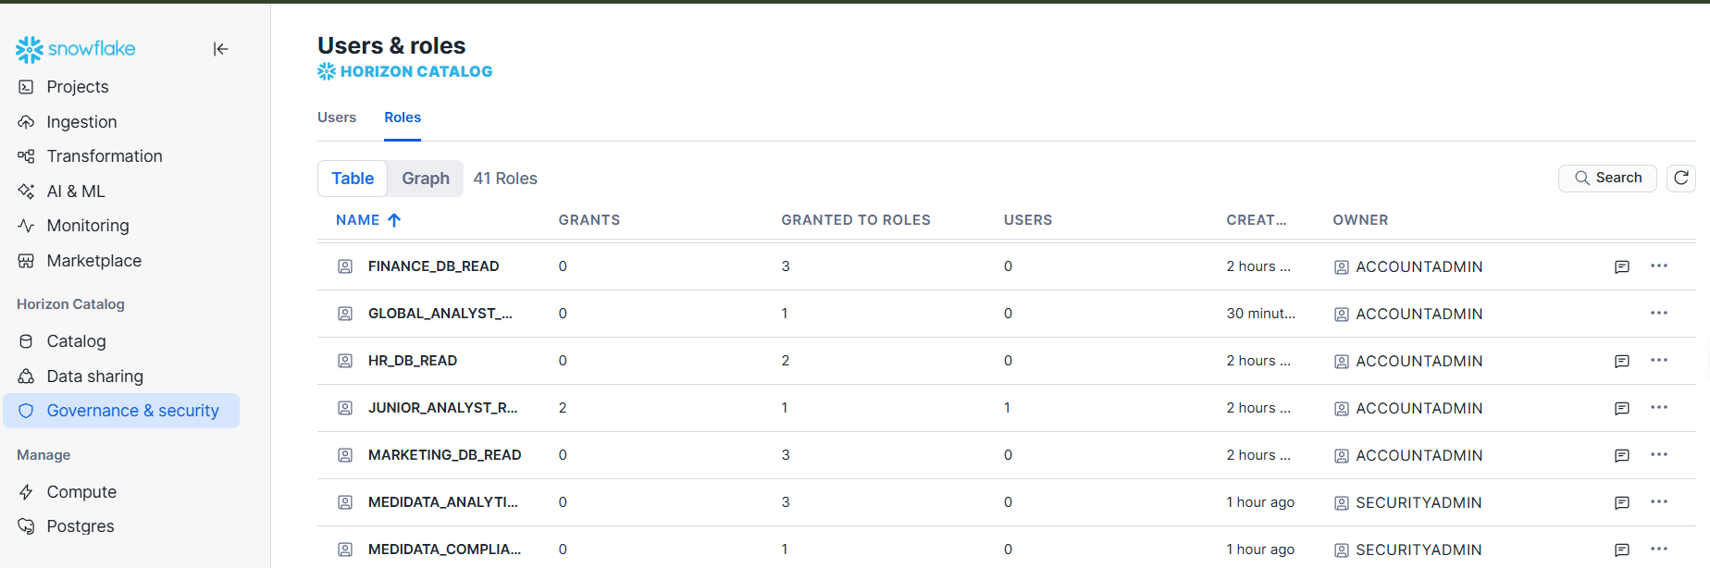

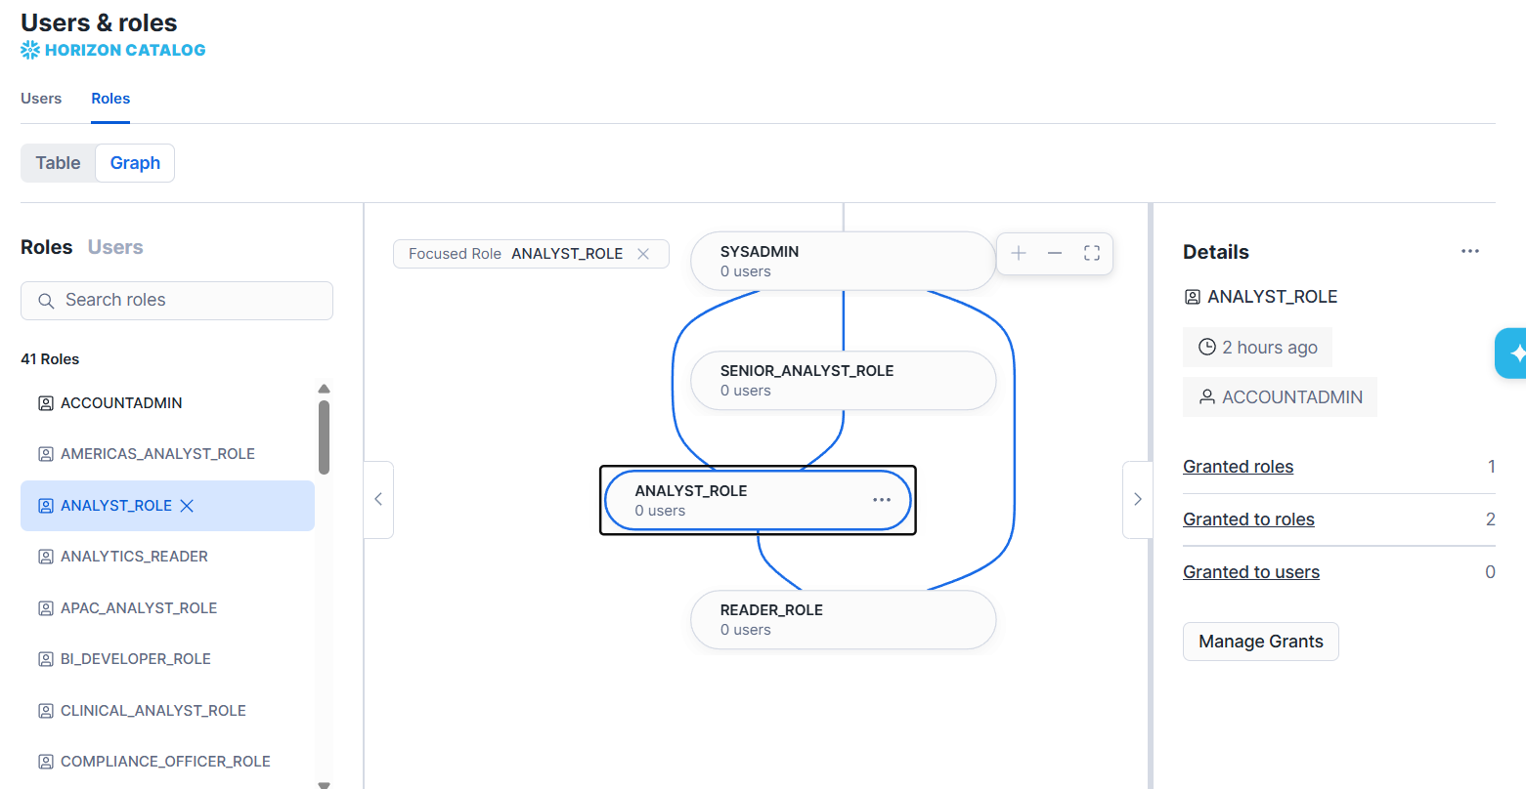

SECTION 6: Authentication Methods (30 Minutes)

6.1 Authentication Overview
Authentication is the process of verifying WHO is connecting to Snowflake. Snowflake supports six distinct authentication methods — from simple username/password to enterprise SSO and programmatic key-pair authentication. Choosing the right method for each use case is a security-critical decision.

Method | Type | Best For | Security Level | Setup Complexity
Username + Password | Basic | Learning/Dev only — NOT for production | Low | Very Low
MFA (Password + Duo) | Multi-Factor | All human users in production | High | Low
SSO (SAML 2.0) | Federated | Enterprise workforce — Okta, Azure AD, Ping | Very High | Medium
OAuth 2.0 | Token-Based | BI tools: Tableau, Power BI, Looker | High | Medium
Key-Pair (RSA) | Certificate | Service accounts, dbt, Airflow, Python scripts | Very High | Medium
External OAuth | Token-Based | Modern apps: Google, Azure AD token flow | Very High | High

6.2 Method 1: Username & Password
The most basic form of authentication. A username and password are stored in Snowflake. Snowflake enforces password complexity (minimum 8 characters, requires uppercase, lowercase, digit). This method alone is NOT recommended for production use — always combine with MFA.
-- Create user with password authentication
CREATE USER analyst_user
PASSWORD = 'SecurePass2025!'
MUST_CHANGE_PASSWORD = TRUE
DEFAULT_ROLE = ANALYTICS_READER;

-- Account-level password policy (enforce complexity)
CREATE PASSWORD POLICY password_policy_prod
PASSWORD_MIN_LENGTH = 12
PASSWORD_MAX_LENGTH = 256
PASSWORD_MIN_UPPER_CASE_CHARS = 1
PASSWORD_MIN_LOWER_CASE_CHARS = 1
PASSWORD_MIN_NUMERIC_CHARS = 1
PASSWORD_MIN_SPECIAL_CHARS = 1
PASSWORD_MAX_AGE_DAYS = 90
PASSWORD_MAX_RETRIES = 5
PASSWORD_LOCKOUT_TIME_MINS = 15
PASSWORD_HISTORY = 10;

-- Apply the password policy to the account
ALTER ACCOUNT SET PASSWORD POLICY password_policy_prod;

6.3 Method 2: Multi-Factor Authentication (MFA)
Multi-factor authentication (MFA) reduces the security risks associated with password authentication. When a password user is enrolled in MFA, they must use a second factor of authentication when signing in to Snowflake. These users enter their password, and then use the second factor.
MFA is intended for human users who authenticate with a password. Service users must use another form of authentication.
Username and password with multi-factor authentication (MFA)
Password authentication lets users access Snowsight by entering a string of characters that conform to the requirements enforced by a password policy. To strengthen the security of this authentication method, Snowflake requires MFA for all password users. With MFA, the user enters a password, and then uses a second factor of authentication to confirm their identity. For example, a user might use a passkey stored on their computer as the second factor of authentication.
Advantages:
Password with MFA implementation is simple.
Challenges:
If passwords are managed by Snowflake, an organization must repeat authentication setup for all of its applications.
MFA adds a second factor (something you have) to the username/password (something you know). Snowflake integrates with Duo Security for MFA. When enabled, users receive a Duo push notification to their mobile device on every login, which they must approve.
- Supported MFA factors: Duo Mobile push notification (default), Duo TOTP code
- MFA can be enforced at account level or per individual user
- MFA bypass period: temporarily disable MFA for a specific user (use carefully)

In Snowflake:
- MFA behavior depends on account edition + org settings
- Some MFA properties are not available in all accounts
- Some commands work only for ACCOUNTADMIN
So don’t rely on every MFA command executing successfully in a trial environment.

-- Check MFA status
SELECT
name,
has_mfa,
disabled
FROM snowflake.account_usage.users
ORDER BY has_mfa;

-- Snowflake MFA enforcement depends on organizational security architecture. In many enterprises, MFA is enforced through SSO providers like Okta, Azure AD, or PingFederate rather than directly in Snowflake.

SELECT *
FROM snowflake.account_usage.users; -- Shows Snowflake monitoring views

-- This is how most enterprises actually implement MFA.
-- User → SSO (Okta/Azure AD)
-- ↓
-- MFA happens here
-- ↓
-- Snowflake Access

Recovering a user who is locked out
If a password user is locked out of Snowflake because they don’t have access to a second factor of authentication, an administrator can help them recover the ability to sign in by temporarily disabling MFA or by helping the user set up a new MFA method.
Prompt user to add a new MFA method
If a user loses access to the MFA method that they use as their second factor of authentication (for example, by losing the YubiKey that stores their passkey), an administrator can help the user set up a new MFA method so that they can sign in to Snowflake.
When a user does not have access to their MFA method and needs to set up a new one, the administrator executes an ALTER USER … ENROLL MFA statement. For example, if user joe needs to establish a new MFA method, the administrator can execute the following:
ALTER USER user_name ENROLL MFA;
- If the user has a verified email, Snowflake sends an email prompting them to add an MFA authentication method.
- If the user doesn’t have a verified email, Snowflake returns the URL of a page that prompts the user to add an MFA authentication method. Administrators can send this URL to the locked-out user.
Temporarily Disable MFA:
If an administrator needs to temporarily disable MFA for a user, they can execute an ALTER USER … SET MINS_TO_BYPASS_MFA statement. For example, to temporarily disable MFA so that user can authenticate with a single-factor password for 30 minutes, execute the following:
ALTER USER user_name SET MINS_TO_BYPASS_MFA = 30;

6.4 Method 3: Single Sign-On (SSO) via SAML 2.0

With SSO for Snowsight, users authenticate with a third-party identity provider (IdP) rather than authenticating with Snowflake directly. When a user accesses Snowsight, the sign-in page includes an option to authenticate with the IdP instead of a Snowflake-managed password. The IdP confirms the user’s identity, and then sends a Security Assertion Markup Language (SAML) assertion to Snowflake. Because Snowflake and the IdP have a previously established relationship of trust, Snowflake accepts the assertion as proof of the user’s identity, and allows the user to access Snowsight.

Some organizations use the same IdP to provide an SSO experience for all of the organization’s applications. These organizations can simply add Snowflake as a new service provider (SP) to allow its employees to use the IdP to access Snowsight.
Advantages:
Single sign-on lets an organization centrally manage authentication. A user authenticates with the same IdP for all of the organization’s applications, not just Snowflake.
Challenges:
Requires configuration of a third-party IdP.
SSO allows users to log into Snowflake using their existing corporate credentials (e.g., their Windows/Office 365 login). This uses the SAML 2.0 standard. Snowflake supports integration with all major Identity Providers (IdPs): Okta, Microsoft Azure AD / Entra ID, Ping Identity, OneLogin, ADFS, and others.

SSO Architecture
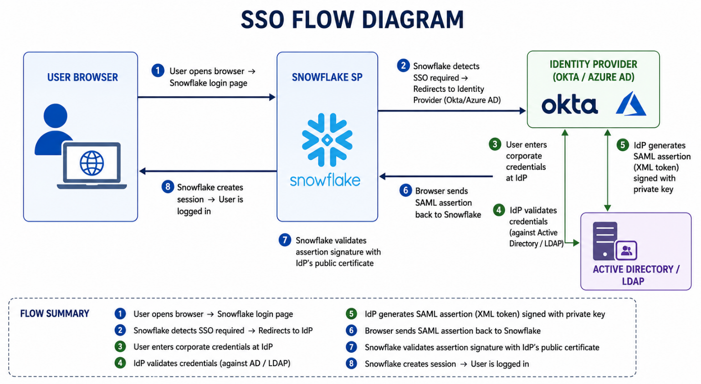

SSO Benefits for Enterprise
With SSO: employees use ONE password for everything; IT manages access in ONE place (Active Directory); when an employee leaves, disabling their AD account immediately revokes Snowflake access; password resets are centralized; MFA managed by IdP.

6.5 Method 4: OAuth 2.0 for BI Tools
OAuth 2.0 is used primarily for BI and analytics tools connecting to Snowflake — Tableau, Power BI, Looker, Qlik, and others. Instead of storing a username/password in the BI tool, OAuth issues a short-lived access token that represents the user's identity and permissions.

Snowflake Supports Two OAuth Flows
- Snowflake OAuth: Built-in OAuth server — simplest setup; Snowflake acts as the authorization server
- External OAuth: Use an external IdP (Okta, Azure AD) as the authorization server — more secure, enterprise-preferred

-- Configure Snowflake OAuth for Tableau
CREATE SECURITY INTEGRATION tableau_oauth
TYPE = OAUTH
ENABLED = TRUE
OAUTH_CLIENT = TABLEAU_SERVER
OAUTH_REDIRECT_URI = 'https://your-tableau-server/auth/add_oauth_token'
OAUTH_ISSUE_REFRESH_TOKENS = TRUE
OAUTH_REFRESH_TOKEN_VALIDITY = 7776000; -- 90 days

-- Get integration details for Tableau configuration
DESC SECURITY INTEGRATION tableau_oauth;
SELECT SYSTEM$SHOW_OAUTH_CLIENT_SECRETS('TABLEAU_OAUTH');

6.6 Method 5: Key-Pair Authentication (RSA)
Key-pair authentication is the most secure method for service accounts and programmatic access (ETL tools, Python scripts, dbt, Airflow, Matillion). It uses RSA public-private key cryptography — no password is ever stored or transmitted.
Snowflake allows a safer login method called key pair authentication instead of using just a username and password.
You create two keys:
- Public key → stored in Snowflake
- Private key → kept securely by the user
When connecting, Snowflake checks that both keys match to verify the user securely. The keys are usually created using OpenSSL with at least 2048-bit RSA encryption.
Snowflake also supports rotating public keys in an effort to allow compliance with more robust security and governance postures.

How Key-Pair Authentication Works
- Generate an RSA key pair (private key + public key) on the client machine
Snowflake lets you use either:
- Encrypted private keys → more secure (recommended)
- Unencrypted private keys → easier but less secure
The choice depends on the Snowflake client you use, and Snowflake suggests checking with your security team before deciding.
Snowflake supports these security algorithms:
- RSA: RS256, RS384, RS512
- ECDSA: ES256, ES384, ES512

- Store the PRIVATE key securely on the client/vault — NEVER share it
The private key is your most secret credential.
Only:
- your application,
- automation job,
- ETL tool,
- or secure vault
  - should have access to it.
  - Nobody else should ever see or copy it.
  - Because anyone with the private key can pretend to be your Snowflake user.
  - So it must be protected like:
- production passwords,
- bank PINs,
- root certificates.
Example:
Suppose your Python ETL app connects to Snowflake.
Instead of:
password = "MyPassword123"
You use:
private_key = load_from_vault()
The app signs requests using the private key.
The private key never leaves the secure vault.

- Upload the PUBLIC key to the Snowflake user account
Snowflake needs a way to verify that signatures created by your private key are genuine.
So you give Snowflake the public key. The public key is safe to share.
Keys come in pairs:
Key Type | Purpose
Private Key | Secret signing
Public Key | Signature verification
Anything signed by the private key can be verified by the public key.

4. Client signs a JWT token with the private key when connecting
When the application wants to log in:
- It creates a JWT token
- It digitally signs the token using the private key
- It sends the signed JWT to Snowflake

JWT = JSON Web Token
It is basically:
- a small identity document,
- digitally signed,
- proving who you are.

5. Snowflake validates the JWT signature using the stored public key
Snowflake receives the JWT.
Then it:
- Reads the token
- Uses the stored public key
- Verifies the signature
If valid:
Snowflake knows the sender owns the correct private key.
Snowflake validates:
- signature is correct
- token not expired
- user exists
- issuer is trusted
For Example:
Snowflake sees:
User: etl_user
It retrieves the stored public key for etl_user.
Then verifies:
Did this JWT come from the matching private key?
If yes:
- authentication succeeds
If not:
- access denied

6. Connection established — no password ever sent
At no point is a password transmitted. Instead identity is proven cryptographically. This is much more secure than password authentication.
Why This is Better Than Passwords
Password Auth | Key Pair Auth
Password travels over network | No password sent
Password can be stolen | Private key stays local
Vulnerable to phishing | Much harder to attack
Humans manage passwords | Better for automation
Password rotation pain | Easier key rotation

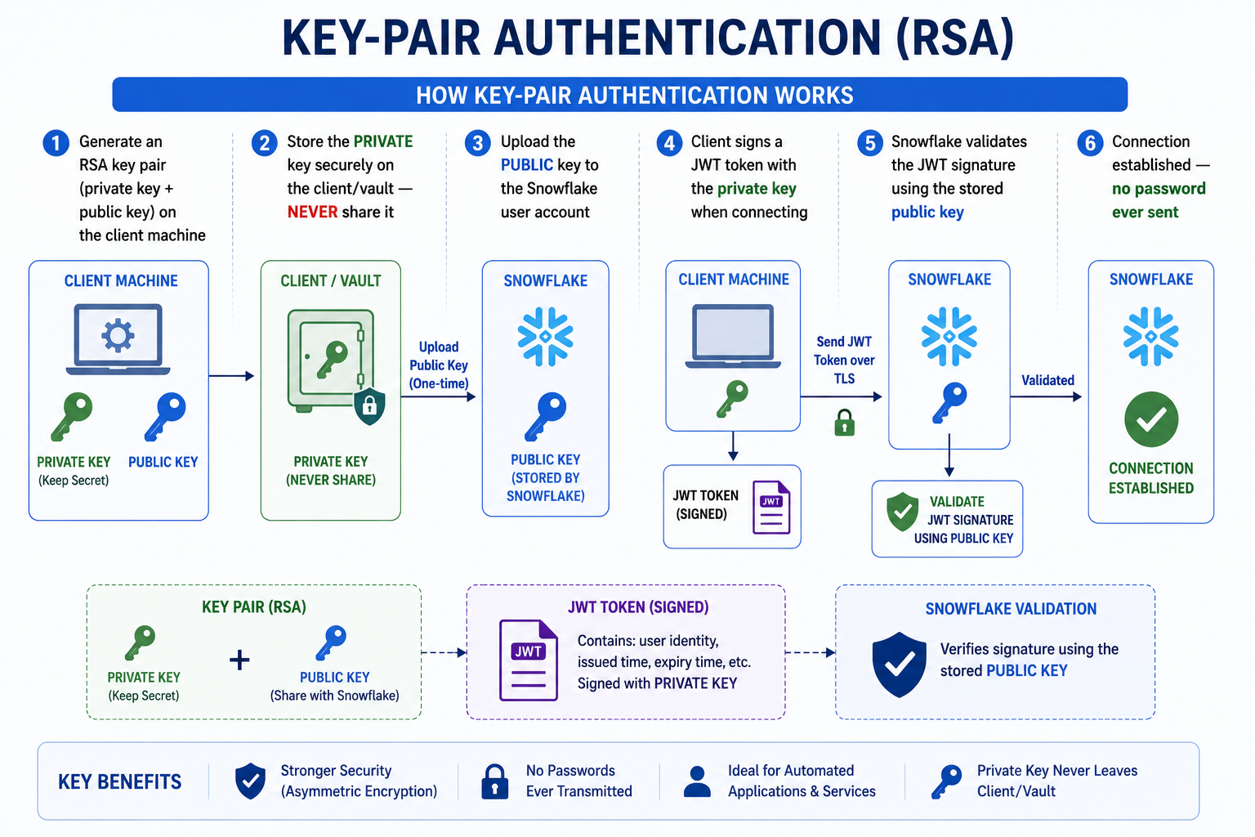

KEY TAKEAWAYS
- Username/Password alone is NOT acceptable for production — always pair with MFA
- SSO (SAML 2.0) is ideal for enterprise workforce — centralized identity management
- Key-Pair authentication is mandatory for all service accounts and ETL tools
- OAuth is the right choice for BI tools: Tableau, Power BI, Looker
- Rotate RSA keys every 90 days using RSA_PUBLIC_KEY and RSA_PUBLIC_KEY_2 dual-key rotation

SECTION 7: Hands-On Lab Part 1 — RBAC Design & Build (30 Minutes)
Lab Setup
Use your Snowflake Trial Account. Run all commands as ACCOUNTADMIN or SECURITYADMIN as instructed. This lab builds a complete RBAC model for a fictional HealthTech company.

7.1 Lab Scenario: MediData Analytics Platform
Business Scenario
MediData is a healthcare analytics company. They have the following teams and access needs: Clinical Analysts: Read anonymized patient outcomes data. NO access to PII. Data Engineers: Load and transform raw clinical data. Write access to staging. BI Developers: Build dashboards from reporting schema. Read-only. Compliance Officer: Read-only access to all schemas for audit. Must see PII. ETL Service Account: Load data via Snowpipe. Specific INSERT only. Your task: Design and implement a complete RBAC model for MediData.

7.2 Complete Lab SQL Script
-- =============================================
-- MEDIDATA ANALYTICS PLATFORM — RBAC LAB
-- =============================================

-- PHASE 1: SETUP AS ACCOUNTADMIN
USE ROLE ACCOUNTADMIN;

-- Create the database structure
CREATE DATABASE IF NOT EXISTS MEDIDATA_DB
DATA_RETENTION_TIME_IN_DAYS = 7
COMMENT = 'MediData Healthcare Analytics Platform';

CREATE SCHEMA MEDIDATA_DB.RAW
COMMENT = 'Raw ingested data — PHI/PII present';
CREATE SCHEMA MEDIDATA_DB.STAGING
COMMENT = 'Transformed data — PII masked';
CREATE SCHEMA MEDIDATA_DB.REPORTING
COMMENT = 'Business-ready analytics — anonymized';
CREATE SCHEMA MEDIDATA_DB.COMPLIANCE
COMMENT = 'Audit and compliance views — full data';

-- Create warehouses
CREATE WAREHOUSE IF NOT EXISTS MEDIDATA_ETL_WH
WAREHOUSE_SIZE = 'MEDIUM' AUTO_SUSPEND = 300 AUTO_RESUME = TRUE
COMMENT = 'ETL and data loading warehouse';

CREATE WAREHOUSE IF NOT EXISTS MEDIDATA_ANALYTICS_WH
WAREHOUSE_SIZE = 'SMALL' AUTO_SUSPEND = 180 AUTO_RESUME = TRUE
COMMENT = 'Analytics and BI warehouse';

-- PHASE 2: CREATE ROLES AS SECURITYADMIN
USE ROLE SECURITYADMIN;

-- Data access roles (granular)
CREATE ROLE MEDIDATA_RAW_READ COMMENT = 'SELECT on RAW schema — PHI access';
CREATE ROLE MEDIDATA_RAW_WRITE COMMENT = 'INSERT/COPY on RAW schema';
CREATE ROLE MEDIDATA_STAGING_READ COMMENT = 'SELECT on STAGING — masked data';
CREATE ROLE MEDIDATA_STAGING_WRITE COMMENT = 'Write access to STAGING schema';
CREATE ROLE MEDIDATA_REPORTING_READ COMMENT = 'SELECT on REPORTING — anonymized';
CREATE ROLE MEDIDATA_COMPLIANCE_READ COMMENT = 'SELECT on COMPLIANCE schema';
CREATE ROLE MEDIDATA_ETL_WH_USAGE COMMENT = 'USAGE on ETL warehouse';
CREATE ROLE MEDIDATA_ANALYTICS_WH_USAGE COMMENT = 'USAGE on Analytics warehouse';

-- Functional roles (job-title level)
CREATE ROLE CLINICAL_ANALYST_ROLE
COMMENT = 'Clinical Analyst — anonymized reporting read';
CREATE ROLE DATA_ENGINEER_ROLE
COMMENT = 'Data Engineer — staging write + ETL warehouse';
CREATE ROLE BI_DEVELOPER_ROLE
COMMENT = 'BI Developer — reporting read + analytics warehouse';
CREATE ROLE COMPLIANCE_OFFICER_ROLE
COMMENT = 'Compliance Officer — all schemas read including PHI';
CREATE ROLE ETL_SERVICE_ROLE
COMMENT = 'Service account role — raw write only';

-- PHASE 3: GRANT OBJECT PRIVILEGES — AS SYSADMIN
USE ROLE SYSADMIN;

-- RAW schema access
GRANT USAGE ON DATABASE MEDIDATA_DB TO ROLE MEDIDATA_RAW_READ;
GRANT USAGE ON SCHEMA MEDIDATA_DB.RAW TO ROLE MEDIDATA_RAW_READ;
GRANT SELECT ON ALL TABLES IN SCHEMA MEDIDATA_DB.RAW TO ROLE MEDIDATA_RAW_READ;
GRANT SELECT ON FUTURE TABLES IN SCHEMA MEDIDATA_DB.RAW TO ROLE MEDIDATA_RAW_READ;

GRANT USAGE ON DATABASE MEDIDATA_DB TO ROLE MEDIDATA_RAW_WRITE;
GRANT USAGE ON SCHEMA MEDIDATA_DB.RAW TO ROLE MEDIDATA_RAW_WRITE;
GRANT INSERT ON ALL TABLES IN SCHEMA MEDIDATA_DB.RAW TO ROLE MEDIDATA_RAW_WRITE;
GRANT CREATE TABLE ON SCHEMA MEDIDATA_DB.RAW TO ROLE MEDIDATA_RAW_WRITE;

-- STAGING schema access
GRANT USAGE ON DATABASE MEDIDATA_DB TO ROLE MEDIDATA_STAGING_READ;
GRANT USAGE ON SCHEMA MEDIDATA_DB.STAGING TO ROLE MEDIDATA_STAGING_READ;
GRANT SELECT ON ALL TABLES IN SCHEMA MEDIDATA_DB.STAGING TO ROLE MEDIDATA_STAGING_READ;
GRANT SELECT ON FUTURE TABLES IN SCHEMA MEDIDATA_DB.STAGING TO ROLE MEDIDATA_STAGING_READ;

GRANT USAGE ON DATABASE MEDIDATA_DB TO ROLE MEDIDATA_STAGING_WRITE;
GRANT USAGE ON SCHEMA MEDIDATA_DB.STAGING TO ROLE MEDIDATA_STAGING_WRITE;
GRANT SELECT, INSERT, UPDATE, DELETE, TRUNCATE
ON ALL TABLES IN SCHEMA MEDIDATA_DB.STAGING TO ROLE MEDIDATA_STAGING_WRITE;
GRANT CREATE TABLE ON SCHEMA MEDIDATA_DB.STAGING TO ROLE MEDIDATA_STAGING_WRITE;

-- REPORTING schema access
GRANT USAGE ON DATABASE MEDIDATA_DB TO ROLE MEDIDATA_REPORTING_READ;
GRANT USAGE ON SCHEMA MEDIDATA_DB.REPORTING TO ROLE MEDIDATA_REPORTING_READ;
GRANT SELECT ON ALL TABLES IN SCHEMA MEDIDATA_DB.REPORTING TO ROLE MEDIDATA_REPORTING_READ;
GRANT SELECT ON ALL VIEWS IN SCHEMA MEDIDATA_DB.REPORTING TO ROLE MEDIDATA_REPORTING_READ;
GRANT SELECT ON FUTURE TABLES IN SCHEMA MEDIDATA_DB.REPORTING TO ROLE MEDIDATA_REPORTING_READ;
GRANT SELECT ON FUTURE VIEWS IN SCHEMA MEDIDATA_DB.REPORTING TO ROLE MEDIDATA_REPORTING_READ;

-- Warehouse grants
GRANT USAGE ON WAREHOUSE MEDIDATA_ETL_WH TO ROLE MEDIDATA_ETL_WH_USAGE;
GRANT USAGE ON WAREHOUSE MEDIDATA_ANALYTICS_WH TO ROLE MEDIDATA_ANALYTICS_WH_USAGE;

-- PHASE 4: WIRE FUNCTIONAL ROLES TO DATA ACCESS ROLES
USE ROLE SECURITYADMIN;

-- Clinical Analyst: reporting read + analytics warehouse
GRANT ROLE MEDIDATA_REPORTING_READ TO ROLE CLINICAL_ANALYST_ROLE;
GRANT ROLE MEDIDATA_ANALYTICS_WH_USAGE TO ROLE CLINICAL_ANALYST_ROLE;

-- Data Engineer: staging read/write + ETL warehouse
GRANT ROLE MEDIDATA_STAGING_READ TO ROLE DATA_ENGINEER_ROLE;
GRANT ROLE MEDIDATA_STAGING_WRITE TO ROLE DATA_ENGINEER_ROLE;
GRANT ROLE MEDIDATA_ETL_WH_USAGE TO ROLE DATA_ENGINEER_ROLE;

-- BI Developer: reporting read + analytics warehouse
GRANT ROLE MEDIDATA_REPORTING_READ TO ROLE BI_DEVELOPER_ROLE;
GRANT ROLE MEDIDATA_ANALYTICS_WH_USAGE TO ROLE BI_DEVELOPER_ROLE;

-- Compliance Officer: all schemas including RAW + analytics warehouse
GRANT ROLE MEDIDATA_RAW_READ TO ROLE COMPLIANCE_OFFICER_ROLE;
GRANT ROLE MEDIDATA_STAGING_READ TO ROLE COMPLIANCE_OFFICER_ROLE;
GRANT ROLE MEDIDATA_REPORTING_READ TO ROLE COMPLIANCE_OFFICER_ROLE;
GRANT ROLE MEDIDATA_COMPLIANCE_READ TO ROLE COMPLIANCE_OFFICER_ROLE;
GRANT ROLE MEDIDATA_ANALYTICS_WH_USAGE TO ROLE COMPLIANCE_OFFICER_ROLE;

-- ETL Service Account: RAW write + ETL warehouse only
GRANT ROLE MEDIDATA_RAW_WRITE TO ROLE ETL_SERVICE_ROLE;
GRANT ROLE MEDIDATA_ETL_WH_USAGE TO ROLE ETL_SERVICE_ROLE;

-- ALWAYS grant to SYSADMIN
GRANT ROLE CLINICAL_ANALYST_ROLE TO ROLE SYSADMIN;
GRANT ROLE DATA_ENGINEER_ROLE TO ROLE SYSADMIN;
GRANT ROLE BI_DEVELOPER_ROLE TO ROLE SYSADMIN;
GRANT ROLE COMPLIANCE_OFFICER_ROLE TO ROLE SYSADMIN;
GRANT ROLE ETL_SERVICE_ROLE TO ROLE SYSADMIN;

-- PHASE 5: CREATE USERS AND ASSIGN ROLES
USE ROLE SECURITYADMIN;

CREATE USER dr_priya_menon
PASSWORD = 'MediData@2025!' MUST_CHANGE_PASSWORD = TRUE
DEFAULT_ROLE = CLINICAL_ANALYST_ROLE
DEFAULT_WAREHOUSE = MEDIDATA_ANALYTICS_WH
EMAIL = 'priya.menon@medidata.com'
COMMENT = 'Clinical Analyst — Oncology Department';
GRANT ROLE CLINICAL_ANALYST_ROLE TO USER dr_priya_menon;

CREATE USER rahul_de
PASSWORD = 'MediData@2025!' MUST_CHANGE_PASSWORD = TRUE
DEFAULT_ROLE = DATA_ENGINEER_ROLE
DEFAULT_WAREHOUSE = MEDIDATA_ETL_WH
EMAIL = 'rahul.de@medidata.com'
COMMENT = 'Data Engineer — Clinical Data Platform';
GRANT ROLE DATA_ENGINEER_ROLE TO USER rahul_de;

CREATE USER svc_snowpipe
DEFAULT_ROLE = ETL_SERVICE_ROLE
DEFAULT_WAREHOUSE = MEDIDATA_ETL_WH
COMMENT = 'Service account: Snowpipe ingestion. Owner: Data Engineering.';
GRANT ROLE ETL_SERVICE_ROLE TO USER svc_snowpipe;

-- PHASE 6: AUDIT AND VERIFICATION
-- Verify role grants
SHOW GRANTS TO ROLE CLINICAL_ANALYST_ROLE;
SHOW GRANTS TO ROLE DATA_ENGINEER_ROLE;
SHOW GRANTS TO ROLE ETL_SERVICE_ROLE;

-- Verify user role assignments
SHOW GRANTS TO USER dr_priya_menon;
SHOW GRANTS TO USER rahul_de;

-- List all users
SHOW USERS;

-- Verify database grants
SHOW GRANTS ON DATABASE MEDIDATA_DB;
SHOW GRANTS ON SCHEMA MEDIDATA_DB.REPORTING;

Lab Validation Check
After completing the setup, test access by switching roles: USE ROLE CLINICAL_ANALYST_ROLE; SELECT CURRENT_ROLE(); — should work USE ROLE CLINICAL_ANALYST_ROLE; SELECT * FROM MEDIDATA_DB.RAW.PATIENTS; — should FAIL (expected!) This confirms the Principle of Least Privilege is correctly enforced.

SECTION 8: Network Policies & Data Governance (20 Minutes)

8.1 Network Policies
A Network Policy in Snowflake restricts Snowflake access to specific IP address ranges (allowlist) and optionally blocks specific IPs (blocklist). This is your first line of network-level defence — ensuring only traffic from trusted networks can reach your Snowflake account.

How Network Policies Work
- Network policies are defined with ALLOWED_IP_LIST and BLOCKED_IP_LIST (CIDR notation)
- Can be applied at account level (all users) or per individual user
- User-level policy overrides account-level policy for that user
- If an IP is in both allowed and blocked lists — BLOCKED takes precedence
- Snowflake Support IPs are automatically exempt from network policies
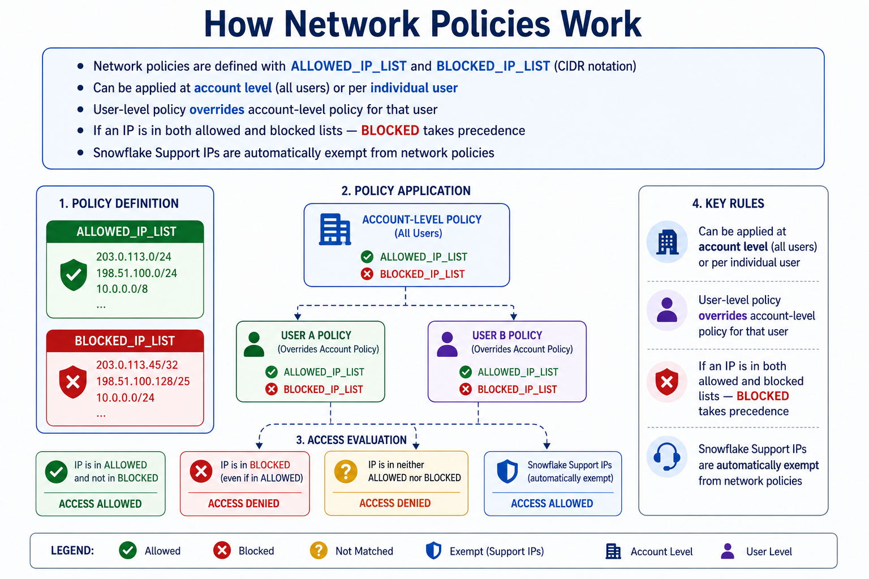

8.2 Dynamic Data Masking (Enterprise+)
Dynamic Data Masking (DDM) lets you define masking policies on columns. The same query returns different results depending on the querying user's role — full data for authorized roles, masked/obscured data for others. The masking happens dynamically at query time — there is only ONE copy of data.
Why Dynamic Data Masking Matters
Without DDM, organizations create multiple copies of data — one with PII for compliance teams, one masked for analysts. This creates data synchronization nightmares and doubles storage costs. With DDM, ONE table, ONE policy, different views based on role.

-- =========================================================
-- MEDIDATA — DYNAMIC DATA MASKING
-- =========================================================

-- =========================================================
-- STEP 1 — USE ADMIN ROLE
-- =========================================================
USE ROLE ACCOUNTADMIN;

-- =========================================================
-- STEP 2 — CREATE DATABASE + SCHEMA
-- =========================================================
CREATE DATABASE IF NOT EXISTS MEDIDATA_DB;

CREATE SCHEMA IF NOT EXISTS MEDIDATA_DB.STAGING;

-- =========================================================
-- STEP 3 — CREATE ROLES
-- =========================================================
CREATE ROLE IF NOT EXISTS CLINICAL_ANALYST_ROLE;
CREATE ROLE IF NOT EXISTS COMPLIANCE_OFFICER_ROLE;

-- Grant roles to SYSADMIN so you can test easily
GRANT ROLE CLINICAL_ANALYST_ROLE TO ROLE SYSADMIN;
GRANT ROLE COMPLIANCE_OFFICER_ROLE TO ROLE SYSADMIN;

-- =========================================================
-- STEP 4 — CREATE SAMPLE TABLE
-- =========================================================
USE ROLE SYSADMIN;

USE DATABASE MEDIDATA_DB;
USE SCHEMA STAGING;

CREATE OR REPLACE TABLE PATIENTS (
patient_id INT,
full_name VARCHAR,
dob DATE,
aadhaar_id VARCHAR,
diagnosis VARCHAR
);

-- =========================================================
-- STEP 5 — INSERT SAMPLE DATA
-- =========================================================
INSERT INTO PATIENTS VALUES
(1, 'Rajesh Kumar', '1980-03-15', '2345-6789-0123', 'Diabetes'),

(2, 'Priya Menon', '1992-07-21', '8765-4321-9876', 'Hypertension');

-- =========================================================
-- STEP 6 — GRANT ACCESS TO CLINICAL ANALYST ROLE
-- =========================================================
GRANT USAGE ON DATABASE MEDIDATA_DB
TO ROLE CLINICAL_ANALYST_ROLE;

GRANT USAGE ON SCHEMA MEDIDATA_DB.STAGING
TO ROLE CLINICAL_ANALYST_ROLE;

GRANT SELECT ON TABLE MEDIDATA_DB.STAGING.PATIENTS
TO ROLE CLINICAL_ANALYST_ROLE;

-- =========================================================
-- STEP 7 — CREATE MASKING POLICIES
-- =========================================================
USE ROLE ACCOUNTADMIN;

-- ---------------------------------------------------------
-- Policy 1 — Mask Patient Name
-- ---------------------------------------------------------
CREATE OR REPLACE MASKING POLICY mask_patient_name
AS (val VARCHAR)
RETURNS VARCHAR ->
CASE
WHEN CURRENT_ROLE() IN (
'COMPLIANCE_OFFICER_ROLE',
'ACCOUNTADMIN',
'SYSADMIN'
)
THEN val

ELSE REGEXP_REPLACE(val, '[A-Za-z]', 'X')
END;

-- ---------------------------------------------------------
-- Policy 2 — Mask DOB
-- ---------------------------------------------------------
CREATE OR REPLACE MASKING POLICY mask_dob
AS (val DATE)
RETURNS DATE ->
CASE
WHEN CURRENT_ROLE() IN (
'COMPLIANCE_OFFICER_ROLE',
'ACCOUNTADMIN',
'SYSADMIN'
)
THEN val

ELSE DATE_FROM_PARTS(YEAR(val),1,1)
END;

-- ---------------------------------------------------------
-- Policy 3 — Mask Aadhaar ID
-- ---------------------------------------------------------
CREATE OR REPLACE MASKING POLICY mask_national_id
AS (val VARCHAR)
RETURNS VARCHAR ->
CASE
WHEN CURRENT_ROLE() IN (
'COMPLIANCE_OFFICER_ROLE',
'ACCOUNTADMIN',
'SYSADMIN'
)
THEN val

ELSE '****-****-****'
END;

-- ---------------------------------------------------------
-- Policy 4 — Mask Diagnosis
-- ---------------------------------------------------------
CREATE OR REPLACE MASKING POLICY mask_diagnosis
AS (val VARCHAR)
RETURNS VARCHAR ->
CASE
WHEN CURRENT_ROLE() IN (
'COMPLIANCE_OFFICER_ROLE',
'ACCOUNTADMIN',
'SYSADMIN'
)
THEN val

ELSE '*** RESTRICTED ***'
END;

-- =========================================================
-- STEP 8 — APPLY MASKING POLICIES
-- =========================================================
ALTER TABLE MEDIDATA_DB.STAGING.PATIENTS
MODIFY COLUMN full_name
SET MASKING POLICY mask_patient_name;

ALTER TABLE MEDIDATA_DB.STAGING.PATIENTS
MODIFY COLUMN dob
SET MASKING POLICY mask_dob;

ALTER TABLE MEDIDATA_DB.STAGING.PATIENTS
MODIFY COLUMN aadhaar_id
SET MASKING POLICY mask_national_id;

ALTER TABLE MEDIDATA_DB.STAGING.PATIENTS
MODIFY COLUMN diagnosis
SET MASKING POLICY mask_diagnosis;

-- =========================================================
-- STEP 9 — TEST AS SYSADMIN (FULL DATA VISIBLE)
-- =========================================================
USE ROLE SYSADMIN;

SELECT CURRENT_ROLE();

SELECT *
FROM MEDIDATA_DB.STAGING.PATIENTS;

-- =========================================================
-- EXPECTED OUTPUT
-- =========================================================
-- Rajesh Kumar
-- 1980-03-15
-- 2345-6789-0123
-- Diabetes

-- =========================================================
-- STEP 10 — TEST AS CLINICAL_ANALYST_ROLE
-- =========================================================
USE ROLE CLINICAL_ANALYST_ROLE;

SELECT CURRENT_ROLE();

SELECT *
FROM MEDIDATA_DB.STAGING.PATIENTS;

-- =========================================================
-- EXPECTED OUTPUT
-- =========================================================
-- XXXXXX XXXXX
-- 1980-01-01
-- ****-****-****
-- *** RESTRICTED ***

8.3 Row Access Policies (Enterprise+)
Row Access Policies (RAP) control WHICH ROWS a user can see in a query result, based on their role or other attributes. Unlike views (which are static), RAPs are centrally managed policies that apply across all queries on the table — even if accessed through other views or joins.
-- =========================================================
-- ROW ACCESS POLICIES — REGIONAL DATA ISOLATION
-- =========================================================
-- Scenario:
-- APAC analysts → only APAC rows
-- EMEA analysts → only EMEA rows
-- GLOBAL analysts → all rows
-- ACCOUNTADMIN/SYSADMIN → all rows

-- =========================================================
-- STEP 1 — USE ADMIN ROLE
-- =========================================================
USE ROLE ACCOUNTADMIN;

-- =========================================================
-- STEP 2 — CREATE DATABASE + SCHEMA
-- =========================================================
CREATE DATABASE IF NOT EXISTS SALES_DB;

CREATE SCHEMA IF NOT EXISTS SALES_DB.REPORTING;

-- =========================================================
-- STEP 3 — CREATE ROLES
-- =========================================================
CREATE ROLE IF NOT EXISTS APAC_ANALYST_ROLE;
CREATE ROLE IF NOT EXISTS EMEA_ANALYST_ROLE;
CREATE ROLE IF NOT EXISTS AMERICAS_ANALYST_ROLE;
CREATE ROLE IF NOT EXISTS GLOBAL_ANALYST_ROLE;

-- Optional: grant to SYSADMIN for testing
GRANT ROLE APAC_ANALYST_ROLE TO ROLE SYSADMIN;
GRANT ROLE EMEA_ANALYST_ROLE TO ROLE SYSADMIN;
GRANT ROLE AMERICAS_ANALYST_ROLE TO ROLE SYSADMIN;
GRANT ROLE GLOBAL_ANALYST_ROLE TO ROLE SYSADMIN;

-- =========================================================
-- STEP 4 — CREATE SALES TABLE
-- =========================================================
USE ROLE ACCOUNTADMIN;

USE DATABASE SALES_DB;
USE SCHEMA REPORTING;

CREATE OR REPLACE TABLE SALES_FACT (
sale_id INT,
customer_name VARCHAR,
region VARCHAR,
sales_amount NUMBER(10,2)
);

-- =========================================================
-- STEP 5 — INSERT SAMPLE DATA
-- =========================================================
INSERT INTO SALES_FACT VALUES
(1, 'ABC Corp', 'APAC', 12000),
(2, 'XYZ Ltd', 'EMEA', 18000),
(3, 'Nova Inc', 'Americas', 25000),
(4, 'Zen Corp', 'APAC', 15000),
(5, 'Beta LLC', 'EMEA', 22000),
(6, 'Delta Co', 'Americas', 30000);

-- =========================================================
-- STEP 6 — CREATE ROLE-REGION MAPPING TABLE
-- =========================================================
CREATE OR REPLACE TABLE SALES_ROLE_REGION_MAP (
role_name VARCHAR(100),
region VARCHAR(50)
);

INSERT INTO SALES_ROLE_REGION_MAP VALUES
('APAC_ANALYST_ROLE', 'APAC'),
('EMEA_ANALYST_ROLE', 'EMEA'),
('AMERICAS_ANALYST_ROLE', 'Americas'),
('GLOBAL_ANALYST_ROLE', 'APAC'),
('GLOBAL_ANALYST_ROLE', 'EMEA'),
('GLOBAL_ANALYST_ROLE', 'Americas');

-- =========================================================
-- STEP 7 — GRANT ACCESS TO ROLES
-- =========================================================
GRANT USAGE ON DATABASE SALES_DB
TO ROLE APAC_ANALYST_ROLE;

GRANT USAGE ON SCHEMA SALES_DB.REPORTING
TO ROLE APAC_ANALYST_ROLE;

GRANT SELECT ON TABLE SALES_DB.REPORTING.SALES_FACT
TO ROLE APAC_ANALYST_ROLE;

-- ---------------------------------------------------------

GRANT USAGE ON DATABASE SALES_DB
TO ROLE EMEA_ANALYST_ROLE;

GRANT USAGE ON SCHEMA SALES_DB.REPORTING
TO ROLE EMEA_ANALYST_ROLE;

GRANT SELECT ON TABLE SALES_DB.REPORTING.SALES_FACT
TO ROLE EMEA_ANALYST_ROLE;

-- ---------------------------------------------------------

GRANT USAGE ON DATABASE SALES_DB
TO ROLE AMERICAS_ANALYST_ROLE;

GRANT USAGE ON SCHEMA SALES_DB.REPORTING
TO ROLE AMERICAS_ANALYST_ROLE;

GRANT SELECT ON TABLE SALES_DB.REPORTING.SALES_FACT
TO ROLE AMERICAS_ANALYST_ROLE;

-- ---------------------------------------------------------

GRANT USAGE ON DATABASE SALES_DB
TO ROLE GLOBAL_ANALYST_ROLE;

GRANT USAGE ON SCHEMA SALES_DB.REPORTING
TO ROLE GLOBAL_ANALYST_ROLE;

GRANT SELECT ON TABLE SALES_DB.REPORTING.SALES_FACT
TO ROLE GLOBAL_ANALYST_ROLE;

-- =========================================================
-- STEP 8 — CREATE ROW ACCESS POLICY
-- =========================================================
USE ROLE ACCOUNTADMIN;

CREATE OR REPLACE ROW ACCESS POLICY regional_data_policy
AS (region VARCHAR)
RETURNS BOOLEAN ->

CURRENT_ROLE() IN ('ACCOUNTADMIN','SYSADMIN')

OR EXISTS (

SELECT 1
FROM SALES_DB.REPORTING.SALES_ROLE_REGION_MAP

WHERE role_name = CURRENT_ROLE()

AND SALES_ROLE_REGION_MAP.region = region
);

-- =========================================================
-- STEP 9 — APPLY POLICY TO TABLE
-- =========================================================
ALTER TABLE SALES_DB.REPORTING.SALES_FACT
ADD ROW ACCESS POLICY regional_data_policy
ON (region);

-- =========================================================
-- STEP 10 — TEST AS SYSADMIN
-- =========================================================
USE ROLE SYSADMIN;

SELECT CURRENT_ROLE();

SELECT region, COUNT(*)
FROM SALES_DB.REPORTING.SALES_FACT
GROUP BY region;

-- =========================================================
-- EXPECTED OUTPUT
-- =========================================================
-- APAC 2
-- EMEA 2
-- Americas 2

-- =========================================================
-- STEP 11 — TEST AS APAC ANALYST
-- =========================================================
USE ROLE APAC_ANALYST_ROLE;

SELECT CURRENT_ROLE();

SELECT region, COUNT(*)
FROM SALES_DB.REPORTING.SALES_FACT
GROUP BY region;

-- =========================================================
-- EXPECTED OUTPUT
-- =========================================================
-- APAC 2

-- =========================================================
-- STEP 12 — TEST AS EMEA ANALYST
-- =========================================================
USE ROLE EMEA_ANALYST_ROLE;

SELECT CURRENT_ROLE();

SELECT region, COUNT(*)
FROM SALES_DB.REPORTING.SALES_FACT
GROUP BY region;

-- =========================================================
-- EXPECTED OUTPUT
-- =========================================================
-- EMEA 2

-- =========================================================
-- STEP 13 — TEST AS GLOBAL ANALYST
-- =========================================================
USE ROLE GLOBAL_ANALYST_ROLE;

SELECT CURRENT_ROLE();

SELECT region, COUNT(*)
FROM SALES_DB.REPORTING.SALES_FACT
GROUP BY region;

-- =========================================================
-- EXPECTED OUTPUT
-- =========================================================
-- APAC 2
-- EMEA 2
-- Americas 2

8.4 Access History & Auditing
Snowflake provides comprehensive audit logging through the ACCOUNT_USAGE schema. This data is available up to 1 year and is critical for compliance audits, security investigations, and governance reporting.
-- =============================================
-- AUDIT QUERIES — GOVERNANCE & COMPLIANCE
-- =============================================

USE ROLE ACCOUNTADMIN;

-- =========================================================
-- QUERY 1 — QUERY HISTORY
-- Who accessed what in last 7 days?
-- =========================================================
SELECT
start_time,
user_name,
role_name,
database_name,
schema_name,
execution_status,
query_text
FROM SNOWFLAKE.ACCOUNT_USAGE.QUERY_HISTORY
WHERE start_time >= DATEADD(DAY, -7, CURRENT_TIMESTAMP())
ORDER BY start_time DESC
LIMIT 50;

-- =========================================================
-- EXPECTED OUTPUT
-- =========================================================
-- QUERY_START_TIME
-- USER_NAME
-- ROLE_NAME
-- DATABASE_NAME
-- QUERY_TEXT
-- EXECUTION_STATUS

-- =========================================================
-- QUERY 2 — LOGIN HISTORY
-- Detect unusual login attempts
-- =========================================================
SELECT
event_timestamp,
user_name,
client_ip,
reported_client_type,
is_success,
error_message
FROM SNOWFLAKE.ACCOUNT_USAGE.LOGIN_HISTORY
WHERE event_timestamp >= DATEADD(DAY, -7, CURRENT_TIMESTAMP())
ORDER BY event_timestamp DESC;

-- =========================================================
-- EXPECTED OUTPUT
-- =========================================================
-- USER_NAME
-- CLIENT_IP
-- IS_SUCCESS
-- ERROR_MESSAGE

-- =========================================================
-- QUERY 3 — FAILED LOGIN ANALYSIS
-- Security investigation
-- =========================================================
SELECT
user_name,
client_ip,
COUNT(*) AS failed_attempts
FROM SNOWFLAKE.ACCOUNT_USAGE.LOGIN_HISTORY
WHERE is_success = 'NO'
AND event_timestamp >= DATEADD(HOUR, -24, CURRENT_TIMESTAMP())
GROUP BY user_name, client_ip
HAVING COUNT(*) > 3
ORDER BY failed_attempts DESC;

-- =========================================================
-- EXPECTED OUTPUT
-- =========================================================
-- USER_NAME
-- CLIENT_IP
-- FAILED_ATTEMPTS

-- =========================================================
-- QUERY 4 — ACCESS HISTORY
-- Who queried sensitive tables?
-- =========================================================
SELECT
ah.query_start_time,
ah.user_name,
qh.role_name,
ah.direct_objects_accessed
FROM SNOWFLAKE.ACCOUNT_USAGE.ACCESS_HISTORY ah
JOIN SNOWFLAKE.ACCOUNT_USAGE.QUERY_HISTORY qh
ON ah.query_id = qh.query_id
WHERE ah.query_start_time >= DATEADD(DAY, -30, CURRENT_TIMESTAMP())
ORDER BY ah.query_start_time DESC
LIMIT 50;

-- =========================================================
-- IMPORTANT NOTE FOR TRAINING
-- =========================================================
-- ACCESS_HISTORY may have 45–90 minute latency.
-- Some trial accounts may not expose full access history.

-- =========================================================
-- QUERY 5 — ROLE GRANT AUDIT
-- Who granted which role?
-- =========================================================
SELECT
created_on,
role,
grantee_name,
granted_by
FROM SNOWFLAKE.ACCOUNT_USAGE.GRANTS_TO_USERS
ORDER BY created_on DESC
LIMIT 50;

-- =========================================================
-- EXPECTED OUTPUT
-- =========================================================
-- CREATED_ON
-- ROLE
-- GRANTEE_NAME
-- GRANTED_BY

-- =========================================================
-- QUERY 6 — USERS WITHOUT MFA
-- Compliance monitoring
-- =========================================================
SELECT
name,
login_name,
email,
created_on,
disabled
FROM SNOWFLAKE.ACCOUNT_USAGE.USERS
WHERE disabled = FALSE
AND name NOT ILIKE 'SVC_%'
ORDER BY created_on DESC;

-- =========================================================
-- NOTE:
-- has_mfa column may not exist in all Snowflake editions.
-- Some orgs enforce MFA externally through SSO/Okta/Azure AD.
-- =========================================================

-- =========================================================
-- ACTIVE ROLES
-- =========================================================
SHOW ROLES;

-- =========================================================
-- USER ROLE ASSIGNMENTS
-- =========================================================
SHOW GRANTS TO USER rahul_de;

-- =========================================================
-- CURRENT SESSION CONTEXT
-- =========================================================
SELECT
CURRENT_USER(),
CURRENT_ROLE(),
CURRENT_WAREHOUSE(),
CURRENT_DATABASE(),
CURRENT_SCHEMA();

KEY TAKEAWAYS
- Network Policies restrict Snowflake access to specific IP ranges — first line of network defence
- Dynamic Data Masking: same table, one policy, different data visible per role — no data duplication
- Row Access Policies: control which ROWS each role sees — centrally managed, applies everywhere
- ACCOUNT_USAGE schema provides 1-year audit log: query history, login history, access history
- Always monitor failed logins and users without MFA for security compliance

SECTION 9: Quiz & Interview Questions

9.1 Multiple Choice Quiz — 5 Questions

Q1: Which system role should be used to create databases, schemas, and warehouses?
A) ACCOUNTADMIN
B) SECURITYADMIN
C) SYSADMIN
D) USERADMIN

Q2: In Snowflake RBAC, what does 'GRANT ROLE R1 TO ROLE R2' mean?
A) R1 gets all privileges of R2
B) R2 inherits all privileges of R1
C) Both roles get the same privileges
D) R1 is deleted and merged into R2

Q3: A user queries a table and gets 'Access Denied.' Which of these is NOT a likely cause?
A) USAGE privilege missing on the database
B) USAGE privilege missing on the schema
C) Virtual Warehouse too small for the query
D) SELECT privilege not granted on the table

Q4: What is the recommended authentication method for service accounts and ETL pipelines?
A) Username + Password
B) SSO via SAML 2.0
C) Key-Pair (RSA) Authentication
D) MFA with Duo Mobile

Q5: How does Dynamic Data Masking differ from creating separate masked tables/views?
A) DDM only works with JSON data
B) DDM creates encrypted copies of data
C) DDM applies dynamically at query time from ONE table — no data duplication
D) DDM requires a separate database

10.3 Interview Questions & Model Answers
Interview Question | Strong Answer Points
Explain Snowflake RBAC | Privileges granted to Roles; Roles granted to Users. 5 system roles: ACCOUNTADMIN>SECURITYADMIN>USERADMIN; SYSADMIN>PUBLIC. Custom roles sit under SYSADMIN. Role hierarchy enables privilege inheritance. Never grant directly to users.
What is the difference between SECURITYADMIN and USERADMIN? | SECURITYADMIN: can manage users/roles AND grant/revoke any privilege on any object. USERADMIN: can ONLY create/manage users and roles — cannot grant object privileges. SECURITYADMIN is a superset.
How would you onboard a new Data Analyst in Snowflake? | 1) Create user with MUST_CHANGE_PASSWORD=TRUE 2) Grant appropriate functional role 3) Set DEFAULT_ROLE, DEFAULT_WAREHOUSE, DEFAULT_NAMESPACE 4) Enforce MFA 5) Brief them on data governance policies
What is Dynamic Data Masking and when would you use it? | DDM applies a policy at query time — same table, different results per role. Use when: PII data (names, SSN, Aadhaar) accessed by multiple teams with different clearance levels. Eliminates need for multiple copies of data.
How do you audit who accessed sensitive data in Snowflake? | Query SNOWFLAKE.ACCOUNT_USAGE.ACCESS_HISTORY for object-level access and QUERY_HISTORY for full query text. Both retain 1 year. ACCESS_HISTORY tracks direct and indirect object access even through views.
What is the OWNERSHIP privilege and why does it matter? | OWNERSHIP is the highest privilege on an object — the owner role can grant/revoke all other privileges. By default, the role that creates an object owns it. Critical for: SYSADMIN should own infrastructure objects; custom roles should own domain objects.
How does key-pair authentication work in Snowflake? | Generate RSA key pair. Store private key securely (vault). Upload public key to Snowflake user. Client signs a JWT with private key. Snowflake validates JWT signature using stored public key. No password ever transmitted. Rotate every 90 days using RSA_PUBLIC_KEY and RSA_PUBLIC_KEY_2.

SECTION 11: FAQs & Troubleshooting

11.1 Frequently Asked Questions
Question | Answer
Can a user have multiple roles simultaneously? | A user can be GRANTED multiple roles, but can only USE one role at a time per session. They switch with USE ROLE. However, secondary roles can be enabled with USE SECONDARY ROLES ALL to use all granted roles simultaneously.
What is the difference between a role and a user? | A USER is an identity (human or service) that connects to Snowflake. A ROLE is a collection of privileges. Users receive roles; roles receive privileges. A user with no role can connect but cannot do anything useful.
If I DROP a role, what happens to objects it owns? | Snowflake will not allow you to DROP a role that owns objects — you get an error. First TRANSFER OWNERSHIP of all owned objects to another role, then DROP the role.
Can I grant a role to itself? Create circular role grants? | Snowflake prevents circular role grants and will return an error. Role A cannot be in A's own hierarchy.
What is the PUBLIC role and should I grant privileges to it? | PUBLIC is automatically granted to every user. Any privilege on PUBLIC is inherited by all users. NEVER grant privileges on sensitive objects to PUBLIC. It is only appropriate for truly public/shared resources.
How do I find what privileges a specific user has? | SHOW GRANTS TO USER <username> shows roles. Then SHOW GRANTS TO ROLE <rolename> for each role. For comprehensive view, query SNOWFLAKE.ACCOUNT_USAGE.GRANTS_TO_ROLES and GRANTS_TO_USERS.
Can Snowflake admins see my data? | Snowflake employees have limited, audited access to infrastructure. Your DATA is encrypted with keys managed by Snowflake (or your own CMK on Business Critical). All Snowflake employee access is logged and auditable.
What is Tri-Secret Secure? | A Business Critical feature where data is encrypted with a combination of Snowflake's key + your own HSM-managed key + your cloud provider key. Snowflake alone cannot decrypt your data without your key — maximum security.

11.2 Troubleshooting Guide
Error / Problem | Root Cause | Diagnosis Query | Resolution
SQL access control error: Insufficient privileges to operate on SCHEMA | Missing USAGE on database or schema | SHOW GRANTS TO ROLE <role> | GRANT USAGE ON DATABASE X TO ROLE Y; GRANT USAGE ON SCHEMA X.Y TO ROLE Y;
Object 'TABLE_NAME' does not exist | Missing USAGE on namespace OR object genuinely doesn't exist | SELECT * FROM INFORMATION_SCHEMA.TABLES WHERE TABLE_NAME='X' | Grant USAGE on DB/Schema; verify table name and current schema context
Insufficient privileges to operate on warehouse | Missing USAGE privilege on the virtual warehouse | SHOW GRANTS ON WAREHOUSE <wh_name> | GRANT USAGE ON WAREHOUSE <wh> TO ROLE <role>
Role '<ROLE>' does not exist | Trying to USE a role not granted to the user | SHOW GRANTS TO USER <username> | GRANT ROLE <role_name> TO USER <username>
Your IP address is not allowed to connect | User's IP blocked by Network Policy | SHOW NETWORK POLICIES | Add IP to ALLOWED_IP_LIST or create user-level policy exception
Login failed for user — too many failed attempts | Account locked after exceeding PASSWORD_MAX_RETRIES | SELECT * FROM ACCOUNT_USAGE.LOGIN_HISTORY WHERE USER_NAME='X' | ALTER USER <username> SET MINS_TO_UNLOCK=0 (requires ACCOUNTADMIN)
FUTURE GRANTS not applying to new tables | FUTURE GRANT applied AFTER existing objects — only applies to NEW objects | SHOW FUTURE GRANTS IN SCHEMA <schema> | Re-run GRANT ON ALL TABLES for existing objects + keep FUTURE GRANT for new ones

SECTION 12: Session Summary & RBAC Cheat Sheet

12.1 Day 2 Master Summary
Topic | Key Concepts Covered
Security Model | Defence-in-depth: Network → Auth → RBAC → Data → Encryption. AES-256 + TLS always on.
System Roles | ACCOUNTADMIN (max 3 people), SECURITYADMIN, USERADMIN, SYSADMIN (daily admin), PUBLIC (default)
Role Hierarchy | Roles inherit from child roles. Always grant custom roles to SYSADMIN. PoLP always.
Users | CREATE with DEFAULT_ROLE, DEFAULT_WAREHOUSE. MUST_CHANGE_PASSWORD for humans. Key-pair for services.
Privileges | USAGE on DB + Schema required before any object access. FUTURE GRANTS prevent access gaps.
Authentication | Password+MFA for humans, SSO for enterprise, Key-Pair for services, OAuth for BI tools.
Network Policies | ALLOWED_IP_LIST + BLOCKED_IP_LIST. Account-level or user-level. User-level overrides account.
Dynamic Data Masking | One table, one policy, role-based column masking at query time. No data duplication.
Row Access Policies | Role-based row filtering. Applied centrally. Works through views and joins.
Auditing | ACCOUNT_USAGE: QUERY_HISTORY, LOGIN_HISTORY, ACCESS_HISTORY, USERS, GRANTS_TO_USERS — 1-year retention.

12.2 RBAC Quick-Reference SQL Cheat Sheet
-- =============================================
-- SNOWFLAKE RBAC CHEAT SHEET — DAY 2
-- =============================================

-- ── ROLE MANAGEMENT ──
CREATE ROLE my_role COMMENT = 'Description';
DROP ROLE my_role;
GRANT ROLE child_role TO ROLE parent_role;
GRANT ROLE my_role TO USER my_user;
REVOKE ROLE my_role FROM USER my_user;
SHOW ROLES;
SHOW GRANTS TO ROLE my_role;
SHOW GRANTS OF ROLE my_role;

-- ── USER MANAGEMENT ──
CREATE USER u PASSWORD='P@ss!' DEFAULT_ROLE=R DEFAULT_WAREHOUSE=WH MUST_CHANGE_PASSWORD=TRUE;
ALTER USER u SET DISABLED=TRUE; -- Disable (offboarding)
ALTER USER u SET DISABLED=FALSE; -- Re-enable
ALTER USER u RESET PASSWORD; -- Force password reset
ALTER USER u SET DAYS_TO_EXPIRY=90; -- Temp/contractor user
ALTER USER u SET MINS_TO_ENFORCE_MFA=0; -- Enforce MFA immediately
DROP USER u;
SHOW USERS;
DESC USER u;
SHOW GRANTS TO USER u;

-- ── PRIVILEGE GRANTS ──
GRANT USAGE ON DATABASE db TO ROLE r;
GRANT USAGE ON SCHEMA db.schema TO ROLE r;
GRANT SELECT ON ALL TABLES IN SCHEMA db.schema TO ROLE r;
GRANT SELECT ON FUTURE TABLES IN SCHEMA db.schema TO ROLE r;
GRANT SELECT ON ALL VIEWS IN SCHEMA db.schema TO ROLE r;
GRANT SELECT ON FUTURE VIEWS IN SCHEMA db.schema TO ROLE r;
GRANT INSERT, UPDATE, DELETE ON ALL TABLES IN SCHEMA db.s TO ROLE r;
GRANT CREATE TABLE ON SCHEMA db.schema TO ROLE r;
GRANT USAGE ON WAREHOUSE wh TO ROLE r;
GRANT USAGE ON STAGE db.schema.my_stage TO ROLE r;
REVOKE SELECT ON ALL TABLES IN SCHEMA db.schema FROM ROLE r;
SHOW GRANTS ON DATABASE db;
SHOW GRANTS ON SCHEMA db.schema;
SHOW GRANTS ON TABLE db.schema.tbl;
SHOW FUTURE GRANTS IN SCHEMA db.schema;

-- ── NETWORK POLICIES ──
CREATE NETWORK POLICY p ALLOWED_IP_LIST=('10.0.0.0/8') BLOCKED_IP_LIST=('10.1.2.3/32');
ALTER ACCOUNT SET NETWORK_POLICY=p;
ALTER USER u SET NETWORK_POLICY=p;
ALTER ACCOUNT UNSET NETWORK_POLICY;
ALTER USER u UNSET NETWORK_POLICY;
SHOW NETWORK POLICIES;

-- ── DYNAMIC DATA MASKING ──
CREATE MASKING POLICY mp AS (val VARCHAR) RETURNS VARCHAR ->
CASE WHEN CURRENT_ROLE() IN ('ADMIN_ROLE') THEN val ELSE '****' END;
ALTER TABLE tbl MODIFY COLUMN col SET MASKING POLICY mp;
ALTER TABLE tbl MODIFY COLUMN col UNSET MASKING POLICY;
SHOW MASKING POLICIES;

-- ── ROW ACCESS POLICY ──
CREATE ROW ACCESS POLICY rap AS (region VARCHAR) RETURNS BOOLEAN ->
CURRENT_ROLE()='ACCOUNTADMIN' OR EXISTS (SELECT 1 FROM map WHERE role=CURRENT_ROLE() AND map.region=region);
ALTER TABLE tbl ADD ROW ACCESS POLICY rap ON (region);
ALTER TABLE tbl DROP ROW ACCESS POLICY rap;

-- ── PASSWORD POLICY ──
CREATE PASSWORD POLICY pp PASSWORD_MIN_LENGTH=12 PASSWORD_MAX_AGE_DAYS=90 PASSWORD_MAX_RETRIES=5;
ALTER ACCOUNT SET PASSWORD POLICY pp;

-- ── KEY-PAIR AUTH ──
ALTER USER svc_user SET RSA_PUBLIC_KEY='<public-key-content>';
ALTER USER svc_user SET RSA_PUBLIC_KEY_2='<new-key-for-rotation>';
ALTER USER svc_user UNSET RSA_PUBLIC_KEY;

-- ── AUDIT QUERIES ──
SELECT * FROM snowflake.account_usage.query_history
WHERE start_time >= DATEADD('days',-7,CURRENT_TIMESTAMP()) ORDER BY start_time DESC;
SELECT * FROM snowflake.account_usage.login_history
WHERE is_success='NO' ORDER BY event_timestamp DESC;
SELECT name, has_mfa, disabled FROM snowflake.account_usage.users WHERE has_mfa=FALSE AND disabled=FALSE;
SELECT * FROM snowflake.account_usage.grants_to_users ORDER BY created_on DESC;

12.3 Enterprise Security Checklist
Category | Checklist Item | Priority | Done?
Roles | ACCOUNTADMIN limited to max 3 named people | Critical | ☐
Roles | All custom roles granted to SYSADMIN | Critical | ☐
Roles | No object privileges granted to PUBLIC | Critical | ☐
Roles | Two-tier role model implemented (functional + access roles) | High | ☐
Users | All human users have MFA enabled | Critical | ☐
Users | Service accounts use key-pair authentication | Critical | ☐
Users | MUST_CHANGE_PASSWORD=TRUE set for new users | High | ☐
Users | Contractor/vendor users have DAYS_TO_EXPIRY set | High | ☐
Network | Network Policy applied at account level | High | ☐
Network | Private Link configured for production (Business Critical) | Medium | ☐
Data | Dynamic Data Masking on PII columns | Critical (GDPR/HIPAA) | ☐
Data | Row Access Policies for multi-tenant/regional data | High | ☐
Audit | ACCOUNT_USAGE queries scheduled for weekly review | High | ☐
Audit | Failed login alerts configured | High | ☐
Audit | Users without MFA report run monthly | High | ☐
Auth | SSO configured for all human users | High | ☐
Auth | RSA key rotation schedule established (90-day) | Medium | ☐
Passwords | Password Policy applied to account | High | ☐

Day 2 Complete! Security is not optional — it is the foundation of every Snowflake deployment.
Resources: docs.snowflake.com | community.snowflake.com | learn.snowflake.com | trial.snowflake.com

