SNOWFLAKE
ENTERPRISE TRAINING PROGRAM

DAY 3
Snowflake SQL Essentials &
Advanced Analytics SQL

Session Duration | 4 Hours (Instructor-Led)
Training Day | Day 3 of Snowflake Training Series
Delivery Mode | Classroom / Virtual (Zoom / MS Teams)
Level | Beginner to Intermediate
Target Audience | Freshers, Data Analysts, SQL Developers, Data Engineers, BI Developers, Cloud Engineers
Prerequisites | Day 1 & Day 2 Completion (or equivalent)
Document Version | v1.0 — Enterprise Edition

TRAINER-READY DOCUMENT | PREMIUM ENTERPRISE EDITION
Based on Official Snowflake Documentation & Enterprise Best Practices

SESSION AGENDA
This 4-hour session is structured to balance theory, live demonstrations, hands-on practice, and interactive engagement. The agenda below gives the trainer a clear time roadmap.

Time Block | Topic / Activity
0:00 – 0:10 | Welcome, Recap of Day 1 & Day 2, Session Overview
0:10 – 0:30 | Section 1A: SQL Fundamentals — Databases, Schemas, Tables, Data Types
0:30 – 0:55 | Section 1B: DML — SELECT Deep Dive, Filtering, Sorting, Aggregation
0:55 – 1:05 | CHECKPOINT + Poll: SQL Basics Quiz (10 min)
1:05 – 1:30 | Section 1C: Advanced Filtering — CASE, NULL Handling, Functions
1:30 – 2:00 | Section 1D: JOINs Deep Dive + Set Operators (Live Demo + Lab)
2:00 – 2:10 | SHORT BREAK (10 min)
2:10 – 2:30 | Section 1E: Subqueries, CTEs, Temp Tables, Views
2:30 – 3:00 | Section 2A: Window Functions — ROW_NUMBER, RANK, DENSE_RANK, LEAD, LAG
3:00 – 3:15 | HANDS-ON LAB: Window Function Challenge
3:15 – 3:40 | Section 2B: Advanced Analytics — Pivot, Qualify, Deduplication, Time-Series
3:40 – 3:50 | Section 2C: Query Optimization & Best Practices
3:50 – 4:00 | Summary, Interview Q&A, Homework Assignment, Q&A

LEARNING OBJECTIVES
By the end of this 4-hour session, participants will be able to:

Section 1 — Snowflake SQL Essentials
- Create and manage databases, schemas, and tables using DDL commands in Snowflake
- Write complete DML scripts including INSERT, UPDATE, DELETE, and MERGE
- Execute complex SELECT queries with WHERE, GROUP BY, HAVING, ORDER BY, and DISTINCT
- Apply all data type categories available in Snowflake with conversion functions
- Use CASE expressions, NULL-handling functions (COALESCE, IFNULL, NVL), and CAST
- Apply built-in Date/Time, String, and Numeric functions in real reporting scenarios
- Write all JOIN types (INNER, LEFT, RIGHT, FULL OUTER, CROSS, SELF) with confidence
- Combine result sets using UNION, UNION ALL, INTERSECT, and MINUS
- Construct subqueries, correlated subqueries, CTEs, Temporary & Transient tables
- Create and query Standard Views and understand Materialized View basics

Section 2 — Advanced Analytics SQL
- Understand and apply Window Functions with OVER, PARTITION BY, and ORDER BY
- Use ROW_NUMBER, RANK, DENSE_RANK, NTILE for ranking and segmentation
- Apply LEAD, LAG, FIRST_VALUE, LAST_VALUE for time-series and shift analysis
- Calculate running totals, moving averages, and percentile distributions
- Implement PIVOT and UNPIVOT for report-style data transformation
- Use the Snowflake-specific QUALIFY clause for filtered window results
- Apply advanced deduplication strategies using CTE + ROW_NUMBER
- Build cohort analysis, Top-N analysis, and time-series reporting patterns
- Write performance-conscious SQL using Snowflake optimization techniques
- Debug common SQL errors and apply enterprise best practices

PRE-REQUISITES

Required Knowledge (from Day 1 & Day 2)
- Snowflake architecture: Virtual Warehouses, Cloud Services Layer, Storage Layer
- Snowflake account setup and navigation in Snowflake Web UI
- Role-Based Access Control (RBAC): Roles, privileges, and user management
- Basic understanding of relational database concepts (tables, rows, columns)
- Familiarity with what SQL is and its general purpose

Technical Environment Setup
1. Log in to your Snowflake account.
2. Open a new Worksheet.

SECTION 1: SNOWFLAKE SQL ESSENTIALS

1.1 Databases, Schemas, Tables & Data Types
Every Snowflake SQL journey begins with understanding the three-tier namespace: Database → Schema → Table. This mirrors how real enterprise data is organized.
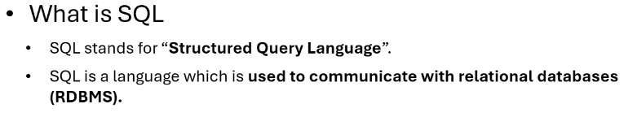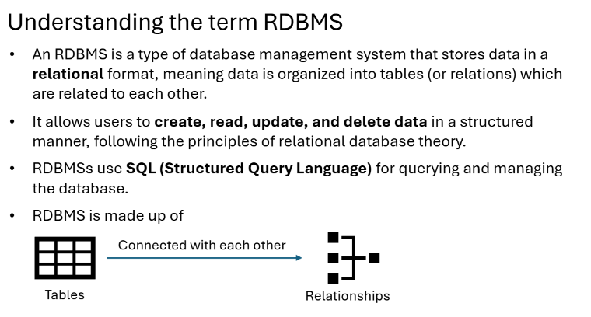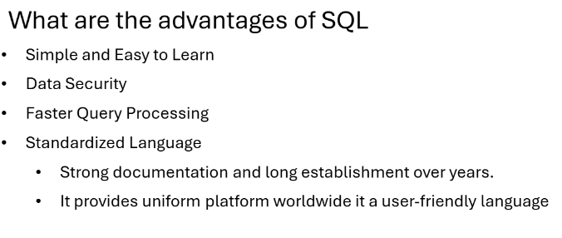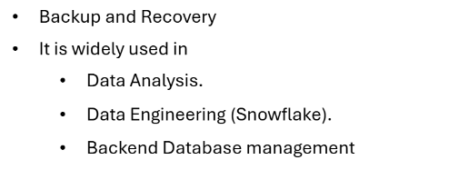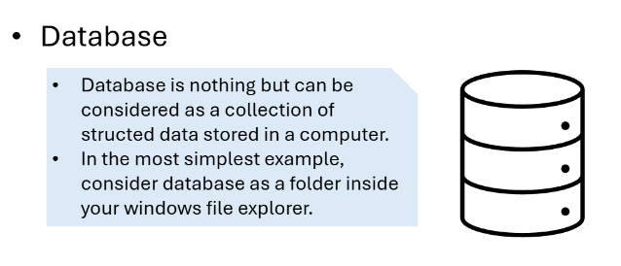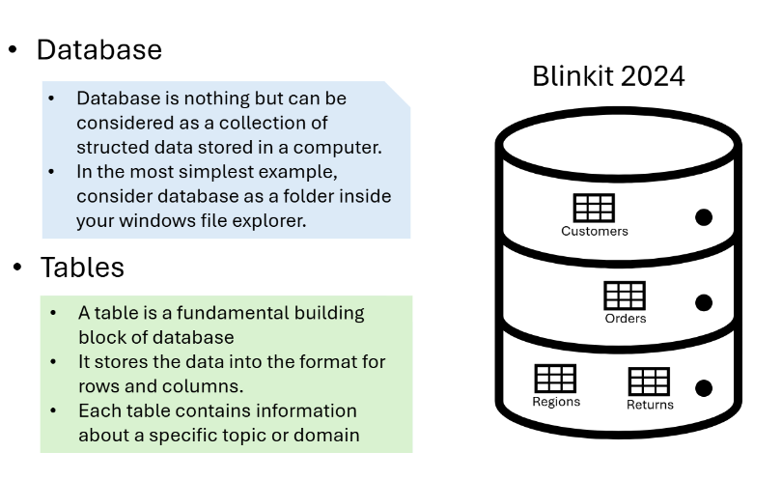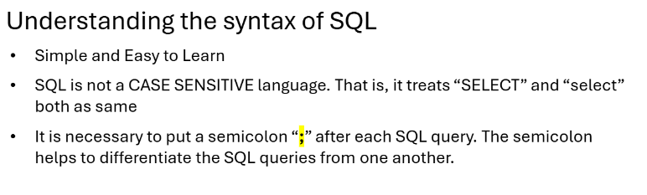
1. Database
A Database is the highest level of data storage. It is an organized collection of structured information or data, typically stored electronically in a computer system.
- Purpose: To store, manage, and retrieve data efficiently.
- Action: You can create one using the CREATE DATABASE command.
2. Schema
A Schema is a logical container or "namespace" within a database that groups together objects like tables, views, and stored procedures.
- Hierarchy: A single database can contain multiple schemas (e.g., HR, Sales, Finance) to segregate data for different applications or security levels.
- Blueprint: In a broader sense, "schema" refers to the overall blueprint or design of how data is structured and related.
- Action: Use the CREATE SCHEMA statement to organize your objects.

3. View
A View is a virtual table based on the result-set of a SQL query.
- Virtual Nature: Unlike a table, a view does not store data itself; it just stores the query and pulls data from the underlying physical tables whenever it is called.
- Use Cases:
  - Security: Restricting users to only see specific columns or rows of a sensitive table.
  - Simplicity: Combining complex joins into a single "table-like" object for easier reporting.
- Action: Create one using the CREATE VIEW syntax.

Concept: The Three-Tier Namespace
Object | Description | Real-World Analogy
DATABASE | Top-level container for all data | A filing cabinet
SCHEMA | Logical grouping within a database | A drawer inside the cabinet
TABLE | Stores actual rows and columns of data | A folder inside the drawer
VIEW | Virtual table based on a SELECT query | A label that reads a folder

Snowflake Data Types Overview
Category | Data Types | Example Values
Numeric | NUMBER, INT, BIGINT, FLOAT, DOUBLE, DECIMAL | 42, 3.14, 1000000
String / Text | VARCHAR, CHAR, STRING, TEXT | 'Hello | 'Bengaluru'
Date & Time | DATE, TIME, TIMESTAMP, TIMESTAMP_NTZ, TIMESTAMP_LTZ | '2024-01-15', '14:30:00'
Boolean | BOOLEAN | TRUE, FALSE
Semi-structured | VARIANT, OBJECT, ARRAY | {"name": "Alice"}
Binary | BINARY, VARBINARY | Raw binary data
Geographic | GEOGRAPHY, GEOMETRY | Spatial coordinates

Semi-structured—Snowflake Data Types
Semi-structured Snowflake data types are particularly versatile, allowing storage and manipulation of a variety of data formats. These are:
VARIANT
VARIANT is a flexible data type that can hold any other type, including OBJECT and ARRAY. It’s particularly useful for storing data in formats like JSON, Avro, ORC, Parquet, or XML. VARIANT has a maximum size of 16 MB and it stores both the value and its type, allowing for operations without explicit casting.
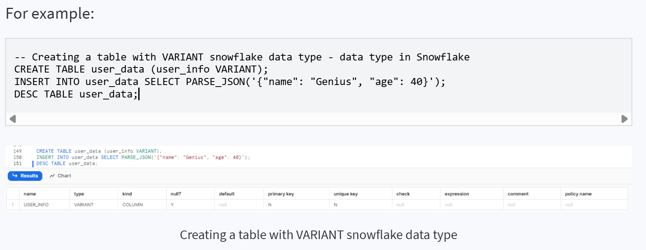

OBJECT
OBJECT is similar to a JSON object or a dictionary in other languages. It contains key-value pairs, with each key as a VARCHAR and each value as a VARIANT. OBJECT is perfect for representing structured data in a flexible format.
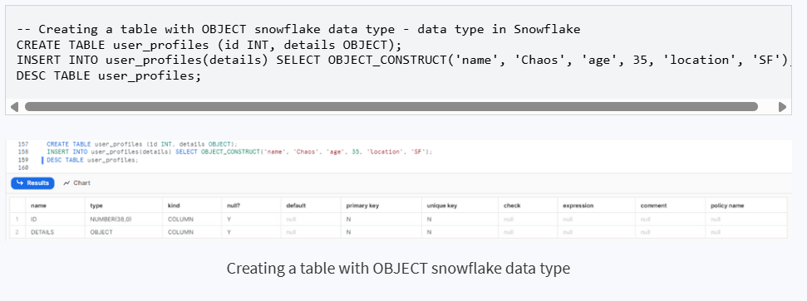
ARRAY
ARRAY Snowflake data type is similar to arrays in many programming languages, capable of holding an ordered list of elements. An ARRAY contains 0 or more pieces of data. Each element is accessed by specifying its position in the array. Each element in an ARRAY is a VARIANT, meaning it can store diverse types of data. ARRAY is useful for storing lists or sequences of values, where each element can be different but often is of the same or compatible types for uniform processing.
Note: Snowflake does not support fixed-size arrays or arrays with values of a specific non-VARIANT type.

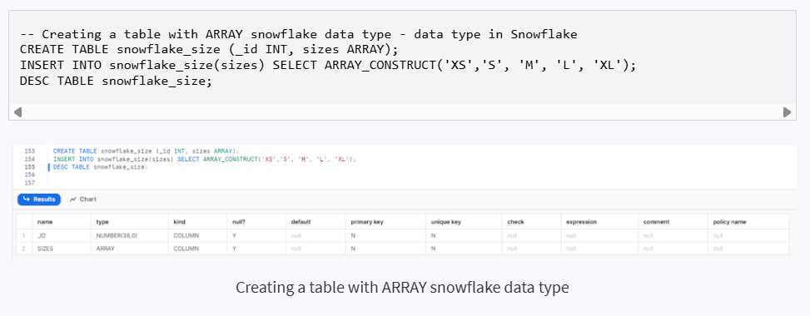

Which datatype is not supported by Snowflake?
Certain data types are common in other db systems but they are not supported in Snowflake. Here are the list of the unsupported Snowflake data types, they are:
LOB (Large Object)
- BLOB: Snowflake does not support the Binary Large Object type. As an alternative, the BINARY data type can be used, with a maximum size limit of 8,388,608 bytes.
- CLOB: Character Large Object type is also unsupported. VARCHAR is the recommended alternative in Snowflake, with a maximum capacity of 16,777,216 bytes for single-byte characters.
Other Unsupported Types
- ENUM: The ENUM type, used in other database systems for a list of predefined values, is not supported in Snowflake.
- User-defined Data Types: Snowflake does not support data types that are defined by users, which are commonly supported in some other database systems.

Live Demo: Full Database Setup Script

-- ============================================================
-- SNOWFLAKE DAY 3 TRAINING: COMPLETE SETUP
-- ============================================================

-- STEP 1: Create Training Database
CREATE DATABASE IF NOT EXISTS TRAINING_DB
COMMENT = 'Day 3 SQL Training Database - Snowflake Enterprise Program';

-- STEP 2: Create Schemas (Logical separation of data domains)
CREATE SCHEMA IF NOT EXISTS TRAINING_DB.SALES_SCHEMA
COMMENT = 'Schema for Sales and Customer data';

CREATE SCHEMA IF NOT EXISTS TRAINING_DB.HR_SCHEMA
COMMENT = 'Schema for Employee and HR data';

CREATE SCHEMA IF NOT EXISTS TRAINING_DB.FINANCE_SCHEMA
COMMENT = 'Schema for Finance and Order data';

-- STEP 3: Set Working Context
USE DATABASE TRAINING_DB;
USE SCHEMA SALES_SCHEMA;
USE WAREHOUSE COMPUTE_WH;

-- STEP 4: Verify Setup
SHOW DATABASES LIKE 'TRAINING_DB';
SHOW SCHEMAS IN DATABASE TRAINING_DB;

-- ============================================================
-- CREATE TABLES: CUSTOMERS
-- ============================================================
CREATE OR REPLACE TABLE CUSTOMERS (
CUSTOMER_ID NUMBER(10) NOT NULL PRIMARY KEY,
FIRST_NAME VARCHAR(100) NOT NULL,
LAST_NAME VARCHAR(100) NOT NULL,
EMAIL VARCHAR(200) UNIQUE,
PHONE VARCHAR(20),
CITY VARCHAR(100),
STATE VARCHAR(50),
COUNTRY VARCHAR(50) DEFAULT 'India',
SIGNUP_DATE DATE,
IS_ACTIVE BOOLEAN DEFAULT TRUE,
CUSTOMER_TIER VARCHAR(20) CHECK (CUSTOMER_TIER IN ('BRONZE','SILVER','GOLD','PLATINUM')),
ANNUAL_REVENUE DECIMAL(15,2),
CREATED_AT TIMESTAMP_NTZ DEFAULT CURRENT_TIMESTAMP()
)
COMMENT = 'Master customer dimension table';

-- ============================================================
-- CREATE TABLES: PRODUCTS
-- ============================================================
CREATE OR REPLACE TABLE PRODUCTS (
PRODUCT_ID NUMBER(10) NOT NULL PRIMARY KEY,
PRODUCT_NAME VARCHAR(200) NOT NULL,
CATEGORY VARCHAR(100),
SUB_CATEGORY VARCHAR(100),
BRAND VARCHAR(100),
UNIT_PRICE DECIMAL(10,2) NOT NULL,
COST_PRICE DECIMAL(10,2),
STOCK_QTY NUMBER(10) DEFAULT 0,
IS_ACTIVE BOOLEAN DEFAULT TRUE,
LAUNCH_DATE DATE
)
COMMENT = 'Product catalog table';

-- ============================================================
-- CREATE TABLES: ORDERS
-- ============================================================
CREATE OR REPLACE TABLE ORDERS (
ORDER_ID NUMBER(10) NOT NULL PRIMARY KEY,
CUSTOMER_ID NUMBER(10) REFERENCES CUSTOMERS(CUSTOMER_ID),
ORDER_DATE DATE NOT NULL,
SHIP_DATE DATE,
STATUS VARCHAR(30) DEFAULT 'PENDING',
TOTAL_AMOUNT DECIMAL(15,2),
DISCOUNT_PCT DECIMAL(5,2) DEFAULT 0,
PAYMENT_METHOD VARCHAR(50),
REGION VARCHAR(50),
SALES_REP_ID NUMBER(10)
)
COMMENT = 'Sales orders fact table';

-- ============================================================
-- CREATE TABLES: ORDER_ITEMS
-- ============================================================
CREATE OR REPLACE TABLE ORDER_ITEMS (
ITEM_ID NUMBER(10) NOT NULL PRIMARY KEY,
ORDER_ID NUMBER(10) REFERENCES ORDERS(ORDER_ID),
PRODUCT_ID NUMBER(10) REFERENCES PRODUCTS(PRODUCT_ID),
QUANTITY NUMBER(10) NOT NULL,
UNIT_PRICE DECIMAL(10,2) NOT NULL,
DISCOUNT_AMOUNT DECIMAL(10,2) DEFAULT 0,
LINE_TOTAL DECIMAL(15,2)
)
COMMENT = 'Order line items — one row per product per order';

-- ============================================================
-- CREATE TABLES: EMPLOYEES (HR Schema)
-- ============================================================
USE SCHEMA HR_SCHEMA;

CREATE OR REPLACE TABLE EMPLOYEES (
EMP_ID NUMBER(10) NOT NULL PRIMARY KEY,
FIRST_NAME VARCHAR(100),
LAST_NAME VARCHAR(100),
DEPARTMENT VARCHAR(100),
JOB_TITLE VARCHAR(150),
SALARY DECIMAL(12,2),
HIRE_DATE DATE,
MANAGER_ID NUMBER(10),
OFFICE_CITY VARCHAR(100),
PERFORMANCE_RATING VARCHAR(20) CHECK (PERFORMANCE_RATING IN ('EXCEPTIONAL','GOOD','AVERAGE','POOR')),
IS_ACTIVE BOOLEAN DEFAULT TRUE
)
COMMENT = 'Employee master data for HR analytics';

-- ============================================================
-- VERIFY TABLES
-- ============================================================
SHOW TABLES IN DATABASE TRAINING_DB;

Expected Output
After running the CREATE SCHEMA statements: SHOW SCHEMAS IN DATABASE TRAINING_DB should display 3 schemas: SALES_SCHEMA, HR_SCHEMA, FINANCE_SCHEMA. The SHOW TABLES command should list all 5 tables created.

Load Data via File Staging (Internal Stage + COPY INTO)
-- ============================================================
-- LOAD DATA VIA STAGING: CUSTOMERS
-- ============================================================
USE DATABASE TRAINING_DB;
USE SCHEMA SALES_SCHEMA;

-- STEP 1: Upload local CSV file to the internal stage using PUT

-- Run this from SnowSQL CLI (PUT is not supported in Snowflake Web UI):
-- SnowSQL is a separate command-line application that you install on your local machine.
-- Install SnowSQL
-- Download from: https://www.snowflake.com/en/developers/downloads/snowsql/

-- After Download
-- After installation open Command promp in window and run => snowsql -v
-- Connect to Snowflake
-- Run: snowsql -a <account_identifier> -u <username>
-- Then enter your password.

-- Once connected:

-- USE DATABASE MY_DB;
-- USE SCHEMA PUBLIC;

-- Now run your PUT command:

-- PUT 'file:///path/to/your/csv_data/customers.csv'
-- @STG_PRODUCTS
-- AUTO_COMPRESS=TRUE;

-- To verify the staged file:
LIST @STG_CUSTOMERS;

-- STEP 2: Load data from stage into the table using COPY INTO

COPY INTO CUSTOMERS (
CUSTOMER_ID, FIRST_NAME, LAST_NAME, EMAIL, PHONE,
CITY, STATE, COUNTRY, SIGNUP_DATE, IS_ACTIVE,
CUSTOMER_TIER, ANNUAL_REVENUE, CREATED_AT
)
FROM @STG_CUSTOMERS/customers.csv
FILE_FORMAT = TRAINING_CSV_FORMAT
ON_ERROR = 'CONTINUE'
PURGE = FALSE;

-- Verify load results
SELECT 'CUSTOMERS' AS TABLE_NAME, COUNT(*) AS ROW_COUNT FROM CUSTOMERS;
-- Expected: 5,500 rows

-- If you want to remove the dataset from the stage
-- REMOVE @STG_CUSTOMERS/products.csv.gz;

-- ============================================================
-- LOAD DATA VIA STAGING: PRODUCTS
-- ============================================================

-- PUT file:///path/to/your/csv_data/products.csv @STG_PRODUCTS AUTO_COMPRESS=TRUE;

LIST @STG_PRODUCTS;

COPY INTO PRODUCTS (
PRODUCT_ID, PRODUCT_NAME, CATEGORY, SUB_CATEGORY, BRAND,
UNIT_PRICE, COST_PRICE, STOCK_QTY, IS_ACTIVE, LAUNCH_DATE
)
FROM @STG_PRODUCTS/products.csv
FILE_FORMAT = TRAINING_CSV_FORMAT
ON_ERROR = 'CONTINUE'
PURGE = FALSE;

SELECT
'PRODUCTS' AS TABLE_NAME,
COUNT(*) AS ROW_COUNT
FROM PRODUCTS;
-- Expected: 5,200 rows

-- ============================================================
-- LOAD DATA VIA STAGING: ORDERS
-- ============================================================

-- PUT file:///path/to/your/csv_data/orders.csv @STG_ORDERS AUTO_COMPRESS=TRUE;

LIST @STG_ORDERS;

COPY INTO ORDERS (
ORDER_ID, CUSTOMER_ID, ORDER_DATE, SHIP_DATE, STATUS,
TOTAL_AMOUNT, DISCOUNT_PCT, PAYMENT_METHOD, REGION, SALES_REP_ID
)
FROM @STG_ORDERS/orders.csv
FILE_FORMAT = TRAINING_CSV_FORMAT
ON_ERROR = 'CONTINUE'
PURGE = FALSE;

SELECT
'ORDERS' AS TABLE_NAME,
COUNT(*) AS ROW_COUNT
FROM ORDERS;
-- Expected: 5,500 rows

-- ============================================================
-- LOAD DATA VIA STAGING: ORDER_ITEMS
-- ============================================================

-- PUT file:///path/to/your/csv_data/order_items.csv @STG_ORDER_ITEMS AUTO_COMPRESS=TRUE;

LIST @STG_ORDER_ITEMS;

COPY INTO ORDER_ITEMS (
ITEM_ID, ORDER_ID, PRODUCT_ID, QUANTITY,
UNIT_PRICE, DISCOUNT_AMOUNT, LINE_TOTAL
)
FROM @STG_ORDER_ITEMS/order_items.csv
FILE_FORMAT = TRAINING_CSV_FORMAT
ON_ERROR = 'CONTINUE'
PURGE = FALSE;

SELECT
'ORDER_ITEMS' AS TABLE_NAME,
COUNT(*) AS ROW_COUNT
FROM ORDER_ITEMS;
-- Expected: 6,000 rows

-- ============================================================
-- LOAD DATA VIA STAGING: EMPLOYEES (HR Schema)
-- ============================================================
USE SCHEMA HR_SCHEMA;

-- Create internal stage for HR data
CREATE OR REPLACE STAGE STG_EMPLOYEES
FILE_FORMAT = TRAINING_CSV_FORMAT
COMMENT = 'Internal stage for loading EMPLOYEES CSV data';

-- Here before running the PUT command change schema first to HR_SCHEMA
-- USE SCHEMA HR_SCHEMA;
-- PUT file:///path/to/your/csv_data/employees.csv @STG_EMPLOYEES AUTO_COMPRESS=TRUE;

LIST @STG_EMPLOYEES;

COPY INTO EMPLOYEES (
EMP_ID, FIRST_NAME, LAST_NAME, DEPARTMENT, JOB_TITLE,
SALARY, HIRE_DATE, MANAGER_ID, OFFICE_CITY,
PERFORMANCE_RATING, IS_ACTIVE
)
FROM @STG_EMPLOYEES/employees.csv
FILE_FORMAT = TRAINING_CSV_FORMAT
ON_ERROR = 'CONTINUE'
PURGE = FALSE;

SELECT
'EMPLOYEES' AS TABLE_NAME,
COUNT(*) AS ROW_COUNT
FROM EMPLOYEES;
-- Expected: 5,000 rows

-- Verify all staged data loads
USE DATABASE TRAINING_DB;
USE SCHEMA SALES_SCHEMA;
SELECT 'CUSTOMERS' AS TABLE_NAME, COUNT(*) AS ROW_COUNT FROM CUSTOMERS
UNION ALL SELECT 'PRODUCTS', COUNT(*) FROM PRODUCTS
UNION ALL SELECT 'ORDERS', COUNT(*) FROM ORDERS
UNION ALL SELECT 'ORDER_ITEMS', COUNT(*) FROM ORDER_ITEMS;

-- Check stage files (should show uploaded .csv.gz files)
LIST @STG_CUSTOMERS;
LIST @STG_PRODUCTS;
LIST @STG_ORDERS;
LIST @STG_ORDER_ITEMS;

-- View COPY INTO load history for troubleshooting
SELECT *
FROM TABLE(INFORMATION_SCHEMA.COPY_HISTORY(
TABLE_NAME => 'CUSTOMERS',
START_TIME => DATEADD('hour', -1, CURRENT_TIMESTAMP())
))
ORDER BY LAST_LOAD_TIME DESC;

ALTER & DROP Commands
-- ALTER TABLE: Add a new column
ALTER TABLE CUSTOMERS ADD COLUMN LOYALTY_POINTS NUMBER(10) DEFAULT 0;

-- ALTER TABLE: Rename a column
ALTER TABLE CUSTOMERS RENAME COLUMN LOYALTY_POINTS TO REWARD_POINTS;

-- ALTER TABLE: Change data type (VARCHAR size)
ALTER TABLE CUSTOMERS ALTER COLUMN EMAIL SET DATA TYPE VARCHAR(300);

-- ALTER TABLE: Set NOT NULL constraint
ALTER TABLE CUSTOMERS ALTER COLUMN FIRST_NAME SET NOT NULL;

-- DROP a column
ALTER TABLE CUSTOMERS DROP COLUMN REWARD_POINTS;

-- DROP TABLE (be careful!)
-- DROP TABLE IF EXISTS TEMP_TABLE;

-- UNDROP TABLE (Snowflake-specific — recover dropped table within retention period)
-- UNDROP TABLE TEMP_TABLE;

CHECKPOINT
Q1: What are the 3 levels in Snowflake object hierarchy?
Q2: Which data type should you use to store JSON in Snowflake?
Q3: What is the difference between VARCHAR and STRING in Snowflake?
Q4: How does UNDROP TABLE work? What is the time limit?
Expected Answers: 1) Database→Schema→Table 2) VARIANT 3) They are synonyms 4) Uses Time Travel (default 1 day)

1.2 SELECT Statement Deep Dive
The SELECT statement is the backbone of all SQL analytics. Understanding its full clause execution order is critical for writing accurate and efficient queries.

SQL Clause Execution Order (Logical)
IMPORTANT: SQL clauses are executed in a different order than they are written. Understanding this prevents common mistakes.
Execution Order | Clause | Purpose
1 | FROM / JOIN | Identify source tables
2 | WHERE | Filter individual rows (before grouping)
3 | GROUP BY | Group filtered rows
4 | HAVING | Filter groups (after aggregation)
5 | SELECT | Calculate and select output columns
6 | DISTINCT | Remove duplicates from output
7 | ORDER BY | Sort the result set
8 | LIMIT / FETCH | Restrict number of output rows

NOTE
"Why can you NOT use a SELECT alias in the WHERE clause?"
Answer: WHERE runs before SELECT.

Live Demo: Complete SELECT Examples
-- ============================================================
-- SELECT FUNDAMENTALS
-- ============================================================
USE DATABASE TRAINING_DB;
USE SCHEMA SALES_SCHEMA;

-- 1. Basic SELECT
SELECT * FROM CUSTOMERS;

-- 2. SELECT specific columns with Aliases
SELECT
CUSTOMER_ID AS CUST_ID,
FIRST_NAME || ' ' || LAST_NAME AS FULL_NAME,
CITY,
CUSTOMER_TIER AS TIER,
ANNUAL_REVENUE
FROM CUSTOMERS;

-- 3. WHERE clause — filtering rows
SELECT CUSTOMER_ID, FIRST_NAME, CITY, CUSTOMER_TIER
FROM CUSTOMERS
WHERE CUSTOMER_TIER = 'GOLD'
AND IS_ACTIVE = TRUE;

-- 4. WHERE with multiple conditions
SELECT ORDER_ID, CUSTOMER_ID, ORDER_DATE, TOTAL_AMOUNT, STATUS
FROM ORDERS
WHERE TOTAL_AMOUNT > 50000
AND STATUS = 'DELIVERED'
AND ORDER_DATE >= '2024-01-01';

-- 5. WHERE with IN operator
SELECT FIRST_NAME, LAST_NAME, CITY, CUSTOMER_TIER
FROM CUSTOMERS
WHERE CUSTOMER_TIER IN ('GOLD','PLATINUM');

-- 6. WHERE with BETWEEN
SELECT ORDER_ID, ORDER_DATE, TOTAL_AMOUNT
FROM ORDERS
WHERE TOTAL_AMOUNT BETWEEN 10000 AND 150000
ORDER BY TOTAL_AMOUNT DESC;

-- 7. WHERE with LIKE (pattern matching)
SELECT FIRST_NAME, LAST_NAME, EMAIL
FROM CUSTOMERS
WHERE EMAIL LIKE '%@email.com'
AND FIRST_NAME LIKE 'P%';

-- 8. ORDER BY — ascending and descending
SELECT PRODUCT_NAME, CATEGORY, UNIT_PRICE
FROM PRODUCTS
ORDER BY CATEGORY ASC, UNIT_PRICE DESC;

-- 9. DISTINCT — unique values
SELECT DISTINCT CUSTOMER_TIER
FROM CUSTOMERS;

SELECT DISTINCT REGION, STATUS
FROM ORDERS;

-- 10. LIMIT — restrict rows
SELECT PRODUCT_NAME, UNIT_PRICE
FROM PRODUCTS
ORDER BY UNIT_PRICE DESC
LIMIT 5; -- Top 5 most expensive products

-- ============================================================
-- GROUP BY and HAVING
-- ============================================================

-- 11. Basic GROUP BY — aggregate by tier
SELECT
CUSTOMER_TIER,
COUNT(*) AS TOTAL_CUSTOMERS,
AVG(ANNUAL_REVENUE) AS AVG_REVENUE,
MAX(ANNUAL_REVENUE) AS MAX_REVENUE,
MIN(ANNUAL_REVENUE) AS MIN_REVENUE,
SUM(ANNUAL_REVENUE) AS TOTAL_REVENUE
FROM CUSTOMERS
GROUP BY CUSTOMER_TIER
ORDER BY TOTAL_REVENUE DESC;

-- 12. GROUP BY with HAVING (filter on aggregate)
SELECT
CUSTOMER_ID,
COUNT(ORDER_ID) AS ORDER_COUNT,
SUM(TOTAL_AMOUNT) AS TOTAL_SPENT
FROM ORDERS
WHERE STATUS != 'CANCELLED'
GROUP BY CUSTOMER_ID
HAVING COUNT(ORDER_ID) >= 2
ORDER BY TOTAL_SPENT DESC;

-- 13. GROUP BY multiple columns
SELECT
REGION,
STATUS,
COUNT(*) AS ORDER_COUNT,
ROUND(AVG(TOTAL_AMOUNT), 2) AS AVG_ORDER_VALUE
FROM ORDERS
GROUP BY REGION, STATUS
ORDER BY REGION, ORDER_COUNT DESC;

STUDENT ACTIVITY 1 — 10 Minutes
1. Write a query to find all orders placed in March 2024 (use ORDER_DATE).
2. Find the total revenue by PAYMENT_METHOD from the ORDERS table.
3. Find customers from "Maharashtra" or "Karnataka" who are active.
4. Which product CATEGORY has the highest average unit price?
5. BONUS: Find customers who have NOT placed any orders (use NOT IN or subquery).

Operators and Keys in SQL
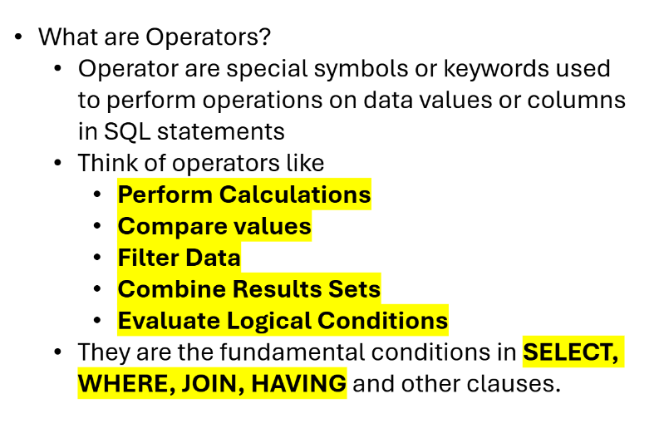
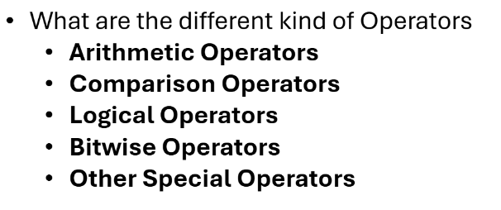

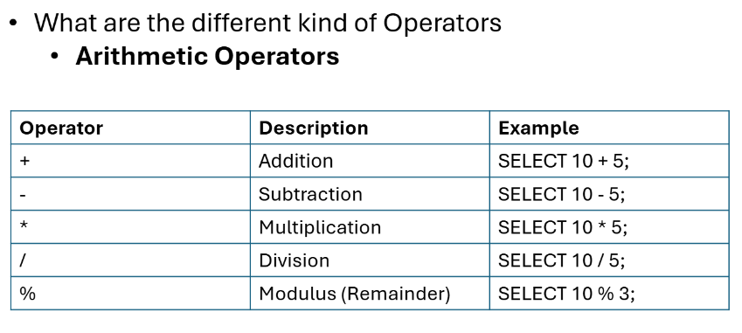

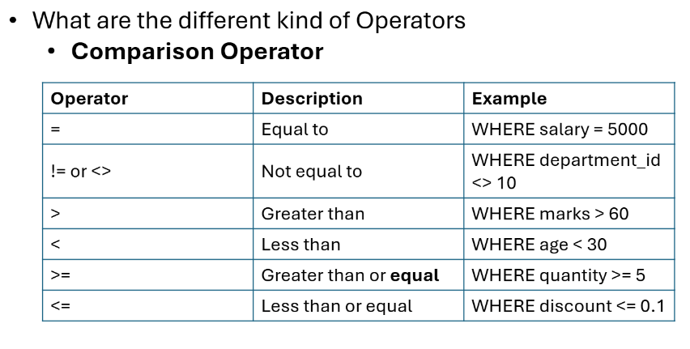

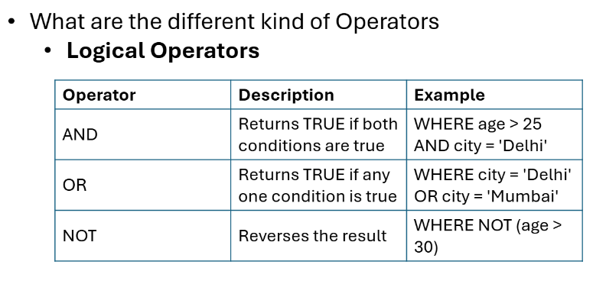

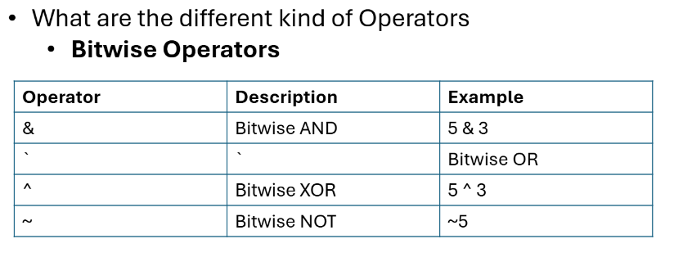

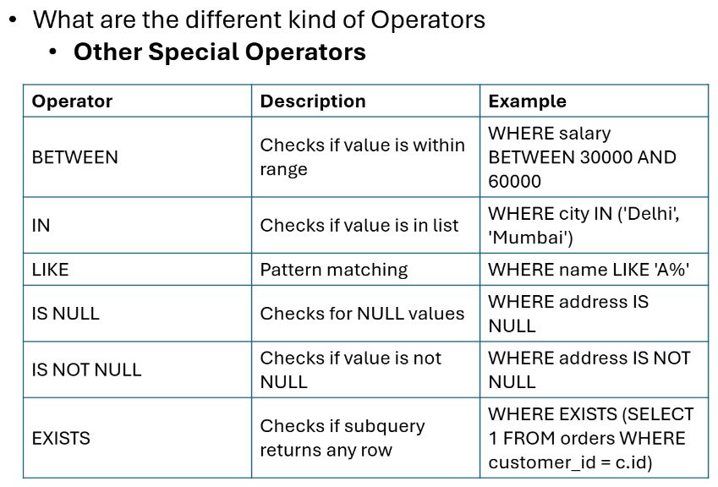

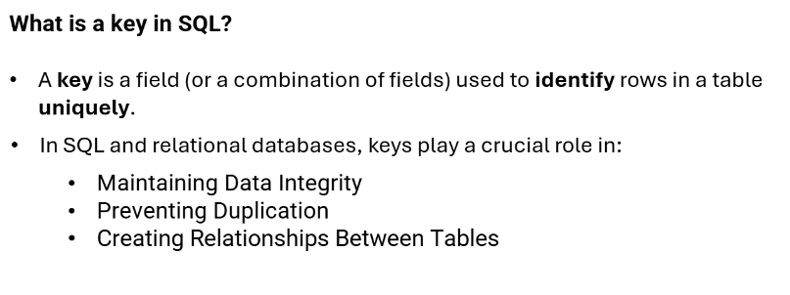

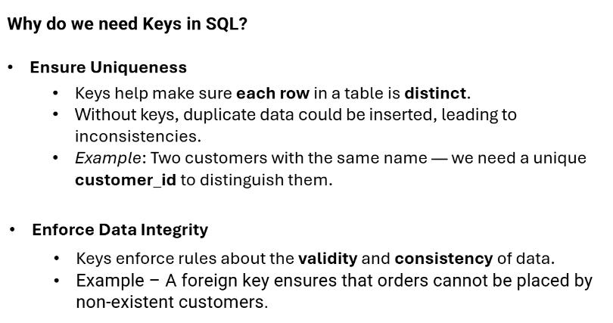

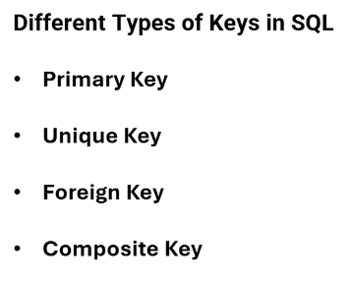

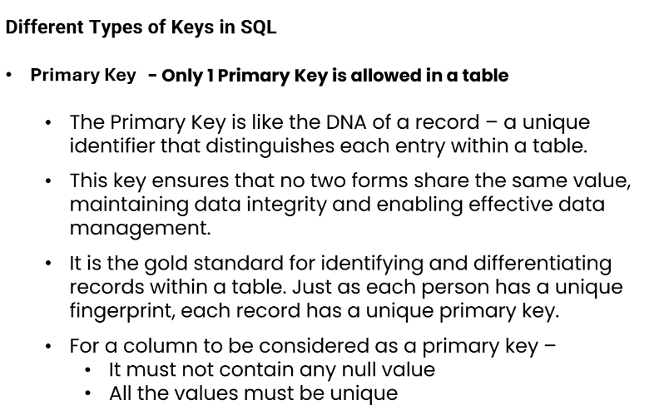

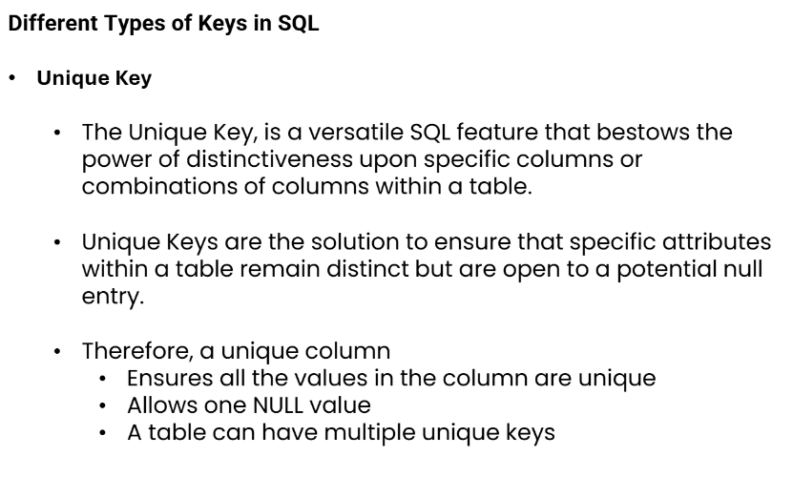

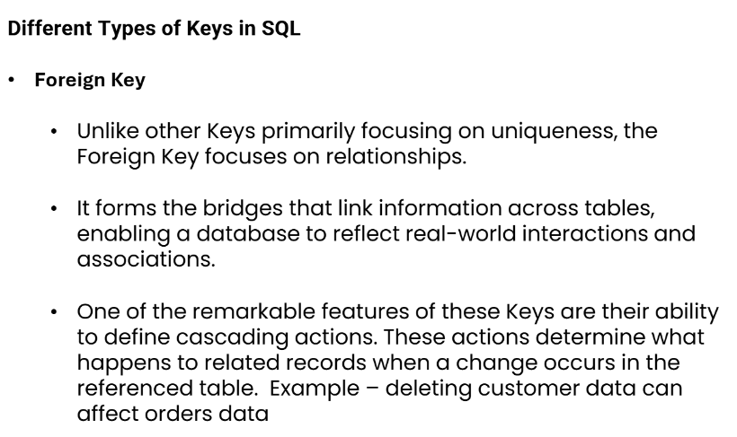

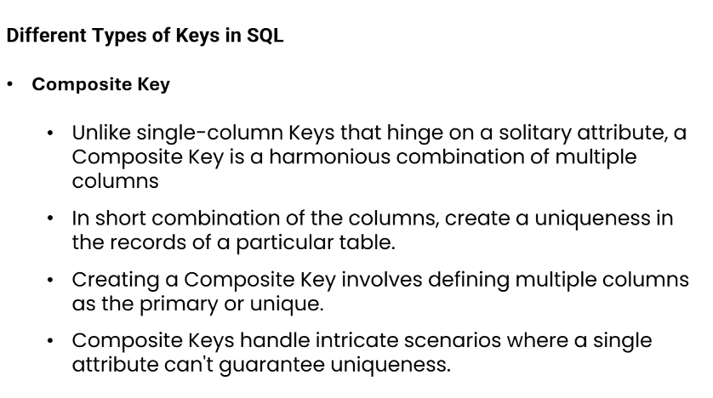
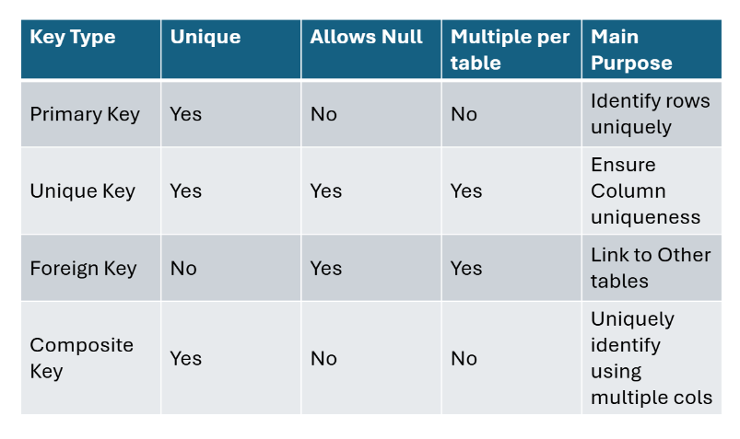

1.3 CASE Statements, NULL Handling & Built-in Functions

CASE Statement
CASE is SQL's version of IF-THEN-ELSE. It allows conditional logic directly inside SELECT, WHERE, ORDER BY, and GROUP BY clauses.
-- ============================================================
-- CASE STATEMENTS
-- ============================================================
USE DATABASE TRAINING_DB;
USE SCHEMA SALES_SCHEMA;

-- 1. Simple CASE (exact match)
SELECT
ORDER_ID,
STATUS,
CASE STATUS
WHEN 'DELIVERED' THEN 'Completed'
WHEN 'SHIPPED' THEN 'In Transit'
WHEN 'PENDING' THEN 'Awaiting Processing'
WHEN 'CANCELLED' THEN 'Order Cancelled'
ELSE 'Unknown Status'
END AS STATUS_LABEL
FROM ORDERS;

-- 2. Searched CASE (range conditions)
SELECT
CUSTOMER_ID,
FIRST_NAME,
ANNUAL_REVENUE,
CASE
WHEN ANNUAL_REVENUE >= 2000000 THEN 'Enterprise'
WHEN ANNUAL_REVENUE >= 500000 THEN 'Mid-Market'
WHEN ANNUAL_REVENUE >= 100000 THEN 'SMB'
ELSE 'Micro'
END AS SEGMENT,
CASE
WHEN CUSTOMER_TIER = 'PLATINUM' AND IS_ACTIVE = TRUE THEN 'VIP Active'
WHEN CUSTOMER_TIER = 'GOLD' AND IS_ACTIVE = TRUE THEN 'Priority Active'
WHEN IS_ACTIVE = FALSE THEN 'Inactive'
ELSE 'Standard'
END AS ACCOUNT_STATUS
FROM CUSTOMERS;

-- 3. CASE in GROUP BY for custom buckets
SELECT
CASE
WHEN TOTAL_AMOUNT >= 100000 THEN 'High Value (100K+)'
WHEN TOTAL_AMOUNT >= 50000 THEN 'Mid Value (50K-100K)'
WHEN TOTAL_AMOUNT >= 10000 THEN 'Low Value (10K-50K)'
ELSE 'Micro (<10K)'
END AS ORDER_BUCKET,
COUNT(*) AS ORDER_COUNT,
SUM(TOTAL_AMOUNT) AS BUCKET_REVENUE
FROM ORDERS
GROUP BY 1 -- GROUP BY the CASE expression (positional reference)
ORDER BY BUCKET_REVENUE DESC;

NULL Handling Functions
NULL represents missing or unknown data. It is NOT the same as zero or an empty string. Snowflake provides several functions to handle NULLs gracefully.
Function | Syntax | Description
IS NULL | col IS NULL | Filter rows where column is NULL
IS NOT NULL | col IS NOT NULL | Filter rows where column is not NULL
COALESCE | COALESCE(a, b, c) | Returns first non-NULL value
IFNULL | IFNULL(a, b) | Returns b if a is NULL (2-arg COALESCE)
NVL | NVL(a, b) | Snowflake alias for IFNULL
NVL2 | NVL2(a, b, c) | Returns b if a is NOT NULL, else c
NULLIF | NULLIF(a, b) | Returns NULL if a equals b, else a
ZEROIFNULL | ZEROIFNULL(a) | Returns 0 if a is NULL

-- ============================================================
-- NULL HANDLING EXAMPLES
-- ============================================================

-- 1. Find customers with missing email
SELECT CUSTOMER_ID, FIRST_NAME, LAST_NAME, EMAIL, PHONE
FROM CUSTOMERS
WHERE EMAIL IS NULL;
-- OUTPUT: Suresh Kumar (CUSTOMER_ID 1008)

-- 2. Find customers with either email or phone missing
SELECT CUSTOMER_ID, FIRST_NAME, EMAIL, PHONE
FROM CUSTOMERS
WHERE EMAIL IS NULL OR PHONE IS NULL;

-- 3. COALESCE — use email, fallback to phone, fallback to 'No Contact'
SELECT
CUSTOMER_ID,
FIRST_NAME,
COALESCE(EMAIL, PHONE, 'No Contact Info') AS CONTACT_METHOD
FROM CUSTOMERS;

-- 4. IFNULL / NVL — default value for NULL
SELECT
ORDER_ID,
CUSTOMER_ID,
IFNULL(SHIP_DATE, '9999-12-31') AS EFFECTIVE_SHIP_DATE,
NVL(DISCOUNT_PCT, 0) AS DISCOUNT,
TOTAL_AMOUNT * (1 - NVL(DISCOUNT_PCT,0)/100) AS FINAL_AMOUNT
FROM ORDERS;

-- 5. NULLIF — convert 0 to NULL (avoid division by zero)
SELECT
PRODUCT_ID,
UNIT_PRICE,
COST_PRICE,
UNIT_PRICE / NULLIF(COST_PRICE, 0) AS PRICE_TO_COST_RATIO
FROM PRODUCTS;

-- 6. NULL in aggregates — NULL is IGNORED by aggregate functions
SELECT
COUNT(*) AS TOTAL_CUSTOMERS, -- Counts all rows
COUNT(EMAIL) AS CUSTOMERS_WITH_EMAIL, -- Ignores NULL emails
COUNT(PHONE) AS CUSTOMERS_WITH_PHONE -- Ignores NULL phones
FROM CUSTOMERS;

Date & Time Functions

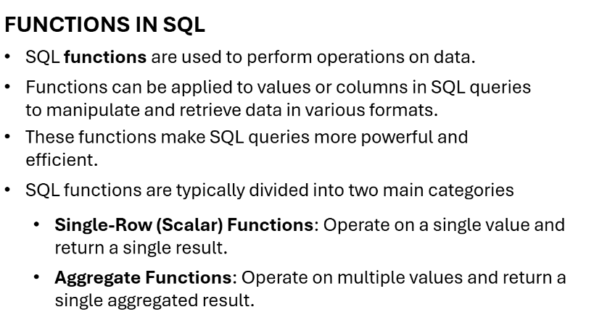

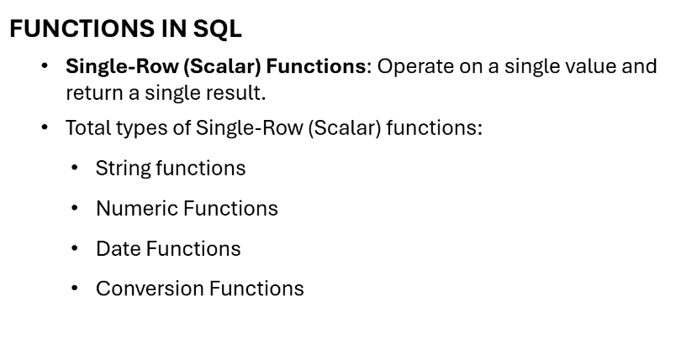

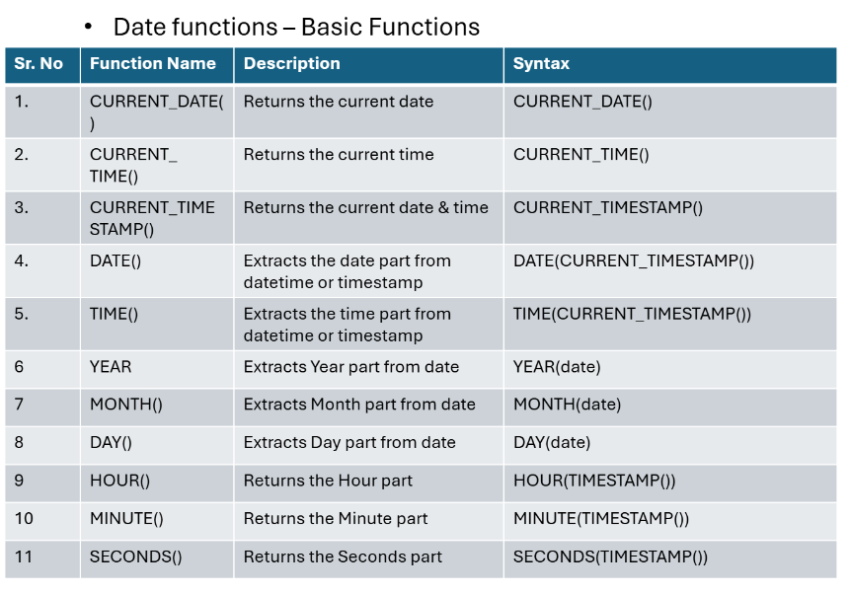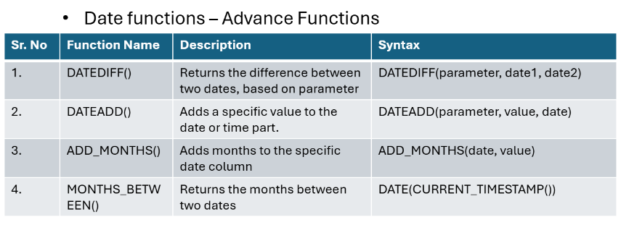

-- ============================================================
-- DATE & TIME FUNCTIONS IN SNOWFLAKE
-- ============================================================

-- Current date/time functions
SELECT
CURRENT_DATE() AS TODAY,
CURRENT_TIME() AS NOW_TIME,
CURRENT_TIMESTAMP() AS NOW_TS,
GETDATE() AS NOW_GETDATE, -- alias
SYSDATE() AS SYSDATE_VAL;

-- DATEADD and DATEDIFF
SELECT
ORDER_ID,
ORDER_DATE,
SHIP_DATE,
DATEDIFF('day', ORDER_DATE, COALESCE(SHIP_DATE, CURRENT_DATE())) AS DAYS_TO_SHIP,
DATEADD('day', 30, ORDER_DATE) AS PAYMENT_DUE_DATE,
DATEADD('month', 1, ORDER_DATE) AS ONE_MONTH_LATER
FROM ORDERS;

-- Date extraction functions
SELECT
ORDER_ID,
ORDER_DATE,
YEAR(ORDER_DATE) AS ORDER_YEAR,
MONTH(ORDER_DATE) AS ORDER_MONTH,
DAY(ORDER_DATE) AS ORDER_DAY,
DAYOFWEEK(ORDER_DATE) AS DAY_OF_WEEK, -- 0=Sunday
DAYNAME(ORDER_DATE) AS DAY_NAME,
MONTHNAME(ORDER_DATE) AS MONTH_NAME,
QUARTER(ORDER_DATE) AS QUARTER,
WEEKOFYEAR(ORDER_DATE) AS WEEK_NUMBER,
DATE_TRUNC('month', ORDER_DATE) AS MONTH_START
FROM ORDERS;

-- Practical: Orders grouped by month
SELECT
DATE_TRUNC('month', ORDER_DATE) AS SALES_MONTH,
TO_CHAR(ORDER_DATE, 'Mon YYYY') AS MONTH_LABEL,
COUNT(*) AS ORDER_COUNT,
ROUND(SUM(TOTAL_AMOUNT)/1000, 1) AS REVENUE_IN_K
FROM ORDERS
WHERE STATUS != 'CANCELLED'
GROUP BY 1, 2
ORDER BY 1;

String Functions

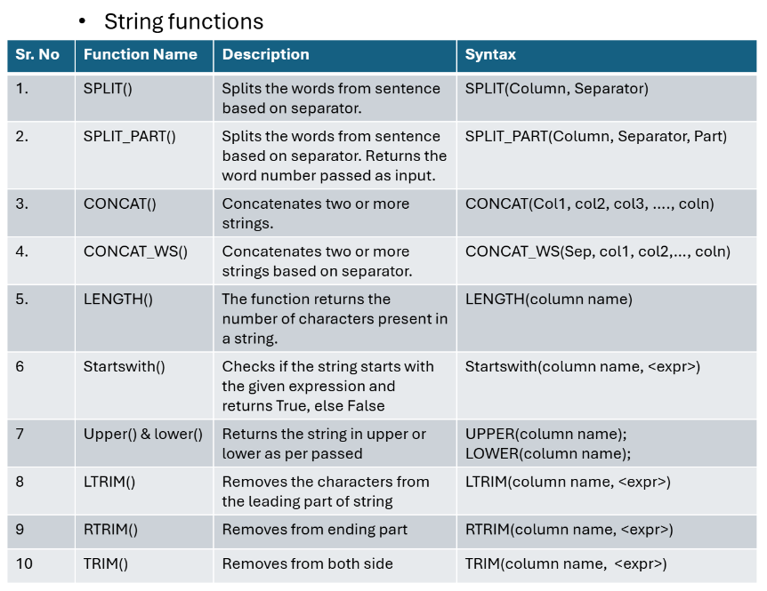
-- ============================================================
-- STRING FUNCTIONS IN SNOWFLAKE
-- ============================================================

/*
String Functions Covered:
1. LTRIM()
2. RTRIM()
3. TRIM()
4. SPLIT()
5. SPLIT_PART()
6. CONCAT()
7. CONCAT_WS()
*/

-- -----------------------------------------------------
-- Environment Setup
-- -----------------------------------------------------

-- Assign Role
USE ROLE ACCOUNTADMIN;
-- Assign Warehouse
USE WAREHOUSE COMPUTE_WH;

-- Create Database
CREATE DATABASE IF NOT EXISTS String_SQL;

-- Use Database
USE DATABASE String_SQL;

-- Create Schema
CREATE SCHEMA IF NOT EXISTS StringFunctionsSchema;

-- Use Schema
USE SCHEMA StringFunctionsSchema;

-- -----------------------------------------------------
-- Sequence Creation (Auto Increment)
-- -----------------------------------------------------

CREATE SEQUENCE AUTO_INCREMENT_SEQUENCE
START WITH 1
INCREMENT BY 1;

-- -----------------------------------------------------
-- Table Creation
-- -----------------------------------------------------

CREATE TABLE IF NOT EXISTS SALES (
SALE_ID INT DEFAULT AUTO_INCREMENT_SEQUENCE.NEXTVAL PRIMARY KEY NOT NULL,
ORDER_ID VARCHAR(100) NOT NULL,
CUSTOMER_NAME VARCHAR(100) NOT NULL,
PRODUCT_NAME VARCHAR(150) NOT NULL,
PRODUCT_CATEGORY VARCHAR(50),
ORDER_CITY VARCHAR(50),
ORDER_STATE VARCHAR(50),
ORDER_COUNTRY VARCHAR(50),
SALES_CHANNEL VARCHAR(50),
PAYMENT_METHOD VARCHAR(50),
FEEDBACK VARCHAR(255),
SALE_AMOUNT DECIMAL(10, 2),
DISCOUNT DECIMAL(5, 2),
ORDER_DATE DATE,
SHIPPING_DATE DATE
);

-- -----------------------------------------------------
-- File Staging Setup for SALES Table
-- -----------------------------------------------------
CREATE OR REPLACE FILE FORMAT STRING_SQL_CSV_FORMAT
TYPE = 'CSV'
FIELD_DELIMITER = ','
RECORD_DELIMITER = '\n'
SKIP_HEADER = 1
FIELD_OPTIONALLY_ENCLOSED_BY = '"'
NULL_IF = ('', 'NULL')
EMPTY_FIELD_AS_NULL = TRUE
TRIM_SPACE = FALSE -- Keep spaces for LTRIM/RTRIM/TRIM demos
COMMENT = 'CSV format for String Functions — preserves whitespace for demos';

CREATE OR REPLACE STAGE STG_SALES
FILE_FORMAT = STRING_SQL_CSV_FORMAT
COMMENT = 'Internal stage for SALES string functions data';

-- Before running go to cmd and type:
-- USE DATABASE String_SQL;
-- USE SCHEMA StringFunctionsSchema;
-- After that:
-- Upload the CSV from your local machine using SnowSQL:
-- PUT file:///path/to/your/csv_data/sales_string.csv @STG_SALES AUTO_COMPRESS=TRUE;

LIST @STG_SALES;

COPY INTO SALES (
ORDER_ID, CUSTOMER_NAME, PRODUCT_NAME, PRODUCT_CATEGORY,
ORDER_CITY, ORDER_STATE, ORDER_COUNTRY,
SALES_CHANNEL, PAYMENT_METHOD, FEEDBACK,
SALE_AMOUNT, DISCOUNT, ORDER_DATE, SHIPPING_DATE
)
FROM @STG_SALES/sales_string.csv
FILE_FORMAT = STRING_SQL_CSV_FORMAT
ON_ERROR = 'CONTINUE'
PURGE = FALSE;

SELECT COUNT(*) AS TOTAL_ROWS FROM SALES;
-- Expected: 5,100 rows
-- -----------------------------------------------------
-- Verify Data
-- -----------------------------------------------------
SELECT *
FROM SALES;

-- =====================================================
-- STRING FUNCTION QUESTIONS
-- =====================================================
-- -----------------------------------------------------
-- Question 1 : LTRIM()
-- -----------------------------------------------------
/*
Remove unwanted leading spaces from CUSTOMER_NAME.
Filter only state = 'CA'.
Sort data by SALE_ID from highest to lowest.
*/

SELECT
SALE_ID,
CUSTOMER_NAME,
LENGTH(CUSTOMER_NAME) AS ORIGINAL_LENGTH,
LTRIM(CUSTOMER_NAME) AS CLEANED_CUSTOMER_NAME,
LENGTH(LTRIM(CUSTOMER_NAME)) AS CLEANED_LENGTH,
ORDER_STATE
FROM SALES
WHERE ORDER_STATE = 'CA'
ORDER BY SALE_ID DESC;

-- -----------------------------------------------------
-- Question 2 : RTRIM()
-- -----------------------------------------------------
/*
Remove unwanted trailing spaces from PRODUCT_CATEGORY.
Filter states: CA, TX, WA
Payment Method must be Credit Card.
*/

SELECT
SALE_ID,
PRODUCT_CATEGORY,
LENGTH(PRODUCT_CATEGORY) AS ORIGINAL_LENGTH,
RTRIM(PRODUCT_CATEGORY) AS CLEANED_PRODUCT_CATEGORY,
LENGTH(RTRIM(PRODUCT_CATEGORY)) AS CLEANED_LENGTH
FROM SALES
WHERE
ORDER_STATE IN ('CA', 'TX', 'WA')
AND PAYMENT_METHOD = 'Credit Card'
ORDER BY SALE_ID ASC;

-- -----------------------------------------------------
-- Question 3 : TRIM()
-- -----------------------------------------------------
/*
Remove unwanted characters (#, -, *) from FEEDBACK.
*/

SELECT
SALE_ID,
CUSTOMER_NAME,
FEEDBACK,
TRIM(FEEDBACK, '#-*') AS CLEANED_FEEDBACK,
TRIM(CUSTOMER_NAME) AS CLEANED_CUSTOMER_NAME
FROM SALES;

-- -----------------------------------------------------
-- Question 4 : SPLIT()
-- -----------------------------------------------------
/*
Split CUSTOMER_NAME into First Name and Last Name.
*/

SELECT
SALE_ID,
ORDER_ID,
CUSTOMER_NAME,
SPLIT(LTRIM(CUSTOMER_NAME), ' ') AS FIRSTNAME_LASTNAME,
ORDER_STATE,
SALES_CHANNEL,
PAYMENT_METHOD
FROM SALES;

-- -----------------------------------------------------
-- Question 5 : SPLIT_PART()
-- -----------------------------------------------------
/*
Extract First Name and Last Name separately.
*/

SELECT
SALE_ID,
ORDER_ID,
CUSTOMER_NAME,
SPLIT_PART(LTRIM(CUSTOMER_NAME), ' ', 1) AS FIRST_NAME,
SPLIT_PART(LTRIM(CUSTOMER_NAME), ' ', 2) AS LAST_NAME,
ORDER_STATE,
SALES_CHANNEL,
PAYMENT_METHOD
FROM SALES;

-- -----------------------------------------------------
-- Question 6 : CONCAT()
-- -----------------------------------------------------
/*
Combine ORDER_STATE and ORDER_COUNTRY.
*/

SELECT
SALE_ID,
ORDER_ID,
ORDER_STATE,
ORDER_COUNTRY,
CONCAT(ORDER_STATE, ' - ', ORDER_COUNTRY) AS ORDER_STATE_COUNTRY
FROM SALES;

-- -----------------------------------------------------
-- Question 7 : CONCAT_WS()
-- -----------------------------------------------------
/*
Combine ORDER_STATE, ORDER_CITY, ORDER_COUNTRY.
*/

SELECT
SALE_ID,
ORDER_ID,
ORDER_STATE,
ORDER_CITY,
ORDER_COUNTRY,
CONCAT_WS(' - ', ORDER_STATE, ORDER_CITY, ORDER_COUNTRY) AS ORDER_STATE_CITY_COUNTRY
FROM SALES;

-- -----------------------------------------------------
-- Data Cleaning Example (Product Category)
-- -----------------------------------------------------

SELECT
ORDER_ID,
PRODUCT_CATEGORY,
CONCAT(
SPLIT_PART(PRODUCT_CATEGORY, ' ', 1),
SPLIT_PART(PRODUCT_CATEGORY, ' ', 2)
) AS CLEANED_PRODUCT_CATEGORY
FROM SALES
WHERE ORDER_ID = 'ORD-1034';

Numeric Functions
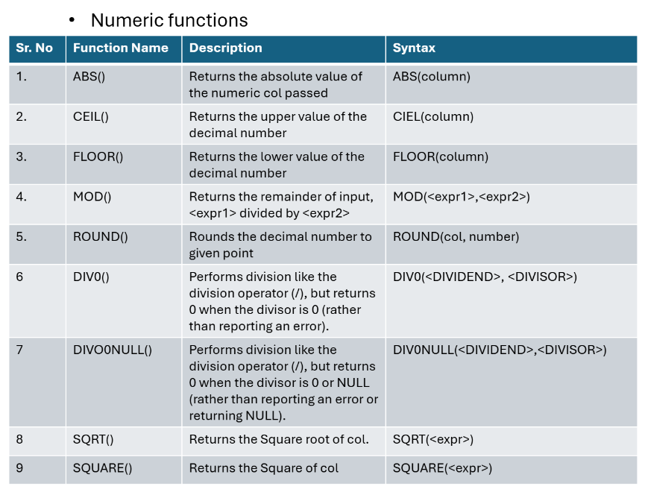
-- =====================================================
-- Session : Numeric Functions in SQL (Snowflake)
-- =====================================================

-- -------------------------
-- Environment Setup
-- -------------------------

-- Assign Role
USE ROLE ACCOUNTADMIN;

-- Assign Warehouse
USE WAREHOUSE COMPUTE_WH;

-- Create Database
CREATE DATABASE IF NOT EXISTS EndtoEndSQL;

-- Use Database
USE DATABASE EndtoEndSQL;

-- Create Schema
CREATE SCHEMA IF NOT EXISTS NumericFunctionsSchema;

-- Use Schema
USE SCHEMA NumericFunctionsSchema;

-- =====================================================
-- Table Creation
-- =====================================================

CREATE TABLE IF NOT EXISTS Sales_Transactions (
Transaction_ID INT PRIMARY KEY,
Customer_ID INT,
Transaction_Date DATE,
Amount_Spent DECIMAL(10, 2),
Discount_Percentage DECIMAL(5, 2),
Quantity_Purchased INT,
Shipping_Cost DECIMAL(10, 2),
Delivery_Date DATE,
Return_Date DATE
);

-- =====================================================
-- File Staging Setup for Sales_Transactions Table
-- =====================================================
CREATE OR REPLACE FILE FORMAT NUMERIC_CSV_FORMAT
TYPE = 'CSV'
FIELD_DELIMITER = ','
RECORD_DELIMITER = '\n'
SKIP_HEADER = 1
FIELD_OPTIONALLY_ENCLOSED_BY = '"'
NULL_IF = ('', 'NULL')
EMPTY_FIELD_AS_NULL = TRUE
TRIM_SPACE = TRUE
COMMENT = 'CSV format for Numeric Functions training data';

CREATE OR REPLACE STAGE STG_SALES_TRANSACTIONS
FILE_FORMAT = NUMERIC_CSV_FORMAT
COMMENT = 'Internal stage for Sales_Transactions numeric data';

-- Before using PUT change to
-- Use Database
-- USE DATABASE EndtoEndSQL;
-- Use Schema
-- USE SCHEMA NumericFunctionsSchema;
-- THEN Upload via SnowSQL:
-- PUT file:///path/to/your/csv_data/sales_transactions.csv @STG_SALES_TRANSACTIONS AUTO_COMPRESS=TRUE;

LIST @STG_SALES_TRANSACTIONS;

COPY INTO Sales_Transactions (
Transaction_ID, Customer_ID, Transaction_Date,
Amount_Spent, Discount_Percentage, Quantity_Purchased,
Shipping_Cost, Delivery_Date, Return_Date
)
FROM @STG_SALES_TRANSACTIONS/sales_transactions.csv
FILE_FORMAT = NUMERIC_CSV_FORMAT
ON_ERROR = 'CONTINUE'
PURGE = FALSE;

SELECT COUNT(*) AS TOTAL_ROWS FROM Sales_Transactions;
-- Expected: 5,000 rows
-- =====================================================
-- Verify Data
-- =====================================================

SELECT *
FROM Sales_Transactions;

-- =====================================================
-- NUMERIC FUNCTIONS
-- =====================================================

-- Query 1 : ABS()
SELECT
Customer_ID,
Amount_Spent,
ABS(Discount_Percentage) AS ABS_DISCOUNT
FROM Sales_Transactions
WHERE Discount_Percentage < 0
ORDER BY Amount_Spent DESC;

-- Query 2 : CEIL()
SELECT
Transaction_ID,
Amount_Spent,
CEIL(Shipping_Cost) AS CEIL_SHIPPING_COST
FROM Sales_Transactions
WHERE Amount_Spent > 1000
ORDER BY Transaction_Date ASC;

-- Query 3 : FLOOR()
SELECT
Customer_ID,
Quantity_Purchased,
FLOOR(Shipping_Cost) AS FLOOR_SHIPPING_COST
FROM Sales_Transactions
WHERE Amount_Spent > 500
ORDER BY Quantity_Purchased DESC;

-- Query 4 : MOD()
SELECT
Customer_ID,
Transaction_ID,
MOD(Amount_Spent, 7) AS REMAINDER_VALUE
FROM Sales_Transactions
WHERE Amount_Spent > 300
ORDER BY Transaction_ID ASC;

-- Query 5 : ROUND()
SELECT
Transaction_ID,
Amount_Spent,
ROUND(Discount_Percentage, 0) AS ROUNDED_DISCOUNT
FROM Sales_Transactions
WHERE Discount_Percentage > 5
ORDER BY Discount_Percentage DESC;

-- Query 6 : DIV0()
SELECT
Customer_ID,
Quantity_Purchased,
DIV0(Amount_Spent, Quantity_Purchased) AS AMOUNT_PER_UNIT
FROM Sales_Transactions
WHERE Quantity_Purchased <> 0
ORDER BY Customer_ID ASC;

-- Query 7 : DIV0NULL()
SELECT
Transaction_ID,
Amount_Spent,
DIV0NULL(Shipping_Cost, Quantity_Purchased) AS SHIPPING_PER_UNIT
FROM Sales_Transactions
WHERE Quantity_Purchased < 3
ORDER BY Shipping_Cost DESC;

-- Query 8 : SQRT()
SELECT
Transaction_ID,
Amount_Spent,
SQRT(Amount_Spent) AS SQRT_AMOUNT
FROM Sales_Transactions
WHERE Amount_Spent > 1000
ORDER BY Amount_Spent ASC;

-- Query 9 : POWER()
SELECT
Customer_ID,
Quantity_Purchased,
POWER(Discount_Percentage, 2) AS DISCOUNT_SQUARE
FROM Sales_Transactions
WHERE Discount_Percentage < 10
ORDER BY Discount_Percentage ASC;

-- Query 10 : BONUS (Multiple Numeric Functions)
SELECT
Transaction_ID,
Amount_Spent,
Quantity_Purchased,
ROUND(Quantity_Purchased * Amount_Spent, 2) AS TOTAL_AMOUNT,
CEIL(SQRT(ROUND(Quantity_Purchased * Amount_Spent, 2))) AS CEIL_SQRT_TOTAL,
FLOOR(MOD(Amount_Spent, 500)) AS FLOOR_REMAINDER
FROM Sales_Transactions
WHERE (Quantity_Purchased * Amount_Spent) > 1000
ORDER BY Amount_Spent ASC;

1.4 JOINs — The Complete Guide
JOINs are the most powerful feature in relational SQL. They combine rows from two or more tables based on a related column. Every real-world analytics query uses JOINs.

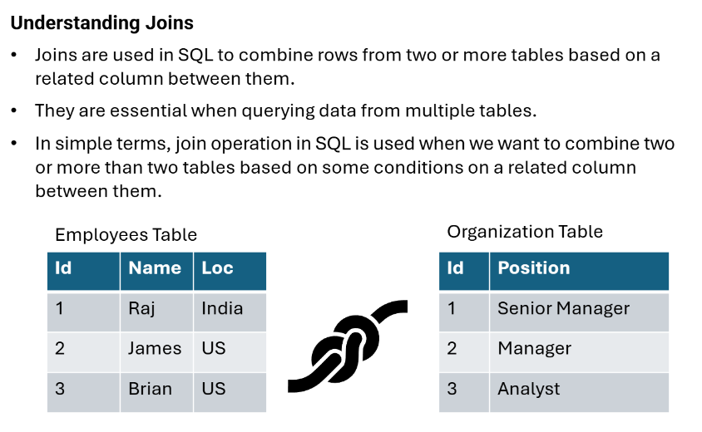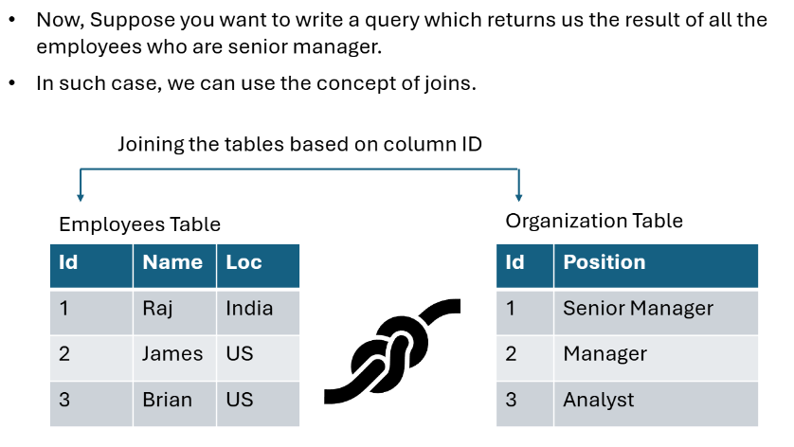

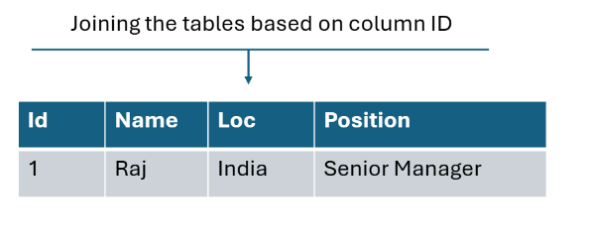

JOIN Types Visual Guide
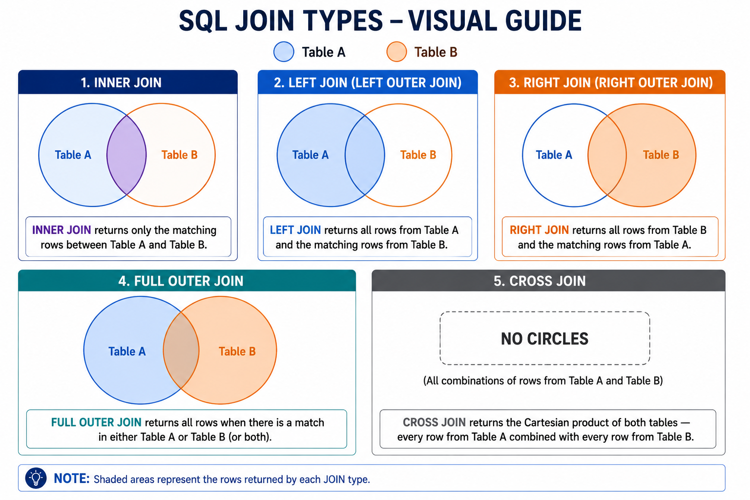

JOIN Type | Returns | Common Use Case
INNER JOIN | Only rows matching in BOTH tables | Orders with customer details
LEFT JOIN | All rows from LEFT + matching right | All customers, show orders if any
RIGHT JOIN | All rows from RIGHT + matching left | All orders, show customer if found
FULL OUTER JOIN | All rows from BOTH tables | Find unmatched records on both sides
CROSS JOIN | All combinations of both tables | Cartesian product, date dimension x products
SELF JOIN | Table joined to itself | Employee → Manager hierarchy

Live Demo: All JOIN Types
Run each JOIN separately. Show the row counts after each one. Students should observe how count changes.
Use SELECT COUNT(*) before and after to make the difference tangible.
-- ============================================================
-- JOINS COMPLETE DEMO
-- ============================================================
USE DATABASE TRAINING_DB;
USE SCHEMA SALES_SCHEMA;

-- 1. INNER JOIN — Only customers who have orders
SELECT
C.CUSTOMER_ID,
C.FIRST_NAME || ' ' || C.LAST_NAME AS CUSTOMER_NAME,
C.CUSTOMER_TIER,
O.ORDER_ID,
O.ORDER_DATE,
O.TOTAL_AMOUNT,
O.STATUS
FROM CUSTOMERS C
INNER JOIN ORDERS O ON C.CUSTOMER_ID = O.CUSTOMER_ID
ORDER BY O.ORDER_DATE;
-- Row Count: 15 (only customers who have orders)

-- 2. LEFT JOIN — ALL customers, orders if they exist
SELECT
C.CUSTOMER_ID,
C.FIRST_NAME || ' ' || C.LAST_NAME AS CUSTOMER_NAME,
C.CUSTOMER_TIER,
COALESCE(CAST(O.ORDER_ID AS VARCHAR), 'No Orders') AS ORDER_INFO,
O.TOTAL_AMOUNT
FROM CUSTOMERS C
LEFT JOIN ORDERS O ON C.CUSTOMER_ID = O.CUSTOMER_ID
ORDER BY C.CUSTOMER_ID;
-- Row Count: 15+ (all 10 customers, customers with multiple orders appear multiple times)

-- 3. Find customers who have NEVER placed an order (anti-join pattern)
SELECT
C.CUSTOMER_ID,
C.FIRST_NAME || ' ' || C.LAST_NAME AS CUSTOMER_NAME,
C.SIGNUP_DATE
FROM CUSTOMERS C
LEFT JOIN ORDERS O ON C.CUSTOMER_ID = O.CUSTOMER_ID
WHERE O.ORDER_ID IS NULL;
-- Customers with no orders at all

-- 4. FULL OUTER JOIN — all customers and all orders (even orphaned ones)
SELECT
C.CUSTOMER_ID,
C.FIRST_NAME AS CUSTOMER_FIRST_NAME,
O.ORDER_ID,
O.TOTAL_AMOUNT
FROM CUSTOMERS C
FULL OUTER JOIN ORDERS O ON C.CUSTOMER_ID = O.CUSTOMER_ID;

-- 5. Three-table JOIN — Customer + Order + Product (via ORDER_ITEMS)
SELECT
C.FIRST_NAME || ' ' || C.LAST_NAME AS CUSTOMER_NAME,
C.CUSTOMER_TIER,
O.ORDER_DATE,
O.STATUS,
P.PRODUCT_NAME,
P.CATEGORY,
OI.QUANTITY,
OI.UNIT_PRICE,
OI.LINE_TOTAL
FROM CUSTOMERS C
INNER JOIN ORDERS O ON C.CUSTOMER_ID = O.CUSTOMER_ID
INNER JOIN ORDER_ITEMS OI ON O.ORDER_ID = OI.ORDER_ID
INNER JOIN PRODUCTS P ON OI.PRODUCT_ID = P.PRODUCT_ID
ORDER BY O.ORDER_DATE DESC;

-- 6. CROSS JOIN — Generate all product-region combinations
SELECT
P.PRODUCT_NAME,
P.CATEGORY,
REGIONS.REGION_NAME
FROM PRODUCTS P
CROSS JOIN (
SELECT 'North' AS REGION_NAME UNION ALL
SELECT 'South' UNION ALL
SELECT 'East' UNION ALL
SELECT 'West'
) REGIONS
ORDER BY P.PRODUCT_NAME, REGIONS.REGION_NAME;

-- 7. SELF JOIN — Employee to Manager hierarchy
USE SCHEMA HR_SCHEMA;
SELECT
E.EMP_ID,
E.FIRST_NAME || ' ' || E.LAST_NAME AS EMPLOYEE_NAME,
E.JOB_TITLE,
M.FIRST_NAME || ' ' || M.LAST_NAME AS MANAGER_NAME,
M.JOB_TITLE AS MANAGER_TITLE
FROM EMPLOYEES E
LEFT JOIN EMPLOYEES M ON E.MANAGER_ID = M.EMP_ID
ORDER BY E.DEPARTMENT, E.EMP_ID;

Set Operators — UNION, INTERSECT, MINUS
Set operators combine result sets from multiple SELECT queries. All queries must have the same number of columns and compatible data types.
Set Operator | Description
UNION ALL | Combines ALL rows from both queries (including duplicates)
UNION | Combines rows, removes duplicates (slower — sorts to deduplicate)
INTERSECT | Returns only rows that appear in BOTH result sets
MINUS (EXCEPT) | Returns rows in first set that are NOT in second set

-- ============================================================
-- SET OPERATORS
-- ============================================================
USE DATABASE TRAINING_DB;
USE SCHEMA SALES_SCHEMA;

-- 1. UNION ALL — combine all customers and all sales reps into one contact list
SELECT CUSTOMER_ID AS ID, FIRST_NAME, LAST_NAME, 'CUSTOMER' AS SOURCE
FROM CUSTOMERS
UNION ALL
SELECT EMP_ID, FIRST_NAME, LAST_NAME, 'EMPLOYEE'
FROM TRAINING_DB.HR_SCHEMA.EMPLOYEES;

-- 2. UNION — active customers from two different date ranges (removes dups if any)
SELECT CUSTOMER_ID FROM CUSTOMERS WHERE SIGNUP_DATE < '2022-01-01'
UNION
SELECT CUSTOMER_ID FROM CUSTOMERS WHERE ANNUAL_REVENUE > 500000;

-- 3. INTERSECT — customers who BOTH signed up before 2022 AND have high revenue
SELECT CUSTOMER_ID FROM CUSTOMERS WHERE SIGNUP_DATE < '2022-01-01'
INTERSECT
SELECT CUSTOMER_ID FROM CUSTOMERS WHERE ANNUAL_REVENUE > 500000;

-- 4. MINUS — customers who signed up before 2022 but do NOT have high revenue
SELECT CUSTOMER_ID FROM CUSTOMERS WHERE SIGNUP_DATE < '2022-01-01'
MINUS
SELECT CUSTOMER_ID FROM CUSTOMERS WHERE ANNUAL_REVENUE > 500000;

STUDENT ACTIVITY 3 — JOIN CHALLENGE (12 min)
1. Write a query showing: Customer Name, Tier, Order Date, Product Name, Category, and Line Total.
2. Find all customers who placed orders in Q1 2024 (Jan-Mar) — use INNER JOIN.
3. Using a LEFT JOIN, find which products have NEVER been ordered.
4. Write a SELF JOIN to find employees who are also managers.
5. BONUS: Using UNION, create a list of all cities from CUSTOMERS and EMPLOYEES tables (unique cities only).

1.5 Subqueries, CTEs, Temporary Tables & Views

Subqueries
A subquery is a SELECT statement nested inside another SQL statement. They can appear in SELECT, FROM, WHERE, and HAVING clauses.
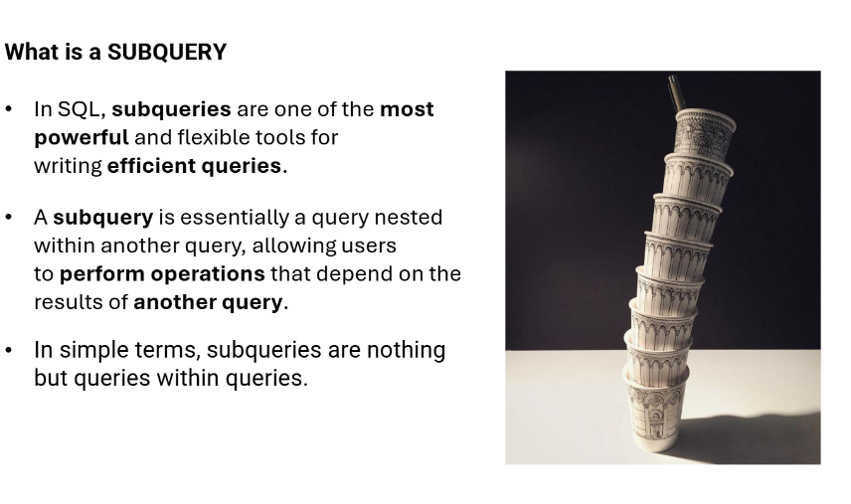
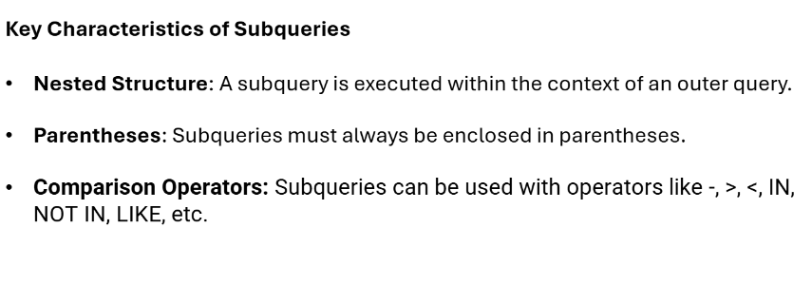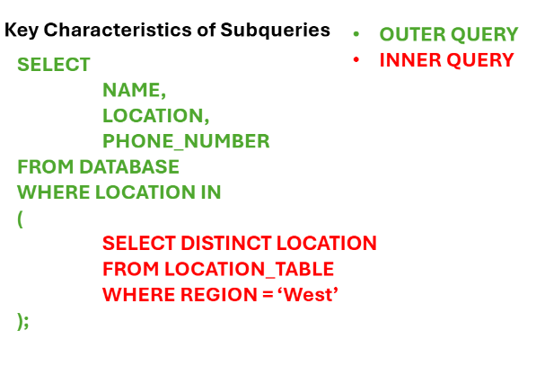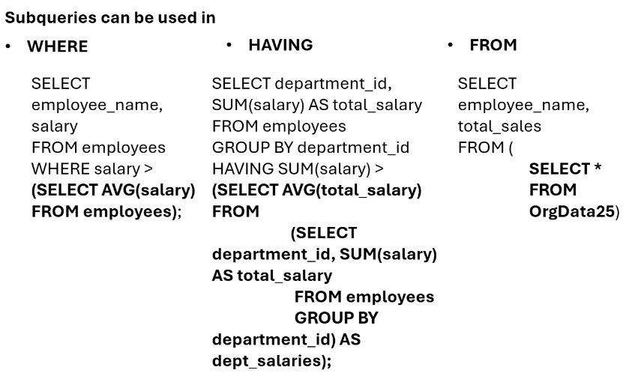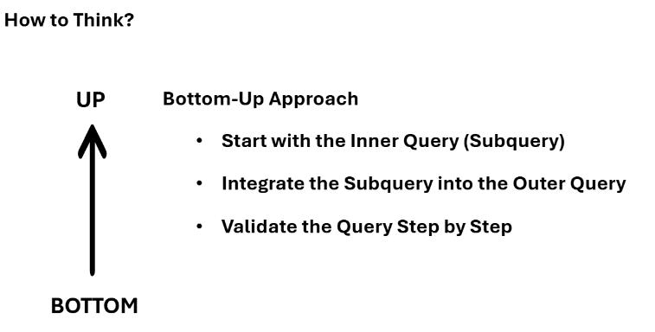

-- ============================================================
-- SUBQUERIES
-- ============================================================
USE DATABASE TRAINING_DB;
USE SCHEMA SALES_SCHEMA;

-- 1. Subquery in WHERE (Scalar subquery — returns one value)
-- Find customers whose annual revenue is above average
SELECT CUSTOMER_ID, FIRST_NAME, ANNUAL_REVENUE
FROM CUSTOMERS
WHERE ANNUAL_REVENUE > (
SELECT AVG(ANNUAL_REVENUE) FROM CUSTOMERS
)
ORDER BY ANNUAL_REVENUE DESC;

-- 2. Subquery with IN (Multi-row subquery)
-- Find customers who have placed at least one delivered order
SELECT CUSTOMER_ID, FIRST_NAME, CITY, CUSTOMER_TIER
FROM CUSTOMERS
WHERE CUSTOMER_ID IN (
SELECT DISTINCT CUSTOMER_ID
FROM ORDERS
WHERE STATUS = 'DELIVERED'
);

-- 3. Subquery with NOT IN (Anti-join)
-- Customers who have NEVER placed a delivered order
SELECT CUSTOMER_ID, FIRST_NAME
FROM CUSTOMERS
WHERE CUSTOMER_ID NOT IN (
SELECT DISTINCT CUSTOMER_ID FROM ORDERS WHERE STATUS = 'DELIVERED'
);

-- 4. Subquery in FROM (Derived table / inline view)
SELECT
TIER_SUMMARY.CUSTOMER_TIER,
TIER_SUMMARY.CUSTOMER_COUNT,
TIER_SUMMARY.AVG_REVENUE,
ROUND(TIER_SUMMARY.AVG_REVENUE / SUM(TIER_SUMMARY.AVG_REVENUE) OVER() * 100, 1) AS PCT_OF_TOTAL
FROM (
SELECT
CUSTOMER_TIER,
COUNT(*) AS CUSTOMER_COUNT,
AVG(ANNUAL_REVENUE) AS AVG_REVENUE
FROM CUSTOMERS
GROUP BY CUSTOMER_TIER
) AS TIER_SUMMARY
ORDER BY AVG_REVENUE DESC;

-- 5. Correlated Subquery — inner query references outer query
-- Find orders where TOTAL_AMOUNT > average order value for THAT customer
SELECT
O.ORDER_ID,
O.CUSTOMER_ID,
O.TOTAL_AMOUNT,
O.ORDER_DATE
FROM ORDERS O
WHERE O.TOTAL_AMOUNT > (
SELECT AVG(O2.TOTAL_AMOUNT)
FROM ORDERS O2
WHERE O2.CUSTOMER_ID = O.CUSTOMER_ID -- correlated reference
);

Common Table Expressions (CTEs)
CTEs (WITH clause) make complex queries modular, readable, and reusable within a single statement. Think of them as temporary named result sets.
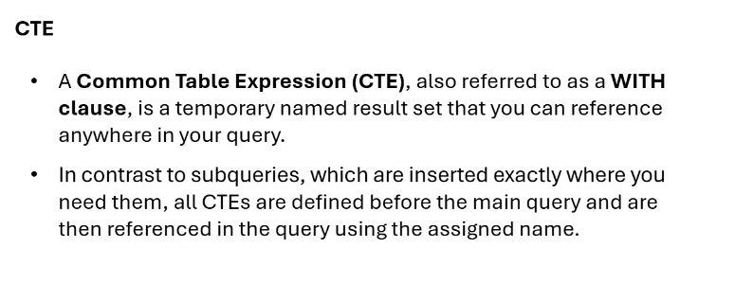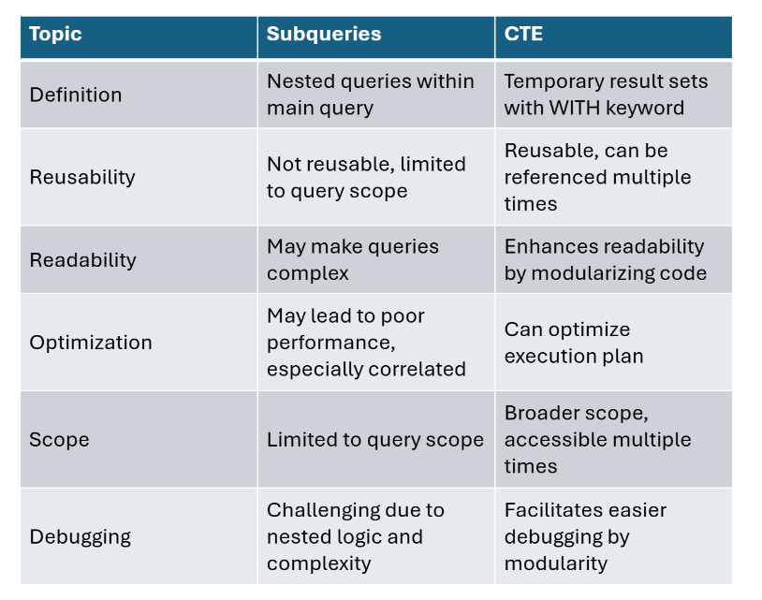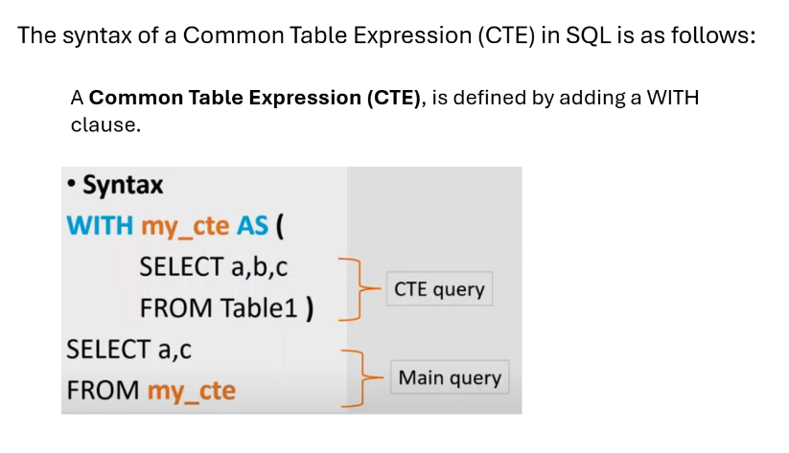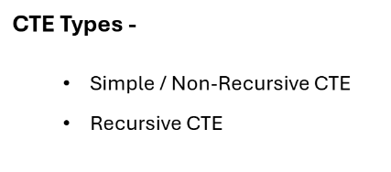
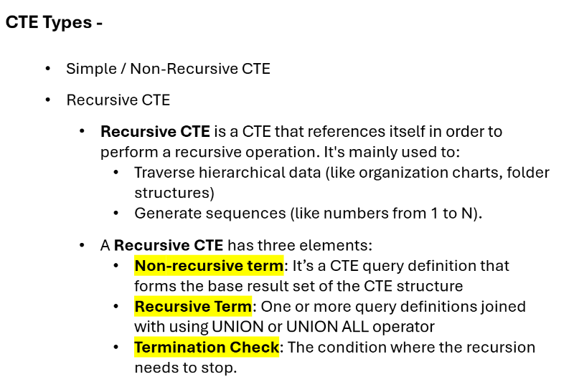

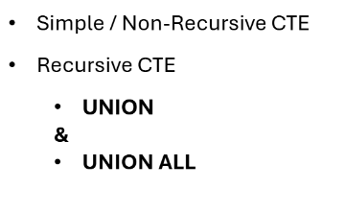

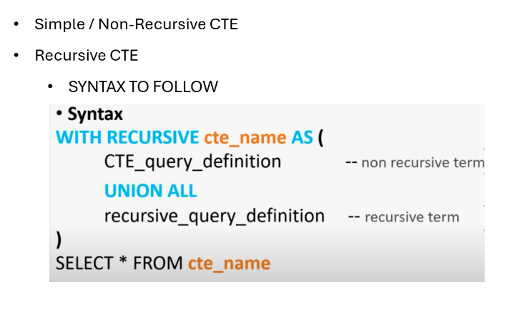
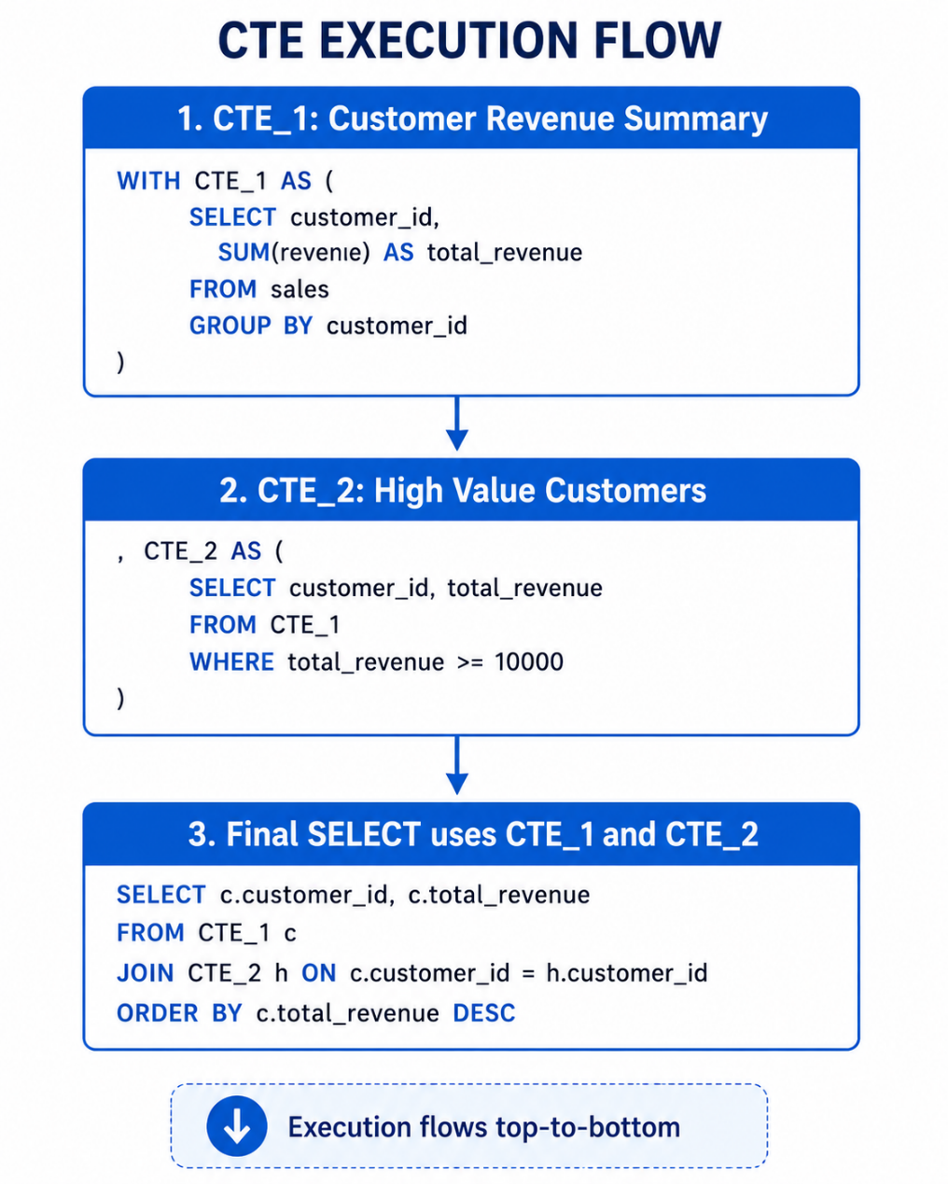

-- ============================================================
-- COMMON TABLE EXPRESSIONS (CTEs)
-- ============================================================

-- 1. Basic CTE — cleaner alternative to subquery
WITH HIGH_VALUE_CUSTOMERS AS (
SELECT
CUSTOMER_ID,
FIRST_NAME || ' ' || LAST_NAME AS CUSTOMER_NAME,
CUSTOMER_TIER,
ANNUAL_REVENUE
FROM CUSTOMERS
WHERE ANNUAL_REVENUE > 500000
AND IS_ACTIVE = TRUE
)
SELECT
HVC.CUSTOMER_NAME,
HVC.CUSTOMER_TIER,
COUNT(O.ORDER_ID) AS ORDER_COUNT,
SUM(O.TOTAL_AMOUNT) AS LIFETIME_VALUE
FROM HIGH_VALUE_CUSTOMERS HVC
LEFT JOIN ORDERS O ON HVC.CUSTOMER_ID = O.CUSTOMER_ID
GROUP BY HVC.CUSTOMER_NAME, HVC.CUSTOMER_TIER
ORDER BY LIFETIME_VALUE DESC;

-- 2. Multiple CTEs (chained CTEs)
WITH
CUSTOMER_ORDERS AS (
SELECT
C.CUSTOMER_ID,
C.FIRST_NAME || ' ' || C.LAST_NAME AS CUSTOMER_NAME,
C.CUSTOMER_TIER,
COUNT(O.ORDER_ID) AS TOTAL_ORDERS,
SUM(O.TOTAL_AMOUNT) AS TOTAL_SPENT,
MAX(O.ORDER_DATE) AS LAST_ORDER_DATE
FROM CUSTOMERS C
LEFT JOIN ORDERS O ON C.CUSTOMER_ID = O.CUSTOMER_ID
GROUP BY C.CUSTOMER_ID, C.FIRST_NAME, C.LAST_NAME, C.CUSTOMER_TIER
),
ORDER_SEGMENTS AS (
SELECT
*,
CASE
WHEN TOTAL_ORDERS >= 3 THEN 'Loyal'
WHEN TOTAL_ORDERS = 2 THEN 'Repeat'
WHEN TOTAL_ORDERS = 1 THEN 'One-Time'
ELSE 'Prospect'
END AS PURCHASE_SEGMENT
FROM CUSTOMER_ORDERS
)
SELECT
PURCHASE_SEGMENT,
COUNT(*) AS CUSTOMERS,
ROUND(AVG(TOTAL_SPENT), 0) AS AVG_SPEND,
ROUND(AVG(TOTAL_ORDERS), 1) AS AVG_ORDERS
FROM ORDER_SEGMENTS
GROUP BY PURCHASE_SEGMENT
ORDER BY AVG_SPEND DESC;

Temporary & Transient Tables
In Snowflake, there are two types of temporary tables: temporary tables and transient tables.

Temporary tables are only visible to the current session and are dropped automatically when the session ends. On the other hand, transient tables have a wider scope of visibility and persist beyond the current session unless explicitly dropped. Once created, it is impossible to convert a temporary or transient table into any other type of table.

When working with temporary and transient tables in Snowflake, it's important to consider their integration with the Time Travel and Fail-safe features. Time Travel allows you to query data as it existed at a specific point in time. At the same time, Fail-safe protects historical data in the event of unexpected system failures or security breaches. Both temporary and transient tables can have Time Travel enabled with a retention period of up to one day. This means you can query the table data as it existed at a specific point in time within a 1-day window.

Regarding Fail-safe, neither temporary nor transient tables support this feature.

In contrast, transient tables are intended for data that needs to be retained for longer than a single session but do not require the same level of data protection and recovery provided by permanent tables. Unlike permanent tables, transient tables do not have a Fail-safe period, a feature unique to permanent tables. Also, the maximum available Time Travel can be set up to one day. This makes them ideal for temporary or transitory data that will not be needed in the long term.

However, it's important to note that due to the absence of Fail-safe and supported maximum 1-day Time Travel, transient tables are not recommended for data that requires data protection and recovery.

Feature | Temporary Table | Transient Table | Permanent Table
Session scope | Current session only | Persistent across sessions | Persistent across sessions
Time Travel | Not supported (0 days) | 0-1 days | 0-90 days (default 1)
Fail-safe | Not supported | Not supported | 7 days
Storage cost | Minimal | Lower (no Fail-safe) | Full
Use case | Intermediate ETL steps | Staging area / temp load | Production data

-- ============================================================
-- TEMPORARY AND TRANSIENT TABLES
-- ============================================================

-- 1. Temporary Table — only exists in current session
CREATE TEMPORARY TABLE TEMP_ORDER_SUMMARY AS
SELECT
O.CUSTOMER_ID,
C.FIRST_NAME || ' ' || C.LAST_NAME AS CUSTOMER_NAME,
C.CUSTOMER_TIER,
COUNT(O.ORDER_ID) AS ORDER_COUNT,
SUM(O.TOTAL_AMOUNT) AS TOTAL_REVENUE,
MIN(O.ORDER_DATE) AS FIRST_ORDER,
MAX(O.ORDER_DATE) AS LAST_ORDER
FROM ORDERS O
JOIN CUSTOMERS C ON O.CUSTOMER_ID = C.CUSTOMER_ID
WHERE O.STATUS != 'CANCELLED'
GROUP BY O.CUSTOMER_ID, C.FIRST_NAME, C.LAST_NAME, C.CUSTOMER_TIER;

SELECT * FROM TEMP_ORDER_SUMMARY ORDER BY TOTAL_REVENUE DESC;

-- 2. Transient Table — persists across sessions, no fail-safe
CREATE TRANSIENT TABLE IF NOT EXISTS STAGING_ORDERS (
ORDER_ID NUMBER,
CUSTOMER_ID NUMBER,
ORDER_DATE DATE,
TOTAL_AMOUNT DECIMAL(15,2),
LOAD_TIMESTAMP TIMESTAMP_NTZ DEFAULT CURRENT_TIMESTAMP()
);

Views and Materialized Views
In Snowflake, both standard views and materialized views are used to simplify access to data, but they differ fundamentally in how they handle data storage and query execution.

Core Differences
Feature | Standard View | Materialized View
Storage | Does not store data; only stores the SQL query definition. | Stores the pre-computed results of the query physically on disk.
Query Performance | Depends on the complexity of the underlying query; runs every time it's called. | Significantly faster for complex or frequent queries because results are pre-calculated.
Data Freshness | Always real-time; fetches latest data from base tables. | Always current; Snowflake automatically maintains and updates it when base tables change.
Cost | No additional storage or maintenance costs. | Incurs both storage costs and maintenance costs (credits) for background refreshes.
Source Tables | Can join multiple tables and other views. | Limited to querying a single base table.

Standard Views
Standard views are "virtual tables" that act as a saved query. They are ideal for:
- Security: Hiding sensitive columns or rows from certain users.
- Simplicity: Providing a cleaner interface for end-users to interact with complex joins.
- Cost-Effectiveness: When storage budgets are tight and query performance is already acceptable.
Materialized Views
Materialized views are best for scenarios where query speed is critical and the data is large but doesn't change every second. [1, 2]
- Performance Tuning: Excellent for expensive aggregations or filtering on massive datasets.
- Automatic Rewriting: Snowflake’s optimizer can automatically rewrite a query against a base table to use a materialized view instead if it improves performance.
- Enterprise Edition: Note that creating materialized views requires Snowflake Enterprise Edition or higher.

-- ============================================================
-- VIEWS
-- ============================================================

-- 1. Standard View — no data storage, just a saved query
CREATE OR REPLACE VIEW VW_CUSTOMER_360 AS
SELECT
C.CUSTOMER_ID,
C.FIRST_NAME || ' ' || C.LAST_NAME AS CUSTOMER_NAME,
C.EMAIL,
C.PHONE,
C.CITY,
C.STATE,
C.CUSTOMER_TIER,
C.IS_ACTIVE,
C.ANNUAL_REVENUE,
COALESCE(OS.ORDER_COUNT, 0) AS LIFETIME_ORDERS,
COALESCE(OS.TOTAL_SPENT, 0) AS LIFETIME_SPENT,
OS.LAST_ORDER_DATE
FROM CUSTOMERS C
LEFT JOIN (
SELECT CUSTOMER_ID,
COUNT(*) AS ORDER_COUNT,
SUM(TOTAL_AMOUNT) AS TOTAL_SPENT,
MAX(ORDER_DATE) AS LAST_ORDER_DATE
FROM ORDERS
WHERE STATUS != 'CANCELLED'
GROUP BY CUSTOMER_ID
) OS ON C.CUSTOMER_ID = OS.CUSTOMER_ID;

-- Query the view like a table
SELECT * FROM VW_CUSTOMER_360 WHERE CUSTOMER_TIER = 'GOLD';

-- 2. Secure View (hides definition from non-owners)
CREATE OR REPLACE SECURE VIEW VW_CUSTOMER_SENSITIVE AS
SELECT
CUSTOMER_ID,
FIRST_NAME,
CUSTOMER_TIER,
IS_ACTIVE
-- EMAIL and PHONE deliberately excluded
FROM CUSTOMERS;

-- 3. Materialized View basics (note: requires Enterprise edition)
-- Materialized views store pre-computed results for fast query performance
-- Syntax:
-- CREATE MATERIALIZED VIEW MVW_MONTHLY_SALES AS
-- SELECT DATE_TRUNC('month', ORDER_DATE) AS MONTH,
-- COUNT(*) AS ORDERS,
-- SUM(TOTAL_AMOUNT) AS REVENUE
-- FROM ORDERS
-- GROUP BY 1;

-- 4. Manage views
SHOW VIEWS IN SCHEMA SALES_SCHEMA;
DESCRIBE VIEW VW_CUSTOMER_360;
-- DROP VIEW VW_CUSTOMER_360;

CHECKPOINT
Q1: What is the difference between a CTE and a subquery?
Q2: When would you use a Temporary Table vs a CTE?
Q3: Does a View store data? What about a Materialized View?
Q4: What is the correlated subquery, and why is it potentially slow?
STUDENT ACTIVITY 4 — CTE Challenge (10 min)
1. Write a CTE "TOP_PRODUCTS" that finds the 3 most sold products (by quantity).
2. Extend it with a second CTE "PRODUCT_REVENUE" to calculate total revenue per product.
3. Write a view VW_SALES_DASHBOARD that shows: Month, Order Count, Revenue, Avg Order Value.
4. BONUS: Write a correlated subquery to find each customer's most recent order.

SECTION 2: ADVANCED ANALYTICS SQL

2.1 Window Functions — The Analytics Powerhouse
Collapsing rows like GROUP BY does. They are the most powerful and interview-critical SQL feature.
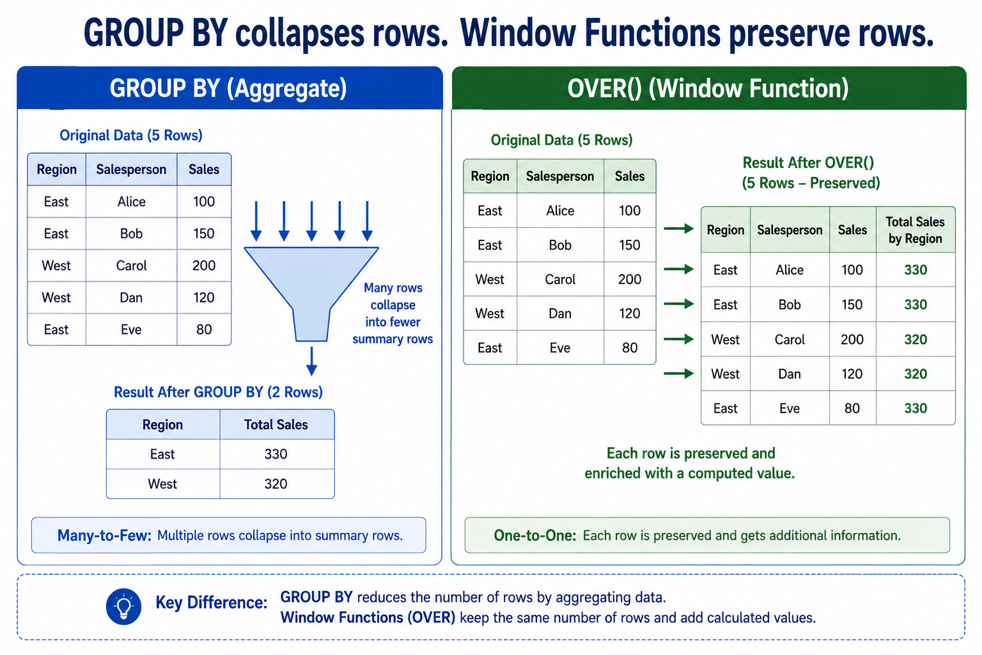
- Window functions in Snowflake are a way to compute values over a group of rows.
- They return a single value for each row, in contrast to aggregate functions which return a single value for a group of rows.
- Window functions are the base of data warehousing workloads for many reasons.
- First of all they are very similar to the GROUP BY clause as they run on a set of rows instead of a single one but, but unlike the GROUP BY clause we do not lose the individual rows.
- To remedy this we could perform a self join with the result of GROUP BY operation but window functions implement the same functionality in a more efficient way that gives better performance.
- Window functions also provide complex functions that are based on the (requested) order of rows such as DENSE_RANK which would be hard to implement with traditional SQL.
- Using window functions you can avoid writing procedural SQL code.
What is a Window?
- A window is a group of related rows.
- For example, a window might be defined based on timestamps, with all rows in the same month grouped in the same window.
- Or a window might be defined based on location, with all rows from a particular city grouped in the same window.
- A window can consist of zero, one, or multiple rows.
- For simplicity, Snowflake documentation usually says that a window contains multiple rows.

Why use window functions?
Window functions are very powerful, and once you've gotten your head around how to use them, you'll be surprised at what they allow you to do.
Some common use cases are:
- Running/Cumulative Total
- Moving Average
- Rank rows by custom criteria and groupings
- Finding the year-over-year % Change

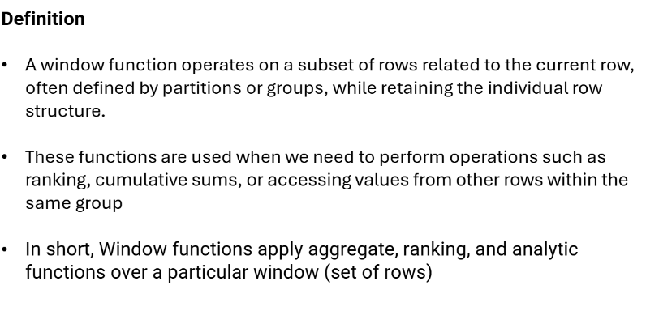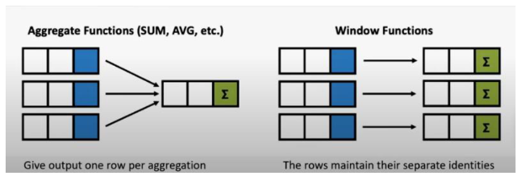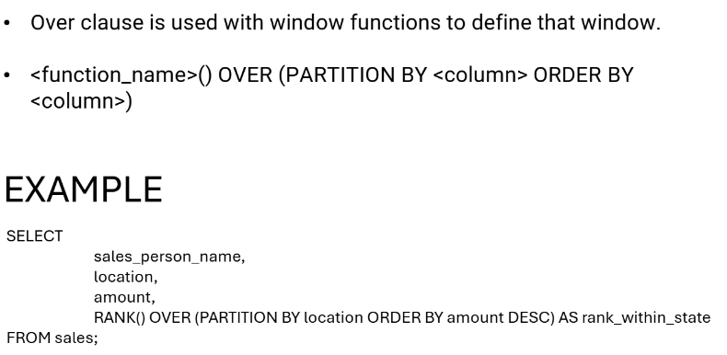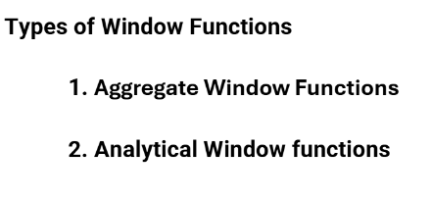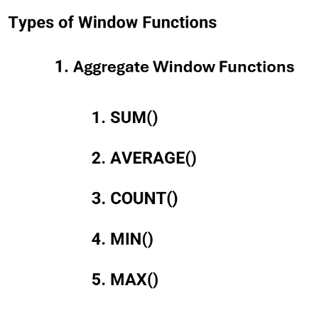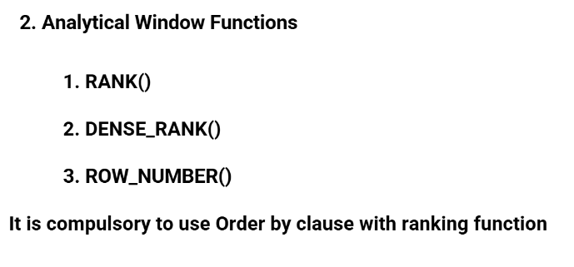
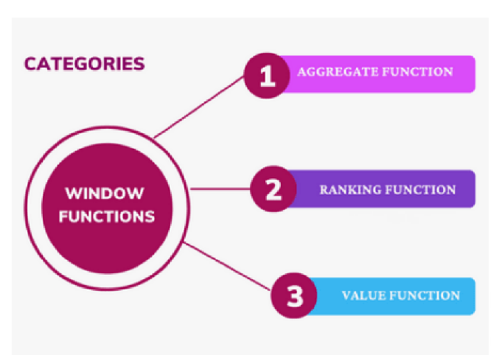

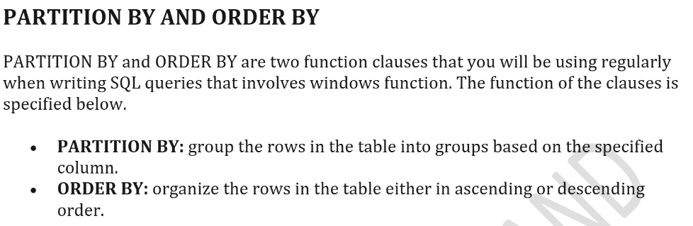

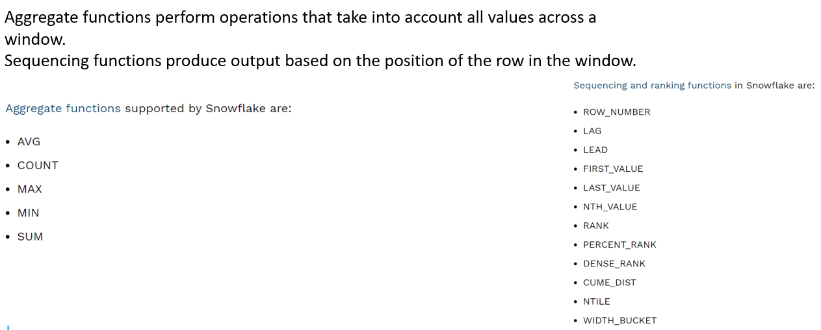

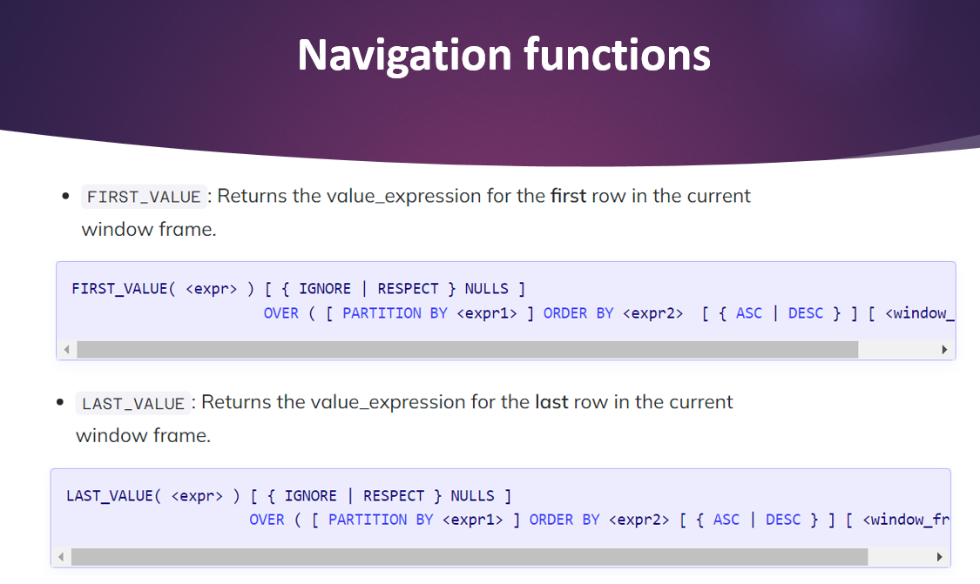
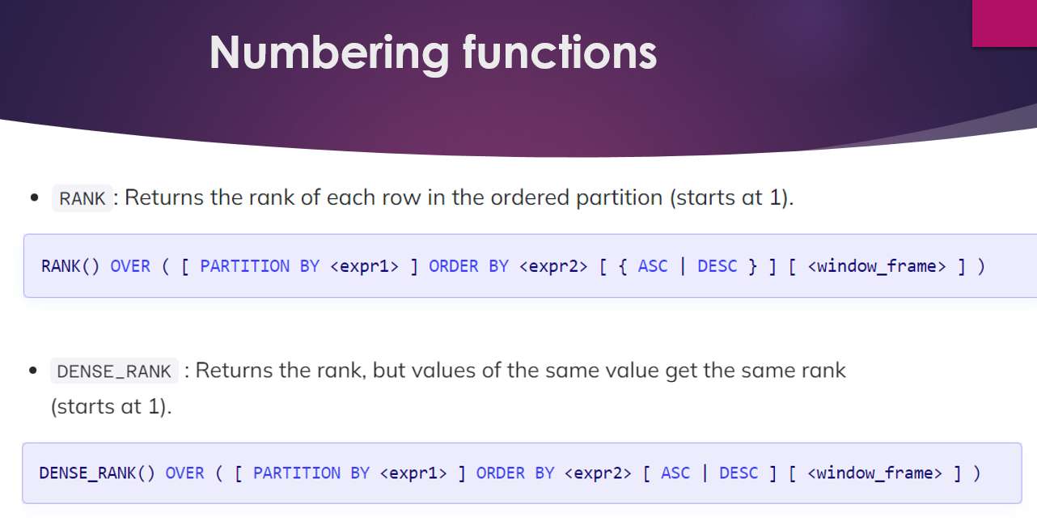

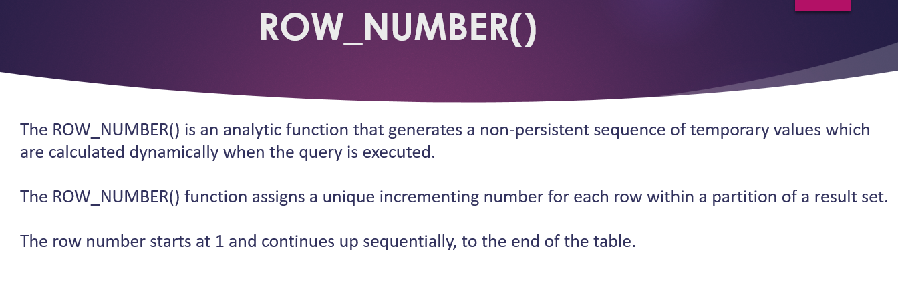

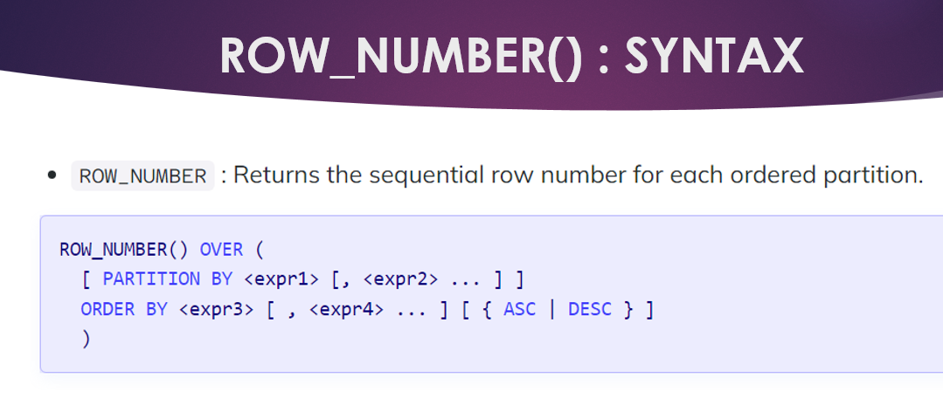

Window Function vs Aggregate Function

Aspect | GROUP BY Aggregate | Window Function
Rows in output | Fewer — one per group | Same as input — all rows preserved
Access to row detail | Lost after aggregation | Retained alongside calculation
Can mix aggregate + detail? | No | Yes — e.g., SUM() OVER() in same SELECT
Syntax | SELECT col, SUM(x) FROM t GROUP BY col | SELECT col, SUM(x) OVER(...) FROM t
Real-world use | Summary reports | Rankings, running totals, analytics

Window Function Anatomy
-- WINDOW FUNCTION SYNTAX:
-- function_name() OVER (
-- [PARTITION BY column(s)] -- divide rows into groups (like GROUP BY for the window)
-- [ORDER BY column(s)] -- sort within each partition
-- [ROWS/RANGE BETWEEN ...] -- frame specification (optional)
-- )

-- Simple example to explain each part:
SELECT
CUSTOMER_ID,
ORDER_DATE,
TOTAL_AMOUNT,

-- No PARTITION, no ORDER: applies to entire result set
SUM(TOTAL_AMOUNT) OVER () AS GRAND_TOTAL,

-- PARTITION BY: subtotal per customer
SUM(TOTAL_AMOUNT) OVER (PARTITION BY CUSTOMER_ID) AS CUSTOMER_TOTAL,

-- PARTITION + ORDER: running total per customer (ordered by date)
SUM(TOTAL_AMOUNT) OVER (
PARTITION BY CUSTOMER_ID
ORDER BY ORDER_DATE
ROWS BETWEEN UNBOUNDED PRECEDING AND CURRENT ROW
) AS RUNNING_TOTAL,

-- Percentage of grand total
ROUND(TOTAL_AMOUNT / SUM(TOTAL_AMOUNT) OVER() * 100, 2) AS PCT_OF_TOTAL

FROM ORDERS
WHERE STATUS != 'CANCELLED'
ORDER BY CUSTOMER_ID, ORDER_DATE;

Ranking Functions

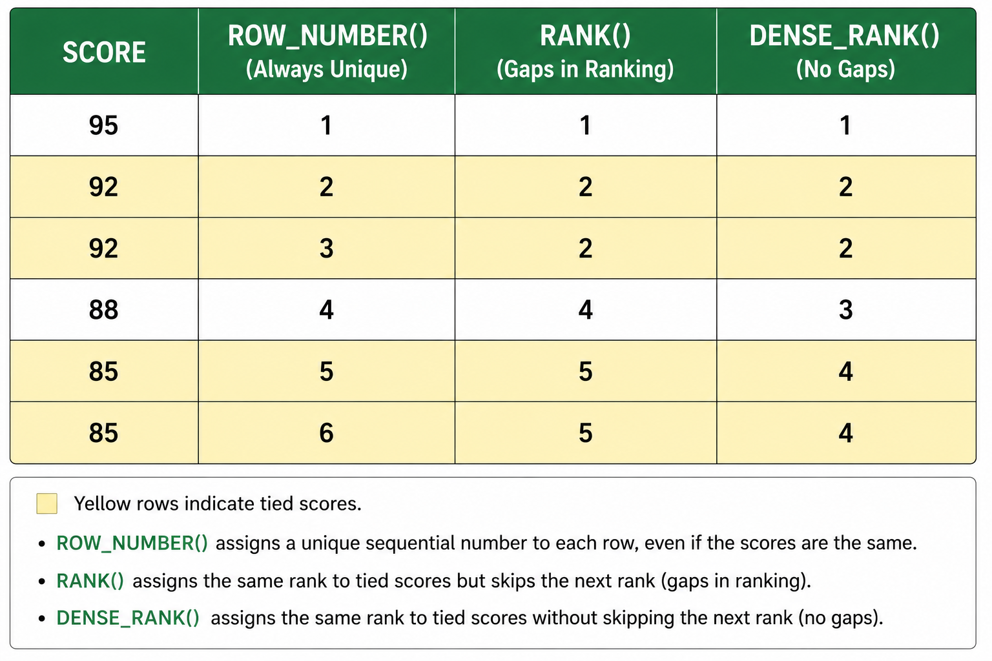

-- ============================================================
-- RANKING FUNCTIONS
-- ============================================================
USE DATABASE TRAINING_DB;
USE SCHEMA SALES_SCHEMA;

-- 1. ROW_NUMBER, RANK, DENSE_RANK side by side
SELECT
ORDER_ID,
CUSTOMER_ID,
TOTAL_AMOUNT,

ROW_NUMBER() OVER (ORDER BY TOTAL_AMOUNT DESC) AS ROW_NUM,
-- Always unique 1,2,3,4,5... regardless of ties

RANK() OVER (ORDER BY TOTAL_AMOUNT DESC) AS RANK_NUM,
-- 1,2,2,4 — skips rank 3 after two rows tied at rank 2

DENSE_RANK() OVER (ORDER BY TOTAL_AMOUNT DESC) AS DENSE_RANK_NUM
-- 1,2,2,3 — no gaps, consecutive after ties

FROM ORDERS
WHERE STATUS != 'CANCELLED';

-- 2. RANK within each customer (PARTITION BY)
SELECT
CUSTOMER_ID,
ORDER_ID,
ORDER_DATE,
TOTAL_AMOUNT,
RANK() OVER (
PARTITION BY CUSTOMER_ID
ORDER BY TOTAL_AMOUNT DESC
) AS RANK_WITHIN_CUSTOMER
FROM ORDERS;

-- 3. Use ROW_NUMBER for deduplication (Top-1 per group)
-- Find the most recent order per customer
WITH RANKED_ORDERS AS (
SELECT
*,
ROW_NUMBER() OVER (
PARTITION BY CUSTOMER_ID
ORDER BY ORDER_DATE DESC, ORDER_ID DESC
) AS RN
FROM ORDERS
)
SELECT * FROM RANKED_ORDERS WHERE RN = 1;

-- 4. NTILE — divide rows into N equal buckets
SELECT
CUSTOMER_ID,
ANNUAL_REVENUE,
NTILE(4) OVER (ORDER BY ANNUAL_REVENUE DESC) AS QUARTILE,
CASE NTILE(4) OVER (ORDER BY ANNUAL_REVENUE DESC)
WHEN 1 THEN 'Top 25%'
WHEN 2 THEN 'Upper-Mid 25%'
WHEN 3 THEN 'Lower-Mid 25%'
WHEN 4 THEN 'Bottom 25%'
END AS REVENUE_QUARTILE
FROM CUSTOMERS;

LEAD and LAG — Time-Series Shift Functions
LEAD looks ahead to the NEXT row. LAG looks back to the PREVIOUS row. These are essential for period-over-period analysis.
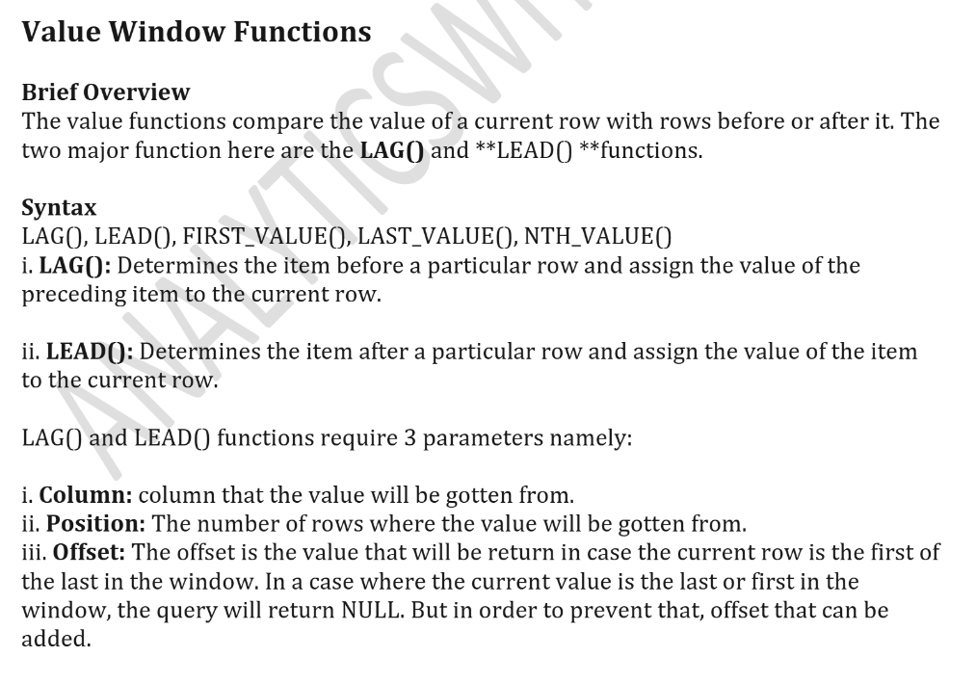
-- ============================================================
-- LEAD AND LAG FUNCTIONS
-- ============================================================

-- 1. LAG — compare each order to the previous order value
SELECT
ORDER_ID,
CUSTOMER_ID,
ORDER_DATE,
TOTAL_AMOUNT,
LAG(TOTAL_AMOUNT, 1, 0) OVER (
PARTITION BY CUSTOMER_ID
ORDER BY ORDER_DATE
) AS PREV_ORDER_AMOUNT,
TOTAL_AMOUNT - LAG(TOTAL_AMOUNT, 1, 0) OVER (
PARTITION BY CUSTOMER_ID
ORDER BY ORDER_DATE
) AS AMOUNT_CHANGE
FROM ORDERS
ORDER BY CUSTOMER_ID, ORDER_DATE;

-- 2. LEAD — look at the next order date
SELECT
CUSTOMER_ID,
ORDER_ID,
ORDER_DATE,
LEAD(ORDER_DATE, 1) OVER (
PARTITION BY CUSTOMER_ID
ORDER BY ORDER_DATE
) AS NEXT_ORDER_DATE,
DATEDIFF('day', ORDER_DATE,
LEAD(ORDER_DATE, 1) OVER (
PARTITION BY CUSTOMER_ID
ORDER BY ORDER_DATE
)
) AS DAYS_BETWEEN_ORDERS
FROM ORDERS
ORDER BY CUSTOMER_ID, ORDER_DATE;

-- 3. Monthly revenue with month-over-month growth
WITH MONTHLY_REVENUE AS (
SELECT
DATE_TRUNC('month', ORDER_DATE) AS SALES_MONTH,
SUM(TOTAL_AMOUNT) AS MONTHLY_REVENUE
FROM ORDERS
WHERE STATUS != 'CANCELLED'
GROUP BY 1
),
WITH_GROWTH AS (
SELECT
SALES_MONTH,
MONTHLY_REVENUE,
LAG(MONTHLY_REVENUE) OVER (ORDER BY SALES_MONTH) AS PREV_MONTH_REVENUE,
ROUND(
(MONTHLY_REVENUE - LAG(MONTHLY_REVENUE) OVER (ORDER BY SALES_MONTH))
/ NULLIF(LAG(MONTHLY_REVENUE) OVER (ORDER BY SALES_MONTH), 0) * 100,
1
) AS MOM_GROWTH_PCT
FROM MONTHLY_REVENUE
)
SELECT * FROM WITH_GROWTH ORDER BY SALES_MONTH;

FIRST_VALUE, LAST_VALUE — Frame Functions
-- ============================================================
-- FIRST_VALUE AND LAST_VALUE
-- ============================================================

-- 1. FIRST_VALUE — first order date per customer (in each partition)
SELECT
CUSTOMER_ID,
ORDER_ID,
ORDER_DATE,
TOTAL_AMOUNT,
FIRST_VALUE(ORDER_DATE) OVER (
PARTITION BY CUSTOMER_ID
ORDER BY ORDER_DATE
ROWS BETWEEN UNBOUNDED PRECEDING AND UNBOUNDED FOLLOWING
) AS FIRST_ORDER_DATE,
FIRST_VALUE(TOTAL_AMOUNT) OVER (
PARTITION BY CUSTOMER_ID
ORDER BY TOTAL_AMOUNT DESC
ROWS BETWEEN UNBOUNDED PRECEDING AND UNBOUNDED FOLLOWING
) AS HIGHEST_ORDER_AMOUNT
FROM ORDERS
ORDER BY CUSTOMER_ID, ORDER_DATE;

-- 2. Running Total and Moving Average
SELECT
DATE_TRUNC('month', ORDER_DATE) AS MONTH,
SUM(TOTAL_AMOUNT) AS MONTHLY_REVENUE,
-- Running total (cumulative sum)
SUM(SUM(TOTAL_AMOUNT)) OVER (
ORDER BY DATE_TRUNC('month', ORDER_DATE)
ROWS BETWEEN UNBOUNDED PRECEDING AND CURRENT ROW
) AS CUMULATIVE_REVENUE,
-- 3-month moving average
AVG(SUM(TOTAL_AMOUNT)) OVER (
ORDER BY DATE_TRUNC('month', ORDER_DATE)
ROWS BETWEEN 2 PRECEDING AND CURRENT ROW
) AS MOVING_AVG_3M
FROM ORDERS
WHERE STATUS != 'CANCELLED'
GROUP BY DATE_TRUNC('month', ORDER_DATE)
ORDER BY MONTH;

-- 3. PERCENTILE_CONT and PERCENTILE_DISC (ordered set functions)
SELECT
PERCENTILE_CONT(0.50) WITHIN GROUP (ORDER BY TOTAL_AMOUNT) AS MEDIAN_ORDER,
PERCENTILE_CONT(0.75) WITHIN GROUP (ORDER BY TOTAL_AMOUNT) AS P75_ORDER,
PERCENTILE_CONT(0.90) WITHIN GROUP (ORDER BY TOTAL_AMOUNT) AS P90_ORDER,
PERCENTILE_CONT(0.95) WITHIN GROUP (ORDER BY TOTAL_AMOUNT) AS P95_ORDER
FROM ORDERS
WHERE STATUS != 'CANCELLED';

HANDS-ON LAB: Window Function Challenge (15 min)
1. Rank all customers by ANNUAL_REVENUE using ROW_NUMBER, RANK, and DENSE_RANK. Output all three.
2. For each order, show the previous order amount (LAG) and next order amount (LEAD) for the same customer.
3. Calculate a 2-month moving average of monthly revenue.
4. For each product category, find the highest-priced product using FIRST_VALUE.
5. BONUS: Find the bottom 20% of customers by revenue using NTILE(5) where quartile=5.

2.2 Advanced Analytics — QUALIFY, PIVOT, Deduplication & More

The QUALIFY Clause (Snowflake-Specific)
QUALIFY filters the results of window functions — similar to how HAVING filters GROUP BY results. This is a Snowflake-specific feature that makes deduplication and ranking elegant.
-- ============================================================
-- QUALIFY CLAUSE (Snowflake-specific)
-- ============================================================
USE DATABASE TRAINING_DB;
USE SCHEMA SALES_SCHEMA;

-- 1. QUALIFY: Keep only the latest order per customer (without a CTE!)
SELECT
ORDER_ID,
CUSTOMER_ID,
ORDER_DATE,
TOTAL_AMOUNT,
STATUS
FROM ORDERS
QUALIFY ROW_NUMBER() OVER (
PARTITION BY CUSTOMER_ID
ORDER BY ORDER_DATE DESC
) = 1;
-- This replaces the CTE + WHERE RN = 1 pattern — more efficient!

-- 2. QUALIFY: Top 2 orders per customer by amount
SELECT
ORDER_ID,
CUSTOMER_ID,
ORDER_DATE,
TOTAL_AMOUNT
FROM ORDERS
QUALIFY RANK() OVER (
PARTITION BY CUSTOMER_ID
ORDER BY TOTAL_AMOUNT DESC
) <= 2;

-- 3. QUALIFY: Orders where amount is above customer's own average
SELECT
ORDER_ID,
CUSTOMER_ID,
ORDER_DATE,
TOTAL_AMOUNT
FROM ORDERS
QUALIFY TOTAL_AMOUNT > AVG(TOTAL_AMOUNT) OVER (PARTITION BY CUSTOMER_ID);

PIVOT and UNPIVOT
PIVOT rotates rows into columns (converts long format to wide format). UNPIVOT does the reverse.
-- ============================================================
-- PIVOT AND UNPIVOT
-- ============================================================

-- Setup: Monthly revenue by region (long format)
CREATE OR REPLACE TEMP TABLE MONTHLY_REGION_SALES AS
SELECT
TO_CHAR(DATE_TRUNC('month', ORDER_DATE), 'MON') AS MONTH_NAME,
REGION,
SUM(TOTAL_AMOUNT) AS REVENUE
FROM ORDERS
WHERE STATUS != 'CANCELLED'
AND REGION IS NOT NULL
GROUP BY 1, 2;

SELECT * FROM MONTHLY_REGION_SALES ORDER BY MONTH_NAME, REGION;
-- Output: rows like (JAN, North, 134999), (JAN, South, 12349)...

-- 1. PIVOT: Show each month as a column, regions as rows
SELECT *
FROM MONTHLY_REGION_SALES
PIVOT (
SUM(REVENUE)
FOR MONTH_NAME IN ('JAN','FEB','MAR','APR','MAY')
) AS PIVOTED
ORDER BY REGION;
-- Output: Each row = one REGION, columns = JAN through MAY revenue

-- 2. Dynamic PIVOT alternative using CASE statements
SELECT
REGION,
SUM(CASE WHEN MONTH_NAME = 'JAN' THEN REVENUE ELSE 0 END) AS JAN,
SUM(CASE WHEN MONTH_NAME = 'FEB' THEN REVENUE ELSE 0 END) AS FEB,
SUM(CASE WHEN MONTH_NAME = 'MAR' THEN REVENUE ELSE 0 END) AS MAR,
SUM(CASE WHEN MONTH_NAME = 'APR' THEN REVENUE ELSE 0 END) AS APR,
SUM(CASE WHEN MONTH_NAME = 'MAY' THEN REVENUE ELSE 0 END) AS MAY,
SUM(REVENUE) AS TOTAL
FROM MONTHLY_REGION_SALES
GROUP BY REGION
ORDER BY TOTAL DESC;

-- 3. UNPIVOT: Convert wide format back to long format
-- (useful when source data has months as columns)
CREATE OR REPLACE TEMP TABLE WIDE_SALES (
REGION VARCHAR,
JAN NUMBER, FEB NUMBER, MAR NUMBER, APR NUMBER, MAY NUMBER
);
-- Upload wide_sales data using staging
-- Note: For this small demo table, we still use staging for consistency
CREATE OR REPLACE STAGE STG_WIDE_SALES
FILE_FORMAT = TRAINING_CSV_FORMAT
COMMENT = 'Internal stage for WIDE_SALES pivot demo data';

-- Since WIDE_SALES is a small demo table derived from ORDERS data,
-- we create it using CTAS from the already-loaded MONTHLY_REGION_SALES:
INSERT INTO WIDE_SALES
SELECT
REGION,
SUM(CASE WHEN MONTH_NAME = 'JAN' THEN REVENUE ELSE 0 END) AS JAN,
SUM(CASE WHEN MONTH_NAME = 'FEB' THEN REVENUE ELSE 0 END) AS FEB,
SUM(CASE WHEN MONTH_NAME = 'MAR' THEN REVENUE ELSE 0 END) AS MAR,
SUM(CASE WHEN MONTH_NAME = 'APR' THEN REVENUE ELSE 0 END) AS APR,
SUM(CASE WHEN MONTH_NAME = 'MAY' THEN REVENUE ELSE 0 END) AS MAY
FROM MONTHLY_REGION_SALES
GROUP BY REGION;

SELECT REGION, MONTH_NAME, REVENUE
FROM WIDE_SALES
UNPIVOT (REVENUE FOR MONTH_NAME IN (JAN, FEB, MAR, APR, MAY))
ORDER BY REGION, MONTH_NAME;

Data Deduplication Techniques
-- ============================================================
-- DEDUPLICATION STRATEGIES
-- ============================================================

-- Setup: Simulate duplicate records
CREATE OR REPLACE TEMP TABLE DUPLICATE_ORDERS AS
SELECT * FROM ORDERS
UNION ALL
SELECT * FROM ORDERS WHERE ORDER_ID IN (5001, 5002, 5003); -- Add 3 duplicates

SELECT COUNT(*) AS TOTAL_ROWS FROM DUPLICATE_ORDERS;

-- Strategy 1: DISTINCT (simple but limited)
SELECT DISTINCT * FROM DUPLICATE_ORDERS; -- Works if ALL columns are identical

-- Strategy 2: ROW_NUMBER + QUALIFY (recommended — most flexible)
SELECT * FROM DUPLICATE_ORDERS
QUALIFY ROW_NUMBER() OVER (
PARTITION BY ORDER_ID -- Define what makes a row "unique"
ORDER BY ORDER_DATE -- Keep the earliest (or change to DESC for latest)
) = 1;

-- Strategy 3: GROUP BY with aggregation (when some columns can vary)
SELECT
ORDER_ID,
CUSTOMER_ID,
MIN(ORDER_DATE) AS FIRST_ORDER_DATE,
MAX(TOTAL_AMOUNT) AS MAX_AMOUNT,
COUNT(*) AS DUPLICATE_COUNT
FROM DUPLICATE_ORDERS
GROUP BY ORDER_ID, CUSTOMER_ID
HAVING COUNT(*) > 1; -- Show only actual duplicates

-- Strategy 4: DELETE duplicates from a real table using CTE
-- (This is the enterprise pattern for data cleanup)
DELETE FROM DUPLICATE_ORDERS
WHERE ORDER_ID IN (
SELECT ORDER_ID FROM (
SELECT ORDER_ID,
ROW_NUMBER() OVER (PARTITION BY ORDER_ID ORDER BY ORDER_DATE) AS RN
FROM DUPLICATE_ORDERS
) WHERE RN > 1
);

Top-N and Cohort Analysis
-- ============================================================
-- TOP-N ANALYSIS
-- ============================================================

-- Top 3 customers by revenue per tier
SELECT *
FROM (
SELECT
C.CUSTOMER_ID,
C.FIRST_NAME || ' ' || C.LAST_NAME AS CUSTOMER_NAME,
C.CUSTOMER_TIER,
SUM(O.TOTAL_AMOUNT) AS TOTAL_SPENT
FROM CUSTOMERS C
JOIN ORDERS O ON C.CUSTOMER_ID = O.CUSTOMER_ID
GROUP BY C.CUSTOMER_ID, C.FIRST_NAME, C.LAST_NAME, C.CUSTOMER_TIER
)
QUALIFY ROW_NUMBER() OVER (
PARTITION BY CUSTOMER_TIER
ORDER BY TOTAL_SPENT DESC
) <= 3;

-- ============================================================
-- COHORT ANALYSIS (First Purchase Month)
-- ============================================================
WITH FIRST_PURCHASE AS (
SELECT
CUSTOMER_ID,
DATE_TRUNC('month', MIN(ORDER_DATE)) AS COHORT_MONTH
FROM ORDERS
GROUP BY CUSTOMER_ID
),
CUSTOMER_ORDERS_MONTHLY AS (
SELECT
O.CUSTOMER_ID,
FP.COHORT_MONTH,
DATE_TRUNC('month', O.ORDER_DATE) AS ORDER_MONTH,
DATEDIFF('month', FP.COHORT_MONTH, DATE_TRUNC('month', O.ORDER_DATE)) AS MONTHS_SINCE_FIRST
FROM ORDERS O
JOIN FIRST_PURCHASE FP ON O.CUSTOMER_ID = FP.CUSTOMER_ID
)
SELECT
COHORT_MONTH,
MONTHS_SINCE_FIRST,
COUNT(DISTINCT CUSTOMER_ID) AS ACTIVE_CUSTOMERS
FROM CUSTOMER_ORDERS_MONTHLY
GROUP BY 1, 2
ORDER BY COHORT_MONTH, MONTHS_SINCE_FIRST;

Time-Series Analytics
-- ============================================================
-- TIME-SERIES ANALYTICS PATTERNS
-- ============================================================

-- 1. Daily revenue trend with 7-day moving average
SELECT
ORDER_DATE,
COUNT(*) AS DAILY_ORDERS,
SUM(TOTAL_AMOUNT) AS DAILY_REVENUE,
ROUND(
AVG(SUM(TOTAL_AMOUNT)) OVER (
ORDER BY ORDER_DATE
ROWS BETWEEN 6 PRECEDING AND CURRENT ROW
), 2
) AS MOVING_AVG_7D
FROM ORDERS
WHERE STATUS != 'CANCELLED'
GROUP BY ORDER_DATE
ORDER BY ORDER_DATE;

-- 2. Year-over-Year comparison (with sample extended dataset)
-- Note: Our sample data is all 2024; concept shown below
SELECT
YEAR(ORDER_DATE) AS ORDER_YEAR,
MONTH(ORDER_DATE) AS ORDER_MONTH,
MONTHNAME(ORDER_DATE) AS MONTH_NAME,
SUM(TOTAL_AMOUNT) AS MONTHLY_REVENUE,
LAG(SUM(TOTAL_AMOUNT)) OVER (
PARTITION BY MONTH(ORDER_DATE)
ORDER BY YEAR(ORDER_DATE)
) AS PREV_YEAR_REVENUE,
ROUND(
(SUM(TOTAL_AMOUNT) - LAG(SUM(TOTAL_AMOUNT)) OVER (
PARTITION BY MONTH(ORDER_DATE)
ORDER BY YEAR(ORDER_DATE)
)) / NULLIF(
LAG(SUM(TOTAL_AMOUNT)) OVER (
PARTITION BY MONTH(ORDER_DATE)
ORDER BY YEAR(ORDER_DATE)
), 0
) * 100, 1
) AS YOY_GROWTH_PCT
FROM ORDERS
WHERE STATUS != 'CANCELLED'
GROUP BY 1, 2, 3
ORDER BY 1, 2;

-- 3. Week-over-Week orders
SELECT
WEEKOFYEAR(ORDER_DATE) AS WEEK_NUM,
MIN(ORDER_DATE) AS WEEK_START,
COUNT(*) AS WEEKLY_ORDERS,
SUM(TOTAL_AMOUNT) AS WEEKLY_REVENUE,
LAG(COUNT(*)) OVER (ORDER BY WEEKOFYEAR(ORDER_DATE)) AS PREV_WEEK_ORDERS,
COUNT(*) - LAG(COUNT(*)) OVER (ORDER BY WEEKOFYEAR(ORDER_DATE)) AS WOW_CHANGE
FROM ORDERS
GROUP BY WEEKOFYEAR(ORDER_DATE)
ORDER BY WEEK_NUM;

Business Reporting SQL Patterns
-- ============================================================
-- BUSINESS REPORTING PATTERNS
-- ============================================================

-- 1. Executive Summary Dashboard Query
WITH SUMMARY_STATS AS (
SELECT
COUNT(DISTINCT O.ORDER_ID) AS TOTAL_ORDERS,
COUNT(DISTINCT O.CUSTOMER_ID) AS UNIQUE_CUSTOMERS,
SUM(O.TOTAL_AMOUNT) AS GROSS_REVENUE,
SUM(O.TOTAL_AMOUNT * (1 - NVL(O.DISCOUNT_PCT,0)/100)) AS NET_REVENUE,
ROUND(AVG(O.TOTAL_AMOUNT), 2) AS AVG_ORDER_VALUE,
COUNT(CASE WHEN O.STATUS='CANCELLED' THEN 1 END) AS CANCELLED_ORDERS,
COUNT(CASE WHEN O.STATUS='DELIVERED' THEN 1 END) AS DELIVERED_ORDERS
FROM ORDERS O
WHERE ORDER_DATE >= '2024-01-01'
)
SELECT
*,
ROUND(DELIVERED_ORDERS * 100.0 / TOTAL_ORDERS, 1) AS DELIVERY_RATE_PCT,
ROUND(CANCELLED_ORDERS * 100.0 / TOTAL_ORDERS, 1) AS CANCELLATION_RATE_PCT
FROM SUMMARY_STATS;

-- 2. Sales Funnel Analysis
SELECT
STATUS,
COUNT(*) AS ORDER_COUNT,
ROUND(COUNT(*) * 100.0 / SUM(COUNT(*)) OVER(), 1) AS PCT_OF_TOTAL,
ROUND(SUM(TOTAL_AMOUNT)/1000, 1) AS REVENUE_K
FROM ORDERS
GROUP BY STATUS
ORDER BY ORDER_COUNT DESC;

-- 3. RFM Analysis (Recency, Frequency, Monetary)
WITH RFM_BASE AS (
SELECT
CUSTOMER_ID,
DATEDIFF('day', MAX(ORDER_DATE), CURRENT_DATE()) AS RECENCY_DAYS,
COUNT(DISTINCT ORDER_ID) AS FREQUENCY,
SUM(TOTAL_AMOUNT) AS MONETARY
FROM ORDERS
WHERE STATUS != 'CANCELLED'
GROUP BY CUSTOMER_ID
),
RFM_SCORES AS (
SELECT
CUSTOMER_ID,
RECENCY_DAYS,
FREQUENCY,
MONETARY,
NTILE(5) OVER (ORDER BY RECENCY_DAYS ASC) AS R_SCORE, -- lower days = better
NTILE(5) OVER (ORDER BY FREQUENCY DESC) AS F_SCORE,
NTILE(5) OVER (ORDER BY MONETARY DESC) AS M_SCORE
FROM RFM_BASE
)
SELECT
CUSTOMER_ID,
RECENCY_DAYS,
FREQUENCY,
ROUND(MONETARY, 0) AS MONETARY,
R_SCORE, F_SCORE, M_SCORE,
(R_SCORE + F_SCORE + M_SCORE) AS RFM_TOTAL,
CASE
WHEN R_SCORE >= 4 AND F_SCORE >= 4 THEN 'Champion'
WHEN R_SCORE >= 3 AND F_SCORE >= 3 THEN 'Loyal Customer'
WHEN R_SCORE >= 4 AND F_SCORE <= 2 THEN 'Recent Customer'
WHEN R_SCORE <= 2 AND F_SCORE >= 3 THEN 'At Risk'
ELSE 'Need Attention'
END AS CUSTOMER_SEGMENT
FROM RFM_SCORES
ORDER BY RFM_TOTAL DESC;

MINI CHALLENGE: Real-World Reporting (10 min)
1. Build a product performance report: Product Name, Category, Units Sold, Revenue, Avg Price, Rank by Revenue.
2. Create a customer lifetime value (LTV) report with: Customer Name, Tier, Days Since Signup, Total Orders, Total Spent, Avg Monthly Spend.
3. Using PIVOT, show monthly order counts per STATUS (columns: PENDING, SHIPPED, DELIVERED, CANCELLED).
4. BONUS: Build an RFM segmentation using NTILE(3) (simpler 3-tier version).

2.3 Query Optimization & Performance Best Practices
Writing correct SQL is step one. Writing FAST, scalable SQL for enterprise workloads is the next level. These practices apply directly to real Snowflake projects.
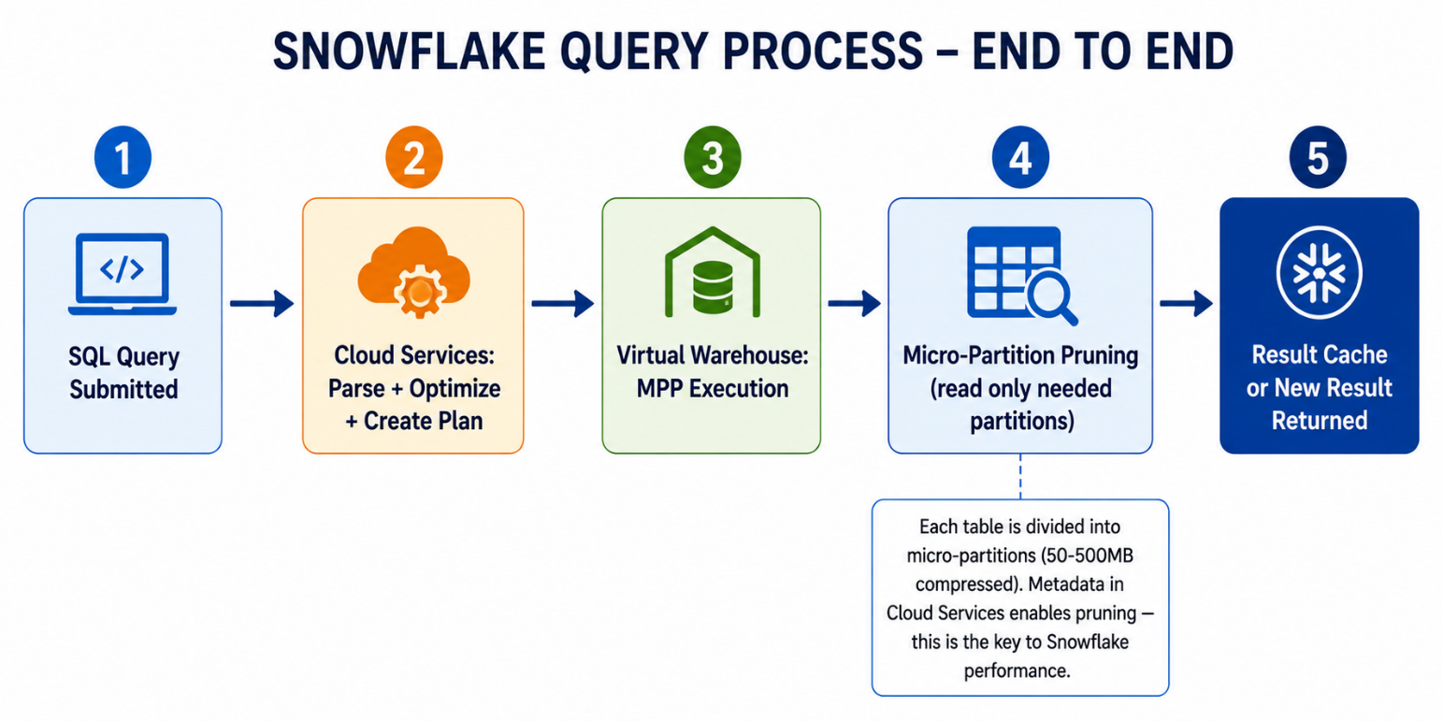

Snowflake Query Execution — How it Works

Optimization Technique | Description | Impact
Result Cache | Identical query returns cached result (no warehouse compute) | Instant — 0 credit cost
Micro-partition pruning | Filter on clustered columns skips irrelevant partitions | Very High
Clustering Keys | Define physical sort order of table data | High for range filters
Projection pushdown | SELECT only needed columns — never use SELECT * | Medium
Predicate pushdown | Apply WHERE filters early in query plan | High
JOIN order | Filter before joining — join smaller filtered sets | Medium-High
Avoid DISTINCT overuse | Use WHERE or GROUP BY instead where possible | Medium
Warehouse sizing | Scale warehouse up for heavy transforms, down for reports | High for large queries

Performance-Conscious SQL Examples
-- ============================================================
-- QUERY OPTIMIZATION EXAMPLES
-- ============================================================
USE DATABASE TRAINING_DB;
USE SCHEMA SALES_SCHEMA;

-- BAD: SELECT * brings unnecessary columns, more data scanned
SELECT * FROM ORDERS O JOIN CUSTOMERS C ON O.CUSTOMER_ID = C.CUSTOMER_ID;

-- GOOD: Select only needed columns
SELECT
O.ORDER_ID,
O.ORDER_DATE,
O.TOTAL_AMOUNT,
C.FIRST_NAME || ' ' || C.LAST_NAME AS CUSTOMER_NAME,
C.CUSTOMER_TIER
FROM ORDERS O
JOIN CUSTOMERS C ON O.CUSTOMER_ID = C.CUSTOMER_ID
WHERE O.STATUS = 'DELIVERED'
AND O.ORDER_DATE >= '2024-01-01';

-- BAD: Applying function on filtered column prevents pruning
SELECT * FROM ORDERS WHERE YEAR(ORDER_DATE) = 2024;

-- GOOD: Use range filter — enables micro-partition pruning
SELECT * FROM ORDERS
WHERE ORDER_DATE >= '2024-01-01' AND ORDER_DATE < '2025-01-01';

-- BAD: Correlated subquery runs once per outer row
SELECT ORDER_ID,
(SELECT AVG(TOTAL_AMOUNT) FROM ORDERS) AS AVG_AMOUNT -- OK for scalar
FROM ORDERS;

-- GOOD for complex correlated: Use CTE or window function instead
SELECT
ORDER_ID,
TOTAL_AMOUNT,
AVG(TOTAL_AMOUNT) OVER() AS AVG_AMOUNT, -- Window function — calculated once
TOTAL_AMOUNT - AVG(TOTAL_AMOUNT) OVER() AS DIFF_FROM_AVG
FROM ORDERS;

-- Check if result cache was used (look for "Query Profile" in UI)
-- In Snowflake UI: Results > Query Profile > look for "Result reuse" node

-- EXPLAIN PLAN (analyze query plan)
EXPLAIN
SELECT C.FIRST_NAME, O.ORDER_DATE, O.TOTAL_AMOUNT
FROM CUSTOMERS C
JOIN ORDERS O ON C.CUSTOMER_ID = O.CUSTOMER_ID
WHERE O.TOTAL_AMOUNT > 100000;

-- Monitor query performance
SELECT
QUERY_ID,
QUERY_TEXT,
EXECUTION_STATUS,
ROUND(TOTAL_ELAPSED_TIME/1000, 2) AS ELAPSED_SECONDS,
BYTES_SCANNED,
ROWS_PRODUCED,
COMPILATION_TIME,
EXECUTION_TIME
FROM TABLE (INFORMATION_SCHEMA.QUERY_HISTORY(
END_TIME_RANGE_START => DATEADD('hour', -1, CURRENT_TIMESTAMP()),
RESULT_LIMIT => 20
))
ORDER BY TOTAL_ELAPSED_TIME DESC;

Common SQL Mistakes & Troubleshooting
Common Mistake | Symptom | Fix
Using alias in WHERE | Column not found error | Use original expression or CTE
NULL comparison with = | Query returns 0 rows | Use IS NULL / IS NOT NULL
GROUP BY mismatch | Expression not in GROUP BY error | Add all non-aggregated cols to GROUP BY
HAVING vs WHERE confusion | Wrong filter results | WHERE = before GROUP, HAVING = after
DISTINCT vs GROUP BY | Unexpected row count | Test both; they can behave differently
Division by zero | Division by zero error | Wrap denominator in NULLIF(..., 0)
Date format mismatch | Cannot cast error | Use TO_DATE() with explicit format
Cartesian JOIN | Massive row explosion | Always check JOIN conditions; avoid cross join accidentally
Correlated subquery perf | Very slow on large tables | Rewrite with window function or CTE

COMMON TROUBLESHOOTING SCENARIOS
ERROR: "Expression not in GROUP BY" → Add the column to GROUP BY or wrap it in an aggregate.
ERROR: "Invalid value for parameter TIMESTAMP" → Check date format; use TO_DATE() or TO_TIMESTAMP().
ERROR: "Column X is ambiguous" → Fully qualify with table alias: C.CUSTOMER_ID not just CUSTOMER_ID.
SLOW QUERY → Check Query Profile in Snowflake UI. Look for "TableScan" — is partition pruning happening?
UNEXPECTED NULL RESULTS → Check for NULLs in JOIN keys; use COALESCE or filter IS NOT NULL.

INTERVIEW QUESTIONS & ANSWERS
These questions are commonly asked in data analyst, data engineer, and SQL developer interviews. Master them before your next interview.

SQL Fundamentals
Question | Expected Answer
What is the difference between WHERE and HAVING? | WHERE filters rows before GROUP BY. HAVING filters groups after aggregation. You cannot use aggregate functions in WHERE.
Explain the SQL query execution order. | FROM → JOIN → WHERE → GROUP BY → HAVING → SELECT → DISTINCT → ORDER BY → LIMIT
What is a correlated subquery? | A subquery that references a column from the outer query. It executes once per row of the outer query, making it potentially slow.
Difference between UNION and UNION ALL? | UNION removes duplicates (slower, sorts data). UNION ALL keeps all rows including duplicates (faster).
What is a CTE and when do you use it? | Common Table Expression defined with WITH clause. Use for modular SQL, recursive queries, or when you need to reference a subquery multiple times.

Window Functions
Question | Expected Answer
What is the difference between ROW_NUMBER, RANK, and DENSE_RANK? | ROW_NUMBER: always unique (1,2,3). RANK: ties get same number, then skips (1,2,2,4). DENSE_RANK: ties same number, no gaps (1,2,2,3).
What does PARTITION BY do in a window function? | It divides the result set into groups. The window function is applied independently within each partition.
How do you calculate a running total in SQL? | SUM(col) OVER (ORDER BY date ROWS BETWEEN UNBOUNDED PRECEDING AND CURRENT ROW)
What is LEAD and LAG used for? | LEAD looks at a future row. LAG looks at a past row. Used for period-over-period comparisons without self-joins.
What is QUALIFY in Snowflake? | Snowflake-specific clause that filters the output of window functions. Equivalent to adding a CTE + WHERE on a ranked column.

Snowflake-Specific
Question | Expected Answer
Difference between Temporary, Transient, and Permanent tables? | Temp: session-only, no Time Travel/Fail-safe. Transient: persists across sessions, no Fail-safe, 0-1 day Time Travel. Permanent: full Time Travel (0-90 days) + 7-day Fail-safe.
What is a Secure View? | A view that hides its definition from users who have access to it. Used for data privacy — non-owners cannot see the underlying SQL.
What is micro-partition pruning? | Snowflake automatically stores metadata about min/max values per column per micro-partition. Range filters skip partitions that cannot contain matching data.
How does result caching work in Snowflake? | If an identical query runs within 24 hours and underlying data has not changed, Snowflake returns the cached result instantly at zero compute cost.
What is the VARIANT data type? | A semi-structured data type that can store JSON, Avro, ORC, Parquet data. Allows dot notation and bracket notation to access nested fields.

SESSION SUMMARY

Key Takeaways — Section 1: SQL Essentials
- Snowflake uses a 3-tier hierarchy: Database → Schema → Table
- SQL clause execution order: FROM → WHERE → GROUP BY → HAVING → SELECT → ORDER BY → LIMIT
- CASE expressions enable conditional logic anywhere in a query
- NULL is not zero — use COALESCE, IFNULL, NVL, IS NULL for NULL handling
- All JOIN types serve different purposes — INNER (matching rows), LEFT (all left + matching right), FULL OUTER (all rows from both)
- CTEs make complex queries modular and readable — prefer over nested subqueries
- Temporary tables exist for session only; Transient tables persist without Fail-safe
- Views are virtual tables — Materialized Views store pre-computed results

Key Takeaways — Section 2: Advanced Analytics
- Window functions PRESERVE rows while GROUP BY collapses them
- ROW_NUMBER (unique), RANK (gaps), DENSE_RANK (no gaps) — memorize the difference
- LEAD and LAG are essential for time-series and period-over-period analysis
- QUALIFY is a Snowflake-specific clause — replaces CTE + WHERE for window function filtering
- PIVOT converts rows to columns; UNPIVOT does the reverse
- Deduplication best practice: ROW_NUMBER() OVER (PARTITION BY key ORDER BY timestamp) = 1
- Never use YEAR(date) in WHERE — use date range filters for micro-partition pruning

CLEANUP SCRIPTS
-- ============================================================
-- CLEANUP SCRIPT — Run at end of session or when done practicing
-- ============================================================

-- Drop views
USE DATABASE TRAINING_DB;
USE SCHEMA SALES_SCHEMA;
DROP VIEW IF EXISTS VW_CUSTOMER_360;
DROP VIEW IF EXISTS VW_CUSTOMER_SENSITIVE;

-- Drop temp tables (auto-deleted when session ends, but good practice)
DROP TABLE IF EXISTS TEMP_ORDER_SUMMARY;
DROP TABLE IF EXISTS DUPLICATE_ORDERS;
DROP TABLE IF EXISTS STAGING_ORDERS;
DROP TABLE IF EXISTS MONTHLY_REGION_SALES;
DROP TABLE IF EXISTS WIDE_SALES;

-- Drop internal stages (clean up staged files)
DROP STAGE IF EXISTS STG_CUSTOMERS;
DROP STAGE IF EXISTS STG_PRODUCTS;
DROP STAGE IF EXISTS STG_ORDERS;
DROP STAGE IF EXISTS STG_ORDER_ITEMS;
USE SCHEMA HR_SCHEMA;
DROP STAGE IF EXISTS STG_EMPLOYEES;
USE SCHEMA SALES_SCHEMA;
-- Drop main tables
DROP TABLE IF EXISTS ORDER_ITEMS;
DROP TABLE IF EXISTS ORDERS;
DROP TABLE IF EXISTS PRODUCTS;
DROP TABLE IF EXISTS CUSTOMERS;

USE SCHEMA HR_SCHEMA;
DROP TABLE IF EXISTS EMPLOYEES;

-- Drop schemas
USE DATABASE TRAINING_DB;
DROP SCHEMA IF EXISTS SALES_SCHEMA;
DROP SCHEMA IF EXISTS HR_SCHEMA;
DROP SCHEMA IF EXISTS FINANCE_SCHEMA;

-- Drop database
DROP DATABASE IF EXISTS TRAINING_DB;

SELECT 'Cleanup Complete!' AS STATUS;

MCQ Practice:

[SQL Execution Order]
Q1. Consider the following Snowflake SQL query:

SELECT CUSTOMER_TIER, COUNT(*) AS CNT
FROM CUSTOMERS
WHERE IS_ACTIVE = TRUE
GROUP BY CUSTOMER_TIER
HAVING COUNT(*) > 100
ORDER BY CNT DESC
LIMIT 3;

In which order does Snowflake logically execute the clauses?

A) SELECT → FROM → WHERE → GROUP BY → HAVING → ORDER BY → LIMIT
B) FROM → WHERE → GROUP BY → HAVING → SELECT → ORDER BY → LIMIT
C) FROM → GROUP BY → WHERE → SELECT → HAVING → ORDER BY → LIMIT
D) FROM → WHERE → SELECT → GROUP BY → HAVING → ORDER BY → LIMIT
Your Answer: _________

[JOINs — Anti-Join Pattern]
Q2. A trainer wants to find all products from the PRODUCTS table that have never been ordered. Which query correctly implements this using the anti-join pattern?

Given:
• PRODUCTS (PRODUCT_ID, PRODUCT_NAME, ...)
• ORDER_ITEMS (ITEM_ID, ORDER_ID, PRODUCT_ID, ...)

A) SELECT P.* FROM PRODUCTS P INNER JOIN ORDER_ITEMS OI ON P.PRODUCT_ID = OI.PRODUCT_ID WHERE OI.ITEM_ID IS NULL;
B) SELECT P.* FROM PRODUCTS P LEFT JOIN ORDER_ITEMS OI ON P.PRODUCT_ID = OI.PRODUCT_ID WHERE OI.ITEM_ID IS NULL;
C) SELECT P.* FROM PRODUCTS P RIGHT JOIN ORDER_ITEMS OI ON P.PRODUCT_ID = OI.PRODUCT_ID WHERE OI.ITEM_ID IS NULL;
D) SELECT P.* FROM PRODUCTS P FULL OUTER JOIN ORDER_ITEMS OI ON P.PRODUCT_ID = OI.PRODUCT_ID WHERE P.PRODUCT_ID IS NULL;
Your Answer: _________

[NULL Handling]
Q3. Given the CUSTOMERS table where some rows have EMAIL = NULL and some have PHONE = NULL, what does the following query return?

SELECT COUNT(*) AS TOTAL,
COUNT(EMAIL) AS WITH_EMAIL,
COUNT(PHONE) AS WITH_PHONE
FROM CUSTOMERS;

A) TOTAL counts all rows; WITH_EMAIL and WITH_PHONE also count all rows because COUNT(*) always counts everything
B) TOTAL counts all rows; WITH_EMAIL counts only rows where EMAIL IS NOT NULL; WITH_PHONE counts only rows where PHONE IS NOT NULL
C) All three columns return the same value because NULL is treated as an empty string
D) The query throws an error because you cannot use COUNT on nullable columns
Your Answer: _________

[Window Functions — ROW_NUMBER vs RANK vs DENSE_RANK]
Q4. The ORDERS table has these rows (sorted by TOTAL_AMOUNT DESC):

ORDER_ID | TOTAL_AMOUNT
5001 | 189999
5010 | 189999
5008 | 129999
5002 | 134999

What values do ROW_NUMBER(), RANK(), and DENSE_RANK() assign to ORDER_ID 5008 when ordered by TOTAL_AMOUNT DESC?

A) ROW_NUMBER = 3, RANK = 3, DENSE_RANK = 3
B) ROW_NUMBER = 3, RANK = 3, DENSE_RANK = 2
C) ROW_NUMBER = 4, RANK = 3, DENSE_RANK = 2
D) ROW_NUMBER = 3, RANK = 2, DENSE_RANK = 2
Your Answer: _________

[QUALIFY Clause]
Q5. Which statement about the Snowflake-specific QUALIFY clause is TRUE?

A) QUALIFY filters rows before the window function is evaluated, similar to WHERE
B) QUALIFY can only be used with ROW_NUMBER() and not with other window functions
C) QUALIFY filters the output of window functions, similar to how HAVING filters GROUP BY results
D) QUALIFY is a standard SQL clause supported by all major database platforms
Your Answer: _________

[CTEs vs Subqueries]
Q6. A data analyst wrote this query using a CTE:

WITH HIGH_SPENDERS AS (
SELECT CUSTOMER_ID, SUM(TOTAL_AMOUNT) AS TOTAL_SPENT
FROM ORDERS GROUP BY CUSTOMER_ID
HAVING SUM(TOTAL_AMOUNT) > 200000
)
SELECT C.FIRST_NAME, C.CUSTOMER_TIER, HS.TOTAL_SPENT
FROM CUSTOMERS C
INNER JOIN HIGH_SPENDERS HS ON C.CUSTOMER_ID = HS.CUSTOMER_ID;

Which of the following is NOT a valid advantage of using a CTE over an equivalent inline subquery?

A) CTEs improve readability by giving meaningful names to intermediate result sets
B) CTEs can be referenced multiple times within the same query, avoiding code duplication
C) CTEs are always faster than subqueries because Snowflake materializes them automatically
D) CTEs support modular query design by allowing chaining of multiple named result sets
Your Answer: _________

[Correlated Subquery]
Q7. What happens when Snowflake executes the following correlated subquery?

SELECT O.ORDER_ID, O.CUSTOMER_ID, O.TOTAL_AMOUNT
FROM ORDERS O
WHERE O.TOTAL_AMOUNT > (
SELECT AVG(O2.TOTAL_AMOUNT)
FROM ORDERS O2
WHERE O2.CUSTOMER_ID = O.CUSTOMER_ID
);

A) The inner query runs once, calculates the global average, and the outer query filters against it
B) The inner query runs once per unique CUSTOMER_ID value referenced by the outer query, computing that customer's average
C) The query fails because you cannot reference an outer table alias inside a subquery
D) The inner query returns multiple rows, causing a runtime error
Your Answer: _________

[LAG and LEAD]
Q8. Given this query on the ORDERS table:

SELECT ORDER_ID, CUSTOMER_ID, ORDER_DATE,
LAG(TOTAL_AMOUNT, 1, 0) OVER (
PARTITION BY CUSTOMER_ID ORDER BY ORDER_DATE
) AS PREV_AMOUNT
FROM ORDERS;

What value does PREV_AMOUNT contain for a customer's FIRST order (chronologically)?

A) NULL, because there is no previous row
B) 0, because the third argument to LAG specifies the default value when no previous row exists
C) The same row's own TOTAL_AMOUNT, because LAG wraps around
D) An error, because LAG cannot be used with a default value
Your Answer: _________

[File Staging — COPY INTO]
Q9. During the Day 3 training, data was loaded using Snowflake's internal staging workflow. Which of the following correctly describes the complete data loading sequence?

A) CREATE STAGE → COPY INTO → PUT → LIST
B) CREATE FILE FORMAT → CREATE STAGE → COPY INTO → PUT
C) CREATE FILE FORMAT → CREATE STAGE → PUT → COPY INTO
D) PUT → CREATE STAGE → CREATE FILE FORMAT → COPY INTO
Your Answer: _________

[Window Frames — Running Totals]
Q10. What does the following window frame specification produce?

SUM(TOTAL_AMOUNT) OVER (
ORDER BY ORDER_DATE
ROWS BETWEEN UNBOUNDED PRECEDING AND CURRENT ROW
)

A) The total sum of TOTAL_AMOUNT across all rows in the result set (grand total)
B) A running (cumulative) total that grows with each row as ordered by ORDER_DATE
C) A 3-row moving sum centered on the current row
D) The sum of TOTAL_AMOUNT only for the current row
Your Answer: _________

[PIVOT]
Q11. The MONTHLY_REGION_SALES table has columns: MONTH_NAME (VARCHAR), REGION (VARCHAR), REVENUE (NUMBER). Which PIVOT query correctly transforms rows into columns where each region becomes a row and each month becomes a column?

A) SELECT * FROM MONTHLY_REGION_SALES PIVOT (SUM(REVENUE) FOR REGION IN ('North','South','East','West')) ORDER BY MONTH_NAME;
B) SELECT * FROM MONTHLY_REGION_SALES PIVOT (SUM(REVENUE) FOR MONTH_NAME IN ('JAN','FEB','MAR','APR','MAY')) ORDER BY REGION;
C) SELECT * FROM MONTHLY_REGION_SALES UNPIVOT (REVENUE FOR MONTH_NAME IN ('JAN','FEB','MAR','APR','MAY')) ORDER BY REGION;
D) SELECT * FROM MONTHLY_REGION_SALES PIVOT (COUNT(REVENUE) FOR MONTH_NAME IN ('JAN','FEB','MAR','APR','MAY')) ORDER BY REGION;
Your Answer: _________

[Temporary vs Transient vs Permanent Tables]
Q12. A data engineer needs a staging table that persists across sessions, has minimal storage cost, and does not require Fail-safe protection. Which table type is most appropriate?

A) Temporary Table — because it has the lowest storage cost
B) Permanent Table with DATA_RETENTION_TIME_IN_DAYS = 0
C) Transient Table — because it persists across sessions with no Fail-safe and up to 1 day of Time Travel
D) External Table — because external tables have no storage cost in Snowflake
Your Answer: _________

[Query Optimization — Micro-Partition Pruning]
Q13. Which WHERE clause allows Snowflake to perform micro-partition pruning most efficiently on the ORDER_DATE column?

A) WHERE YEAR(ORDER_DATE) = 2024
B) WHERE TO_CHAR(ORDER_DATE, 'YYYY') = '2024'
C) WHERE ORDER_DATE >= '2024-01-01' AND ORDER_DATE < '2025-01-01'
D) WHERE DATE_PART('year', ORDER_DATE) = 2024
Your Answer: _________

[Deduplication with QUALIFY]
Q14. A table DUPLICATE_ORDERS contains duplicate rows. Which query correctly keeps only the most recent version of each order (identified by ORDER_ID) using the Snowflake-specific approach?

A) SELECT DISTINCT * FROM DUPLICATE_ORDERS;
B) SELECT * FROM DUPLICATE_ORDERS GROUP BY ORDER_ID;
C) SELECT * FROM DUPLICATE_ORDERS QUALIFY ROW_NUMBER() OVER (PARTITION BY ORDER_ID ORDER BY ORDER_DATE DESC) = 1;
D) SELECT * FROM DUPLICATE_ORDERS WHERE ROW_NUMBER() OVER (PARTITION BY ORDER_ID ORDER BY ORDER_DATE DESC) = 1;
Your Answer: _________

[Views — Standard vs Materialized]
Q15. Which of the following statements correctly distinguishes Standard Views from Materialized Views in Snowflake?

A) Standard Views store pre-computed results; Materialized Views store only the query definition
B) Materialized Views can join multiple base tables; Standard Views are limited to a single table
C) Standard Views always return real-time data by re-executing the query; Materialized Views store pre-computed results and are automatically maintained by Snowflake
D) Materialized Views are available in all Snowflake editions; Standard Views require Enterprise Edition
Your Answer: _________

ADDITIONAL RESOURCES
Resource | URL / Reference
Snowflake Official Docs | docs.snowflake.com
Snowflake SQL Reference | docs.snowflake.com/en/sql-reference/sql
Window Functions Guide | docs.snowflake.com/en/user-guide/functions-window-using
Snowflake QuickStarts | quickstarts.snowflake.com
Practice SQL (LeetCode) | leetcode.com/problemset/database/
SQL Bolt (Beginner) | sqlbolt.com
Mode SQL Tutorial | mode.com/sql-tutorial
LearnSQL Window Functions | learnsql.com/blog/sql-window-functions-guide/

— END OF DAY 3 TRAINING DOCUMENT —
Snowflake Enterprise Training Program | Day 3: SQL Essentials & Advanced Analytics

