SNOWFLAKE TRAINING
DAY 5: Clustering & Row-Level Security

Enterprise Corporate Training Program
Duration: 4 Hours | Level: Intermediate to Advanced
Trainer: ANAND JHA

Topics Covered:
Manual Clustering • Automatic Clustering • Row-Level Security (Row Access Policies)

Dataset: 5 Million Records | Hands-on Labs | Production Best Practices

Session Agenda
This 4-hour session is structured for maximum engagement with theory, demonstrations, and hands-on labs.
Time | Duration | Topic | Type
09:00 - 09:10 | 10 min | Welcome, Recap of Day 4, Session Overview | Lecture
09:10 - 09:35 | 25 min | Manual Clustering: Theory & Architecture | Lecture
09:35 - 10:10 | 35 min | Manual Clustering: Hands-on Lab | Lab
10:10 - 10:25 | 15 min | Performance Benchmarking: Before vs After | Demo
10:25 - 10:40 | 15 min | Break
10:40 - 11:05 | 25 min | Automatic Clustering: Theory & Monitoring | Lecture
11:05 - 11:35 | 30 min | Automatic Clustering: Hands-on Lab | Lab
11:35 - 11:50 | 15 min | Clustering Cost Optimization & Best Practices | Discussion
11:50 - 12:05 | 15 min | Break
12:05 - 12:30 | 25 min | Row-Level Security: Theory & Architecture | Lecture
12:30 - 13:05 | 35 min | Row-Level Security: Hands-on Lab | Lab
13:05 - 13:20 | 15 min | Monitoring, Troubleshooting & Interview Prep | Discussion
13:20 - 13:30 | 10 min | Session Wrap-up & Q&A | Interactive

Environment Setup

1.1 Warehouse, Database & Schema Creation
Before starting any lab, all participants must run the following setup scripts in their Snowflake Worksheets.
-- ============================================================
-- DAY 5 TRAINING: ENVIRONMENT SETUP
-- ============================================================

-- Step 1: Create or use the warehouse
USE ROLE SYSADMIN;
CREATE WAREHOUSE IF NOT EXISTS COMPUTE_WH
WITH WAREHOUSE_SIZE = 'MEDIUM'
AUTO_SUSPEND = 300
AUTO_RESUME = TRUE
INITIALLY_SUSPENDED = TRUE;

-- Step 2: Create the training database and schema
CREATE DATABASE IF NOT EXISTS DAY5_TRAINING_DB;
USE DATABASE DAY5_TRAINING_DB;
CREATE SCHEMA IF NOT EXISTS DAY5_DEMO;
USE SCHEMA DAY5_DEMO;
USE WAREHOUSE COMPUTE_WH;

1.2 File Format & Internal Stage Creation
We will use Snowflake internal staging to bulk-load 5 million records from a CSV file.

-- Step 3: Create a CSV file format
CREATE OR REPLACE FILE FORMAT DAY5_CSV_FORMAT
TYPE = 'CSV'
FIELD_DELIMITER = ','
RECORD_DELIMITER = '\n'
SKIP_HEADER = 1
FIELD_OPTIONALLY_ENCLOSED_BY = '"'
NULL_IF = ('NULL', 'null', '')
EMPTY_FIELD_AS_NULL = TRUE
COMPRESSION = 'AUTO';

-- Step 4: Create a named internal stage
CREATE OR REPLACE STAGE DAY5_INTERNAL_STAGE
FILE_FORMAT = DAY5_CSV_FORMAT
COMMENT = 'Internal stage for Day 5 training data';

1.3 Table Creation
-- Step 5: Create the main orders table (no clustering key yet)
CREATE OR REPLACE TABLE ORDERS_RAW (
ORDER_ID NUMBER(10,0),
ORDER_DATE DATE,
CUSTOMER_ID NUMBER(10,0),
CUSTOMER_NAME VARCHAR(100),
REGION VARCHAR(50),
COUNTRY VARCHAR(50),
CITY VARCHAR(50),
DEPARTMENT VARCHAR(50),
PRODUCT_CATEGORY VARCHAR(50),
PRODUCT_NAME VARCHAR(100),
QUANTITY NUMBER(10,0),
UNIT_PRICE NUMBER(12,2),
TOTAL_AMOUNT NUMBER(15,2),
PAYMENT_METHOD VARCHAR(50),
ORDER_STATUS VARCHAR(20),
SALES_CHANNEL VARCHAR(50),
FISCAL_YEAR NUMBER(4,0),
FISCAL_QUARTER VARCHAR(5)
);

1.4 Data Loading
-- You have to use SnowSQL as discussed in Day 03 session
-- Open Command Prompt / Terminal and run:
-- snowsql -a <account_identifier> -u <username>
-- It will ask for password.
-- You can find your account identifier from:
-- SELECT CURRENT_ACCOUNT();

-- Set Context in SnowSQL:
-- After login:
-- USE ROLE SYSADMIN;
-- USE WAREHOUSE COMPUTE_WH;
-- USE DATABASE DAY5_TRAINING_DB;
-- USE SCHEMA DAY5_DEMO;

-- Upload CSV File Using PUT Command

-- PUT file://C:/Users/YourName/Downloads/day5_training_dataset.csv
-- @DAY5_INTERNAL_STAGE
-- AUTO_COMPRESS=TRUE
-- PARALLEL=4;
-- Use forward slashes /
-- No spaces in file path unless quoted
-- File must exist locally

-- AUTO_COMPRESS=TRUE => Snowflake automatically compresses the file before storing it.
-- Your CSV:
-- day5_training_dataset.csv => becomes => day5_training_dataset.csv.gz

-- Benefits:
-- Faster upload
-- Less storage
-- Faster loading
-- Usually keep this as TRUE.

-- PARALLEL=4 => Controls how many threads SnowSQL uses for uploading.
-- means: Use 4 parallel upload threads
-- Useful for large files Higher value, Faster upload, More CPU/network usage
-- Typical values: 4, 8, 16

-- Step 6a: Upload file to internal stage (run from SnowSQL CLI)
-- PUT file://C:/path/to/day5_training_dataset.csv @DAY5_INTERNAL_STAGE
-- AUTO_COMPRESS=TRUE PARALLEL=4;

-- Step 6b: Verify the file is staged
LIST @DAY5_INTERNAL_STAGE;

-- Step 7: Bulk load data using COPY INTO
COPY INTO ORDERS_RAW
FROM @DAY5_INTERNAL_STAGE
FILE_FORMAT = DAY5_CSV_FORMAT
ON_ERROR = 'CONTINUE'
PURGE = FALSE;

-- Step 8: Validate the load
SELECT COUNT(*) AS total_records FROM ORDERS_RAW;
-- Expected output: 5,000,000

SELECT * FROM ORDERS_RAW LIMIT 10;

Topic 1: Manual Clustering in Snowflake

2.1 Understanding Micro-Partitions
Snowflake stores all data in micro-partitions — contiguous, immutable storage units sized between 50 MB and 500 MB of compressed data. Each micro-partition holds between 50,000 and 500,000 rows, organized in a columnar format. When data is loaded, Snowflake automatically divides it into these micro-partitions based on the insertion order.
Micro-partitions are the foundational unit of Snowflake’s storage layer. They enable features such as automatic encryption, time travel, and partition pruning. Understanding micro-partitions is essential before learning about clustering.
Snowflake stores metadata about all rows stored in a micro-partition, including:
- The range of values for each of the columns in the micro-partition.
- The number of distinct values.
- Additional properties used for both optimization and efficient query processing.
Note
Micro-partitioning is automatically performed on all Snowflake tables. Tables are transparently partitioned using the ordering of the data as it is inserted/loaded.

Benefits of Micro-partitioning
The benefits of Snowflake’s approach to partitioning table data include:
- In contrast to traditional static partitioning, Snowflake micro-partitions are derived automatically; they don’t need to be explicitly defined up-front or maintained by users.
- As the name suggests, micro-partitions are small in size (50 to 500 MB, before compression), which enables extremely efficient DML and fine-grained pruning for faster queries.
- Micro-partitions can overlap in their range of values, which, combined with their uniformly small size, helps prevent skew.
- Columns are stored independently within micro-partitions, often referred to as columnar storage. This enables efficient scanning of individual columns; only the columns referenced by a query are scanned.
- Columns are also compressed individually within micro-partitions. Snowflake automatically determines the most efficient compression algorithm for the columns in each micro-partition.
Impact of Micro-partitions

DML
All DML operations (e.g. DELETE, UPDATE, MERGE) take advantage of the underlying micro-partition metadata to facilitate and simplify table maintenance. For example, some operations, such as deleting all rows from a table, are metadata-only operations.
Dropping a Column in a Table¶
When a column in a table is dropped, the micro-partitions that contain the data for the dropped column are not re-written when the drop statement is executed. The data in the dropped column remains in storage.
Query Pruning
The micro-partition metadata maintained by Snowflake enables precise pruning of columns in micro-partitions at query run-time, including columns containing semi-structured data. In other words, a query that specifies a filter predicate on a range of values that accesses 10% of the values in the range should ideally only scan 10% of the micro-partitions.
For example, assume a large table contains one year of historical data with date and hour columns. Assuming uniform distribution of the data, a query targeting a particular hour would ideally scan 1/8760th of the micro-partitions in the table and then only scan the portion of the micro-partitions that contain the data for the hour column; Snowflake uses columnar scanning of partitions so that an entire partition is not scanned if a query only filters by one column.
In other words, the closer the ratio of scanned micro-partitions and columnar data is to the ratio of actual data selected, the more efficient is the pruning performed on the table.
For time-series data, this level of pruning enables potentially sub-second response times for queries within ranges (i.e. “slices”) as fine-grained as one hour or even less.
Not all predicate expressions can be used to prune. For example, Snowflake does not prune micro-partitions based on a predicate with a subquery, even if the subquery results in a constant.

SNOWFLAKE TABLE STORAGE MODEL
─────────────────────────────────
Table: ORDERS_RAW (5 Million Rows)
┌───────────────────────────────┐
│ Micro-Partition 1 (MP-1) │
│ Rows: 1 - 100,000 │
│ Dates: 2022-01-01 to 2025-12 │ <-- Wide overlap
│ Regions: All mixed │
├───────────────────────────────┤
│ Micro-Partition 2 (MP-2) │
│ Rows: 100,001 - 200,000 │
│ Dates: 2022-01-01 to 2025-12 │ <-- Wide overlap
│ Regions: All mixed │
├───────────────────────────────┤
│ ... │
├───────────────────────────────┤
│ Micro-Partition N (MP-N) │
│ Dates: 2022-01-01 to 2025-12 │ <-- Wide overlap
└───────────────────────────────┘

Without clustering: All partitions have overlapping
date ranges => Full table scans required

2.2 What is Clustering?
Clustering is the process of physically co-locating related rows into the same micro-partitions based on one or more column values. A clustering key tells Snowflake how to organize (or re-organize) data so that rows with similar values in the key columns end up in the same or adjacent micro-partitions.
When data is well-clustered on a column, each micro-partition covers a narrow, non-overlapping range of values for that column. This enables partition pruning — the query optimizer’s ability to skip entire micro-partitions that cannot contain relevant data.

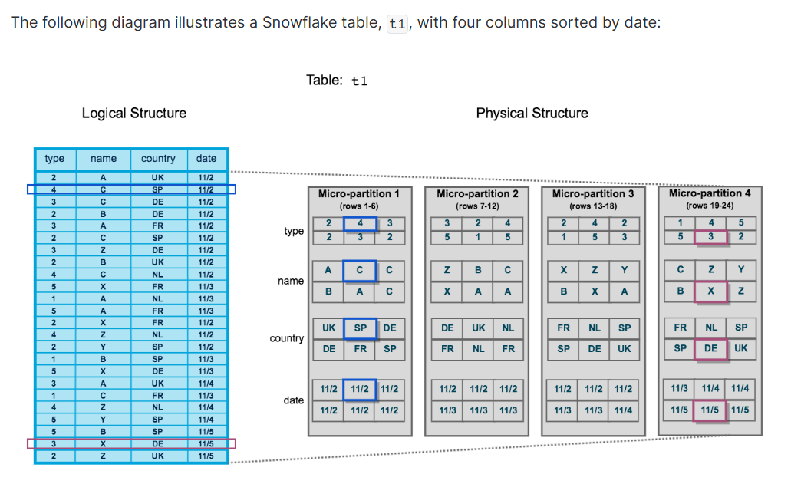
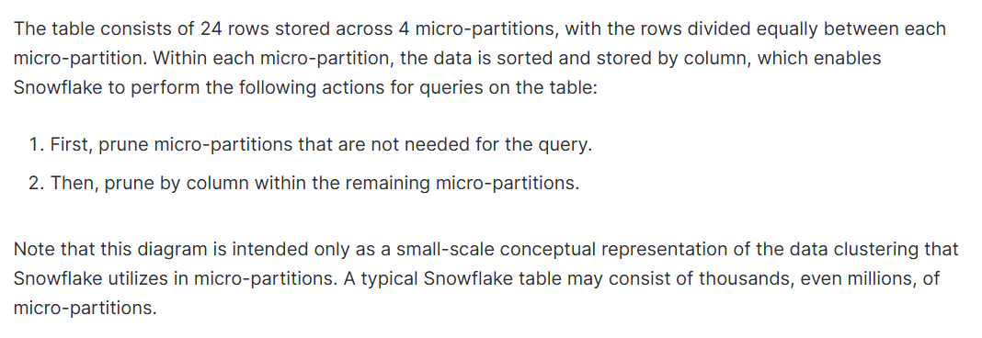

2.3 Cluster Depth & Partition Pruning
Cluster depth is a metric that measures the average overlap of micro-partitions for a given column. A cluster depth of 1.0 means each partition covers a unique, non-overlapping range (ideal clustering). Higher values indicate more overlap and less effective pruning.

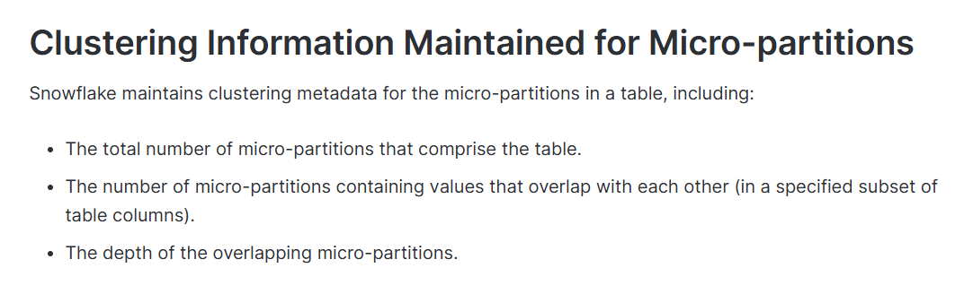
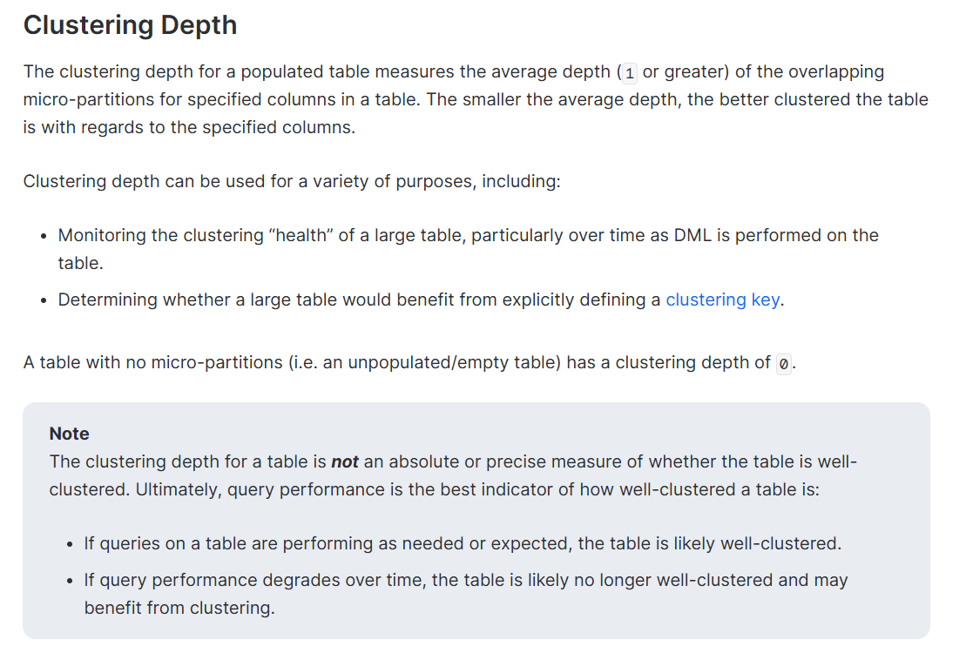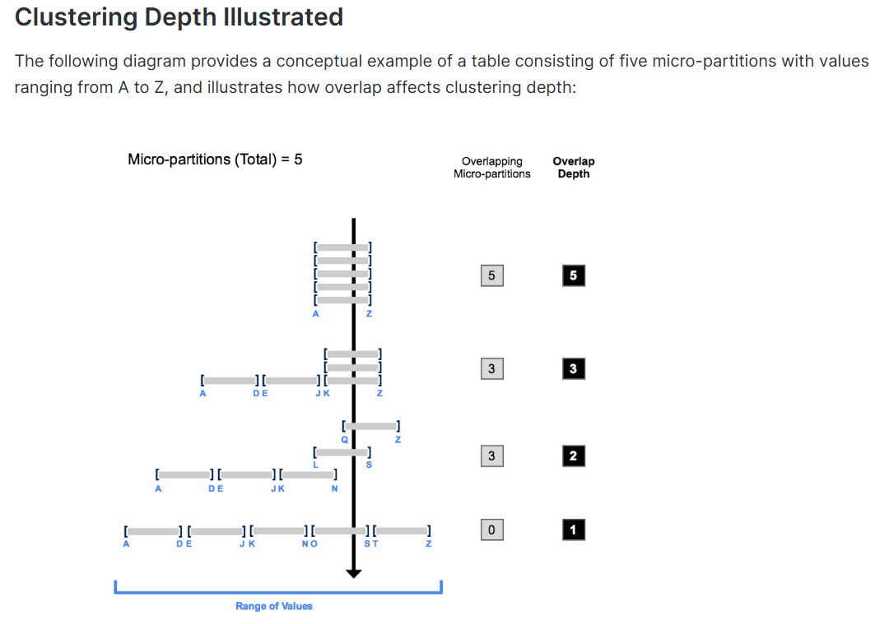

2.4 Clustering Key Selection Strategy
Choosing the right clustering key is critical. A poor key can waste credits on re-clustering without improving query performance. Consider the following principles:
Factor | Guideline | Example
Cardinality | Prefer columns with medium cardinality (10–10,000 distinct values). Too low = no benefit; too high = excessive re-clustering. | REGION (5 values) — good; ORDER_ID (5M values) — bad
Query Patterns | Choose columns most frequently used in WHERE, JOIN, and ORDER BY clauses. | ORDER_DATE, REGION, COUNTRY
Column Order | Place the most-filtered column first in a multi-column key. | CLUSTER BY (ORDER_DATE, REGION)
Data Freshness | Dates are ideal for time-series data; they naturally align with insertion order. | ORDER_DATE
Avoid | Do not cluster on columns rarely used in filters, or with very high cardinality like primary keys. | ORDER_ID, CUSTOMER_NAME

A clustering key in Snowflake is a way to organize large table data so related rows are stored close together.
Think of a huge library:
- If books are randomly placed, finding one topic takes longer.
- If books are arranged by category, searching becomes much faster.
Snowflake does the same with data.
What happens normally?
Snowflake automatically stores data efficiently in micro-partitions.
But after many updates, inserts, or deletes on very large tables, the data can become scattered.
What does a clustering key do?
You choose important columns (like date, customer_id, region) as the clustering key.
Snowflake then:
- reorganizes the data behind the scenes,
- keeps similar values together,
- and speeds up queries that filter on those columns.
Example
If queries often use:
WHERE order_date = '2026-05-01'
then clustering by order_date helps Snowflake find matching data faster.
Benefits
- Faster query performance
- Less data scanned
- Better performance on huge tables
Drawback
- Costs extra credits because Snowflake continuously maintains the clustering.
- Not useful for small tables.
Best use case
Use clustering when:
- tables are very large,
- queries are slow,
- and users frequently filter on the same columns.
A clustering key in Snowflake is a column (or group of columns) used to organize large table data so similar values are stored together in the same micro-partitions.
For Example
Imagine a table with millions of sales records:
order_date | customer_id | amount
2026-01-01 | 101 | 500
2026-01-01 | 102 | 300
2026-01-02 | 103 | 700
If most queries search by order_date, then setting:
CLUSTER BY(order_date)
helps Snowflake keep rows with similar dates together.
So when you run:
SELECT *
FROM sales
WHERE order_date = '2026-01-01';
Snowflake scans only relevant micro-partitions instead of the whole table.

Why Use Clustering Keys?
They help:
- Speed up queries
- Reduce data scanned
- Improve filtering, sorting, joins, and GROUP BY performance
- Improve compression

Best for:
- Very large tables
- Frequently queried tables
- Queries filtering on the same columns repeatedly

Not Good For:
- Small tables
- Tables updated constantly (maintenance costs more credits)

Important Points
- Snowflake automatically maintains clustering after you define the key.
- You can add/remove clustering anytime using:
  - CREATE TABLE
  - ALTER TABLE
- Maintenance is automatic but consumes compute credits.

Easy Analogy
Think of a supermarket:
- Without clustering → items are randomly placed.
- With clustering → all similar items are grouped together.
Finding products becomes much faster — same idea with data queries.

When clustering is actually worth using in Snowflake.
Use clustering only if the table is:
1. Very Large
Usually tables with terabytes of data and many micro-partitions.
Small tables don’t need clustering because Snowflake can already scan them quickly.

2. Queries Read Small Portions of Data
Clustering works best when queries filter specific data, like:
WHERE order_date = '2026-05-01'
Instead of scanning the whole table, Snowflake scans only relevant partitions.
This is called better scan efficiency.

3. Queries Often Sort Data
If queries use:
ORDER BY
GROUP BY
JOIN
then clustering helps because related data is already organized together.

4. Most Queries Use the Same Columns
Example:
Most queries filter by:
- customer_id
- order_date
Then clustering on these columns is useful.
But if every query uses different columns, clustering gives little benefit.

Important Cost Consideration
Clustering is best when:
- Queries happen frequently
- Data changes happen less frequently
Every:
- INSERT
- UPDATE
- DELETE
can disturb clustering, and Snowflake spends compute credits to reorganize the data again.

Best Practice
Instead of many small updates:
- Frequent tiny DML operations
Do:
- Large batch updates occasionally
This reduces clustering maintenance cost.

Simple Rule
Use clustering when:
- table is huge,
- queries are slow,
- queries repeatedly filter/sort on the same columns,
- and the table is not updated too often.
Avoid clustering for:
- small tables,
- rapidly changing tables,
- or tables with unpredictable query patterns.

How to choose good clustering keys in Snowflake:
A clustering key should be chosen based on how your data is actually queried. The goal is to help Snowflake quickly skip unnecessary data.

1. Pick the most important filter columns first
Start with columns used in WHERE conditions, especially selective ones:
Example:
WHERE invoice_date BETWEEN '2026-01-01' AND '2026-01-31'
So good clustering keys are:
- invoice_date
- event_type (if many event types exist)
These help Snowflake ignore irrelevant data quickly.

2. Then consider JOIN columns
If tables are often joined like:
ON table1.user_id = table2.user_id
Then user_id can be a good clustering candidate (if it’s used frequently).

3. Multiple columns are okay (but keep it small)
You can use 2–4 columns max, for example:
CLUSTER BY (application_id, user_status)
But:
- More columns = higher cost
- Too many columns = weak benefit

4. Cardinality (very important idea)
Cardinality = number of unique values.
Too low (bad):
- is_active (true/false)
- gender
Not useful because data is not well separated.
Too high (also bad):
- nanosecond timestamps
- unique IDs
Too expensive, little benefit
Best:
- moderate number of unique values (balanced grouping)

5. If a column is too “detailed”, reduce it
Instead of raw timestamps:
c_timestamp
Use:
TO_DATE(c_timestamp)
Or truncate numbers:
TRUNC(amount, -3)
This reduces uniqueness and improves clustering efficiency.

6. Order of columns matters
If using multiple clustering keys:
- Put low-cardinality first, then high-cardinality.
Example:
CLUSTER BY (region, customer_id)

7. Prefer filter/join columns over sorting columns
Even if a column is used in:
- ORDER BY
- GROUP BY
it is less important than:
- WHERE
- JOIN
Filtering matters more than sorting for clustering.

Good clustering keys are:
- Frequently used in WHERE filters
- Moderately unique (not too few, not too many values)
- Stable and consistent across queries
- Few in number (1–4 columns)
Bad clustering keys are:
- Boolean flags
- Extremely unique IDs
- Highly volatile or rarely used columns

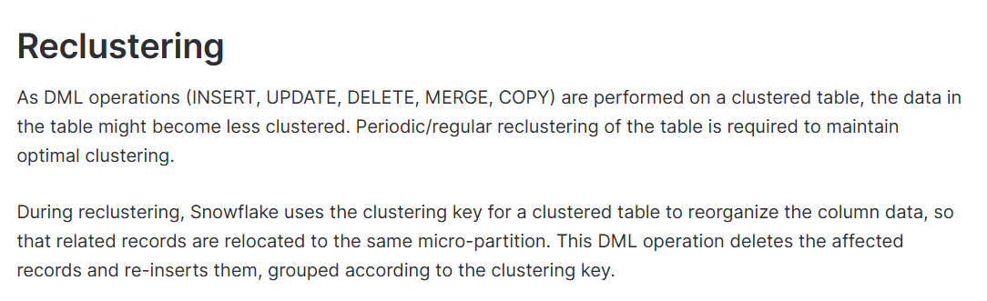
This diagram illustrates how reclustering a table can help reduce scanning of micro-partitions to improve query performance:
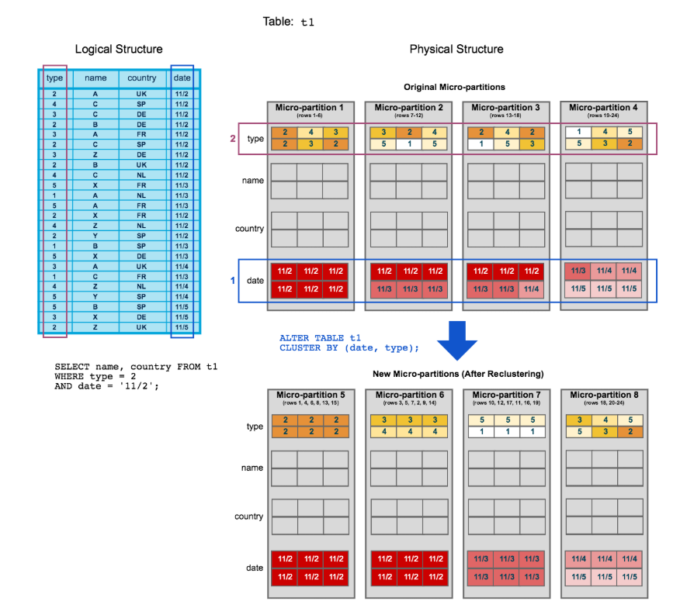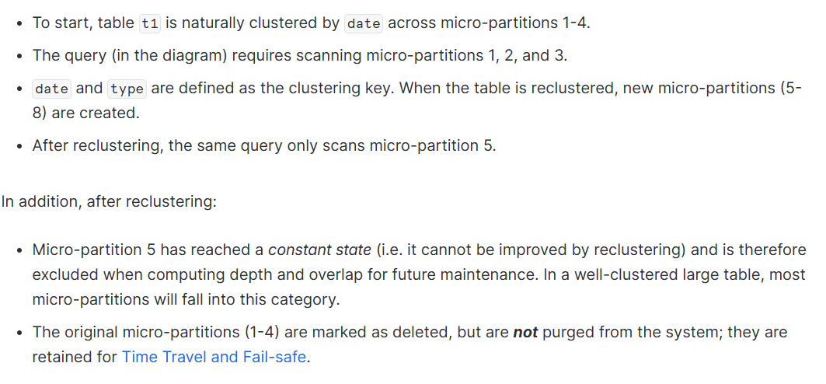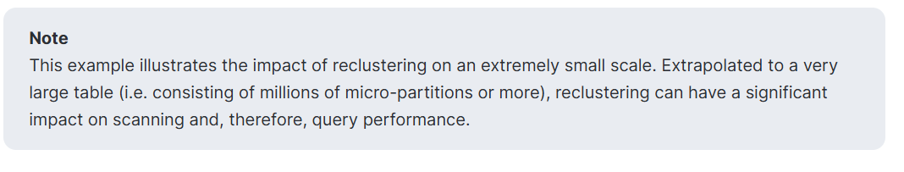

2.5 Cost Implications
Clustering consumes Snowflake credits. Manual re-clustering via ALTER TABLE ... RECLUSTER uses compute resources from your virtual warehouse. For tables under 1 TB, clustering may not provide significant benefits. Always benchmark before and after to validate the ROI.
Credit and Storage Impact of Reclustering
Similar to all DML operations in Snowflake, reclustering consumes credits. The number of credits consumed depends on the size of the table and the amount of data that needs to be reclustered.
Reclustering also results in storage costs. Each time data is reclustered, the rows are physically grouped based on the clustering key for the table, which results in Snowflake generating new micro-partitions for the table. Adding even a small number of rows to a table can cause all micro-partitions that contain those values to be recreated.
This process can create significant data turnover because the original micro-partitions are marked as deleted, but retained in the system to enable Time Travel and Fail-safe. The original micro-partitions are purged only after both the Time Travel retention period and the subsequent Fail-safe period have passed (i.e. minimum of 8 days and up to 97 days for extended Time Travel, if you are using Snowflake Enterprise Edition (or higher)). This typically results in increased storage costs.
Important
Before defining a clustering key for a table, you should consider the associated credit and storage costs.

2.6 Hands-on Lab: Manual Clustering

Lab 1A: Baseline Performance (Before Clustering)
First, let us run baseline queries on the unclustered table and observe the partition scans.
-- ============================================================
-- LAB 1A: BASELINE QUERIES (BEFORE CLUSTERING)
-- ============================================================
USE DATABASE DAY5_TRAINING_DB;
USE SCHEMA DAY5_DEMO;
USE WAREHOUSE COMPUTE_WH;

-- IMPORTANT: Disable result cache so we get real execution times
ALTER SESSION SET USE_CACHED_RESULT = FALSE;

-- Check current clustering information (no key defined yet)
SELECT SYSTEM$CLUSTERING_INFORMATION('ORDERS_RAW', '(ORDER_DATE)');
-- Expected: cluster_depth will be high (poor clustering)

SELECT SYSTEM$CLUSTERING_DEPTH('ORDERS_RAW', '(ORDER_DATE)');
-- Expected: High value (e.g., 50+) indicating significant overlap

-- ── Baseline Query 1: Filter by specific date ──
-- Tag the query so we can find it in QUERY_HISTORY later
ALTER SESSION SET QUERY_TAG = 'BEFORE_CLUSTERING_Q1';

SELECT COUNT(*) AS order_count, SUM(TOTAL_AMOUNT) AS total_revenue
FROM ORDERS_RAW
WHERE ORDER_DATE = '2024-06-15';

-- Capture Query 1 timing immediately via LAST_QUERY_ID()
SET BEFORE_Q1_ID = LAST_QUERY_ID();
SELECT $BEFORE_Q1_ID AS before_q1_query_id;

-- ── Baseline Query 2: Filter by date range ──
ALTER SESSION SET QUERY_TAG = 'BEFORE_CLUSTERING_Q2';

SELECT REGION, COUNT(*) AS order_count, SUM(TOTAL_AMOUNT) AS revenue
FROM ORDERS_RAW
WHERE ORDER_DATE BETWEEN '2024-01-01' AND '2024-03-31'
GROUP BY REGION
ORDER BY revenue DESC;

SET BEFORE_Q2_ID = LAST_QUERY_ID();
SELECT $BEFORE_Q2_ID AS before_q2_query_id;

-- ── Baseline Query 3: Filter by region + date ──
ALTER SESSION SET QUERY_TAG = 'BEFORE_CLUSTERING_Q3';

SELECT PRODUCT_CATEGORY, COUNT(*) AS cnt, AVG(TOTAL_AMOUNT) AS avg_order
FROM ORDERS_RAW
WHERE REGION = 'Asia Pacific'
AND ORDER_DATE BETWEEN '2024-06-01' AND '2024-06-30'
GROUP BY PRODUCT_CATEGORY
ORDER BY cnt DESC;

SET BEFORE_Q3_ID = LAST_QUERY_ID();
SELECT $BEFORE_Q3_ID AS before_q3_query_id;

-- Reset query tag
ALTER SESSION SET QUERY_TAG = '';

-- ── Quick-look: Pull timing for all 3 baseline queries ──
SELECT
QUERY_TAG,
QUERY_ID,
TOTAL_ELAPSED_TIME / 1000 AS elapsed_sec,
EXECUTION_TIME / 1000 AS exec_sec,
COMPILATION_TIME / 1000 AS compile_sec,
PARTITIONS_SCANNED,
PARTITIONS_TOTAL,
ROUND(PARTITIONS_SCANNED / NULLIF(PARTITIONS_TOTAL, 0) * 100, 1)
AS pct_partitions_scanned,
BYTES_SCANNED / POWER(1024,2) AS mb_scanned,
ROWS_PRODUCED
FROM TABLE(INFORMATION_SCHEMA.QUERY_HISTORY_BY_SESSION())
WHERE QUERY_TAG LIKE 'BEFORE_CLUSTERING%'
ORDER BY START_TIME;
-- Expected: All partitions scanned (pct_partitions_scanned ~ 100%)

🎤 Note: After each query open the Query Profile (click the query ID in the History tab). Point out the TableScan operator and note the number of partitions scanned vs. total partitions. Record these numbers on the board for comparison later.

Lab 1B: Apply Clustering Key & Observe Improvement
-- ============================================================
-- LAB 1B: APPLY CLUSTERING KEY
-- ============================================================

-- Ensure cache is still disabled
ALTER SESSION SET USE_CACHED_RESULT = FALSE;

-- Create a clustered copy of the table
CREATE OR REPLACE TABLE ORDERS_CLUSTERED
CLUSTER BY (ORDER_DATE, REGION)
AS
SELECT * FROM ORDERS_RAW
ORDER BY ORDER_DATE, REGION;

-- Verify clustering key is set
SHOW TABLES LIKE 'ORDERS_CLUSTERED';
-- Look for the 'cluster_by' column in the output

-- Check clustering information AFTER clustering
SELECT SYSTEM$CLUSTERING_INFORMATION('ORDERS_CLUSTERED', '(ORDER_DATE)');
-- Expected: cluster_depth close to 1.0 (well-clustered!)

SELECT SYSTEM$CLUSTERING_DEPTH('ORDERS_CLUSTERED', '(ORDER_DATE)');
-- Expected: Low value (e.g., 1-3)

-- ── After-Clustering Query 1: Same filter by specific date ──
ALTER SESSION SET QUERY_TAG = 'AFTER_CLUSTERING_Q1';

SELECT COUNT(*) AS order_count, SUM(TOTAL_AMOUNT) AS total_revenue
FROM ORDERS_CLUSTERED
WHERE ORDER_DATE = '2024-06-15';

SET AFTER_Q1_ID = LAST_QUERY_ID();

-- ── After-Clustering Query 2: Same date range filter ──
ALTER SESSION SET QUERY_TAG = 'AFTER_CLUSTERING_Q2';

SELECT REGION, COUNT(*) AS order_count, SUM(TOTAL_AMOUNT) AS revenue
FROM ORDERS_CLUSTERED
WHERE ORDER_DATE BETWEEN '2024-01-01' AND '2024-03-31'
GROUP BY REGION
ORDER BY revenue DESC;

SET AFTER_Q2_ID = LAST_QUERY_ID();

-- ── After-Clustering Query 3: Same region + date filter ──
ALTER SESSION SET QUERY_TAG = 'AFTER_CLUSTERING_Q3';

SELECT PRODUCT_CATEGORY, COUNT(*) AS cnt, AVG(TOTAL_AMOUNT) AS avg_order
FROM ORDERS_CLUSTERED
WHERE REGION = 'Asia Pacific'
AND ORDER_DATE BETWEEN '2024-06-01' AND '2024-06-30'
GROUP BY PRODUCT_CATEGORY
ORDER BY cnt DESC;

SET AFTER_Q3_ID = LAST_QUERY_ID();

-- Reset query tag
ALTER SESSION SET QUERY_TAG = '';

-- ── Quick-look: Pull timing for all 3 after-clustering queries ──
SELECT
QUERY_TAG,
QUERY_ID,
TOTAL_ELAPSED_TIME / 1000 AS elapsed_sec,
EXECUTION_TIME / 1000 AS exec_sec,
PARTITIONS_SCANNED,
PARTITIONS_TOTAL,
ROUND(PARTITIONS_SCANNED / NULLIF(PARTITIONS_TOTAL, 0) * 100, 1)
AS pct_partitions_scanned,
BYTES_SCANNED / POWER(1024,2) AS mb_scanned,
ROWS_PRODUCED
FROM TABLE(INFORMATION_SCHEMA.QUERY_HISTORY_BY_SESSION())
WHERE QUERY_TAG LIKE 'AFTER_CLUSTERING%'
ORDER BY START_TIME;
-- Expected: pct_partitions_scanned drops to ~5-15% !

🎤 Note: Compare the Query Profile results now. Participants should see a dramatic reduction in partitions scanned. Highlight the Partitions Scanned vs Partitions Total metric from the TableScan operator.

Lab 1B-2: Side-by-Side Timing Comparison Report
This is the key deliverable of the clustering demo: a single query that joins BEFORE and AFTER metrics into one comparison table, showing exact elapsed time, partitions scanned, bytes scanned, and the improvement percentage for each query.
-- ============================================================
-- LAB 1B-2: BEFORE vs AFTER TIMING COMPARISON
-- ============================================================

-- Method 1: Using QUERY_TAG (recommended for training demos)
-- This pulls both BEFORE and AFTER results into one comparison

WITH before_stats AS (
SELECT
REPLACE(QUERY_TAG, 'BEFORE_CLUSTERING_', '') AS query_label,
TOTAL_ELAPSED_TIME AS elapsed_ms,
EXECUTION_TIME AS exec_ms,
PARTITIONS_SCANNED AS parts_scanned,
PARTITIONS_TOTAL AS parts_total,
BYTES_SCANNED AS bytes_scanned,
ROWS_PRODUCED
FROM TABLE(INFORMATION_SCHEMA.QUERY_HISTORY_BY_SESSION())
WHERE QUERY_TAG LIKE 'BEFORE_CLUSTERING_Q%'
),
after_stats AS (
SELECT
REPLACE(QUERY_TAG, 'AFTER_CLUSTERING_', '') AS query_label,
TOTAL_ELAPSED_TIME AS elapsed_ms,
EXECUTION_TIME AS exec_ms,
PARTITIONS_SCANNED AS parts_scanned,
PARTITIONS_TOTAL AS parts_total,
BYTES_SCANNED AS bytes_scanned,
ROWS_PRODUCED
FROM TABLE(INFORMATION_SCHEMA.QUERY_HISTORY_BY_SESSION())
WHERE QUERY_TAG LIKE 'AFTER_CLUSTERING_Q%'
)
SELECT
b.query_label,
'--- TIME (ms) ---' AS "_",
b.elapsed_ms AS before_elapsed_ms,
a.elapsed_ms AS after_elapsed_ms,
ROUND((b.elapsed_ms - a.elapsed_ms)
/ NULLIF(b.elapsed_ms, 0) * 100, 1)
AS time_improvement_pct,
'--- PARTITIONS ---' AS "__",
b.parts_scanned AS before_parts_scanned,
b.parts_total AS before_parts_total,
a.parts_scanned AS after_parts_scanned,
a.parts_total AS after_parts_total,
ROUND((b.parts_scanned - a.parts_scanned)
/ NULLIF(b.parts_scanned, 0) * 100, 1)
AS partition_pruning_pct,
'--- BYTES ---' AS "___",
ROUND(b.bytes_scanned / POWER(1024,2), 1)
AS before_mb_scanned,
ROUND(a.bytes_scanned / POWER(1024,2), 1)
AS after_mb_scanned,
ROUND((b.bytes_scanned - a.bytes_scanned)
/ NULLIF(b.bytes_scanned, 0) * 100, 1)
AS bytes_reduction_pct
FROM before_stats b
JOIN after_stats a ON b.query_label = a.query_label
ORDER BY b.query_label;

/*
EXPECTED OUTPUT (approximate):
┌───────┬──────────────┬─────────────┬────────────┬───────────┬...
│ LABEL │ BEFORE_MS │ AFTER_MS │ TIME_IMP % │ PRUNE % │
├───────┼──────────────┼─────────────┼────────────┼───────────┤
│ Q1 │ 4500 - 8000 │ 300 - 800 │ 80 - 93% │ 85 - 97% │
│ Q2 │ 5000 - 9000 │ 800 - 2000 │ 70 - 85% │ 70 - 85% │
│ Q3 │ 4000 - 7000 │ 200 - 600 │ 85 - 95% │ 90 - 98% │
└───────┴──────────────┴─────────────┴────────────┴───────────┘
Exact numbers depend on warehouse size and Snowflake load.
*/

-- Method 2: Using stored QUERY_ID variables for individual lookup
-- Useful when you want to compare a single query pair
SELECT
'BEFORE' AS phase, QUERY_ID,
TOTAL_ELAPSED_TIME / 1000 AS elapsed_sec,
PARTITIONS_SCANNED, PARTITIONS_TOTAL,
BYTES_SCANNED / POWER(1024,2) AS mb_scanned
FROM TABLE(INFORMATION_SCHEMA.QUERY_HISTORY())
WHERE QUERY_ID = $BEFORE_Q1_ID
UNION ALL
SELECT
'AFTER' AS phase, QUERY_ID,
TOTAL_ELAPSED_TIME / 1000 AS elapsed_sec,
PARTITIONS_SCANNED, PARTITIONS_TOTAL,
BYTES_SCANNED / POWER(1024,2) AS mb_scanned
FROM TABLE(INFORMATION_SCHEMA.QUERY_HISTORY())
WHERE QUERY_ID = $AFTER_Q1_ID;

-- Method 3: Cluster depth comparison (summary view)
SELECT
'BEFORE (ORDERS_RAW)' AS table_label,
PARSE_JSON(SYSTEM$CLUSTERING_INFORMATION(
'ORDERS_RAW','(ORDER_DATE)')):
average_depth::FLOAT AS avg_depth,
PARSE_JSON(SYSTEM$CLUSTERING_INFORMATION(
'ORDERS_RAW','(ORDER_DATE)')):
average_overlaps::FLOAT AS avg_overlaps
UNION ALL
SELECT
'AFTER (ORDERS_CLUSTERED)' AS table_label,
PARSE_JSON(SYSTEM$CLUSTERING_INFORMATION(
'ORDERS_CLUSTERED','(ORDER_DATE)')):
average_depth::FLOAT AS avg_depth,
PARSE_JSON(SYSTEM$CLUSTERING_INFORMATION(
'ORDERS_CLUSTERED','(ORDER_DATE)')):
average_overlaps::FLOAT AS avg_overlaps;

/*
EXPECTED OUTPUT:
┌────────────────────────────┬───────────┬──────────────┐
│ TABLE_LABEL │ AVG_DEPTH │ AVG_OVERLAPS │
├────────────────────────────┼───────────┼──────────────┤
│ BEFORE (ORDERS_RAW) │ 45 - 60 │ 40 - 55 │
│ AFTER (ORDERS_CLUSTERED) │ 1 - 3 │ 0.5 - 2 │
└────────────────────────────┴───────────┴──────────────┘
*/

-- Re-enable result cache for normal operations
ALTER SESSION SET USE_CACHED_RESULT = TRUE;

Lab 1C: Manual Reclustering
-- ============================================================
-- LAB 1C: MANUAL RECLUSTERING
-- ============================================================

-- Simulate DML drift by inserting new random data
INSERT INTO ORDERS_CLUSTERED
SELECT
ORDER_ID + 5000000,
DATEADD(day, UNIFORM(0, 1460, RANDOM()), '2022-01-01'::DATE),
CUSTOMER_ID, CUSTOMER_NAME, REGION, COUNTRY, CITY,
DEPARTMENT, PRODUCT_CATEGORY, PRODUCT_NAME,
QUANTITY, UNIT_PRICE, TOTAL_AMOUNT,
PAYMENT_METHOD, ORDER_STATUS, SALES_CHANNEL,
FISCAL_YEAR, FISCAL_QUARTER
FROM ORDERS_RAW
LIMIT 500000;

-- Check clustering depth after new inserts
SELECT SYSTEM$CLUSTERING_DEPTH('ORDERS_CLUSTERED', '(ORDER_DATE)');
-- Expected: Cluster depth has increased (degraded)

-- Manual recluster (Enterprise Edition feature)
-- ALTER TABLE ORDERS_CLUSTERED RECLUSTER;
-- Note: RECLUSTER is deprecated in favor of Automatic Clustering
-- Shown here for conceptual understanding only

-- Alternative: Recreate the table with ordering
CREATE OR REPLACE TABLE ORDERS_CLUSTERED
CLUSTER BY (ORDER_DATE, REGION)
AS
SELECT * FROM ORDERS_CLUSTERED
ORDER BY ORDER_DATE, REGION;

-- Verify depth is improved again
SELECT SYSTEM$CLUSTERING_DEPTH('ORDERS_CLUSTERED', '(ORDER_DATE)');

Lab 1D: SYSTEM$ Functions Deep Dive
-- ============================================================
-- LAB 1D: CLUSTERING SYSTEM FUNCTIONS
-- ============================================================

-- SYSTEM$CLUSTERING_INFORMATION returns JSON with detailed metrics
SELECT SYSTEM$CLUSTERING_INFORMATION('ORDERS_CLUSTERED', '(ORDER_DATE)');
/*
Expected JSON output includes:
- cluster_by_keys: The defined clustering columns
- total_partition_count: Total micro-partitions
- total_constant_partition_count: Partitions with single value
- average_overlaps: Average overlap (lower = better)
- average_depth: Average cluster depth (lower = better)
- partition_depth_histogram: Distribution of depths
*/

-- Parse the JSON for a cleaner view
SELECT
PARSE_JSON(SYSTEM$CLUSTERING_INFORMATION(
'ORDERS_CLUSTERED', '(ORDER_DATE)')):
average_depth::FLOAT AS avg_depth,
PARSE_JSON(SYSTEM$CLUSTERING_INFORMATION(
'ORDERS_CLUSTERED', '(ORDER_DATE)')):
average_overlaps::FLOAT AS avg_overlaps,
PARSE_JSON(SYSTEM$CLUSTERING_INFORMATION(
'ORDERS_CLUSTERED', '(ORDER_DATE)')):
total_partition_count::INT AS total_partitions;

-- Compare clustering on different columns
SELECT SYSTEM$CLUSTERING_INFORMATION('ORDERS_CLUSTERED', '(REGION)');
SELECT SYSTEM$CLUSTERING_INFORMATION('ORDERS_CLUSTERED', '(PRODUCT_CATEGORY)');
SELECT SYSTEM$CLUSTERING_INFORMATION('ORDERS_CLUSTERED', '(ORDER_DATE, REGION)');

Challenge Exercise: Manual Clustering
Try clustering the ORDERS_RAW table on (PRODUCT_CATEGORY, ORDER_DATE) and compare query performance for category-based analytical queries. Which clustering key gives better pruning for the query: SELECT * FROM ... WHERE PRODUCT_CATEGORY = ‘Electronics’ AND ORDER_DATE > ‘2024-01-01’?

Topic 2: Automatic Clustering in Snowflake

3.1 What is Automatic Clustering?
Automatic Clustering is a Snowflake-managed background service (Enterprise Edition and above) that continuously monitors tables with defined clustering keys and automatically reclusters them when the cluster depth degrades beyond a threshold. Unlike manual reclustering, automatic clustering requires no user intervention after the clustering key is defined.
Benefits of Automatic Clustering
Ease-of-maintenance¶
Automatic Clustering eliminates the need for performing any of the following tasks:
- Monitoring the state of clustered tables.
Instead, as DML is performed on these tables, Snowflake monitors and evaluates the tables to determine whether they would benefit from reclustering, and automatically reclusters them, as needed.
- Designating warehouses in your account to use for reclustering.
Snowflake performs automatic reclustering in the background, and you do not need to specify a warehouse to use.
All you need to do is define a clustering key for each table (if appropriate) and Snowflake manages all future maintenance.
Full control¶
You can suspend and resume Automatic Clustering for a clustered table at any time using ALTER TABLE … SUSPEND / RESUME RECLUSTER.
While Automatic Clustering is suspended for a table, the table is never automatically reclustered, regardless of its clustering state and, therefore, does not incur any related credit charges.
You can also drop the clustering key on a clustered table at any time, which prevents all future reclustering on the table.
Non-blocking DML
Automatic Clustering is transparent and does not block DML statements issued against tables while they are being reclustered.
Optimal efficiency
With Automatic Clustering, Snowflake internally manages the state of clustered tables, as well as the resources (servers, memory, etc.) used for all automated clustering operations. This allows Snowflake to dynamically allocate resources as needed, resulting in the most efficient and effective reclustering.
Also, Automatic Clustering does not perform any unnecessary reclustering. Reclustering is triggered only if/when the table would benefit from the operation.
Enabling Automatic Clustering for a table
In most cases, no tasks are required to enable Automatic Clustering for a table. You simply define a clustering key for the table.
However, the rule does not apply to tables created by cloning (CREATE TABLE … CLONE …) from a source table that has clustering keys. The new table starts with Automatic Clustering suspended – even if Automatic Clustering for the source table is not suspended. (This is true whether the CLONE command cloned the table, the schema containing the table, or the database containing the table.)
Tip
Before you define a clustering key for a table, consider the following conditions, which may cause reclustering activity (and corresponding credit charges):
- The table is not optimally-clustered.
- The clustering key on the table has changed.
As such, we recommend starting with one or two selected tables and assessing the impact of Automatic Clustering on these tables. Once you are comfortable/familiar with how Automatic Clustering performs reclustering, you can then define clustering keys for your other tables.

3.2 Manual vs Automatic Clustering
Aspect | Manual Clustering | Automatic Clustering
Trigger | User runs ALTER TABLE RECLUSTER | Background service runs automatically
Maintenance | Requires ongoing manual effort | Fully managed by Snowflake
Credit Usage | Charged to user's warehouse | Charged as serverless compute credits
Best For | One-time reorganization, small tables | Large, frequently updated tables
Edition | Standard and above | Enterprise Edition and above
Scheduling | On-demand | Snowflake determines optimal timing
Monitoring | Manual query of SYSTEM$ functions | AUTOMATIC_CLUSTERING_HISTORY view

3.3 Architecture: How Automatic Clustering Works

AUTOMATIC CLUSTERING ARCHITECTURE
─────────────────────────────────────────

┌─────────────────────┐
│ DML Operations │ INSERT / UPDATE / DELETE / MERGE
│ (User Workloads) │
└─────────┬───────────┘
│
▼
┌─────────────────────┐
│ Clustering Depth │ Snowflake monitors cluster_depth
│ Monitor (Background)│ continuously for all tables with
└─────────┬───────────┘ a clustering key defined
│
▼ Depth exceeds threshold?
┌─────────────────────┐
│ Serverless Compute │ Snowflake-managed compute
│ (Auto Recluster) │ (NOT your warehouse)
└─────────┬───────────┘
│
▼
┌─────────────────────┐
│ Reorganized Micro- │ Partitions re-written with
│ Partitions │ optimal clustering alignment
└─────────────────────┘

3.4 When NOT to Use Clustering
Clustering is not a universal optimization. Here are scenarios where it provides little or negative ROI:
Scenario | Reason
Tables smaller than 1 TB | Snowflake can scan small tables quickly; clustering overhead exceeds benefit
Tables with no clear filter patterns | If queries access data randomly, no clustering key helps
Very high cardinality keys (e.g., UUID, ORDER_ID) | Creates too many micro-partitions with single rows each
Rarely queried tables | Clustering cost is wasted on seldom-read data
Frequently fully scanned tables | If every query reads every row, pruning has no value

3.5 Hands-on Lab: Automatic Clustering
-- ============================================================
-- LAB 2: AUTOMATIC CLUSTERING
-- ============================================================
USE DATABASE DAY5_TRAINING_DB;
USE SCHEMA DAY5_DEMO;
USE WAREHOUSE COMPUTE_WH;

-- Step 1: Create a table WITH a clustering key
-- (Automatic clustering activates when a clustering key is defined)
CREATE OR REPLACE TABLE ORDERS_AUTO_CLUSTERED
CLUSTER BY (ORDER_DATE, REGION)
AS
SELECT * FROM ORDERS_RAW;

-- Note: Data was loaded randomly, so clustering is initially poor
-- Automatic clustering will begin working in the background

-- Step 2: Check current clustering state
SELECT SYSTEM$CLUSTERING_INFORMATION(
'ORDERS_AUTO_CLUSTERED', '(ORDER_DATE, REGION)');

-- Step 3: Verify clustering key is defined
SHOW TABLES LIKE 'ORDERS_AUTO_CLUSTERED';

-- Step 4: Suspend automatic clustering (if needed for cost control)
ALTER TABLE ORDERS_AUTO_CLUSTERED SUSPEND RECLUSTER;

-- Step 5: Resume automatic clustering
ALTER TABLE ORDERS_AUTO_CLUSTERED RESUME RECLUSTER;

-- Step 6: Drop a clustering key entirely
-- ALTER TABLE ORDERS_AUTO_CLUSTERED DROP CLUSTERING KEY;

-- Step 7: Change the clustering key
ALTER TABLE ORDERS_AUTO_CLUSTERED
CLUSTER BY (ORDER_DATE, PRODUCT_CATEGORY);

Lab 2B: Monitoring Automatic Clustering
-- ============================================================
-- LAB 2B: MONITORING AUTOMATIC CLUSTERING
-- ============================================================

-- Query the AUTOMATIC_CLUSTERING_HISTORY view
-- (Requires ACCOUNTADMIN or MONITOR privilege)
USE ROLE ACCOUNTADMIN;

SELECT *
FROM SNOWFLAKE.ACCOUNT_USAGE.AUTOMATIC_CLUSTERING_HISTORY
WHERE TABLE_NAME = 'ORDERS_AUTO_CLUSTERED'
AND START_TIME >= DATEADD(day, -7, CURRENT_TIMESTAMP())
ORDER BY START_TIME DESC;

-- Check credit consumption for automatic clustering
SELECT
TO_DATE(START_TIME) AS cluster_date,
TABLE_NAME,
SUM(CREDITS_USED) AS total_credits,
SUM(NUM_BYTES_RECLUSTERED) / POWER(1024,3) AS gb_reclustered,
SUM(NUM_ROWS_RECLUSTERED) AS rows_reclustered
FROM SNOWFLAKE.ACCOUNT_USAGE.AUTOMATIC_CLUSTERING_HISTORY
WHERE START_TIME >= DATEADD(day, -30, CURRENT_TIMESTAMP())
GROUP BY 1, 2
ORDER BY cluster_date DESC;

-- Information Schema alternative (real-time, last 14 days)
SELECT *
FROM TABLE(INFORMATION_SCHEMA.AUTOMATIC_CLUSTERING_HISTORY(
DATE_RANGE_START => DATEADD(day, -14, CURRENT_TIMESTAMP()),
DATE_RANGE_END => CURRENT_TIMESTAMP()
));
🎤 Note: The AUTOMATIC_CLUSTERING_HISTORY view has a latency of up to 3 hours. For real-time monitoring, use the INFORMATION_SCHEMA table function.

3.6 Cost Optimization Best Practices
Automatic clustering is powerful but can become expensive if mismanaged. Here are enterprise-grade cost optimization strategies:
Strategy | Implementation
Limit clustering to large, high-query tables | Only define keys on tables >1 TB with frequent filter queries
Use low-to-medium cardinality keys | DATE, REGION, STATUS — not UUID or ORDER_ID
Monitor credit consumption weekly | Use AUTOMATIC_CLUSTERING_HISTORY and set up alerts
Suspend during low-usage periods | ALTER TABLE ... SUSPEND RECLUSTER during off-peak
Drop unnecessary clustering keys | If a table is rarely queried, remove the key to stop charges
Limit to 3-4 columns in the key | More columns = more maintenance overhead

Topic 3: Row-Level Security (Row Access Policies)

4.1 What is Row-Level Security?
Row-Level Security (RLS) in Snowflake allows you to dynamically control which rows a user or role can see when querying a table or view. This is implemented through Row Access Policies — schema-level objects that contain conditional logic determining row visibility based on the querying role, user, or other session context.
Unlike column-level masking policies that hide or transform specific column values, row access policies filter entire rows — invisible rows are completely excluded from query results, as if they do not exist.
Row-level security in Snowflake controls which rows of a table a user is allowed to see.
It is implemented using a Row Access Policy.

Simple Example
Imagine an employee table:
employee | department | salary
Alice | HR | 5000
Bob | IT | 7000
Carol | Finance | 9000
With row-level security:
- HR users see only HR rows
- IT users see only IT rows
- Finance users see only Finance rows
Even though everyone queries the same table.

How It Works
Snowflake checks a policy whenever someone runs:
- SELECT
- UPDATE
- DELETE
- MERGE
The policy decides:
“Can this user see this row?”

What is a Row Access Policy?
A row access policy is a special schema object containing rules.
Example logic:
IF role = 'HR_ROLE'
THEN show HR rows
The policy can also:
- check user roles,
- use conditions,
- reference mapping tables,
- apply complex access rules.

Mapping Table Concept
Sometimes access rules are stored in another table.
Example:
role | allowed_region
SALES_US | US
SALES_EU | EU
The policy checks this mapping table to decide which rows users can access.

Important Benefits
1. Protects Sensitive Data
Users only see authorized rows.

2. Centralized Security
One policy can be applied to:
- multiple tables,
- multiple views.

3. Automatic Enforcement
No need to manually add filters in every query.
Without policy:
WHERE department = 'HR'
With policy:
Snowflake automatically filters rows.

4. Supports Governance
Security teams can define policies separately from developers or analysts.

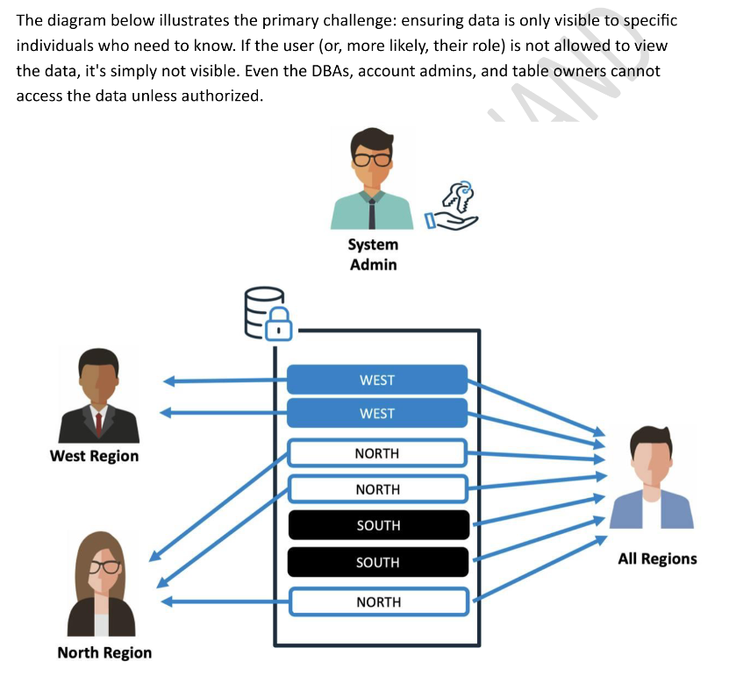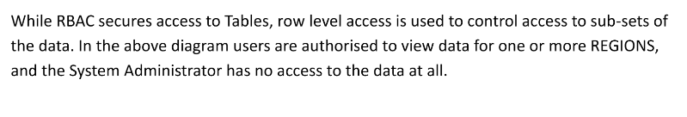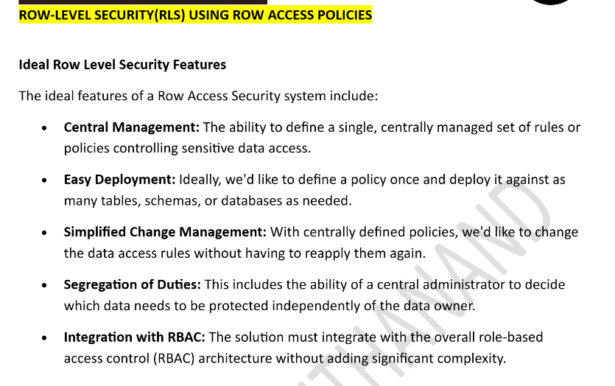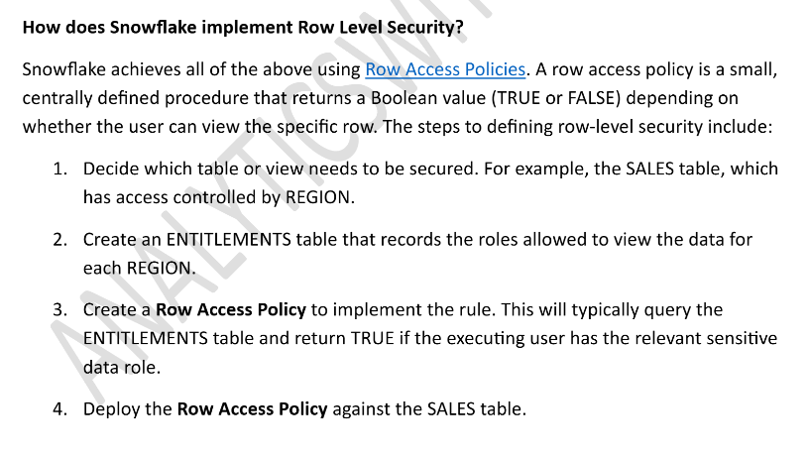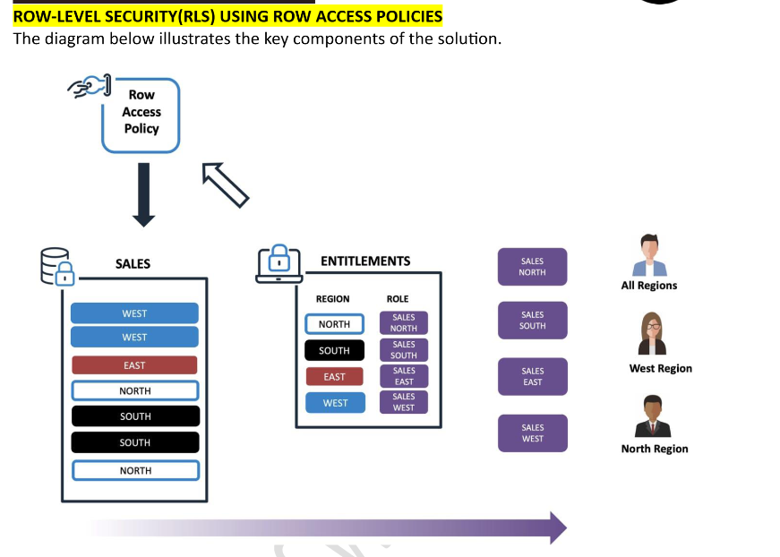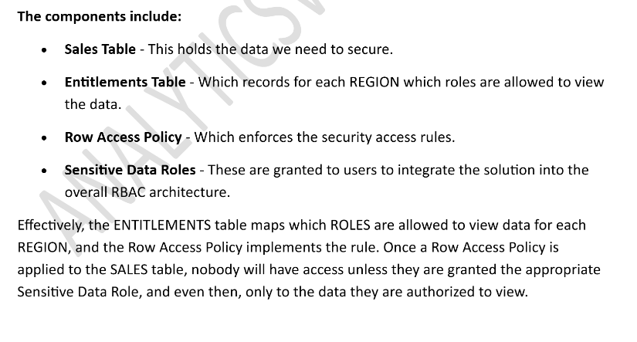

4.2 Row Access Policy vs Masking Policy
Feature | Row Access Policy | Dynamic Data Masking
What it controls | Which ROWS are visible | How COLUMN values appear
Return type | BOOLEAN (show/hide row) | Same data type as the column
Scope | Entire row filtered out | Specific column values masked
Use case | Regional data segregation | Hide SSN, mask email
Attachment | One policy per table/view | One policy per column
Stacking | Cannot stack multiple on same table | One per column, many per table

Row access policies can include conditions and functions in the policy expression to transform the data at query runtime when those conditions are met. The policy-driven approach supports segregation of duties to allow governance teams to define policies that can limit sensitive data exposure. This approach also includes the object owner (i.e. the role with the OWNERSHIP privilege on the object, such as a table or view) who normally has full access to the underlying data. A single policy can be set on different tables and views at the same time.
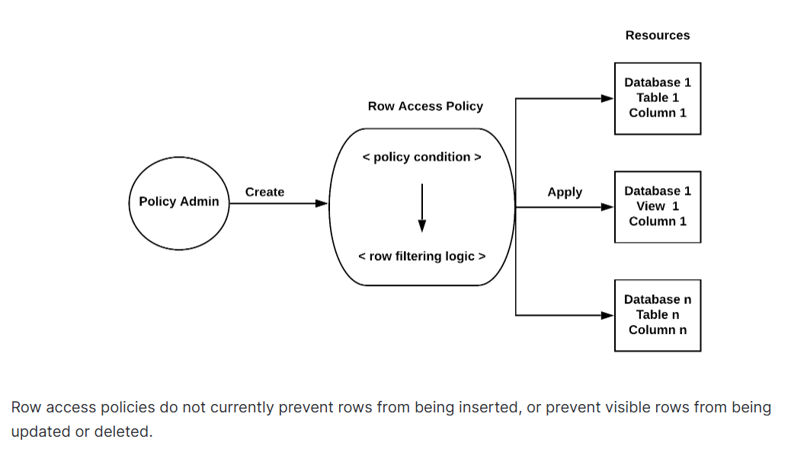
A row access policy can be added to a table or view either when the object is created or after the object is created.

How does a row access policy work?
A row access policy contains an expression that can specify Snowflake database objects (e.g. table or view), and use Conditional expression functions and Context functions to determine which rows should be visible in a given context.
Snowflake evaluates the policy expression by using the role of the policy owner, not the role of the operator who executed the query. This approach allows Snowflake not to return a row in a query result because the query operator does not require access to the mapping tables in the row access policy.

If you want to update an existing row access policy and need to see the current definition of the policy, call the GET_DDL function or run the DESCRIBE ROW ACCESS POLICY command.
The row access policy expression can then be updated with the ALTER ROW ACCESS POLICY command. This command does not require dropping a row access policy from a table or view. So, a table or view that is protected by a row access policy remains protected while the policy expression is being updated.

Row access policies at query runtime
At query runtime, Snowflake goes through the following process:
- Snowflake determines whether a row access policy is set on a database object. If a policy is added to the database object, all rows are protected by the policy.
- Snowflake creates a dynamic secure view (i.e. a secure inline view) of the database object.
- The values of the columns specified in the ALTER TABLE or ALTER VIEW command (i.e when adding a row access policy to a table or view) are bound to the corresponding parameters in the policy, and the policy expression is evaluated.
- Snowflake generates the query output for the user, and the query output only contains rows based on the policy definition evaluating to TRUE.
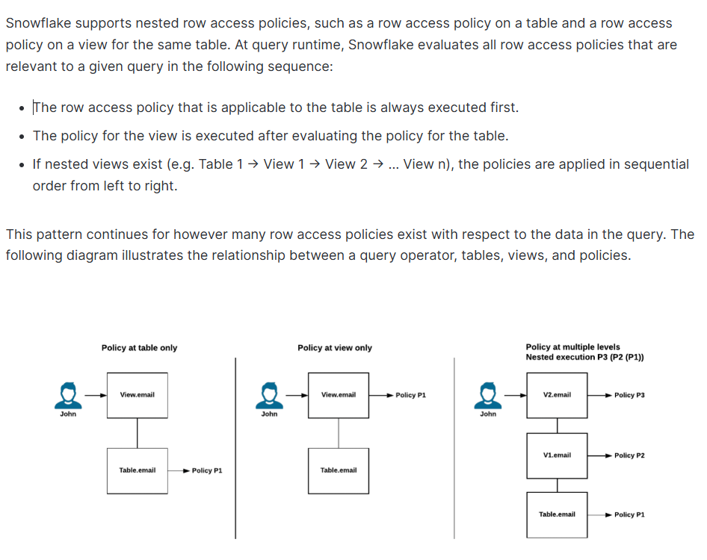

4.3 Security Architecture

ROW ACCESS POLICY EXECUTION FLOW
────────────────────────────────────────

User: analyst_india (Role: INDIA_ANALYST)
│
▼
┌────────────────────────────┐
│ SELECT * FROM ORDERS; │ Original query
└─────────────┬──────────────┘
│
▼
┌────────────────────────────┐
│ Row Access Policy │ Snowflake injects the
│ Evaluates: │ policy as a hidden WHERE
│ IS_ROLE_IN_SESSION( │ clause at query time
│ 'INDIA_ANALYST') AND │
│ COUNTRY = 'India' │
└─────────────┬──────────────┘
│
▼
┌────────────────────────────┐
│ RESULT SET │ User only sees rows
│ Only India rows returned │ where COUNTRY = 'India'
└────────────────────────────┘

4.4 Enterprise Use Cases
Use Case | Implementation
Regional Sales Access | Sales reps see only their region's data; managers see all regions
HR Data Segregation | HR India sees Indian employees; HR Europe sees European employees
Finance Compliance | Country-specific financial regulations restrict cross-border data access
Multi-Tenant SaaS | Each tenant sees only their own data in shared tables
Healthcare (HIPAA) | Doctors see only their patients' records

4.5 Hands-on Lab: Row-Level Security

Lab 3A: Setup Roles, Mapping Table & Secure Table
-- ============================================================
-- LAB 3A: ROW-LEVEL SECURITY SETUP
-- ============================================================
USE ROLE SECURITYADMIN;

-- Step 1: Create regional analyst roles
CREATE ROLE IF NOT EXISTS INDIA_ANALYST;
CREATE ROLE IF NOT EXISTS US_ANALYST;
CREATE ROLE IF NOT EXISTS EUROPE_ANALYST;
CREATE ROLE IF NOT EXISTS GLOBAL_ANALYST;
CREATE ROLE IF NOT EXISTS RLS_ADMIN;

-- Step 2: Grant roles to SYSADMIN for hierarchy
GRANT ROLE INDIA_ANALYST TO ROLE SYSADMIN;
GRANT ROLE US_ANALYST TO ROLE SYSADMIN;
GRANT ROLE EUROPE_ANALYST TO ROLE SYSADMIN;
GRANT ROLE GLOBAL_ANALYST TO ROLE SYSADMIN;
GRANT ROLE RLS_ADMIN TO ROLE SYSADMIN;

-- Step 3: Grant necessary privileges
USE ROLE SYSADMIN;
GRANT USAGE ON DATABASE DAY5_TRAINING_DB TO ROLE INDIA_ANALYST;
GRANT USAGE ON DATABASE DAY5_TRAINING_DB TO ROLE US_ANALYST;
GRANT USAGE ON DATABASE DAY5_TRAINING_DB TO ROLE EUROPE_ANALYST;
GRANT USAGE ON DATABASE DAY5_TRAINING_DB TO ROLE GLOBAL_ANALYST;
GRANT USAGE ON DATABASE DAY5_TRAINING_DB TO ROLE RLS_ADMIN;

GRANT USAGE ON SCHEMA DAY5_TRAINING_DB.DAY5_DEMO TO ROLE INDIA_ANALYST;
GRANT USAGE ON SCHEMA DAY5_TRAINING_DB.DAY5_DEMO TO ROLE US_ANALYST;
GRANT USAGE ON SCHEMA DAY5_TRAINING_DB.DAY5_DEMO TO ROLE EUROPE_ANALYST;
GRANT USAGE ON SCHEMA DAY5_TRAINING_DB.DAY5_DEMO TO ROLE GLOBAL_ANALYST;
GRANT USAGE ON SCHEMA DAY5_TRAINING_DB.DAY5_DEMO TO ROLE RLS_ADMIN;

GRANT USAGE ON WAREHOUSE COMPUTE_WH TO ROLE INDIA_ANALYST;
GRANT USAGE ON WAREHOUSE COMPUTE_WH TO ROLE US_ANALYST;
GRANT USAGE ON WAREHOUSE COMPUTE_WH TO ROLE EUROPE_ANALYST;
GRANT USAGE ON WAREHOUSE COMPUTE_WH TO ROLE GLOBAL_ANALYST;
GRANT USAGE ON WAREHOUSE COMPUTE_WH TO ROLE RLS_ADMIN;

Lab 3B: Create the Role-to-Country Mapping Table
-- ============================================================
-- LAB 3B: MAPPING TABLE FOR RLS
-- ============================================================
USE ROLE SYSADMIN;
USE DATABASE DAY5_TRAINING_DB;
USE SCHEMA DAY5_DEMO;

-- Create a mapping table that links roles to allowed countries
CREATE OR REPLACE TABLE ROLE_COUNTRY_MAPPING (
ROLE_NAME VARCHAR(50),
COUNTRY VARCHAR(50)
);

-- Insert mappings
INSERT INTO ROLE_COUNTRY_MAPPING VALUES
('INDIA_ANALYST', 'India'),
('US_ANALYST', 'USA'),
('US_ANALYST', 'Canada'),
('US_ANALYST', 'Mexico'),
('EUROPE_ANALYST', 'UK'),
('EUROPE_ANALYST', 'Germany'),
('EUROPE_ANALYST', 'France'),
('EUROPE_ANALYST', 'Netherlands'),
('EUROPE_ANALYST', 'Spain');
-- GLOBAL_ANALYST is NOT mapped => will get full access via policy logic

-- Verify
SELECT * FROM ROLE_COUNTRY_MAPPING ORDER BY ROLE_NAME;

-- Grant SELECT on mapping table to all roles
GRANT SELECT ON TABLE ROLE_COUNTRY_MAPPING TO ROLE INDIA_ANALYST;
GRANT SELECT ON TABLE ROLE_COUNTRY_MAPPING TO ROLE US_ANALYST;
GRANT SELECT ON TABLE ROLE_COUNTRY_MAPPING TO ROLE EUROPE_ANALYST;
GRANT SELECT ON TABLE ROLE_COUNTRY_MAPPING TO ROLE GLOBAL_ANALYST;
GRANT SELECT ON TABLE ROLE_COUNTRY_MAPPING TO ROLE RLS_ADMIN;

Lab 3C: Create the Secure Orders Table
-- ============================================================
-- LAB 3C: SECURE TABLE FOR RLS DEMO
-- ============================================================

-- Create a secure copy of orders for RLS testing
CREATE OR REPLACE TABLE ORDERS_SECURE AS
SELECT * FROM ORDERS_RAW;

-- Grant SELECT to all analyst roles
GRANT SELECT ON TABLE ORDERS_SECURE TO ROLE INDIA_ANALYST;
GRANT SELECT ON TABLE ORDERS_SECURE TO ROLE US_ANALYST;
GRANT SELECT ON TABLE ORDERS_SECURE TO ROLE EUROPE_ANALYST;
GRANT SELECT ON TABLE ORDERS_SECURE TO ROLE GLOBAL_ANALYST;
GRANT SELECT ON TABLE ORDERS_SECURE TO ROLE RLS_ADMIN;

Lab 3D: Create and Apply the Row Access Policy
-- ============================================================
-- LAB 3D: ROW ACCESS POLICY CREATION
-- ============================================================
USE ROLE SYSADMIN;
USE DATABASE DAY5_TRAINING_DB;
USE SCHEMA DAY5_DEMO;

-- Create the Row Access Policy
CREATE OR REPLACE ROW ACCESS POLICY COUNTRY_RLS_POLICY
AS (country_val VARCHAR) RETURNS BOOLEAN ->
-- SYSADMIN and RLS_ADMIN see everything
IS_ROLE_IN_SESSION('SYSADMIN')
OR IS_ROLE_IN_SESSION('RLS_ADMIN')
-- GLOBAL_ANALYST sees everything
OR IS_ROLE_IN_SESSION('GLOBAL_ANALYST')
-- Regional analysts see only their mapped countries
OR EXISTS (
SELECT 1 FROM DAY5_TRAINING_DB.DAY5_DEMO.ROLE_COUNTRY_MAPPING m
WHERE IS_ROLE_IN_SESSION(m.ROLE_NAME)
AND m.COUNTRY = country_val
);

-- Apply the policy to the ORDERS_SECURE table
ALTER TABLE ORDERS_SECURE ADD ROW ACCESS POLICY COUNTRY_RLS_POLICY
ON (COUNTRY);

-- Verify the policy is attached
SELECT *
FROM TABLE(INFORMATION_SCHEMA.POLICY_REFERENCES(
REF_ENTITY_NAME => 'DAY5_TRAINING_DB.DAY5_DEMO.ORDERS_SECURE',
REF_ENTITY_DOMAIN => 'TABLE'
));
🎤 Note: IS_ROLE_IN_SESSION: it checks the current role AND all roles in the hierarchy below it. This is more flexible than CURRENT_ROLE() which only checks the exact active role.

Lab 3E: Test Row Access Policy with Different Roles
-- ============================================================
-- LAB 3E: TESTING ROW ACCESS POLICY
-- ============================================================

-- Test 1: INDIA_ANALYST should see only India data
USE ROLE INDIA_ANALYST;
USE WAREHOUSE COMPUTE_WH;
SELECT COUNTRY, COUNT(*) AS row_count
FROM DAY5_TRAINING_DB.DAY5_DEMO.ORDERS_SECURE
GROUP BY COUNTRY
ORDER BY row_count DESC;
-- Expected: Only 'India' appears

SELECT COUNT(*) AS total_visible FROM DAY5_TRAINING_DB.DAY5_DEMO.ORDERS_SECURE;
-- Expected: ~1M rows (India subset of 5M)

-- Test 2: US_ANALYST should see USA, Canada, Mexico
USE ROLE US_ANALYST;
SELECT COUNTRY, COUNT(*) AS row_count
FROM DAY5_TRAINING_DB.DAY5_DEMO.ORDERS_SECURE
GROUP BY COUNTRY
ORDER BY row_count DESC;
-- Expected: USA, Canada, Mexico

-- Test 3: EUROPE_ANALYST should see UK, Germany, France, etc.
USE ROLE EUROPE_ANALYST;
SELECT COUNTRY, COUNT(*) AS row_count
FROM DAY5_TRAINING_DB.DAY5_DEMO.ORDERS_SECURE
GROUP BY COUNTRY
ORDER BY row_count DESC;
-- Expected: UK, Germany, France, Netherlands, Spain

-- Test 4: GLOBAL_ANALYST should see ALL countries
USE ROLE GLOBAL_ANALYST;
SELECT COUNTRY, COUNT(*) AS row_count
FROM DAY5_TRAINING_DB.DAY5_DEMO.ORDERS_SECURE
GROUP BY COUNTRY
ORDER BY row_count DESC;
-- Expected: All 20+ countries visible

-- Test 5: SYSADMIN should see everything
USE ROLE SYSADMIN;
SELECT COUNT(*) AS total_rows
FROM DAY5_TRAINING_DB.DAY5_DEMO.ORDERS_SECURE;
-- Expected: 5,000,000

Lab 3F: Validation & Governance Queries
-- ============================================================
-- LAB 3F: VALIDATION QUERIES
-- ============================================================
USE ROLE SYSADMIN;

-- View all row access policies in the schema
SHOW ROW ACCESS POLICIES IN SCHEMA DAY5_TRAINING_DB.DAY5_DEMO;

-- Describe the policy to see its body
DESCRIBE ROW ACCESS POLICY COUNTRY_RLS_POLICY;

-- View policy references (which tables have this policy)
SELECT *
FROM TABLE(INFORMATION_SCHEMA.POLICY_REFERENCES(
POLICY_NAME => 'COUNTRY_RLS_POLICY'
));

-- Detach policy (if needed)
-- ALTER TABLE ORDERS_SECURE DROP ROW ACCESS POLICY COUNTRY_RLS_POLICY;

-- Modify and reattach (common pattern)
-- Step 1: Drop existing policy from table
-- ALTER TABLE ORDERS_SECURE DROP ROW ACCESS POLICY COUNTRY_RLS_POLICY;
-- Step 2: Replace the policy definition
-- CREATE OR REPLACE ROW ACCESS POLICY ... (new definition);
-- Step 3: Re-attach
-- ALTER TABLE ORDERS_SECURE ADD ROW ACCESS POLICY ... ON (COUNTRY);

4.6 Common Mistakes & Troubleshooting
Issue | Cause | Resolution
Policy returns 0 rows for all roles | Policy logic is too restrictive or mapping table has no matching rows | Test with SYSADMIN first; check mapping table data
Cannot attach two policies to same table | Snowflake allows only ONE row access policy per table | Consolidate logic into a single policy with OR conditions
Policy blocks SYSADMIN | SYSADMIN not included in the policy Boolean logic | Always include IS_ROLE_IN_SESSION('SYSADMIN') as a bypass
Performance degradation after attaching | EXISTS subquery on large mapping table without optimization | Keep mapping table small; index by role name
Policy not filtering as expected | Using CURRENT_ROLE() instead of IS_ROLE_IN_SESSION() | Use IS_ROLE_IN_SESSION() for hierarchy-aware checks
DESCRIBE shows policy body to users | Non-admin roles can see policy definition | Grant DESCRIBE privileges selectively

Challenge Exercise: Row-Level Security
Create a DEPARTMENT-based Row Access Policy that restricts HR data so that only the HR_ANALYST role can see rows where DEPARTMENT = ‘HR’, while the FINANCE_ANALYST role sees only DEPARTMENT = ‘Finance’. All other roles see all departments except HR and Finance.

Performance Benchmarks

5.1 Before vs After Clustering Comparison
The following table summarizes expected performance improvements from clustering. Actual numbers will vary based on warehouse size and account configuration.
Metric | Before Clustering | After Clustering | Improvement
Partitions Scanned (Date filter) | All (~50-80) | 3-5 | ~90% reduction
Partitions Scanned (Date + Region) | All (~50-80) | 1-2 | ~97% reduction
Query Execution Time (Date filter) | ~4-8 seconds | ~0.5-1 second | 5-10x faster
Bytes Scanned | ~2-4 GB | ~50-200 MB | ~90% reduction
Cluster Depth (ORDER_DATE) | 40-60 | 1-3 | Near-ideal
Credit Cost (one-time recluster) | N/A | 0.5-2 credits | One-time cost

PERFORMANCE COMPARISON: PARTITIONS SCANNED
────────────────────────────────────────────

BEFORE: [██████████████████████████] 100%
AFTER: [███] 10%

BYTES SCANNED
BEFORE: [██████████████████████████] ~3.5 GB
AFTER: [███] ~150 MB

QUERY EXECUTION TIME
BEFORE: [██████████████████████████] ~6 sec
AFTER: [███] ~0.7 sec

Monitoring & Governance Queries

6.1 Query History Analysis
-- ============================================================
-- MONITORING: QUERY HISTORY
-- ============================================================
USE ROLE ACCOUNTADMIN;

-- Find slow queries on our training tables
SELECT
QUERY_ID, QUERY_TEXT, USER_NAME,
EXECUTION_TIME / 1000 AS exec_seconds,
PARTITIONS_SCANNED, PARTITIONS_TOTAL,
BYTES_SCANNED / POWER(1024,2) AS mb_scanned,
ROWS_PRODUCED
FROM SNOWFLAKE.ACCOUNT_USAGE.QUERY_HISTORY
WHERE DATABASE_NAME = 'DAY5_TRAINING_DB'
AND EXECUTION_STATUS = 'SUCCESS'
AND START_TIME >= DATEADD(hour, -4, CURRENT_TIMESTAMP())
ORDER BY EXECUTION_TIME DESC
LIMIT 20;

6.2 Access History (for RLS Audit)
-- ============================================================
-- MONITORING: ACCESS HISTORY
-- ============================================================

-- Track which roles accessed which tables
SELECT
QUERY_ID, USER_NAME, ROLE_NAME,
BASE_OBJECTS_ACCESSED,
POLICIES_REFERENCED,
QUERY_START_TIME
FROM SNOWFLAKE.ACCOUNT_USAGE.ACCESS_HISTORY
WHERE QUERY_START_TIME >= DATEADD(day, -1, CURRENT_TIMESTAMP())
AND ARRAY_SIZE(POLICIES_REFERENCED) > 0
ORDER BY QUERY_START_TIME DESC
LIMIT 20;

6.3 Table Storage Metrics
-- ============================================================
-- MONITORING: TABLE STORAGE METRICS
-- ============================================================

SELECT
TABLE_NAME,
ACTIVE_BYTES / POWER(1024,3) AS active_gb,
TIME_TRAVEL_BYTES / POWER(1024,3) AS time_travel_gb,
FAILSAFE_BYTES / POWER(1024,3) AS failsafe_gb,
RETAINED_FOR_CLONE_BYTES / POWER(1024,3) AS clone_gb
FROM SNOWFLAKE.ACCOUNT_USAGE.TABLE_STORAGE_METRICS
WHERE TABLE_CATALOG = 'DAY5_TRAINING_DB'
AND TABLE_SCHEMA = 'DAY5_DEMO'
ORDER BY ACTIVE_BYTES DESC;

Troubleshooting Guide

7.1 Clustering Issues
Problem | Diagnosis | Solution
High cluster depth despite key | New DML inserts break clustering order | Enable automatic clustering or periodically recreate with ORDER BY
Clustering key on wrong column | Queries filter on columns not in the key | Analyze QUERY_HISTORY for most common WHERE columns; redefine key
Auto clustering not triggering | Table too small or depth within threshold | Check AUTOMATIC_CLUSTERING_HISTORY; ensure table is large enough
Excessive re-clustering credits | High-churn table with frequent DML | Consider reducing key columns or suspending during batch loads
SYSTEM$CLUSTERING_INFORMATION shows nulls | No clustering key defined on the table | Define a clustering key with ALTER TABLE ... CLUSTER BY

7.2 Row Access Policy Issues
Problem | Diagnosis | Solution
All rows visible (policy not filtering) | Policy returns TRUE for all roles | Check policy logic; verify mapping table has correct data
Zero rows returned for valid role | Mapping table missing entries for that role | INSERT correct role-country mappings
Cannot CREATE ROW ACCESS POLICY | Insufficient privileges | Requires SYSADMIN or schema OWNERSHIP privilege
Policy conflict error | Two policies on same table | Drop one policy; consolidate into single policy
IS_ROLE_IN_SESSION returns FALSE | Role not granted to user or not in hierarchy | Verify GRANT ROLE ... TO USER and role hierarchy

Best Practices Summary

8.1 Clustering Best Practices
Category | Best Practice
Key Selection | Use columns with medium cardinality that appear frequently in WHERE clauses
Column Order | Place the most selective (most-filtered) column first in multi-column keys
Table Size | Only cluster tables larger than 1 TB for meaningful ROI
Monitoring | Review AUTOMATIC_CLUSTERING_HISTORY weekly to track credit consumption
DML Operations | Batch DML operations to reduce clustering fragmentation
Key Limit | Use a maximum of 3-4 columns in a clustering key
Validation | Always run SYSTEM$CLUSTERING_INFORMATION before and after changes
Cost Control | SUSPEND RECLUSTER during large batch load windows, then RESUME

8.2 Row-Level Security Best Practices
Category | Best Practice
Policy Design | Always include SYSADMIN bypass in policy logic
Mapping Tables | Use a centralized mapping table rather than hardcoded role names in the policy
Testing | Test with every role BEFORE deploying to production
Performance | Keep mapping tables small and indexed; avoid complex joins in policy body
Governance | Use POLICY_REFERENCES to audit which tables have policies attached
Hierarchy | Use IS_ROLE_IN_SESSION() instead of CURRENT_ROLE() for hierarchy support
Documentation | Document all policies in a governance wiki with owner, purpose, and attached objects
Change Management | Always DROP policy from table before replacing the definition, then re-ADD

Interview Questions

9.1 Clustering Interview Questions
# | Question | Key Points in Answer
1 | What are micro-partitions in Snowflake? | Immutable, compressed columnar storage units; 50-500 MB each; foundation for pruning, time travel, and encryption
2 | What is cluster depth and why does it matter? | Measures partition overlap for a column; lower is better; depth of 1 = ideal non-overlapping ranges
3 | When should you NOT use clustering? | Tables under 1 TB, high-cardinality keys, rarely queried tables, tables always fully scanned
4 | Explain the difference between manual and automatic clustering. | Manual = user-triggered RECLUSTER using own warehouse; Automatic = Snowflake background service with serverless credits
5 | How do you choose an optimal clustering key? | Medium cardinality columns; frequently in WHERE/JOIN; date columns for time-series; most selective column first
6 | What is partition pruning? | Query optimizer skips micro-partitions that cannot contain matching rows based on metadata min/max values
7 | How do you monitor automatic clustering costs? | AUTOMATIC_CLUSTERING_HISTORY in ACCOUNT_USAGE; INFORMATION_SCHEMA table function for real-time; check CREDITS_USED
8 | What happens to clustering when you INSERT new data? | New partitions are appended in insertion order; may degrade clustering; auto-clustering will detect and recluster

9.2 Row-Level Security Interview Questions
# | Question | Key Points in Answer
1 | What is Row-Level Security in Snowflake? | Dynamic row filtering using Row Access Policies; returns BOOLEAN; filters rows at query time transparently
2 | How does a Row Access Policy differ from Dynamic Data Masking? | RLS filters entire rows (BOOLEAN); masking transforms column values (returns same data type)
3 | Can you attach multiple row access policies to one table? | No; only one per table; consolidate all logic into a single policy with OR/AND conditions
4 | What is IS_ROLE_IN_SESSION() and why is it preferred? | Checks if a role is the current role OR any subordinate role in the hierarchy; more flexible than CURRENT_ROLE()
5 | How would you implement multi-tenant RLS? | Mapping table linking TENANT_ID to roles; policy checks current role against tenant-allowed mappings
6 | What is the performance impact of row access policies? | Minimal for simple policies; EXISTS on small mapping tables is efficient; complex joins can degrade performance
7 | How do you audit row access policy usage? | ACCESS_HISTORY view in ACCOUNT_USAGE; POLICIES_REFERENCED column shows which policies were evaluated
8 | How do you modify an existing row access policy on a table? | DROP policy from table, CREATE OR REPLACE the policy definition, then ADD policy back to the table

Real-World Enterprise Scenarios

10.1 Scenario: E-Commerce Data Warehouse
A large e-commerce company has a TRANSACTIONS table with 10 billion rows. Most analytical queries filter by ORDER_DATE and REGION. The data engineering team notices query times degrading as the table grows.
Solution: Define a clustering key on (ORDER_DATE, REGION) with automatic clustering enabled. Monitor via AUTOMATIC_CLUSTERING_HISTORY. Result: Query times dropped from 45 seconds to 3 seconds for date-range queries; partition pruning improved from 5% to 92%.

10.2 Scenario: Global Bank Compliance
A multinational bank must ensure that analysts in India can only view Indian customer transactions, while European analysts see only EU data. The CISO requires audit trails for all data access.
Solution: Row Access Policy with a ROLE_COUNTRY_MAPPING table. IS_ROLE_IN_SESSION() for hierarchy-aware filtering. ACCESS_HISTORY view for compliance auditing. Quarterly reviews of mapping table entries by the governance team.

10.3 Scenario: SaaS Multi-Tenant Platform
A SaaS company stores data for 500 clients in a shared EVENTS table. Each client must only see their own data. The platform team needs to onboard new clients without modifying the policy.
Solution: Row Access Policy that checks the querying role’s TENANT_ID against the row’s TENANT_ID column via a mapping table. New clients are onboarded by adding a row to the mapping table — no DDL changes required.

Cleanup Scripts
Run these scripts after the training session to remove all training objects.
-- ============================================================
-- CLEANUP: Remove all Day 5 training objects
-- ============================================================
USE ROLE SYSADMIN;

-- Drop Row Access Policies first (must detach before dropping table)
ALTER TABLE DAY5_TRAINING_DB.DAY5_DEMO.ORDERS_SECURE
DROP ROW ACCESS POLICY COUNTRY_RLS_POLICY;

-- Drop the database (cascades all schemas, tables, stages, etc.)
DROP DATABASE IF EXISTS DAY5_TRAINING_DB;

-- Drop custom roles
USE ROLE SECURITYADMIN;
DROP ROLE IF EXISTS INDIA_ANALYST;
DROP ROLE IF EXISTS US_ANALYST;
DROP ROLE IF EXISTS EUROPE_ANALYST;
DROP ROLE IF EXISTS GLOBAL_ANALYST;
DROP ROLE IF EXISTS RLS_ADMIN;

-- Optionally drop the warehouse
-- USE ROLE SYSADMIN;
-- DROP WAREHOUSE IF EXISTS COMPUTE_WH;

Session Summary

Key Takeaways
Topic | Key Concepts | Critical Functions/Commands
Micro-Partitions | Immutable columnar storage units; 50-500 MB; enable pruning and time travel | N/A (internal Snowflake mechanism)
Manual Clustering | Physically co-locate rows by key columns; improves partition pruning; one-time cost | CLUSTER BY, SYSTEM$CLUSTERING_INFORMATION, SYSTEM$CLUSTERING_DEPTH
Automatic Clustering | Snowflake-managed background reclustering; serverless credits; Enterprise Edition | SUSPEND/RESUME RECLUSTER, AUTOMATIC_CLUSTERING_HISTORY
Row Access Policies | Dynamic row filtering based on role/user context; one policy per table; BOOLEAN return | CREATE ROW ACCESS POLICY, IS_ROLE_IN_SESSION(), POLICY_REFERENCES
Monitoring | Track clustering costs, query performance, and security audit trails | QUERY_HISTORY, ACCESS_HISTORY, TABLE_STORAGE_METRICS

Multiple Choice Questions (15 Questions)

Q1. What is the typical size range of a Snowflake micro-partition? [Micro-Partitions]
A) 1 MB to 10 MB of uncompressed data
B) 50 MB to 500 MB of compressed data
C) 1 GB to 5 GB of compressed data
D) 10 KB to 50 KB of compressed data
Your Answer: ________
Q2. What does a cluster depth of 1.0 indicate for a table? [Cluster Depth]
A) The table has only one micro-partition
B) Each micro-partition covers a unique, non-overlapping range for the clustering key
C) The clustering key has a cardinality of 1
D) The table needs immediate reclustering
Your Answer: ________
Q3. Which Snowflake system function returns JSON output with average_depth, average_overlaps, and partition_depth_histogram? [System Functions]
A) SYSTEM$CLUSTERING_DEPTH()
B) SYSTEM$CLUSTERING_INFORMATION()
C) SYSTEM$PARTITION_STATS()
D) SYSTEM$TABLE_CLUSTERING_REPORT()
Your Answer: ________
Q4. Which of the following is the WORST choice for a clustering key on a 5-million-row orders table? [Clustering Key Selection]
A) ORDER_DATE
B) REGION
C) ORDER_ID (unique per row)
D) (ORDER_DATE, REGION)
Your Answer: ________
Q5. In a multi-column clustering key like CLUSTER BY (ORDER_DATE, REGION), which column should be placed first? [Clustering Key Selection]
A) The column with the highest cardinality
B) The column most frequently used in WHERE clauses
C) The column with the fewest distinct values
D) The column with the largest data type
Your Answer: ________
Q6. What is the primary difference between manual reclustering and automatic clustering? [Automatic Clustering]
A) Manual uses serverless credits; automatic uses the user’s warehouse
B) Manual is triggered by the user and uses the user’s warehouse; automatic is a Snowflake-managed background service using serverless credits
C) Automatic clustering is available in Standard Edition; manual requires Enterprise
D) Manual clustering can only be done on views; automatic works on tables
Your Answer: ________
Q7. How do you temporarily stop automatic clustering on a table without removing the clustering key? [Automatic Clustering]
A) DROP CLUSTERING KEY
B) ALTER TABLE ... SUSPEND RECLUSTER
C) ALTER TABLE ... DISABLE AUTO_CLUSTER
D) ALTER WAREHOUSE ... SUSPEND
Your Answer: ________
Q8. Which ACCOUNT_USAGE view do you query to monitor automatic clustering credit consumption? [Monitoring]
A) WAREHOUSE_METERING_HISTORY
B) QUERY_HISTORY
C) AUTOMATIC_CLUSTERING_HISTORY
D) TABLE_STORAGE_METRICS
Your Answer: ________
Q9. When should you generally AVOID defining a clustering key on a Snowflake table? [Clustering Best Practices]
A) When the table has over 10 billion rows
B) When the table is under 1 TB and queries are already fast
C) When the table is frequently queried with date filters
D) When the table receives daily batch inserts
Your Answer: ________
Q10. What does a Row Access Policy return? [Row Access Policies]
A) A VARCHAR value that replaces the column
B) A masked version of the row
C) A BOOLEAN that determines whether the row is visible
D) An INTEGER representing the access level
Your Answer: ________
Q11. How many Row Access Policies can be attached to a single Snowflake table? [Row Access Policies]
A) Unlimited
B) One per column
C) Exactly one
D) One per role
Your Answer: ________
Q12. Why is IS_ROLE_IN_SESSION() preferred over CURRENT_ROLE() in Row Access Policies? [Row Access Policies]
A) IS_ROLE_IN_SESSION() is faster to execute
B) IS_ROLE_IN_SESSION() checks the active role AND all subordinate roles in the hierarchy
C) CURRENT_ROLE() is deprecated in Snowflake
D) IS_ROLE_IN_SESSION() works with masking policies; CURRENT_ROLE() does not
Your Answer: ________
Q13. What is the key difference between a Row Access Policy and a Dynamic Data Masking Policy? [Row Access Policies]
A) Row Access Policies work on views; masking policies work on tables
B) Row Access Policies filter entire rows (BOOLEAN); masking policies transform column values (same data type)
C) Masking policies are more secure than Row Access Policies
D) Row Access Policies require Enterprise Edition; masking policies do not
Your Answer: ________
Q14. A Row Access Policy is attached to a table, but the INDIA_ANALYST role sees zero rows. What is the most likely cause? [RLS Troubleshooting]
A) The COMPUTE_WH warehouse is suspended
B) The mapping table has no entry linking INDIA_ANALYST to any country value
C) The Row Access Policy was created by a different role
D) Snowflake’s cache is returning stale results
Your Answer: ________
Q15. You have disabled result caching with ALTER SESSION SET USE_CACHED_RESULT = FALSE and tagged queries with QUERY_TAG. Which view should you query to compare execution times within the current session? [Performance Monitoring]
A) SNOWFLAKE.ACCOUNT_USAGE.QUERY_HISTORY (latency: up to 45 min)
B) TABLE(INFORMATION_SCHEMA.QUERY_HISTORY_BY_SESSION()) (real-time)
C) SNOWFLAKE.ACCOUNT_USAGE.ACCESS_HISTORY
D) TABLE(INFORMATION_SCHEMA.AUTOMATIC_CLUSTERING_HISTORY())
Your Answer: ________

Thank you for attending Day 5! Practice the hands-on labs and attempt the challenge exercises before the next session.

