Build a Sales Data Pipeline — Complete Guide
Airflow + Docker + Snowflake, from absolute zero
You have never used Airflow, Docker, or Snowflake. This guide assumes exactly that.
Everything is here in this one document — what each tool is, *why* we use it, and every step to build a working, realistic data pipeline. Follow it top to bottom. Don't skip. Where you must type your own value, it looks like THIS_IN_CAPITALS. After important steps there's a checkmark (✓) checkpoint — always confirm it before moving on.

Contents
PART A — Understand the tools (read first, no computer needed)
A1. The big picture: what is a data pipeline?
A2. What is Airflow?
A3. What is Docker?
A4. What is Snowflake?
A5. How the three work together
A6. The 5 words that are all of Airflow
A7. What you'll build today
PART B — Run Airflow with Docker
B1. (Windows only) Set up Ubuntu/WSL
B2. Install Docker Desktop
B3. Get the project folder & understand its files
B4. Download the Docker Compose file (+ one edit)
B5. Create the .env file
B6. Build and start Airflow
B7. Open the dashboard
PART C — Set up Snowflake
C1. Create a free Snowflake account
C2. Run the setup SQL
C3. Connect Airflow to Snowflake
PART D — Build & run the pipeline
D1. Understand the pipeline
D2. Upload the first data file
D3. Run it and see your results
D4. See the "incremental" magic
PART E — Recap, problems & next steps
PART F — Coming back the next day (restart)

PART A — Understand the tools
(Read this like a short story. It makes every step afterward make sense.)

A1. The big picture: what is a data pipeline?
Every day, businesses get new data — sales, sign-ups, payments — usually as files. Someone has to take those files, put them into a database, tidy them up, and turn them into reports people can use.
Doing that by hand every day is slow and error-prone. A data pipeline is an automated assembly line that does it for you: take the data → load it → transform it → produce reports, on a schedule, reliably.
That's what you're building today. Three tools each play one role:
- Airflow — the *manager* that runs the steps in order, on time.
- Docker — the *clean box* that Airflow runs inside, so the setup is tidy and works the same on any computer.
- Snowflake — the *warehouse* where the data actually lives and gets processed.

A2. What is Airflow?
What it is: Apache Airflow is a free tool that runs a list of tasks in a set order, on a schedule, automatically — and shows you what happened on a web dashboard.
An analogy: think of a kitchen manager. They don't cook every dish themselves — they make sure each step happens in the right order ("chop before you fry"), at the right time ("start the roast at 5pm"), and they notice immediately if something burns.
Why we need it: real data jobs are repeating, multi-step, and must not break silently. Airflow gives you four things:
- Order — step 3 never runs before step 2 finishes.
- Timing — "run every morning at 6am" (a built-in alarm clock).
- Reliability — if a step fails, it can retry and alert you.
- Visibility — a dashboard shows every run: what worked, what failed, and why.
How it works: you describe your pipeline in a small Python file. Airflow reads it and runs it. A pipeline is called a DAG (just read "DAG" as "pipeline"); each step is a task.
Where it runs: on your computer now (for learning); on servers or cloud in a company.

A3. What is Docker?
This is the part people find fuzzy, so let's be really clear.
What it is: Docker is a tool that packs a program plus everything it needs to run (the right Python version, libraries, settings) into a sealed box called a container. That container then runs the same way on any computer.
An analogy: a shipping container. Before shipping containers, loading a boat was chaos — every item packed differently. The container standardized it: seal your goods in a box, and any ship, truck, or crane handles it identically. Docker does that for software. Another way to picture it: a lunchbox that already contains the meal, the cutlery, and the napkin — you just open and eat; nothing missing.
Why we use it (this matters for a real project):
- "It works on my machine" disappears. Everyone who runs your project gets the exact same environment.
- It's clean. Nothing gets messily installed onto your computer; it all lives inside containers you can start and stop.
- Airflow is actually several programs (a web dashboard, a scheduler, a database…). Docker starts them all together with one command, correctly wired up.
- It matches industry. This is how data teams actually run Airflow.
How it works — three words you'll see:
- Image = a *recipe/snapshot* of a sealed box (e.g. "Airflow with the Snowflake add-on"). Built from a file called a Dockerfile.
- Container = a *running copy* of an image (the actual box, live and working).
- Docker Compose = a file (docker-compose.yaml) that describes several containers and how they connect, so you can start them all at once with docker compose up.
Where it runs: containers run on your computer through Docker Desktop (the app you install in B2). In a company, the same containers run on cloud servers.
Key point: Docker doesn't replace Airflow. Docker is just the clean, organized box that Airflow runs inside. You'll still use the exact same Airflow dashboard at localhost:8080.

A4. What is Snowflake?
What it is: Snowflake is a cloud data warehouse — a big, fast database that lives on the internet. You store data in it (in tables, like spreadsheets) and ask it questions using SQL.
An analogy: a giant, well-organized filing cabinet in the cloud that can also do math on its contents instantly.
Why we use it: it stores lots of data cheaply, runs big calculations fast, and needs no installation — it's all in your web browser.
Airflow is the worker. Snowflake is the filing cabinet. Airflow doesn't hold your data — its steps tell Snowflake what to do ("load this file," "add up these sales").
Where it runs: entirely in the cloud; you use it through a website called Snowsight.

A5. How the three work together
Here's the whole system in one sentence: Docker runs Airflow on your computer; Airflow tells Snowflake (in the cloud) to load and transform your sales data.
Picture it:
YOUR COMPUTER THE CLOUD
+-----------------------------------+
| Docker |
| +-----------------------------+ |
| | Airflow | | +------------------+
| | - web dashboard (8080) | | --> | Snowflake |
| | - scheduler + workers | | | (your tables) |
| | - Postgres (its memory) | | +------------------+
| +-----------------------------+ |
+-----------------------------------+

A6. The 5 words that are all of Airflow
Learn these five and you understand Airflow. Everything else is detail.
Word | Plain meaning | Everyday comparison
Pipeline (real name DAG) | A list of steps run in order | A recipe
Task | One single step | One line of the recipe
Dependencies | Which step comes before which | "Boil water before the pasta"
Schedule | When it runs | An alarm clock
Dashboard | Where you watch it | A control panel

A7. What you'll build today
A realistic daily sales pipeline. Files of sales orders arrive; your pipeline loads them, transforms them, and produces report tables — adding only new data each day (incremental).
Data teams keep data in "layers." You'll build all three:
1. raw_sales — the *landing zone*: files land here untouched (the raw truth).
2. *(transform in between — the pipeline calculates revenue and groups the data)*
3. Three final report tables — your polished output:
  - summary_by_region — orders + revenue per region
  - summary_by_product — orders + revenue per product
  - summary_by_day_region — orders + revenue per day, per region
The pipeline (one DAG, its steps run in order):
Files arrive in a Snowflake "stage" (a drop-box for files)
|
v
Step 1 LOAD -> copy the files into raw_sales (COPY INTO)
Step 2 CAPTURE -> grab only the brand-new rows (a "bookmark")
Step 3 SUMMARIZE -> update the 3 report tables (in parallel) (MERGE)
Step 4 CHECK -> make sure the reports have data
Your data: 3 files, daily_sales_2024_01_01/02/03.csv, 12,000 orders total (4,000 per day). Columns: order_id, order_date, product, region, quantity, unit_price.
Okay — now let's build it.

PART B — Run Airflow with Docker

B1. (Windows only) Set up Ubuntu/WSL
(On Mac or Linux? Skip to B2.)
Docker on Windows works best with WSL (a small, free Linux inside Windows). Set it up once:
1. Click Start, type PowerShell, right-click Windows PowerShell, choose Run as administrator, click Yes.
2. Type this and press Enter:
wsl –install
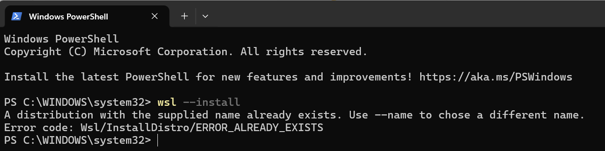
3. Restart your PC (required).
4. After restart, an Ubuntu window opens; create a username and password when asked (the password won't show as you type — that's normal). Write it down.
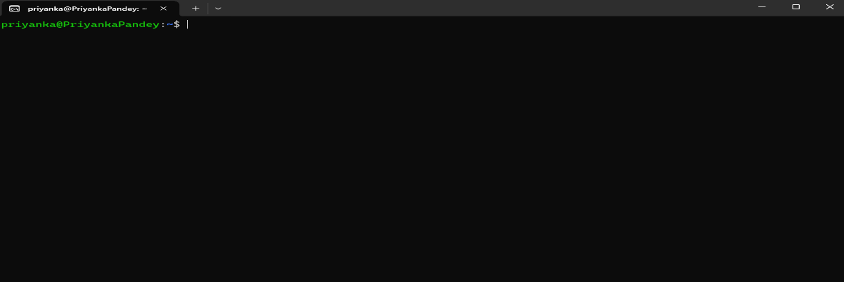

✓ You now have WSL/Ubuntu ready. Docker Desktop (next) will use it automatically.

B2. Install Docker Desktop
What you're doing: installing the app that runs containers on your computer.
1. Download Docker Desktop: https://www.docker.com/products/docker-desktop/
docker.com/products/docker-desktop → download Docker Desktop for Windows
2. Install it. On Windows, during install keep "Use WSL 2" ticked.
3. Open Docker Desktop and leave it running. You'll see a whale icon in your taskbar (Windows) or menu bar (Mac) — that means Docker is on.
4. Give Docker enough memory: Docker Desktop → Settings → Resources → set memory to at least 4 GB (8 GB is better). Airflow needs it.
✓ Docker Desktop is installed and running (whale icon visible).
Quick test — open a terminal (on Windows, use the Ubuntu app) and type:
docker --version
You should see a version number.
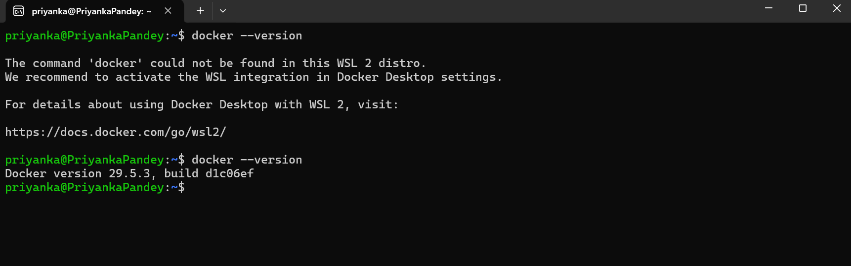
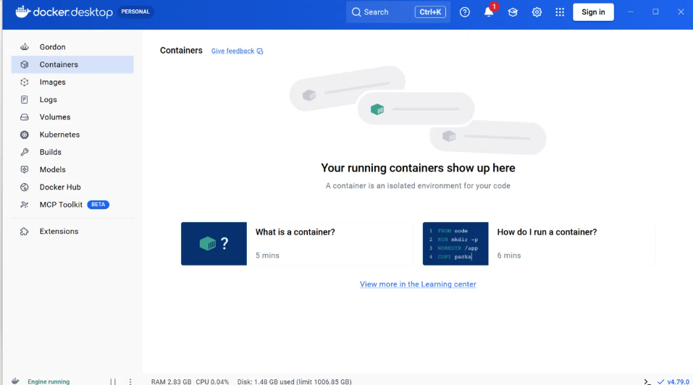
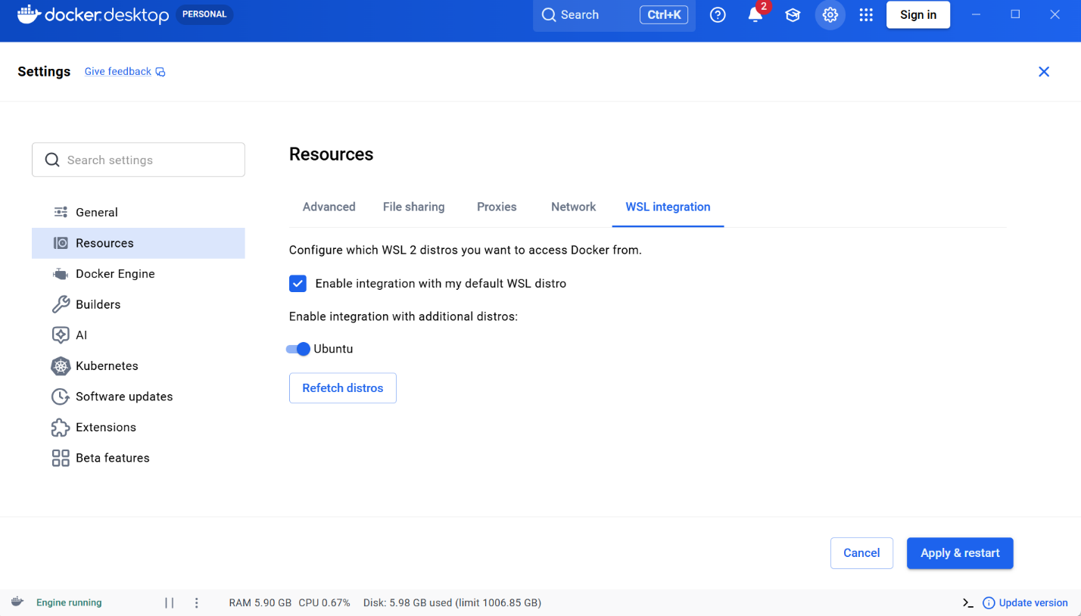

B3. Get the project folder & understand its files
Download and unzip this project. You'll have a folder like this:
sales-pipeline-project/
|-- dags/
| |-- daily_sales_pipeline.py <- the pipeline (Python)
|-- data/
| |-- daily_sales_2024_01_01.csv <- the sales files (upload to Snowflake)
| |-- daily_sales_2024_01_02.csv
| |-- daily_sales_2024_01_03.csv
|-- Dockerfile <- the "recipe" for our Airflow box
|-- requirements.txt <- extra packages (Snowflake support)
|-- .env.example <- a small settings file
|-- setup.sql <- run once in Snowflake
|-- COMPLETE_GUIDE <- this document
What each Docker-related file is (plain words):
- Dockerfile — the *recipe*. It says "start from the official Airflow box, then add the Snowflake packages." Docker reads it to build our custom image.
- requirements.txt — the *shopping list* of extra Python packages (here: the Snowflake add-ons).
- docker-compose.yaml — (you download it in B4) the file that defines all the Airflow services and starts them together.
- .env — a tiny settings file Docker reads automatically.
Open a terminal, and cd into the folder (on Windows, do this in the Ubuntu app):
cd path/to/sales-pipeline-project
Create the folders Airflow uses for logs and plugins:
mkdir -p logs plugins config

B4. Download the Docker Compose file (+ one edit)
The docker-compose.yaml file defines every Airflow service (dashboard, scheduler, database…). We download the official one so it's guaranteed correct:
curl -LfO 'https://airflow.apache.org/docs/apache-airflow/3.2.2/docker-compose.yaml'
✓ You now have docker-compose.yaml in your folder.
Now one small edit so it uses *our* Dockerfile (the one with Snowflake support). Open docker-compose.yaml in a text editor and find these two lines near the top:
image: ${AIRFLOW_IMAGE_NAME:-apache/airflow:3.2.2}
# build: .
Change them to (comment the first, un-comment the second):
# image: ${AIRFLOW_IMAGE_NAME:-apache/airflow:3.2.2}
build: .
Save the file.
(Optional, for a cleaner dashboard: in the same file find AIRFLOW__CORE__LOAD_EXAMPLES: 'true' and change 'true' to 'false' to hide the built-in example pipelines.)

B5. Create the .env file
This sets file permissions so containers and you share files cleanly:
echo "AIRFLOW_UID=$(id -u)" > .env
(If that command doesn't work, just make a copy of .env.example named .env.)

B6. Build and start Airflow
1) Build our custom image (only needed once, or after changing requirements.txt):
docker compose build
This downloads the Airflow box and adds Snowflake support. Give it a few minutes.
2) Set up Airflow's database (run once):
docker compose up airflow-init
3) Start everything:
docker compose up -d
(-d means "run in the background.") The first start takes 1–3 minutes.
Check the containers are healthy:
docker compose ps
✓ You should see services like apiserver, scheduler, postgres marked healthy or running.

B7. Open the dashboard
Open your web browser to:
http://localhost:8080
Log in with username `airflow` and password `airflow`.

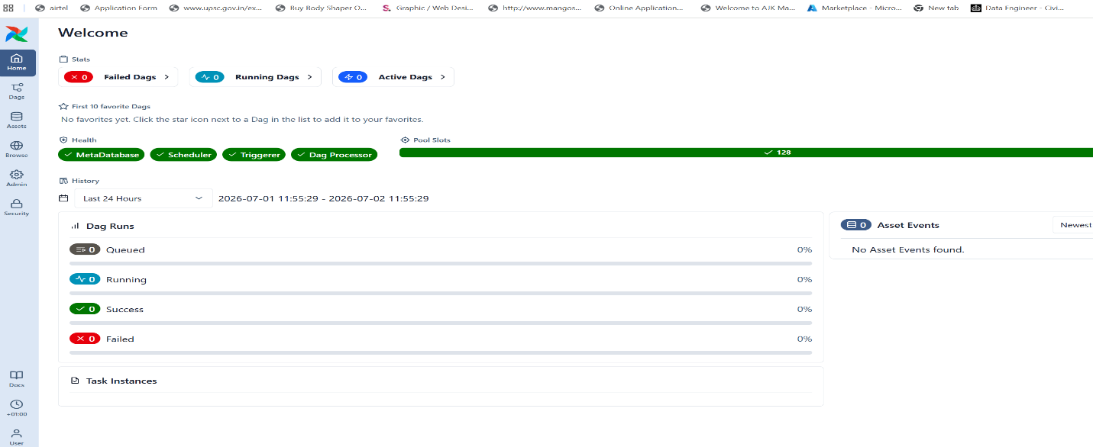
✓ You're looking at Airflow, running in Docker. (You'll see your daily_sales_pipeline in the list — we'll run it in Part D.)
To stop later: docker compose down (keeps your data). To start again: docker compose up -d. Keep Docker Desktop running while you work. (Full restart steps are in Part F.)

PART C — Set up Snowflake

C1. Create a free Snowflake account
1. Go to https://signup.snowflake.com/
2. Fill in the form (any cloud, any region is fine). Choose the free trial.
3. Check your email → click the activation link.
4. Create a username and password. Write these down.
5. You'll land on Snowflake's website, Snowsight.
Get your account identifier (needed to connect Airflow):
- Look at your browser's address bar: https://app.snowflake.com/abcdefg/xy12345/...
- Your identifier is usually `abcdefg-xy12345` (the two parts joined with a dash).
- Write it down as YOUR_ACCOUNT_IDENTIFIER.

C2. Run the setup SQL
1. In Snowsight: Projects → Worksheets → + (opens a blank SQL page).
2. Open setup.sql, copy all of it, paste it into the worksheet, click Run.
✓ You should see: Setup complete - you are ready.
What you just created (plain words): a drop-box for files (sales_stage), a landing table (raw_sales), a "new rows" bookmark (new_sales_stream), a small holding table (new_sales_batch), and the 3 report tables. The pipeline uses all of these for you.

C3. Connect Airflow to Snowflake
Airflow needs your Snowflake login, saved once as a connection.
1. In the Airflow dashboard, click Admin → Connections in the top menu.
2. Click + (add).
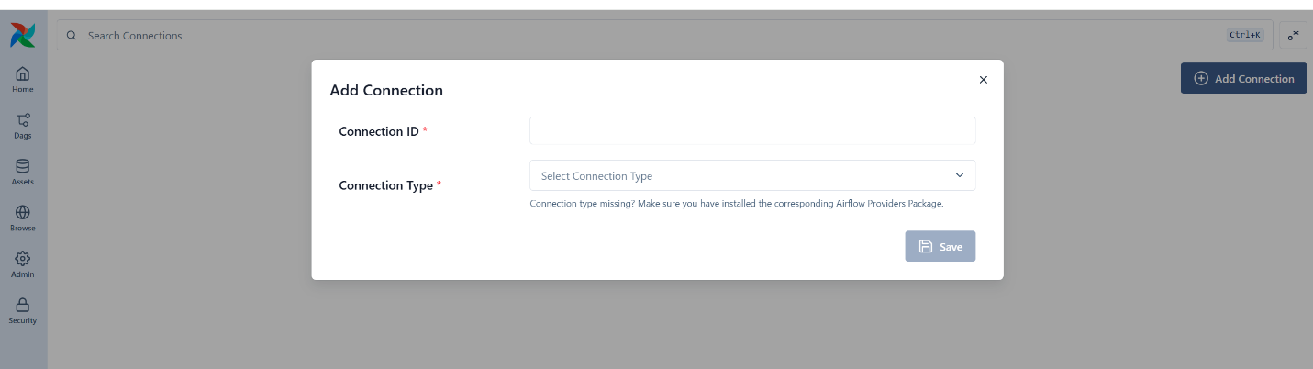
3. Fill in these boxes (leave others blank):
Box | What to type
Connection Id | snowflake_default
Connection Type | choose Snowflake
Login | your Snowflake username
Password | your Snowflake password
Account | YOUR_ACCOUNT_IDENTIFIER (e.g. abcdefg-xy12345)
Warehouse | COMPUTE_WH
Database | AIRFLOW_DB
Schema | PUBLIC
4. Click Save.
✓ snowflake_default now appears in your connections list. (The pipeline looks for exactly that name.) Tip: leave the Region field EMPTY — the account identifier already includes everything needed.

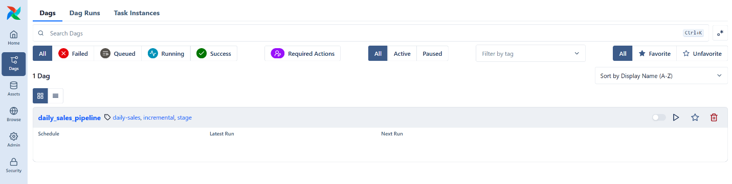

PART D — Build & run the pipeline

D1. Understand the pipeline
Your pipeline is already in dags/daily_sales_pipeline.py. You don't need to write it — but here's what each step does, so it's not a mystery:
Step | Task name | Plain-English job | Snowflake tool
1 | load_raw | Load staged files into the landing table | COPY INTO
2 | capture_new_rows | Take only the brand-new rows | stream + INSERT
3a | update_summary_by_region | Add new data to region totals | MERGE
3b | update_summary_by_product | Add new data to product totals | MERGE
3c | update_summary_by_day_region | Add new data to day+region totals | MERGE
4 | check_final_tables | Confirm the outputs have rows | SELECT COUNT
The order is: load_raw → capture_new_rows → (3a, 3b, 3c together) → check_final_tables.
- `COPY INTO` = Snowflake's fast, standard command for loading files from a stage.
- stream = the "bookmark" that knows which rows are new (this is what makes it incremental).
- `MERGE` = "if this group already exists, add to it; if it's new, create it."

D2. Upload the first data file
Start with Day 1 so you can watch the totals grow later.
1. In Snowsight: Data → Databases → AIRFLOW_DB → PUBLIC → Stages → SALES_STAGE.
2. Click + Files (top right).
3. Upload only daily_sales_2024_01_01.csv. Click Upload.
✓ The file now appears inside the stage. (In a real company, another system drops files here automatically — here you do it by hand to see how it works.)

D3. Run it and see your results
1. In the Airflow dashboard, find `daily_sales_pipeline` and turn it ON (toggle).
2. Click its name → Graph (to see the steps as boxes).
3. Click Trigger (top right) → confirm.
4. Watch the boxes turn dark green, in order. The 3 summary steps light up together.
5. Click check_final_tables → Logs to see the row counts.
See your report tables — in Snowsight, run:
USE DATABASE AIRFLOW_DB; USE SCHEMA PUBLIC;

SELECT * FROM summary_by_region ORDER BY total_revenue DESC;
SELECT * FROM summary_by_product ORDER BY total_revenue DESC;
SELECT * FROM summary_by_day_region ORDER BY order_date, region;
✓ You'll see Day-1 totals in all three tables. You just ran a real pipeline that loaded 4,000 orders and built reports.

D4. See the "incremental" magic
1. In Snowflake, go back to the SALES_STAGE stage (D2 path).
2. Upload `daily_sales_2024_01_02.csv` (Day 2).
3. In Airflow, trigger `daily_sales_pipeline` again.
- It loads only the new file (Day 1 is skipped automatically).
- It grabs only Day-2's rows (the bookmark remembers Day 1 is done).
- It adds Day-2's numbers on top of the existing totals.
4. Check again:
SELECT * FROM summary_by_day_region ORDER BY order_date, region;
SELECT * FROM summary_by_region ORDER BY total_revenue DESC;
✓ You now see both Day 1 and Day 2, and the region/product totals grew by exactly Day-2's amounts — Day 1 was never counted twice. That is incremental processing.
5. Repeat once more with `daily_sales_2024_01_03.csv` (Day 3).

PART E — Recap, problems & next steps

What you accomplished
- Ran Airflow inside Docker — a clean, organized, industry-style setup.
- Connected Airflow to Snowflake.
- Built a real pipeline: files land in a stage → load to a raw table → transform → 3 report tables → check.
- Made it incremental — each day only adds new data.

The ideas you actually used
Idea | Where you saw it
Docker image / container | the box Airflow runs in (docker compose up)
Pipeline (DAG) | daily_sales_pipeline
Task | each box: load_raw, capture_new_rows, etc.
Dependencies | the order the boxes ran in
Airflow + Snowflake | every step told Snowflake what to do

If something didn't work
Click the red box in the dashboard → Logs → read the bottom. Common issues:
What you see | Likely cause | Fix
Dashboard keeps restarting | Docker needs more memory | Docker Desktop → Settings → Resources → 4–8 GB
port 8080 already in use | Something else uses 8080 | Stop it, or change the port in docker-compose.yaml
Changed requirements.txt, no effect | Image not rebuilt | docker compose build then docker compose up -d
COPY INTO loaded 0 rows | File not uploaded to the stage | Redo D2; confirm the file shows in SALES_STAGE
object does not exist | setup.sql not run / wrong database | Re-run C2; check connection Database = AIRFLOW_DB
Connection / auth error | Wrong Snowflake details | Fix snowflake_default in Admin → Connections
404 Not Found on login | Region field filled in | Empty the Region field in the connection
docker: command not found | Docker Desktop not running | Start Docker Desktop (whale icon), retry

Where to go next
- Change schedule=None to schedule="@daily" in the DAG so it runs itself each morning.
- Add an email/Slack alert if the check step finds an empty table.
- Put the whole folder in git so anyone can run docker compose up and get the same environment — that's real team workflow.
You did it. You built a professional-shaped data pipeline — Airflow in Docker, loading and transforming real data in Snowflake, incrementally. That's genuinely what the job looks like. Be proud.

PART F — Coming back the next day (restart)
Airflow only runs while its Docker containers are running. When you shut down or restart your computer, they stop. Here's how to pick up exactly where you left off. You do NOT redo any setup — no rebuilding, no re-creating the connection, no re-running setup.sql.

Step 1 — Start Docker Desktop
Open Docker Desktop and wait until the whale icon is steady and it says "Engine running" (bottom-left). Nothing works until Docker is running.

Step 2 — Open your terminal in the project folder
Windows: open the Ubuntu app. Mac/Linux: open Terminal. Then go to your project folder:
cd path/to/sales-pipeline-project

Step 3 — Start the containers again
docker compose up -d
No build needed — the image is already built from your first setup. This start usually takes about a minute.

Step 4 — Check they're healthy
docker compose ps
✓ You want to see the services (apiserver, scheduler, postgres…) marked healthy or running.

Step 5 — Open the dashboard
In your browser, go to http://localhost:8080 and log in with `airflow` / `airflow`. Your DAG, your Snowflake connection, and all your data are still there.

Loading a new day of data
Whenever you want to process another day:
1. In Snowflake, upload the next CSV to the SALES_STAGE stage.
2. In Airflow, trigger `daily_sales_pipeline`.
3. The pipeline loads only the new file and adds it to your totals (incremental).

Stopping when you're done for the day
docker compose down
This stops the containers but keeps your data. Next day, just start again from Step 1.

Full reset (rarely needed)
Only if your Airflow environment gets badly broken and you want a clean slate. This wipes Airflow's internal database (connections, run history) — it does NOT touch your Snowflake account or tables, which live safely in the cloud:
docker compose down --volumes
After a full reset you'd re-run docker compose up airflow-init, start again, and re-add the snowflake_default connection.
Note: If, when you first set up, you gave the project a custom name or port (for example -p sales-pipeline, or port 8081 because 8080 was already in use), use those same values here — e.g. docker compose -p sales-pipeline up -d, and open localhost:8081.
— End of guide —

