**Project Proposal- Pizza Deal**

**Project Purpose**

Pizza Deal is a unique website that is designed to allow the user to acquire the most awarding experience in ordering pizza. One of the biggest deciding factors of people buying pizza are the deals and coupons. Frankly, there are many times that hungry-stricken people would buy pizza if they just easily knew that certain deals were going on. This site will deliver special access and knowledge to pizza lovers from all around. Instead of slowly trudging across various pizza websites looking for the latest deals, all of that information and more can be found here. This site also supports local businesses, from past experiences, the best tasting pizza are those made in small businesses. And Pizza Deal is dedicated to help spread the word of those delicious businesses and their specials. Through Pizza Deal, anyone can effortlessly know about every current deal from all the pizza companies in their area.

**The Audience**

The audience of this site is intended for the men and women from ages 18-25. Generally, those that are in not stable economic conditions and are currently gaining a higher education. With that said, the device that the users will most likely access it will be through a mobile device. However, it is expected that younger to well established families will be interested in this service and website. In addition, this will be opened to the general public, and anyone else who seeks for great deals can simply utilize Pizza Deal for the means to get the job done.

**Web Pages**

This project will include a total of 5 web pages. Each page will deliver unique content in relation of the website. There will be a main page, about page, user registration page, business registration page, local business directory, and deals of the week page.

Main Page- the main page will act as an introductory to new and oncoming users. It will be focused on highlighting hot deals, businesses, and new features. Here they can be directed to straight to the weekly deals or they can explore more of what the website can offer. This will include an introductory video for new users.

About Page- this page will provide contact information and more. On the about page the users can also be informed of necessary legal technical information of the site. As well, they can submit questions, comments, and/or suggestions to the website’s creators

Review Page- to further improve the experience of the customer, they can leave their opinion. What a better a way to improve user satisfaction than through their own opinions? The site will then be modified accordingly. This page will be possible through the use of embedded Google Forms questionnaires.

Business Sign-up Page- businesses wishing to become a part of the Pizza Deal community and may do so by this page. If Pizza Deal’s official representatives have not contacted all the local businesses, or a new business has recently opened, then they can refer to this page to know how to be on the site. On this page, they will be directed to a specific email address and a downloadable pdf file. Using this email address, they will submit the filled-out pdf file requesting to be present on the site. Upon approval, Pizza Deal’s web masters will make sure that they are added in the site.

Local Business Directory- For the convenience of the users, they will be able to look at all the signed-up local business on Pizza Deal. Perhaps they are looking for a specific one or a couple businesses, then they can locate them here. This will use JSON data for displaying the repective information.

Deals of the Week Page- The content of this page will deliver clean and simple information of the various pizza deals and coupons that the businesses nearby the user or any other desired location. By design, this page will be most access and used page on the site.

**Wireframe Sketches**

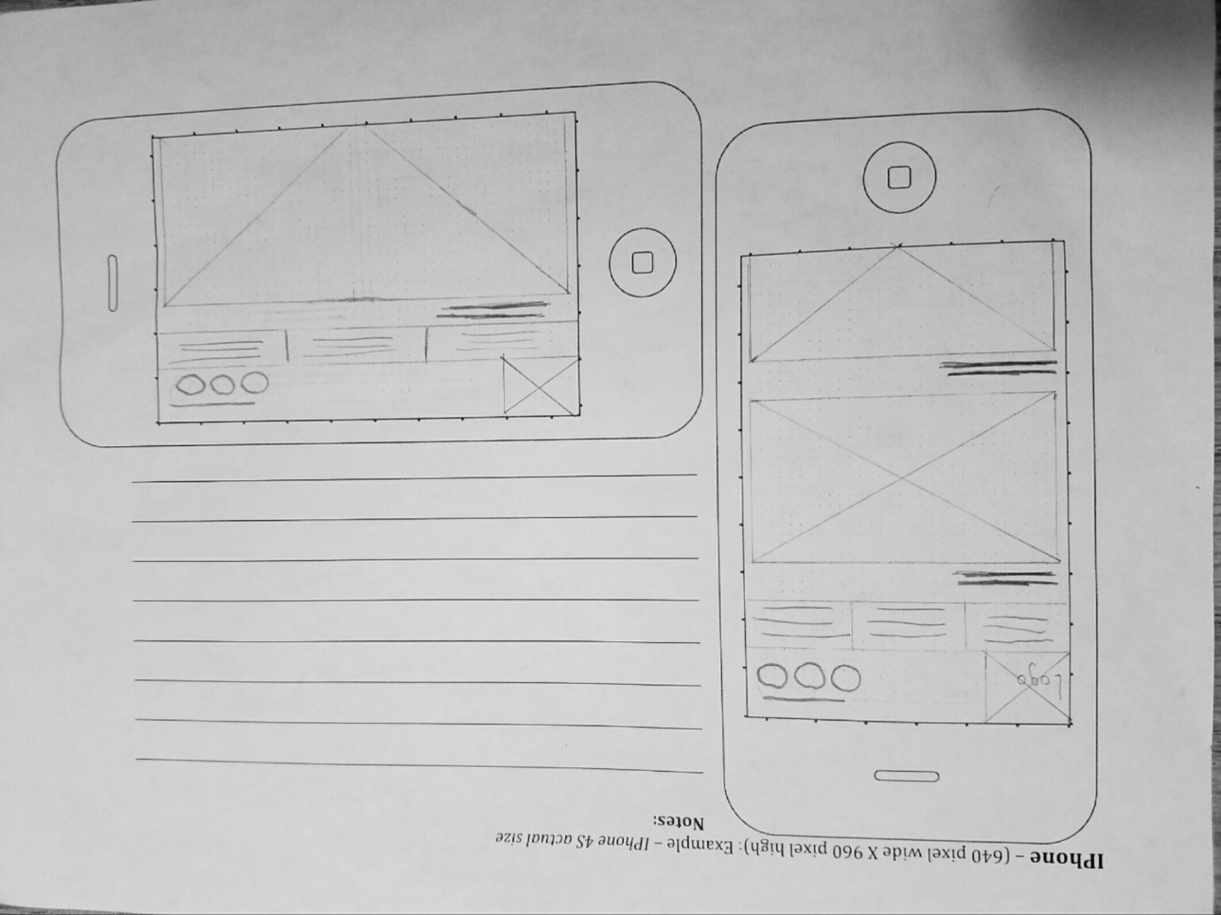

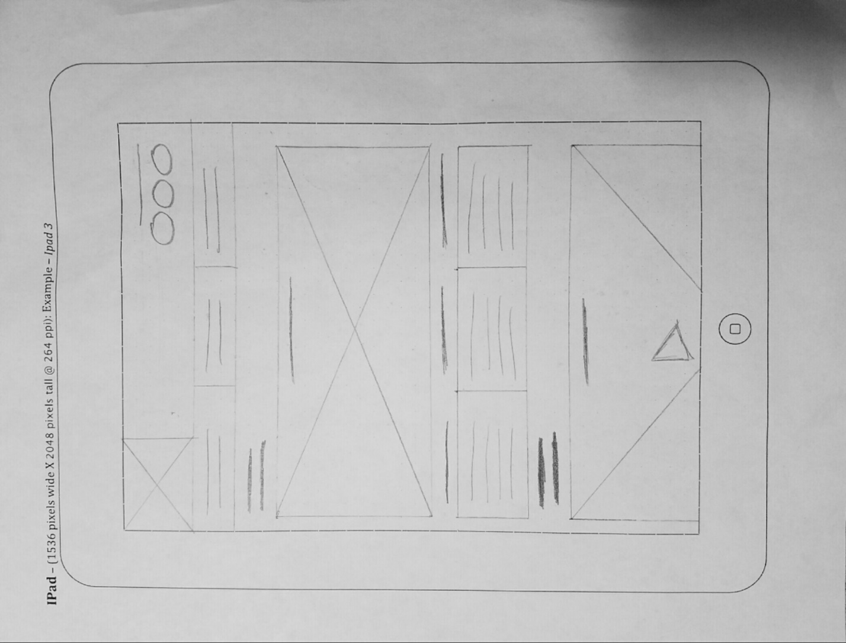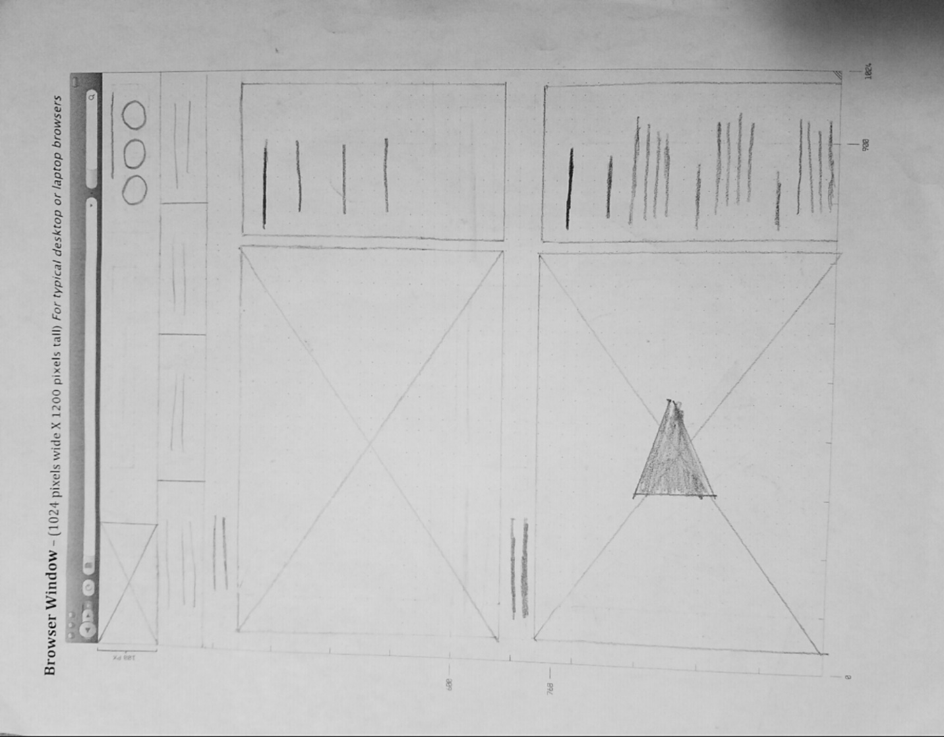

**Usability Concepts**

The Pizza Deal website will be designed from mobile first. Therefore, to maximize the users experience, the factor that the font size/spacing is easy to read will play an important role. Through the utilization of this item, the content will be deliverable to the user on his small mobile screen with ease. As well as the ATL tags will be implemented, especially to improve the mobile experience. So, if the users have a slower internet speed or they have the screen reader tool enabled, they will be able to know what exactly is the image being presented on the page. An important part of navigating the web page will be the links that are located all throughout. The links will consistent and easy to identify, allowing the user to have nice flow feeling while navigating the page. Another important element are the major headings in the page. To successfully deliver the content and preventing the user to become lost in it, the major heading will be clear and descriptive. Thus, helping the user to skim and locate quickly the desired content, such as a specific pizza deal. The main copy will be concise and explanatory. In doing so, the user will not have an anti-climactic feel after locating the correct and clear heading of the section.