Development Automation
& Linux

Lab Test

Submitted By:
Ayush Singh Kushwah
SAP ID: 500095575
Enrolment No: R2142210216
Batch: 03
Semester IV
BTech CSE (DevOps)
Submitted To:

Mr. Suvra Choudhary

SCHOOL OF COMPUTER SCIENCE
UNIVERSITY OF PETROLEUM & ENERGY STUDIES
Dehradun-248007
2022-23
LAB TEST

- Write a program to print the patterns. (Use loop)
a. 1
2 3
4 5 6
7 8 9 10
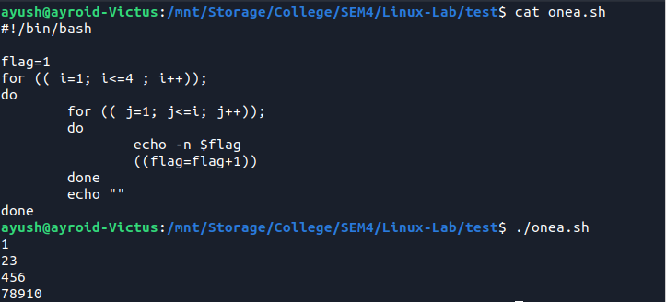
b. 7 8 9 10
4 5 6
2 3
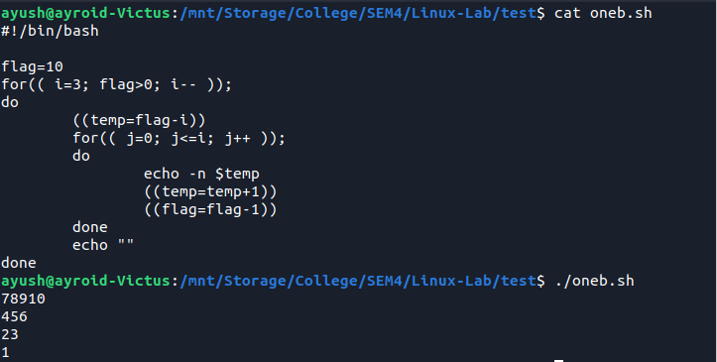
1
c. 1
2 3
4 5 6
7 8
9
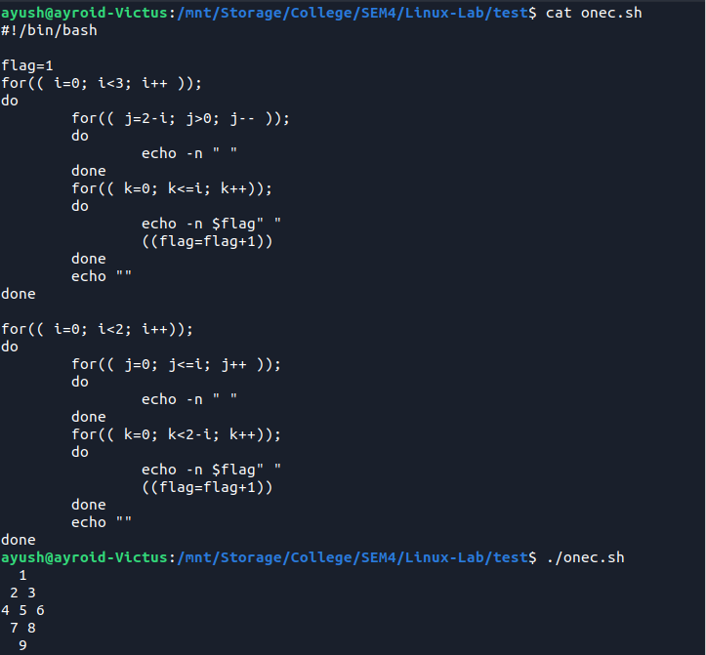
d. 1,1,2,3,5,....
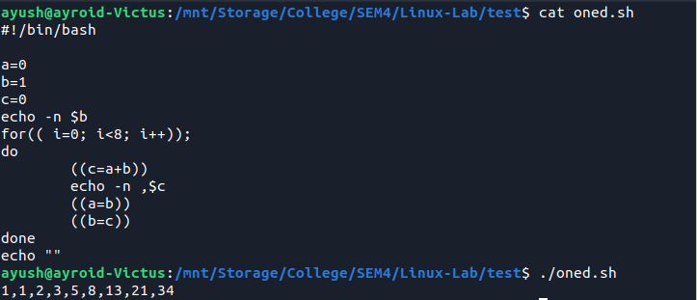
2. Create the pattern of the above questions and move it to another folder
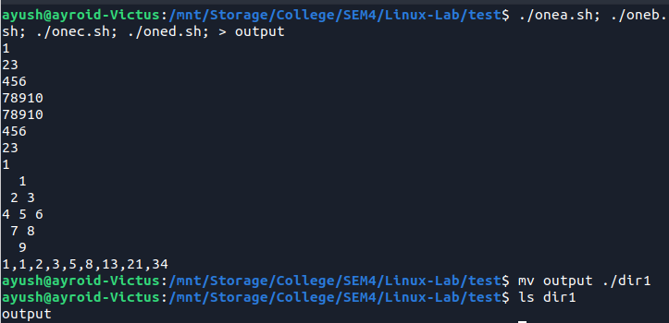
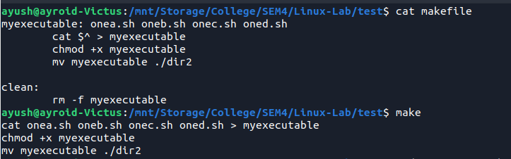
3. Write a make file of question1 and move it to another folder
