EXPERIMENT-9

- Write two script files. In the first program some print message is written. Call the print message from the second script program.
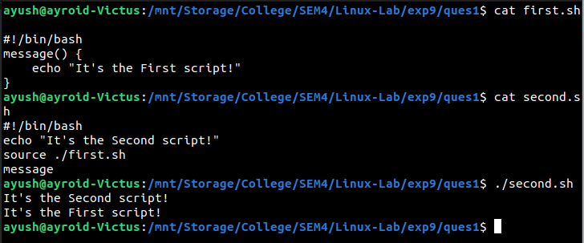
- Write two script files. In the first program two functions are written. The two functions are uppercase and lowercase. Call the two functions from the second script program.
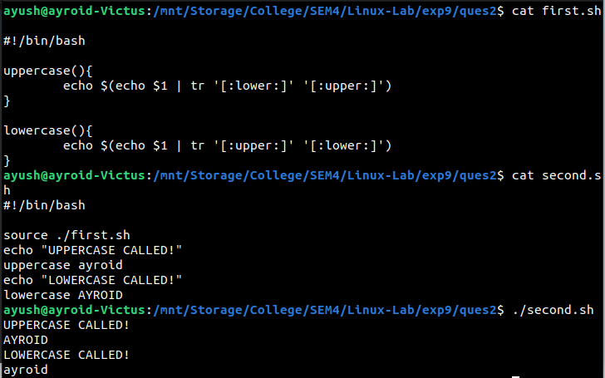
- Write two script files. In the first program four functions are written. The functions are converting a text to different color (red, yellow, green and blue). Call the four functions from the second script program.
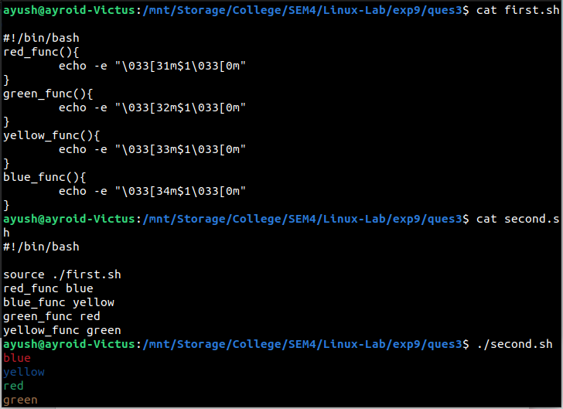
- Try different script codes from the lab material.
