Development Automation
& Linux
Lab Code –

Lab File

Submitted By:
Ayush Singh Kushwah
SAP ID: 500095575
Enrolment No: R2142210216
Batch: 03
Semester IV
BTech CSE (DevOps)
Submitted To:

Mr. Durgesh Singh

SCHOOL OF COMPUTER SCIENCE
UNIVERSITY OF PETROLEUM & ENERGY STUDIES
Dehradun-248007
2022-23

INDEX

S.No. | Experiment | Date | Remark
1. | Experiment 1
2.
3.
4.
5.
6.
7.
8.
9.
10.
11.
12.

EXPERIMENT-1
Introduction to Linux Commands
- Write brief description of the following Shell commands. Also, attach screenshot after running these commands on the terminal.

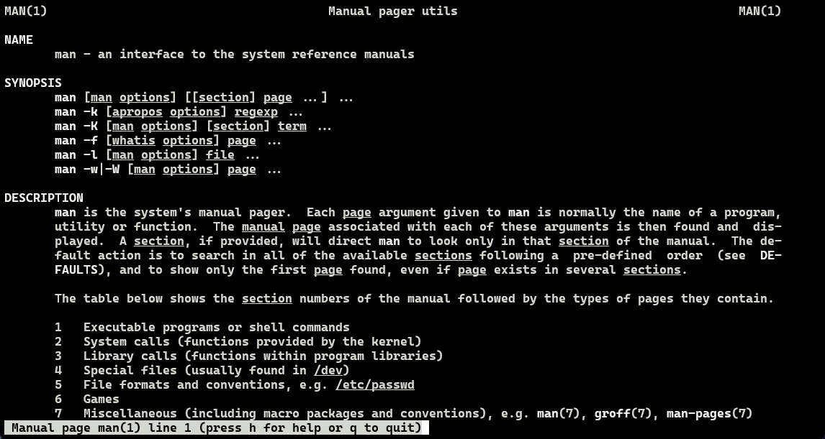
- man: an interface to the system manuals.
- whoami: prints the user name associated with the current effective user ID.
- pwd: prints name of the current working directory.
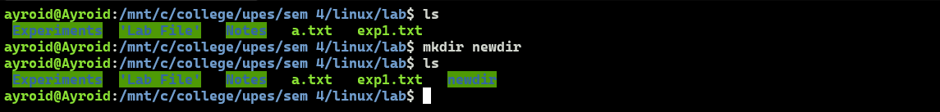
- mkdir: used to create new directories
- cd: used to change directories
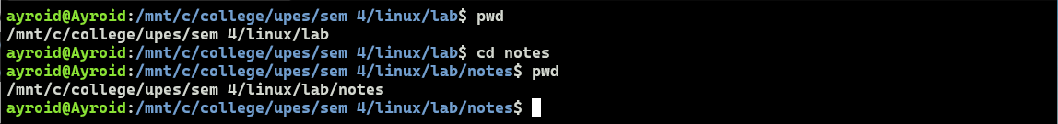
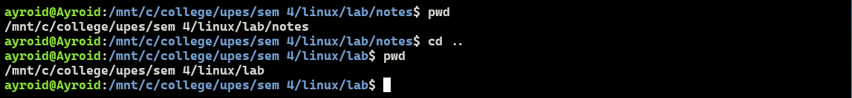
- ls: used to list the contents of the directory.
- ls -l: used to list the contents of the directory in a long listing format.
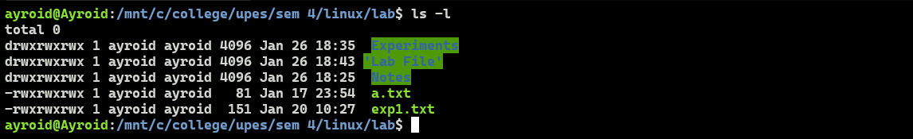
- ls -a: shows all contents of the directory + entries starting with .
- ls -c: sorts and shows the content of the directory according to name/time when combined with l/lt respectively.
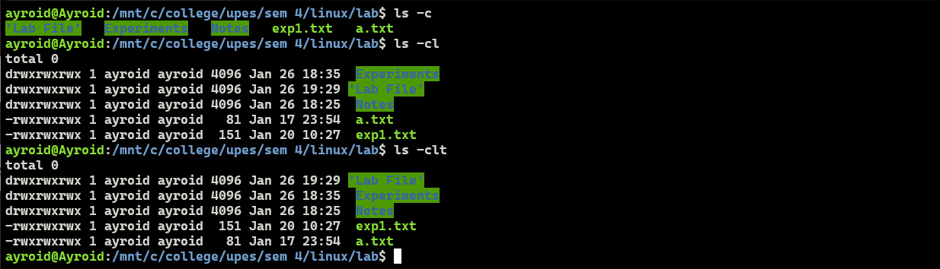
- ls -m: shows the content of the directory separated by commas
- ls -p: shows the content of the directory with / indicating directories
- ls -r: shows the content of the directory by sorting them in reverse
ls -f: shows the content of the directory without sorting or colouring them
- clear: clears the terminal screen
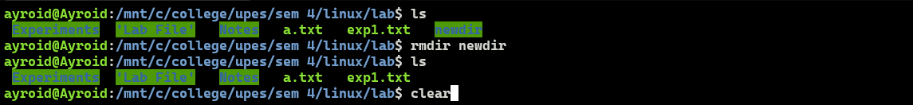
- rmdir: removes empty directories
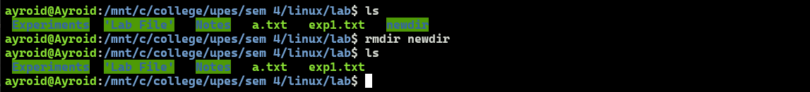
- touch: creates new files without opening the text editor
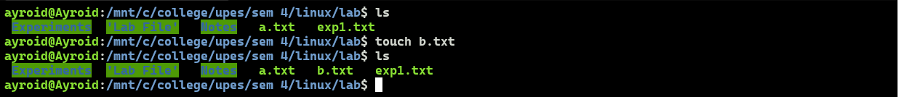
- cat: concatenates files and prints content on the screen
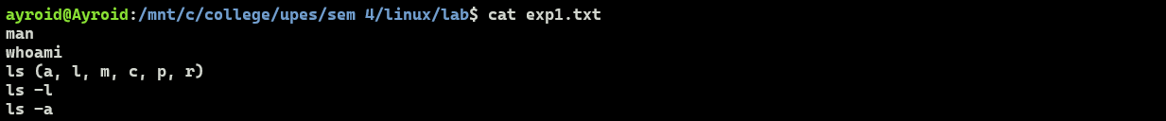
- less: shows file’s contents one screen at a time. It doesn’t load the entire file but accesses it page by page.
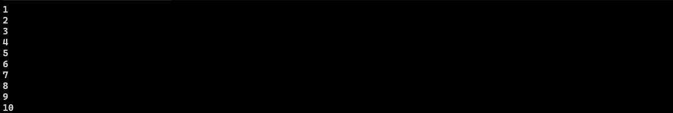
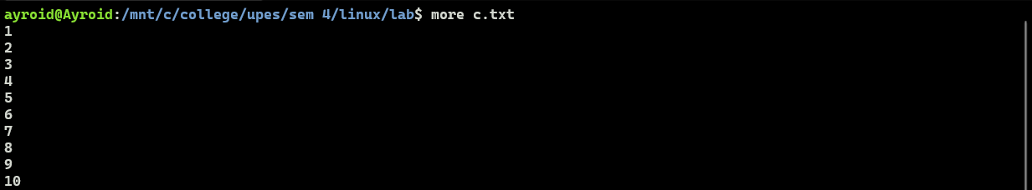
- more: used to view the first section of the file.
- rm: removes files and directories
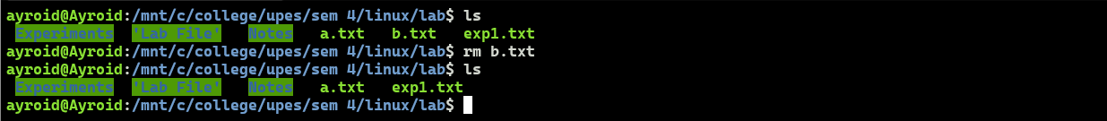
- sort: sorts lines of the text files
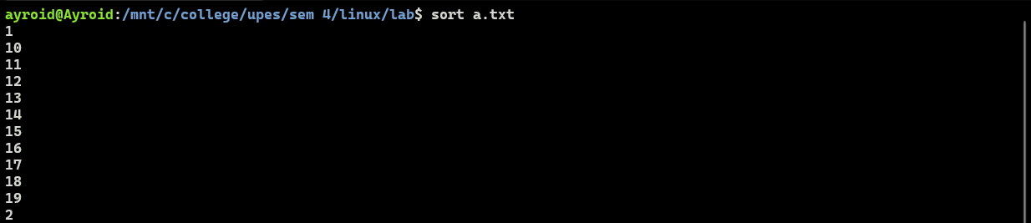
- cp: copies files and directories
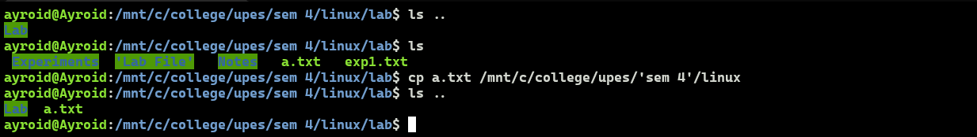
- mv: moves and renames files
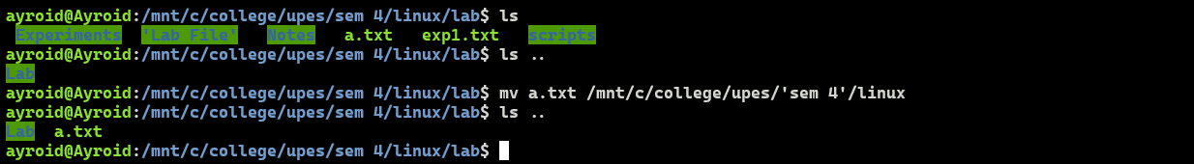

- wc: prints newline, word, and byte counts for each file
- head: prints first n lines of the file. The default value of n is 10.
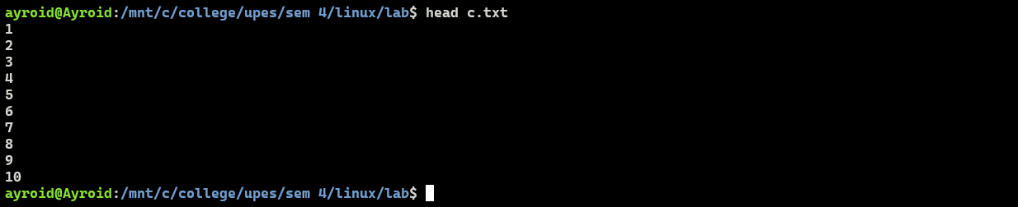
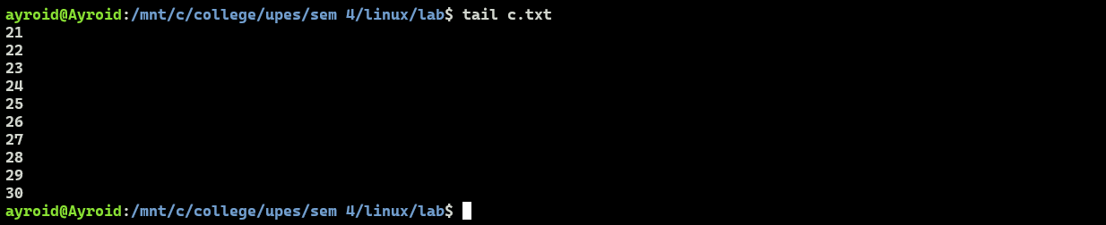
- tail: prints the last n lines of the file. The default value of n is 10.
- history: GNU history library. Keeps record of the previously used commands.
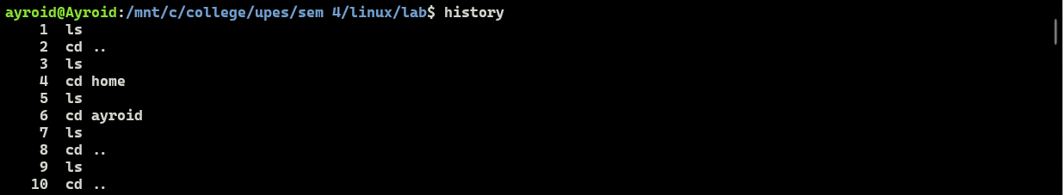

- Write in details about the grep command.
grep searches for PATTERNS in each FILE. PATTERNS is one or more patterns separated by newline characters, and grep prints each line that matches a pattern. Typically, PATTERNS should be quoted when grep is used in a shell command.
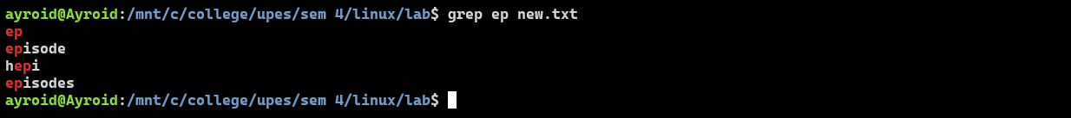
- Find all the patterns that start with “ep” in a given file.
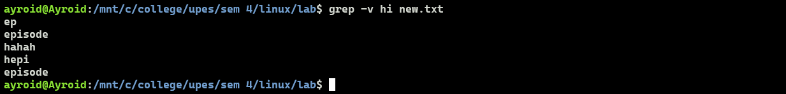
- Print those lines of a given text file which do not contain the word “hi”.

- Explain the usage of options -i, -A, -B, -C in grep command with examples.

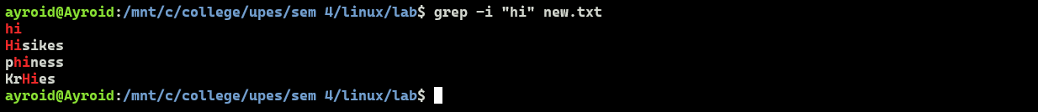
- grep -i: ignores case while looking for a match.
- grep -A n: prints the matched results and n number of lines after that.

- grep -B n: prints the matched results and n number of lines before that.
- grep -C n: prints the matched results and n number of lines before & after that.
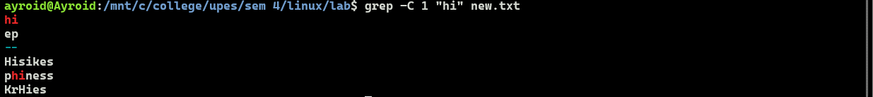
EXPERIMENT-2
Introduction to Bash Scripts

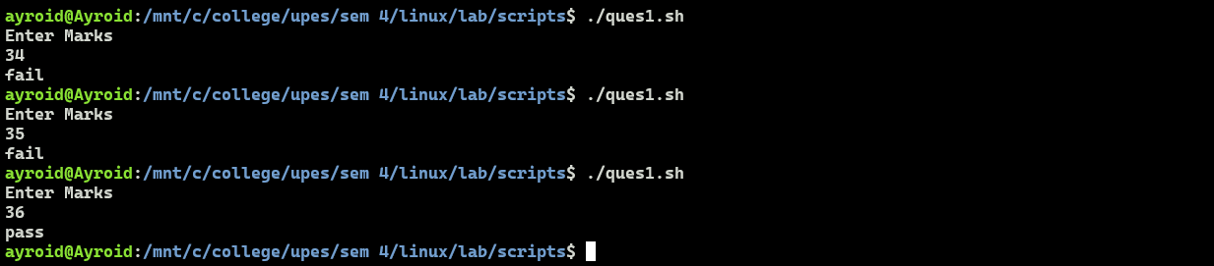
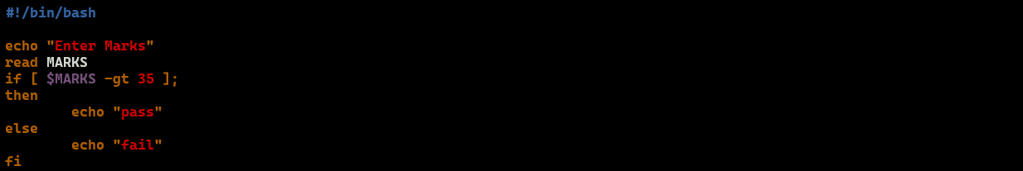
- Write a script to enter marks by user in the terminal. If the entered mark is greater than 35 then output pass, otherwise output fail.

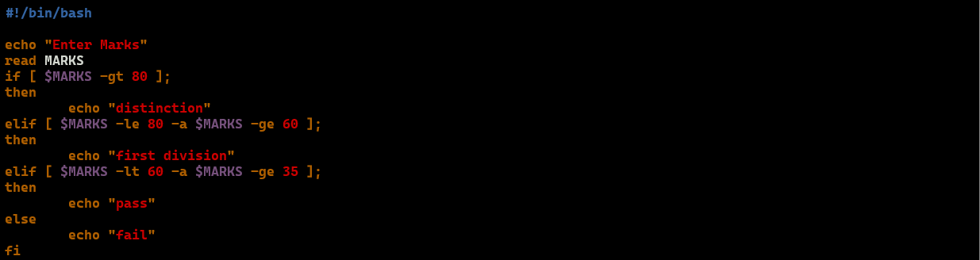
- Write a script to enter marks by user in the terminal. If marks are greater than 80 output distinction, if marks between 60 and 80 then output first division. If marks are less than 60 and greater than or equal to 35 then output pass, otherwise output fail.
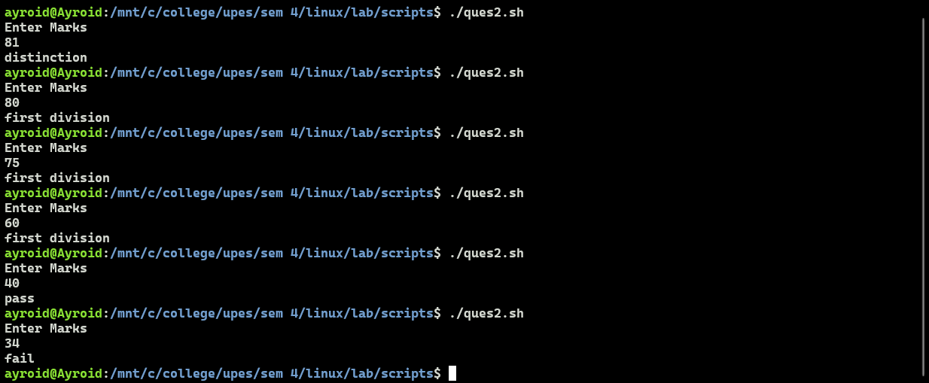
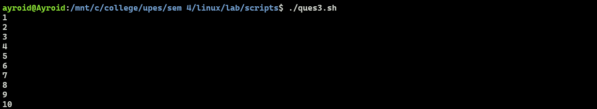
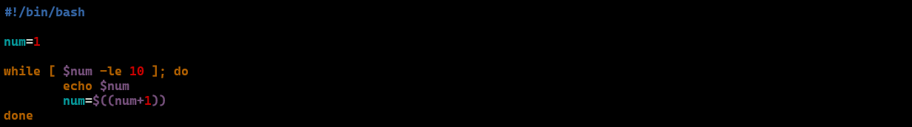
- Write a script to print numbers from 1 to 10 using while loop.
- Write a script to find the average of first N natural numbers, where N is entered by the user at the terminal.
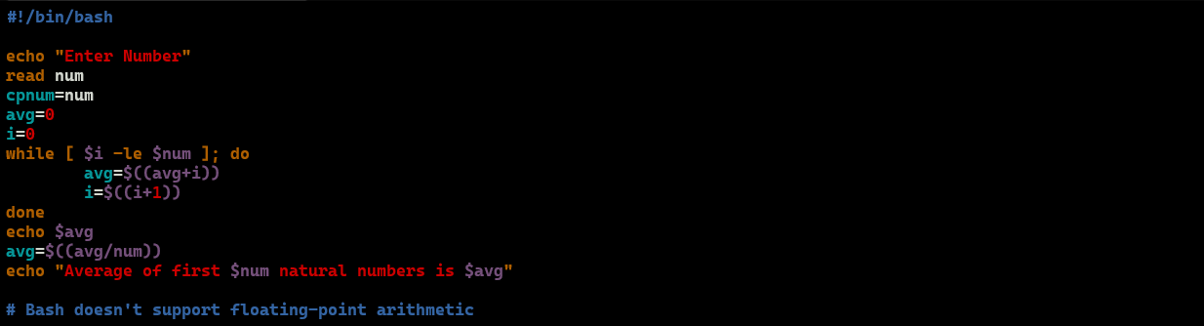
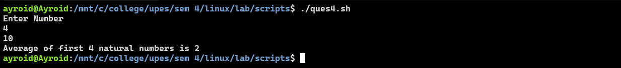
- Write a script to find the average of N numbers of an array (of size N). The values of the array are entered by the user at the terminal. (Use while loop)
