TechStat Website Documentation
1. User Story
Title: Browse and Purchase Tech Products on TechStat
As a customer, I want to browse technology and stationery products on the TechStat website, so that I can view product details, compare options, and purchase items conveniently online.

Acceptance Criteria
- The user can navigate between categories (3D Printing, Electrical, Tools, Arduino, etc.).
- The user can view detailed product information (name, specifications, price, image).
- The user can select quantity and add items to the cart.
- The user can contact TechStat via email or phone for inquiries.
- The website displays company branding and contact details consistently across pages.

2. Use Case Diagram
Actors
- Customer – interacts with the website to browse and purchase products.
- TechStat System – manages product listings, shopping cart, and contact information.
- Admin – updates product details and manages inventory.

Use Cases
Actor | Use Case | Description
Customer | Browse Products | View categories and product listings.
Customer | View Product Details | See specifications, images, and pricing.
Customer | Add to Cart | Select quantity and add product to shopping cart.
Customer | Contact TechStat | Send inquiries via email or phone.
Admin | Manage Products | Add, update, or remove product listings.
Admin | Manage Orders | Process customer orders and update stock.

Use Case Diagram (Textual Representation)
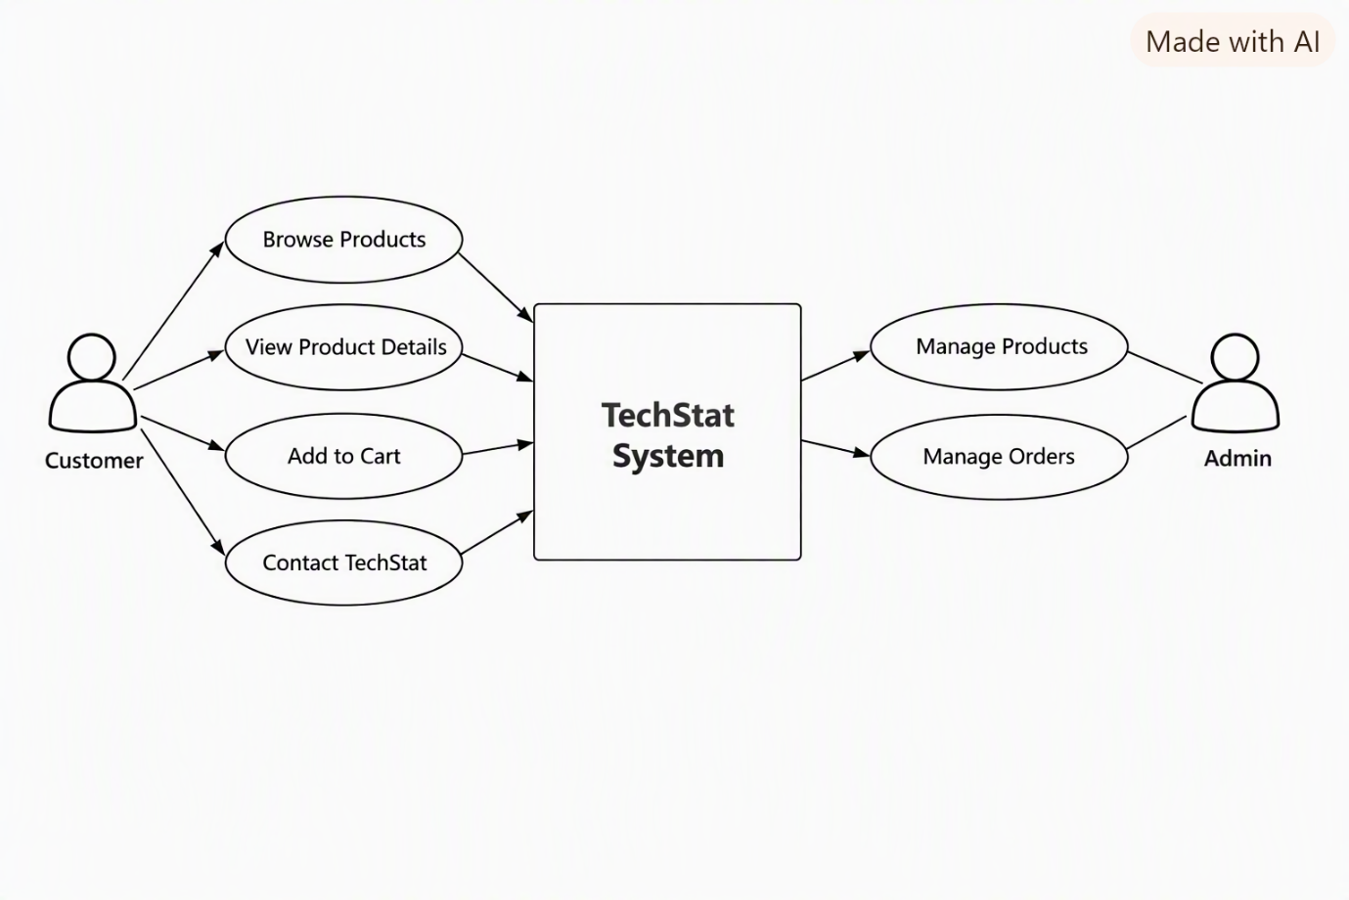

UML Activity Diagram – Business Process & Navigation Flow
Purpose: Illustrates how a user navigates through the TechStat website and how business logic flows from browsing to checkout.
Main Activities:
- Start
- Browse Categories → (Decision: Select Category)
  - 3D Printing
  - Electrical
  - Tools
  - Arduino
- View Product Details
- Decision: Add to Cart?
  - Yes → Proceed to Cart
  - No → Return to Browse
- Checkout Process
  - Enter Customer Info
  - Confirm Order
  - Payment Process
- End
Diagram Flow (Textual Representation):
[Start] → [Browse Categories] → [View Product Details]
→ [Decision: Add to Cart?]
├── Yes → [Proceed to Checkout] → [Confirm Order] → [End]
└── No → [Return to Browse]
2. UML Class Diagram – Object-Oriented Structure
Purpose: Defines the object-oriented design for TechStat’s dynamic website components.
Class | Attributes | Methods | Relationships
User | userID, name, email, password | register(), login(), logout() | 1..* Orders
Product | productID, name, category, price, description, stockQty | viewDetails(), updateStock() | 1..* OrderItems
Order | orderID, date, totalAmount, status | createOrder(), cancelOrder(), updateStatus() | 1 User, 1..* OrderItems
OrderItem | itemID, quantity, subtotal | calculateSubtotal() | 1 Product, 1 Order
Admin | adminID, name, email | manageProducts(), manageOrders() | Controls Product & Order

Relationships:
- User → Order: One-to-many
- Order → OrderItem → Product: Composition
- Admin → Product/Order: Control relationship

3. UML Sequence Diagram – System Interaction Over Time
Scenario: Customer Purchases a Product
Actors: Customer, Web Interface, Controller, Database
Sequence Flow:
Customer → Web Interface: Select Product
Web Interface → Controller: Request Product Details
Controller → Database: Fetch Product Info
Database → Controller: Return Product Info
Controller → Web Interface: Display Product Details
Customer → Web Interface: Add to Cart
Web Interface → Controller: Create Order
Controller → Database: Save Order Data
Database → Controller: Confirm Order Saved
Controller → Web Interface: Display Confirmation
