Agile Team Charter
Evidence
Project Name
TechStat E-Commerce Website
Project Vision
To provide customers with an easy-to-use online platform where they can browse technology and stationery products, compare options, and purchase products conveniently.
My Purpose
Develop a professional e-commerce website that allows customers to browse products, view product information, add items to a cart, and place orders online.
Core Team Values
- Collaboration
- Communication
- Accountability
- Continuous Improvement
- Customer Focus
Working Agreements
- Complete allocated tasks before deadlines.
- Attend scheduled meetings with the customer.
- Update progress regularly.
- Use GitHub for version control.
- Report challenges as soon as they occur.
Communication Plan
- Weekly meetings
- WhatsApp group for daily communication
- GitHub for project updates and code sharing
Conflict Resolution
Any disagreements are discussed during meetings and resolved through team consensus. If no agreement can be reached, the matter is escalated to the project supervisor.

Roles and Responsibilities
Role | Responsibility
Project Team | Develop website features
Designer | Create user interface layouts
Developer | Implement website functionality
Tester | Verify functionality and usability
Documentation Manager | Maintain project documentation

Reflection
The Agile Team Charter provided a structured foundation for the TechStat project. Establishing a shared vision and agreed working practices helped ensure that I understood the project's objectives. Defining communication methods and responsibilities improved coordination and reduced confusion during development. The charter also highlighted the importance of accountability because I needed to understand my role within the project. Through this process, I learned that successful Agile projects rely not only on technical skills but also on clear communication and teamwork (customer). The charter served as a useful reference throughout the project and helped maintain alignment with our goals.

User Stories and Tasks
Evidence
User Story
Title: Browse and Purchase Tech Products on TechStat
As a customer,
I want to browse technology and stationery products on the TechStat website,
So that I can view product details, compare options, and purchase items conveniently online.
Acceptance Criteria
- User can browse product categories.
- User can view product details.
- User can add products to the cart.
- User can contact TechStat.
- Website consistently displays branding and contact details.

User Story Tasks
Task ID | Task Description
T1 | Create navigation menu
T2 | Develop product catalogue page
T3 | Develop product details page
T4 | Implement shopping cart
T5 | Create contact page
T6 | Add company branding
T7 | Test website functionality
Supporting Diagram
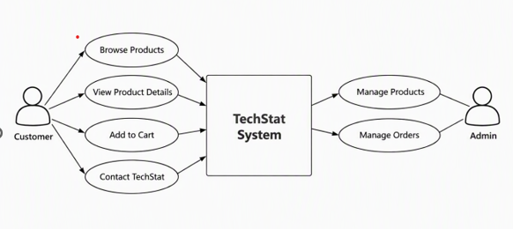
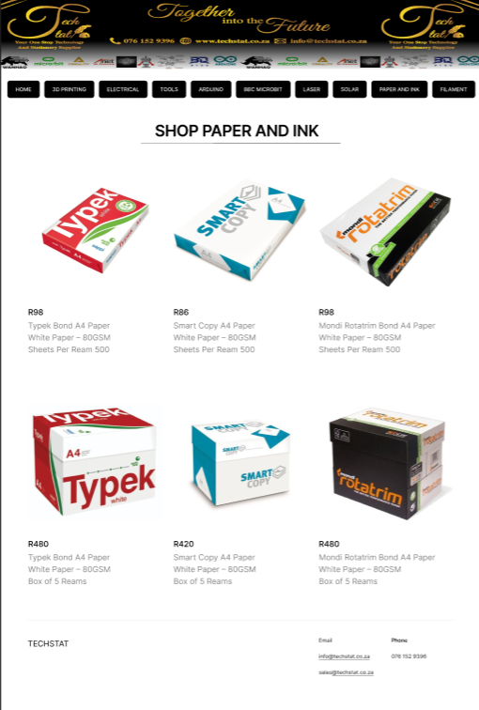
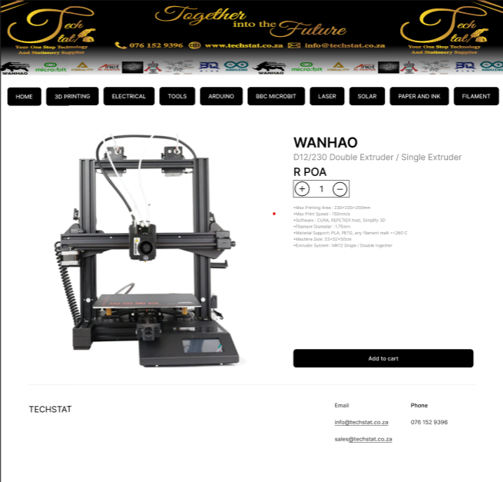

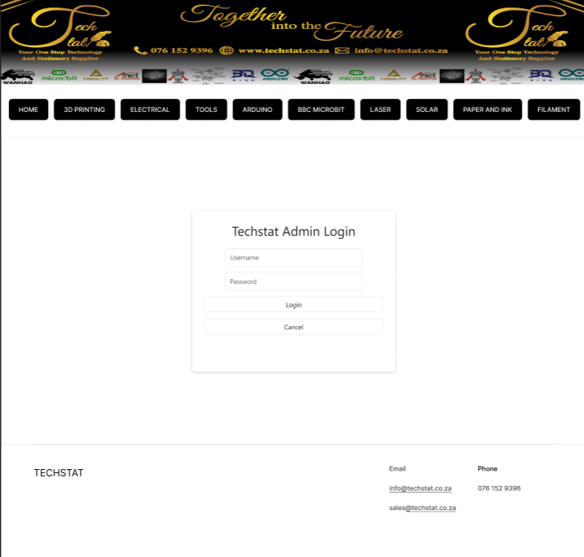

Reflection
Creating user stories helped focus development on the needs of customers rather than purely technical requirements. The user story made it clear that customers needed simple navigation, detailed product information, and an efficient purchasing experience. Breaking the story into smaller tasks made the work easier to plan and manage. It also improved prioritisation because essential features could be completed before less critical enhancements. This Agile approach helped keep the project aligned with user expectations and encouraged continuous delivery of value throughout development.

Product Backlog
Evidence
Priority | Backlog Item | Description
High | Browse Products | View categories and products
High | Product Details | View specifications and pricing
High | Shopping Cart | Add products to cart
High | Checkout Process | Complete purchase
Medium | Contact TechStat | Send inquiries
Medium | Customer Information | Capture customer details
Low | Product Comparisons | Compare product options
The backlog was created from the requirements identified in the user story and use case analysis.

Reflection
The product backlog provided a central location for managing project requirements. By prioritising features, the team was able to focus on delivering the most important functionality first. Features such as product browsing, viewing product details, and cart management were given higher priority because they directly supported the main business objectives. Maintaining the backlog ensured that development efforts remained organised and aligned with customer needs. This process demonstrated the importance of prioritisation within Agile project management.

Sprint Backlog
Evidence
Sprint 1
Task | Status
Create website structure | Completed
Build navigation menu | Completed
Create product categories | Completed
Develop product pages | Completed
Design contact page | Completed

Sprint 2
Task | Status
Implement shopping cart | Completed
Create checkout flow | Completed
Test navigation | Completed
Test product display | Completed
Documentation updates | Completed
Supporting Diagram
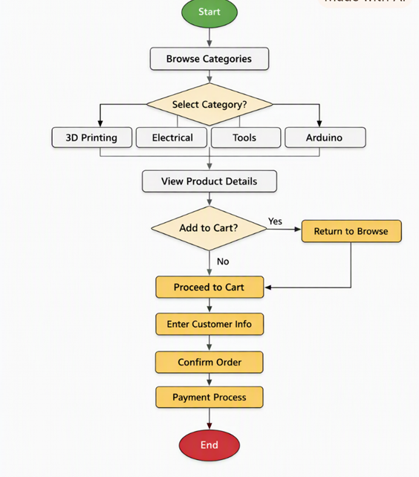

Reflection
The sprint backlog helped organise short-term development goals and track progress throughout the project. Dividing work into smaller sprints allowed the team to focus on achievable objectives while monitoring completion rates. Tracking tasks improved transparency and made it easier to identify issues early. The sprint process also encouraged regular reviews and adjustments, ensuring that the final product remained aligned with project requirements. Through this approach, I gained a better understanding of Agile planning and iterative development.

Agile Logbook
Evidence
Week 1
Activities
- Created project requirements.
- Defined user story.
- Identified website categories.
- Planned project structure.
Challenges
- Defining feature priorities.
Solution
- Used user stories to focus on customer requirements.

Week 2
Activities
- Created use case diagram.
- Developed UML activity diagram.
- Designed class diagram.
Challenges
- Understanding object relationships.
Solution
- Used UML modelling to visualise system design.

Week 3
Activities
- Developed website pages.
- Implemented product browsing functionality.
- Added product information sections.
Challenges
- Managing website navigation.

Solution
- Simplified menu structure and tested navigation paths.

Week 4
Activities
- Performed testing.
- Reviewed functionality.
- Updated documentation.
Challenges
- Identifying minor user interface issues.
Solution
- Performed additional testing and refinement.
Supporting Diagrams
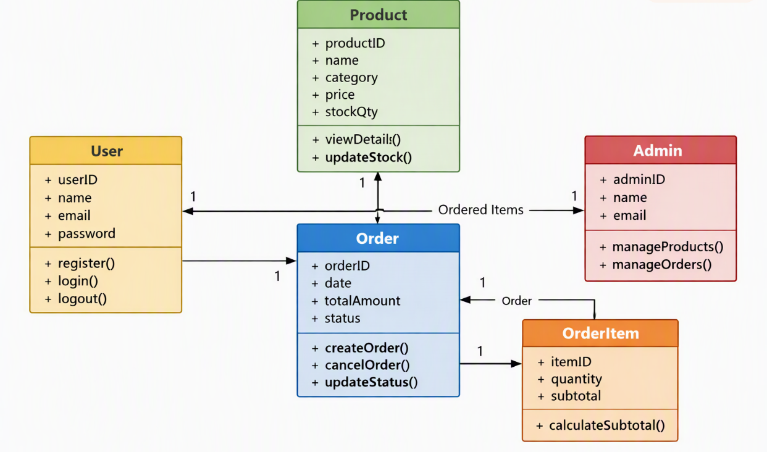
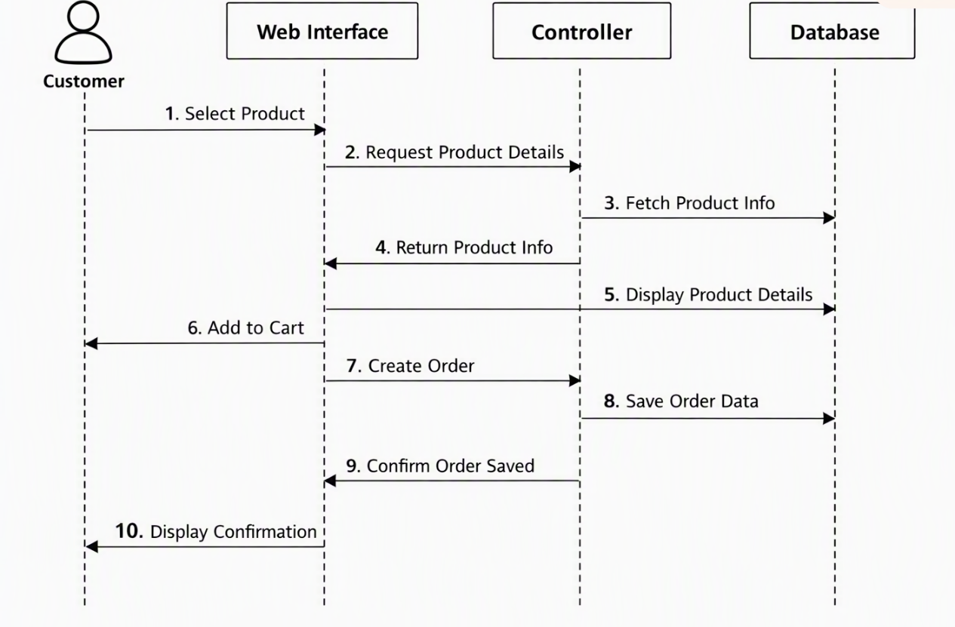

Reflection
The Agile logbook provided a detailed record of project progress throughout development. Recording activities, challenges, and solutions helped identify areas for improvement and encouraged continuous reflection. By documenting weekly progress, it became easier to track achievements and evaluate project performance. The logbook also demonstrated how Agile principles such as iterative development, adaptation, and continuous improvement were applied during the TechStat project. Maintaining consistent records improved organisation and provided evidence of learning and development over time.

